Supplementary section
Neural Mechanisms underlying Bimanual Coordination in Healthy and Stroke Individuals and Application of Non-Invasive Brain Stimulation: A Scoping Review
Jingyi WU¹, Jiaqi LI ¹, Patrick Wai-Hang Kwong¹*, Jack Jiaqi Zhang¹, Ananda Sidarta²
¹ Department of Rehabilitation Sciences, Faculty of Health and Social Sciences, The Hong Kong Polytechnic University, Hong Kong SAR 999077, China.
² Rehabilitation Research Institute of Singapore, Nanyang Technological University, Singapore 247964, Singapore.
* Corresponding author: Patrick Wai-Hang Kwong, Ph.D., Department of Rehabilitation Sciences, Faculty of Health and Social Sciences, The Hong Kong Polytechnic University, Hung Hom, Hong Kong SAR, China.
E-mail: wai-hang.kwong@polyu.edu.hk; Tel: +852 34003958.
ORCID: 0000-0002-1834-5715

This section includes:
Table | Page
Table S1. PubMed Search strategy | Page 3
Figure S1. Brain activation patterns of every cluster during BMCG in healthy subjects | Page 4-6
Table S2. Summary of neural change during bilateral movements with a common goal in Healthy or Stroke individuals | Page 7-13
Table S3. Summary of neural and behavioral effects of neuromodulation techniques on bilateral movements with a common goal in Healthy or Stroke individuals | Page 14-19

Table S1. The detailed search strategy: PubMed
#1 Stroke
#2 CVA
#3 hemiplegia
#4 cerebrovascular accidents
#5 cerebrovascular disorder
#6 paresis
#7 Healthy volunteers
#8 Healthy participants
#9 Healthy subjects
#10 normal volunteer
#11 bilateral coordination
#12 bimanual coordination
#13 cooperative
#14 bimanual cooperative
#15 symmetric
#16 asymmetric
#17 out-of-phase
#18 upper limb
#19 upper extremities
#20 upper limbs
#21 upper extremity
#22 hand
#23 hands
#24 functional imaging
#25 fMRI
#26 functional magnetic resonance imaging
#27 brain imaging
#28 MRI
#29 EEG
#30 electromyography
#31 near-infrared spectrometry
#32 NIRS
#33 TMS
#34 transcranial magnetic stimulation
#35 #1 OR #2 OR #3 OR #4 OR #5 OR #6 OR #7 OR #8 OR #9 OR #10
#36 #11 OR #12 OR #13 OR #14 OR #15 OR #16 OR #17
#37 #18 OR #19 OR #20 OR #21 OR #22 OR #23
#38 #24 OR #25 OR #26 OR #27 OR #28 OR #29 OR #39 OR #31 OR #32 OR #33 OR #34
#39 #35 AND #36 AND #37 AND #38

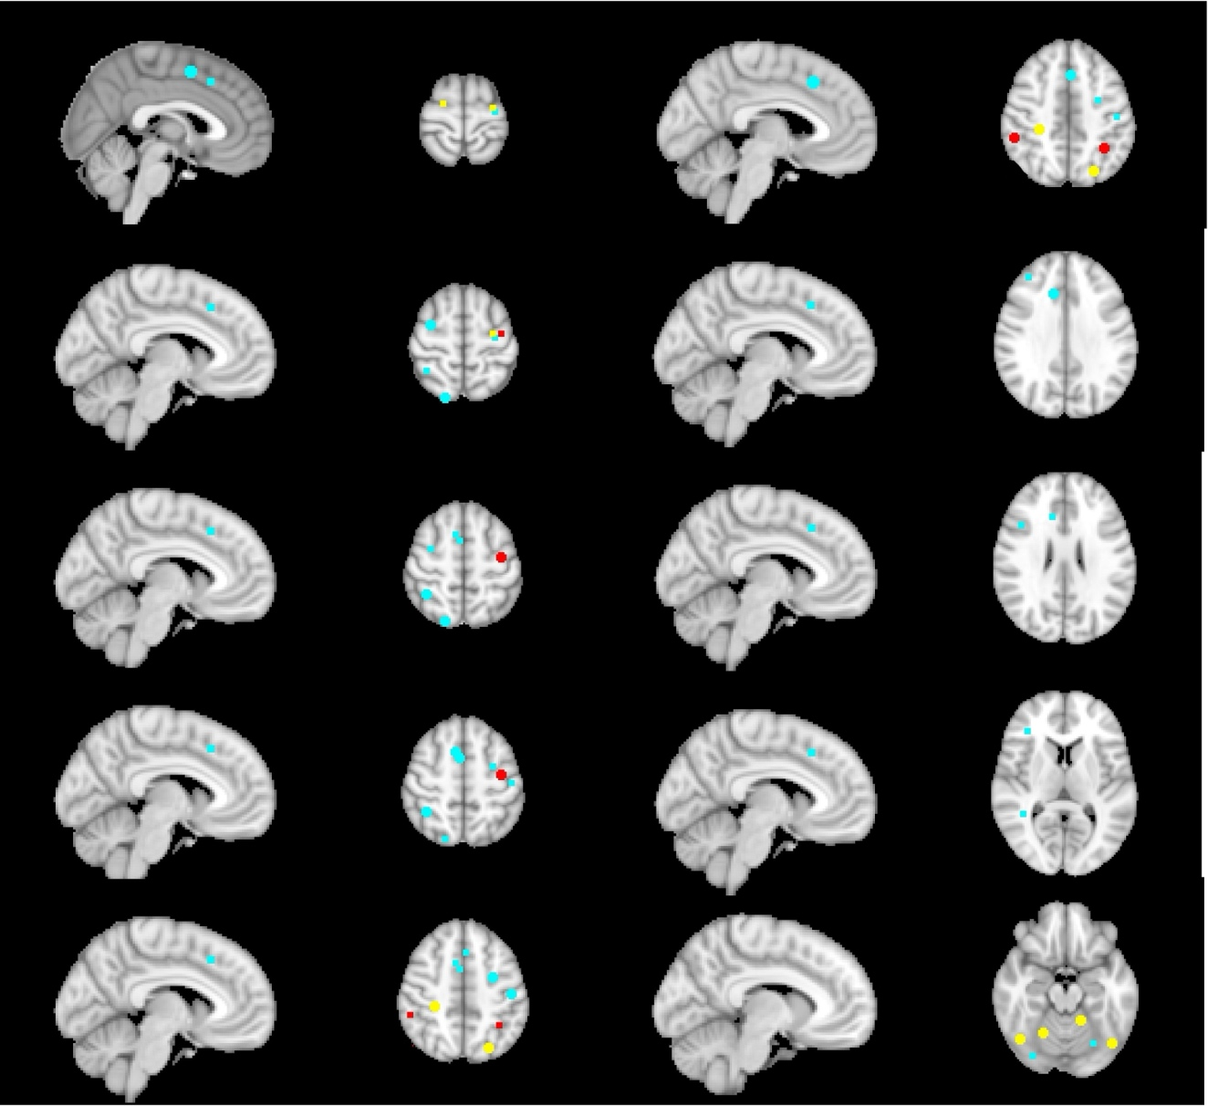
Figure S1a Brain activation patterns of cluster I during BMCG in healthy subjects

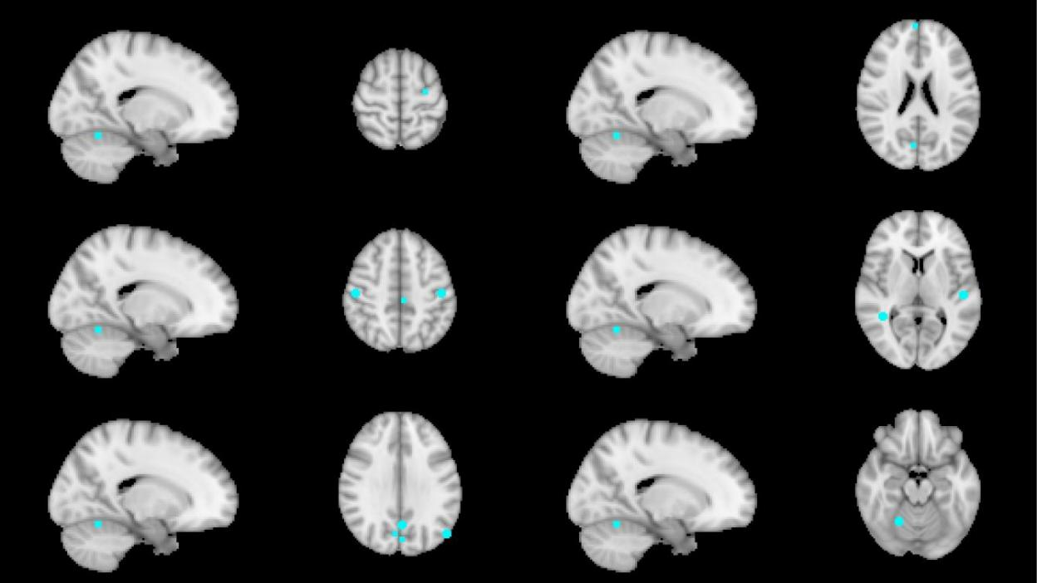
Figure S1b Brain activation patterns of cluster II during BMCG in healthy subjects

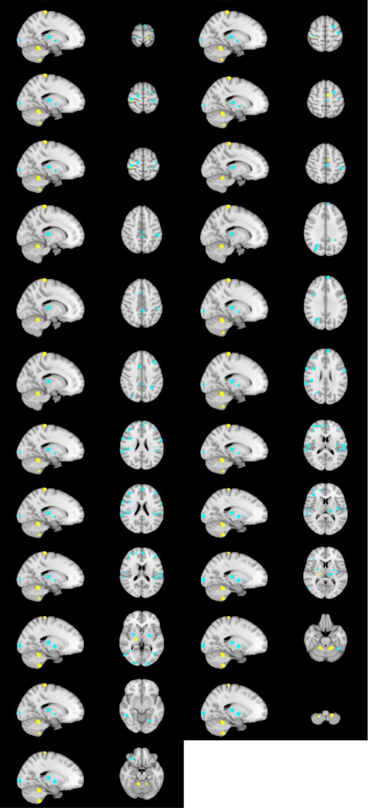
Fig S1c Brain activation patterns of cluster III during BMCG in healthy subjects
Fig S1. Brain activation patterns of every cluster during BMCG in healthy subjects
The red point indicates that the area was activated in all studies in every cluster, and the yellow point suggests that the area was activated in two studies in every cluster. The blue point shows that the area was only activated in one study in every cluster.

Table S2. Summary of neural change during bilateral movements with a common goal in Healthy or Stroke patients
Study | Subjects | Age, Years  (mean ± SD) | Gender  (M: F) | Affected Hand  (L: R) | Bilateral tasks description | Neural outcomes | Results (activated area)
Koeneke et al. (2004) [32] | Healthy,  N=14 | 24.14 ± 5.80 | 6:8 | RH | Bilateral finger pressing  Symmetric and asymmetric common goal | fMRI (xyz) | BMCG vs. rest.  Bilateral IPC, ITC, SFC, cerebellum, M1 ↑  Right IPS, MOC, precuneus, OFC, IFC, MFC, inferior S1 ↑  Left SPC ↑
Hanawa et al. (2016) [36] | Healthy,  N=37 | 20.80 ± 1.50 | 23:14 | RH | Bilateral wrist and hands movements (imitate drive)  Symmetric and asymmetric common goal | fMRI (xyz) | - BMCG vs. rest.  Bilateral STC, S1, cuneus ↑  Right medial PFC, cerebellum ↑  Left SFC, MCC, angular gyrus, precuneus ↑  - BMCG vs. rest.  Bilateral IPC, SMA, M1, MFC, SPC, ITC,  Right ACC, angular gyrus, IFC
Duque et al.  (2010) [34] | Healthy,  N=15 | 25.00 ± 3.40 | None | RH | Bilateral hand movements with given speed ratio  Symmetric and asymmetric common goal | fMRI  (xyz) | BMCG vs. rest.  Bilateral S1, M1, SFC, IPC, cerebellum ↑  Right IFC, DLPFC, MFC, SMA, IPC, MTC, STC, PMv ↑  Left basal ganglia, PMd, MOC ↑  BMCG vs. BMIG:  Right SMA, M1, STC ↑
Dietz et al.  (2013) [35] | Healthy,  N=20 | 33.00 ± 9.80 | 13:7 | RH | Flexion and extension bilateral wrist joint: open and close movement  Asymmetric common goal | fMRI  (xyz) | BMCG vs. rest  Bilateral SMA, PMC, M1, cerebellum and higher visual areas (including V5-MTG), S2, S1↑  Left insular cortex↑  Right posterior thalamus ↑  BMCG vs. BMIG  Bilateral S2, S1↑  Left IC and cerebellum ↑  Right posterior thalamus ↑
Puttemans et al. (2005) [33] | Healthy,  N=11 | 23.90 ± 1.58 | 6:5 | RH | Bilateral wrist movements with given speed ratio with bilateral wrist  Symmetric and asymmetric common goal | fMRI | BMCG vs. rest.  Bilateral S1, M1, SMA, ACC, PCC, FPO, supramarginal, cuneus, thalamus, basal ganglia, cerebellum, PMv, PMd, PFl ↑  Right MTC↑
Ullen et al. (2003) [37] | Healthy,  N = 14 | 21.00-27.00 | 14:0 | RH | Bilateral hand movements with given speed ratio  Symmetric and asymmetric common goal | fMRI | BMCG vs. BMIG.  mid preSMA, bilateral STC, right IPS
Schrafl-Altermatt et al. (2014) [38] | Healthy,  N=13 | 26.40 ± 3.70 | 3:10 | RH | Flexion and extention bilateral wrist joint: open and close movement  Asymmetric common goal | fMRI | BMCG vs. rest.  Bilateral S2 ↑  BMCG vs. BMIG  Bilateral S2 ↑
Grefkes et al. (2008) [39] | Healthy,  N = 12  Stroke,  N = 12 | Healthy  46.4  Stroke  46.60 ± 9.10 | Healthy  None  Stroke  9:3 | Healthy  RH  Stroke  5:7 | Bilateral hand fist with given instruction  Symmetric and asymmetric common goal | fMRI | Functional connectivity  BMCG vs. rest.  Healthy:  positive interhemispheric interaction between bilateral PMC, intrahemispheric interaction beteen SMA and M1, PMC and M1, PMC and SMA in each hemisphere↑.  negative interhemispheric interaction between bilateral SMA and M1, intrahemispheric interaction between SMA to M1 in each hemisphere↑.  Stroke vs. Healthy:  positive intrahemispheric interaction between ipsilateral SMA and M1 ↓.  No negative interhemispheric interaction between bilateral SMA, and ipsilateral M1 and contralateral SMA.
Schrafl-Altermatt et al. (2016) [40] | Healthy,  N = 8  Stroke,  N = 12 | Healthy  61.00 ± 8.00  Stroke  61.70 ± 8.40 | Healthy  None  Stroke  9:3 | Healthy  RH  Stroke  5:7 | Flexion and extention bilateral wrist joint: open and close movement  Asymmetric common goal | EEG | BMCG vs. BMIG or rest, covered with bilateral M1.  Stroke: amplitude ratio of SSEP in the unaffected hemisphere ↑, which means more involvement of the unaffected hemisphere during the coordinate task.
SD: standard deviation; M: male; F: female; L: light; R: right; RH: right-handed; IPC: inferior parietal cortex; ITC: inferior temporal cortex; SFC: Superior frontal cortex; M1: precentral gyrus = primary motor cortex; IPS: Intraparietal sulcus; MOC: Medial occipital cortex; OFC: orbitofrontal cortex; IFC: inferior frontal cortex; MFC: medial frontal cortex; S1: postcentral gyrus primary somatosensory cortex; SPC: superior parietal cortex; STC: superior temporal cortex; a: familiar BMCG for healthy subjects; b: unfamiliar BMCG for healthy subjects; PFC: prefrontal cortex; MCC: middle cingulate cortex; IPC: Inferior postcentral cortex; SMA: supplementary motor area; ACC: anterior cingulate cortex; DLPFC: dorsal left prefrontal cortex; MTC: middle temporal cortex; PMv: ventral premotor cortex; PMd: dorsal premotor cortex; PMC: premotor cortex; S2: secondary somatosensory cortex; CMC: cingulate motor cortex; FPO: frontal and parietal opercular; PFv: ventral prefrontal cortex; PFd: dorsal prefrontal cortex; PFl: lateral prefrontal cortex; SSEP: somatosensory evoked potentials.

Table S3. Summary of neural and behavioral effects in association with non-invasive brain stimulation in Healthy or Stroke patients
Study | Subjects | Study Design | Age (Years) | Gender  (M: F) | Intervention | Neural Outcomes | Behavioral Outcomes
Duque et al.  (2010) [34] | Healthy, RH  N=15 | CT | 25.00 ± 3.40 | None | The first day: virtual lesions inducing by right and left M1 (80%RMT)  The second day: virtual lesions inducing by right SMA and bilateral STC (120% RMT)  6min/block, 3 block every stimulation site, 10hz rTMS  during each block, participants were required to perform 12 BMCG and 18 BMIG trials. | None | vs. control trial (no TMS):  - Virtual lesion over the right STC negatively affected hand error of BMCG rather than BMIG.  - Virtual lesion over the right M1 improved hand error slope and coordination index during BMIG rather than BMCG.  - Virtual lesion applied over the right SMA, left STC or M1 had no effect on the BMCG and BMIG
Berger et al. (2018) [44] | Healthy, RH  N=24 | RCT | G1:22±2  G2:22±3  G3:23±3 | G1: 6:2  G2: 3:5  G3: 3:5 | G1: 10hz, 1mA, 20min, tACS left parietal lobe (p3, p4)  G2: 20hz, 1mA, 20min, tACS left parietal lobe (p3, p4)  G3: sham tACS, 60s | - real stimulation groups increased alpha during bilateral task (10hz up to 30min, 20hz up to 1d after stimulation) in parietal compared to frontal cortex  - after 10hz: Hboxy concentration decreased in right PMC, M1, the primary somatosensory cortex compared to sham stimulation.  - after 20 Hz: Hboxy concentration decreased in right PMC compared to the control group. | All groups improved BMCG with main time effect assessed by both hands task, independent of tACS.
Liao et al.  - [29] | Stroke  N = 14 | repeated  cross-over | 43-79 | 9:5  Affected Hand (L:R)  8:6 | G1: cPMd, rTMS, 5hz, 70%AMT, 930s, 1200 pulses, first two visits  G2: iM1, rTMS, 5hz, 70%AMT, 930s, 1200 pulses, last two visits | - iM1 responders:  ISP inhibition decreased after stimulation over the iM1  ISP inhibition increased after stimulation over the cPMd  CSP ratio decreased after stimulation over the iM1  CSP ratio increased after stimulation over the cPMd  CSP ratio increased after stimulation over the iM1 and cPMd  iMEP ratio greater in stimulation over the iM1 than cPMd  a greater MEP ratio in ipsilateral than contralesional for stimulation over the iM1.  - cPMd responders:  ISP decreased after stimulation over the cPMd  iMEP ratio greater in the cPMd than iM1 condition.  iMEP ratio ≥ cMEP ratio | - Enhanced temporal coordination during BMGG after stimulation over the iM1 or cPMd.  - Participants with more severe impairment and weaker IHI had improvement in bimanual force/neuromuscular coordination after stimulation over the cPMd.  - Those with milder impairment and stronger IHI triggered improved BMCG after stimulation over the iM1.
Azarpankai et al. (2020) [41] | Healthy, RH  N=64 | RCT | None | 37:27 | G1: tDCS follow two-hand coordination training for two days  G2: tDCS during two-hand coordination training for two days  G3: two-hand coordination training follow tDCS for two days  G4: sham during two-hand coordination training for two days  15min tDCS, 1.5mA, anode cerebellar, cathode right medial deltoid | None | - G2 ↑ skill acquisition of BMCG  - G3 ↑ consolidation of BMCG  - G2 and G3 ↑ speed/accuracy of BMCG
Verstraelen et al. (2021) [42] | Healthy, RH  N=20 | pseudo-randomized within-subject design | 22.85 ± 3.73 | 9:11 | G1: right PMd  G2: left PMd  rTMS, 10hz, 5 pulses, 110% RMT during BMCG | None | - Stimulation over the left PMd during planning of BMCG improved hand movement speed and movement accuracy of BMCG assessed by BTT.  - Stimulation over the right PMd during both planning and execution of BMCG decreased movement stability of BMCG  - rTMS-induced modulation of IHI between PMd and M1 during planning of BMCG did not predict rTMS-induced performance modulation.
Schonefeld et al. (2021) [43] | Healthy, RH  N=54 | double  blind RCT | 24.05 ± 4.76 | 26:28 | G1: tACS, bilateral M1, in-phase stimulation, 20min, 2 mA, 20hz  G2: tACS bilateral M1, out-of-phase stimulation, 20min, 2 mA, 20hz  G3: sham tACS ( 3s of stimulation)  during BMCG (40 min) | None | - Significant main effect of time for all groups  - No significant main effect of group and interaction effect between time and group  - Individuals successfully learned the BMCG, but that beta tACS did not modulate the learning.
De Late et al. (2022) [45] | Healthy,  N = 7,  Stroke,  chronic  N=17 | double bilnd RCT  crossover | Healthy:None  Stroke: 60 ± 13 | Healthy:  None  Stroke: 8:9  Affected Hand (L:R)  7:10 | Healthy  Robot training  Stroke  G1: tDCS, anodal cM1, 30min, 1mA during robot training  G2: sham tDCS during robot training | None | - Bimanual motor skill learning, retention, and generalization in patients with chronic hemiparetic stroke was not improved by anodal tDCS over the cM1 compared to sham tDCS.  - The healthy individuals performed better than patients on bimanual motor skill learning, but generalization was similar in both groups  - The retention after 1 week was superior for healthy than stroke in terms of bilateral speed/accuracy trade-off.
CT: controlled trial; M1: primary motor cortex; RMT: rest motor threshold; SMA: supplementary motor area; STC: superior temporal cortex; rTMS: repetitive transcranial magnetic stimulation; RCT: randomized controlled trial; tDCS: transcranial direct current stimulation; cPMd: contralesional dorsal premotor cortex; TCI: transcallosal inhibition; i: ipsilateral; MEP: motor evoked potential; tACS: transcranial alternating current stimulation; AMT: active motor threshold; iM1: ipsilateral primary motor cortex; IHI: interhemispheric inhibition; ISP:ipsilateral silent period; CSP:cortical silent period; BTT: bimanual visuomotor tracking task; cM1: contralateral primary motor cortex.

