The raw data of western blot
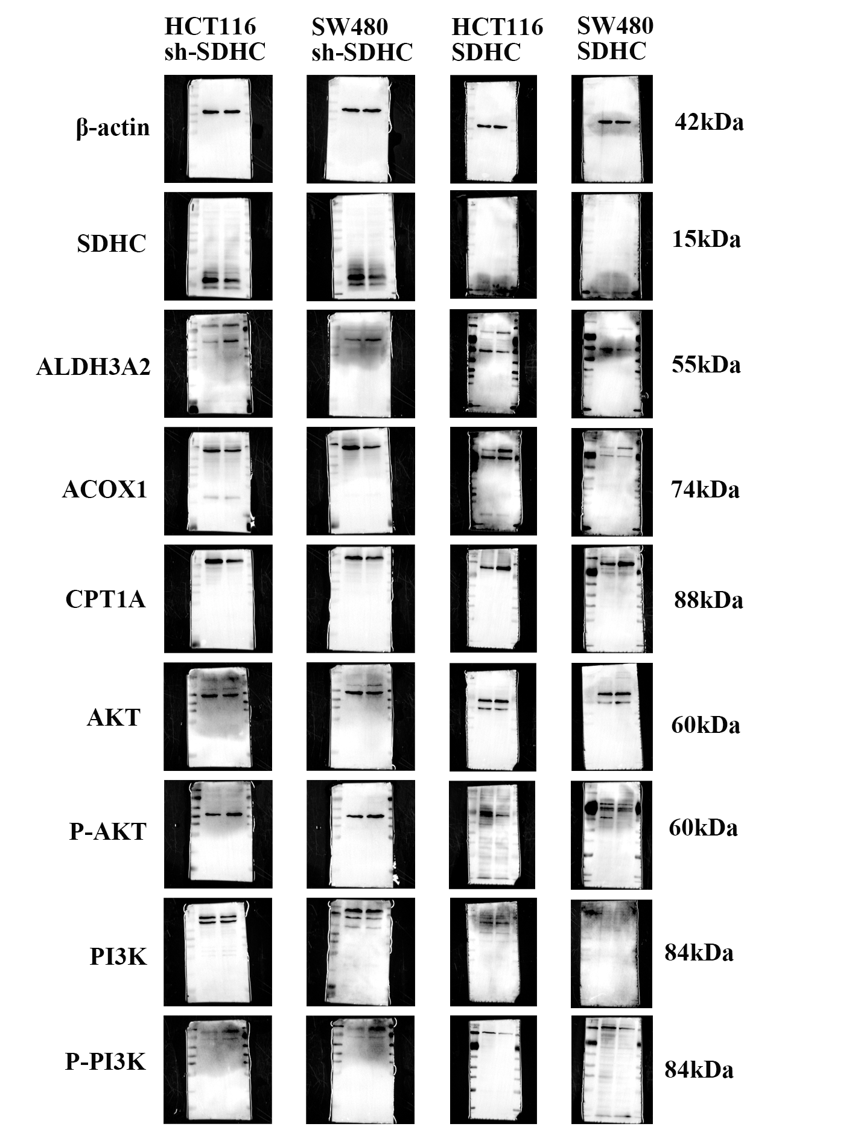
Raw data, Figure1, Full uncropped immunoblot images

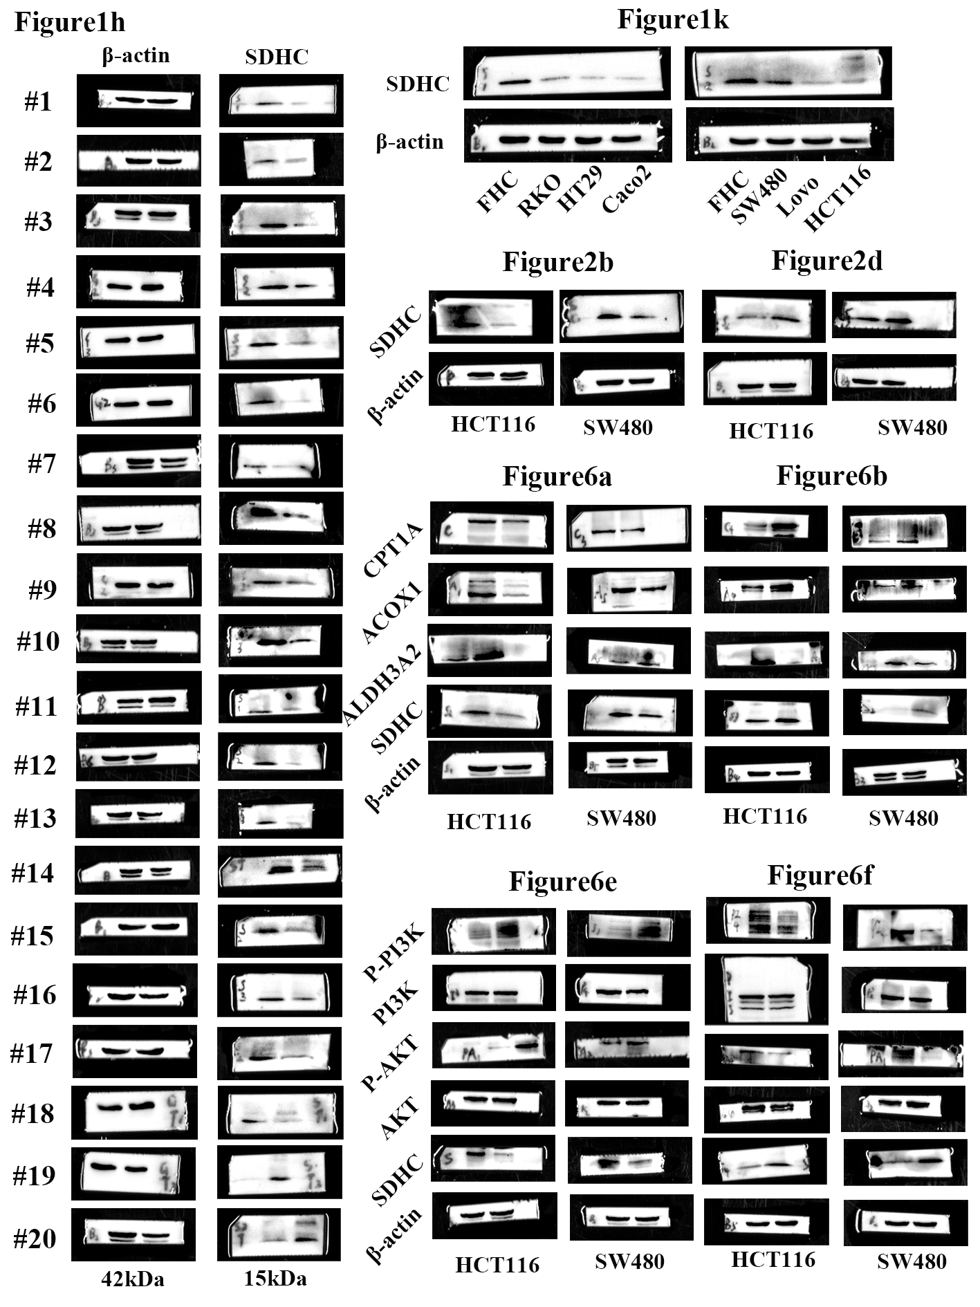
Raw data, Figure2, The uncropped scans of western blots from the main figures
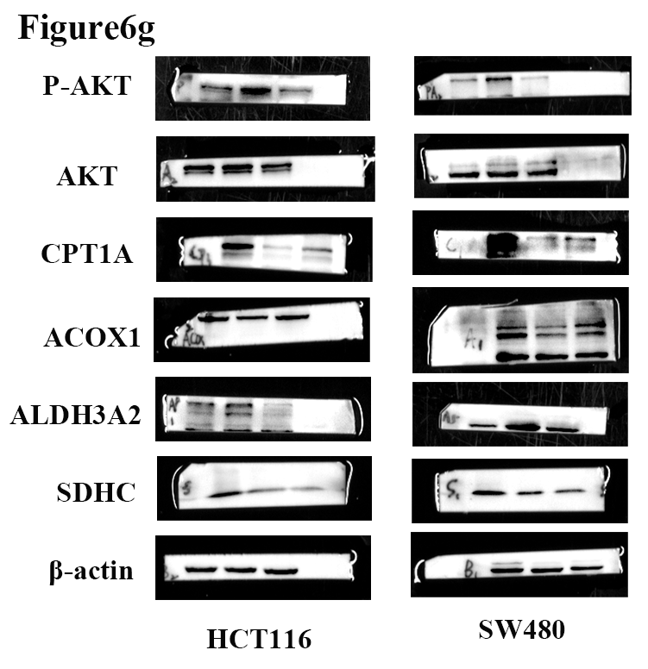
Raw data, Figure3, The uncropped scans of western blots from the main figures

