Additional file
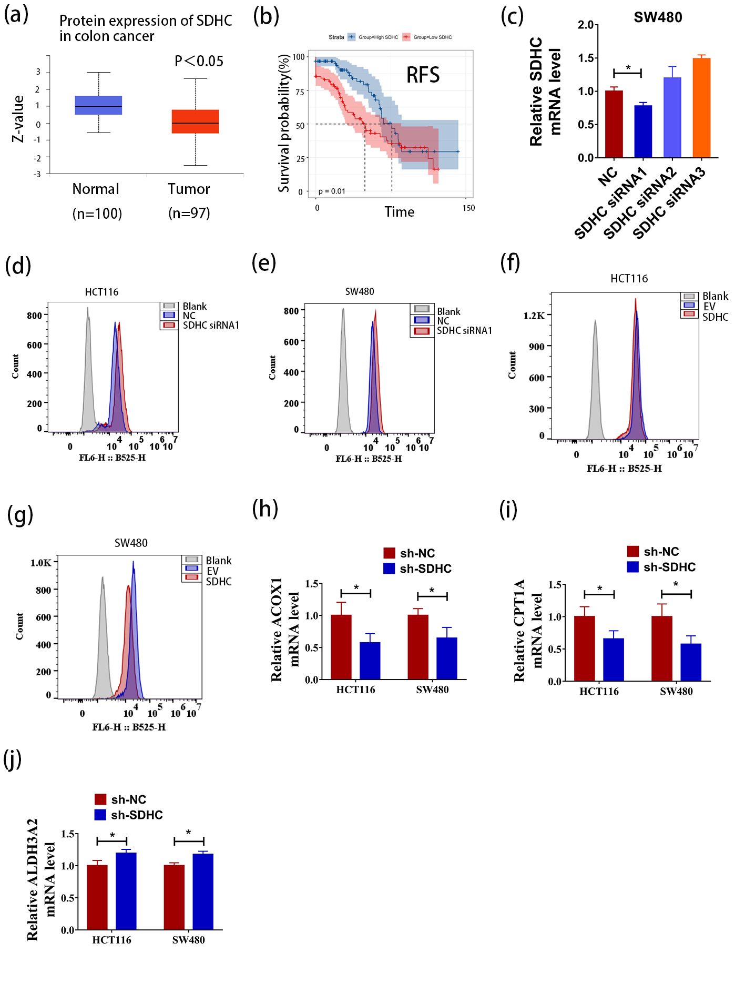
Figure S1. (a) The protein expression of SDHC was low in CRC compared to normal by UALCAN. (b) Low expression of SDHC was found to be associated with poor Recurrence free survival in CRC in GSE17538. (c) SDHC levels in SW480 cells were analyzed by qPCR after transfection with siRNA negative control (NC), SDHC siRNA1, SDHC siRNA2 and SDHC siRNA3. (d-e) Representative flow cytometry histograms showing the fluorescence for HCT116 (NC/ SDHC siRNA1) and SW480 (NC/ SDHC siRNA1) cells modified with BODIPY 493/503. Shown in gray is the fluorescence for unmodified control cells. (f-g) Representative flow cytometry histograms showing the fluorescence for HCT116 (EV/ SDHC) and SW480 (EV/ SDHC) cells modified with BODIPY 493/503. Shown in gray is the fluorescence for unmodified control cells. (h-j) qPCR was used to demonstrate the effects of silencing SDHC on the expression of critical enzymes involved in lipid metabolism, namely ACOX1, CPT1A, and ALDH3A2. Data are presented as the mean ± SD and analyzed by Student’s t-test. *P < 0.05, **P < 0.01, ***P < 0.001.

Table S1. Biological Processes
Term ID | Term Description | Rich Ratio | P value | Q value
GO:1904871 | positive regulation of protein localization to Cajal body | 0.727273 | 1.08E-06 | 1.86E-04
GO:1902949 | positive regulation of tau-protein kinase activity | 0.714286 | 1.62E-04 | 0.015317
GO:1904851 | positive regulation of establishment of protein localization to telomere | 0.7 | 8.08E-06 | 0.001205
GO:0045899 | positive regulation of RNA polymerase II transcriptional preinitiation complex assembly | 0.6 | 1.33E-04 | 0.013213
GO:0006521 | regulation of cellular amino acid metabolic process | 0.596154 | 1.14E-18 | 3.48E-15
GO:1904874 | positive regulation of telomerase RNA localization to Cajal body | 0.5625 | 5.08E-06 | 7.99E-04
GO:0010499 | proteasomal ubiquitin-independent protein catabolic process | 0.545455 | 1.99E-07 | 4.03E-05
GO:1903715 | regulation of aerobic respiration | 0.545455 | 2.68E-04 | 0.022668

Table S2. Cellular Components
Term ID | Term Description | Rich Ratio | P value | Q value
GO:0005610 | laminin-5 complex | 1 | 8.14E-05 | 0.002364
GO:0043259 | laminin-10 complex | 1 | 8.58E-04 | 0.018017
GO:0022624 | proteasome accessory complex | 0.882353 | 5.01E-14 | 7.07E-12
GO:0031597 | cytosolic proteasome complex | 0.857143 | 4.71E-06 | 2.33E-04
GO:0005838 | proteasome regulatory particle | 0.833333 | 3.25E-09 | 3.21E-07
GO:0008540 | proteasome regulatory particle, base subcomplex | 0.75 | 1.05E-07 | 7.96E-06
GO:0005832 | chaperonin-containing T-complex | 0.7 | 6.43E-06 | 2.88E-04
GO:0008541 | proteasome regulatory particle, lid subcomplex | 0.625 | 3.38E-04 | 0.007763

Table S3. Molecular Functions
Term ID | Term Description | Rich Ratio | P value | Q value
GO:0036402 | proteasome-activating ATPase activity | 1 | 8.02E-07 | 1.65E-04
GO:0043426 | MRF binding | 0.8 | 3.99E-04 | 0.01993
GO:0030235 | nitric-oxide synthase regulator activity | 0.666667 | 5.20E-05 | 0.004288
GO:0008379 | thioredoxin peroxidase activity | 0.666667 | 0.001105 | 0.040479
GO:0070883 | pre-miRNA binding | 0.666667 | 0.001105 | 0.040479
GO:0016504 | peptidase activator activity | 0.545455 | 2.41E-04 | 0.014426
GO:0004298 | threonine-type endopeptidase activity | 0.5 | 1.43E-04 | 0.010819
GO:0001094 | TFIID-class transcription factor complex binding | 0.5 | 0.001385 | 0.045639

Table S4. KEGG Pathway
Term ID | Term Description | Rich Ratio | P value | Q value
3050 | Proteasome | 0.673913 | 5.44E-20 | 1.84E-17
5017 | Spinocerebellar ataxia | 0.316901 | 6.54E-12 | 5.53E-10
4392 | Hippo signaling pathway - multiple species | 0.310345 | 0.002464 | 0.023003
5230 | Central carbon metabolism in cancer | 0.3 | 7.69E-06 | 2.00E-04
4214 | Apoptosis | 0.285714 | 4.40E-04 | 0.005955
5222 | Small cell lung cancer | 0.282609 | 2.29E-06 | 7.73E-05
4391 | Hippo signaling pathway | 0.271429 | 9.55E-05 | 0.001793
5012 | Parkinson disease | 0.268775 | 2.04E-13 | 3.46E-11

Table S5. GSEA
MSigDB C2(curated) KEGG Term Desc | NES | NOM p-val | FDR q-val
Proteasome | 2.250839 | 0 | 0
Parkinson's disease | 2.119942 | 0 | 0
Oxidative phosphorylation | 1.937079 | 0 | 0.009484
Fatty acid metabolism | 1.885555 | 0 | 0.012493
Butanoate metabolism | 1.773249 | 0.005602 | 0.035317
Citrate cycle (TCA cycle) | 1.653092 | 0.017094 | 0.091673

Table S6. Drugs screening
Drugs | Target | selectivity index (SI)
GSK1059615 | PI3K/AKT signaling | 470.478
Tacrolimus | PI3K/AKT signaling | 56.32805
Voxtalisib Analogue | PI3K/AKT signaling | 17.37569
Adenosine 5'-monophosphate | PI3K/AKT signaling | 4.579134
INK 128 | PI3K/AKT signaling | 2.921348
Temsirolimus | PI3K/AKT signaling | 2.500308
P7C3 | Others | 87.08972
Clotrimazole | Microbiology&Virology | 3.355631
Pralatrexate | Metabolism | 374.7693
Orlistat | Metabolism | 1390.484
(R)-Etomoxir sodium salt | Metabolism | 497.6239
Mevastatin | Metabolism | 7.615274
Prednisolone-21-acetate | Metabolism | 3.933708
Atorvastatin Calcium | Metabolism | 2.796075
Sulfameter | Metabolism | 2.390029
Tioxolone | Metabolism | 2.115538
Cinobufagin | Membrane transporter/Ion channel | 1042.735
Ranolazine dihydrochloride | Membrane transporter/Ion channel | 50.32815
Revaprazan hydrochloride | Membrane transporter/Ion channel | 8.625819
CFTRinh172 | Membrane transporter/Ion channel | 6.00951
Esomeprazole Sodium | Membrane transporter/Ion channel | 2.802787
Sudoterb free base | Membrane transporter/Ion channel | 2.349109
TBHQ | Immunology/Inflammation | 3.350621
Curcumin | Chromatin/Epigenetic; Others | 15.77938
Gimeracil | Autophagy | 205.0812
Sulfanilamide | Autophagy | 8.325187
Pifithrin-μ | Apoptosis | 27753.78
PK11007 | Apoptosis | 4.109632
COTI2 | Apoptosis | 2.79421
LW6 | Angiogenesis | 2.66004
IDF-11774 | Angiogenesis | 74.21094
Lificiguat | Angiogenesis | 3.042985

