Sl No. | Ions | Concentration (ppm)
1. | Na+ | 185.53
2. | Ca++ | 59.14
3. | Mg++ | 27.00
4. | SO4-- | 244.20
5. | Cl- | 382.83
6. | HCO3- | 77.50
TDS |  | 976.2
SUPPLEMENTARY MATERIALS

Table S1 - Ion Concentration in Field Mixing Water

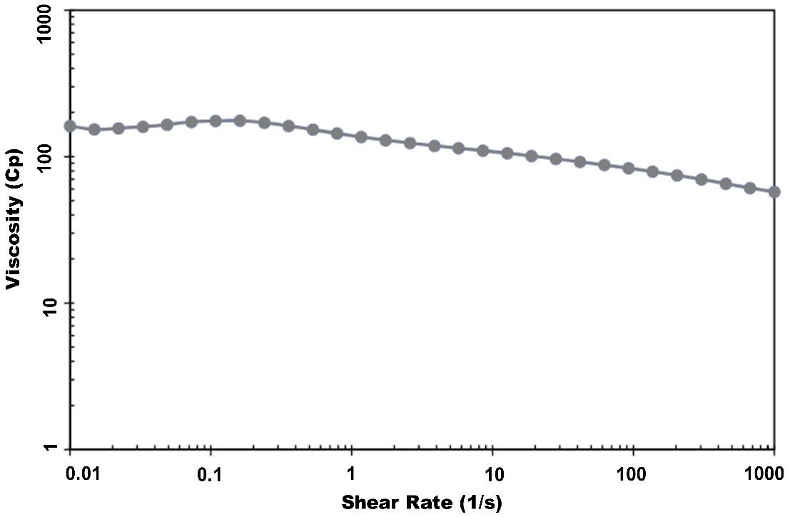
Figure S1- Crude oil rheology at 25℃

