Fair National Greenhouse Gas Reduction Targets Under Multiple Equity Perspectives - A Synthesis Framework

Gaurav Ganti^{1,*}, Andreas Geiges¹, Louise Jeffery², Hanna Fekete² , Matthew J. Gidden^{1,3}, Michiel Schaeffer^{1,4}, Bill Hare¹, Niklas Höhne^{2,5}

¹ Climate Analytics, Berlin, Germany
² NewClimate Institute, Cologne, Germany
³ International Institute for Applied Systems Analysis, Laxenburg, Austria
⁴ The Global Center on Adaptation, Rotterdam, The Netherlands
⁵ Wageningen University & Research, Wageningen, The Netherlands

* Corresponding author: gaurav.ganti@climateanalytics.org

Supplementary Information
1. Brief Overview of Equity Literature 2
2. Overview of input literature 3
3. Description of Simplified Effort-Sharing Approach 6
4. Assessing Geopolitical Sub-Units 9
5. Comparing Three Types of Equity Distributions 11
6. References 13

Brief Overview of Equity Literature
In this section we present a brief overview of the strategies currently adopted in the literature to provide guidance to countries on the fairness (both of their own targets as well as the targets of their countries) while keeping the Paris Agreement in sight. The scientific literature so far has adopted three strategies:
- Present a single approach and argue for its relevance: In these studies, a single approach is used to consistently determine mitigation targets for all countries. Examples of such studies include (Holz, Kartha, & Athanasiou, 2017), (Jayaraman, Kanitkar, & Dsouza, 2011), (Winkler, Letete, & Marquard, 2013), (Elzen, Schaeffer, & Lucas, 2005), among others. These papers provide important guidance on the ethical basis and numerical quantification of specific allocation schemes. Some approaches reflect a single principle, for instance, convergence towards equal per-capita emissions whereas other integrate multiple principles into one allocation scheme, such as the Civil Society Equity Review that integrates principles of responsibility, capability and need.
- Present quantitative results from different approaches (each implemented individually) and compare them: In these studies, multiple allocation schemes are implemented using the same data input to facilitate a comparison between the outcomes for different allocation schemes and to try to derive a generalisable insight from their quantification. Examples of such studies include (Pan, Elzen, Höhne, Teng, & Wang, 2017), (Robiou du Pont et al., 2017), (van den Berg et al., 2019), among others. These studies help to clarify the impact of different effort-sharing principles on a country’s emission allocation by controlling for other differences such as reference and historical data. However, they are limited by a lack of comprehensive representation of diverse equity literature estimates and open to questions on the normative choices behind the selection of approaches that they present (see, for e.g. the criticism of (Robiou du Pont et al., 2017) by Kartha et al., (2018)).
- Present an analysis of differentiated (heterogenous) approach selection: This approach is followed by (Meinshausen et al., 2015) and (Robiou du Pont & Meinshausen, 2018). These studies assume that countries consistently select the emission allocation approach that provides them the most generous allocations and demonstrate different approaches to reconcile this “self-interested” selection.

In addition to these three groups, there is a fourth set of studies that aim to review the existing literature and derive general insights; examples of these review studies include (N. Höhne et al., 2012) and (Höhne et al., 2014).

Overview of input literature
In this section we provide an overview of the literature included in this study and the justification for excluding certain studies in our curated dataset. The dataset is curated to address a number of challenges with combining data from multiple sources and collated over an extended period of time. We remove studies and individual data points where the historic data in the study disagrees substantially with the more up to date historic data used in the analysis. If included, this mismatching data is distorted during the harmonisation step (see below) and yields results that do not reflect the original study. For similar reasons, we also exclude studies that are based on energy CO₂ only or that are based on emissions including LULUCF where the share of LULUCF is >20%. Finally, we exclude some older studies where a more recent version of the same approach has been published by a similar set of authors.

Reference | Title | Included in Curated Dataset? | Reason for exclusion
(den Elzen, Beltran, Hof, van Ruijven, & van Vliet, 2013) | Reduction targets and abatement costs of developing countries resulting from global and developed countries’ reduction targets by 2050. | Yes
(van Vuuren, Isaac, Den Elzen, Stehfest, & Van Vliet, 2010) | Low stabilisation scenarios and implications for major world regions from an integrated assessment perspective. | Yes
(Hof & Den Elzen, 2010) | The effect of different historical emissions datasets on emission targets of the sectoral mitigation approach Triptych. | Yes
(Knopf et al., 2009) | The economics of low stabilisation: implications for technological change and policy | No | Based on energy-CO₂ only
(den Elzen, Lucas, & van Vuuren, 2008) | Regional abatement action and costs under allocation schemes for emission allowances for achieving low CO2-equivalent concentrations. | No | Emissions in 2050 target pathway are too high
(den Elzen, Höhne, & Moltmann, 2008) | The Triptych approach revisited – A staged sectoral approach for climate mitigation | Yes
(van Vuuren et al., 2009) | Comparison of different climate regimes: the impact of broadening participation. | Yes
(den Elzen, Höhne, Brouns, Winkler, & Ott, 2007) | Differentiation of countries’ future commitments in a post-2010 climate regime: An assessment of the “South-North Dialogue” Proposal. | Partial | 450 ppm scenario only
(den Elzen & Meinshausen, 2006) | Meeting the EU 2°C climate target: global and regional emission implications. | Yes
(den Elzen, Lucas, & van Vuuren, 2005) | Abatement costs of post-Kyoto climate regimes. | No | Baseline only
(Criqui et al., 2003) | Greenhouse gas reduction pathways in the UNFCCC Process up to 2025. | No | Baseline only
(Berk & den Elzen, 2001) | Options for differentiation of future commitments in climate policy: how to realise timely participation to meet stringent climate goals? | No | Baseline only
(Kuntsi-Reunanen & Luukkanen, 2006) | Greenhouse gas emission reductions in the post-Kyoto period: Emission intensity changes required under the “contraction and convergence” approach. | No | Emissions in 2050 target pathway are too high
(Winkler et al., 2013) | Equitable access to sustainable development: operationalising key criteria. | No | Emission reductions through to 2050 based on index and baseline reference from 2000 data
(Chakravarty et al., 2009) | Sharing global CO2 emission reductions among one billion high emitters. | Yes
(Bows & Anderson, 2008) | Contraction and convergence: an assessment of the CC options model. | Yes
(Vaillancourt & Waaub, 2004) | Equity in international greenhouse gases abatement scenarios: A multicriteria approach. | No | Emissions in 2050 target pathway are too high
(Miketa & Schrattenholzer, 2006) | Equity implications of two burden sharing rules for stabilizing greenhouse gas concentrations. | No | Emissions in 2050 target pathway are too high
(Bode, 2004) | Equal emissions per capita over time – A proposal to combine responsibility and equity of rights for post-2012 GHG emission entitlement allocation. | No | Emissions in 2050 target pathway are too high
(Böhringer & Welsch, 2006) | Burden sharing in a greenhouse: Egalitarianism and sovereignty reconciled. | No | Baseline only
(Groenenberg, Blok, & van der Sluijs, 2004) | Global Triptych: a bottom-up approach for the differentiation of commitments under the Climate Convention. | No | Emissions in 2050 target pathway are too high
(WBGU, 2009) | Solving the climate dilemma: The budget approach. | Yes
(Knopf, Kowarsch, Lüken, Edenhofer, & Luderer, 2012) | A global carbon market and the allocation of emission rights. | No | Based on energy-CO₂ only
(Nabel et al., 2011) | Decision support for international climate policy – The PRIMAP emission module. | Yes
(Peterson & Klepper, 2007) | Distribution Matters – Taxes vs. Emissions Trading in Post Kyoto Climate Regimes. | No | Baseline only
(Onigkeit, Anger, & Brouns, 2009) | Fairness aspects of linking the European emissions trading scheme under a long-term stabilization scenario for CO2 concentration. | Yes
(Jacoby, Babiker, Paltsev, & Reilly, 2008) | Sharing the burden of GHG reductions. | Yes
(Edenhofer et al., 2010) | The economics of low stabilization: Model comparison of mitigation strategies and costs. | No | Based on energy-CO₂ only
(Niklas Höhne & Moltmann, 2009) | Sharing the effort under a global carbon budget. | Yes
(Niklas Höhne & Moltmann, 2008) | Distribution of emission allowances under the Greenhouse Development Rights and other effort-sharing approaches. | Yes
(Jayaraman et al., 2011) | Equitable access to sustainable development: An Indian Approach | Yes
(Kriegler et al., 2014) | Can we still meet 2°C with global climate action? The LIMITS study on implications of Durban Action Platform scenarios. | Partial | Include C&C only
(Kober, Zwaan, & Rösler, 2012) | The role of burden sharing regimes to reach the global 2°C climate target TIAM-ECN model approach Cost optimal GHG mitigation to reach the global 2°C climate target. | No | Data issues
(Baer, Athanasiou, Kartha, & Kemp-Benedict, 2008) | The Greenhouse Development Rights framework. The right to development in a climate constrained world. | Yes
(Pan, Teng, & Wang, 2013) | Sharing emission space at an equitable basis: Allocation scheme based on the equal cumulative emission per capita principle. | No | Superseded by (Pan et al., 2017)
EVOC tool  (Moltmann et al., 2011) | Tool developed to quantify multiple effort-sharing schemes, including contraction and convergence, common bud differentiated convergence, GDR, and multi-stage approaches. | Yes
(Robiou du Pont et al., 2017) | Equitable mitigation to achieve the Paris Agreement goals | Yes
(Pan et al., 2017) | Exploring fair and ambitious mitigation contributions under the Paris Agreement goals. | Yes
(Holz et al., 2017) | Fairly sharing 1.5: national fair shares of a 1.5°C compliant global mitigation effort. | Yes
(van den Berg et al., 2019) | Implications of various effort-sharing approaches for national carbon budgets and emission pathways. | Yes

Description of Simplified Effort-Sharing Approach

In this section we discuss the simplified equity allocation scheme that we use to create a consistent dataset covering all countries that represents a number of core equity principles. The criteria and the empirical metrics used to evaluate them are:
- Historical Responsibility: In this effort sharing scheme, the metric used to determine future allocations is the cumulative emissions per capita, i.e., the ratio of cumulative emissions for each country and its cumulative emissions over the pre-set time frame. There are two choices here (among which we construct different combinations for the equity metric):
  - The timeframe over which to count cumulative emissions: The reason this choice is important is due to a lack of consensus on whether the responsibility for historic emissions accrues to benefits that accrue due to climate change (and argument that is put forth by the BASIC expert group in (Jayaraman et al., 2011), for example), while other scholars argue that historical responsibility should be established only from the point from which global consensus emerged on the issue of climate change (cite Caney)
  - Emission coverage: Here, we decide whether all greenhouse gas emissions are covered, or only energy CO₂ emissions, for example.
- Capability: The overall capacity to mitigate is related to a country’s wealth or degree of developments, as they relate to the country’s ability to pay for and implement measures to reduce greenhouse gas emissions. The metric we use to operationalise this is the GDP (PPP) per capita.
These metrics are used to construct an index to share the mitigation burden as we explain below.

Here, we present the simplified effort-sharing approach that is used to fill in data gaps. The approach depend on two model-based pathways, the baseline pathways given a model i $E_{Bi}^{Gl}(t)$ and a target pathway $E_{Tj}^{Gl}(t)$ which would be required to reach a GMT level according to model j and a given time t.

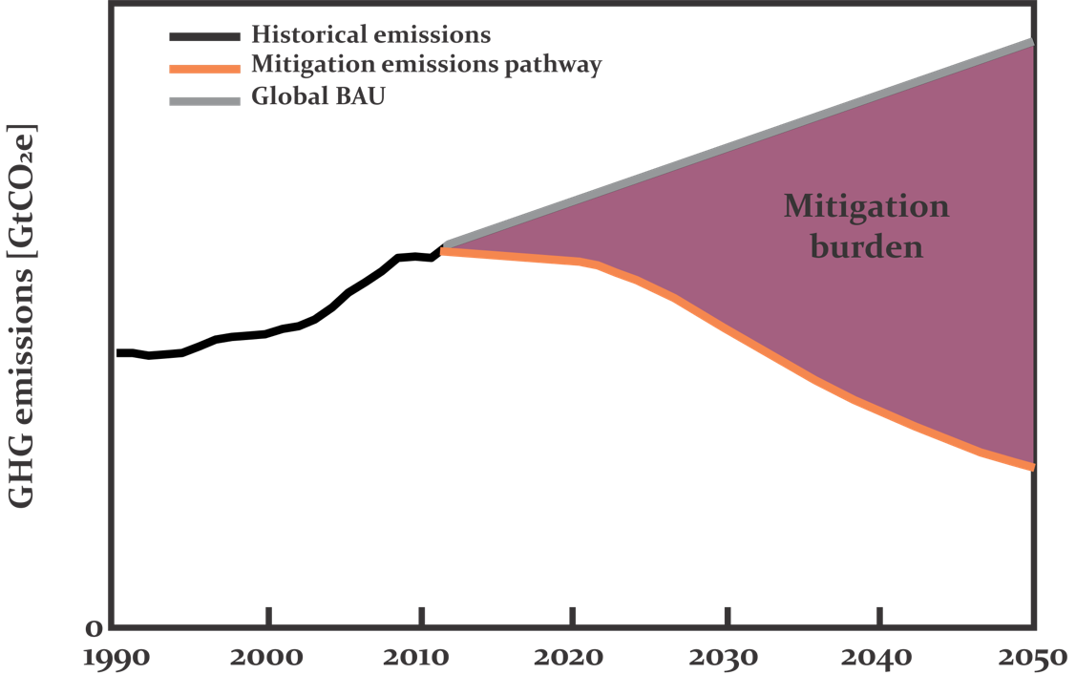
The required global mitigation burden ${MB}_{i,j}^{Gl}(t)$ (see Figure above) would be computed as the different of the baseline scenario and the target scenario:
$${MB}_{i,j}^{Gl}(t)= E_{Bi}^{Gl}(t)- E_{Tj}^{Gl}(t)$$
In this work, we use the downscaled PRIMAP baselines per country for the SSP2-RCP8.5 combination (cite). The target scenarios at the global level use the pathways underlying the IPCC’s Special Report on 1.5°C. Given a particular equity approach a, an Index $I_{a}^{C}$ is computed that for each country that indicates which share of a global reduction is the responsibility of country c. This index is proportional to a selected measure $M_{a}$(e.g. cumulative historic emissions):
$$I_{a}^{C}∝ M_{a}^{C}$$
The index is normalized to a range between zero and one and after that used to split the global mitigation burden between countries and derive a country specific mitigation burden $MB_{a}^{C}$:
$$MB_{A}^{C}(t)=I_{A}^{C}*MB_{\left\{i,i\right\}}^{Gl}(t)$$

Emission allowances $EA_{a}^{C}$ are computed by subtracting the countries mitigation burden from the downscaled emission baseline $E_{Bi,k}^{Gl}$. Since several downscaling methods are possible, the indicator k indicates the selected downscaling approach k.
$${EA_{a,i,k,j}^{C}(t)= E}_{Bi,k}^{Gl}(t)- MB_{A}^{C}(t)$$
For a final value of estimated emission allowances, finally the average over all given baselines i, target pathways a and downscaling approaches k are computed:
$\overline{EA_{a}^{C}}=\frac{1}{n} \sum_{i,j,k}{{EA}_{a,i,k,j}^{C}(t)}$,
While n is the number of overall variations:
$$n= i*j*k$$

Finally, a complete data set for all available countries and approach is assembled.

Assessing Geopolitical Sub-Units
In this section we provide the mathematical formulation of the two approaches to assess geopolitical units (and sub-units), for example, the European Union. In the main body of this paper we have assessed two possible approaches. The first was to sum up the emissions of the sub-units to arrive at the fair share of emissions for the geopolitical units.

The second option is to formulate the problem as a case where the fair share levels of the individual sub-units need to sum up to the geopolitical unit. In the following text we refer to the EU27 and member states to sketch out the method. The reason this approach does not match the approach presented above is that there are literature data points for the individual member states that are not present for the EU27 – hence summing up each percentile of the country distributions would not result in achieving the resulting point in the EU27 distribution.

Our starting point is the fair share levels for the EU27 (x), for a given temperature level (t), in time step (y). The allowance for the EU27 from our framework can be formulated as:
$$A_{EU27}^{x_{t,y}}= {lo}_{EU27,y}+x({up}_{EU27,y}- {lo}_{EU27,y})$$
Where,
$${lo}_{EU27,y}=Lower end of fair share range for EU27 in year (y)$$
$${up}_{EU27,y}=Upper end of fair share range for EU27 in year (y)$$
For x = 1this would lead to the allowances for the given temperature level being equal to the upper bound, while for x = 0, this would lead to the allowance being equal to the lower bound. Similarly, we can calculate the allowances for the member states as:
$$A_{members}^{x_{t,y}}= \sum_{mem}^{EU members}{({lo}_{mem}+x({up}_{mem}- {lo}_{mem})}$$
As we have already highlighted above the core problem is that:
$$A_{members}^{x_{t,y}}≠ A_{EU27}^{x_{t,y}}$$
To resolve this, we solve for a new fair share level per member state (z) such that:
$$A_{members}^{z_{t,y}}= A_{EU27}^{x_{t,y}}$$
For the linear range assessment, this can be solved analytically as:
$$z= \frac{A_{EU27}^{x_{t,y}}- \sum_{mem}^{EU members}{{lo}_{mem}}}{\sum_{mem}^{EU members}{{up}_{mem}}- {lo}_{mem}}$$

Comparing Three Types of Equity Distributions
In this section we compare the three types of distributions that we construct using the equity literature – this section accompanies the results and discussion presented in Sections 3.3 and 4 of the main text. The three types of distributions are:
- Long tail towards highly positive values (example: India)
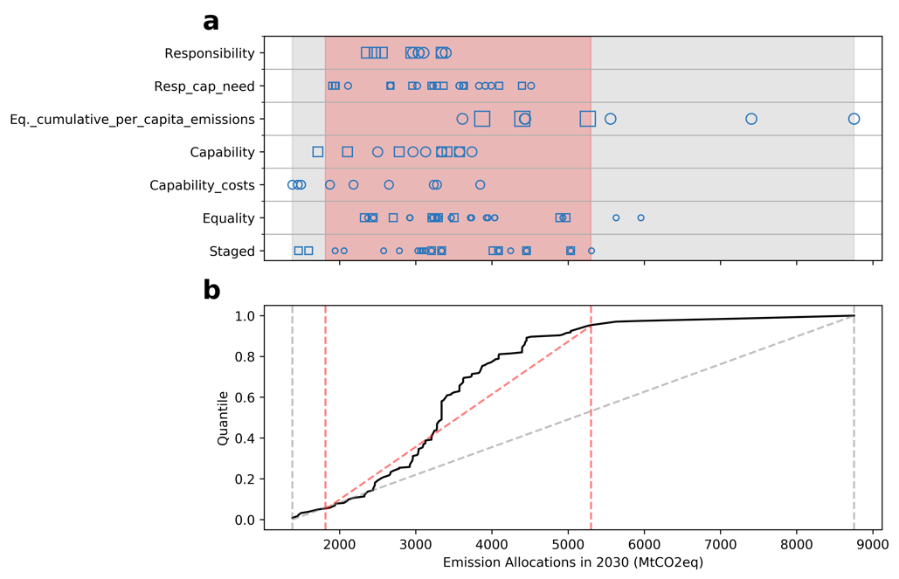
- Long tail towards highly negative values (example: Germany)
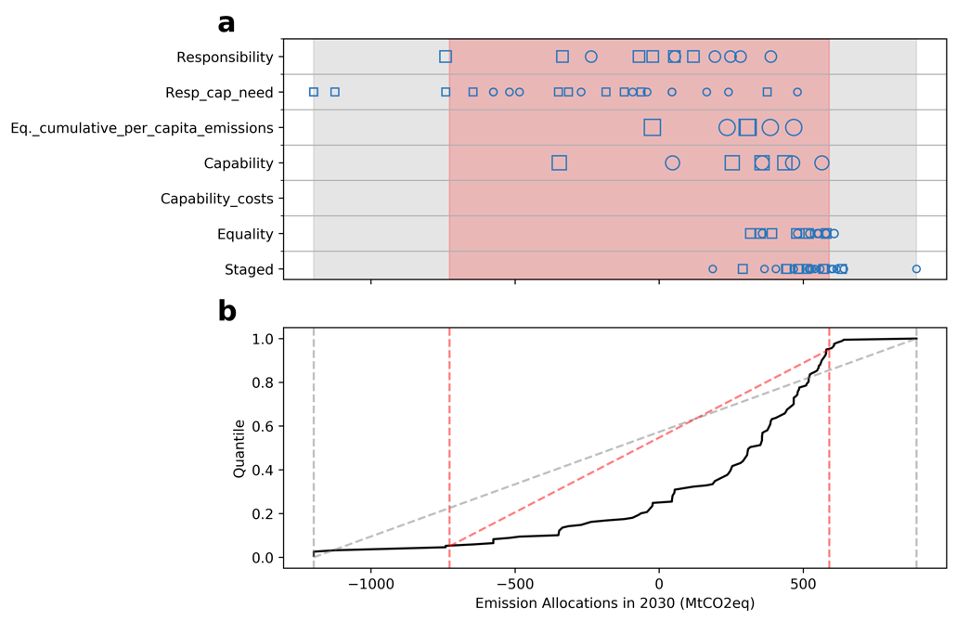
- Balanced distribution (example: South Africa)
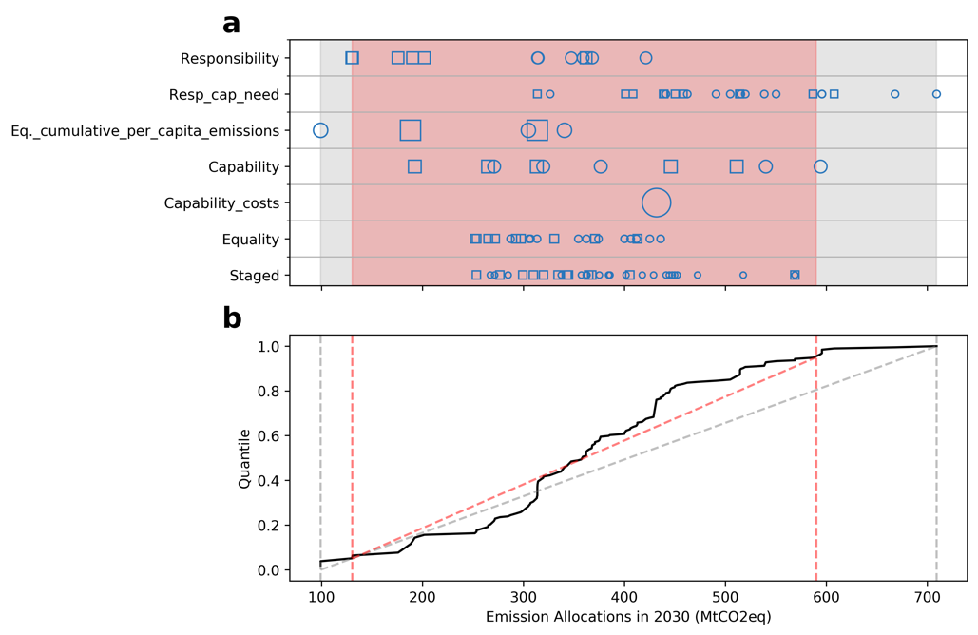
For a balanced distribution, the effect of different choices on how to construct the bounds of the fair share range, and the method used to walk through the different effort levels will have a relatively lower impact on the fair share levels. This is because a linear walk along the boundaries is effectively very close to the core of the distribution (the red line in Figures above).

However, as we have highlighted in the main text, the distributions that have a long tail to positive values can lead to more generous fair share levels if a Min/Max (Linear Walk) assumption is used – this shows the risk of ignoring the distribution completely in the method. Distributions that have a long tail to negative values are allocated more generous fair share levels if a Min/Max (Distribution Walk) assumption is used – here, the concept of the “equal percentile walk” essentially walks over the long tail leading to more generous allowances. Overall, we find that using a balanced approach that defines the fair share range with the 5th and 95th percentile and then uses a linear assumption gets us closer to a balanced distribution for most countries, avoiding redistribution between countries that is purely an artefact of the processing method.

References
Baer, P., Athanasiou, T., Kartha, S., & Kemp-Benedict, E. (2008). The Greenhouse Development Rights framework. The right to development in a climate constrained world. Berlin.
Berk, M. M., & den Elzen, M. G. J. (2001). Options for differentiation of future commitments in climate policy: how to realise timely participation to meet stringent climate goals? Climate Policy, 1(4), 465–480.
Bode, S. (2004). Equal emissions per capita over time - A proposal to combine responsibility and equity of rights for post-2012 GHG emission entitlement allocation. European Environment, 14(5), 300–316. https://doi.org/10.1002/eet.359
Böhringer, C., & Welsch, H. (2006). Burden sharing in a greenhouse: Egalitarianism and sovereignty reconciled. Applied Economics, 38(9), 981–996. https://doi.org/10.1080/00036840500399453
Bows, A., & Anderson, K. (2008). Contraction and convergence: an assessment of the CC Options model. Climatic Change, 91(3–4), 275–290. https://doi.org/10.1007/s10584-008-9468-z
Chakravarty, S. P., Chikkatur, A., Coninck, H., Pacala, S., Socolow, R., & Tavoni, M. (2009). Sharing global CO2 emission reductions among one billion high emitters. Proceedings of the National Academy of Sciences USA, 106(29), 11884–11888.
Criqui, P., Kitous, A., Berk, M., den Elzen, M. G. J., Eickhout, B., Lucas, P., … Vanregemorter, D. (2003). Greenhouse gas reduction pathways in the UNFCCC Process up to 2025 - Technical Report. Grenoble; France.
den Elzen, M. G. J., Beltran, A. M., Hof, A. F., van Ruijven, B., & van Vliet, J. (2013). Reduction targets and abatement costs of developing countries resulting from global and developed countries’ reduction targets by 2050. Mitigation and Adaptation Strategies for Global Change, 18(4), 491–512. https://doi.org/10.1007/s11027-012-9371-9
den Elzen, M. G. J., Höhne, N., Brouns, B., Winkler, H., & Ott, H. E. (2007). Differentiation of countries’ future commitments in a post-2012 climate regime. Environmental Science & Policy, 10(3), 185–203. https://doi.org/10.1016/j.envsci.2006.10.009
den Elzen, M. G. J., Höhne, N., & Moltmann, S. (2008). The Triptych approach revisited - A staged sectoral approach for climate mitigation. Energy Policy, 36(2008), 1107–1124.
den Elzen, M. G. J., Lucas, P. L., & van Vuuren, D. P. (2008). Regional abatement action and costs under allocation schemes for emission allowances for achieving low CO2-equivalent concentrations. Climatic Change, 90, 243–268.
den Elzen, M. G. J., Lucas, P., & van Vuuren, D. P. (2005). Abatement costs of post-Kyoto climate regimes. Energy Policy, 33(16), 2138–2151.
den Elzen, M. G. J., & Meinshausen, M. (2006). Meeting the EU 2°C climate target: global and regional emission implications. Climate P, 6(5), 545–564.
Edenhofer, O., Knopf, B., Barker, T., Baumstark, L., Bellevrat, E., Chateau, B., … Van Vuuren, D. P. (2010). The economics of low stabilization: Model comparison of mitigation strategies and costs. Energy Journal, 31(SPECIAL ISSUE), 11–48. https://doi.org/10.5547/ISSN0195-6574-EJ-Vol31-NoSI-2
Elzen, M. G. J., Schaeffer, M., & Lucas, P. L. (2005). Differentiating Future Commitments on the Basis of Countries’ Relative Historical Responsibility for Climate Change: Uncertainties in the ‘Brazilian Proposal’ in the Context of a Policy Implementation. Climatic Change, 71(3), 277–301. https://doi.org/10.1007/s10584-005-5382-9
Groenenberg, H., Blok, K., & van der Sluijs, J. P. (2004). Global Triptych: a bottom-up approach for the differentiation of commitments under the Climate Convention. Climate Policy, 4(2), 153–175. https://doi.org/10.1080/14693062.2004.9685518
Hof, A. F., & Den Elzen, M. G. J. (2010). The effect of different historical emissions datasets on emission targets of the sectoral mitigation approach Triptych. Climate Policy, 10(6), 684–704. https://doi.org/10.3763/cpol.2009.0649
Höhne, N., Elias, R., Elzen, D. M., Riahi, K., Chen, C., Rogelj, J., … Zhao, X. (2012). National GHG emissions reduction pledges and 2°C: comparison of studies. Climate Policy, 12(3), 356–377.
Höhne, Niklas, den Elzen, M., & Escalante, D. (2014). Regional GHG reduction targets based on effort sharing: a comparison of studies. Climate Policy, 14(1), 122–147. https://doi.org/10.1080/14693062.2014.849452
Höhne, Niklas, & Moltmann, S. (2008). Distribution of emission allowances under the Greenhouse Development Rights and other effort sharing approaches. Berlin.
Höhne, Niklas, & Moltmann, S. (2009). Sharing the effort under a global carbon budget. 1–40.
Holz, C., Kartha, S., & Athanasiou, T. (2017). Fairly Sharing 1.5 – National Fair Shares of a 1.5°C-compliant Global Mitigation Effort.
Jacoby, H. D., Babiker, M. H., Paltsev, S., & Reilly, J. M. (2008). Sharing the Burden of GHG Reductions. Massachusetts; USA.
Jayaraman, T., Kanitkar, T., & Dsouza, M. (2011). Equitable access to sustainable development: An Indian approach. In H. Winkler, T. Jayaraman, J. Pan, A. Santhiago de Oliveira, Y. Zhang, & G. Sant (Eds.), Equitable access to sustainable development: Contribution to the body of scinetific knowledge. A paper by experts from BASIC countries (pp. 59–77).
Knopf, B., Edenhofer, O., Barker, T., Bauer, N., Baumstark, L., Chateau, B., … Vuuren Van, D. (2009). The economics of low stabilisation: Implications for technological change and policy. In M. Hulme (Ed.), Making Climate Change Work for Us: European Perspectives on Adaptation and Mitigation Strategies (1st ed., pp. 291–318). Cambridge: ADAM synthesis book, Cambridge University Press.
Knopf, B., Kowarsch, M., Lüken, M., Edenhofer, O., & Luderer, G. (2012). A global carbon market and the allocation of emission rights. In O. Edenhofer, J. Wallacher, H. Lotze-Campen, H. Reder, B. Knopf, & J. Müller (Eds.), Climate Change, Justice and Sustainability: Linking Climate and Development Policy (pp. 179–191). https://doi.org/10.1007/978-94-007-4540-7
Kober, T., Zwaan, B. Van Der, & Rösler, H. (2012, December). The role of burden sharing regimes to reach the global 2 ˚ C climate target TIAM-ECN model approach Cost optimal GHG mitigation to reach the global 2 ˚ C climate target. ECN, pp. 1–12.
Kriegler, E., Tavoni, M., Aboumahboub, T., Luderer, G., Calvin, K., DeMaere, G., … van Vuuren, D. P. (2014). Can we still meet 2°C with global climate action? The LIMITS study on implications of Durban Action Platform scenarios. In LIMITS. Berlin.
Kuntsi-Reunanen, E., & Luukkanen, J. (2006). Greenhouse gas emission reductions in the post-Kyoto period: Emission intensity changes required under the “contraction and convergence” approach. Natural Resources Forum, 30(4), 272–279. https://doi.org/10.1111/j.1477-8947.2006.00119.x
Meinshausen, M., Jeffery, L., Guetschow, J., Robiou du Pont, Y., Rogelj, J., Schaeffer, M., … Meinshausen, N. (2015). National post-2020 greenhouse gas targets and diversity-aware leadership. Nature Climate Change, (October), 1–10. https://doi.org/10.1038/nclimate2826
Miketa, A., & Schrattenholzer, L. (2006). Equity implications of two burden-sharing rules for stabilizing greenhouse-gas concentrations. Energy Policy, 34(7), 877–891.
Moltmann, S., Hagemann, M., Eisbrenner, K., Höhne, N., Sterk, W., Mersmann, F., … Watanabe, R. (2011). Quantifying emission reduction contributions by emerging economies. Retrieved from http://www.umweltdaten.de/publikationen/fpdf-l/4097.pdf
Nabel, J. E. M. S., Rogelj, J., Chen, C. M., Markmann, K., Gutzmann, D. J. H., & Meinshausen, M. (2011). Decision support for international climate policy – The PRIMAP emission module. Environmental Modelling & Software, 26(12), 1419–1433.
Onigkeit, J., Anger, N., & Brouns, B. (2009). Fairness aspects of linking the European emissions trading scheme under a long-term stabilization scenario for CO2 concentration. Mitigation and Adaptation Strategies for Global Change, 14(5), 477–494. https://doi.org/10.1007/s11027-009-9177-6
Pan, X., Elzen, M. den, Höhne, N., Teng, F., & Wang, L. (2017). Exploring fair and ambitious mitigation contributions under the Paris Agreement goals. Environmental Science and Policy, 74, 49–56. https://doi.org/10.1016/j.envsci.2017.04.020
Pan, X., Teng, F., & Wang, G. (2013). Sharing emission space at an equitable basis: Allocation scheme based on the equal cumulative emission per capita principle. In Applied Energy (Vol. 113). https://doi.org/10.1016/j.apenergy.2013.07.021
Peterson, S., & Klepper, G. (2007). Distribution Matters – Taxes vs . Emissions Trading in Post Kyoto Climate Regimes. Kiel; Germany.
Robiou du Pont, Y., Jeffery, M. L., Gütschow, J., Rogelj, J., Christoff, P., & Meinshausen, M. (2017). Equitable mitigation to achieve the Paris Agreement goals. Nature Climate Change, 7(1), 38–43. https://doi.org/10.1038/nclimate3186
Robiou du Pont, Y., & Meinshausen, M. (2018). Warming assessment of the bottom-up Paris Agreement emissions pledges. Nature Communications, 9(1), 4810. https://doi.org/10.1038/s41467-018-07223-9
Vaillancourt, K., & Waaub, J. P. (2004). Equity in international greenhouse gases abatement scenarios: A multicriteria approach. European Journal of Operational Research, 153(2), 489–505. https://doi.org/10.1016/S0377-2217(03)00170-X
van den Berg, N. J., van Soest, H. L., Hof, A. F., den Elzen, M. G. J., van Vuuren, D. P., Chen, W., … Blok, K. (2019). Implications of various effort-sharing approaches for national carbon budgets and emission pathways. Climatic Change. https://doi.org/10.1007/s10584-019-02368-y
van Vuuren, D. P., den Elzen, M. G. J., van Vliet, J., Kram, T., Lucas, P., & Isaac, M. (2009). Comparison of different climate regimes: the impact of broadening participation. Energy Policy, 37(12), 5351–5362. https://doi.org/10.1016/j.enpol.2009.07.058
van Vuuren, D. P., Isaac, M., Den Elzen, M. G. J., Stehfest, E., & Van Vliet, J. (2010). Low stabilization scenarios and implications for major world regions from an integrated assessment perspective. Energy Journal, 31(SPECIAL ISSUE), 165–192. https://doi.org/10.5547/issn0195-6574-ej-vol31-nosi-7
WBGU. (2009). Solving the climate dilemma: The budget approach. Berlin.
Winkler, H., Letete, T., & Marquard, A. (2013). Equitable access to sustainable development: operationalizing key criteria. Climate Policy, 13(4), 411–432. https://doi.org/10.1080/14693062.2013.777610

