Supplementary Information
GCC2 promotes non-small cell lung cancer growth by maintaining Golgi apparatus integrity and stimulating EGFR signaling pathways

Kim et al.

Supplementary Figure S1. GCC2 knockdown inhibits proliferation, migration, invasion, and survival of H1299 cells
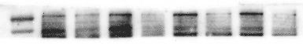
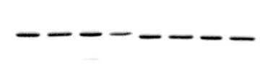
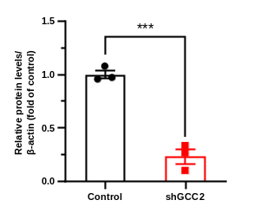
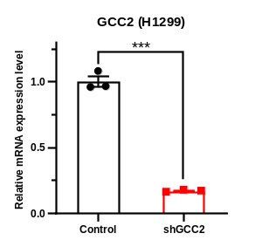
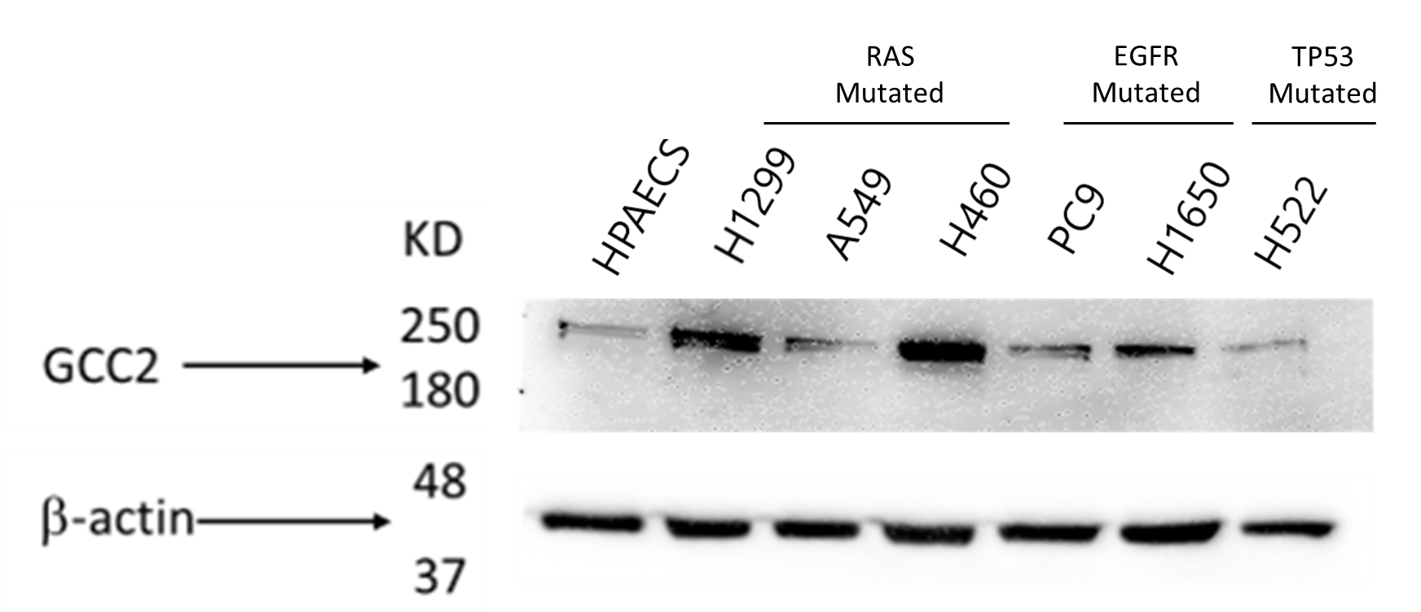
B
35
kDa
250
β-actin
GCC2
Control
shGCC2
H1299
C
β-actin
GCC2
35
250
kDa
HPAEpiC
H1299
A549
H460
PC9
H1650
H522
A

E
D
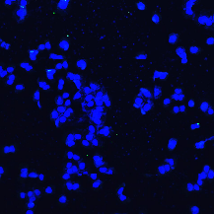
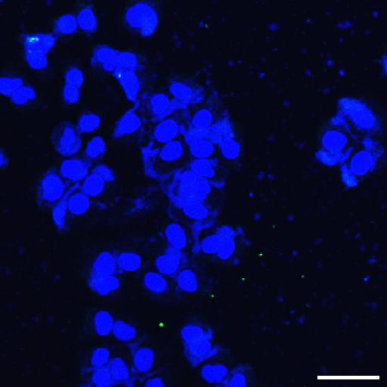
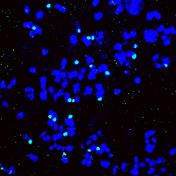
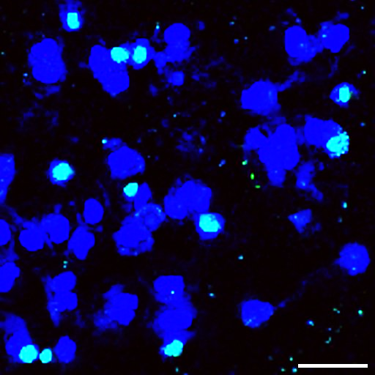
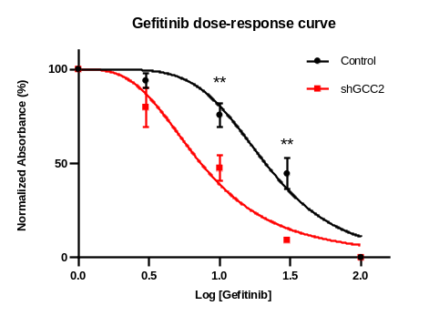
Control
shGGC2
TUNEL
Hoechst
H1299

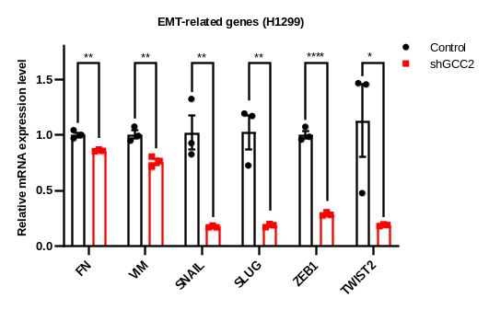
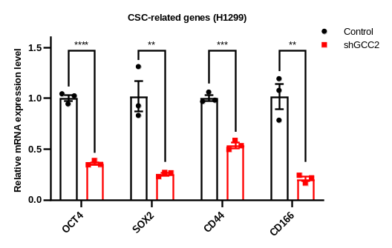
G
F

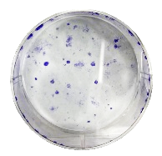
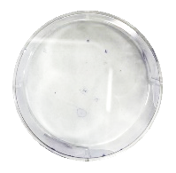
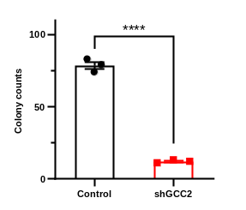
H1299
Control
shGCC2
H

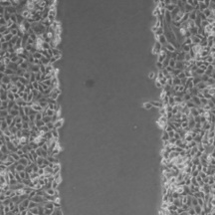
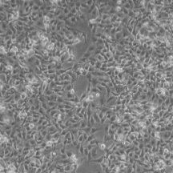
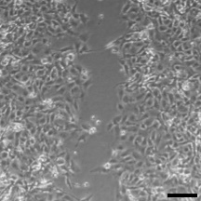
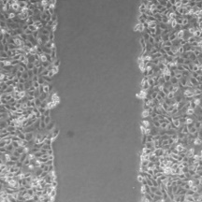
0h
24h
Control
shGCC2
H1299
I

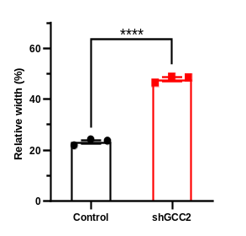

J
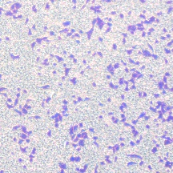
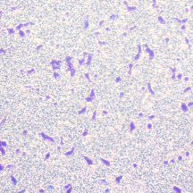
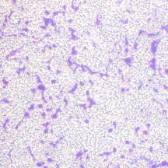
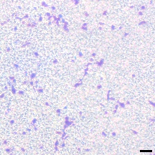
Invasion
Migration
Control
shGCC2
H1299
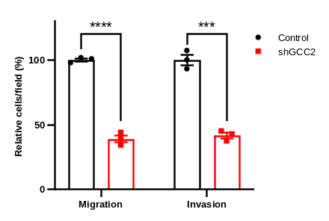

(A) Western blot analysis of GCC2 expression levels in various NSCLC cell lines and HPAEpiC. (B) RT-qPCR analysis and (C) western blot analysis of relative GCC2 expression levels in H1299 cells following transfection with shGCC2. (D) Detection of TUNEL-positive cells in H1299 cells transfected with shGCC2 plasmids. Scale bar = 50 μm. (E) Dose-response curve of control and GCC2 knockdown H460 cells treated with gefitinib at various doses. Results are shown as normalized absorbances from cell viability assays. RT-qPCR analysis of relative gene expression of (F) CSC-related biomarkers and (G) EMT-related genes. (H) Colony formation assays of control and GCC2 knockdown H1299 cells with summarized results of colony counts. (I) Wound-healing assay demonstrating the migratory potential of control and GCC2 knockdown H1299 cells. Scale bar = 100 μm. (J) Transwell migration and invasion assays in control and GCC2 knockdown H1299 cells. Scale bar = 100 μm. Data are presented as mean ± SD. *p < 0.05, **p < 0.01, ***p < 0.001, ****p < 0.0001.

Supplementary Figure S2. GCC2 knockdown decreases expression of receptor tyrosine kinases and inhibits activity of downstream MAPK signaling pathways in H1299 cells
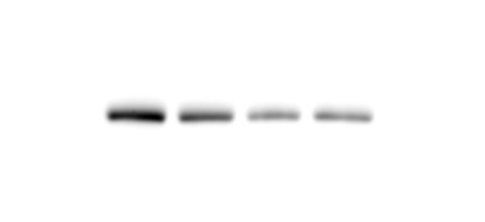
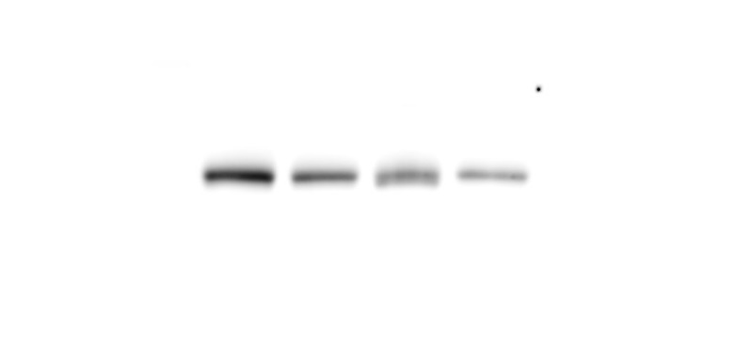
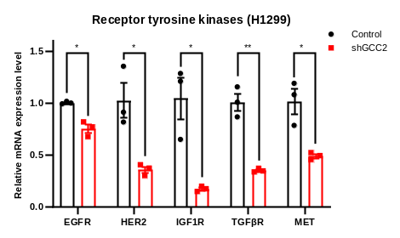
β-actin
pERK1/2
ERK1/2
MEK1/2
pMEK1/2
55
35
55
55
kDa
55
Control
shGCC2
H1299
B
A

D
C
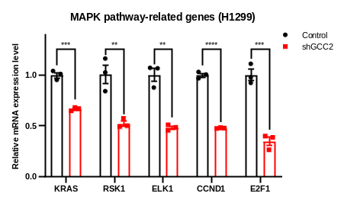
kDa
CCND1
β-actin
35
35
Control
shGCC2
H1299

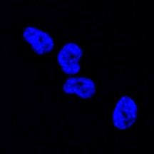
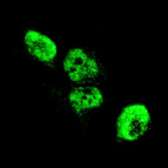
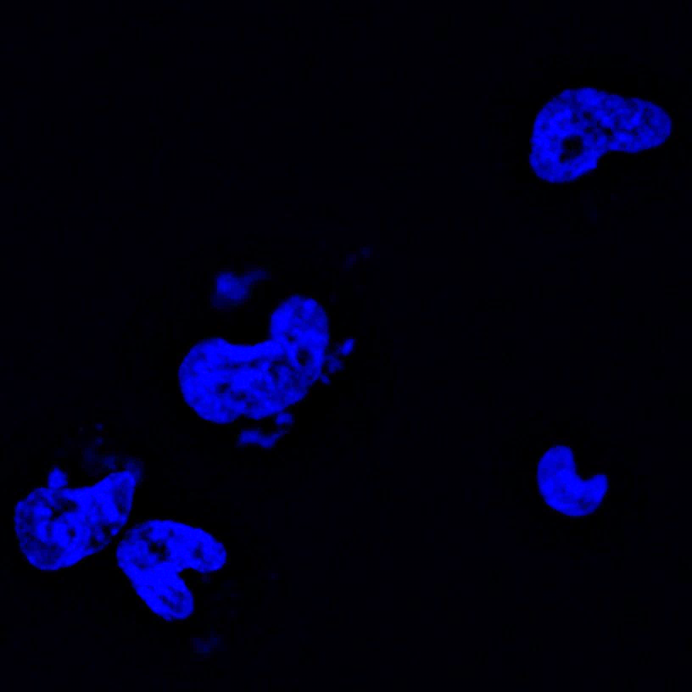
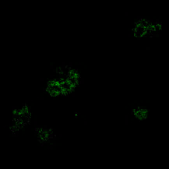
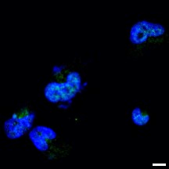
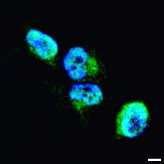
Control
Cyclin D1
Hoechst
Merge
shGCC2
E

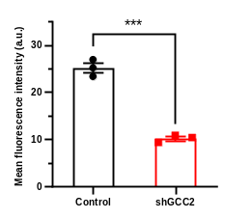

F
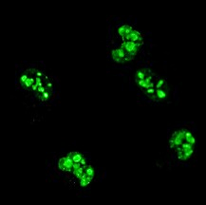
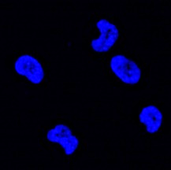
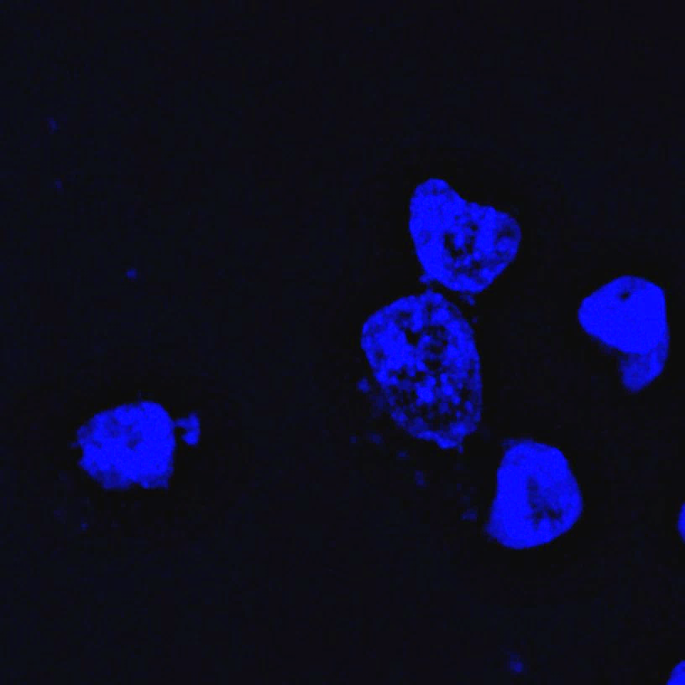
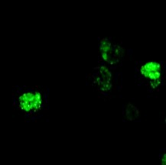
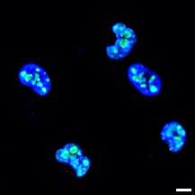
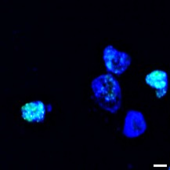
Control
shGCC2
Hoechst
Merge
Ki67
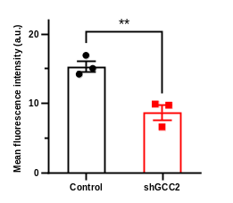

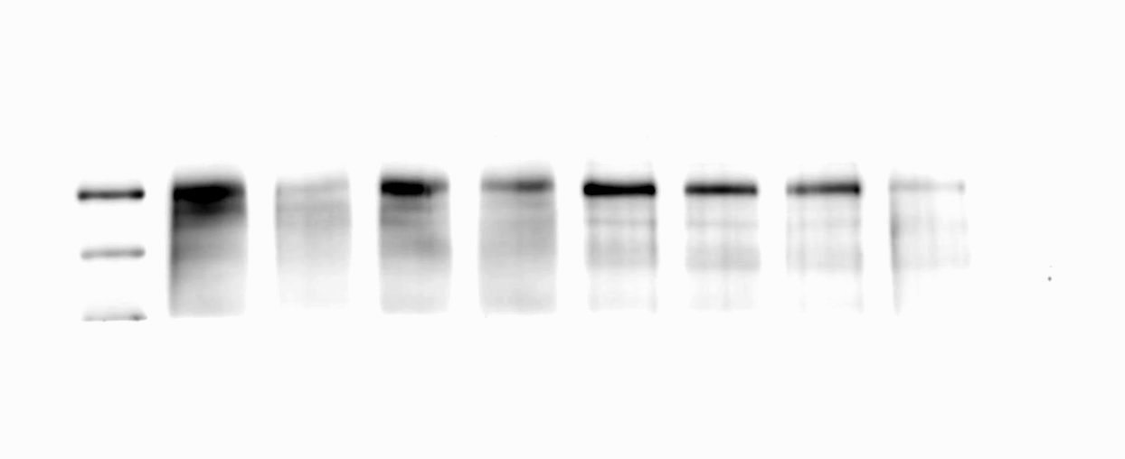
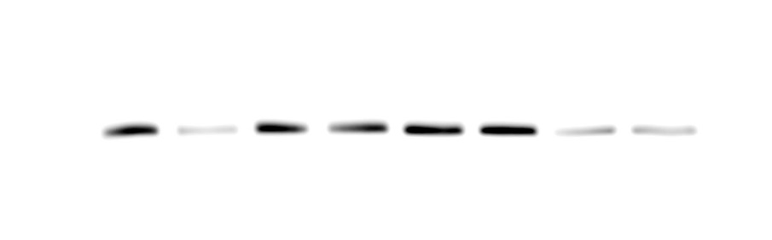
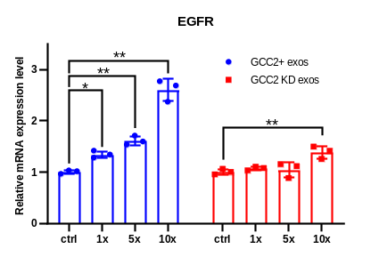
G
H
EGFR
35
250
β-actin
kDa
Control
shGCC2
H1299
1.00
0.69

(A) RT-qPCR analysis of various receptor tyrosine kinases in control and GCC2 knockdown H1299 cells. (B) Western blot analysis of MEK, pMEK, ERK, pERK of whole-cell lysates (WCL) of control and GCC2 knockdown H1299 cells. (C) RT-qPCR analysis of MAPK signaling pathway-related genes in control and GCC2 knockdown H1299 cells. (D) Western blot analysis of cyclin D1 of whole-cell lysates (WCL) of control and GCC2 knockdown H1299 cells. Immunofluorescence analysis of (E) cyclin D1 and (F) ki67 in control and GCC2 knockdown H1299 cells with quantification of mean fluorescence intensities. Scale bar = 10 μm. (G) Western blot analysis of EGFR expression in control and GCC2 knockdown H1299 cells. (H) RT-qPCR analysis of EGFR expression in H460 cells after treatment with GCC2+ or GCC2 KD exosomes at various doses. Data are presented as mean ± SD. *p < 0.05, **p < 0.01, ***p < 0.001, ****p < 0.0001.

Supplementary Table 1. List of primers
Gene | F/R | Sequence
human GAPDH | F (5' - 3') | CCGTCTAGAAAAACCTGCCAAATATGA
human GAPDH | R (5' - 3') | TTCGTTGTCATACCAGGAAATGAGC
human GCC2 | F (5' - 3') | AGAAGACCTCATCAAGTTTGCC
human GCC2 | R (5' - 3') | TCCAGACGTTCAGTTAATGCC
human OCT4 | F (5' - 3') | AGCCCTCATTTCACCAGGCC
human OCT4 | R (5' - 3') | TGGGACTCCTCCGGGTTTTG
human SOX2 | F (5' - 3') | GGGAAATGGGAGGGGTGCAAAAGAGG
human SOX2 | R (5' - 3') | TTGCGTGAGTGTGGATGGGATTGGTG
human NANOG | F (5' - 3') | TGAGATGCCTCACACGGAG
human NANOG | R (5' - 3') | TTGCTCCAGGTTGAATTGTTC
human CD44 | F (5' - 3') | TCAGAGGAGTAGGAGAGAGGA
human CD44 | R (5' - 3') | GAAAAGTCAAAGTAACAATAA
human CD133 | F (5' - 3') | TCAGGATTTTGCTGCTTGTG
human CD133 | R (5' - 3') | GCAGTATCTAGAGCGGTGGC
human CD166 | F (5' - 3') | CTGCTCTGCAGGAGGTTGAA
human CD166 | R (5' - 3') | TCTCTGTTTTCATTAGCAGAGACAT
human ALDH1A | F (5' - 3') | GGCTTTTCAGATTGGATCCCC
human ALDH1A | R (5' - 3') | AACCAACGGGAAATTCCAAGG
human E-cadherin | F (5' - 3') | CCAGGAACCTCTGTGATGGAGGTC
human E-cadherin | R (5' - 3') | GGCCTCAAAATCCAAGCCCTTTGC
human N-cadherin | F (5' - 3') | AGGGGACCTTTTCCTCAAGA
human N-cadherin | R (5' - 3') | CAATGTCAATGGGGTTCTCC
human Fibronectin | F (5' - 3') | AAGATTGGAGAGAAGTGGGACC
human Fibronectin | R (5' - 3') | GAGCAAATGGCACCGAGATA
human Vimentin | F (5' - 3') | TTCCAAACTTTTCCTCCCTGAACC
human Vimentin | R (5' - 3') | TCAAGGTCATCGTGATGCTGAG
human SNAIL | F (5' - 3') | GTTTCCCGGGCAATTTAACA
human SNAIL | R (5' - 3') | CCCGACAAGTGACAGCCATT
human SLUG | F (5' - 3') | CAGCTACCCAATGGCCTCTCT
human SLUG | R (5' - 3') | GGACTCACTCGCCCCAAAG
human ZEB1 | F (5' - 3') | TGTGAATGGGCGACCAAGA
human ZEB1 | R (5' - 3') | GTGGGACTGCCTGGTGATC
human TWIST2 | F (5' - 3') | GCCCAGTGGAGCATGCA
human TWIST2 | R (5' - 3') | GGTGGGACACCGAGATGGT
human EGFR | F (5' - 3') | GGAGAACTGCCAGAAACTGAC
human EGFR | R (5' - 3') | GCCTGCAGCACACTGGTTG
human HER2 | F (5' - 3') | CCTTCCTGCTTGAGTTCCC
human HER2 | R (5' - 3') | CCCTAAGGCTTTCAGTACCC
human IGF1R | F (5' - 3') | TCGGAGTATTGTTTCCTTCGC
human IGF1R | R (5' - 3') | GCTGCTGATAGTCGTTGCG
human TGFβR | F (5' - 3') | TGATCTCTGTTGCCTTTGGG
human TGFβR | R (5' - 3') | AGAGTCAATCAAGGGTTTGGG
human PDGFR-A | F (5' - 3') | ATGTGTGGGACATTCATTGCG
human PDGFR-A | R (5' - 3') | AAGCTGGCAGAGGATTAGGC
human FGFR1 | F (5' - 3') | ACCAAACCAAACCGTATGCC
human FGFR1 | R (5' - 3') | GCATAACGGACCTTGTAGCC
human MET | F (5' - 3') | AGCAAGCAATTTCTTCAACCG
human MET | R (5' - 3') | TGTACTCTTGCATCGTAGCG
human KRAS | F (5' - 3') | GGGGAGGGCTTTCTTTGTGTA
human KRAS | R (5' - 3') | GTCCTGAGCCTGTTTTGTGTC
human RSK1 | F (5' - 3') | ATCAAGCCACCCTTCAAGCC
human RSK1 | R (5' - 3') | TGTCTCCTTTACCACGTAGCC
human ELK1 | F (5' - 3') | GGTGGTGAATTCAAGCTGGT
human ELK1 | R (5' - 3') | ATTTGGCATGGTGGAGGTAA
human CCND1 | F (5' - 3') | CAAGGCCTGAACCTGAGGAG
human CCND1 | R (5' - 3') | CTTGGGGTCCATGTTCTGCT
human E2F1 | F (5' - 3') | CTGGAGCAAGAACCGCTGTT
human E2F1 | R (5' - 3') | GTCACAGTCGAAGAGGTCTCTGAT

Supplementary Table 2. List of antibodies
Antibody | Catalog number | Manufacturer | Use | Dilution
β-actin | sc47778 | Santa Cruz | WB | 1:1,000
GCC2 | ab128173 | Abcam | WB | 1:5,000
GCC2 | HPA035849 | Atlas | ICC | 1:5,000
CD63 | sc5275 | Santa Cruz | ICC | 1:400
MEK1/2 | ab178876 | Abcam | WB | 1:10,000
pMEK1/2 (S218/S222) | ab194754 | Abcam | WB | 1:1,000
ERK1/2 | ab184699 | Abcam | WB | 1:10,000
pERK1/2 (T202/T204; T185/Y187) | ab76299 | Abcam | WB | 1:10,000
CCND1 | sc753 | Santa Cruz | WB | 1:1,000
CCND1 | sc753 | Santa Cruz | ICC | 1:200
Ki67 | ab16667 | Abcam | ICC | 1:250
GM130 | 610822 | BD Bioscience | ICC | 1:500
EGFR | sc-373746 | Santa Cruz | WB | 1:1,000
EGFR | sc-373746 | Santa Cruz | ICC | 1:50
Alexa Flour 488-conjugated donkey anti-mouse IgG (H+L) | A-21202 | Thermo Fisher | ICC | 1:1,000
Alexa Flour 488-conjugated goat anti-mouse IgG (H+L) | A-11070 | Thermo Fisher | ICC | 1:1,000
Alexa Flour 594-conjugated goat anti-mouse IgG (H+L) | A-11020 | Thermo Fisher | ICC | 1:1,000

