Supplementary Figure S1. Kaplan-Meier survival analysis of all AML patients and NUM AML patients.
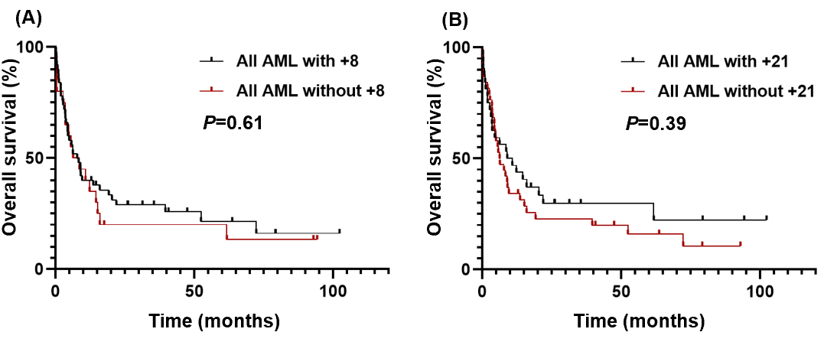
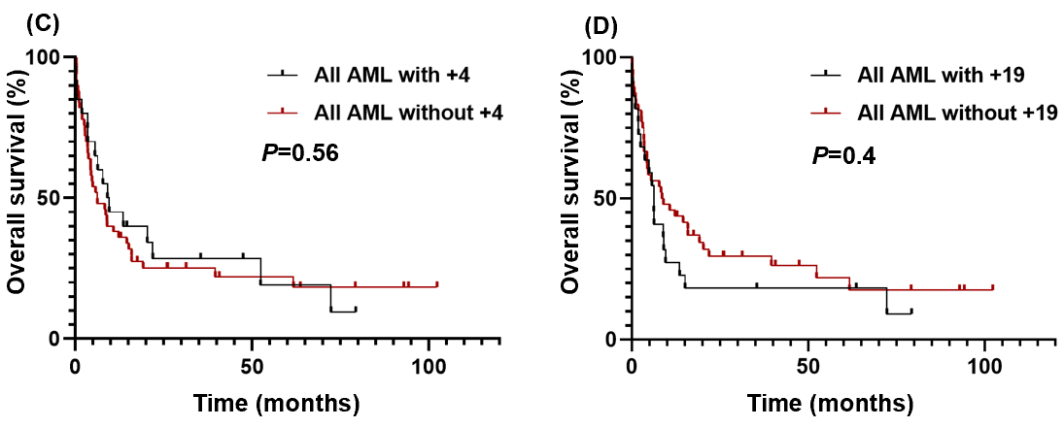
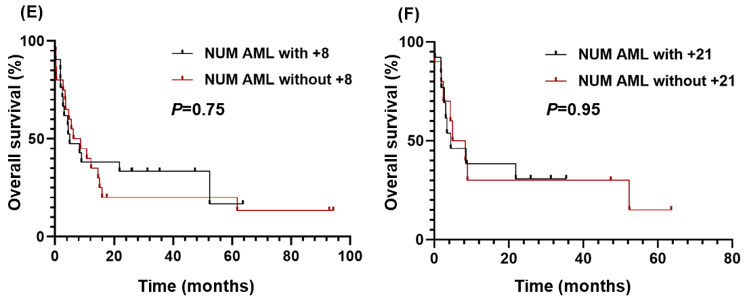
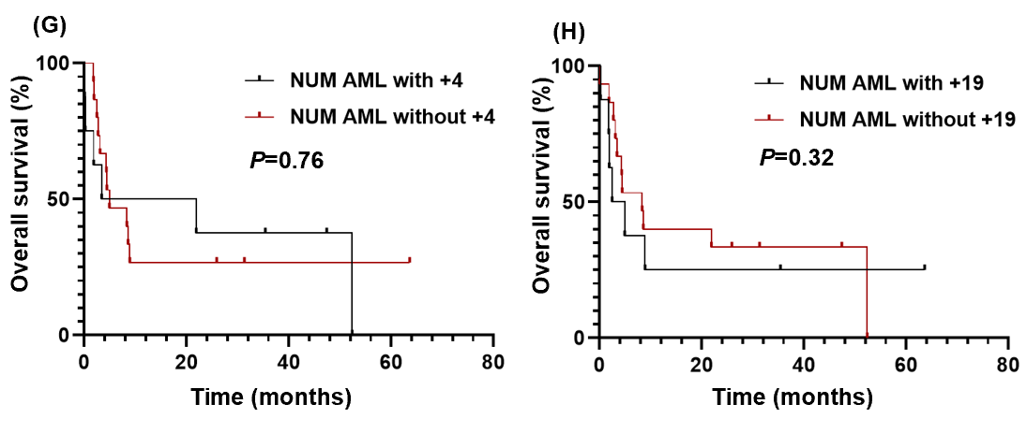
(A) OS of all AML cases with (median, 8.1 months) and without (median, 7.4 months) gaining of chromosome 8, P=0.61. (B) OS of all AML cases with (median, 9.9 months) and without (median, 6.3 months) gaining of chromosome 21, P=0.39. (C) OS of all AML cases with (median, 9.3 months) and without (median, 6.2 months) gaining of chromosome 4, P=0.56. (D) OS of all AML cases with (median, 6.2 months) and without (median, 8.8 months) gaining of chromosome 19, P=0.4. (E) OS of NUM AML cases with (median, 4.9 months) and without (median, 7.4 months) gaining of chromosome 8, P=0.75. (F) OS of NUM AML cases with (median, 4.4 months) and without (median, 6.6 months) gaining of chromosome 21, P=0.95. (G) OS of NUM AML cases with (median, 12.6 months) and without (median, 4.9 months) gaining of chromosome 4, P=0.76. (H) OS of NUM AML cases with (median, 3.7 months) and without (median, 8.3 months) gaining of chromosome 19, P=0.32.

