Supplementary materials

Astrocytic NHERF-1 increases seizure susceptibility by inhibiting surface expression of TREK-1
Yeonju Bae^{1,2}, Ajung Kim¹, Shinae Lee^{1,4}, Seong-Seop Kim², Sunyoung Park², Kanghyun Ryoo², Gwan-Su Yi⁴, Jae-Yong Park^{2*}, and Eun Mi Hwang^{1,3*}
¹Brain Science Institute, Korea Institute of Science and Technology (KIST), Seoul (02792), Republic of Korea
²School of Biosystems and Biomedical Sciences, College of Health Sciences, Korea University, Seoul (02841), Republic of Korea
³Division of Bio-Medical Science & Technology, KIST school, Korea University of Science and Technology, Seoul (02792), Republic of Korea
⁴Department of Bio and Brain Engineering, KAIST, Daejeon (34141), Republic of Korea
*Correspondence and requests for materials should be addressed to emhwang@kist.re.kr (E.M, Hwang), jaeyong68@korea.ac.kr (J.-Y, Park)

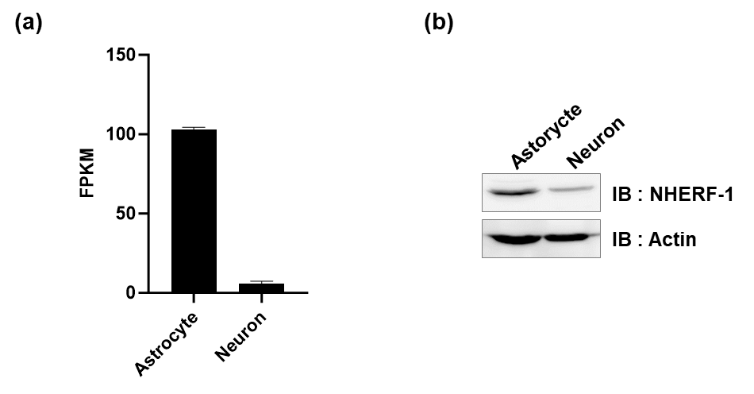

Supplementary Fig. 1. Expression level of NHERF-1 in astrocytes and neuron.
(a) Bar graph of Nherf-1 gene expression using Brain-RNA seq database. (b) Western blotting was performed to NHERF-1 protein expression of cultured astrocytes and neurons.

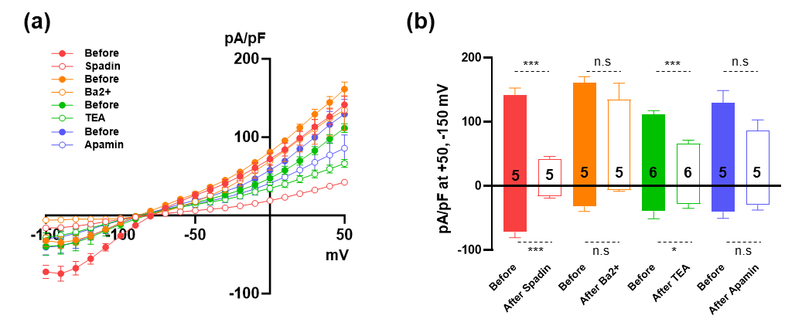
Supplementary Fig. 2. Inhibition of K⁺ currents by various K⁺ inhibitors in cultured astrocytes.
(a) Current densities showing before and after application of various K⁺ channel inhibitors of cultured astrocytes. (Spadin; 10 μM, Ba2+; 100 μM TEA; 1 mM and apamin; 300 nM) (b) Summary bar graph of (a) at +50 mV and -150 mV. The number on each bar indicates n for each condition. All values are mean±SEM. P-values were obtained using Student’s t-test. n.s: not significant, *p<0.05 and ***p < 0.001.

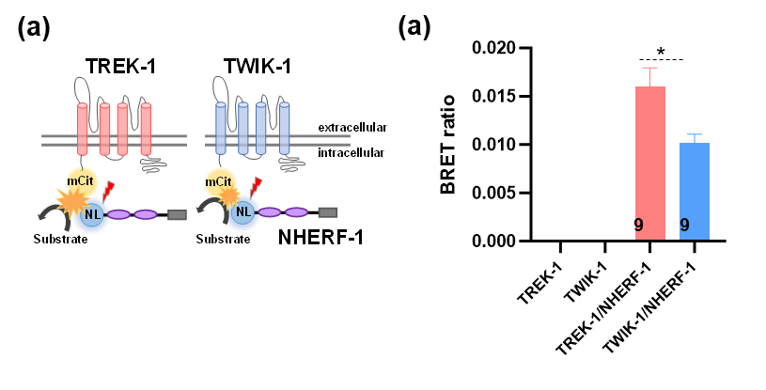
Supplementary Fig. 3. NHERF-1 interacts with TWIK-1. But, less than TREK-1.
(a) Schematic diagram image of the BRET assay represent the NanoLuc Luciferase(NL)-TREK-1 or NL-TWIK-1 and mCitrine-NHERF-1 (mCit). (b) BRET ratio from three independent experiments are presented. Data represent mean ± SEM. The number on each bar indicates n for each condition. P-values were obtained using one-way ANOVA followed by Bonferroni‘s post hoc test. ,*p<0.05

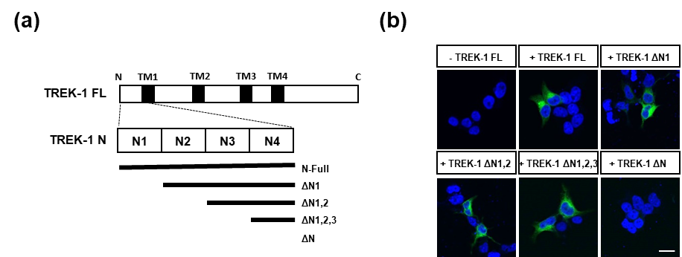

Supplementary Fig. 4. Identification of TREK-1 N terminus binding site with NHERF-1.
(a) Diagram of the ΔN1, ΔN1 2, ΔN1 2 3 or ΔN mutants of TREK-1. (b) BiFC assays were performed in VC-NHERF-1 transfected HEK293T cells with VN-TREK-1, VN-TREK-1 ΔN1, VN-TREK-1 ΔN1 2, VN-TREK-1 ΔN1 2 3 or VN-TREK-1 ΔN. Scale bar, 10 μm.

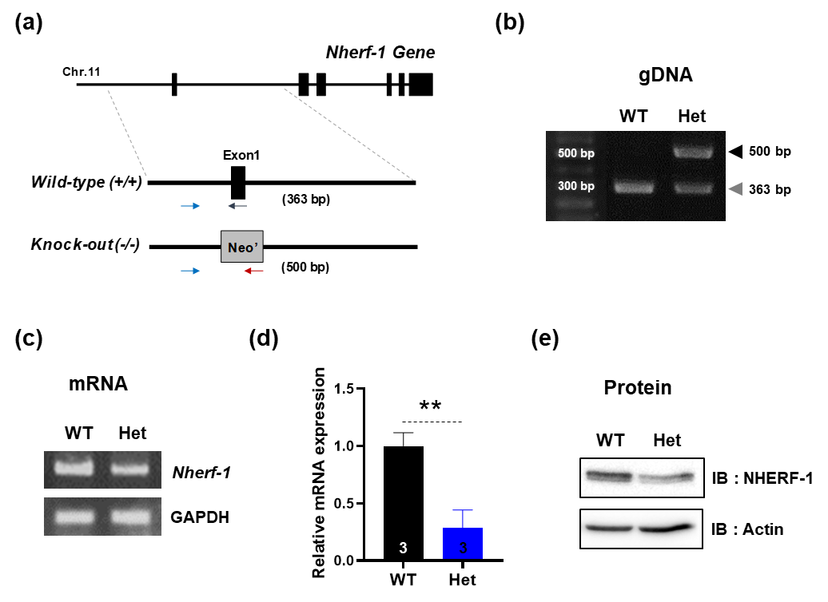

Supplementary Fig. 5. Validation of heterozygous NHERF-1 KO mice (related Figure 7)
(a) A genomic illustration of NHERF-1 KO mice. The Neomycin sequence was inserted into the exon 1 of NHERF-1. Two PCR primers designed for exon 1 (blue and purple arrows) and primer for the Neomycin sequence (red arrow) were used for genotyping. (b) Genotyping result of genomic DNA prepared from NHERF-1 wild-type (WT), heterozygote KO (Het) mice. (c) RT-PCR analysis was performed with mRNA derived from NHERF-1 WT and Het brain samples. (d) A bar graph showing the relative mRNA expression level of NHERF-1 in the brain. (e) Western blot of brain lysates from NHERF-1 WT and Het mice using a specific NHERF-1 antibody. The number on each bar indicates n for each condition. All values are mean±SEM. P-values were obtained with Student’s t-test. **p < 0.01.

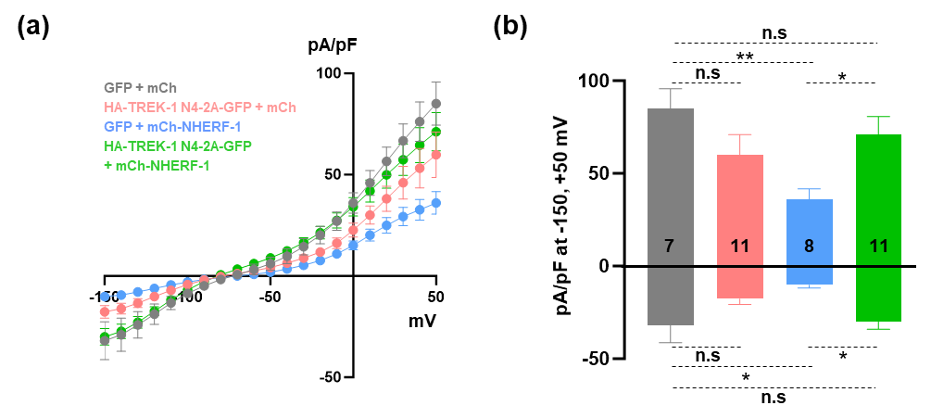
Supplementary Fig. 6. TREK-1 N4 rescues reduced potassium currents by NHERF-1 overexpression in cultured astrocytes (related Figure 8).
(a) Current densities showing to GFP control (GFP)/mCherry control (mCh), HA-TREK-1 N4-2A-GFP/mCh, GFP/mCh-NHREF-1 or HA-TREK-1 N4-2A-GFP/mCh-NHERF-1 transfected astrocytes. (b) Summary bar graph at +50 mV and -150 mV as in (a). The number on each bar indicates n for each condition. All values are mean±SEM. P-values were obtained using one-way ANOVA followed by Bonferroni‘s post hoc test or Student’s t-test. n.s: not significant, *p<0.05 and ** p < 0.01.

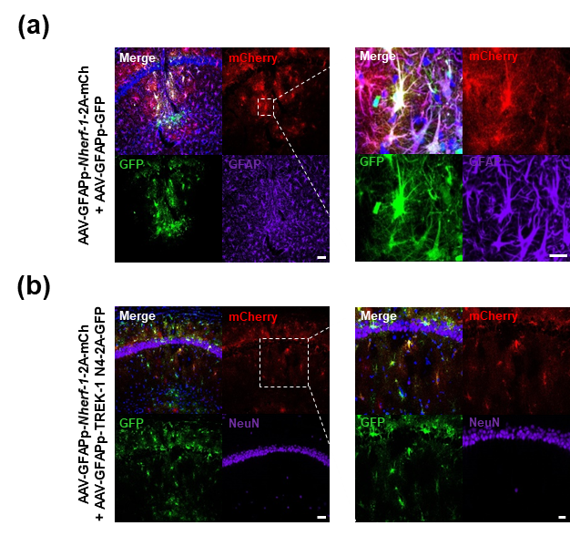
Supplementary Fig. 7. Validation of AAV injection (related Figure 8).
(a) Left; Representative fluorescence images of dual immunostaining of pAAV-GFAPp-GFP (green), pAAV-GFAPp-Nherf-1-2A-mCh virus (red) and GFAP (purple) with DAPI staining of nuclei (blue) in mouse hippocampus. Scale bar, 50 μm. Right; Enlarged images of (a). Scale bar, 20 μm. (b) Left; Representative fluorescence images of dual immunostaining of pAAV-GFAPp-TREK-1 N4-2A-GFP (green), pAAV-GFAPp-Nherf-1-2A-mCh virus (red) and NeuN (purple) with DAPI staining of nuclei (blue) in mouse hippocampus. Scale bar, 50 μm. Right; Enlarged images of (b). Scale bar, 20 μm.

