BnaC09.tfl1 controls determinate inflorescence trait in Brassica napus

SUPPLEMENTARY MATERIAL

Table S1. ORF fragment amplification primer information
Primers name | Primers sequence
ORF-sdt2F | AACCCACAGGTGTTTAGAAAG
ORF-sdt2R | CTAACGTCTGCGAGATGCGG

Table S2. 5' and 3' UTR fragment amplification primer information
Primers name | Primers sequence
5' sdt2-4F | TGAAGAATCGATGCGTTGTC
5' sdt2-3R | AAGTCTCCAATGGCCATGAG
3 ' sdt2-5F | TGTTCAGGCAGAAGCAAAGA
3 ' sdt2-2R | AAACCGAATAAACCGAAAACC

Table S3. TFL1-cDNA fragment amplification primer information
Primers name | Primers sequence
TFL1-cDNAF | ATGGAGAATATGGGAACTAG
TFL1-cDNAR | CCGCATCTCGCAGACGTTAG

Table S4. Primer information construction of vector
Primers type |  | Primers name | Primers sequence
Recombinant primers |  | pCAMBIA2300-proBnaC09.TFL1:BnaC09.TFL1F | tatgaccatgattacGAATTCTGTCGTTCCACGAGTGAGGA
 |  | pCAMBIA2300-proBnaC09.TFL1:BnaC09.TFL1R | gccaagcttgcatgcCTGCAGAAACCGAATAAACCGAAAACC
 |  | pCAMBIA1302-35S:BnaC09.TFL1F | ttaccatgCCATGGAGAATATGGGAACTAGAGTG
 |  | pCAMBIA1302-35S:BnaC09.TFL1R | atgcctagACTAGCACGTCTGCGAGATGCGGTTT
 |  | zmp1CRISPR/Cas9-BnaC09.TFL1DT1-BsF | ATATATGGTCTCGATTGagctgtctcctccaagcctGTT
 |  | zmp1CRISPR/Cas9-BnaC09.TFL1DT1-F0 | TGagctgtctcctccaagcctGTTTTAGAGCTAGAAATAGC
 |  | zmp1CRISPR/Cas9-BnaC09.TFL1DT2-R0 | AACagaaaggggtcactaggatCAATCTCTTAGTCGACTCTAC
 |  | zmp1CRISPR/Cas9-BnaC09.TFL1DT2-BsR | ATTATTGGTCTCGAAACagaaaggggtcactaggatAA
Detection primers | pCAMBIA2300-proBnaC09.TFL1:BnaC09.TFL1TestF |  | CTAGCCAATACGCAAACCGC
Detection primers | pCAMBIA2300-proBnaC09.TFL1:BnaC09.TFL1TestR |  | CTTCTCACTCGGCGATCCTG
Detection primers | pCAMBIA1302-35S:BnaC09.TFL1TestF |  | TGGGAAGAGTGGTCGGAGAT
Detection primers | pCAMBIA1302-35S:BnaC09.TFL1TestR |  | CCTGTTGACGAGGGTGTCTC
Detection primers | zmp1CRISPR/Cas9-BnaC09.TFL1T1TestF |  | TGGTCGGAGATGTTCTTGATAA
Detection primers | zmp1CRISPR/Cas9-BnaC09.TFL1T1TestR |  | CTATGTTTGGCTTTGGCAG
Detection primers | zmp1CRISPR/Cas9-BnaC09.TFL1T2TestF |  | TTTTGTAAAATAGTATGATGCTGTTATG
Detection primers | zmp1CRISPR/Cas9-BnaC09.TFL1T2TestR |  | GAAGACTATGACCAACTCAAC

Table S5. Primer information construction of vector
Primers type | Primers name | Primers sequence
Recombinant primers | pBWA(V)HS-35S:GLosgfpF | cgatCGTCTCacaacatggagaatatgggaactagagtgatagagcca
Recombinant primers | pBWA(V)HS-35S:GLosgfpR | cagtCGTCTCatacaacgtctgcgagatgcggtttctctctgagcgttgaa
Detection primers | pBWA(V)HS-35S:GLosgfpTestF | cgcacaatcccactatcctt
Detection primers | pBWA(V)HS-35S:GLosgfpTestR | aactcatggccattggagac

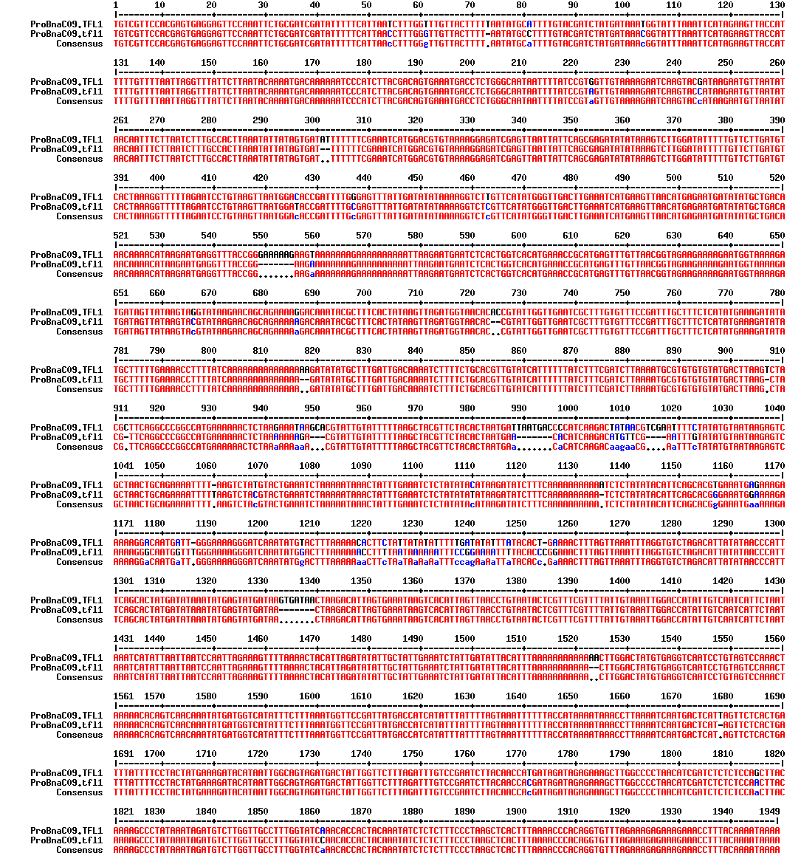
Fig. S1 The differences of 1.9-Kb promoter sequence between BnaC09.TFL1 and BnaC09.tfl1

Fig. S2 Agronomic traits of NIL-BnaC09.TFL1^{IDT2982} and DT4769^{BnaC09.tfl1} lines, NIL-IDT2982 represents NIL-BnaC09.TFL1^{IDT2982}, DT4769 represents DT4769^{BnaC09.tfl1}. (a) X-axis, 2022XN, 2022Xining, 2023XN, 2023Xining, 2023HZ, 2023Huzhu, Y-axis, number of primary branches. (b) Y-axis, effective pods per plant. (c) Y-axis, Filled seed number per sillique. (d) Y-axis, thousand grain weight of per plant (g). (e) Y-axis, yield per plant (g). (f) Y-axis, plot yield (Kg).

Text S1. other plant protein sequences with high similarity to the BnC09.TFL1
>XP_013610369.1:1-178 PREDICTED: protein TERMINAL FLOWER 1-like [Brassica oleracea var. oleracea]
MENMGTRVIEPLIVGRVVGDVLDNFTPTIKMNVSYNKKQVSNGHELFPLAVSSKPRVEIHDGDLRSFFTLVMTDPDVPNPSDPFLKERLHWLVMNIPGTTDATFGKEVVSYELPKPNIGIHRYVFVLFRQKQRRVKFPSNIISRDQFNTREFAIENDLGLPVAAVFFNAQRETASRRR
>KAH0861642.1:19-196 hypothetical protein HID58_089903, partial [Brassica napus]
MENMGTRVIEPLIVGRVVGDVLDNFTPTIKMNVSYNKKQVSNGHELFPLAVSSKPRVEIHDGDLRSFFTLVMTDPDVPNPSDPFLKERLHWLVMNIPGTTDATFGKEVVSYELPKPNIGIHRYVFVLFRQKQRRVKFPSNIISRDQFNTREFAIENDLGLPVAAVFFNAQRETASRRR
>ATQ37959.1:1-178 terminal flower 1 [Brassica carinata]
MENMGTRVIEPLIVGRVVGDVLDNFTPTIKMNVSYNKKQVSNGHELFPLAVSSKPRIEIHDGDLRSFFTLVMTDPDVPNPSDPFLKERLHWLVMNIPGTTDATFGKEVVSYELPKPNIGIHRYVFVLFRQKQRRVKFPSNIISRDQFNTREFAIENDLGLPVAAVFFNAQRETASRRR
>BAA33417.1:1-178 BNTFL1-3 [Brassica napus]
MENMGTRVIEPLIVGRVVGDVLDNFAPTIKMNVSYNKKQVSNGHELFPLAVSSKPRVEIHDGDLRSFFTLVMTDPDVPNPSDPFLKERLHWLVMNIPGTTDATFGKEVVSYELPKPNIGIHRYVFVLFRQKQRRVKFPSNIISRDQFNTREFAIENDLGLPVAAVFFNAQRETASRRR
>KAF3505061.1:1-178 hypothetical protein F2Q69_00045707 [Brassica cretica]
MENMGTRVIEPLIVGRVVGDVLDNFTPTIKMNVSYNKKQVSNGHELLPLAVSSKPRVEIHDGDLRSFFTLVMTDPDVPNPSDPFLKERLHWLVMNIPGTTDATFGKEVVSYELPKPNIGIHRYVFVLFRQKQRRVKFPSNIISRDQFNTREFAIENDLGLPVAAVFFNAQRETASRRR
>XP_009122666.1:1-178 protein TERMINAL FLOWER 1 [Brassica rapa]
MENMGTRVIEPLIVGRVVGDVLDNFTPTIKMNVSYNKKQVSNGHEFLPLAVSSKPRVEIHDGDLRSFFTLVMTDPDVPNPSDPFLKERLHWLVMNIPGTTDATFGKEVVSYELPKPNIGIHRYVFVLFRQKQRRVKFPSNIISRDQFNTREFAIENDLGLPVAAVFFNAQRETASRRR
>KAG5377429.1:19-196 hypothetical protein IGI04_042025, partial [Brassica rapa subsp. trilocularis]
MENMGTRVIEPLIVGRVVGDVLDNFTPTIKMNVSYNKKQVSNGHEFLPLAVSSKPRVEIHDGDLRSFFTLVMTDPDVPNPSDPFLKERLHWLVMNIPGTTDATFGKEVVSYELPKPNIGIHRYVFVLFRQKQRRVKFPSNIISRDQFNTREFAIENDLGLPVAAVFFNAQRETASRRR
>BAA33421.1:1-177 BOTFL1-2, partial [Brassica oleracea]
ENMGTRVIEPLIVGRVVGDVLDNFTPTIKMNVSYNKKQVSNGHELFPLAVSSKPRVEIHDGDLRSFFTLVMTDPDVPNPSDPFLKGRLHWLVMNIPGTTDATFGKEVVSYELPKPNIGIHRYVFVLFRQKQRRVKFPSNIISRDQFNTREFAIENDLGLPVAAVFFNAQRETASRRR
>BAA33419.1:1-178 BRTFL1-2 [Brassica rapa]
MENMGTRVIEPLIVGRVVGDVLDNFTPTIKMNVSYNKKQVSNGHEFLPLAVSSKPRVEIHDGDLRSFFTLVMTDPDVPNPSDPFLKERLHWLVMNIPGTTDATFGKEVVSYELPKPNIGIHRYVFVLFRQKQRRVKFPSNIISRDQFNTREFAIENDLGLPVAAVFFNAQRETASCRR
>BAA33416.1:1-178 BNTFL1-2 [Brassica napus]
MENMGTRVIEPLIVGRVVGDVLDNFTPTIKMNVSYNKKQVSNGHEFLPLAVSSKPRVEIHDGDLRSFFTLVMTDPDVPNPSDPFLKERLPWLVMNIPGTTDAAFGKEVVSYELPKPNIGIHRYVFVLFRQKQRRVKFPSNIISRDQFNTREFAIENDLGLPVAAVFFNAQRETASRRR
>ATQ37953.1:1-178 terminal flower 1 [Brassica juncea]
MENMGTRVIEPLRVGGVVGDVLDNFTPTIKMNVSYNKKQVSNGHEFLPLAVSSKPRVEIHDGDLRSFFTLVMTDPDVPNPSDPFLKERLHWLVMNIPGTTDATFGKEVVSYELPKPNIGIHRYVFVLFRQKQRRVKFPSNIISRDQFNTREFAIENDLGLPVAAVFFNAQRETASRRR
>BAA33420.1:1-177 BOTFL1-1, partial [Brassica oleracea]
ENMGTRVIEPLIVGRVVGDVLDNFTPTIKMNVSYNKKQVSNGHELFPLAVSSKPRVETHDGDLRSFFTQVMTDPDVPNPSDPFLKERLHRLVMNIPGTTDATLGKEVVSYELPKPNIGIHRYVFVLFRQKQRRVKFPSNIISRDQFNTREFAIENDLGLPVAAVFFNAQRETASRRR
>ATQ37950.1:1-178 terminal flower 1 [Brassica juncea]
MENMGTRVIEPLIVGRVVGDVLDDFTPTIKMNVSYNKKQVSNGHEFLPLAVSSKPRVEIHDGDLRSFFTLVMTDPDVPNPSDPFLKEHLHWLVMNIPGTTDATFGKEVVSYELPKPNIGIHRYVFVLFRQKQRRVIFPSNILSRDQFNTREFAIENDLGLPVAAVFSNAQRETAARRR
>XP_018446603.1:1-178 PREDICTED: protein TERMINAL FLOWER 1 [Raphanus sativus]
MEHMGTRVIEPLRVGGVVGDVLDNFTPTIRMNVSYNKKQVSNGHELFPSAVSSKPRVEIHDGDLRSFFTLVMTDPDVPNPSDPFLKEHLHWLVMNIPGTTDATFGKEVVSYELPKPNIGIHRYVFVLFRQKQRRVMLPSNILSRDQFNTREFAIENDLGLPVAAVFFNAQRETASRRR
>KAF8115323.1:1-178 hypothetical protein N665_0029s0158 [Sinapis alba]
MENMGSRVIEPLRVGRVVGDVLDNFTPTIKMNVSYNKKQVSNGHELFPSAVSSKPRVEIHDGDLRSFFTLVMTDPDVPNPSDPYLKEHLHWLVMNIPGTTDATFGKEVISYELPKPNIGIHRYVFVLFRQKQRLVMLPNNILSRDQFNTREFAIENDLGLPVAGVFFNAQRETAARRR
>ATQ37951.1:1-177 terminal flower 1 [Brassica juncea]
MENMGTRVIEPLIMGRVVGDVLDFFTPTIKMNVSYNKKQVSNGHELFPSSVSSKPRVEIHGGDLRSFFTLVMIDPDVPGPSDPFLKEHLHWIVTNIPGTTDATFGKEVVSYELPRPSIGIHRFVFVLFKQKQRRVIFPNIPSRDHFNTRKFAIEYDLGLPVAAVFFNAQRETAARRR
>ATX64404.1:1-177 terminal flower 1 [Brassica juncea]
MENMGTRVLEPLIMGRVVGDVLDFFTPTIKMNVSYNKKQVSNGHELFPSSVSSKPRVEIHGGDLRSFFTLVMIDPDVPGPSDPFLKEHLHWIVTNIPGTTDATFGKEVVSYELPRPSIGIHRFVFVLFKQKQRRVIFPNIPSRDHFNTRKFAIEYDLGLPVAAVFFNAQRETAARRR
>XP_002873117.1:1-177 protein TERMINAL FLOWER 1 [Arabidopsis lyrata subsp. lyrata]
MENMGTRVIEPLIMGRVVGDVLDFFTPTIKMNVSYNKKQVSNGHELFPSSVSSKPRVEIHGGDLRSFFTLVMIDPDVPGPSDPFLKEHLHWIVTNIPGTTDATFGKEVVSYELPRPSIGIHRFVFVLFKQKQRRVIFPNIPSRDHFNTRKFAVEYDLGLPVAAVFFNAQRETAARKR
>AAM27947.1:1-177 terminal flower 1 [Arabidopsis thaliana]
MENMGTRVIEPLIIGRVVGDVLDFFTPTTKMNVSYNKKQVSNGHELFPSSVSSKPRVEIHGGDLRSFFTLVMIDPDVPGPSDPFLKEHLHWIVTNIPGTTDATFGKEVVSYELPRPSIGIHRFVFVLFRQKQRRVIFPNIPSRDHFNTRKFAVEYDLGLPVAAVFFNAQRETAARKR
>XP_006398842.1:1-177 protein TERMINAL FLOWER 1 [Eutrema salsugineum]
MENMGSRVIEPLIVGRVVGDVLDFFTPTIKMSVSYNKKQVSNGHELFPSTVSSKPRVEIHGGDLRSFFTLVMIDPDVPGPSDPFQKEHLHWIVTNIPGTTDATFGKEVVSYELPRPSIGIHRFVFVLFKQKQRRVIFPNILSRDHFNTRKFAIEYDLGLPVAAVFFNAQRETAARRR
>1WKO_A:4-180 Terminal flower 1 (tfl1) from arabidopsis thaliana [Arabidopsis thaliana]
MENMGTRVIEPLIMGRVVGDVLDFFTPTTKMNVSYNKKQVSNGHELFPSSVSSKPRVEIHGGDLRSFFTLVMIDPDVPGPSDPFLKEHLHWIVTNIPGTTDATFGKEVVSYELPRPSIGIHRFVFVLFRQKQRRVIFPNIPSRDHFNTRKFAVEYDLGLPVAAVFFNAQRETAARKR
>NP_196004.1:1-177 PEBP (phosphatidylethanolamine-binding protein) family protein [Arabidopsis thaliana]
MENMGTRVIEPLIMGRVVGDVLDFFTPTTKMNVSYNKKQVSNGHELFPSSVSSKPRVEIHGGDLRSFFTLVMIDPDVPGPSDPFLKEHLHWIVTNIPGTTDATFGKEVVSYELPRPSIGIHRFVFVLFRQKQRRVIFPNIPSRDHFNTRKFAVEYDLGLPVAAVFFNAQRETAARKR
>BnaC09.TFL1
MENMGTRVIEPLIVGRVVGDVLDNFTPTIKMNVSYNKKQVSNGHELFPLAVSSKPRVEIHDGDLRSFFTLVMTDPDVPNPSDPFLKERLHWLVMNIPGTTDATFGKEVVSYELPKPNIGIHRYVFVLFRQKQRRVKFPSNIISRDQFNTREFAIENDLGLPVAAVFFNAQRETASRRR
>chrC09g006434 [Brassica napus]
MENMGTRVIEPLIVGRVVGDVLDNFTPTIKMNVSYNKKQVSNGHELFPLAVSSKPRVEIHDGDLRSFFTLVMTDPDVPNPSDPFLKERLHWLVMNIPGTTDATFGKEVVSYELPKPNIGIHRYVFVLFRQKQRRVKFPSNIISRDQFNTREFAIENDLGLPVAAVFFNAQRETASRRR
>BnA10.TFL1 [Brassica napus]
MENMGTRVIEPLIVGRVVGDVLDNFTPTIKMNVSYNKKQVSNGHEFLPLAVSSKPRVEIHDGDLRSFFTLVMTDPDVPNPSDPFLKERLHWLVMNIPGTTDATFGKEVVSYELPKPNIGIHRYVFVLFRQKQRRVKFPSNIISRDQFNTREFAIENDLGLPVAAVFFNAQRETASRRR

