Supplementary Figure

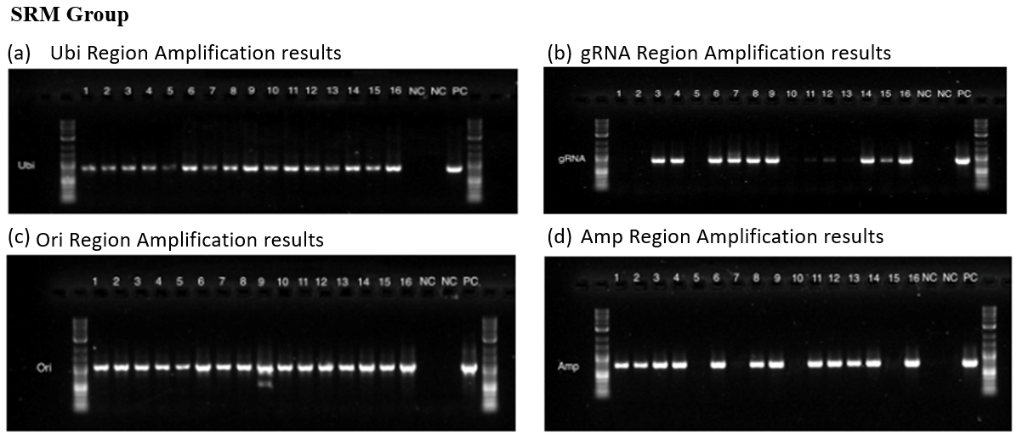
Figure S1: PCR gel images of SRM group for screening different regions of CRISPR constructs. (a) ubi promoter region of pBUN411-zCas9 constructs; (b) gRNA region of NPTII-sbPDS construct; (c) Ori region of pBUN411-zCas9 constructs; (d) Amp region of NPTII-sbPDS construct.

