Supplementary information for
Earth’s core composition constrained by H partitioning at the inner core boundary

Tao Liu¹, Zhicheng Jing^{1*}

¹Department of Earth and Space Sciences, Southern University of Science and Technology, 518055 Shenzhen, Guangdong, China

*Corresponding author Email: jingzc@sustech.edu.cn

Contents of this file

Text S1 to S4
Figures S1 to S10
Tables S1 to S2
References

Text S1. Grid size test and threshold distance test
The spatial integral $\int{exp\left(-{ΔU}/{k_{B}T}\right)}dr_{N+1}$ was performed over a discrete set of grid points dividing the supercell, by inserting an H test particle at each grid point when $exp\left(-{ΔU}/{k_{B}T}\right)$ for that point was calculated and integrated. Fig. S1 shows an example grid (a 2D projection of a 31×26×25 grid) for the Fe₆₄H₂ solid.
According to Fig. S2, the grid size tested for pure Fe system shows that a grid of 30×26×24 points (with a grid point distance of 0.28 Å) is sufficient for pure Fe. For Fe₆₄ liquid, the same grid point distance (0.28 Å) was used, which translates to a grid of 28×28×28 points. For the Fe-H alloys, we tested with the Fe₃₂H₃₂ liquid, and results show that the optimum grid size is 23×23×23, also suggest a grid point distance of 0.28 Å (Fig. S3). We therefore conclude that a grid point distance of 0.28 Å is sufficient for the spatial integral calculations in this study.
It has been shown in previous studies (Guillot & Sator, 2012; Hong & Walle, 2012) that negligible contribution is added to μH ex when the distance between the test particle and a solvent atom (Fe or H) is too small(Guillot & Sator, 2012; Hong & Walle, 2012). We therefore define threshold distances $r_{Fe-H}$ and $r_{H-H}$ as the minimum insertion distances between the inserted test particle (H atom) and solvent atoms (Fe or H). When the distance between the inserted H and solvent atoms is less than $r_{Fe-H}$ or $r_{H-H}$ depending on the specific solvent atom, the gird point is rejected because of its null contribution to $μ_{ex}^{H}$. The threshold distances ($r_{Fe-H}$ and $r_{H-H}$) were tested in Fig. S2~4, suggesting $r_{Fe-H}$ of 1.0 Å and $r_{H-H}$ of 0.6 Å are sufficient for the converge of μH ex. These threshold distances are consistent with the onset distances of the radial pair distribution functions in Fig. S5.

Text S2. Effect of energy cutoff to the chemical potential of H
Here we estimate the effect of energy cutoff to the chemical potential of H by increasing the energy cutoff from 500 eV to 800 eV. The uncertainty in chemical potential due to energy cutoff correction can be estimated based on the relation between the potential energy change and the excess chemical potential, using (Hong and Walle, 2012):
$μ_{ex}^{H}=-k_{B}Tln\left(\frac{1}{V}{〈\int{exp\left(-\frac{ΔU}{k_{B}T}\right)}dr_{N+1}〉}_{N}\right)$,
where $ΔU(r_{N+1})= U(r_{N+1})-U(r_{N})$ is the potential energy change due to insertion of an H atom at a grid point in the super cell. By increasing the energy cutoff from 500 eV to 800 eV, both $U(r_{N+1})$ and $U(r_{N})$ vary in a relatively large range, but the correction for their difference ($ΔU$, the quantity required for chemical potential calculations) is much smaller. Based on the estimation in our previously revised manuscript, we found the correction for $ΔU$ due to an increase of the energy cutoff from 500 eV to 800 eV is about 0.01(2) eV/atom on average, that is $ε_{U}=ΔU_{800eV}-ΔU_{500eV}≈-0.01eV$/atom. Then, the excess chemical potential $μ_{ex_{800eV}}^{H}$ for an energy cutoff of 800 eV can be estimated as
$$μ_{ex_{800eV}}^{H}=-k_{B}Tln\left(\frac{1}{V}{〈\int{exp\left(-\frac{{∆U}_{800eV}}{k_{B}T}\right)}dr_{N+1}〉}_{N}\right)$$
=$-k_{B}Tln\left(\frac{1}{V}{〈\int{exp\left(-\frac{{∆U}_{500eV}+ε_{U}}{k_{B}T}\right)}dr_{N+1}〉}_{N}\right)$
$$=-k_{B}Tln\left(\frac{1}{V}{\exp\left(-\frac{ε_{U}}{k_{B}T}\right)〈\int{exp\left(-\frac{{∆U}_{500eV}}{k_{B}T}\right)}dr_{N+1}〉}_{N}\right)$$
=$-k_{B}Tln\left(\frac{1}{V}{〈\int{exp\left(-\frac{{∆U}_{500eV}}{k_{B}T}\right)}dr_{N+1}〉}_{N}\right)-k_{B}Tln\left(\exp\left(-\frac{ε_{U}}{k_{B}T}\right)\right)$
=$μ_{ex_{500eV}}^{H}+ε_{U}$
Therefore, the correction term for $μ_{ex}^{H}$ is $ε_{U}≈-0.01 eV/atom$, and the correction term for the chemical potential $μ^{H}$is also $ε_{U}≈ -0.01 eV/atom$ since this correction has negligible effect on the ideal gas term.

We have performed direct test simulations for the Fe₆₄H₁₊₁ solid using an energy cutoff of 800 eV to determine its effect on the result of chemical potential of H. We find that the change in chemical potential by correcting energy cutoff from 500 eV to 800 eV is indeed on the order of 0.01 eV/atom. A grid size of 30×26×24 was used in the calculation, analogous to our prior study at an energy cutoff of 500 eV. In total, 17 configurations (122827 data points) were used to train the neural network. We compared the neural network predicted potential energy changes with DFT calculations in Fig. S12 below. The calculated $μ_{ex}^{H}$ in the Fe₆₄H₁₊₁ solid based on averaging 1200 configurations from 24000 molecular dynamics time steps, is determined to be 1.79(1) eV/atom (Fig. S13), which is -0.01 eV/atom lower than our previous study based on the energy cutoff of 500 eV.

Text S3. Test of finite size effects to the chemical potential of H
We have performed additional simulations by doubling the size of the supercell to test the validity of our simulations. The test simulation was performed on the Fe₁₂₈H₂ solid supercell. The grid size used was 61×26×25, determined by the threshold distances between the inserted H atom and the solvent (Fe and H atoms) in the Fe₁₂₈H₃ solid. The comparison of the potential energy changes predicted by the neural network and those calculated through DFT was performed and plotted in Fig. S11. The average excess chemical potential of hydrogen in a Fe₁₂₈H₂₊₁ solid, calculated based on 1200 configurations, is determined to be 1.76(3) eV/atom. When considering the ideal gas term, the $μ_{H}$ of Fe₁₂₈H₂₊₁ solid is -3.72(3) eV/atom, which is 0.05 eV/atom lower than that of smaller supercells (Fe₆₄H₀₊₁ and Fe₆₄H₁₊₁) (Fig. 1b). Based on this result and our test calculations using an energy cutoff of 800 eV (see Text S2), we have made a -0.06 eV/atom correction to the chemical potentials of H ($μ_{H}$) obtained from simulations using supercells of 64~79 atoms and an energy cutoff of 500 eV.

Text S4. Parameters used in Smooth Overlap of Atomic Position (SOAP)
The Smooth Overlap of Atomic Position package (SOAP) (Himanen et al., 2020) was used to encode the atomic structure, the insertion particle, and its surrounding atoms. Similar to (Zhang et al., 2020), we used the Gaussian type orbital radial basis, with n_{max} =8 for the number of basis functions, l_{max}=8 for the angular degree, r_{cut}=5 Å for the cutoff radius, and σ= 0.5 Å for the width of the Gaussian.

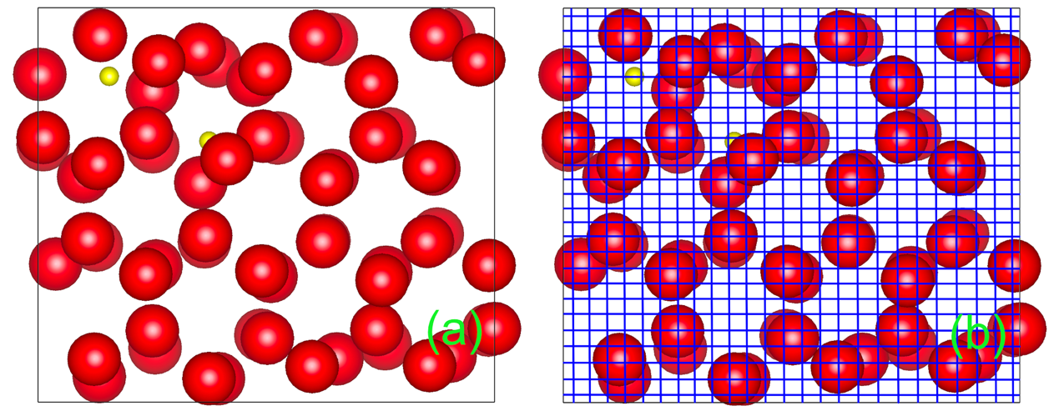
Fig. S1 The snapshots of Fe₆₄H₂ solid before (a) and after (b) inserting an H atom. The inserted H atom is on one of the crossing points of blue grid lines and is not shown in the figure. The red and yellow spheres represent Fe and H atoms, respectively.

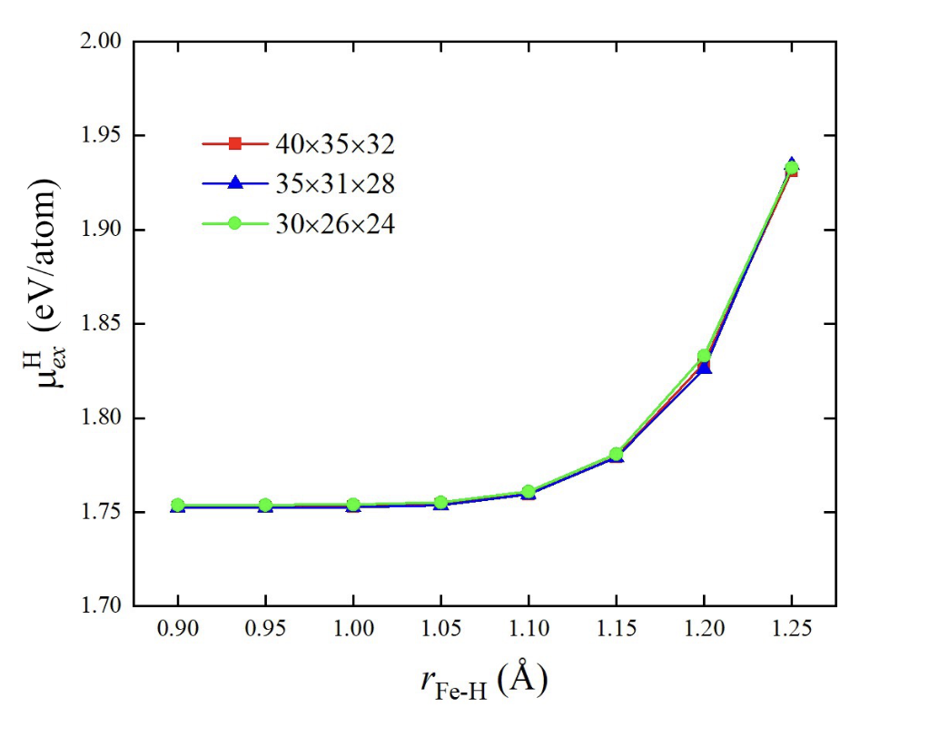
Fig. S2 Excess chemical potentials $μ_{ex}^{H}$ calculated for various grid sizes and threshold distances between the inserted H atom to an Fe atom in Fe₆₄ solid ($r_{Fe-H}$). Grid sizes of 40×35×32 (red squares), 35×31×28 (blue triangles), and 30×26×24 (green circles) for dividing the supercell were tested, corresponding to grid point distances of 0.21 Å, 0.24 Å, and 0.28 Å, respectively. Results show that $μ_{ex}^{H}$ is converged when the grid point distance is smaller than 0.28 Å and $r_{Fe-H}$ is smaller than 1.0 Å.

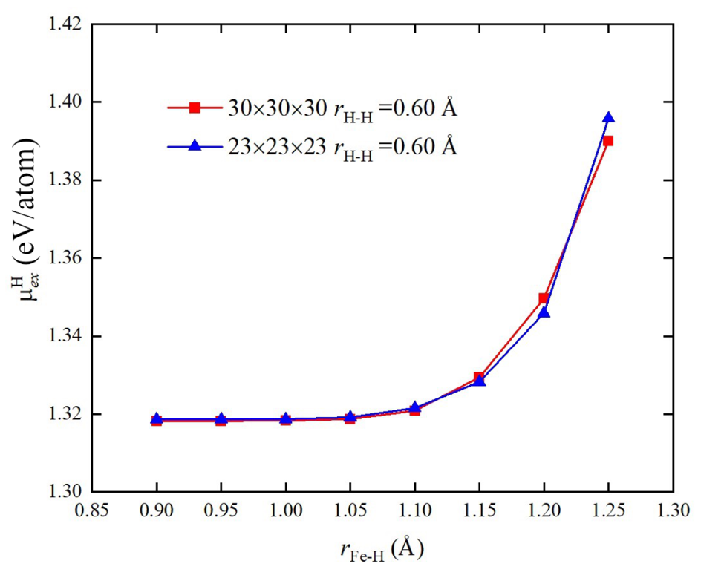
Fig. S3 Excess chemical potentials $μ_{ex}^{H}$ calculated using various grid sizes and threshold distances between the inserted H atom to an Fe atom ($r_{Fe-H}$) in Fe₃₂H₃₂ liquid. Grid sizes of 30×30×30 (red squares) and 23×23×23 (blue triangles) for dividing the supercell were tested, corresponding to grid point distances of 0.21 Å and 0.28 Å, respectively. The threshold distance between the inserted H atom to an H solvent atom ($r_{H-H}$) is set to 0.60 Å. Results show that $μ_{ex}^{H}$ is converged when the grid point distance is smaller than 0.28 Å and $r_{Fe-H}$ is smaller than 1.0 Å.

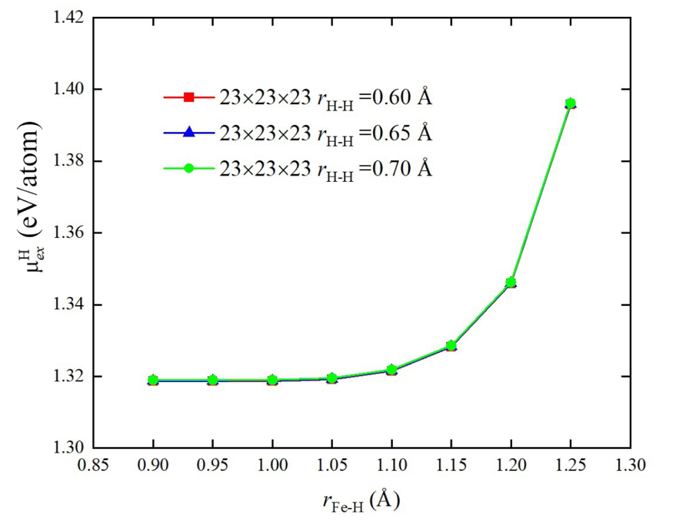
Fig. S4 Excess chemical potentials $μ_{ex}^{H}$ calculated using various threshold distances between the inserted H atom to an Fe atom ($r_{Fe-H}$) or an H atom ($r_{H-H}$) in Fe₃₂H₃₂ liquid. A grid size of 23×23×23 for was used to divide the supercell, corresponding to a grid point distance of 0.28 Å. Results show that $μ_{ex}^{H}$ is converged when $r_{Fe-H}$ is smaller than 1.0 Å and $r_{H-H}$ is smaller than 0.6 Å.

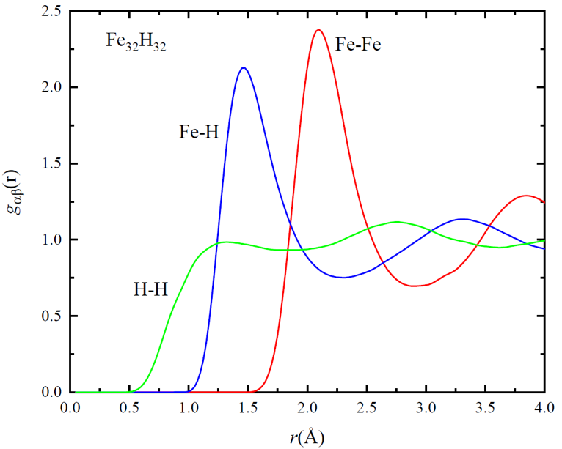

Fig. S5 Radial pair distribution functions ($g_{αβ}$) for Fe₃₂H₃₂ liquid at 6200 K and 330.5 GPa. The onset distances of $g_{Fe-H}$ and $g_{H-H}$ are ~1.0 and ~0.6 Å , respectively.

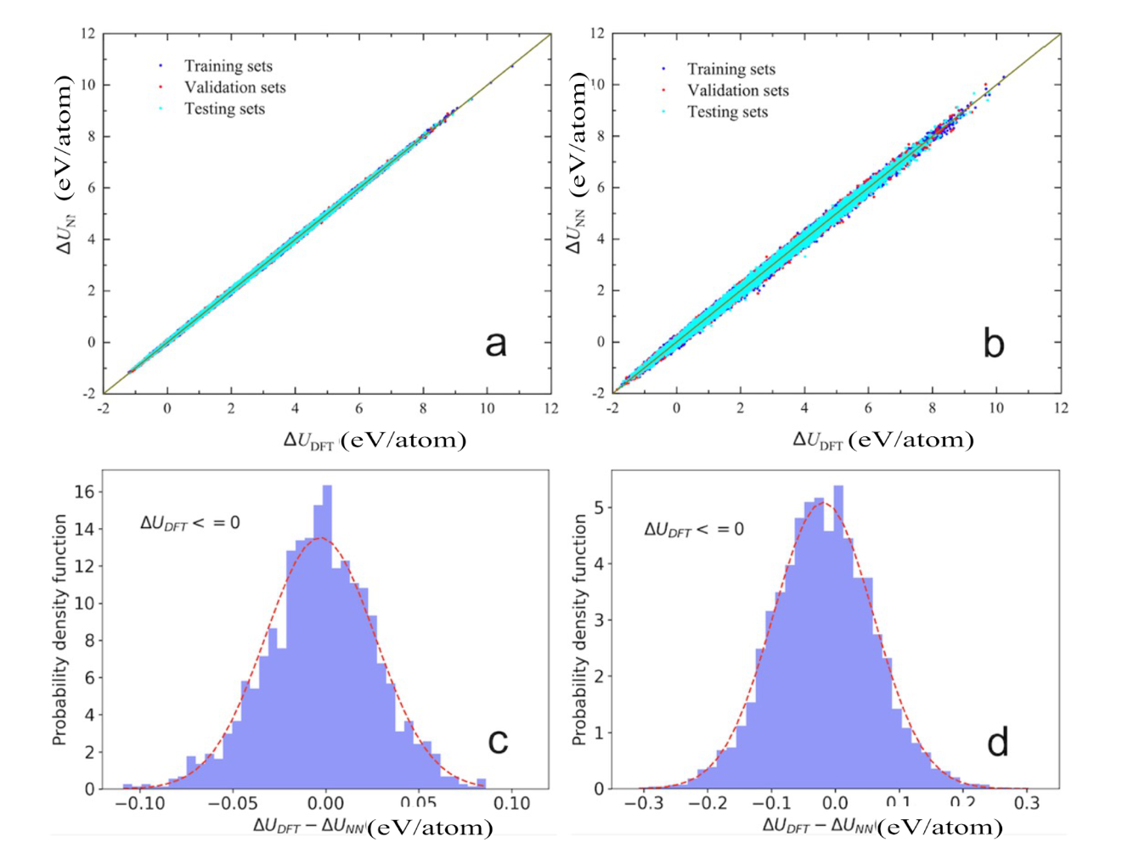
Fig. S6 (a) and (b): Comparison of predicted potential energy changes due to H insertion by the neural network (ΔU_{NN}) with those calculated by DFT (ΔU_{DFT}). (a) Fe₆₄ solid, using 79551 data points ; (b) Fe₃₂H₃₂ liquid, using 113797 data points. Data are divided into three groups: a training dataset (70%), a validation dataset (15%), and a test dataset (15%). (c) and (d): Probability density functions of the error between ΔU_{DFT} and ΔU_{NN} for Fe₆₄ solid and Fe₃₂H₃₂ liquid when ΔU_{DFT} is equal or lesser than 0. The $1σ$ uncertainties in the predicted ΔU for Fe₆₄ solid and Fe₃₂H₃₂ liquid are 0.03 eV/atom and 0.08 eV/atom, respectively.

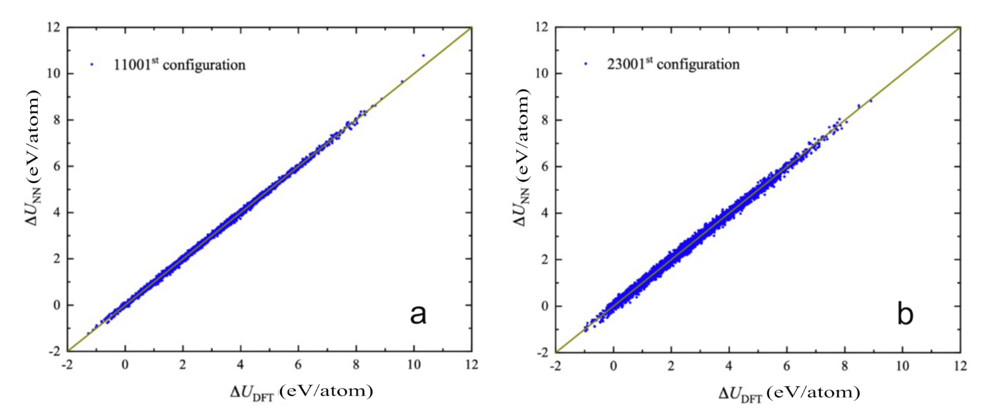
Fig. S7 Comparison of predicted potential energy changes (ΔU_{NN}) with those calculated by DFT (ΔU_{DFT}) using independent datasets. (a) Test results for the Fe₆₄ solid. In total, 7260 data points from the 11001st configuration of the MD simulation were used for the test. (b) Test results for the Fe₃₂H₃₂ liquid. In total, 4947 data points from the 23001st configuration were used.

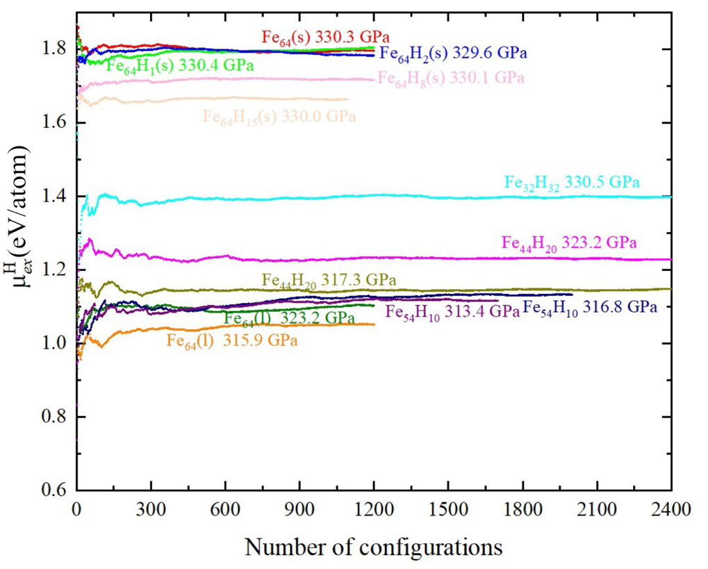
Fig. S8 Evolution of calculated excess chemical potential of H in Fe_{64-x}H_{x} alloys with increasing number of configurations used in ensemble averages. For every 10 MD steps, one configuration was picked for the average to ensure independence of configurations. In total, more than 1200 configurations were picked (for more than 12 ps of simulation time) for each ensemble average (except for Fe₆₄H₁₅, in which case ~1100 configurations were used).

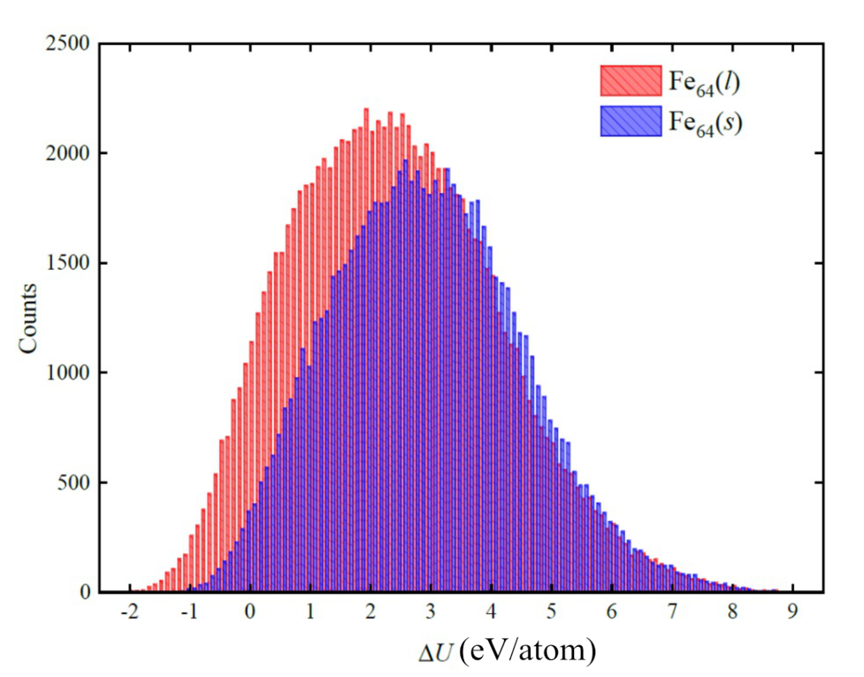
Fig. S9 Histograms of potential energy changes (ΔU) in Fe₆₄ liquid (red) at 323.2 GPa and Fe₆₄ solid (blue) at 330.3 GPa. Under the same H concentrations, the ideal gas term (Eq. 2 in Methods) is nearly independent of pressure (close to 330 GPa) in Table S1, so the chemical potential depends mostly on the μH ex, which is highly dependent on ΔU. Statistically, an H insertion in liquid Fe gives a lower ΔU than that in solid Fe, indicating that H prefers liquid Fe.

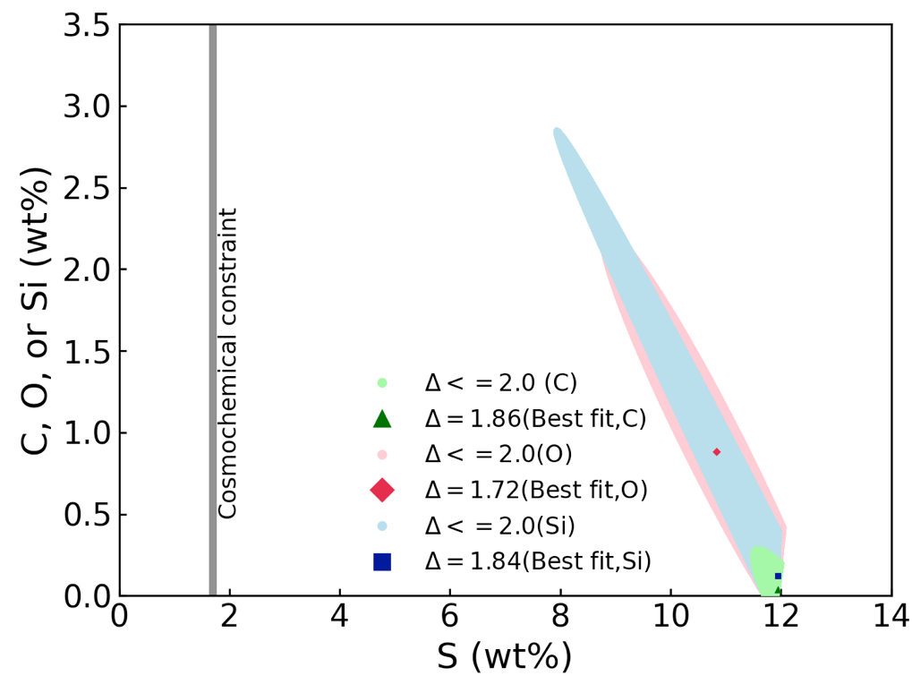
Fig. S10 The fitted light element compositions of the outer core that are consistent with light element partitioning at the ICB, for the (Fe, Ni)-S-Si (blueish), (Fe, Ni)-S-O (reddish), and (Fe, Ni)-S-C (greenish) systems. The ellipses represent the misfits of calculated core properties from PREM results. The blue square, red diamond, and green triangle represent the best fit for the (Fe, Ni)-S-Si, (Fe, Ni)-S-O, and (Fe, Ni)-S-C system, respectively, with the best result for the misfit annotated. The vertical gray line represents the cosmochemical constraint for the S content in the core (1.7 wt% (Dreibus & Palme, 1996)).

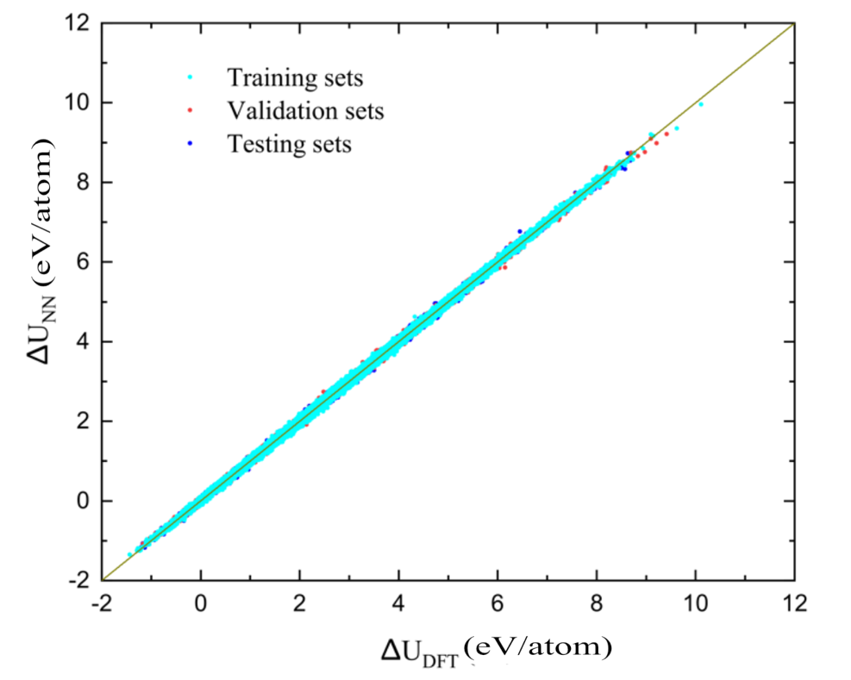
Fig. S11 Comparison of predicted potential energy changes due to H insertion by the neural network (ΔU_{NN}) with those calculated by DFT (ΔU_{DFT}) in Fe₁₂₈H₂₊₁ solid, using 91881 data points.

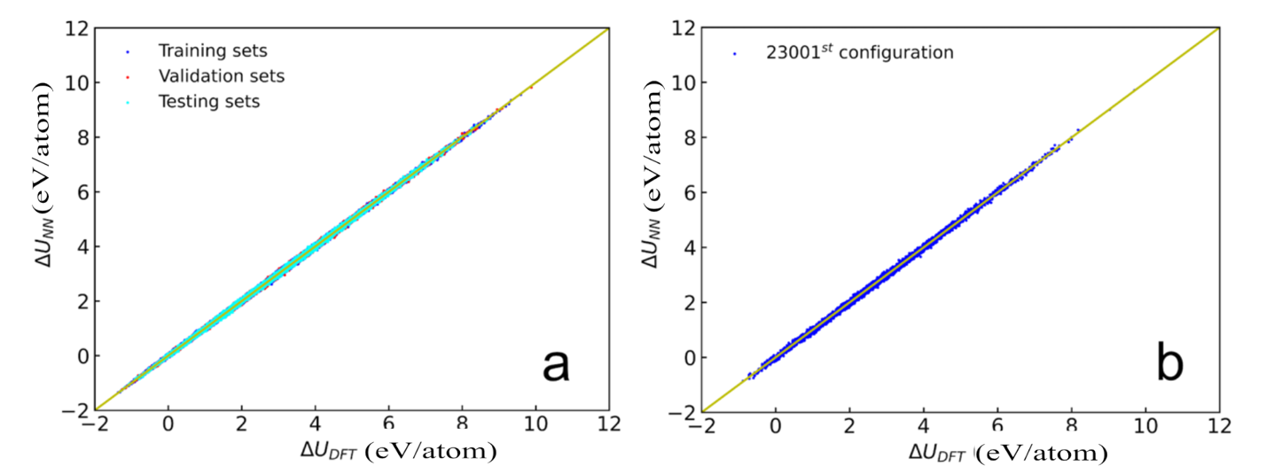
Fig. S12 (a) Comparison of predicted potential energy changes (ΔU_{NN}) with those calculated by DFT (ΔU_{DFT}) with an energy cutoff of 800 eV for 122827 data points. Among the data sets, 70% were training sets (85979 data points), 15% were validation sets (18424 data points), and 15% were test sets (18424 data points). (b) Comparison of predicted potential energy changes (ΔU_{NN}) with those calculated by DFT (ΔU_{DFT}) with an energy cutoff of 800 eV for 7220 independent data points from the 23001st configuration used.

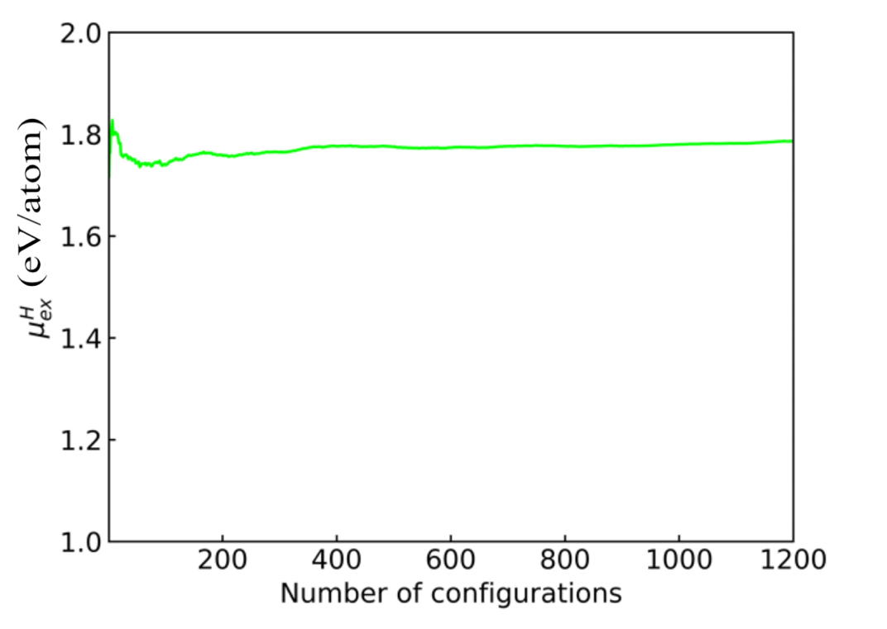
Fig. S13 Evolution of calculated excess chemical potential of H in Fe₆₄H₁₊₁ solid with increasing number of configurations used in ensemble averages. The training data used were based on DFT calculations with an energy cutoff of 800 eV.

Table S1 Calculated chemical potential of H in Fe-H alloys at 6200 K

Components | V(Å³) | P (GPa) | μ_{id}  (eV/atom) | μ_{ex}  (eV/atom) | μa H  (eV/atom) | μb H  (eV/atom)
Fe₆₄(s) | 435.25 | 330.3 | -5.66 | 1.80(3) | -3.89(3) | -3.95(3)
Fe₆₄H₁(s) | 436.47 | 330.4 | -5.29 | 1.80(3) | -3.52(3) | -3.58(3)
Fe₆₄H₂(s) | 438.19 | 329.6 | -5.09 | 1.78(3) | -3.32(3) | -3.38(3)
Fe₆₄H₈(s) | 446.97 | 330.1 | -4.50 | 1.72(3) | -2.81(3) | -2.87(3)
Fe₆₄H₁₅(s) | 457.36 | 330.0 | -4.21 | 1.66(3) | -2.58(3) | -2.64(3)
Fe₆₄(l) | 452.03 | 315.9 | -5.68 | 1.04(8) | -4.67(8) | -4.73(8)
Fe₆₄(l) | 449.33 | 323.2 | -5.68 | 1.11(8) | -4.60(8) | -4.66(8)
Fe₅₄H₁₀(l) | 394.95 | 313.4 | -4.33 | 1.11(8) | -3.25(8) | -3.31(8)
Fe₅₄H₁₀(l) | 393.71 | 316.8 | -4.33 | 1.12(8) | -3.24(8) | -3.30(8)
Fe₄₄H₂₀(l) | 338.40 | 317.3 | -3.90 | 1.16(8) | -2.77(8) | -2.83(8)
Fe₄₄H₂₀(l) | 336.72 | 323.2 | -3.90 | 1.21(8) | -2.72(8) | -2.78(8)
Fe₃₂H₃₂(l) | 267.81 | 330.5 | -3.53 | 1.41(8) | -2.15(8) | -2.21(8)
ª A pressure correction term ($\frac{V}{2K_{T}}ΔP^{2}$) (see Methods) was subtracted to the chemical potential to obtain $μ_{H}$ at a given pressure.
^{b} The chemical potential was corrected by -0.06 eV/atom for the effects of a high cutoff energy of 800 eV and the finite size of the simulation cell.

Table S2 P-V data of Fe-S and Fe-Si alloys at 6200 K

Components | V(Å³) | P (GPa) | Method
Fe₆₃S₁(s) | 433.58 | 335.7 | Simulation
Fe₆₃S₁(s) | 433.84 | 334.8 | Simulation
Fe₆₃S₁(s) | 434.89 | 331.8 | Simulation
Fe₆₃S₁(s) | 435.49 | 330.0 | Fitting*
Fe₆₃Si₁(s) | 435.56 | 330.4 | Simulation
Fe₆₃Si₁(s) | 433.58 | 336.4 | Simulation
Fe₆₃Si₁(s) | 433.84 | 335.6 | Simulation
Fe₆₃Si₁(s) | 434.24 | 334.3 | Simulation
Fe₆₃Si₁(s) | 435.69 | 330.0 | Fitting*
* Volume was calculated by the linear extrapolation of simulated results for the same composition.

Reference

Alfè, D., Gillan, M. J., & Price, G. D. (2002). Composition and temperature of the Earth’s core constrained by combining ab initio calculations and seismic data. Earth and Planetary Science Letters, 195(1–2), 91–98. https://doi.org/10.1016/s0012-821x(01)00568-4
Dreibus, G., & Palme, H. (1996). Cosmochemical constraints on the sulfur content in the Earth’s core. Geochimica et Cosmochimica Acta, 60(7), 1125–1130. https://doi.org/10.1016/0016-7037(96)00028-2
Guillot, B., & Sator, N. (2012). Noble gases in high-pressure silicate liquids: A computer simulation study. Geochimica et Cosmochimica Acta, 80(J. Geophys. Res. 113 2008), 51–69. https://doi.org/10.1016/j.gca.2011.11.040
Himanen, L., Jäger, M. O. J., Morooka, E. V., Canova, F. F., Ranawat, Y. S., Gao, D. Z., et al. (2020). DScribe: Library of descriptors for machine learning in materials science. Computer Physics Communications, 247, 106949. https://doi.org/10.1016/j.cpc.2019.106949
Hong, Q.-J., & Walle, A. van de. (2012). Direct first-principles chemical potential calculations of liquids. The Journal of Chemical Physics, 137(9), 094114. https://doi.org/10.1063/1.4749287
Zhang, Z., Csányi, G., & Alfè, D. (2020). Partitioning of Sulfur between Solid and Liquid Iron under Earth’s Core Conditions: Constraints from Atomistic Simulations with Machine Learning Potentials. Geochimica et Cosmochimica Acta. https://doi.org/10.1016/j.gca.2020.03.028

