Appendix
Figure 1 – Exploratory effectiveness outcomes by treatment group and device (Intention-To-Treat population)
A) Percentage time in very high glucose (>13.9 mmol/L) by Treatment Group and Device
Figure A: Individual participant profiles | Table A: Median (25th and 75th percentile)
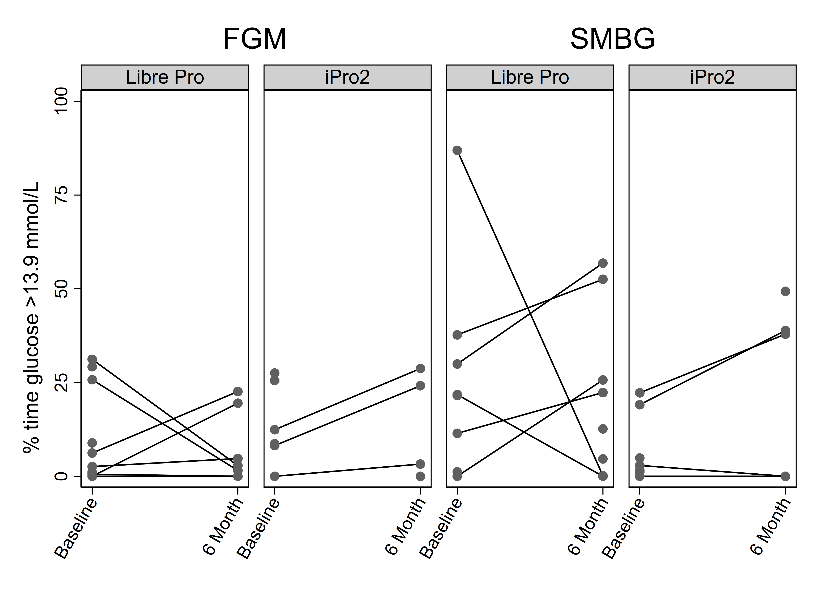
   | Flash glucose monitoring (FGM) |  | Self-monitored blood glucose (SMBG)
   | Libre  Pro | iPro2 | Libre  Pro | iPro2
   | N=11 | N=9 | N=10 | N=10
  Baseline | 4.4  (0.5-25.8) | 10.5  (8.2-25.5) | 21.7  (6.3-33.8) | 2.9  (1.1-19.1)
  6-month | 2.8  (0.0-19.5) | 13.7  (1.6-26.4) | 17.5  (2.4-39.1) | 19.0  (0.0-38.9)
B) Percentage time in high glucose (10.1-13.9 mmol/L) by Treatment Group and Device
Figure B: Individual participant profiles | Table B: Median (25th and 75th percentile)
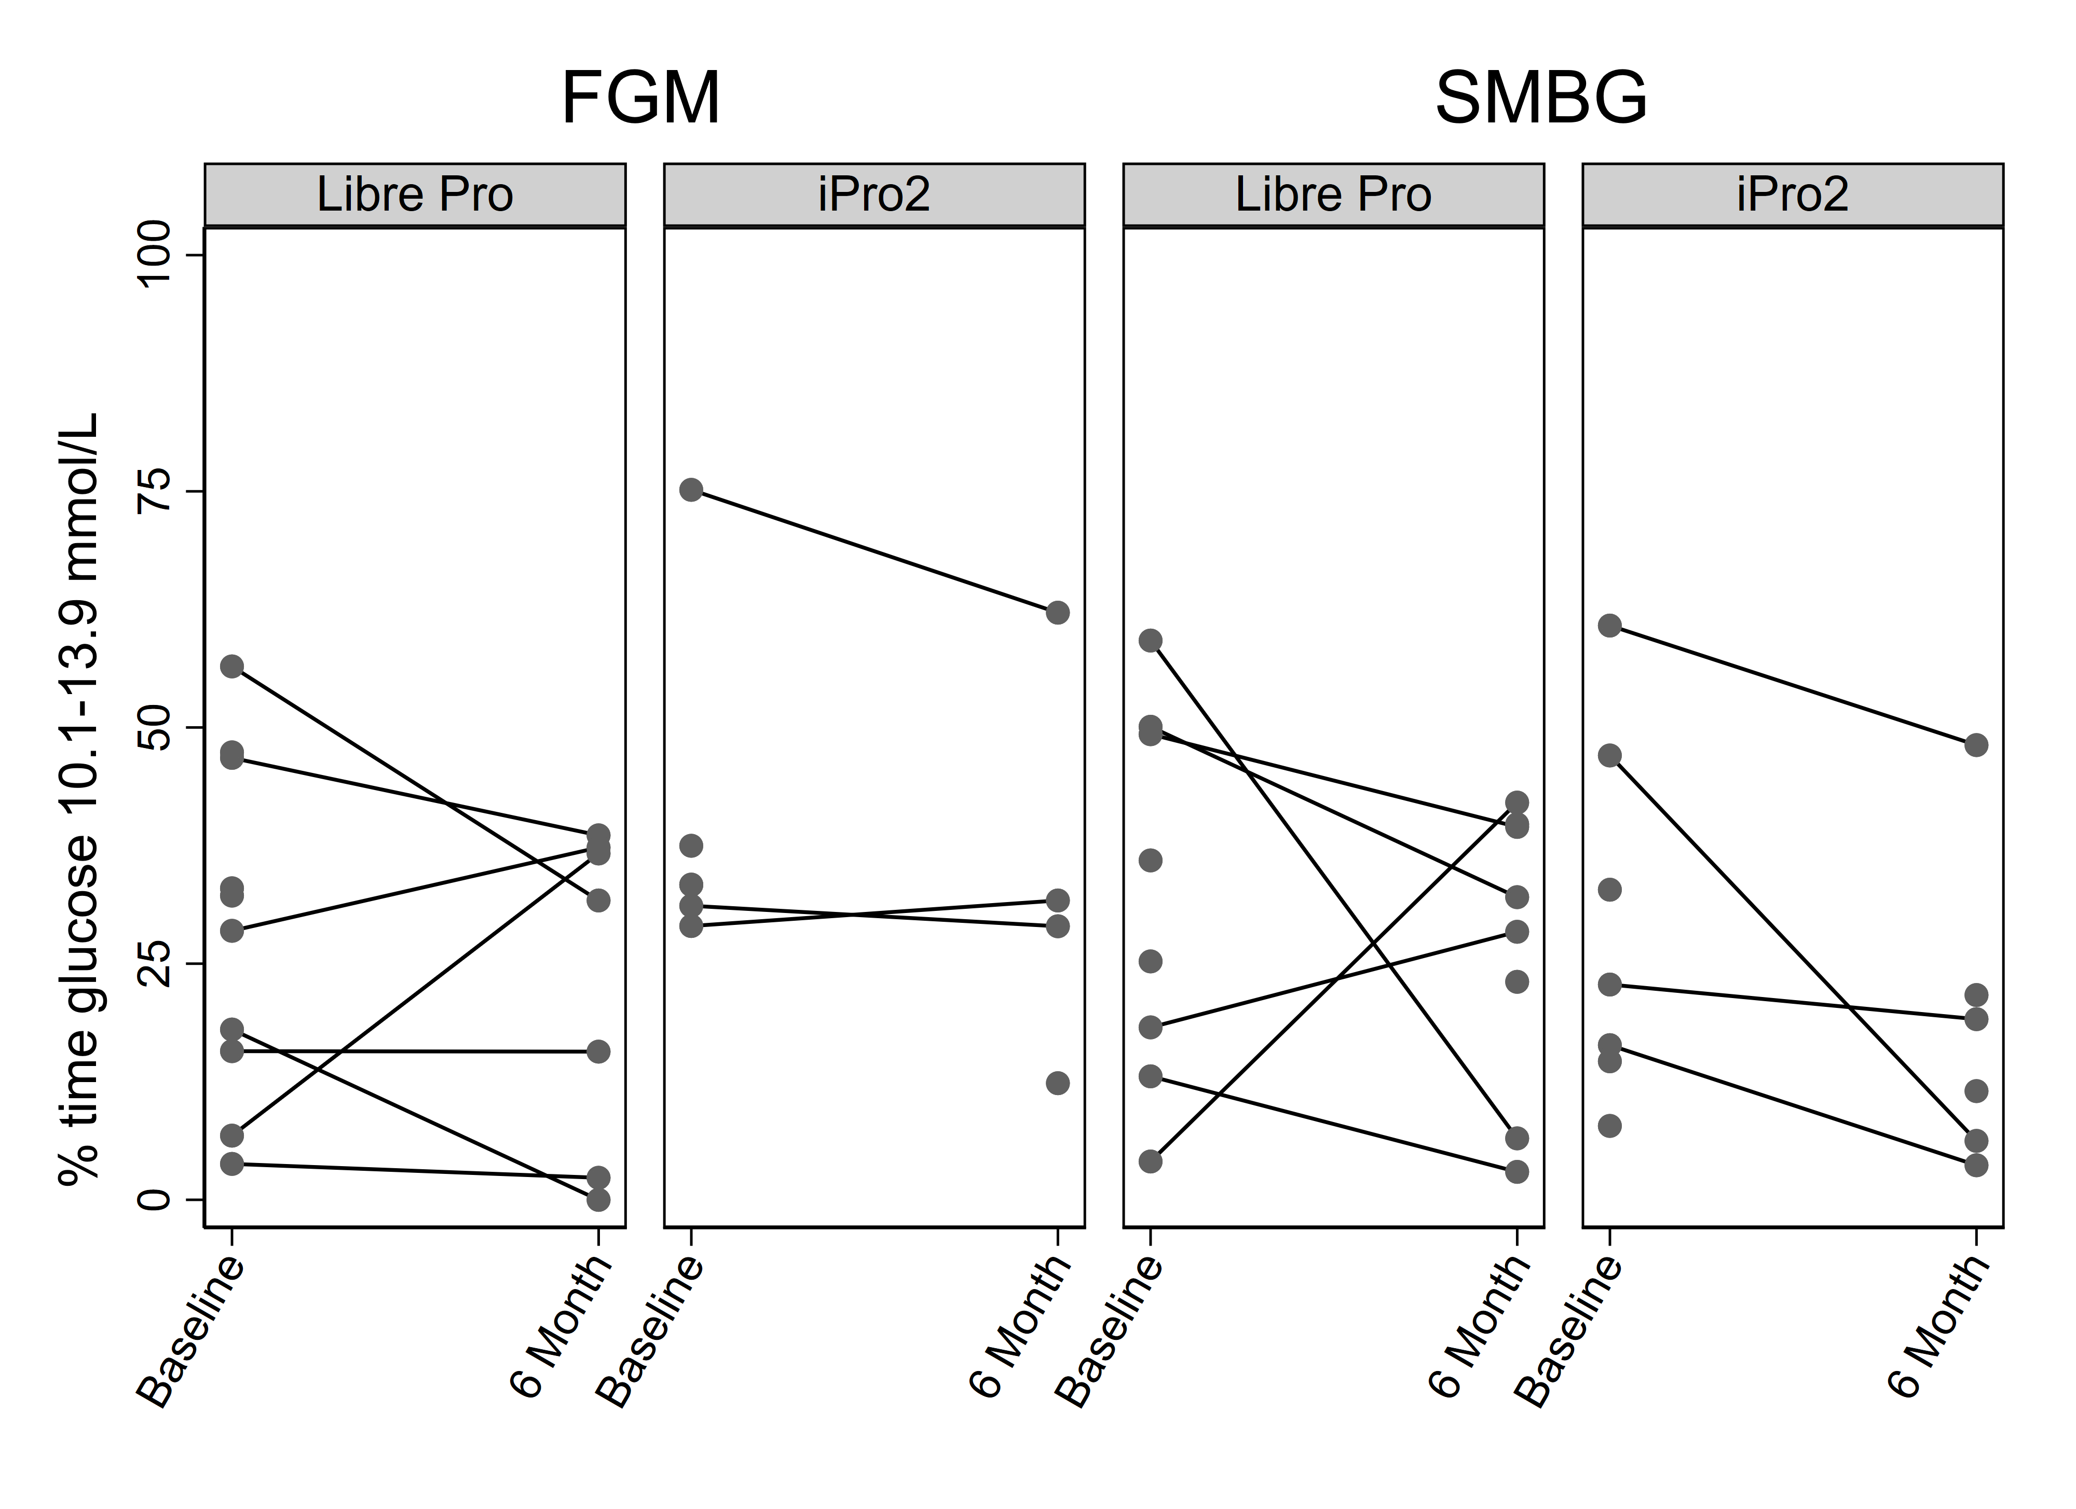
   | Flash glucose monitoring (FGM) |  | Self-monitored blood glucose (SMBG)
   | Libre  Pro | iPro2 | Libre  Pro | iPro2
   | N=11 | N=9 | N=10 | N=10
  Baseline | 30.3  (15.7-46.8) | 33.3  (31.1-37.5) | 30.6  (15.7-49.7) | 22.8  (14.7-47.0)
  6-month | 31.7  (2.3-37.3) | 30.3  (20.7-46.9) | 30.2  (14.8-39.6) | 15.3  (6.2-21.7)
C) Percentage time in target glucose (3.9-10.0 mmol/L) by Treatment Group and Device
Figure C: Individual participant profiles | Table C: Median (25th and 75th percentile)
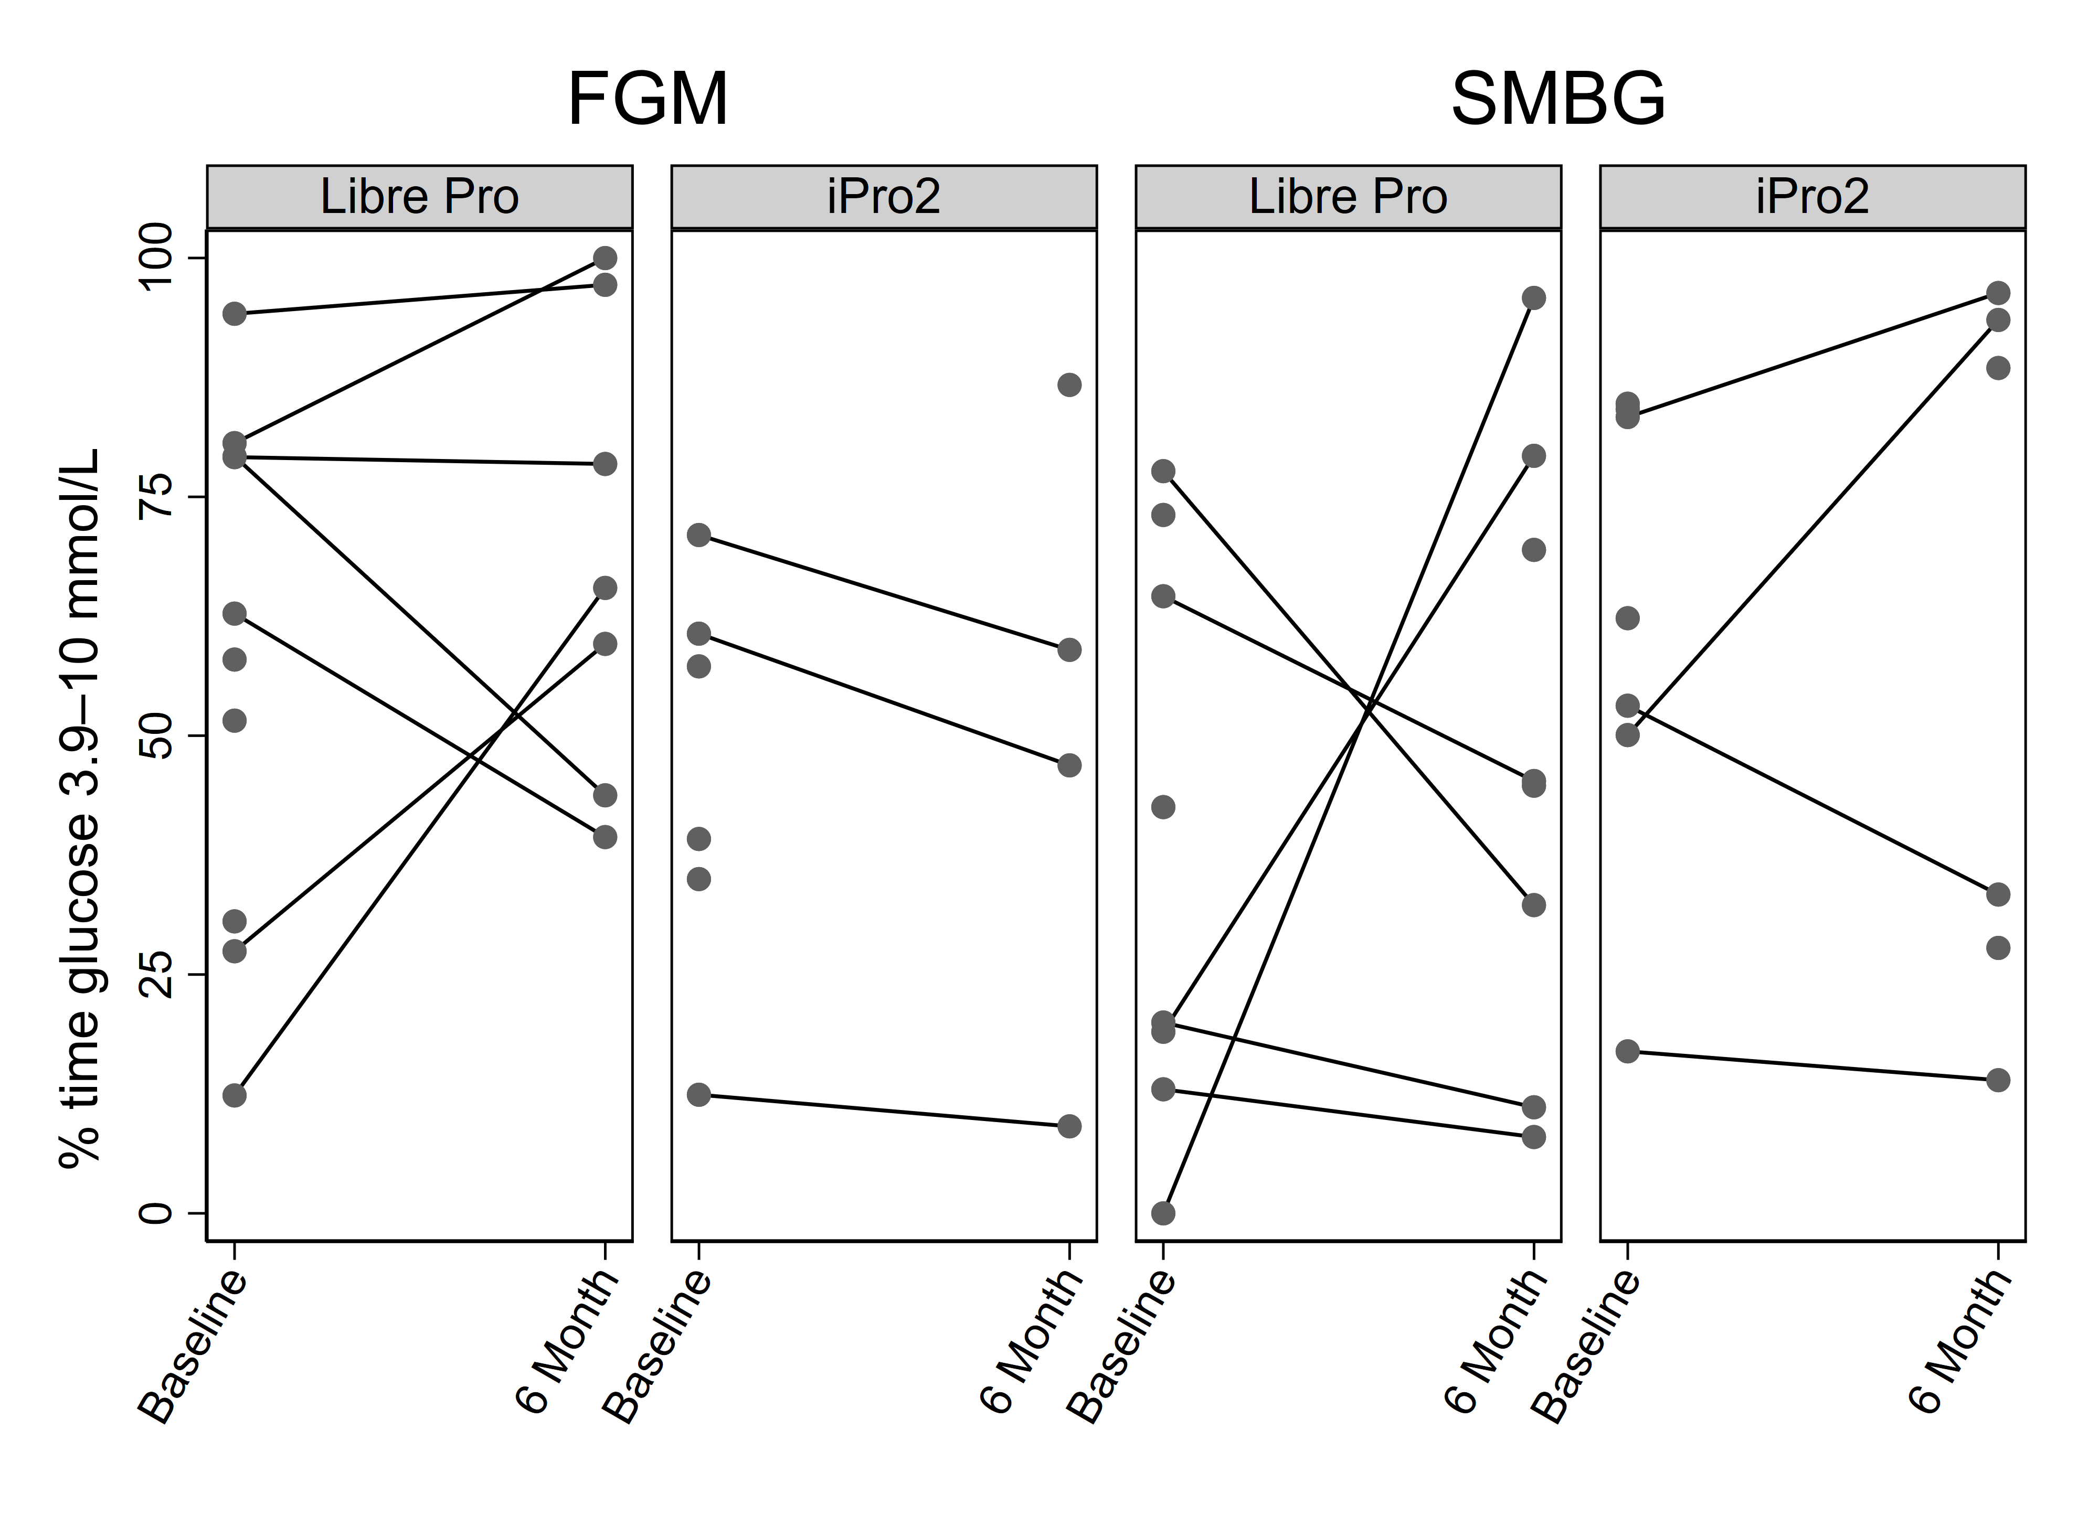
   | Flash glucose monitoring (FGM) |  | Self-monitored blood glucose (SMBG)
   | Libre  Pro | iPro2 | Libre  Pro | iPro2
   | N=11 | N=9 | N=10 | N=10
  Baseline | 60.4  (30.6-79.2) | 48.2  (35.0-60.7) | 31.3  (16.0-68.9) | 62.3  (50.1-84.2)
  6-month | 65.5  (43.8-97.2) | 52.9  (28.0-72.9) | 45.0  (21.7-74.4) | 60.9  (27.8-93.5)
D) Percentage time in low glucose (3.0-3.8 mmol/L) by Treatment Group and Device
Figure D: Individual participant profiles | Table D: Median (25th and 75th percentile)
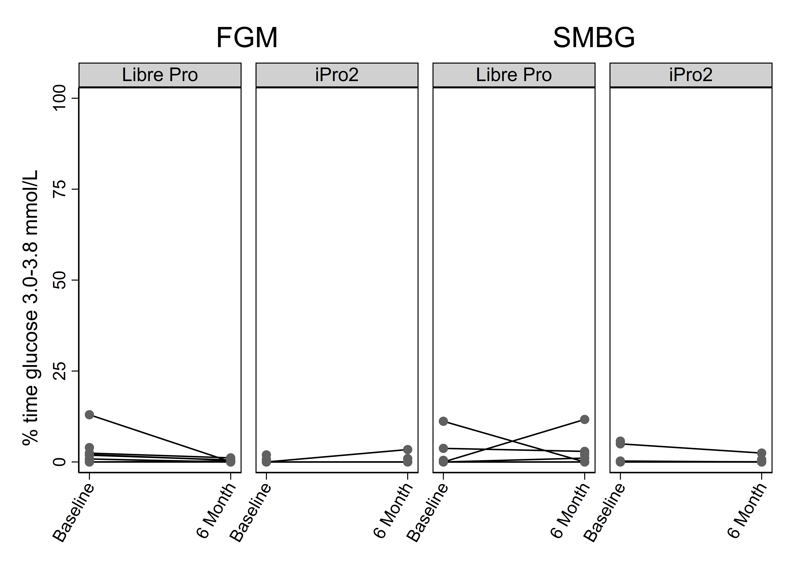
   | Flash glucose monitoring (FGM) |  | Self-monitored blood glucose (SMBG)
   | Libre  Pro | iPro2 | Libre  Pro | iPro2
   | N=11 | N=9 | N=10 | N=10
  Baseline | 1.3  (0.0-2.4) | 0.0  (0.0-0.7) | 0.0  (0.0-2.1) | 0.0  (0.0-5.0)
  6-month | 0.3  (0.0-0.5) | 0.5  (0.0-2.2) | 1.6  (0.0-2.9) | 0.0  (0.0-0.7)
E) Percentage time in very low glucose (<3.0 mmol/L) by Treatment Group and Device
Figure E: Individual participant profiles | Table E: Median (25th and 75th percentile)
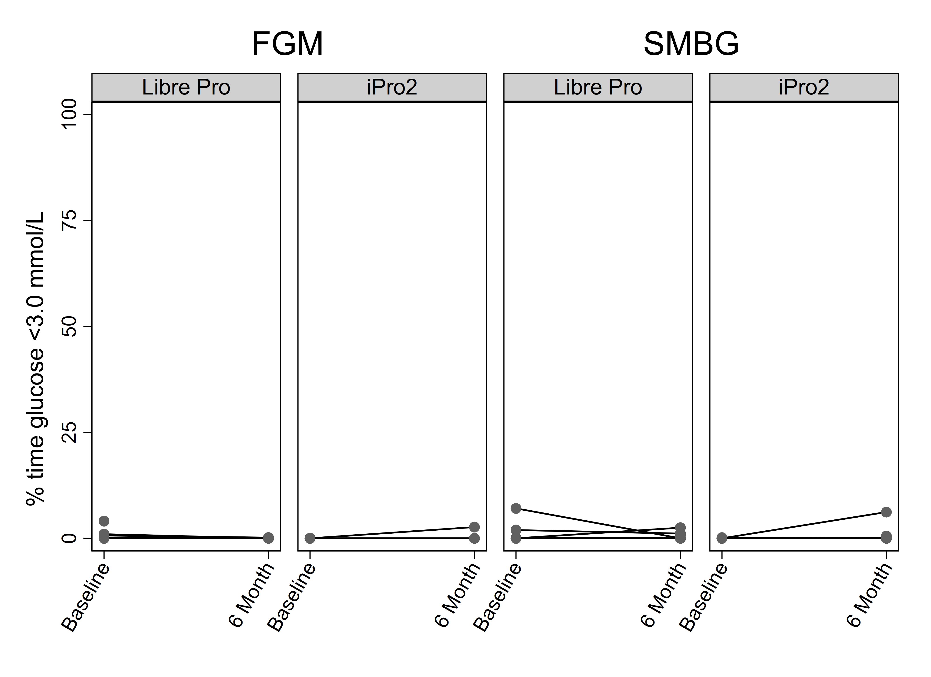
   | Flash glucose monitoring (FGM) |  | Self-monitored blood glucose (SMBG)
   | Libre  Pro | iPro2 | Libre  Pro | iPro2
   | N=11 | N=9 | N=10 | N=10
  Baseline | 0.0  (0.0-0.7) | 0.0  (0.0-0.0) | 0.0  (0.0-1.0) | 0.0  (0.0-0.0)
  6-month | 0.0  (0.0-0.0) | 0.0  (0.0-1.3) | 0.0  (0.0-0.9) | 0.1  (0.0-0.5)
FGM = flash glucose monitoring; SMBG = self-monitored blood glucose.
Data are presented as median (25th to 75th percentile)
1 participant in the intervention arm received SMBG instead of FGM, and 1 participant in the control arm received FGM instead of SMBG. These participants were included in the group ‘as randomised’.
Data measured outside of the scheduled visit windows were excluded from the analysis. As a result, 1 participant data at baseline and 3 at 6 months follow-up were excluded.

Table 1 – Number (%) of participants with insulin and other glucose lowering medications use by treatment group (Safety population)
 | Flash glucose monitoring | Self-monitored blood glucose
 | N=20 | N=20
Insulin use, n (%)
Baseline | 15 (75%) | 13 (65%)
3 months | 11 (65%) | 11 (69%)
6 months | 12 (75%) | 11 (61%)
Total daily dose, Median (IQR)
Baseline | 50.0 (28.0-62.0) | 54.0 (26.0-84.0)
3 months | 46.0 (20.0-64.0) | 37.0 (20.0-94.0)
6 months | 62.0 (53.0-82.0) | 64.0 (26.0-95.0)
No. of non-insulin glucose lowering medication use, n (%)
Baseline
0 | 0 (0%) | 1 (5%)
1 | 5 (25%) | 4 (20%)
2 | 10 (50%) | 9 (45%)
3 | 5 (25%) | 5 (25%)
4 | 0 (0%) | 1 (5%)
3 months
0 | 1 (6%) | 1 (6%)
1 | 4 (24%) | 5 (31%)
2 | 5 (29%) | 6 (38%)
3 | 7 (41%) | 4 (25%)
6 months
0 | 0 (0%) | 1 (6%)
1 | 4 (25%) | 6 (33%)
2 | 8 (50%) | 5 (28%)
3 | 4 (25%) | 6 (33%)
FGM = flash glucose monitoring; SMBG = self-monitored blood glucose.

IQR = Interquartile Range (25th to 75th percentile)

1 participant in the intervention arm received SMBG instead of FGM, and 1 participant in the control arm received FGM instead of SMBG. These participants were included in the group ‘as treated’.

Supplementary data files to be included:
Statistical Analysis Plan (SAP): FLASH_pilot_SAP_Version_1.0

