Table S1: Northward TCC Isolines Trend for 2000-2018 (deg/decade)
Pacific Atlantic
ISCCP CLARA MODIS ISCCP CLARA MODIS
80% NH High Latitudes 0.02 0.05 0.54 0.14 0.37 -0.40
80% NH Midlatitudes 0.93 0.40 0.81 0.18 -0.44 -2.93
65% NH Subtropics 0.63 0.35 0.33 1.21 0.96 0.21
65% NH Tropics -0.39 -0.51 -1.05 -1.12 -0.65 -0.12
65% SH Tropics 0.28 0.44 0.25 0.04 -0.04 0.05
65% SH Subtropics -1.44 -0.68 -0.74 -1.56 -0.04 0.04
80% SH Midlatitudes -0.95 - 0.35 -0.21 -2.44 -1.02 -0.40
80% SH High Latitudes -1.11 0.42 -1.14 -3.56 0.18 -0.30

*Slopes of linear fits to the 80% (red) and 60% (blue) TCC isolines for ISCCP, CLARA-A3, and MODIS, for the Pacific and Atlantic Oceans. Positive/negative slopes indicate Northward/Southward direction, and bold numbers indicate linear fits significant at the 95% level.

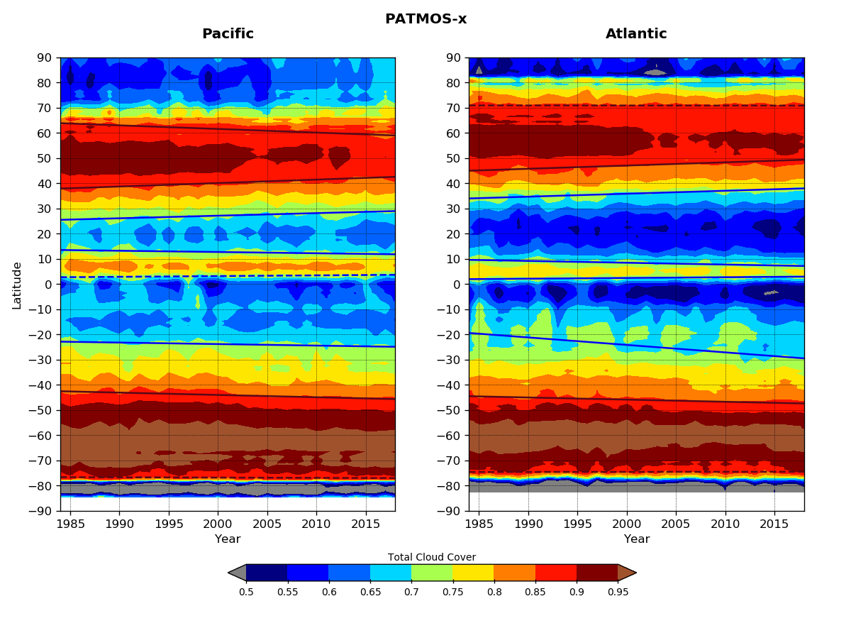

Figure S1: Hovmöller plots of PATMOS-x zonal, annual mean TCC for 1984-2018, for the Pacific (left) and the Atlantic (right). Blue lines show the 65% and red lines the 85% TCC isolines. Solid lines indicate statistically significant trends at the 95% significance level.

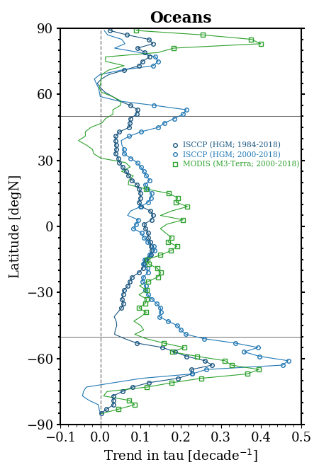
Figure S2: Zonal, annual mean TAU trends for the ISCCP-H 35-year (1984-2018) and 19-year (2000-2018) periods and for the MODIS 19-year period. The data are plotted for 2-degree wide latitude zones, and symbols indicate latitude zones with significant trends at the 95% significance level.

