Supplemental Table S1. Dose-limiting toxicities in the phase-Ⅰ study (N = 10)
Adverse event | Any grade | Grade 3–4 | DLT
Fatigue | 0 | 0 | 0
Nausea | 2 | 0 | 0
Anorexia | 1 | 0 | 0
Diarrhea | 1 | 0 | 0
Radiation esophagitis | 10 | 1 | 1
Radiation pneumonitis | 0 | 0 | 0
Radiation dermatitis | 4 | 0 | 0
Anemia | 6 | 0 | 0
Neutropenia | 4 | 1 | 1
Thrombocytopenia | 0 | 0 | 0
Leukopenia | 10 | 1 | 1
Increase in ALT/AST levels | 0 | 0 | 0
Abbreviations: DLT, dose-limiting toxicity; AST, aspartate transaminase; ALT, alanine transaminase.

Supplemental Figure S1.
The locoregional control (A), overall survival (B), event-free survival (C) and distant metastasis-free survival (D) of all patients.
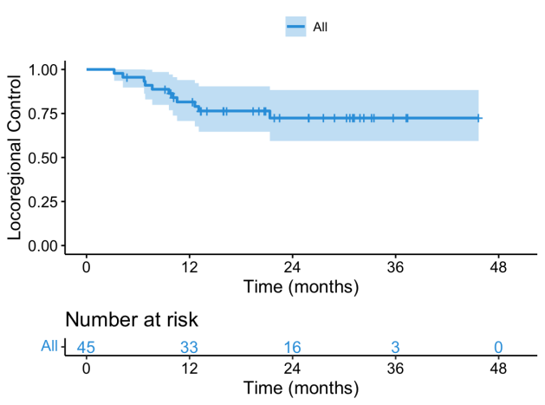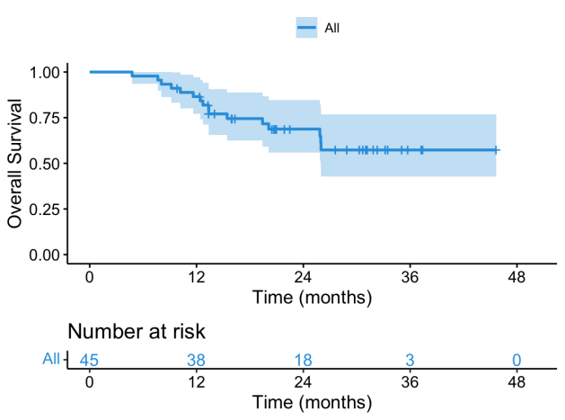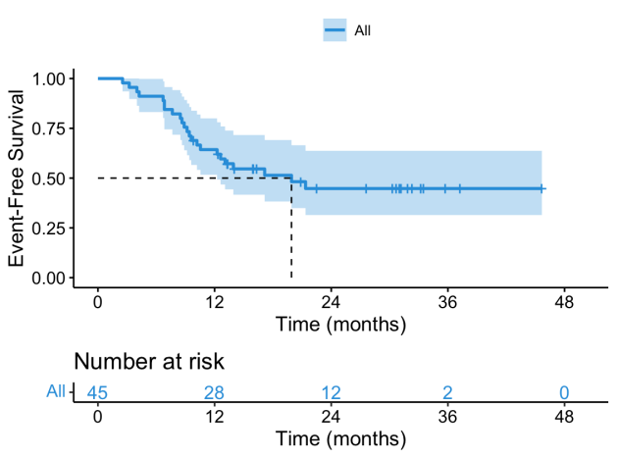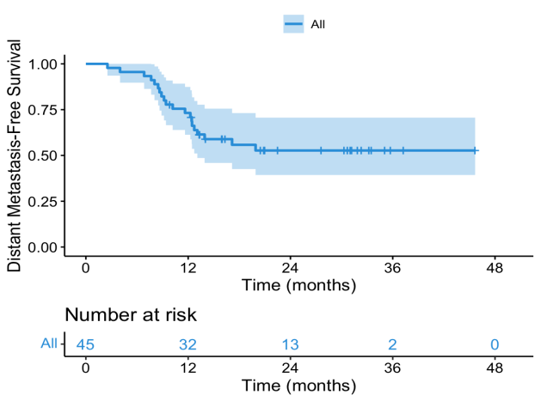
D
B
C
A

