Supplementary Figure 1
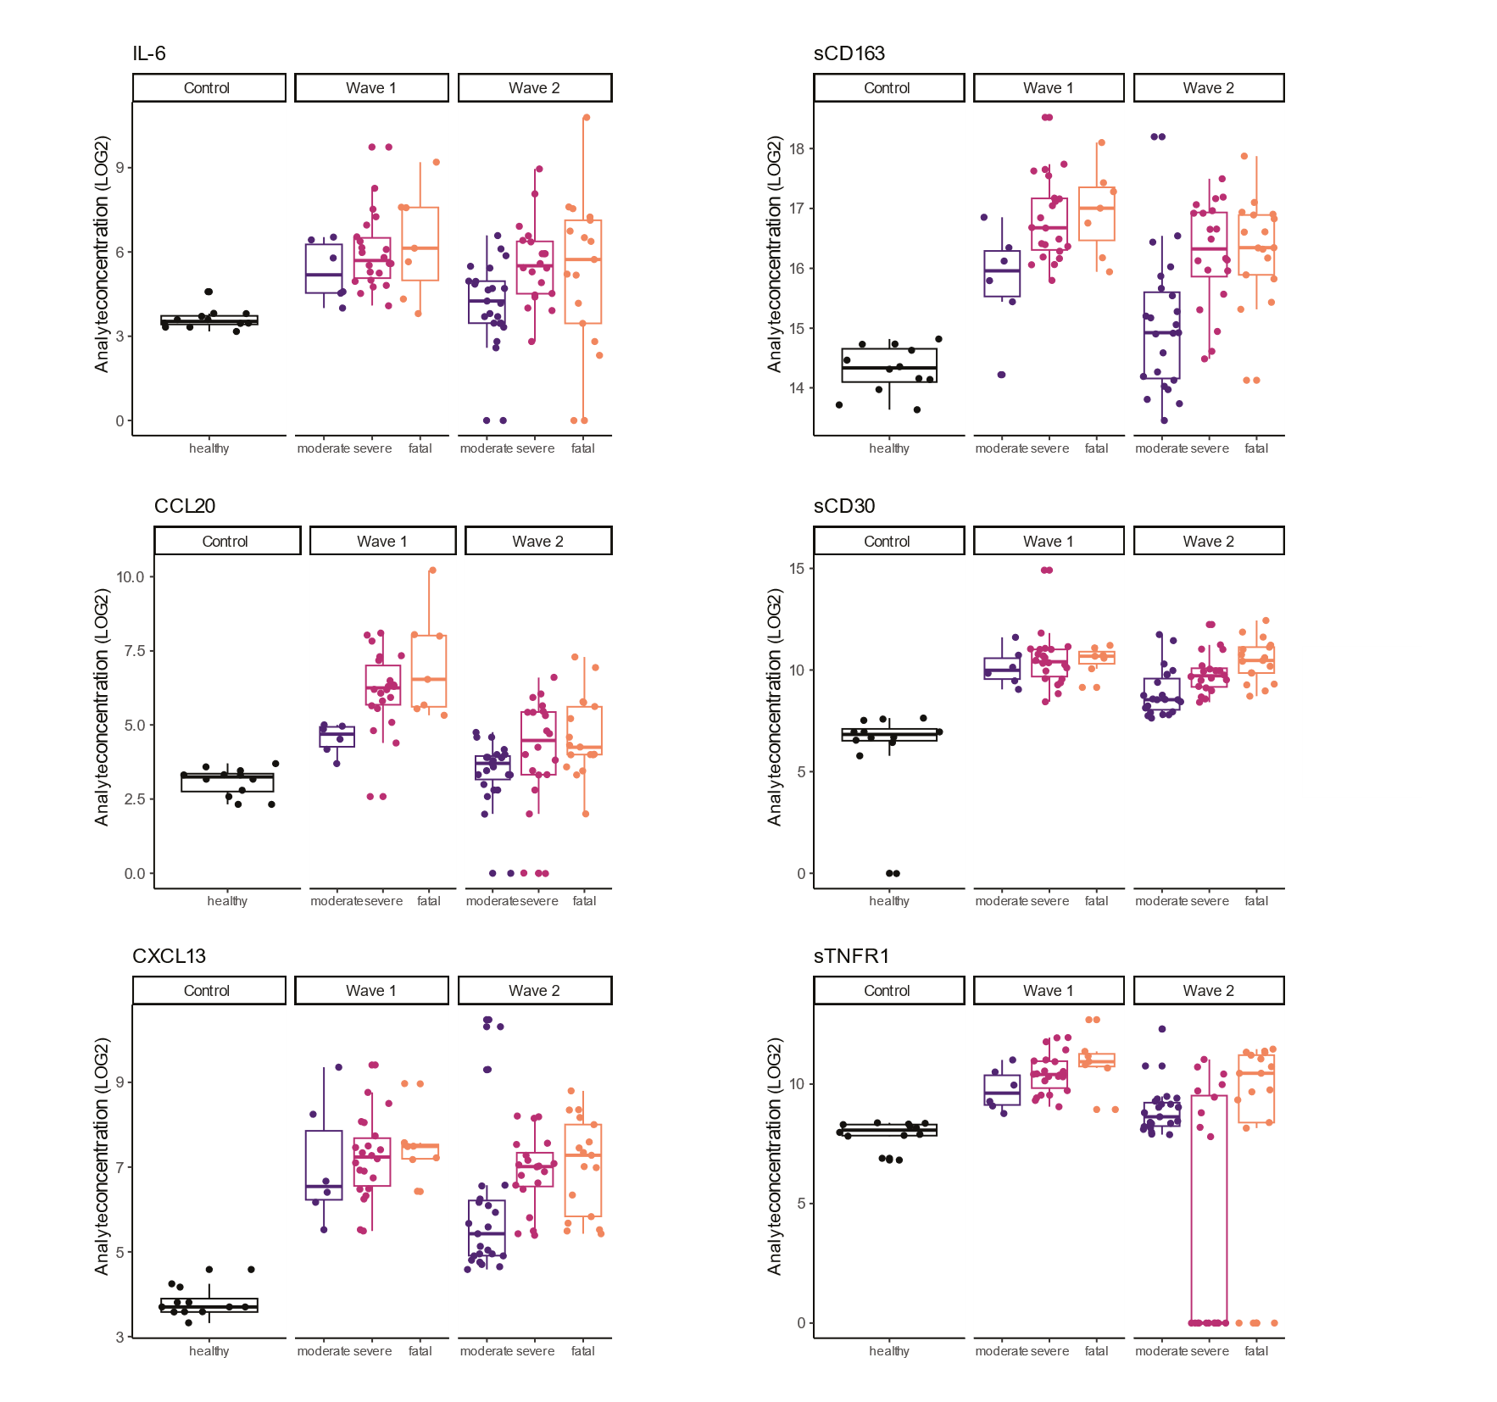Univariate data of individual analytes in outcome groups over the waves at study inclusion
Analyte expression, measured at the first collected sample after hospital admission, is plotted for 6 individual analytes (IL-6, CCL20, CXCL13, sCD163, sCD30, sTNFR1) as examples for the healthy controls, moderate severe and fatal outcome groups separated for wave-1 and 2. Data are expressed as plus one log2 transformations of the concentration in pg/ml. All data points are plotted, boxes indicated the 25-75% percentiles with a line at the median and whiskers indicate 1.5*IQR.

Supplementary Figure 2
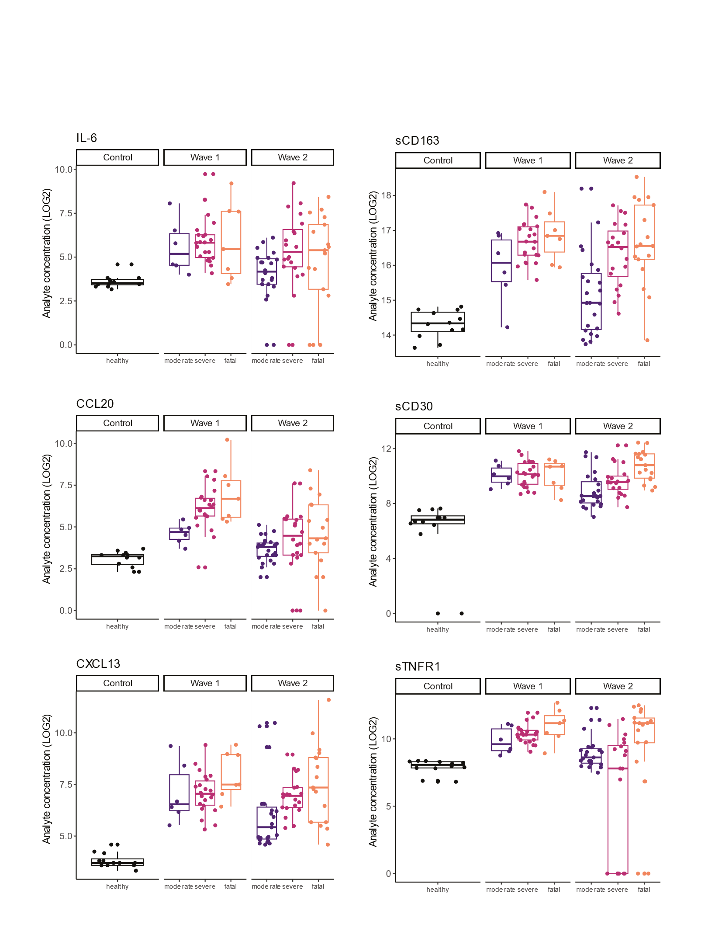
Univariate data of individual analytes in outcome groups over the waves at maximum severity
Analyte expression, measured at the time point the individual patient is experiencing maximum disease severity, is plotted for 6 individual analytes as examples for the healthy controls, moderate severe and fatal outcome groups separated for wave-1 and 2. Data are expressed as plus one log2 transformations of the concentration in pg/ml. All data points are plotted, boxes indicated the 25-75% percentiles with a line at the median and whiskers indicate 1.5*IQR.
Supplementary Figure 3
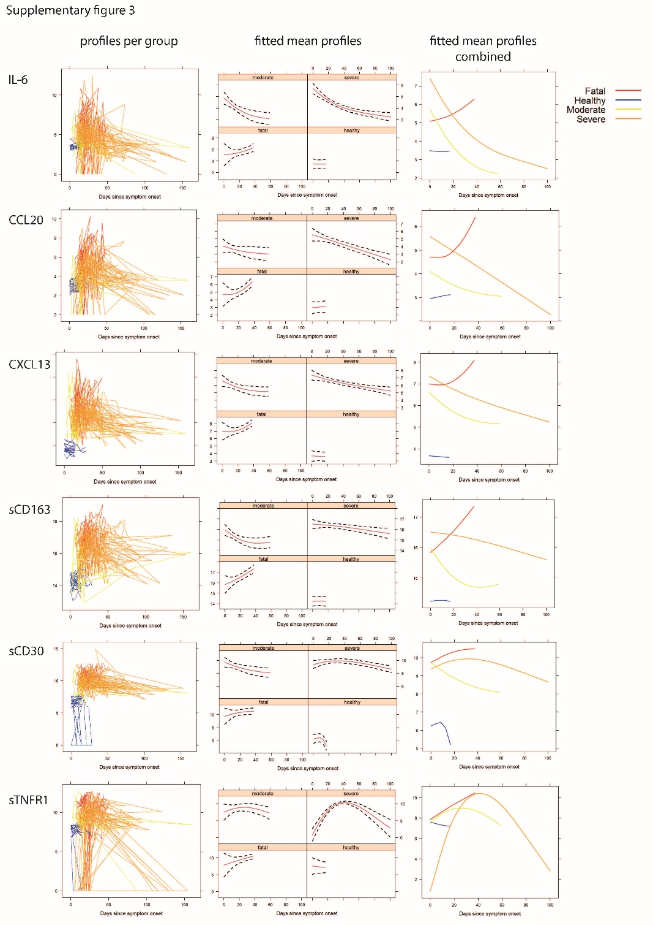
Longitudinal linear mixed effect models of soluble analytes
Analyte expression over time since onset of symptoms plotted for all individuals analysed (healthy individuals in blue, moderate outcome in yellow, severe outcome in orange and fatal outcome in red)(left panel). Profiles are fitted for mean analyte expression profiles within each outcome group over time, red lines indicate mean, black dashed lines indicate 95% pointwise confidence intervals for each group (middle panel). Combined graph of fitted mean profiles for the different outcome groups (right plots/panel).
Supplementary Figure 4
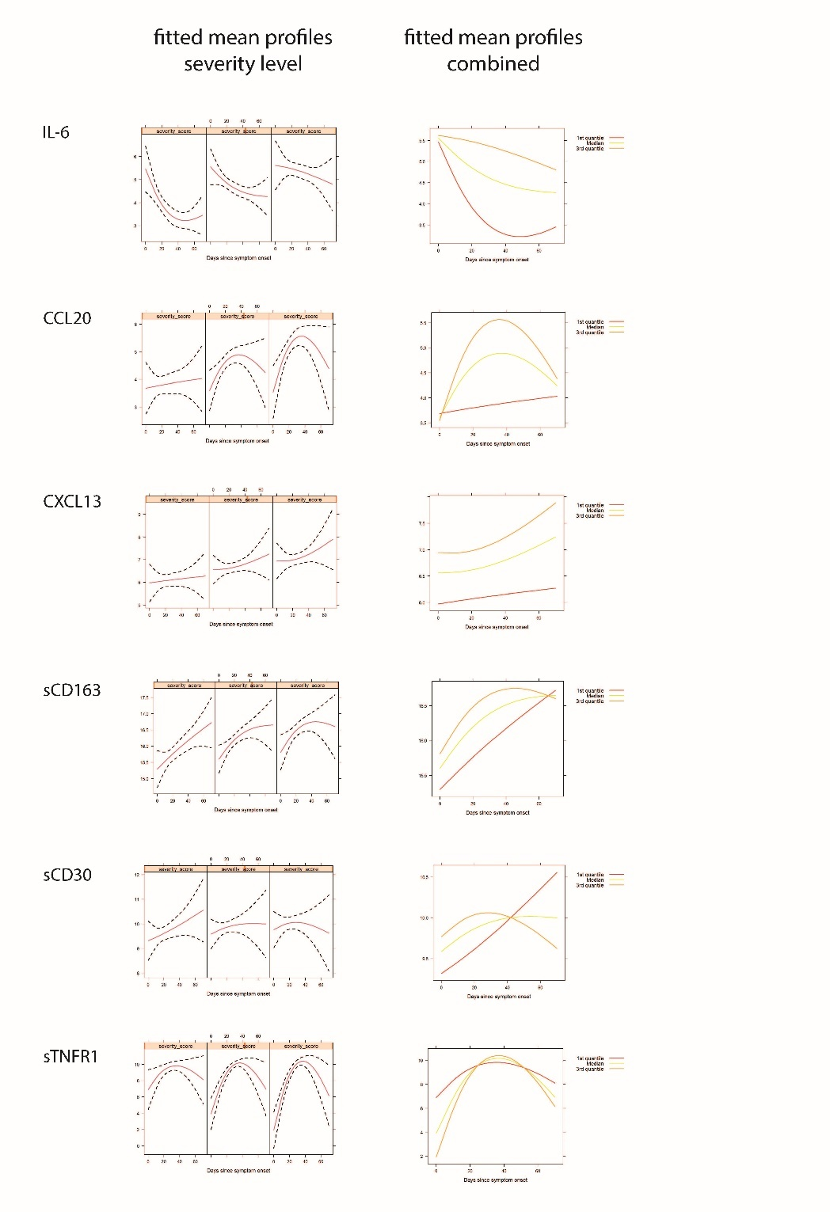
Longitudinal association between soluble analyte levels and daily disease severity (SCODA)
Analyte levels over time since onset of symptoms were fitted over the severity levels, red lines indicate mean, black dashed lines indicate 95% pointwise confidence intervals (left panel). Combined graph of fitted mean profiles for severity levels (right plots/panel).

Supplementary Figure 5
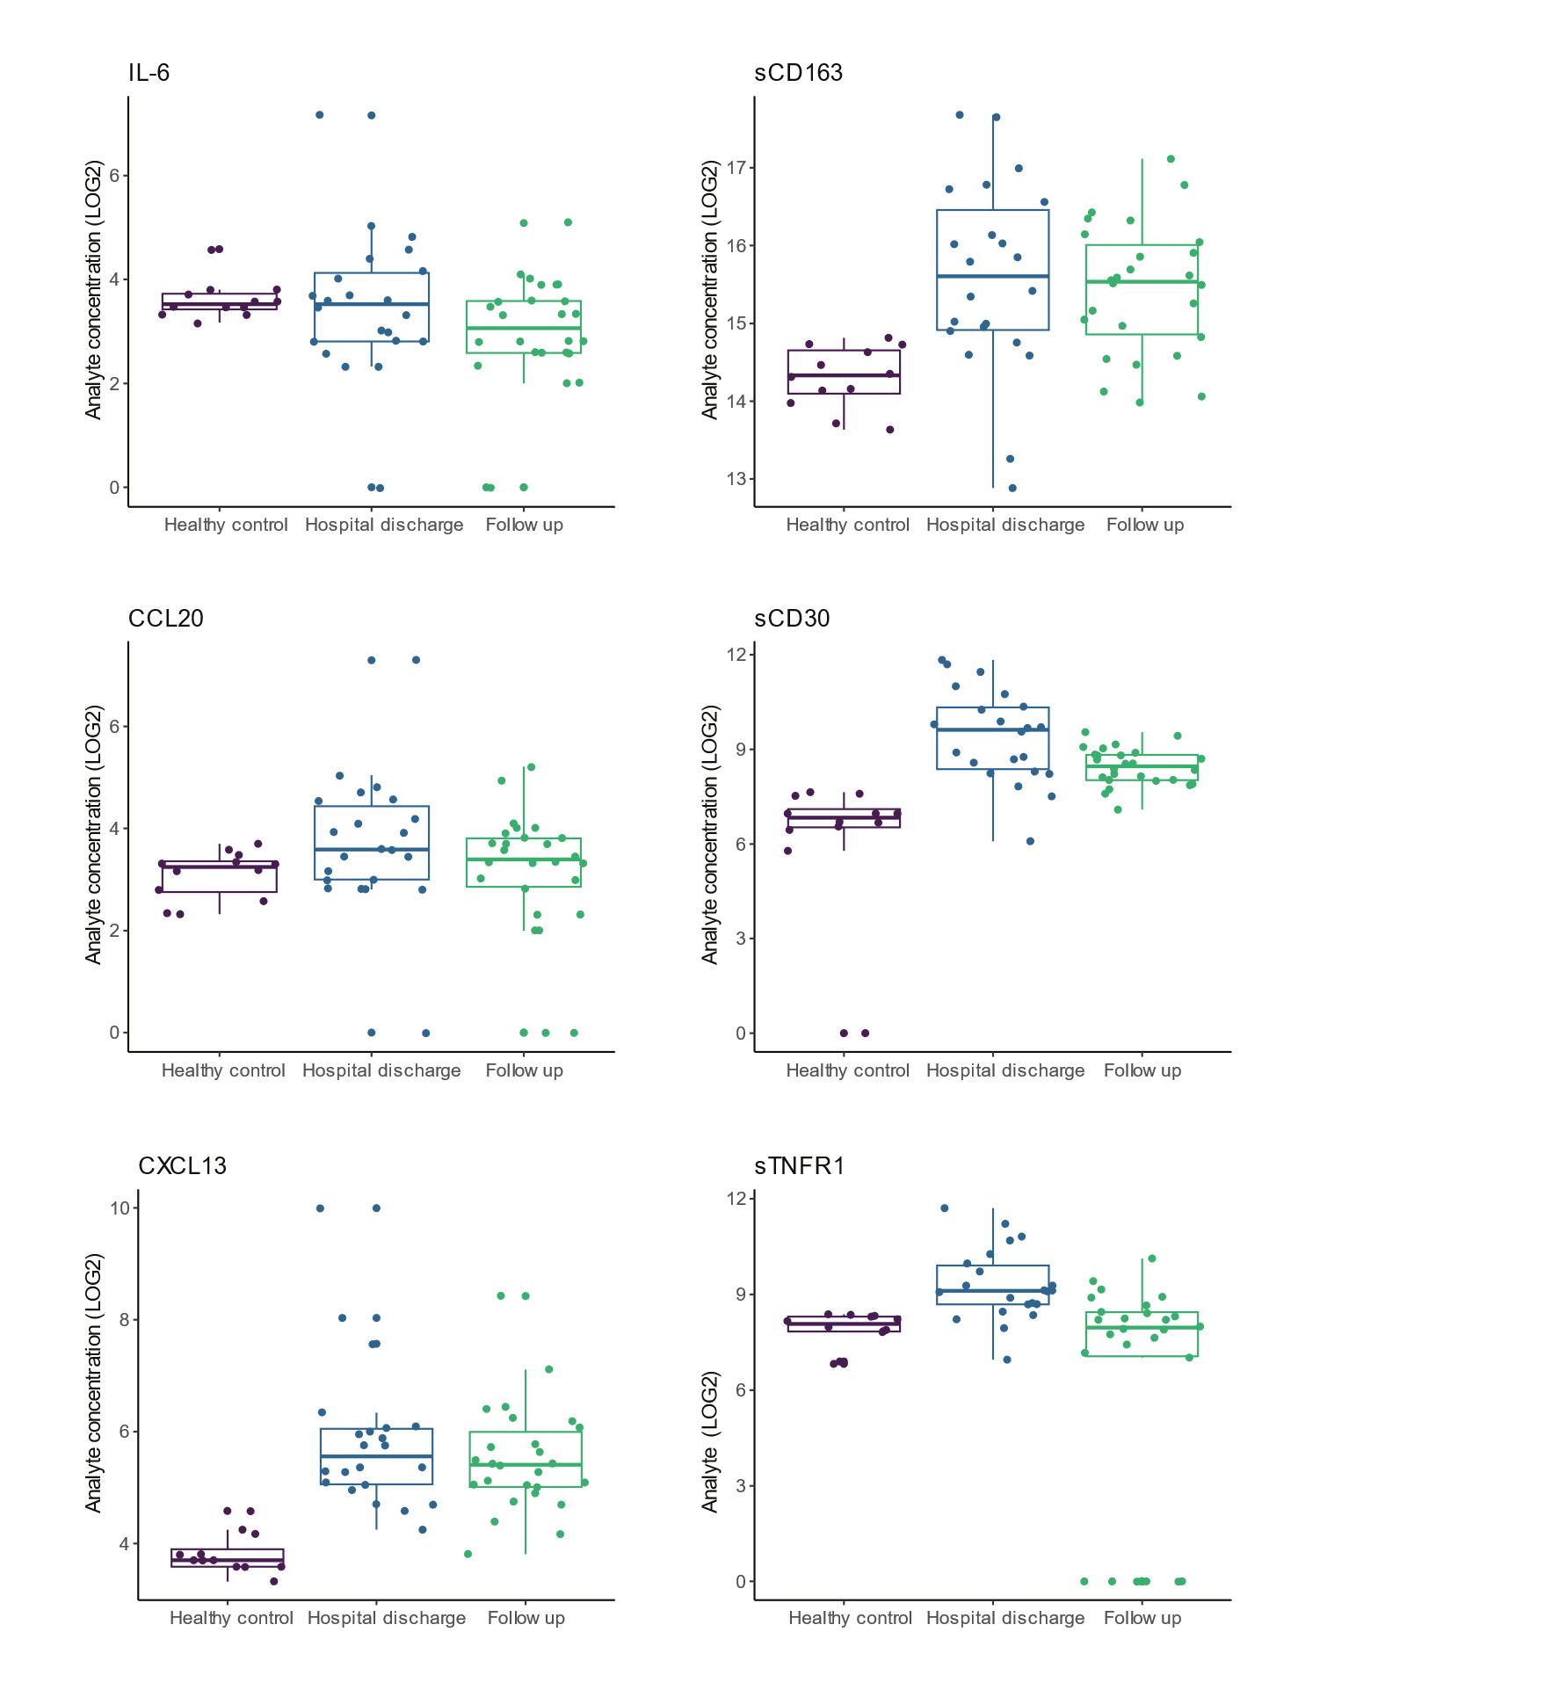Soluble analytes still differ at discharge and follow up from healthy controls
Serum samples were selected at the last point of hospitalization and at a follow up outpatient visit 6-12 weeks later and circulating levels (log2 transformed) plotted relative to the healthy control population.

Supplementary Figure 6
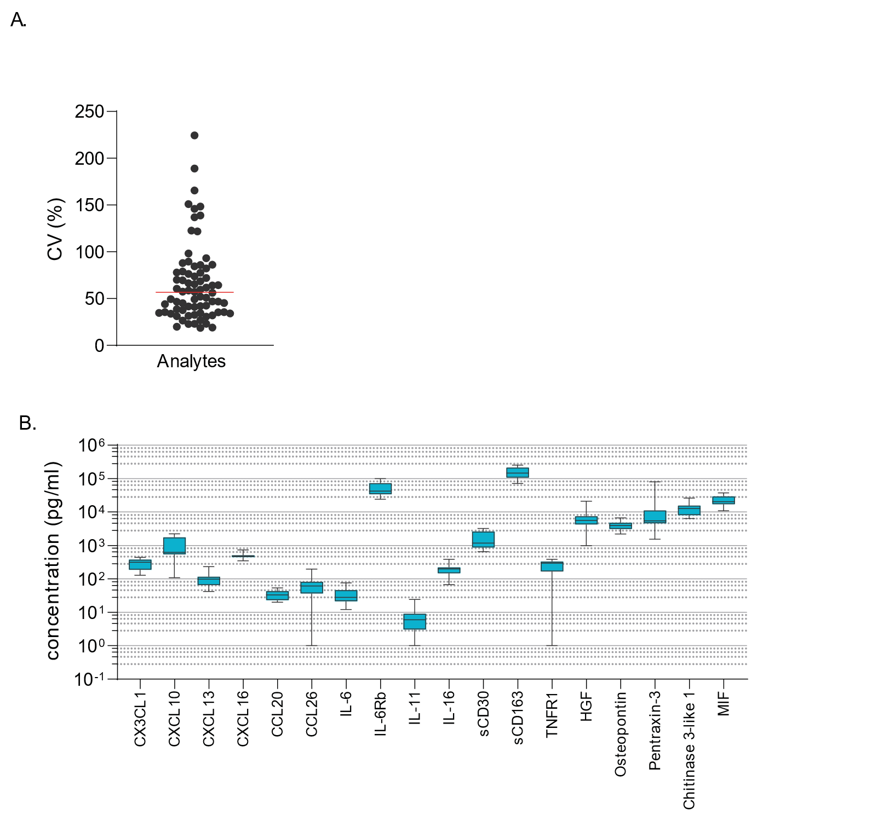Reference control sample performance
An aliquot of the reference control sample was measured in each run for all analytes. In total 11 runs were performed and each analyte is represented by 11 data points.
- Variation coefficients for the reference control dataset for all measured analytes were determined and plotted.
- The reference control data for the key analytes (X-axis) is shown as boxes and whiskers, with boxes for the 5-95 percentile and whiskers for the minimum and maximum concentration (pg/ml) (Y-axis).

Supplementary Extended Methods:
Cohort study
The BEAT-COVID cohort was collected at the Leiden University Medical Center, Leiden, The Netherlands. Individuals diagnosed with PCR positive COVID-19, who required hospital admission between April 2020 and March 2021 were invited to participate¹⁷⁻²⁰. The majority of infections was with Wuhan-like viruses; the Netherlands experienced <1% circulating alpha variant until January 2021 nationally (in Dutch: https://www.rivm.nl/corona/actueel/virusvarianten).
Clinical care was provided according to local and national guidelines and not influenced by study participation. Initially (April-Aug 2020), care was supportive only (wave-1, March 2020-August 2020), however, from August 2020 onwards patients received dexamethasone (wave-2, August 2020- March 2021). Since our study was initiated shortly after the onset of the pandemic in The Netherlands, criteria for hospital admission were also different between the waves. In wave-1 hospital admission was limited to the more severe cases, and generally admission occurred later after onset of symptoms compared to wave-2 as a result of capacity and national guidelines. In addition, SARS-CoV2 PCR testing was only available for hospital admitted patients whereas it was mandatory for all individuals with symptoms in the 2nd wave; hence, people were aware of the infection earlier and may thus have behaved differently.
Patients were included both on the regular ward as well as on the ICU. Inclusion criteria were: admission at LUMC, SARS-CoV-2 PCR positive, and minimum 18 years old. Exclusion criteria were: no informed consent from the patient or a representative. All participants were unvaccinated against SARS-CoV-2. Upon signing informed consent, blood samples were collected 3 times (Monday-Wednesday-Friday) a week during hospitalization and at an outpatient visit 6-12 weeks post discharge. Statistical sample size calculation was not performed, the sample size was determined based on availability. Peripheral blood was collected by venipuncture including a 8.5ml SST Vacutainer tube (Becton Dickinson, VWR, Amsterdam, The Netherlands) to collect serum and processed within 1 hour by the central clinical chemistry laboratory and aliquoted for research purposes. Anti-IL6R antibodies were only used in a few patients during our study.

Ethical approval for the study protocol was provided by the Leiden University Medical Center Medical Ethics committee (protocol NL73740.058.20). The study was registered at the International Clinical Trials Registry Platform no NL8589 (https://trialsearch.who.int/Trial2.aspx?TrialID=NL8589). The study complied with the latest version of the Declaration of Helsinki. The principal investigator had access to information to identify individual patients.

The selection of the BEAT-COVID cohort investigated in the current analysis included the first 95 individuals with samples available for analysis of soluble markers in serum samples collected longitudinally during hospital admission and following discharge (total cohort size 191 individuals). Samples were collected in wave-1 (n=252) as well as in wave-2 (n=284) and individuals included in our study had a median age of 63 years (full cohort, 61 years in wave-1 and 63.5 years in wave-2) (Figure 1A). Samples were included in order of receipt, without further selection. Our cohort included more male than female participants as was intrinsic to the hospital admitted population (74 males, 21 females full cohort, 29 males and 6 females in wave-1 and 45 males and 15 females in wave-2) (Figure 1A) (all data provided in supplementary table 1).
In addition to the daily severity-scores which are used for longitudinal analyses, individuals were categorized based on their overall disease course and outcome into moderate, severe and fatal disease. Moderate disease was defined as hospital admitted with PCR proven SARS-CoV2 infection on the regular ward, never requiring admission to the ICU and hospital discharge. Severe disease was defined as COVID-19 disease requiring ICU admission in some part of treatment but with discharge as outcome. Finally, fatal outcome was defined as all individuals with hospital admission due to SARS-CoV2 who succumbed to the disease. Individuals included in the analysis of soluble markers in wave-1 comprised 6 patients with moderate disease, 22 with severe disease and 7 patients with fatal outcome and in wave-2 23 moderate, 20 severe and 17 fatal disease patients were included (Figure 1A). The number of days since onset of symptoms was higher in wave-1 (median 20 days) compared to wave-2 (median 12 days) (Figure 1A), which is mostly related to hospital capacity, admission guidelines and availability of community testing in the 2nd wave, but important to realize when assessing progression and underlying pathophysiology. At the time of hospital admission, patients in wave-1 had higher severity-scores as calculated by SCODA severity-score (median 13 for wave-1 vs 9.5 for wave-2)(Figure 1A). Moreover, the maximum daily severity-score reached by each individual was also higher in wave-1 (median severity 14) compared to wave-2 (median severity 11)(Figure 1A).

In addition to the patients with COVID-19 disease, a control group of healthy individuals was collected in July 2020 for comparative analyses. None of these healthy volunteers had experienced the infection yet, as was confirmed by serological analyses. Samples were collected from 8 males and 4 females (as the ratio of hospital admissions at that time was 2:1), with a median age of 64 (range 60-72). Healthy volunteers were sampled 5 times, also at 2 day intervals and samples were processed identically to those from the individuals included in the BEAT-COVID cohort.

SCODA severity-scores
The Severity of COronavirus Disease Assessment (SCODA) disease severity-score was developed to track day-to-day disease severity in hospital admitted COVID-19 patients ²¹. The score was based on the 4C mortality score, but constant parameters were substituted with parameters associated with breathing and oxygenation to better reflect the daily condition and its changes ²¹. The SCODA score was developed such that there was continuous scoring during admission on the ward and ICU to permit longitudinal assessment of severity during both types of admission. The SCODA score consisted of the following parameters: respiratory rate, peripheral oxygen saturation on room air (ward only), P/F Ratio (ICU only), oxygen flow (ward only), FiO2 (ICU only), Glasgow Coma Scale (GCS), blood urea level and C-reactive protein (CRP) ²¹. The most severely ill patients admitted to the ICU could reach a maximum severity-score of 17.
We defined the recovery time point, per definition after the highest severity-score for that individual patient, as a SCODA score of a daily severity-score of ≤ 7, with no subsequent increases.

Multiplex bead array
The following cytokine and chemokine reagent kits were selected to analyse the sera of the study cohort; the Bio-Plex Pro human Chemokine panel (40-plex, #171AK99MR2), Bio-Plex Pro human Cytokine Screening panel (48-plex, #12007283), Bio-Plex Pro Human Inflammation panel (37-plex, #171AL001M) and a custom made panel of IL-17F, IL-21, IL-23, IL-25, IL-31, IL-33 of the Bio-Plex Pro human Th17 cytokine panel (all Bio-Rad, Veenendaal, the Netherlands). Assays were performed according to manufacturer’s instructions with manufacturers specific standards and QC control samples. All samples were thawed and diluted 1:4 in sample Diluent HB and run as single measurement with the streptavidin PE (1:200, Becton Dickinson, Erembodegem, Belgium) detection label. Samples were acquired on a Bio-Plex 200 system and analysed with Bio-Plex manager software v6.2. In total 131 analytes were measured, in case measurements were out of range or zero for more than 75% of the samples, analytes were removed from the analysis. When analytes were present in more than one assay panel, the analyte with the largest dynamic working range was selected for downstream analysis to ensure maximum detection window, this resulted in data analysis on 74 unique markers.
Samples were coded, stored directly at -80°C upon collection and not thawed before the first measurement, to minimize the loss of detection due to low level or instable analytes. Measurements were performed continuously when 76 samples were available from the study. Thus, longitudinal samples from an individual were not necessarily measured at the same time but throughout the study period. To ensure technical or inter-assay variation would not impact the analysis, a reference control sample, generated by pooling sera of 4 severely ill COVID-19 patients was included in all assays. The reference control was aliquoted to avoid repeated freezing and thawing cycles, maintaining the quality of the reference sample. After each acquisition all standard curves were checked for performance, outliers were deleted and curve fitting optimized (Regression Type: Logistic - 5PL with standard recovery between 70-130% ). Datapoints out of range below the LLOQ were set to 0 pg/ml and above the ULOQ were set to maximum (200.000 pg/ml).
Evaluation of the reference control sample showed limited variation in the calculated concentrations for most analytes measured between assays (analytes: n=74), assays: 11 plates; median %CV = 56.7% (Supplementary Figure 6A). Analytes with large %CV were mostly produced in high levels with standard curve characteristics of a steep slope and less sensitivity in the lower ranges, impacting the calculated concentration even with minimal fluorescence differences.

Data analysis and modelling
Analysis at first time point
Normalized soluble marker levels were +1 (to avoid zero as possible outcome), log2-transformed. Data was visualised and modelled using R (R Core Team, 2023), RStudio (Posit Team, 2023) and packages stats, ggplot2, ggdendro, mixOmics, caret, glmnet, psych, pROC, ggpubr and GLMMadaptive. Statistical testing comparing medians of two groups was performed using Mann-Whitney U. In addition, for analysis of differential soluble analyte levels between disease outcome groups and healthy controls or between waves Mann-Whitney U was performed and p values were adjusted for multiple testing by Benjamini-Hochberg correction. The heatmap is clustered row-wise based on complete-linkage hierarchical clustering. Supervised dimensionality reduction was carried out using partial least squares-discriminant analysis (PLS-DA), separating disease outcome groups and correlation analyses were performed using Spearman’s Rank and Benjamini-Hochberg correction was performed on p-values. For identification of the best-classifying soluble analyte signatures-profiles to model outcome (fatal outcome yes or no), ICU admission, high maximum disease severity and time to disease recovery at the earliest available time point (closest to hospital admission), logistic regression with lasso regularisation was performed. Leave-one-out cross-validation and train-test split (training set = 70%, test set = 30% of dataset) were used to assess the performance of the trained regression models. The classifying performance was further assessed by evaluating sensitivity, specificity, receiver operating characteristic (ROC) curve and area under the ROC curve (AUC).
Longitudinal data analysis
The progression over time of each soluble analyte was modelled using linear mixed effects models for the total cohort. Linear mixed models are an extension of the simple linear regression models when multiple measurements on the same subject are collected and use random effects to capture the serial correlation. Wave of sample collection was included as confounder into the model. To enhance comparability of the patients and stages of the disease process the number of days since disease onset was used for the timing of the samples within each patient. The non-linear progression over time was captured using natural cubic splines. To compare the progression between the different outcome groups the main effect and the interaction term between the days since disease onset and the outcome groups was added in the model. Similarly to explore association of each soluble analyte with the disease severity the main effect and the interaction term between the days since disease onset and disease severity was added in the model. For soluble analytes with values outside the limits of detection, the truncated normal distribution was used. Finally to capture the serial correlation random intercept and random slope terms were used.
Pathway analyses were performed in Ingenuity Pathway Analysis (Qiagen, Germany).

