SUPPLEMENTARY FILE
STW-24-0014

Analysis of Projection Welding in Relation to the Non-Parallelism of Electrodes

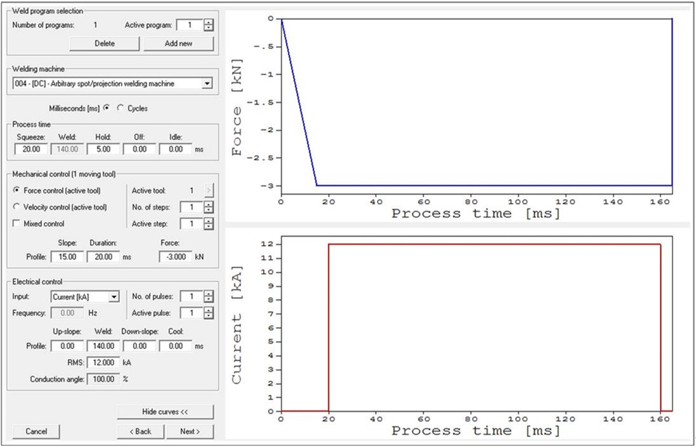
Fig. S1. Welding technology parameters in the Sorpas numerical model

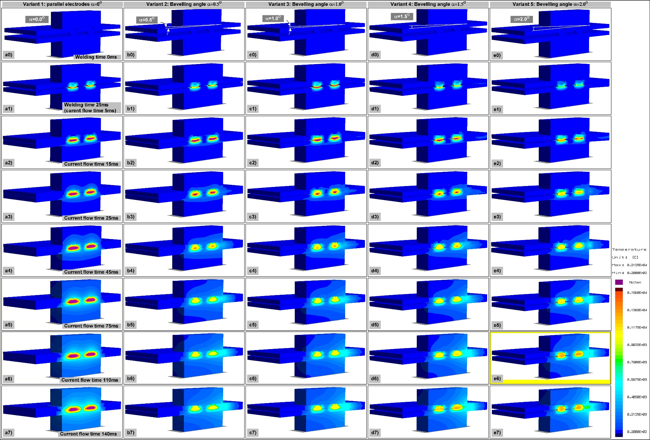
Fig. S2. Temperature distribution in the welding area (Sorpas default view):
a₀ – e₀) welding commencement, a₁ – e₁) 5ms, a₂ – e₂) 15ms, a₃ – e₃) 25ms, a₄ – e₄) 45ms, a₅ – e₅) 75ms, a₆ – e₆) 110ms, a₇ – e₇) 140ms of current flow time.

Table S1. Characteristic quantities obtained in FEM calculations
No | Projection welding model parameters:  - projection type C, (2 projections)  - sheets thickness g=1.0mm  - height of projection h=0.9mm | Parallelism of electrodes | NON-parallelism of electrodes
No |  | A | B | C | D | E | F
No | Variant: | 1 | 2 | 3 | 4 | 5 | 6
1 | Bevelling angle [α] | 0^{O} | 0.5^{O} | 1.0^{O} | 1.5^{O} | 2.0^{O} | 2.5^{O}
2 | Melted volume in the weld [mm³] | 9.9 | 4.9 | 4.2 | 2.4 | 1.5 | 1.0
3 | Melted volume in the embossed projection sheet [mm³] | 6.4 | 3.6 | 3.2 | 1.8 | 1.2 | 0.8
4 | Melted volume in the flat sheet [mm³] | 3.5 | 1.3 | 1.0 | 0.6 | 0.3 | 0.2
5 | Melted area at the interface [mm²] | 19.2 | 12.3 | 10.5 | 7.0 | 3.8 | 2.2
6 | Melted mean diameter at the interface [mm] | 5.0 | 4.0 | 3.7 | 3.0 | 2.2 | 1.5
7 | Energy supplied to the weld [kJ] | 1.20 | 0.87 | 0.89 | 1.02 | 1.05 | 1.10

Figure S3 presents the main parameters demonstrating the final result of projection welding, i.e. the weld nugget volume and the weld nugget diameter as well as the energy supplied to the weld.
The last of the parameters requires an additional discussion. The amount of energy supplied to the weld does did indicate if the course of the welding process was proper. The analysis of this parameter (see Figure S3) did not lead to conclusions related to the proper course of the process and the proper quality of the joint.

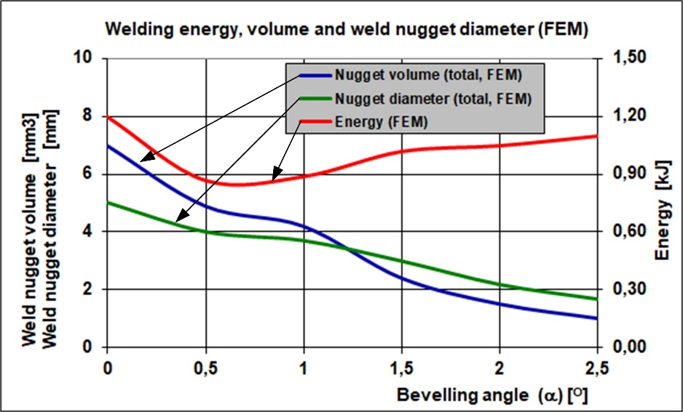
Fig.S3. Graphic presentation of the results from Table 1: energy supplied to the weld, diameter and the volume of weld nugget (FEM calculations)

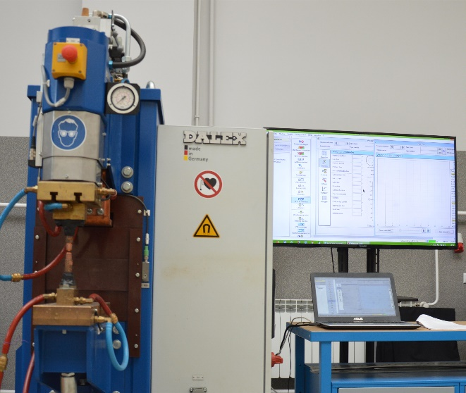
Fig.S4. Welding station with the monitoring system

Table S2. Chemical composition of the weld nuts
Steel | C, %  max | S, %  max | Mn, %  max | P, %  max | Tior/and NB  max
Low-carbon steel | 0.12 | 0.045 | 0.60 | 0.045 | 0.30

Table S3. Chemical composition of the base material
Grade | C max. % | Mn max. %
DC04 | 0.04 | 0.08

Table S4. Mechanical properties of the base material
Grade | Material no. | Yield point Rp0.2 (MPa) | Tensile strength Rm (MPA) | Elongation A80 (w%) min.
DC04 | 1.0338 | ≤ 210 | 270 – 350 | 38

Table S5. Element subjected to welding (flat nut) along with its dimensions
Nut subjected to projection welding (steel + zinc) | Dimensions | M/d/d1 = M6 x 6.1 x 8.3
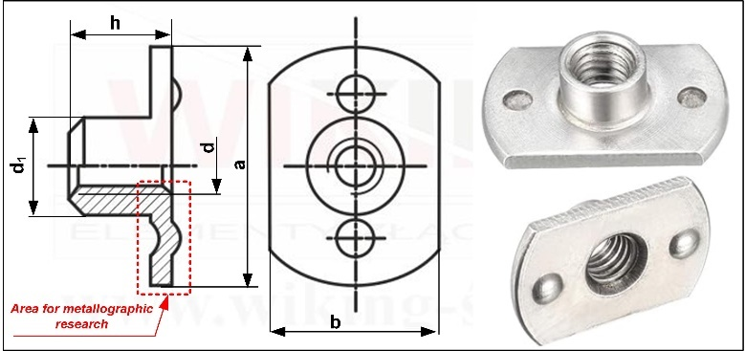 | a | 18.0
 | b | 13.8
 | d₁ | 8.3
 | d | 6.0
 | h _{(min)} | 8.0
 | Number of projections | 2
 | Projection height | 0.9

