Improved Nutritional Value of Surplus Bread and Perennial Ryegrass Extracts Via Solid-State Fermentation (SSF) with Rhizopus oligosporus
Juan Felipe Sandoval, Joe Gallagher, Julia Rodriguez-Garcia, Kerry Whiteside, David N. Bryant
Supplementary materials

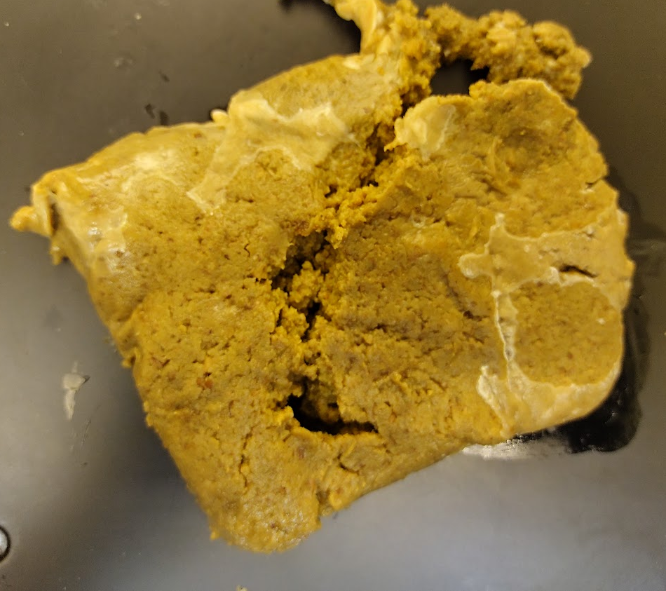
Figure S1. Photographic record SSF of bread crusts (BC)/water (W) with BC milled to a fine powder at 32 °C, moisture content of 56% and pH of 3.5, after 72 h. The fungi is not able to grow homogenously throughout the substrate
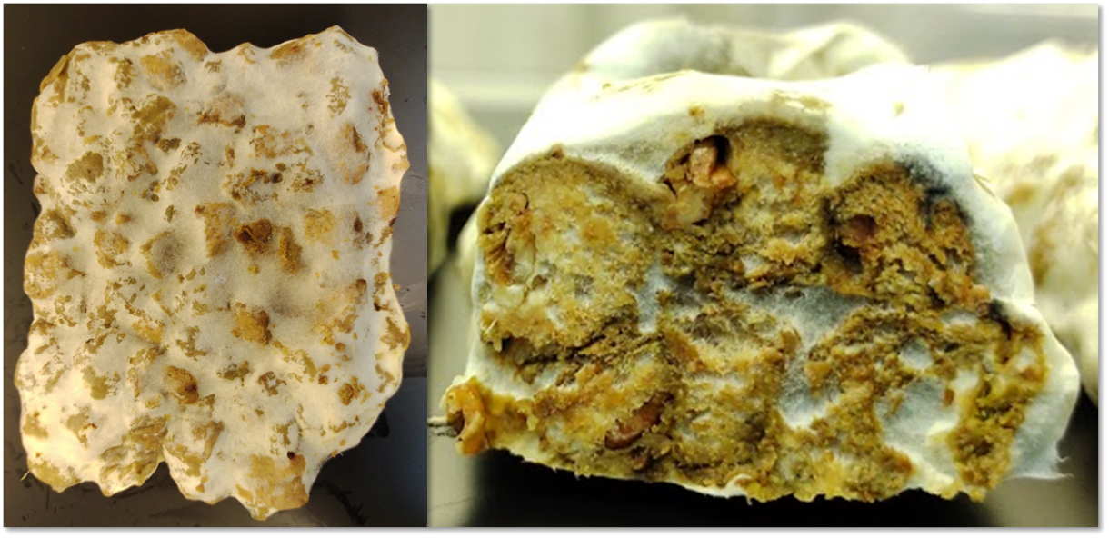
Figure S2. Photographic record SSF of bread crusts (BC)/water (W) with BC cut to 1x1x1 cm squares at 32 °C, moisture content of 56% and pH of 3.5, after 72 h. The fungi is able to grow homogenously throughout the substrate
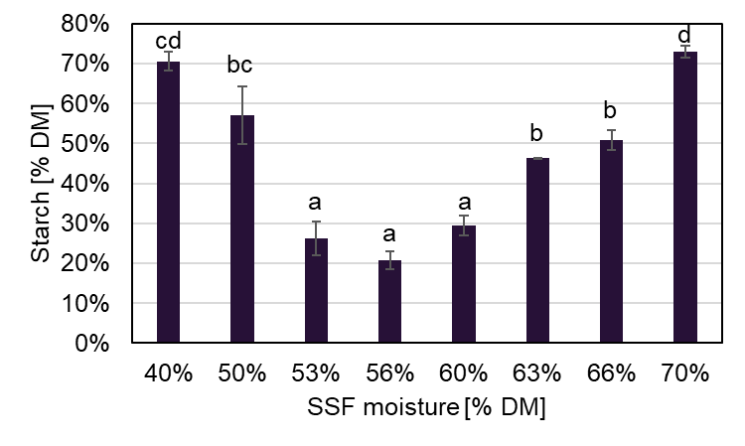
Figure S3. Final starch content of SSF of bread crusts (BC)/Grass Juice (GJ) with BC cut to 1x1x1 cm squares at 32 °C and pH of 3.5, at different starting SSF moisture levels, after 72 h. The error bars represent a standard error. Data with different letters are significantly different (p < 0.05), following Tukey´s HSD post-hoc test. The minimum value of starch is achieved similarly between 53 and 60% moisture content. 56% was chosen for all experiments for standardization purposes.
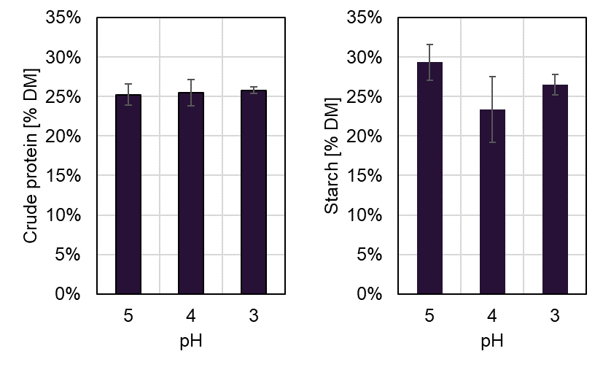
Figure S4. Final crude protein and starch content of SSF of bread crusts (BC)/Grass Juice (GJ) with BC cut to 1x1x1 cm squares at 32 °C and moisture content of 56%, at different starting pH, after 72 h. The error bars represent a standard error. No statistical difference was found between all starting pH points. 3.5 was chosen for all experiments for standardization purposes and is low enough to avoid the growth of undesirable microorganisms.
Table S1. Results of the statistical comparison of the effect of the experimental treatment (bread crusts (BC)/water (W) and BC/green juice (GJ)) and the fermentation time over multiple variables. Data shown are the p-values of a two-way ANOVA.
Result | Experimental treatment | Time | Experimental treatment * Time
SSF Mass loss [%] | 0.000 | 0.000 | 0.158
Chemical composition
Crude protein [%DM] | 0.657 | 0.000 | 0.383
Crude fibre [%DM] | 0.001 | 0.000 | 0.005
Free sugars [%DM] | 0.597 | 0.000 | 0.004
Starch [%DM] | 0.004 | 0.000 | 0.001
Ash [%DM] | 0.000 | 0.000 | 0.002
Ratio of crude protein to starch | 0.389 | 0.000 | 0.714
EAA [g/100g CP]
Histidine | 0.362 | 0.037 | 0.120
Isoleucine | 0.040 | 0.379 | 0.154
Leucine | 0.982 | 0.076 | 0.349
Lysine | 0.043 | 0.219 | 0.764
Methionine | 0.001 | 0.363 | 0.264
Phenylalanine | 0.000 | 0.003 | 0.257
Threonine | 0.230 | 0.000 | 0.335
Valine | 0.000 | 0.415 | 0.515
NEAA [g/100g CP]
Alanine | 0.007 | 0.000 | 0.086
Aspartic acid | 0.689 | 0.000 | 0.052
Cysteine | 0.017 | 0.197 | 0.075
Glutamic acid | 0.219 | 0.000 | 0.055
Glycine | 0.000 | 0.016 | 0.142
Proline | 0.005 | 0.000 | 0.052
Serine | 0.074 | 0.269 | 0.427
Tyrosine | 0.000 | 0.587 | 0.578
Arginine | 0.003 | 0.005 | 0.088
Sum AA [g/100g CP] | 0.070 | 0.381 | 0.486
Sum EAA [g/100g CP] | 0.091 | 0.739 | 0.819
Sum NEAA [g/100g CP] | 0.070 | 0.012 | 0.225
% EAA/AA | 0.498 | 0.000 | 0.257
% NEAA/AA | 1.000 | 0.000 | 0.020
AA: Amino acids EAA: Essential amino acids, NEAA: Non-essential amino acids

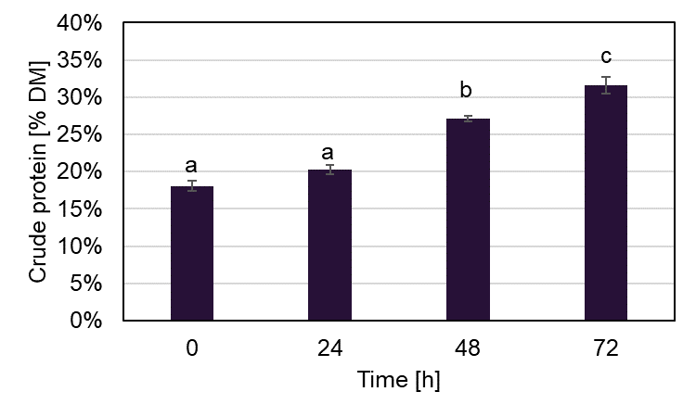
Figure S5. Crude protein content of both bread crusts (BC)/water (W) and BC/green juice (GJ) experiments at 0, 24, 48 and 72 hours of SSF. The error bars represent a standard error
Table S2. Results of the statistical comparison of the effect of the experimental treatment (bread crusts (BC)/ green juice (GJ)/dry green solids (GS) to crude protein 19%, 20%, 23%, 27% and 29% DM) and the fermentation time over multiple variables. Data shown are the p-values of a two-way ANOVA.
Result | Experimental treatment | Time | Experimental treatment * Time
SSF Mass loss [%] | 0.000 | 0.000 | 0.189
Chemical composition
Crude protein [%DM] | 0.000 | 0.000 | 0.000
Crude fibre [%DM] | 0.198 | 0.001 | 0.588
Free sugars [%DM] | 0.000 | 0.000 | 0.015
Starch [%DM] | 0.000 | 0.000 | 0.000
Ash [%DM] | 0.003 | 0.000 | 0.496
Ratio of crude protein to starch | 0.000 | 0.000 | 0.022
EAA [g/100g CP]
Histidine | 0.000 | 0.687 | 0.001
Isoleucine | 0.000 | 0.077 | 0.112
Leucine | 0.000 | 0.000 | 0.128
Lysine | 0.002 | 0.430 | 0.001
Methionine | 0.002 | 0.006 | 0.331
Phenylalanine | 0.000 | 0.165 | 0.002
Threonine | 0.000 | 0.287 | 0.004
Valine | 0.015 | 0.006 | 0.262
NEAA [g/100g CP]
Alanine | 0.000 | 0.058 | 0.045
Aspartic acid | 0.004 | 0.272 | 0.003
Cysteine | 0.825 | 0.266 | 0.150
Glutamic acid | 0.001 | 0.000 | 0.002
Glycine | 0.170 | 0.399 | 0.343
Proline | 0.150 | 0.000 | 0.019
Serine | 0.000 | 0.023 | 0.013
Tyrosine | 0.005 | 0.411 | 0.757
Arginine | 0.000 | 0.398 | 0.000
Sum AA [g/100g CP] | 0.000 | 0.000 | 0.124
Sum EAA [g/100g CP] | 0.000 | 0.026 | 0.174
Sum NEAA [g/100g CP] | 0.002 | 0.000 | 0.053
% EAA/AA | 0.000 | 0.012 | 0.051
% NEAA/AA | 0.000 | 0.012 | 0.051
AA: Amino acids EAA: Essential amino acids, NEAA: Non-essential amino acids

Table S3. Results of the statistical comparison of the effect of the experimental treatment (bread crusts (BC)/water (W), BC/green juice (GJ) and BC/GJ/dry green solids (GS) to crude protein 19%, 20%, 23%, 27% and 29% DM) at 72 h of solid-state fermentation (SSF) versus unfermented BC over multiple variables. Data shown are the p-values of a one-way ANOVA and the grouping letters of a Tukey’s HSD post-hoc analysis.
Result | ANOVA p-value | Tukey's HSD groups
Result | ANOVA p-value | Unfermented BC | BC/W | BC/GJ | BC + GJ + GS to % DM CP
 |  |  |  |  | 19% | 20% | 23% | 27% | 29%
Chemical composition
Crude protein [%DM] | 0.000 | a | b | b | b | b | b | b | b
Crude fibre [%DM] | 0.051 | a | a | a | a | a | a | a | a
Free sugars [%DM] | 0.000 | c | c | b | bc | ab | ab | ab | a
Starch [%DM] | 0.000 | b | a | a | a | a | a | a | a
Ash [%DM] | 0.000 | a | bc | ab | bc | c | c | c | c
Sum AA [g/100g CP] | 0.000 | bc | abc | ab | a | a | c | abc | d
Sum EAA [g/100g CP] | 0.000 | ab | bc | ab | a | ab | d | cd | e
Sum NEAA [g/100g CP] | 0.000 | cd | abc | ab | a | ab | bcd | ab | d
% EAA/AA | 0.000 | a | bc | bcd | ab | abc | bcd | d | cd
% NEAA/AA | 0.000 | d | bc | abc | cd | bcd | abc | a | ab
AA: Amino acids EAA: Essential amino acids, NEAA: Non-essential amino acids

