Supplementary informations

Dynamics, diversity, and roles of bacterial transmission modes during the first asexual life stages of the freshwater sponge Spongilla lacustris

Benoit Paix^{1,2*}, Elodie van der Valk¹, Nicole J. de Voogd^{1,3*}

¹ Naturalis Biodiversity Center, Leiden, The Netherlands
² Present address: UMR CARRTEL, INRAE - Université Savoie Mont-Blanc, Thonon-les-Bains, France
³ Institute of Biology (IBL), Leiden University, The Netherlands

* Corresponding authors: benoit.paix@gmail.com, n.j.de.voogd@biology.leidenuniv.nl

Supplementary material and methods notes

Supplementary note S1. Detailed description of the experiment’s timeline

Day | Sampling | After sampling
Day 0 | t₀ samples (unplated gemmules) | Plating of the gemmules for t₁ to t₆
Day 3 | t₁ samples | Refreshing with FF0.45 and FF0.2
Day 7 | t₂ samples | Refreshing with FF0.45 and FF0.2  Sampling of free-living cells from the FF0.45 filtrate with 0.2μm pore size filters
Day 10 | - | Refreshing with FF0.45 and FF0.2
Day 11 | t₃ samples | -
Day 14 | - | Refreshing with FF0.45 and FF0.2  Sampling of free-living cells from the FF0.45 filtrate with 0.2μm pore size filters
Day 17 | t₄ samples | Refreshing with FF0.45 and FF0.2  Sampling of free-living cells from the FF0.45 filtrate with 0.2μm pore size filters
Day 21 | - | Refreshing with FF0.45 and FF0.2  Sampling of free-living cells from the FF0.45 filtrate with 0.2μm pore size filters
Day 24 | t₅ samples | Refreshing with FF0.45 and FF0.2
Day 28 | - | Refreshing with FF0.45 and FF0.2  Sampling of free-living cells from the FF0.45 filtrate with 0.2μm pore size filters
Day 31 | t₆ samples | -

Supplementary note S2. Tests of DNA extractions and PCR amplifications on gemmule samples

The gemmule coating was found to be resistant to the mechanical breaking method (beat beating) used for the FastDNA™ SPIN Kit for Soil (40 seconds in the FastPrep instrument at a speed setting of 6.0 m/s). Consequently, the effect of breaking the gemmules coating (by crushing them using the top of 10μL filter pipette tips) was tested. We hypothesized that DNA extraction performed without breaking the coating could not allow the detection of bacterial DNA inside the gemmule.
To assess the efficiency of the sterilization of gemmules suggested by Leys et al., 2019 through the washing with H₂O₂ as described, we performed PCR targeting the 16S rRNA gene (same primers and PCR conditions as in the main study) of three types of gemmules: (i) gemmules washed with H2O2 and broken before DNA extraction (named “+H2O2_broken”, n=4), (ii) gemmules washed with H2O2 and let intact before the DNA extraction (named “+H2O2_unbroken”, n=4), (iii) gemmules washed without H2O2 and let intact before the DNA extraction (named “-H2O2_unbroken”, n=4).
The gel electrophoresis results indicated the presence of 16S rRNA gene amplicons for the +H2O2_broken and -H2O2_unbroken gemmules, while no amplicons were detected for the +H2O2_unbroken. These gel electrophoresis results were confirmed using the Tapestation 4150 (Kit HSD 5000, Agilent Technologies, Santa Clara, CA, United States). The absence of amplicons in +H2O2_unbroken samples suggests that the gemmule surface is sterilized and the bacterial DNA from the inside of the gemmule is not extracted. Consequently, this result confirms the efficiency of the sterilization. When the gemmules are broken, the 16S rRNA gene amplicons are always detected, suggesting that the inside of the gemmules are always hosting bacterial symbionts.
Supplementary analyses combining microscopy imaging and qPCR experiments can be considered in the future to confirm these results.

Supplementary tables

Table S1. Summary of the sample list.
The shape and color codes correspond to those used in the experimental workflow (Figure 1), boxplots, and NMDS. NA: Non-applicable.
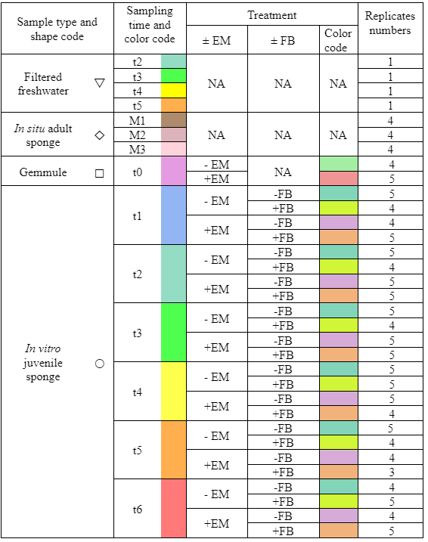

Table S2. Results of the Kruskal-Wallis test conducted with the α-diversity indexes, with the sample types as factors of comparison.

 | χ² | Degree of freedom | p-value
Chao1 | 7.424057 | 3 | 0.059542
Shannon | 4.700287 | 3 | 0.195106
Pielou | 14.7937 | 3 | 0.002002

Table S3. Results of the Kruskal-Wallis test conducted with the α-diversity measures of juvenile sponge samples, with the sampling time combined with ±EM as a comparison factor.
 | χ² | Degree of freedom | p-value
Chao1 | 64.22240002 | 13 | 9.12E-09
Shannon | 74.05576807 | 13 | 1.43E-10
Pielou | 70.6140741 | 13 | 6.19E-10

Table S4. Results of the multivariate statistical analyses performed with all samples

A. Results of the PERMANOVA test conducted with the sample type factor. D. f; F; R² and p correspond to degrees of freedom; F ratio; coefficient of determination and p-value, respectively.
 | D.f. | Sum of squares | R² | F | p
Sample type | 3 | 9.405459 | 0.195338 | 10.51949 | 0.001
Residual | 130 | 38.74426 | 0.804662 | NA | NA
Total | 133 | 48.14972 | 1 | NA | NA

B. Summary of the p-values obtained from the multivariate pairwise test conducted with the sample type factor.
 | In vitro juvenile sponge | In situ adult sponge | Filtered freshwater
Gemmule | 0.001 | 0.001 | 0.004
In vitro juvenile sponge | - | 0.004 | 0.001
In situ adult sponge | - | - | 0.001

Table S5. Results of the multivariate statistical analyses performed on juvenile sponge samples
A. Result of the 3-way PERMANOVA test conducted with the sampling time, ±EM, and ±FB as factors. D. f; F; R² and p correspond to degrees of freedom; F ratio; coefficient of determination and p-value, respectively
 | D.f. | Sum of squares | R² | F | p
Sampling time | 5 | 6.972582 | 0.198154 | 6.941356 | 0.001
± EM | 1 | 3.254917 | 0.092501 | 16.2017 | 0.001
± FB | 1 | 0.903746 | 0.025684 | 4.498491 | 0.001
Sampling time * ± EM | 5 | 2.798326 | 0.079526 | 2.785794 | 0.001
Sampling time * ± FB | 5 | 1.732174 | 0.049227 | 1.724417 | 0.001
± EM * ± FB | 1 | 0.770522 | 0.021897 | 3.835358 | 0.001
Sampling time * ± EM * ± FB | 5 | 1.678989 | 0.047715 | 1.67147 | 0.001
Residual | 85 | 17.07648 | 0.485296 | NA | NA
Total | 108 | 35.18773 | 1 | NA | NA

B. Summary of the p-values obtained from the multivariate pairwise comparison between sampling times
 | t2 | t3 | t4 | t5 | t6
t1 | 0.002 | 0.001 | 0.001 | 0.001 | 0.001
t2 | - | 0.261 | 0.005 | 0.001 | 0.001
t3 | - | - | 0.215 | 0.001 | 0.001
t4 | - | - | - | 0.002 | 0.001
t5 | - | - | - | - | 0.075

C. Summary of the p-values obtained from the multivariate pairwise comparison between treatments
 | -EM-FB | +EM+FB | +EM-FB
-EM+FB | 0.006 | 0.001 | 0.001
-EM-FB | - | 0.001 | 0.001
+EM+FB | - | - | 0.154

Table S6. Results of the multivariate statistical analyses conducted with the microbiome datasets of juvenile sponge samples, at each sampling time independently
A. Result of the 1-way PERMANOVA test (t₀) and 2-way PERANOVA tests (t₁ to t₆), conducted at each sampling time with ±EM and ±FB as factors. D. f; F; R² and p correspond to degrees of freedom; F ratio; coefficient of determination and p-value, respectively

 |  | D.f. | Sum of squares | R² | F | p
t₀ | ±EM | 1 | 0.440197 | 0.314873 | 3.217085 | 0.006
t₀ | Residual | 7 | 0.957816 | 0.685127 | NA | NA
t₀ | Total | 8 | 1.398013 | 1 | NA | NA
t₁ | ±EM | 1 | 0.968039 | 0.201204 | 4.649238 | 0.001
t₁ | ±FB | 1 | 0.459535 | 0.095513 | 2.207025 | 0.01
t₁ | ±EM * :±FB | 1 | 0.468662 | 0.09741 | 2.25086 | 0.006
t₁ | Residual | 14 | 2.915005 | 0.605874 | NA | NA
t₁ | Total | 17 | 4.811241 | 1 | NA | NA
t₂ | ±EM | 1 | 1.184402 | 0.280003 | 8.027761 | 0.001
t₂ | ±FB | 1 | 0.360457 | 0.085215 | 2.44314 | 0.02
t₂ | ±EM * ±FB | 1 | 0.472029 | 0.111592 | 3.199365 | 0.005
t₂ | Residual | 15 | 2.213075 | 0.52319 | NA | NA
t₂ | Total | 18 | 4.229963 | 1 | NA | NA
t₃ | ±EM | 1 | 1.380901 | 0.292065 | 8.576907 | 0.001
t₃ | ±FB | 1 | 0.540712 | 0.114362 | 3.358414 | 0.005
t₃ | ±EM * ±FB | 1 | 0.391418 | 0.082786 | 2.431136 | 0.015
t₃ | Residual | 15 | 2.415034 | 0.510787 | NA | NA
t₃ | Total | 18 | 4.728066 | 1 | NA | NA
t₄ | ±EM | 1 | 0.68379 | 0.13206 | 2.855086 | 0.003
t₄ | ±FB | 1 | 0.42038 | 0.081188 | 1.75525 | 0.032
t₄ | ±EM * ±FB | 1 | 0.481212 | 0.092936 | 2.009246 | 0.021
t₄ | Residual | 15 | 3.592482 | 0.693815 | NA | NA
t₄ | Total | 18 | 5.177864 | 1 | NA | NA
t₅ | ±EM | 1 | 0.812263 | 0.200413 | 4.004134 | 0.001
t₅ | ±FB | 1 | 0.442079 | 0.109076 | 2.179273 | 0.008
t₅ | ±EM * ±FB | 1 | 0.364323 | 0.089891 | 1.795969 | 0.03
t₅ | Residual | 12 | 2.434273 | 0.600619 | NA | NA
t₅ | Total | 15 | 4.052938 | 1 | NA | NA
t₆ | ±EM | 1 | 1.025031 | 0.196551 | 4.092398 | 0.001
t₆ | ±FB | 1 | 0.411573 | 0.07892 | 1.643189 | 0.022
t₆ | ±EM * ±FB | 1 | 0.271867 | 0.052131 | 1.085419 | 0.267
t₆ | Residual | 14 | 3.506607 | 0.672398 | NA | NA
t₆ | Total | 17 | 5.215077 | 1 | NA | NA
B. Summary of the p-values obtained from the multivariate pairwise comparison between treatments, for each sampling time.
 |  | -EM
t₀ | +EM | 0.01
 |  | +EM-FB | -EM+FB | -EM-FB
t₁ | +EM+FB | 0.009 | 0.008 | 0.007
t₁ | +EM-FB | - | 0.024 | 0.008
t₁ | -EM+FB | - | - | 0.011
t₂ | +EM+FB | 0.01 | 0.011 | 0.015
t₂ | +EM-FB | - | 0.006 | 0.008
t₂ | -EM+FB | - | - | 0.107
t₃ | +EM+FB | 0.01 | 0.008 | 0.009
t₃ | +EM-FB | - | 0.009 | 0.01
t₃ | -EM+FB | - | - | 0.01
t₄ | +EM+FB | 0.201 | 0.118 | 0.036
t₄ | +EM-FB | - | 0.025 | 0.009
t₄ | -EM+FB | - | - | 0.013
t₅ | +EM+FB | 0.036 | 0.035 | 0.01
t₅ | +EM-FB | - | 0.031 | 0.013
t₅ | -EM+FB | - | - | 0.01
t₆ | +EM+FB | 0.09 | 0.005 | 0.009
t₆ | +EM-FB | - | 0.014 | 0.032
t₆ | -EM+FB | - | - | 0.133

Table S7. Results of the ANOVA tests conducted on the β-diversity dispersion (distance to centroids) of gemmules and juvenile sponges, at each sampling time separately, using ±EM and the ±FB as comparison factors
D.f.; F; and p correspond to degrees of freedom; F ratio; and p-value, respectively
 |  | D.f. | Sum of squares | Mean square | F | p
t₀ | ±EM | 1 | 0.00282 | 0.00282 | 2.442062 | 0.162094
t₀ | Residuals | 7 | 0.008084 | 0.001155 | NA | NA
t₁ | ±EM | 1 | 0.151627 | 0.151627 | 39.94246 | 1.89E-05
t₁ | ±FB | 1 | 0.000203 | 0.000203 | 0.053424 | 0.820553
t₁ | ±EM * ±FB | 1 | 0.010826 | 0.010826 | 2.851971 | 0.113401
t₁ | Residuals | 14 | 0.053146 | 0.003796 | NA | NA
t₂ | ±EM | 1 | 0.038847 | 0.038847 | 10.88796 | 0.004862
t₂ | ±FB | 1 | 0.000756 | 0.000756 | 0.211881 | 0.651899
t₂ | ±EM * ±FB | 1 | 0.004796 | 0.004796 | 1.34433 | 0.264396
t₂ | Residuals | 15 | 0.053519 | 0.003568 | NA | NA
t₃ | ±EM | 1 | 0.010596 | 0.010596 | 4.2788 | 0.056284
t₃ | ±FB | 1 | 0.000885 | 0.000885 | 0.357301 | 0.558926
t₃ | ±EM * ±FB | 1 | 1.55E-05 | 1.55E-05 | 0.006254 | 0.938011
t₃ | Residuals | 15 | 0.037145 | 0.002476 | NA | NA
t₄ | ±EM | 1 | 0.021569 | 0.021569 | 1.922443 | 0.185851
t₄ | ±FB | 1 | 0.014654 | 0.014654 | 1.306172 | 0.271003
t₄ | ±EM * ±FB | 1 | 0.004449 | 0.004449 | 0.396522 | 0.538365
t₄ | Residuals | 15 | 0.16829 | 0.011219 | NA | NA
t₅ | ±EM | 1 | 0.001252 | 0.001252 | 1.02256 | 0.331868
t₅ | ±FB | 1 | 0.015518 | 0.015518 | 12.67439 | 0.003923
t₅ | ±EM * ±FB | 1 | 0.00403 | 0.00403 | 3.291773 | 0.094691
t₅ | Residuals | 12 | 0.014692 | 0.001224 | NA | NA
t₆ | ±EM | 1 | 0.000115 | 0.000115 | 0.023873 | 0.879413
t₆ | ±FB | 1 | 0.005098 | 0.005098 | 1.060325 | 0.320604
t₆ | ±EM * ±FB | 1 | 0.001109 | 0.001109 | 0.230688 | 0.638433
t₆ | Residuals | 14 | 0.067315 | 0.004808 | NA | NA

Supplementary figures

Figure S1. Pictures of the juveniles at the different sampling times. Red arrows indicate the osculum
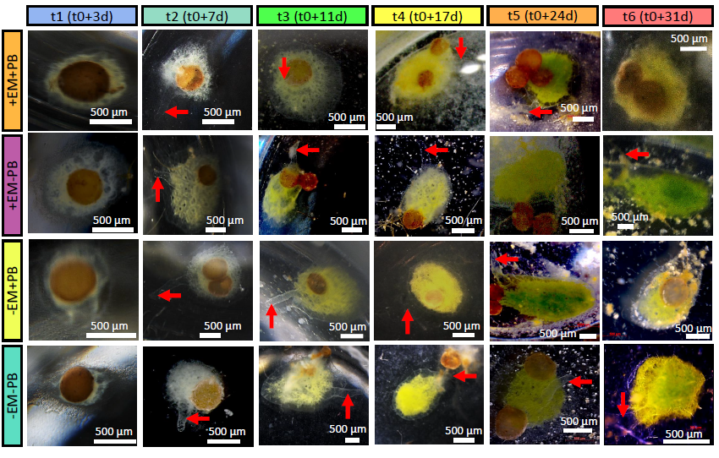

Figure S2. α-diversity measures (A: Chao1 index, B: Shannon index, C: Pielou index) of the bacterial communities associated with the different sample types (in situ adult sponge, gemmules, in vitro juveniles, and filtered freshwater [FF0.45]).
p-values corresponded to the results of Kruskal-Wallis tests using the sample type as a comparison factor. Lowercase indices (a and b) represent results from the Wilcoxon tests comparing each sample type.
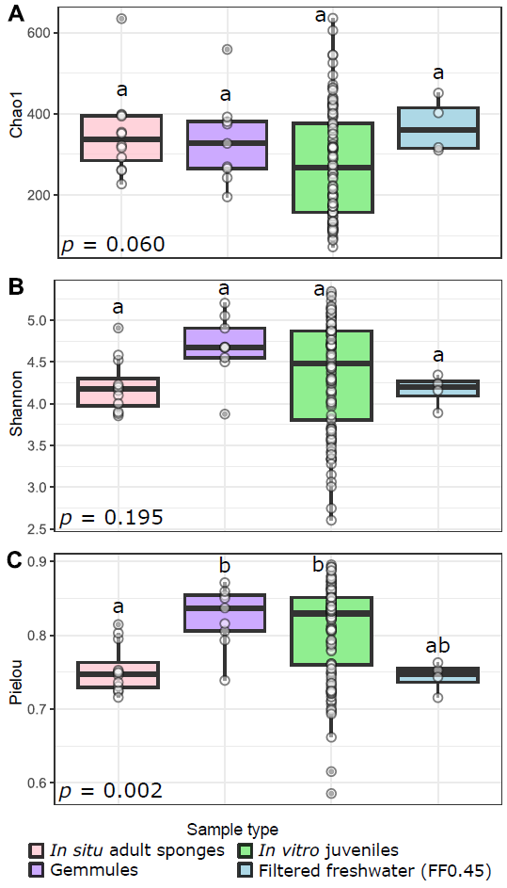

Figure S3. Dynamics of the α-diversity measures (A: Chao1 index and B: Pielou index) of the bacterial communities associated with the gemmules (t₀) and the in vitro juvenile sponges (t₁ to t₆).
Lowercase indices (a to d) represent results from the Wilcoxon test comparing ±EM samples within each time.
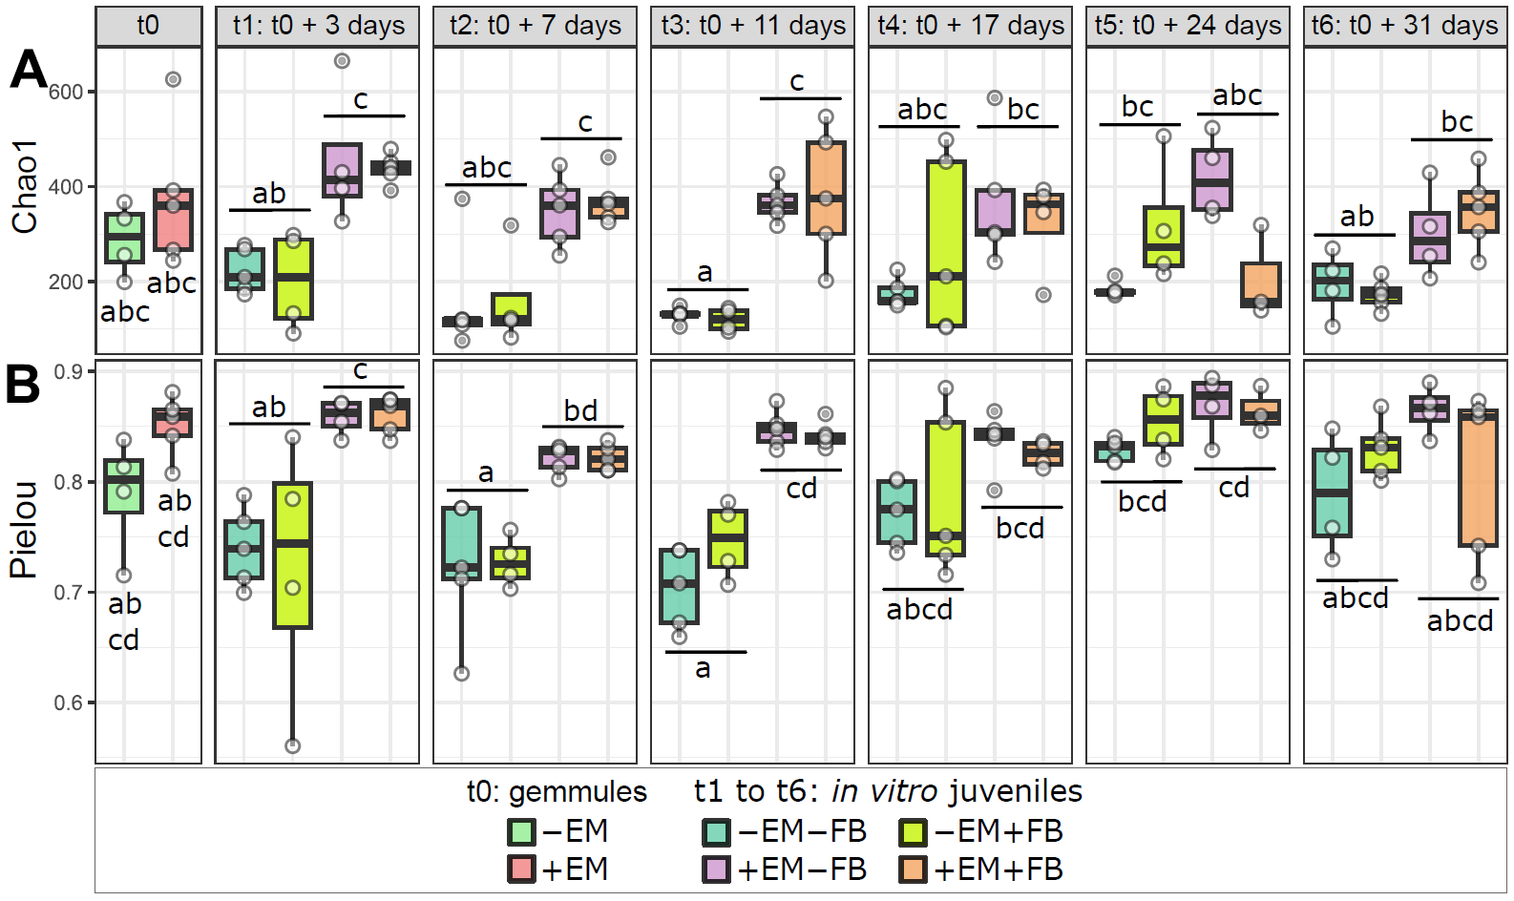

Figure S4. β-diversity of bacterial communities (Bray-Curtis dissimilarity).
The NMDS was plotted with all samples represented according to their sample type (shape) and the treatments for the gemmules and juveniles (color).
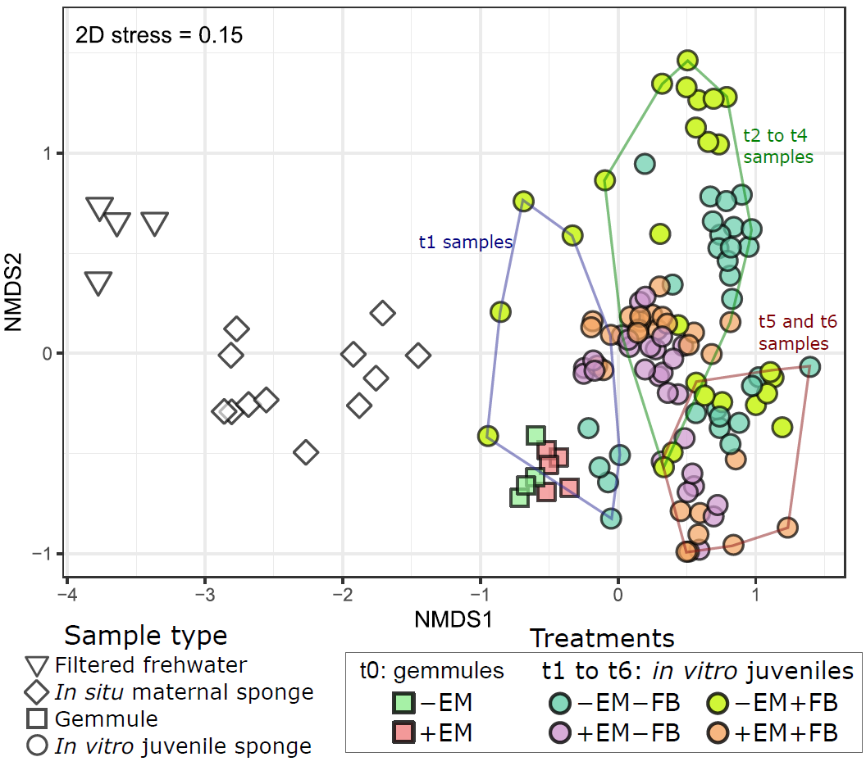

Figure S5. Dispersion dynamics of the β-diversity of gemmules (t₀) and in vitro juvenile sponges (t₁ to t₆) associated bacterial communities.
The β-dispersion (beta-disper) was calculated using the distance to centroid between the Bray-Curtis dissimilarity of replicates from each treatment at each sampling time. p-values corresponded to the results of one-way ANOVA (t₀) and two-way ANOVA (t₁ to t₆) using the sampling ±EM and ±FB as comparison factors. Lowercase indices (a and b) represent results from the HSD Tukey’s tests comparing each treatment within each time.
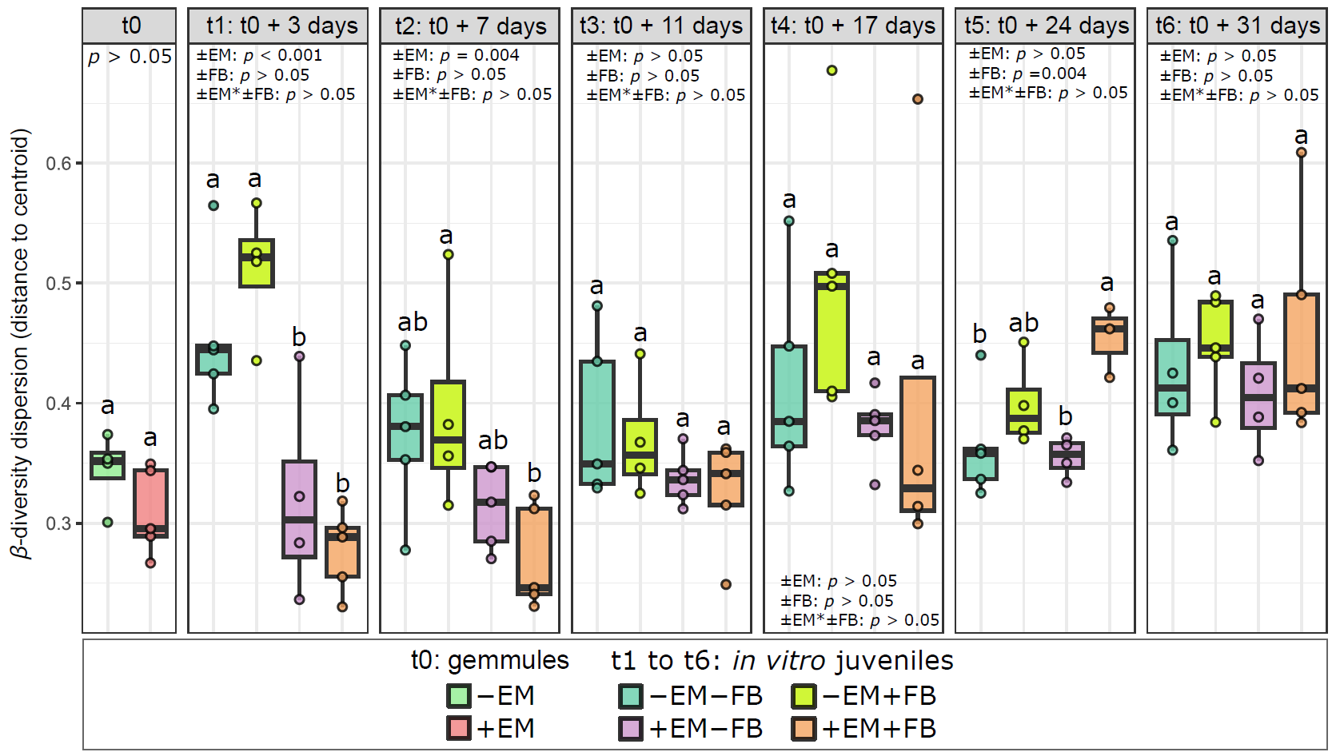

Figure S6. Bacterial community composition at the family level.
A. Barplots of the relative percentages of the bacterial community of filtered freshwater, in situ adult sponges, and gemmule samples. B. Barplots of the relative percentages of the bacterial community of the in vitro juvenile samples.
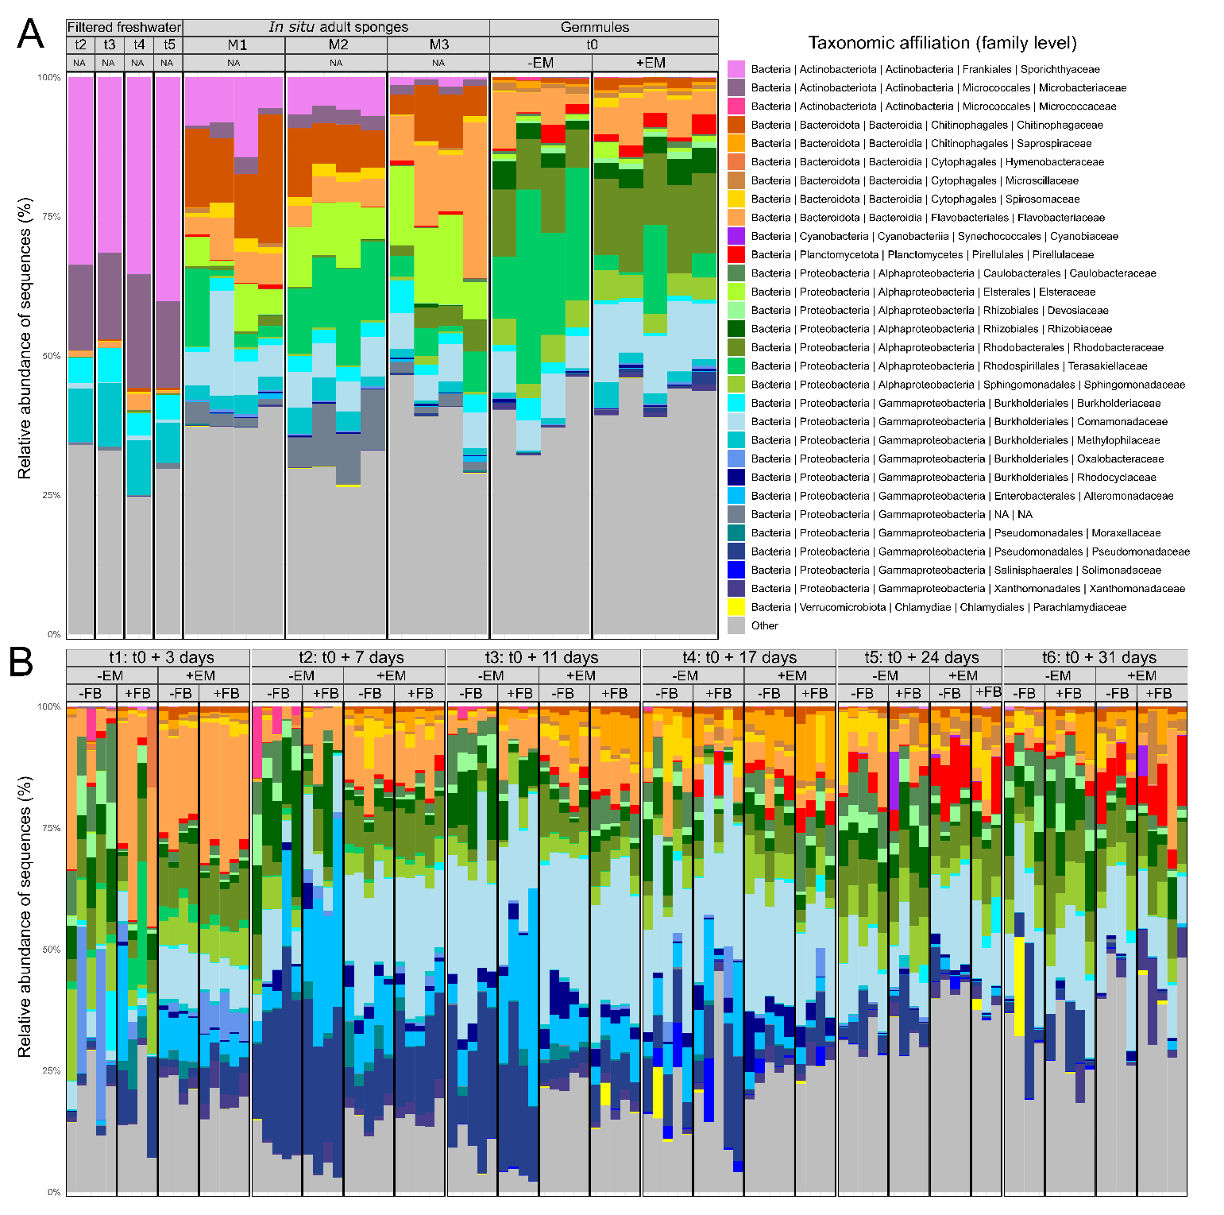

Figure S7. Phylogenetical heat trees performed with gemmule samples (t₀) and representing the taxa significantly and differentially abundant between +EM and -EM gemmules.
For each taxon, (i) the colors of their associated nodes correspond to the log2 fold change between +EM and -EM gemmules, (ii) the size of the nodes corresponds to the relative abundance of each taxa.
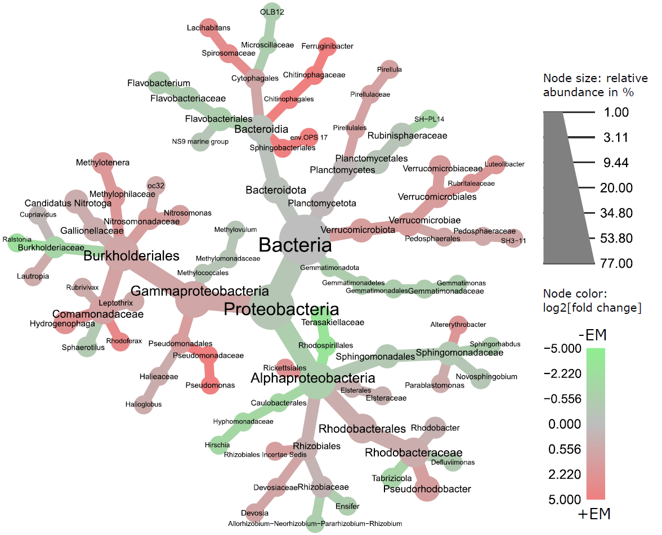

Figure S8. Summary of the numbers of ASVs shared between the gemmules or juvenile sponges, the filtered freshwater (FF0.45), and the in situ adult sponges, for each sampling time.
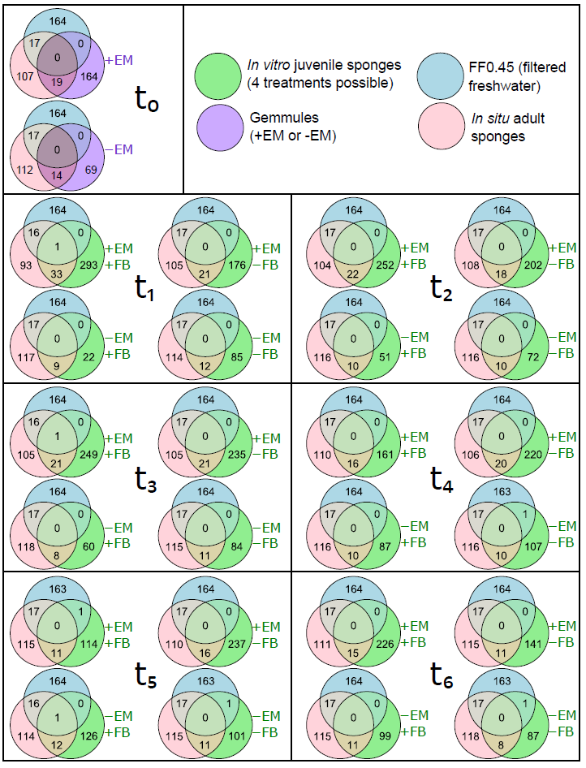

Figure S9. Composition (relative abundances in %) of the ASVs shared between the juveniles and the in situ adult sponges. Taxonomical affiliation of the ASVs was indicated at the family level.
Lowercase indices (a to d) represent results from the HSD Tukey’s tests comparing each sampling time.
