Supplementary Material
1 Supplementary Figures and Tables
1.1supplementary Figures
A field study of the important agronomic traits of chili peppers was conducted, with reference to the "Guidelines for Descriptor Development and Data Standardization for Capsicum Germplasm."
Supplementary Figure 1:A total of 182 materials were surveyed for agronomic traits related to chili peppers, including:(a) Leaf surface (1. Smooth, 2. Slightly wrinkling), leaf shape (1. Ovate, 2. Lanceolate), and leaf size.(b) Branching type (1. Limited bIndeterminate branching, 2. Determinate branching).(c) Flower color (1. White, 2. White with yellow, 3. Light green) and anther color (1. Light purple, 2. Yellow, 3. Green).(d) Style length (1. Longer than stamen, 2. Nearly the same level as stamen, 3. Shorter than stamen).(e) Persistent calyx at base of fruit (1. Sreading, 2. Covering down) and Fruit shoulder shape (1. Pointed, 2. Blunt).(f) Fruit peduncle length, longitudinal diameter, and transverse diameter of fruit.(g) Fruit shape (1. Long finger-shaped, 2. Spherical, 3. Short finger-shaped).(h) Thickness of flesh and placenta size.(i) Number of locules.(j). pendage at blossom end (1. Absent, 2. Present).(k) Color of mature fruit (1. Milk yellow, 2. Light green, 3. Green, 4. Dark green, 5. Yellowish green).(l) Color of mature fruit (1. Tangerine, 2. Bright red, 3. Dark red).The white bar represents 1 cm.
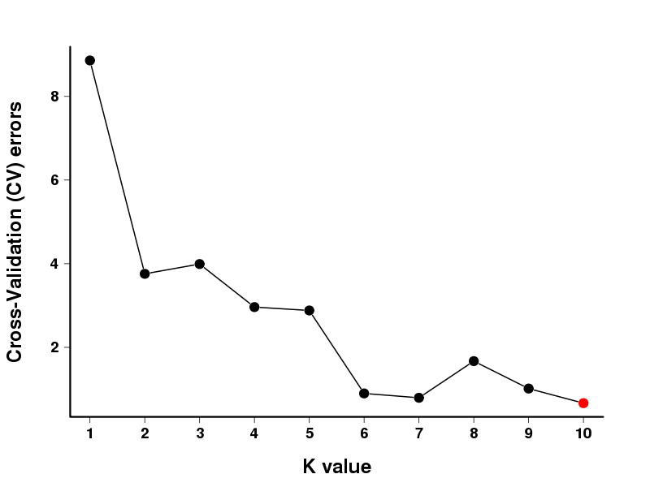
Supplementary Figure 2 Admixture Cross-validation error rate for each K-value

Supplementary Figure 3 Manhattan and Q-Q plots for agronomic traits related to chili peppers under the EMMAX and LMM models are presented. The horizontal axis represents chromosome position, and the vertical axis represents p-values (-log10(p)) on a base-10 logarithmic scale. Each point (or line) on the plot represents the -log10(p) value corresponding to each marker. The green horizontal line represents a value of 5 on the vertical axis, while blue or red represents values corresponding to 0.1/marker quantity and 0.01/marker quantity.

1.2supplementary Tables
Supplementary Table 1 Quality trait survey documentation and assignment of values
Trait | Investigation records and assignment criteria
Trait | 0 | 1 | 2 | 3 | 4
Branching type | Determinate branching | Indeterminate branching
Leaf surface | Smooth | Slightly wrinkling
Leaf shape | Lanceolate | Obvate
Style length | Shorter than stamen | Nearly the same level as stamen | Longer than stamen
Flower color | White | White with yellow | Light green
Anther color | Light purple | Yellow | Green
Appendage at blossom end | Absent | Present
Color of immature fruit | Milk yellow | Light green | Green | Dark green | Yellowish green
Color of mature fruit | Tangerine | Bright red | Dark red
Persistent calyx at base of fruit | Absent | Present
Fruit shoulder shape | Pointed | Blunt
Fruit shape | Long finger-shaped | Short finger-shaped | Spherical

Supplementary Table 2 Distribution frequency and coefficient of variation of quality traits
Trait | Frequency of classification% |  |  |  |  | Shannon-Weaver diversity index (H’)
Trait | 0 | 1 | 2 | 3 | 4 | Shannon-Weaver diversity index (H’)
Branching type | 98.9 | 1.1 |  |  |  | 0.06
Leaf surface | 41.2 | 58.8 |  |  |  | 0.68
Leaf shape | 41.2 | 58.8 |  |  |  | 0.68
Style length | 19.2 | 20.9 | 59.9 |  |  | 0.95
Flower color | 41.8 | 0.5 | 57.7 |  |  | 0.71
Anther color | 89.6 | 6.0 | 4.4 |  |  | 0.24
pendage at blossom end | 96.2 | 3.8 |  |  |  | 0.16
Color of immature fruit | 4.4 | 4.9 | 72.0 | 14.3 | 4.4 | 0.94
Color of mature fruit | 18.1 | 75.3 | 6.6 |  |  | 0.70
Persistent calyx at base of fruit | 99.5 | 0.5 |  |  |  | 0.03
Fruit shoulder shape | 99.5 | 0.5 |  |  |  | 0.03
Fruit shape | 40.7 | 58.8 | 0.5 |  |  | 0.71

Supplementary Table 3 Analysis of genetic diversity in quantitative traits
Trait | Max | Min | Range | Mean | SD | CV(%) | Shannon-Weaver diversity index (H’)
Plant height/cm | 122.20 | 40.50 | 81.70 | 77.05 | 16.03 | 20.81 | 2.07
Plant breadth/cm | 124.30 | 50.90 | 73.40 | 78.54 | 16.37 | 20.84 | 2.02
Leaf length/cm | 13.57 | 3.72 | 9.85 | 8.34 | 2.01 | 24.10 | 2.07
Leaf width/cm | 6.83 | 1.18 | 5.65 | 3.90 | 1.08 | 27.58 | 2.07
Petiole length/cm | 10.25 | 1.22 | 9.03 | 2.83 | 1.10 | 38.83 | 1.70
First stem node length/cm | 8.40 | 1.50 | 6.90 | 4.78 | 1.29 | 26.98 | 2.04
Stem thickness/mm | 22.80 | 9.21 | 13.59 | 16.87 | 2.70 | 16.02 | 2.07
Weight per fruit/g | 5.46 | 0.23 | 5.24 | 1.44 | 1.25 | 86.35 | 1.55
Longitudinal diameter of fruit/mm | 83.87 | 15.48 | 68.38 | 37.10 | 18.86 | 50.85 | 1.82
Transverse diameter of fruit/mm | 19.48 | 3.89 | 15.59 | 7.46 | 2.06 | 27.61 | 1.92
Fruit peduncle length/mm | 47.21 | 21.43 | 25.78 | 31.87 | 4.68 | 14.70 | 2.03
Thickness of flesh/mm | 2.61 | 0.20 | 2.41 | 0.85 | 0.43 | 50.05 | 1.88
Plancenta size/mm | 3.47 | 0.19 | 3.28 | 0.90 | 0.71 | 78.76 | 1.55
Number of locules | 3.00 | 2.00 | 1.00 | 2.29 | 0.44 | 19.05 | 0.95

Supplementary Table 4 Quantitative trait correlation analysis
Trait | Plant height/cm | Plant breadth/cm | Leaf length/cm | Leaf width/cm | Petiole length/cm | First stem node length/cm | Stem thickness/mm | Weight per fruit/g | Longitudinal diameter of fruit/mm | Fruit peduncle length/mm | Fruit peduncle length/mm | Thickness of flesh/mm | Plancenta size/mm | Number of locules
Plant height/cm | 1
Plant breadth/cm | .487** | 1
Leaf length/cm | -.021 | -.056 | 1
Leaf width/cm | -.081 | -.177 | .837** | 1
Petiole length/cm | .036 | .146* | .257** | .022 | 1
First stem node length/cm | .402** | .350** | .065 | .013 | .025 | 1
Stem thickness/mm | .122 | .054 | -.243** | -.243** | .107 | .036 | 1
Weight per fruit/g | .001 | .463** | -.452** | -.452** | .246** | .082 | .374** | 1
Longitudinal diameter of fruit/mm | .267** | .445** | -.468** | -.468** | .246** | .086 | .374** | .931** | 1
Transverse diameter of fruit/mm | .185* | .464** | -.283** | -.283** | .168* | .102 | .320** | .818** | .726** | 1
Fruit peduncle length/mm | .249** | .169* | .161* | .161* | .250** | .247** | -.044 | .179* | .197** | .142 | 1
Thickness of flesh/mm | .219** | .440** | -.453** | -.453** | .264** | .056 | .296** | .802** | .785** | .789** | .147** | 1
Plancenta size/mm | .288** | .394** | -.474** | -.474** | .191* | .161* | .395** | .826** | .797** | .678** | .193** | -.772** | 1
Number of locules | -.037 | -.107 | .373** | .373** | -.098 | .097 | -.183* | -.375** | -.365** | -.288** | .151** | -.473** | -.343** | 1
**. Highly significant correlation at the .01 level (bilaterally).
*. Significantly correlated at the .05 level (bilateral).

Supplementary Table 5 Sequencing quality and comparison results statistics. of 182 pepper accessions.(shown in excel)
Supplementary Table 6 Sample clustering information at each value of k and admixture cross-validation error rate for each value of k.(shown in excel)
Supplementary Table 7 Significant loci and candidate gene information for 24 agronomic traits.(shown in excel)
Supplementary Table 8 Annotation of important candidate genes for 24 agronomic traits.(shown in excel)
Supplementary Table 9 The species and phenotypic data of 182 pepper germplasms were collected in this study.(shown in excel)

