Supporting Information

Sedimentation of large, soluble proteins up to 140 kDa for ¹H-detected MAS NMR and ¹³C DNP NMR – practical aspects
Dallas Bell^{1,2}, Florian Lindemann², Lisa Gerland², Hanna Aucharova³, Alexander Klein³, Daniel Friedrich⁴, Matthias Hiller², Kristof Grohe⁵, Barth van Rossum², Anne Diehl², Jon Hughes^{6,7}, Leonard J. Mueller⁸, Rasmus Linser³, Anne-Frances Miller^{1,9} and Hartmut Oschkinat²

Affiliations
¹Faculty II-Mathematics and Natural Sciences, Technische Universität Berlin, Straße des 17. Juni 135, 10623 Berlin, Germany
²Leibniz-Forschungsinstitut für Molekulare Pharmakologie, Robert-Rössle-Str. 10, 13125 Berlin, Germany
³Department of Chemistry and Chemical Biology, TU Dortmund University, Otto-Hahn-Str. 4a, 44227 Dortmund, Germany.
⁴Department of Chemistry and Biochemistry, University of Cologne, Greinstr. 4, 50939 Cologne, Germany
⁵Bruker BioSpin GmbH & Co. KG, Rudolf-Plank-Str. 23, 76275 Ettlingen, Germany
⁶Justus Liebig University, Institute for Plant Physiology, Senckenbergstr. 3, 35360 Gießen, Germany
⁷Free University of Berlin, Department of Physics, Arnimallee 14, 14195 Berlin, Germany
⁸Department of Chemistry, University of California - Riverside, CA 92521 Riverside, USA
⁹Department of Chemistry, University of Kentucky, KY 40506 Lexington, USA

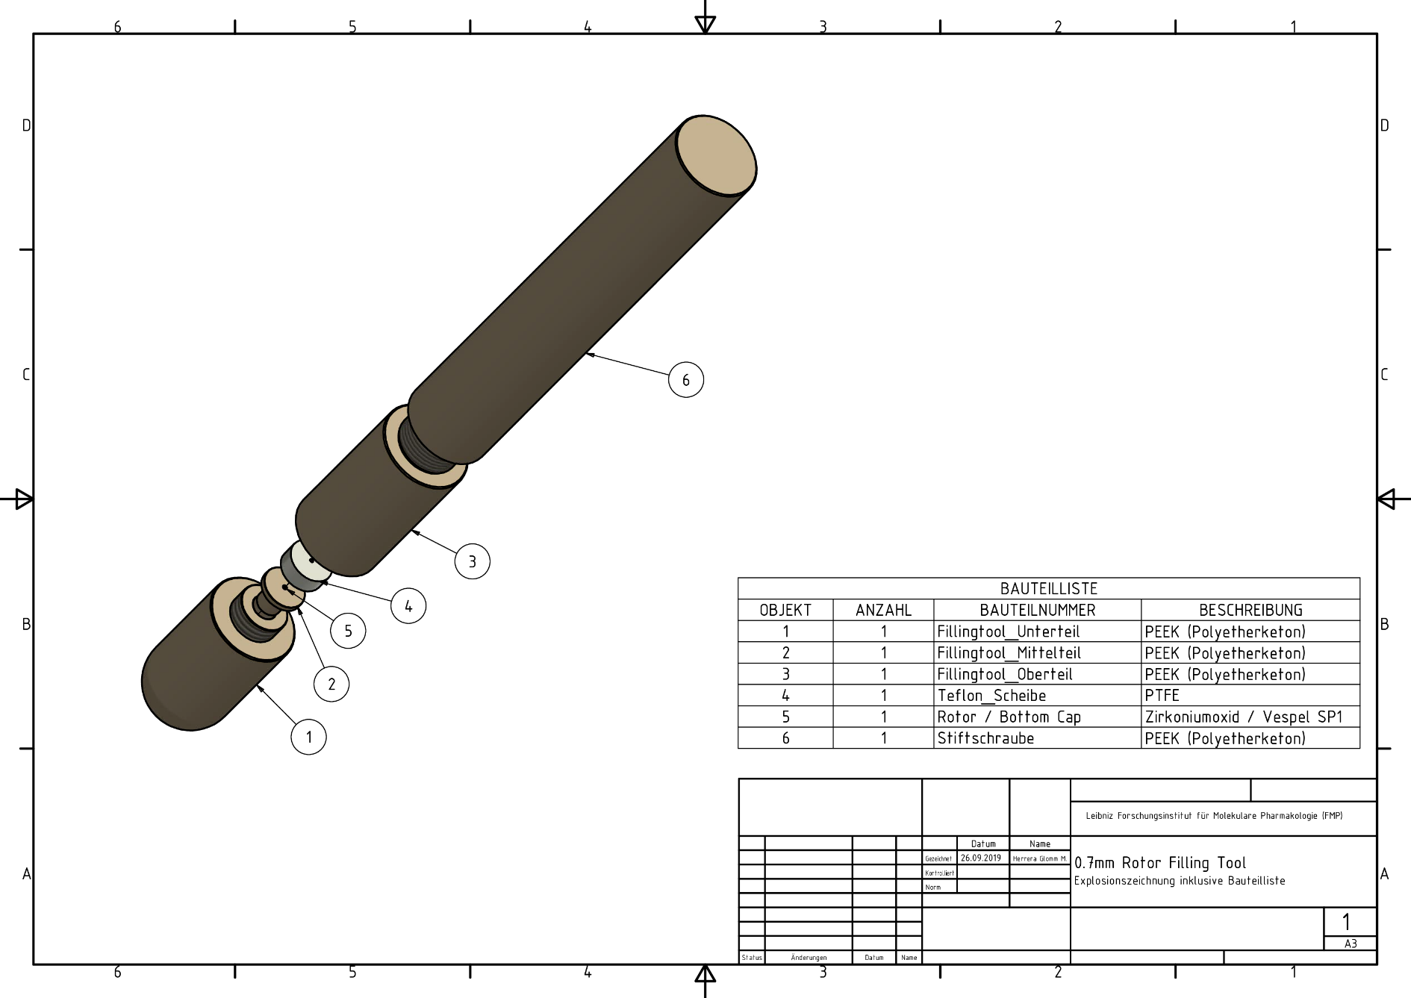
Fig. S1 Technical drawing of the 0.7mm filling tool, overview.

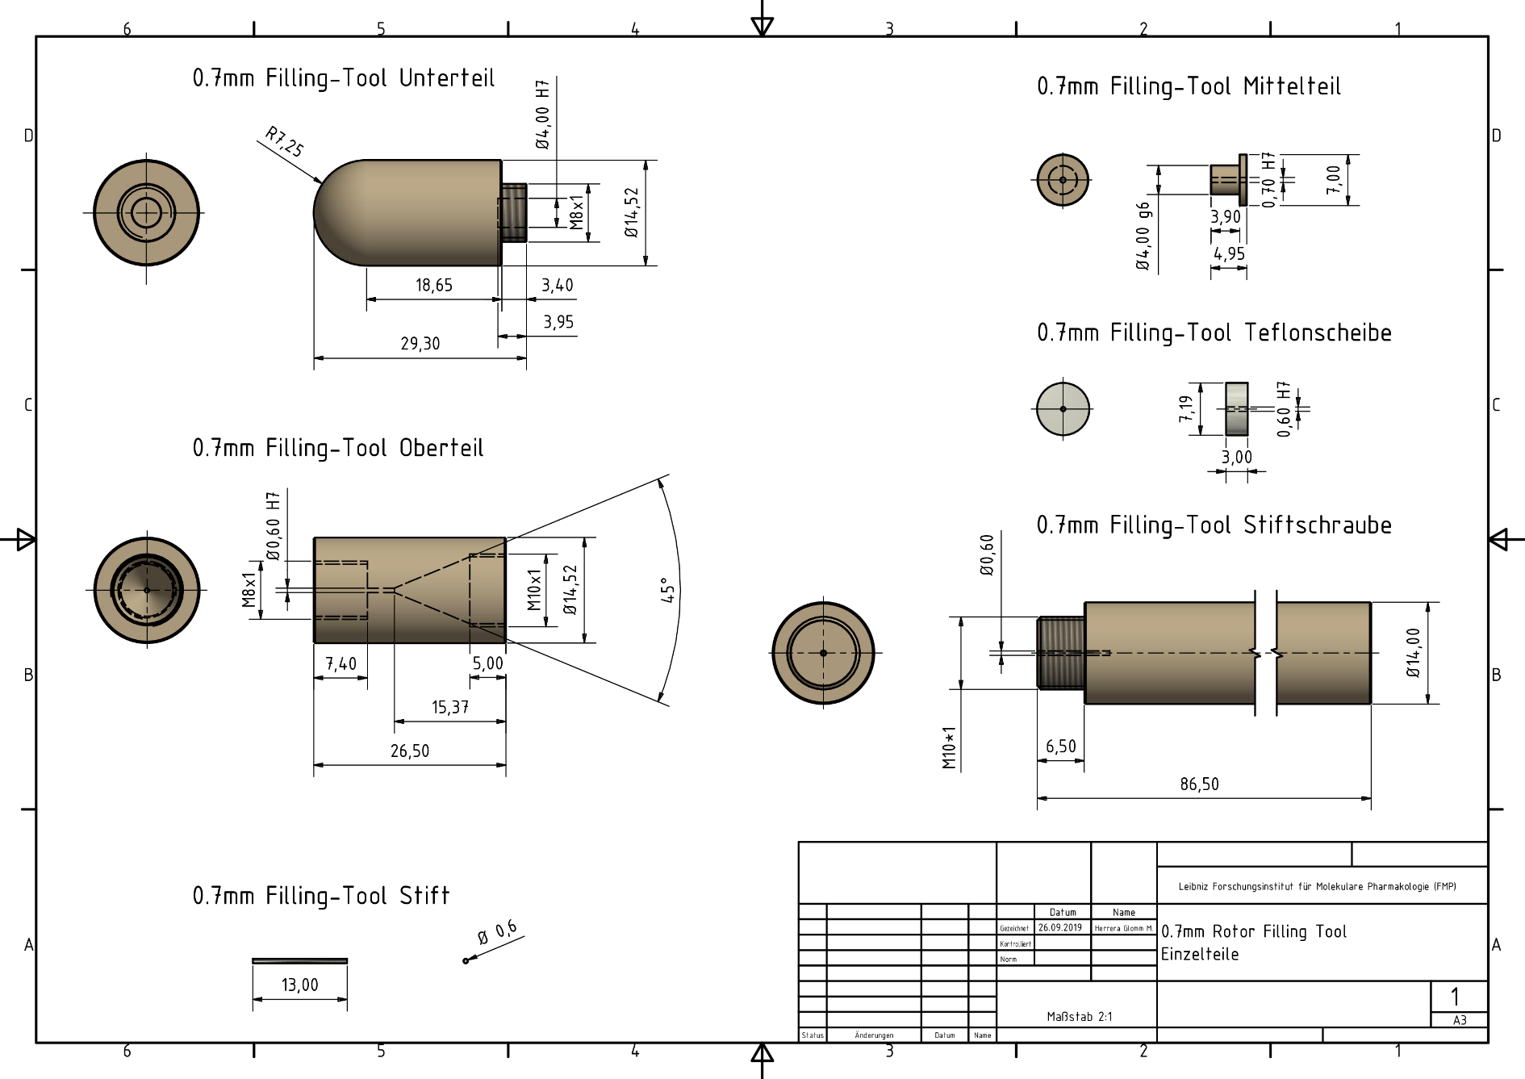
Fig. S2 Technical drawings of the 0.7mm filling tool, detailed view.

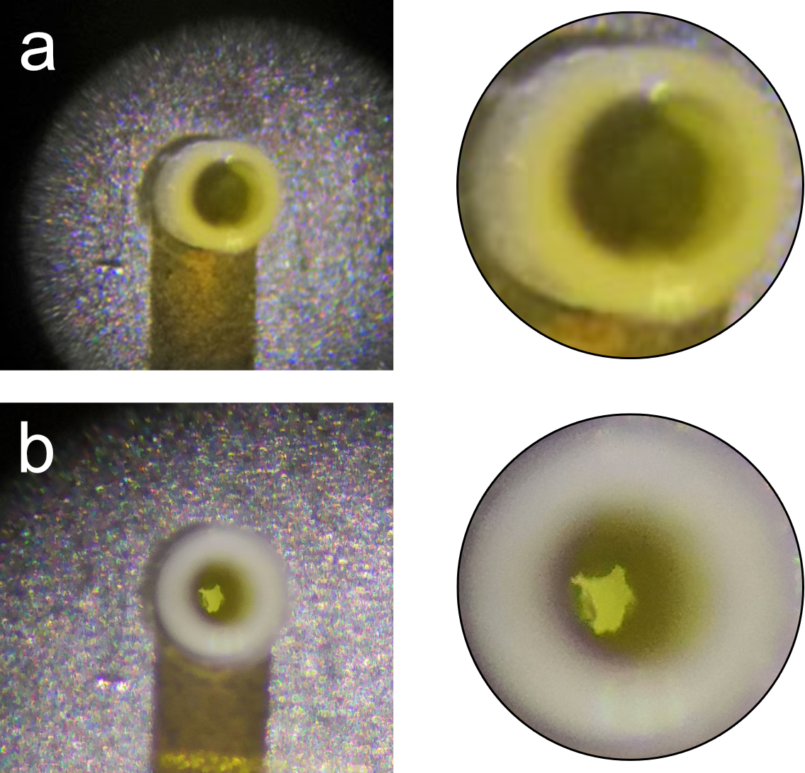
Fig. S3 Effect of magic angle spinning on the sample inside the NMR rotor. (a) Top view of a 0.7 mm diameter rotor directly after filling StTS by ultracentrifugation. Due to the filling procedure, the bottom cap is attached. (b) Top view of the identical 0.7 mm rotor after multiple sessions of MAS NMR measurements at 100 kHz spinning after removing both caps. Enlarged images are shown on the right
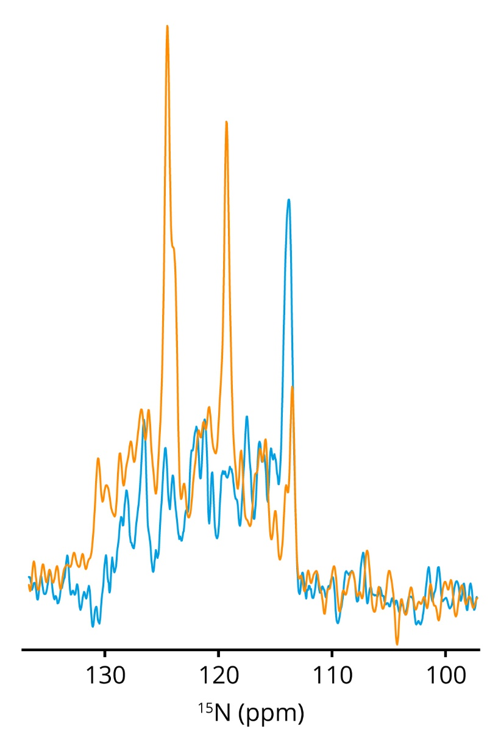
Fig. S4 1D slices along a ¹H chemical shift of 8.95 ppm from ¹H-¹⁵N correlations of deuterated SulfETF by solid-state NMR (CP-based, yellow) and solution NMR (INEPT-based ,blue). Full spectra are shown in main text Fig. 3.
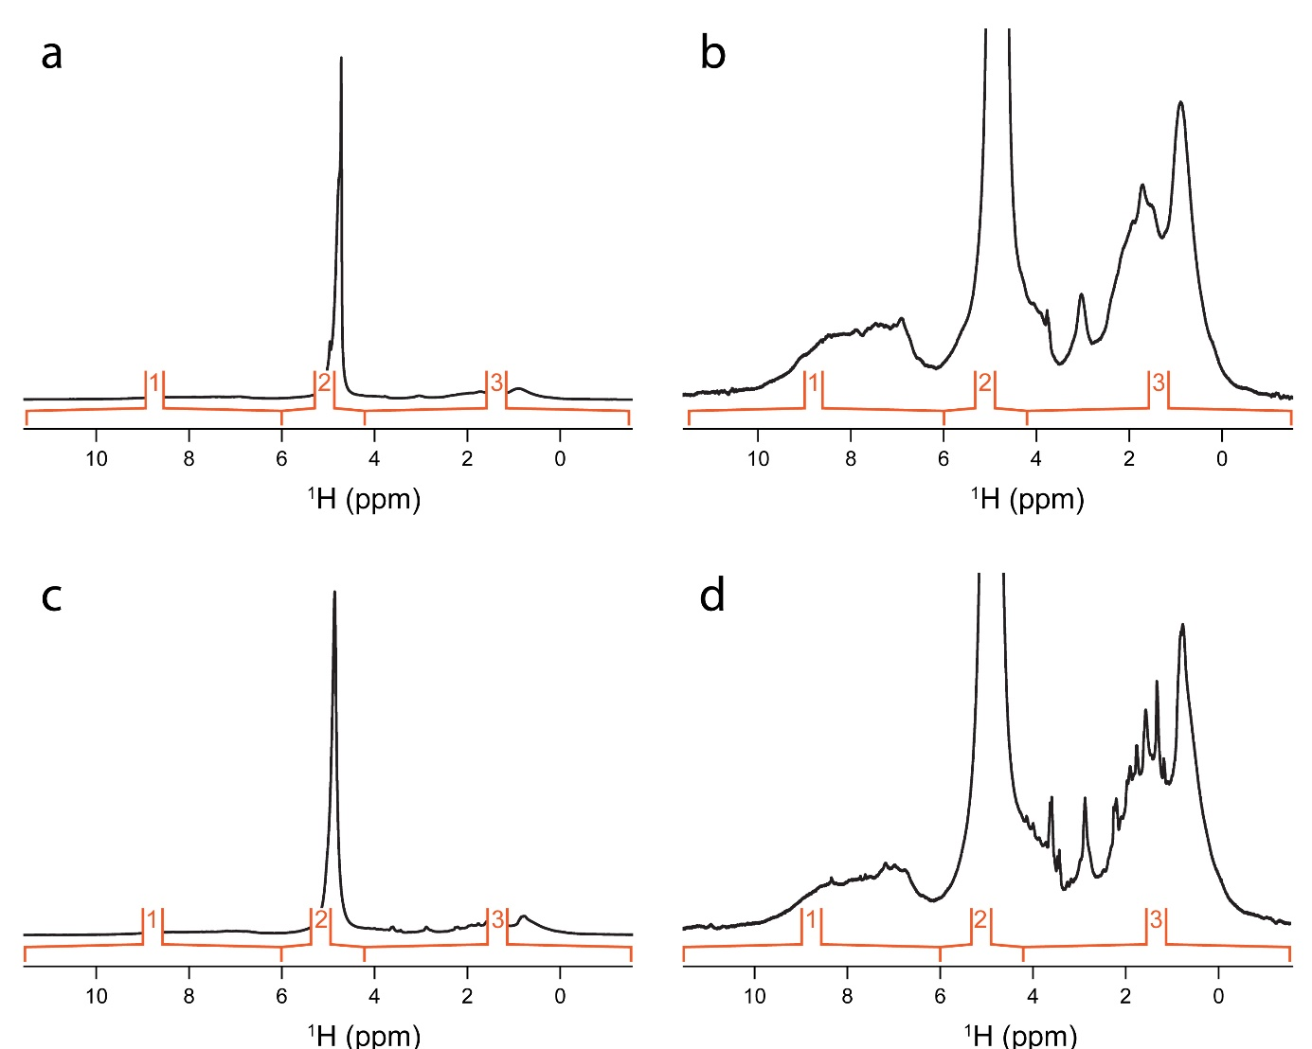Fig. S5 1D ¹H spectra used to determine the change of water content over time. A 0.7 mm diameter rotor containing sedimented SulfETF was measured at 900 MHz ¹H Larmor frequency and at 100 kHz MAS. Spectra and integration regions of freshly filled sample (a and b) and after 1 year (c and d) are shown. The determined integrals are: (a and b) |1|: 1.00; |2|: 12.35; |3|: 2.24, (c and d) |1|: 1.00; |2|: 13.77; |3|: 2.86.
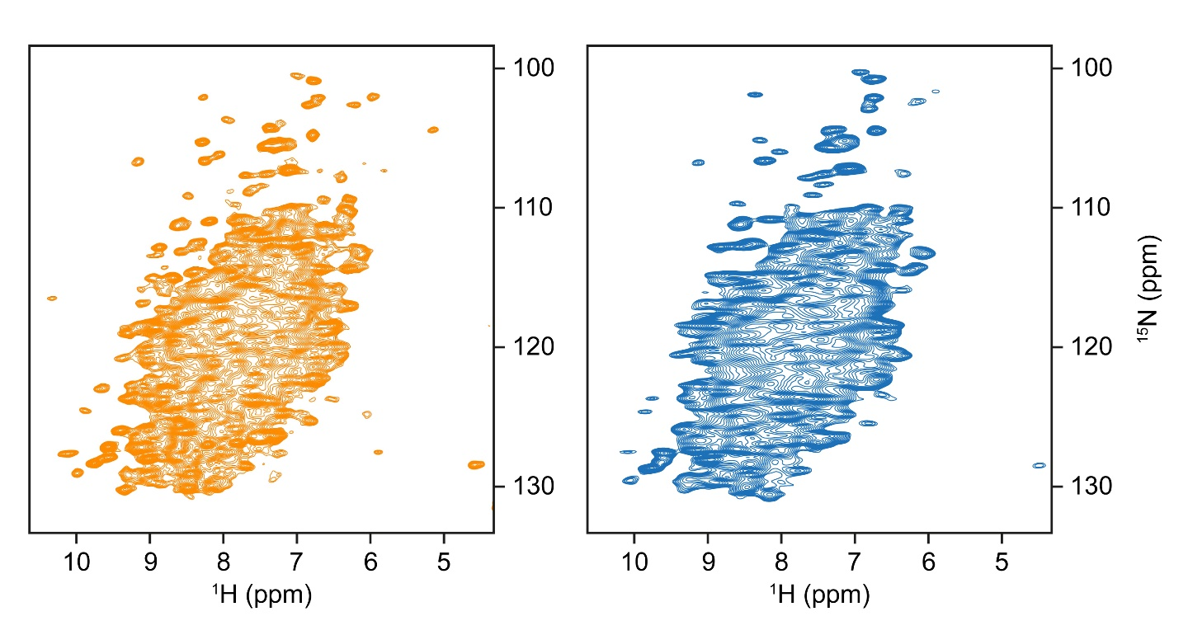
Fig. S6 Comparison of CP-based ¹H-¹⁵N SulfETF spectra to examine the change of the sample over time. Measurements were conducted with a 0.7 mm rotor spinning at 100 kHz MAS on a spectrometer with 900 MHz ¹H Larmor frequency directly after filling (orange, from the main text) and after one year of storage (blue).

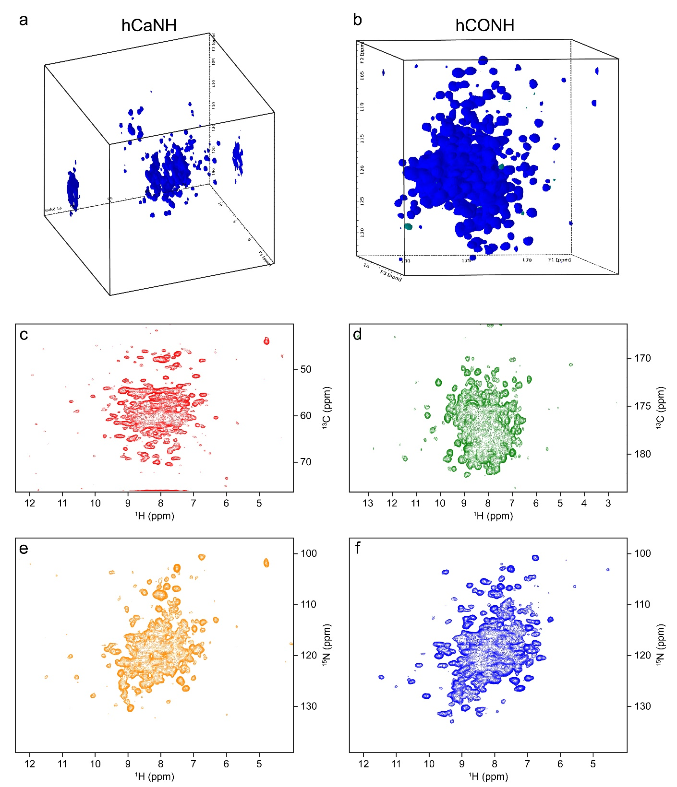
Fig. S7 3D hCANH and hCONH spectra acquired on ¹H,¹³C,¹⁵N-labelled StTS, filled into a 0.7 mm rotor and at 900 MHz ¹H Larmor frequency and 100 kHz MAS. (a) Cube representation of the hCANH. (b) Cube representation of the hCONH. (c) ¹H-¹³C projection of the hCANH. (d) ¹H-¹³C projection of the hCONH. (e) ¹H-¹⁵N projection of the hCANH. (f) ¹H-¹⁵N projection of the hCONH.

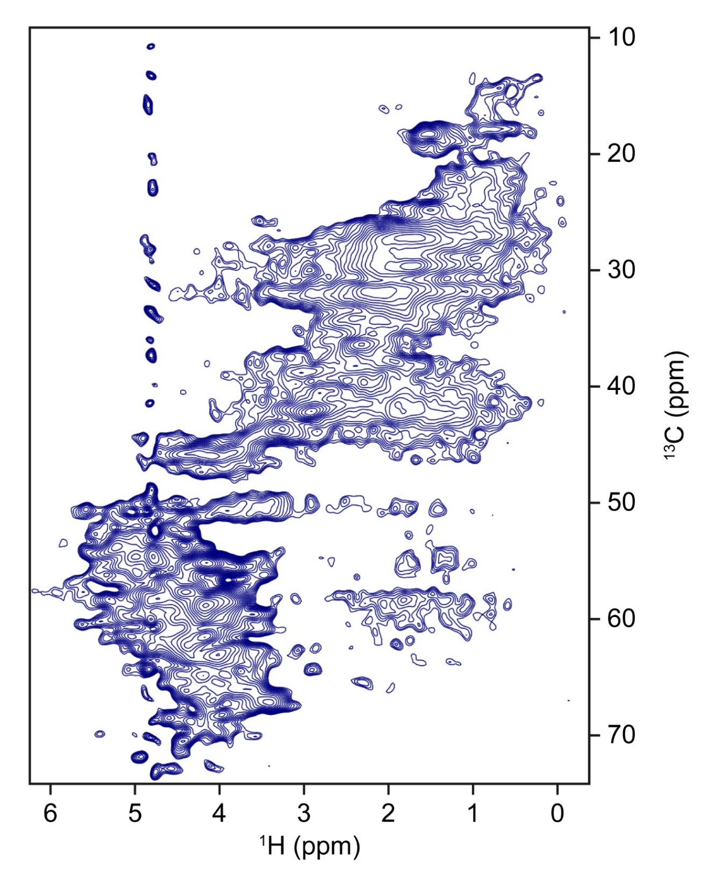
Fig. S8 CP-based ¹H-¹³C correlation of StTS, recorded with a 0.7 mm rotor at 100 kHz MAS and 900 MHz ¹H Larmor frequency.

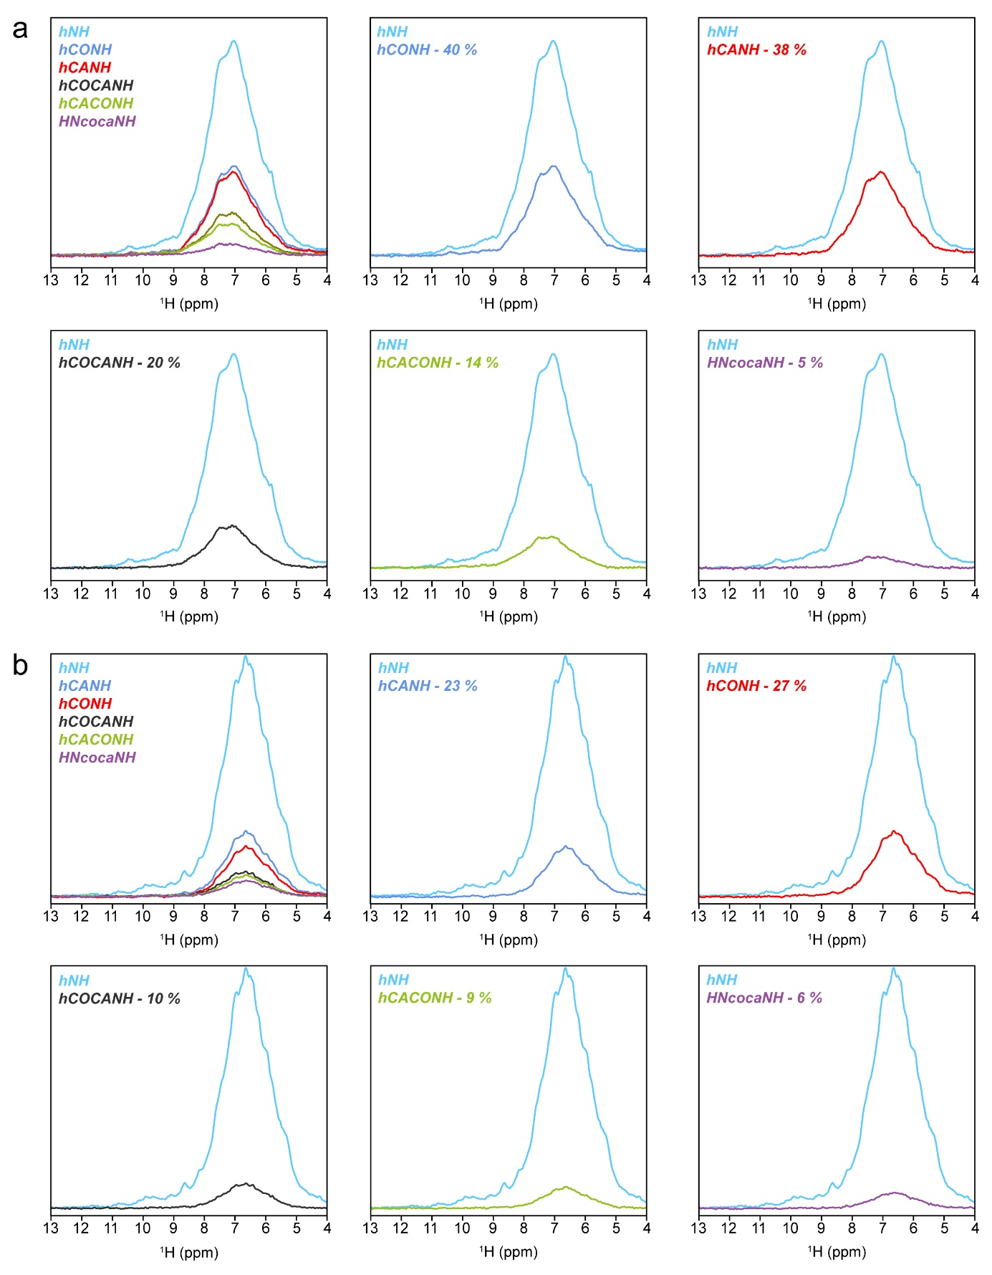Fig. S9 Comparisons of transfer efficiencies on PfTrpB at 700 MHz ¹H Larmor frequency. Individual bulk intensities were determined on the first 1D free induction decay with 256 scans and compared to the bulk intensity of the first 1D experiment of a 2D hNH experiment (also measured with 256 scans). The relative intensities are given as percentages. (a) Measurements using ¹³C, ¹⁵N-labelled protein in a 0.7 mm rotor at 100 kHz. The ¹H bulk T₁ time was determined to be 750 ms, a recycle delay of 1 s was used. (b) Measurements using ²H, ¹³C, ¹⁵N-labelled and back-exchanged sedimented into a 1.3 mm rotor at 55 kHz MAS. The ¹H bulk T₁ time was determined to be 800 ms, a recycle delay of 1 s was used.
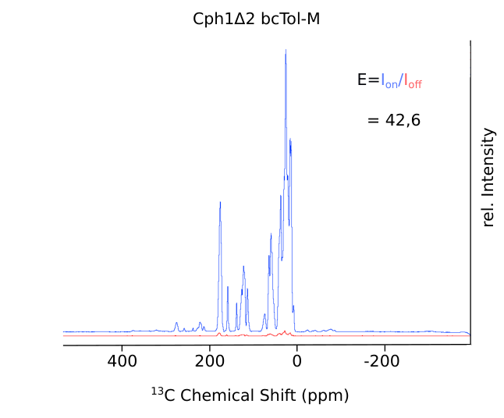
Fig. S10 DNP enhancement obtained by the radical BcTol-M on Cph1Δ2 from Synechocystis at 800 MHz ¹H Larmor frequency spinning at 20 kHz MAS. The spectra shown were acquired with (blue) and without (red) microwave irradiation.

Table S1 Acquisition parameters for the 2D ¹H-¹⁵N spectra of SulfETF.
Acquisition parameters
 | CP-based hNH (Fig. 3) |  |  | Solution ¹H-¹⁵N HSQC (Fig. 3)
 |  | F2 | F1 | F2 | F1
Quad. Mode |  |  | States-TPPI |  | States-TPPI
TD points |  | 1024 | 640 | 1024 | 512
Nucleus |  | ¹H | ¹⁵N | ¹H | ¹⁵N
SW / ppm |  | 39.7 | 99.7 | 16.3 | 79.5
Aq.time / ms |  | 14.3 | 35.2 | 34.8 | 35.3
Scans |  | 32 |  | 64
Acquisition parameters
CP-based hNH @ 289 K (Fig. 4) |  |  |  | CP-based hNH @ 313 K (Fig. 4)
 |  | F2 | F1 | F2 | F1
Quad. Mode |  |  | States-TPPI |  | States-TPPI
TD points |  | 2048 | 512 | 2048 | 512
Nucleus |  | ¹H | ¹⁵N | ¹H | ¹⁵N
SW / ppm |  | 39.7 | 80.0 | 39.7 | 85.7
Aq.time / ms |  | 28.7 | 35.1 | 34.8 | 32.8
Scans |  | 32 |  | 32
Acquisition parameters
INEPT-based hNH @ 289 K (Fig. 4) |  |  |  | INEPT-based hNH @ 313 K (Fig. 4)
 |  | F2 | F1 | F2 | F1
Quad. Mode |  |  | States-TPPI |  | States-TPPI
TD points |  | 2048 | 384 | 2048 | 256
Nucleus |  | ¹H | ¹⁵N | ¹H | ¹⁵N
SW / ppm |  | 39.7 | 80.0 | 39.7 | 85.7
Aq.time / ms |  | 28.7 | 26.3 | 28.7 | 16.4
Scans |  | 32 |  | 48

Acquisition parameters
CP-based hNH after 1 year (Fig. S6)
 | F2 | F1
Quad. Mode |  | States-TPPI
TD points | 2048 | 2048
Nucleus | ¹H | ¹⁵N
SW / ppm | 39.7 | 142.0
Aq.time / ms | 28.7 | 79.1
Scans | 32

Table S2 RF fields used to obtain the 2D ¹H-¹⁵N spectra of SulfETF.
CP-based hNH (Fig. 3) |  |  | Solution ¹H-¹⁵N HSQC (Fig. 3)
Hard pulses | µs | RF / kHz |  | µs | RF / kHz
¹H | 0.85 | 294.12 |  | 10.29 | 24.30
¹⁵N | 5 | 50 |  | 40 | 6.25
¹³C | 5 | 50
CP-based hNH @ 289 K (Fig. 4) |  |  | CP-based hNH @ 313 K (Fig. 4)
Hard pulses | µs | RF / kHz |  | µs | RF / kHz
¹H | 0.9 | 277.78 |  | 1 | 250.0
¹⁵N | 4.6 | 54.35 |  | 5 | 50
¹³C | 2.5 | 100 |  | 5 | 50
INEPT-based hNH @ 289 K (Fig. 4) |  |  | INEPT-based hNH @ 313 K (Fig. 4)
Hard pulses | µs | RF / kHz |  | µs | RF / kHz
¹H | 0.9 | 277.78 |  | 1 | 250.0
¹⁵N | 4.6 | 54.35 |  | 5 | 50
¹³C | 5 | 50 |  | 5 | 50
CP-based hNH after 1 year (Fig. S6)
Hard pulses | µs | RF / kHz
¹H | 0.9 | 277.78
¹⁵N | 5.7 | 44.17
¹³C | 2.5 | 100

Table S3 CP conditions used to obtain the hNH spectra of SulfETF.
hNH (Fig. 3)
H-N CP |  | RF ¹H / kHz | RF ¹⁵N / kHz | N-H CP |  | RF ¹H / kHz | RF ¹⁵N / kHz
Contact time/µs | 800 | 68.6 | 34.13 | Contact time/µs | 600 | 68.6 | 29.22
Shape |  | rectangular | 100-60 tang. | Shape |  | rectangular | 60-100 tang.
hNH @ 289 K (Fig. 4)
H-N CP |  | RF ¹H / kHz | RF ¹⁵N / kHz | N-H CP |  | RF ¹H / kHz | RF ¹⁵N / kHz
Contact time/µs | 1000 | 78.16 | 37.23 | Contact time/µs | 700 | 78.16 | 33.30
Shape |  | rectangular | 100-60 tang. | Shape |  | rectangular | 60-100 tang.
hNH @ 313 K (Fig. 4)
H-N CP |  | RF ¹H / kHz | RF ¹⁵N / kHz | N-H CP |  | RF ¹H / kHz | RF ¹⁵N / kHz
Contact time/µs | 800 | 70.84 | 36.40 | Contact time/µs | 400 | 70.84 | 30.06
Shape |  | rectangular | 100-60 tang. | Shape |  | rectangular | 60-100 tang.
hNH after 1 year (Fig. S6)
H-N CP |  | RF ¹H / kHz | RF ¹⁵N / kHz | N-H CP |  | RF ¹H / kHz | RF ¹⁵N / kHz
Contact time/µs | 1100 | 78.16 | 31.97 | Contact time/µs | 700 | 78.16 | 28.92
Shape |  | rectangular | 100-60 tang. | Shape |  | rectangular | 60-100 tang.

Table S4 Acquisition parameters for the spectra of StTS.
Acquisition parameters
 | hNH (Fig. 5a) |  |  |  | hNH (Fig. 5b)
 | F2 | F1 |  |  |  |  | F2 |  | F1
Quad. Mode |  | States-TPPI |  |  |  |  |  |  | States-TPPI
TD points | 2048 | 400 |  |  |  |  | 2048 |  | 400
Nucleus | ¹H | ¹⁵N |  |  |  |  | ¹H |  | ¹⁵N
SW / ppm | 39.7 | 137 |  |  |  |  | 39.7 |  | 78.34
Aq.time / ms | 28.7 | 16 |  |  |  |  | 28.7 |  | 28
Scans | 128 |  |  |  |  |  | 128
Acquisition parameters
hCANH (Fig. S7a, c and e)
 | F3 |  |  | F2 |  |  | F1
Quad. Mode |  |  |  | States-TPPI |  |  | States-TPPI
TD points | 1024 |  |  | 64 |  |  | 126
Nucleus | ¹H |  |  | ¹⁵N |  |  | ¹³C
SW / ppm | 39.7 |  |  | 34.3 |  |  | 44.2
Aq.time / ms | 14.3 |  |  | 10.2 |  |  | 6.4
Scans | 16
Acquisition parameters
hCONH (Fig. S7b, d and f)
 | F3 |  |  | F2 |  |  | F1
Quad. Mode |  |  |  | States-TPPI |  |  | States-TPPI
TD points | 1024 |  |  | 80 |  |  | 64
Nucleus | ¹H |  |  | ¹⁵N |  |  | ¹³C
SW / ppm | 39.7 |  |  | 34.3 |  |  | 17.7
Aq.time / ms | 14.3 |  |  | 12.8 |  |  | 8.0
Scans | 24

Table S5 RF fields and CP conditions used for the spectra of StTS.
hNH (Fig. 5a and b) |  |  | hCANH and hCONH (Fig. S7)
Hard pulses | µs | RF / kHz |  | µs | RF / kHz
¹H | 0.85 | 294.11 |  | 2.5 | 100
¹⁵N | 5 | 50 |  | 5 | 50
¹³C | 5 | 50 |  | 5 | 50

hNH (Fig. 5a and b)
H-N CP |  | RF ¹H / kHz |  | RF ¹⁵N / kHz |  | N-H CP |  |  | RF ¹H / kHz | RF ¹⁵N / kHz
Contact time/µs | 1200 | 70.15 |  | 34.61 |  | Contact time/µs |  | 800 | 70.15 | 28.87
Shape |  | rectangular |  | 100-60 tang. |  | Shape |  |  | rectangular | 60-100 tang.
hCANH (Fig. S7a, c and e)
H-C CP |  | RF ¹H / kHz |  |  | RF ¹⁵N / kHz |  | RF ¹³C / kHz
Contact time/µs | 1400 | 71.98 |  |  |  |  | 23.61
Shape |  | 80-100 ramp |  |  |  |  | rectangular
CA-N
Contact time/µs | 10000 |  |  |  | 23.71 |  | 71.39
Shape |  |  |  |  | rectangular |  | 70-100 tang.
H-N CP |  | RF ¹H / kHz |  |  | RF ¹⁵N / kHz |  | RF ¹³C / kHz
Contact time/µs | 800 | 70.89 |  |  | 28.2
Shape |  | 80-100 ramp |  |  | rectangular
hCONH (Fig. S7b, d and f)
H-C CP |  | RF ¹H / kHz |  |  | RF ¹⁵N / kHz |  | RF ¹³C / kHz
Contact time/µs | 1400 | 71.98 |  |  |  |  | 23.0
Shape |  | 80-100 ramp |  |  |  |  | rectangular
CO-N CP |  | RF ¹H / kHz |  |  | RF ¹⁵N / kHz |  | RF ¹³C / kHz
Contact time/µs | 10000 |  |  |  | 25.52 |  | 67.94
Shape |  |  |  |  | rectangular |  | 70-100 tang
H-N CP |  | RF ¹H / kHz |  |  | RF ¹⁵N / kHz |  | RF ¹³C / kHz
Contact time/µs | 800 | 70.89 |  |  | 21.65
Shape |  | 80-100 ramp |  |  | rectangular

Table S6 Acquisition parameters for the 2D hNH spectrum of the u-[¹³C,¹⁵N] labeled sample of the 2B9 mutant of PfTrpB spun at 100 kHz MAS in a 0.7 mm rotor as shown in main text Fig. 6.
Acquisition parameters
 | F2 | F1
Quad. Mode |  | States-TPPI
TD points | 800 | 138
Nucleus | ¹H | ¹⁵N
SW / ppm | 39.7 | 39.1
Aq.time / ms | 14.4 | 24.8
Scans | 128

Table S7 RF fields and CP conditions used to obtain the ¹HN bulk intensities in main text Fig. 6 and Fig. S9 for the u-[¹³C,¹⁵N] labeled sample of the 2B9 mutant of PfTrpB spun at 100 kHz MAS in a 0.7 mm rotor.
Hard pulses | µs | RF / kHz
¹H | 1.4 | 178.57
¹⁵N | 2.8 | 89.29
¹³C | 2.6 | 96.15

hNH
H-N CP |  | RF ¹H / kHz | RF ¹⁵N / kHz | RF ¹³C / kHz
Contact time/µs | 1150 | 80.4 | 28.2
Shape |  | 100-50 tang. | rectangular
hCANH
H-C CP |  | RF ¹H / kHz | RF ¹⁵N / kHz | RF ¹³C / kHz
Contact time/µs | 300 | 80.4 |  | 31.3
Shape |  | 100-50 tang. |  | rectangular
Ca-N CP |  | RF 1H / kHz | RF 15N / kHz | RF 13C / kHz
Contact time/µs | 11000 |  | 66.6 | 31.7
Shape |  |  | 90-100 ramp | rectangular
H-N CP |  | RF ¹H / kHz | RF ¹⁵N / kHz | RF ¹³C / kHz
Contact time/µs | 500 | 80.4 | 28.2
Shape |  | 100-50 tang. | rectangular

hCONH
H-C CP |  | RF ¹H / kHz | RF ¹⁵N / kHz | RF ¹³C / kHz
Contact time/µs | 1500 | 80.4 |  | 29.5
Shape |  | 100-50 tang. |  | rectangular
CO-N CP |  | RF ¹H / kHz | RF ¹⁵N / kHz | RF ¹³C / kHz
Contact time/µs | 11000 |  | 66.6 | 31.3
Shape |  |  | 90-100 ramp | rectangular
H-N CP |  | RF ¹H / kHz | RF ¹⁵N / kHz | RF ¹³C / kHz
Contact time/µs | 500 | 80.4 | 28.2
Shape |  | 100-50 tang. | rectangular
hCACONH
H-C CP |  | RF ¹H / kHz | RF ¹⁵N / kHz | RF ¹³C / kHz
Contact time/µs | 650 | 80.4 |  | 31.3
Shape |  | 100-50 tang. |  | rectangular
CO-CA  BSH-CP |  | RF ¹H / kHz | RF ¹⁵N / kHz | RF ¹³C / kHz
Trim pulse/µs | 1.04 |  |  | 96.2
Contact time/µs | 5500 |  |  | 42.2
Shape |  |  |  | 90-100 ramp
CO-N CP |  | RF ¹H / kHz | RF ¹⁵N / kHz | RF ¹³C / kHz
Contact time/µs | 11000 |  | 66.6 | 31.3
Shape |  |  | 90-100 ramp | rectangular
H-N CP |  | RF ¹H / kHz | RF ¹⁵N / kHz | RF ¹³C / kHz
Contact time/µs | 500 | 80.4 | 28.2
Shape |  | 100-50 tang. | rectangular

hCOCANH
H-C CP |  | RF ¹H / kHz | RF ¹⁵N / kHz | RF ¹³C / kHz
Contact time/µs | 1500 | 80.4 |  | 29.5
Shape |  | 100-50 tang. |  | rectangular
CO-CA  BSH-CP |  | RF ¹H / kHz | RF ¹⁵N / kHz | RF ¹³C / kHz
Trim pulse/µs | 1.04 |  |  | 96.2
Contact time/µs | 5500 |  |  | 44.7
Shape |  |  |  | 90-100 ramp
Ca-N CP |  | RF ¹H / kHz | RF ¹⁵N / kHz | RF ¹³C / kHz
Contact time/µs | 11000 |  | 66.6 | 31.7
Shape |  |  | 90-100 ramp | rectangular
H-N CP |  | RF ¹H / kHz | RF ¹⁵N / kHz | RF ¹³C / kHz
Contact time/µs | 500 | 80.4 | 28.2
Shape |  | 100-50 tang. | rectangular
HNcocANH
H-N CP |  | RF ¹H / kHz | RF ¹⁵N / kHz | RF ¹³C / kHz
Contact time/µs | 1500 | 80.4 | 28.2
Shape |  | 100-50 tang. | rectangular
CO-N CP |  | RF ¹H / kHz | RF ¹⁵N / kHz | RF ¹³C / kHz
Contact time/µs | 11000 |  | 66.6 | 31.3
Shape |  |  | 90-100 ramp | rectangular
CO-CA  BSH-CP |  | RF ¹H / kHz | RF ¹⁵N / kHz | RF ¹³C / kHz
Trim pulse/µs | 1.04 |  |  | 96.2
Contact time/µs | 5500 |  |  | 44.7
Shape |  |  |  | 90-100 ramp
Ca-N CP |  | RF ¹H / kHz | RF ¹⁵N / kHz | RF ¹³C / kHz
Contact time/µs | 11000 |  | 66.6 | 31.7
Shape |  |  | 90-100 ramp | rectangular
H-N CP |  | RF ¹H / kHz | RF ¹⁵N / kHz | RF ¹³C / kHz
Contact time/µs | 500 | 80.4 | 28.2
Shape |  | 100-50 tang. | rectangular

Table S8 Acquisition parameters for the 2D hNH spectrum of the u-[²H,¹³C,¹⁵N] labeled sample of the 2B9 mutant of PfTrpB spun at 55 kHz MAS in a 1.3 mm rotor as shown in main text Fig. 6.

Acquisition parameters
 | F2 | F1
Quad. Mode |  | States-TPPI
TD points | 800 | 138
Nucleus | ¹H | ¹⁵N
SW / ppm | 39.7 | 39.1
Aq.time / ms | 19.2 | 24.8
Scans | 128

Table S9 RF fields and CP conditions used to obtain the ¹HN bulk intensities in main text Fig. 6 and Fig. S9 for the u-[²H,¹³C,¹⁵N] labeled sample of the 2B9 mutant of PfTrpB spun at 55 kHz MAS in a 1.3 mm rotor.

Hard pulses | µs | RF / kHz
¹H | 1.6 | 156.25
¹⁵N | 5 | 50.00
¹³C | 3.2 | 78.13

hNH
H-N CP |  | RF ¹H / kHz | RF ¹⁵N / kHz | RF ¹³C / kHz
Contact time/µs | 150 | 13.4 | 42.5
Shape |  | 100-50 tang. | rectangular
hCANH
H-C CP |  | RF ¹H / kHz | RF ¹⁵N / kHz | RF ¹³C / kHz
Contact time/µs | 1200 | 15.9 |  | 45.4
Shape |  | 100-80 ramp |  | rectangular
Ca-N CP |  | RF 1H / kHz | RF 15N / kHz | RF 13C / kHz
Contact time/µs | 11000 |  | 38.3 | 18.7
Shape |  |  | 90-100 ramp | rectangular
H-N CP |  | RF ¹H / kHz | RF ¹⁵N / kHz | RF ¹³C / kHz
Contact time/µs | 150 | 13.4 | 42.5
Shape |  | 100-50 tang. | rectangular
hCONH
H-C CP |  | RF ¹H / kHz | RF ¹⁵N / kHz | RF ¹³C / kHz
Contact time/µs | 1300 | 15.9 |  | 47.0
Shape |  | 100-80 ramp |  | rectangular
CO-N CP |  | RF ¹H / kHz | RF ¹⁵N / kHz | RF ¹³C / kHz
Contact time/µs | 11000 |  | 38.3 | 18.7
Shape |  |  | 90-100 ramp | rectangular
H-N CP |  | RF ¹H / kHz | RF ¹⁵N / kHz | RF ¹³C / kHz
Contact time/µs | 150 | 13.4 | 42.5
Shape |  | 100-50 tang. | rectangular

hCACONH
H-C CP |  | RF ¹H / kHz | RF ¹⁵N / kHz | RF ¹³C / kHz
Contact time/µs | 1300 | 15.9 |  | 46.0
Shape |  | 100-80 ramp |  | rectangular
CO-CA BSHCP |  | RF ¹H / kHz | RF ¹⁵N / kHz | RF ¹³C / kHz
Trim pulse/µs | 1.45 |  |  | 78.13
Contact time/µs | 6500 |  |  | 28.5
Shape |  |  |  | 90-100 ramp
Ca-N CP |  | RF ¹H / kHz | RF ¹⁵N / kHz | RF ¹³C / kHz
Contact time/µs | 11000 |  | 38.3 | 18.7
Shape |  |  | 90-100 ramp | rectangular
H-N CP |  | RF ¹H / kHz | RF ¹⁵N / kHz | RF ¹³C / kHz
Contact time/µs | 150 | 13.4 | 42.5
Shape |  | 100-50 tang. | rectangular
hCOCANH
H-C CP |  | RF ¹H / kHz | RF ¹⁵N / kHz | RF ¹³C / kHz
Contact time/µs | 1300 | 15.9 |  | 47.0
Shape |  | 100-80 ramp |  | rectangular
CO-CA  BSH-CP |  | RF ¹H / kHz | RF ¹⁵N / kHz | RF ¹³C / kHz
Trim pulse/µs | 1.45 |  |  | 78.13
Contact time/µs | 6500 |  |  | 28.5
Shape |  |  |  | 90-100 ramp
Ca-N CP |  | RF ¹H / kHz | RF ¹⁵N / kHz | RF ¹³C / kHz
Contact time/µs | 11000 |  | 38.3 | 18.7
Shape |  |  | 90-100 ramp | rectangular
H-N CP |  | RF ¹H / kHz | RF ¹⁵N / kHz | RF ¹³C / kHz
Contact time/µs | 150 | 13.4 | 42.5
Shape |  | 100-50 tang. | rectangular

HNcoCANH
H-N CP |  | RF ¹H / kHz | RF ¹⁵N / kHz | RF ¹³C / kHz
Contact time/µs | 150 | 13.4 | 42.5
Shape |  | 100-50 tang. | rectangular
CO-N CP |  | RF ¹H / kHz | RF ¹⁵N / kHz | RF ¹³C / kHz
Contact time/µs | 11000 |  | 38.3 | 18.7
Shape |  |  | 90-100 ramp | rectangular
CO-CA BSHCP |  | RF ¹H / kHz | RF ¹⁵N / kHz | RF ¹³C / kHz
Trim pulse/µs | 1.45 |  |  | 78.13
Contact time/µs | 6500 |  |  | 28.5
Shape |  |  |  | 90-100 ramp
Ca-N CP |  | RF ¹H / kHz | RF ¹⁵N / kHz | RF ¹³C / kHz
Contact time/µs | 11000 |  | 38.3 | 18.7
Shape |  |  | 90-100 ramp | rectangular
H-N CP |  | RF ¹H / kHz | RF ¹⁵N / kHz | RF ¹³C / kHz
Contact time/µs | 500 | 13.4 | 42.5
Shape |  | 100-50 tang. | rectangular

