Sewage reclamation process as multifactorial public health risk concern: a longitudinal study.
Inés Girón-Guzmán¹, Santiago Sánchez-Alberola¹, Enric Cuevas-Ferrando^{1*}, Irene Falcó^{1,2}, Azahara Díaz-Reolid¹, Pablo Puchades-Colera¹, Sandra Ballesteros³, Alba Pérez-Cataluña¹, José María Col^{l}, Eugenia Núnez¹, María José Fabra¹, Amparo López-Rubio¹, Gloria Sánchez^{1*}.
¹Institute of Agrochemistry and Food Technology, IATA-CSIC, Av. Agustín Escardino 7, Paterna, Valencia 46980, Spain.
²Department of Microbiology and Ecology, University of Valencia, C/ Doctor Moliner, 50, 46100, Burjassot, Valencia, Spain
³Department of Genetics and Microbiology, Faculty of Biosciences, Universitat Autònoma de Barcelona, Cerdanyola del Vallès, Barcelona, Spain

Supplementary material

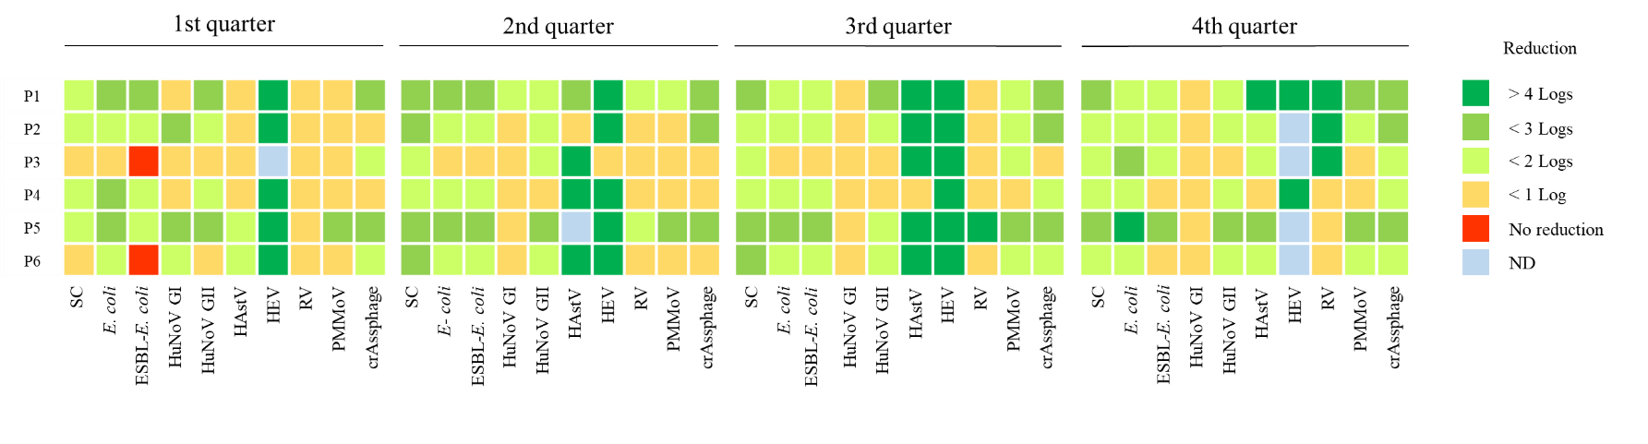

Figure S1. Reduction in the levels of human pathogenic viruses, viral faecal contamination indicators and E. coli during the water reclamation process in samples collected from six different WWTPs (P1-P6). SC: Somatic coliphages; ND: Not detected.

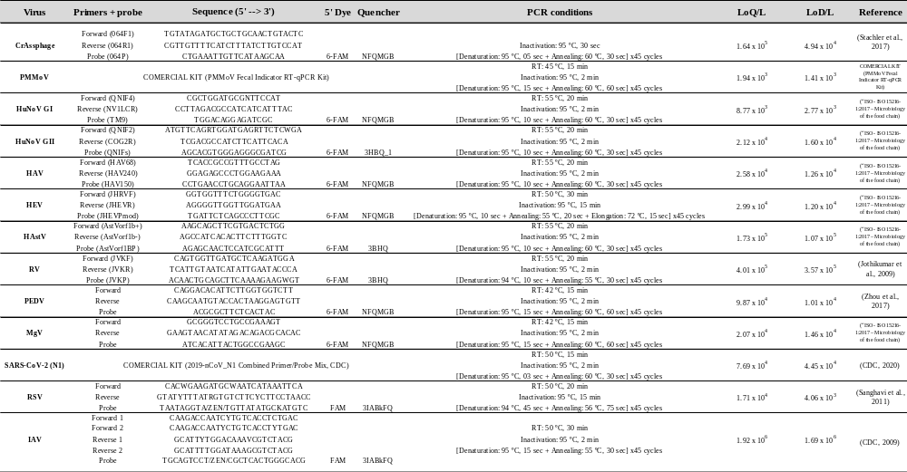
Table S1. Primers, probes, PCR conditions, limit of quantification (LOQ/L), and limit of detection (LOD/L) for all targeted viruses in this work.

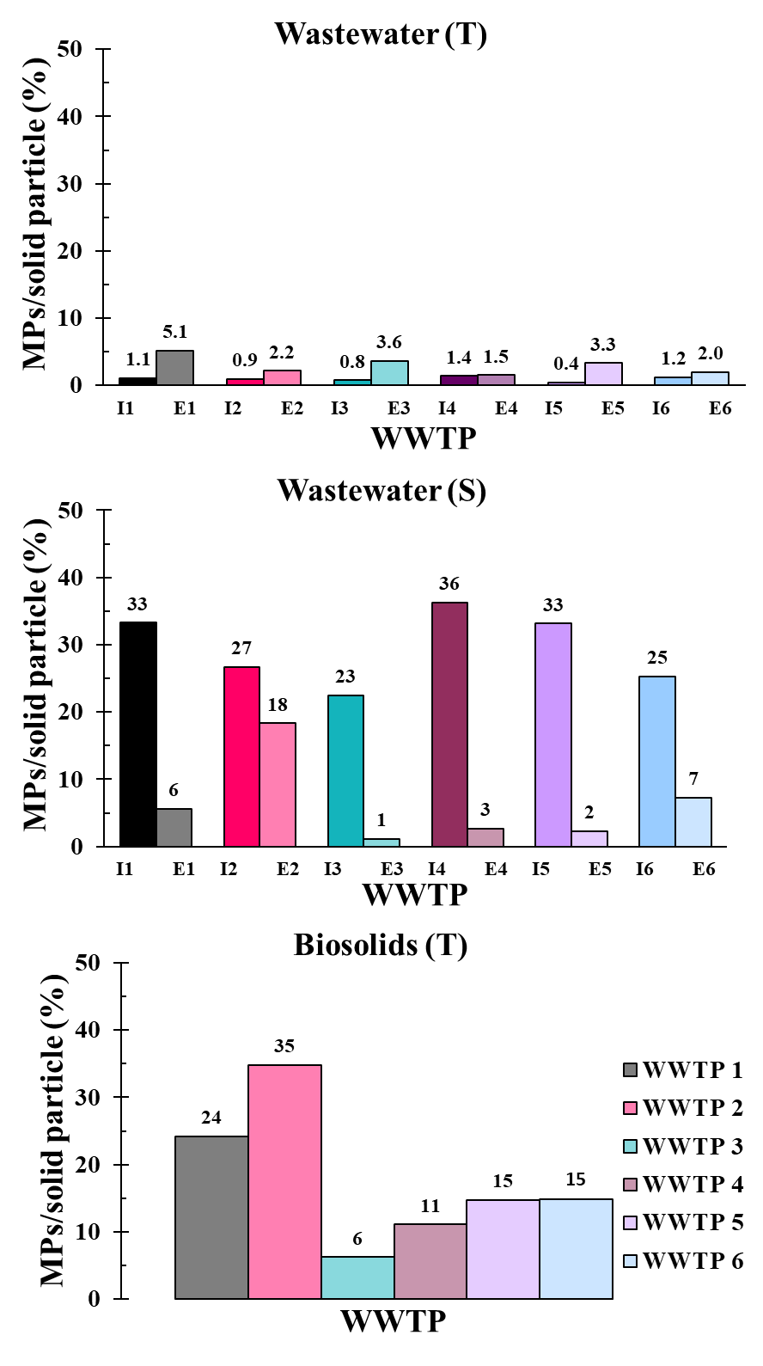

Figure S2. Annual average percentage of MPs respect to all solid particles in influent (I) and effluent (E) wastewater samples and in biosolids samples.

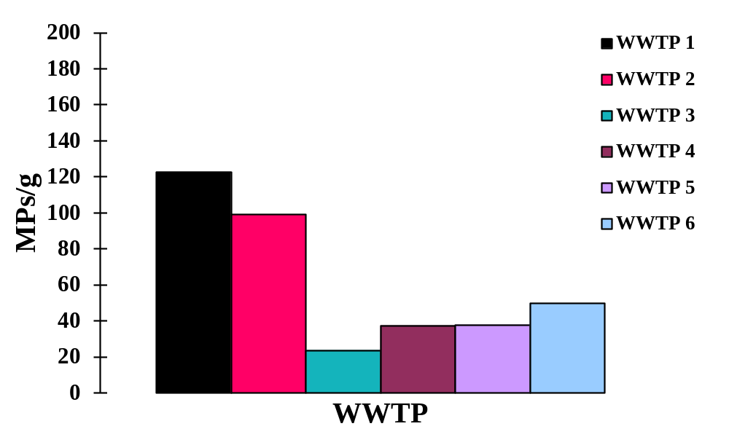
Figure S3. Annual average concentration of (S)-MPs (larger than 300 μm) in biosolids collected from six different WWTPs.

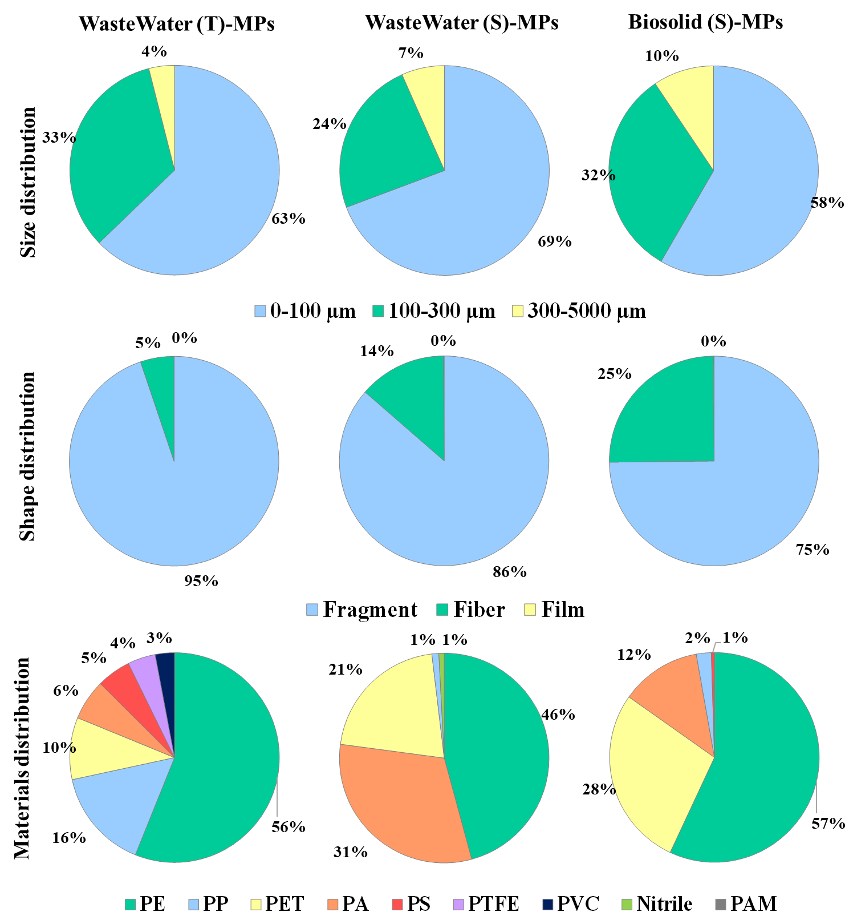
Figure S4. Morphological distribution of type, size, and shape of all identified MPs from six different WWTPs (P1-P6) in influent and effluent wastewaters and biosolids. PE: polyethylene; PET: polyethylene terephthalate; PA: polyamide; PP: polypropylene; PS: polystyrene; PVC: polyvinyl chloride; PTFE: polytetrafluoroethylene; PAM: polyacrylamide.
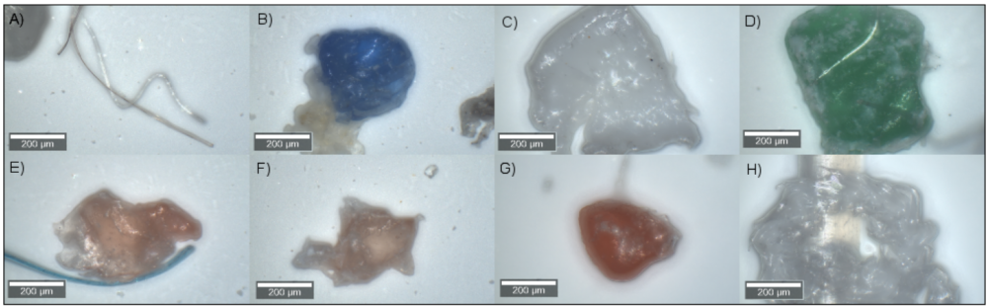

Figure S5. Examples of identified microplastics. A) PET; B-C-D) PP; E-F-G-H) PE. PE: polyethylene; PET: polyethylene terephthalate; PP: polypropylene.
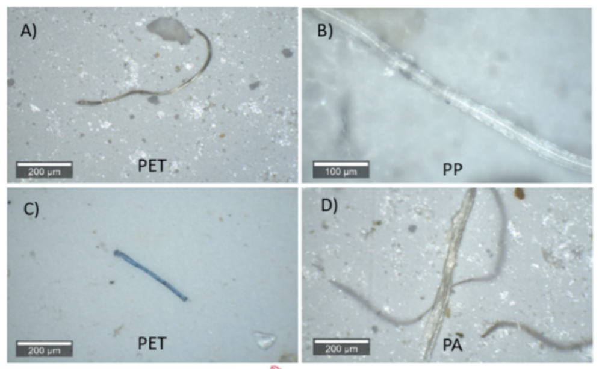

Figure S6. Optical microscopy images of microplastic fibers identified in the wastewater and biosolid samples

