Table 1: Antimicrobial activity of different concentrations of ethanolic extract of leaves of L.camara.
S. No. | Microbe’s Name | Concentration of ethanolic extract of L.camara (gm/100ml) (%) | Zone of Inhibition (mm)
A. | Bacterial Strains (Bacteria)
1. | M.luteus | 1 | No zone
1. | M.luteus | 5 | 11.66
1. | M.luteus | 10 | 11.0
2. | C.freundii | 1 | No zone
2. | C.freundii | 5 | 16.6
2. | C.freundii | 10 | 18.0
3. | S.aureus | 1 | No zone
3. | S.aureus | 5 | No zone
3. | S.aureus | 10 | No zone
B. | Fungal Strains (Fungi)
 | A.niger | 1 | 10.66
 | A.niger | 5 | 10.33
 | A.niger | 10 | 11.66
2. | P.sinensis | 1 | No zone
2. | P.sinensis | 5 | No zone
2. | P.sinensis | 10 | No zone

Table 2: GC-MS analysis of ethanolic extract of L.camara leaves
S.No. | FUNCTIONAL GROUP | NAME OF COMPOUND | CHEMICAL STRUCTURE | RT (Retention Time) | AREA% | APPLICATIONS
1. | Benzoic acid | Diethyl Phthalate  C₁₂H₁₄O₄ | 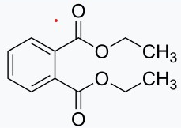 | 14.053 | 81.40 | Making plastics, insecticides, cosmetics and aspirin. (https://pubchem.ncbi.nlm.nih.gov/compound/Diethyl-phthalate)
1. | Benzoic acid | Dibutylphthalate  C₁₆H₂₂O₄ | 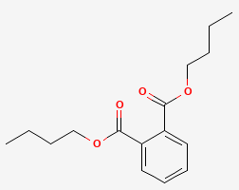 | 17.897 | 0.50 | Used as a plasticizer. Also used in some cosmetic products like nail polishes. Used in printing inks and ectoparasiticide. (https://pubchem.ncbi.nlm.nih.gov/compound/Dibutyl-phthalate)
1. | Benzoic acid | Di-n-octylphthalate  C₂₄H₃₈O₄ | 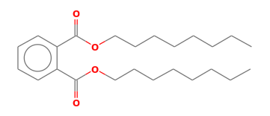 | 23.419 | 0.15 | Colorless viscous liquid, use in plastics, coating products cosmetics and pesticides. (https://pubchem.ncbi.nlm.nih.gov/compound/Dioctyl-phthalate)
2. | Carboxy group | 2-amino-3-cyano-6-methyl-4,5,6,7-tetra hydropyrido(3,4-b)thiophene  C₉H₁₁N₃S | 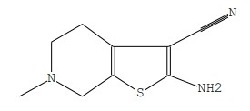 | 14.457 | 0.06 | Primary bile acid, insoluble in water, white crystalline substance.  (https://pubchem.ncbi.nlm.nih.gov/compound/Acetophenone-thiosemicarbazone)
3. | Carbonyl group | 2-Pentadecanone,6,10,14-trimethyl  C₁₈H₃₆O | 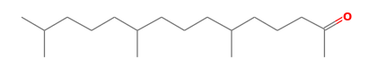 | 16.655 | 0.25 | Used by several species of insect as a pheromone. (https://pubchem.ncbi.nlm.nih.gov/compound/6_10_14-Trimethylpentadecan-2-one#section=Depositor-Supplied-Synonyms)
3. | Carbonyl group | 8-Octadecanone  C₁₈H₃₆O | 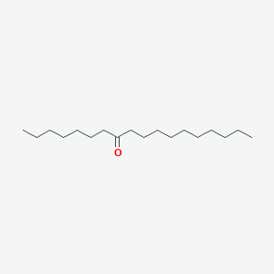 | 14.823 | 0.25 | -
4. | Hydroxyl group + alcohol | (S,E)-6-Hydroxy-6-methyl-2-((2S,5R)-5-methyl-5-vinyltetr  C₁₅H₂₄O₃ | 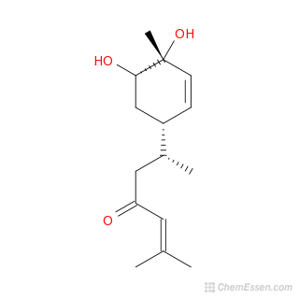 | 15.121 | 0.11 | Taken from turmeric. In vitro, it has several effects including anti-inflammatory, anti-oxidant, and anti-metastatic properties.(https://pubchem.ncbi.nlm.nih.gov/compound/Walleminone)
4. | Hydroxyl group + alcohol | (S,E)-6-Hydroxy-6-methyl-2-((2S,5R)-5-methyl-5-vinyltetr  C₁₅H₂₄O₃ |  | 15.199 | 0.43 | Taken from turmeric. In vitro, it has several effects including anti-inflammatory, anti-oxidant, and anti-metastatic properties.  (https://pubchem.ncbi.nlm.nih.gov/compound/Walleminone)
4. | Hydroxyl group + alcohol | Ledol  C₁₅H₂₆O | 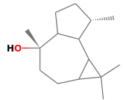 | 16.077 | 0.44 | Poisonous sesquiterpene that can cause cramps, paralysis, and delirium. Caucasian peasants used Rhododendron plants for these effects in shamanistic rituals. (https://en.wikipedia.org/wiki/Ledol)
4. | Hydroxyl group + alcohol | 1,6,10,14,18,22-Tetracosahexaen-3-ol,2,6,10,15,19,23-hexamethyl-  C₃₀H₅₀O | 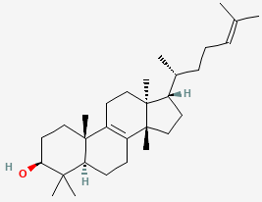 | 28.802 | 0.06 | It has several potential medicinal properties, like anticancer and anti-inflammatory activity. found in a variety of plants. It has a complex pharmacology, displaying antiprotozoal, antimicrobial, antiinflammatory, antitumor and chemopreventive properties. (https://pubchem.ncbi.nlm.nih.gov/compound/5366014)
4. | Hydroxyl group + alcohol | (1R,3E,7E,11R)-1,5,5,8-Tetramethyl-12-oxabicyclo[9.1.0]d/ Humulene epoxide  C₁₅H₂₄O | 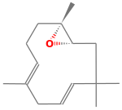 | 14.275 | 0.64 | Useful for its antioxidant properties, antiinflammatory activity. a food additive.(https://pubchem.ncbi.nlm.nih.gov/compound/Humulene-epoxide)
4. | Hydroxyl group + alcohol | Cedran-diol,(8S,14)-  C₁₅H₂₆O₂ | 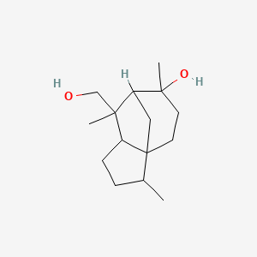 | 35.347 | 1.61 | -
5. | Oxolanes | LilacalcoholD  C₁₀H₁₈O₂ | 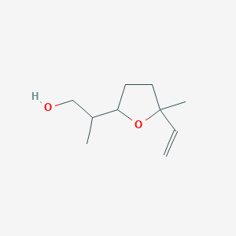 | 15.404 | 0.52 | Found in many flowers and spice plants. pleasant smell. an antimicrobial agent, and an aroma compound. used in manufacturing of soaps, fragrances, food additives as flavors, household products, and insecticides. (https://pubchem.ncbi.nlm.nih.gov/compound/Lilac-alcohol)
6. | Methyl group | Pregn-4-ene-3,20-dione / beta.-progesterone  C₂₁H₃₀O₂ | 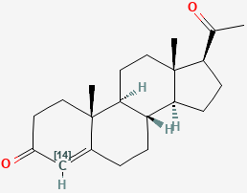 | 16.402 | 0.37 | Popular herbal dietary supplement. Used in treatment of cancer. it acts as an antagonist. (https://pubchem.ncbi.nlm.nih.gov/compound/Pregn-4-ene-3_20-dione-4-14C)
6. | Methyl group | Neophytadiene  C₂₀H₃₈ | 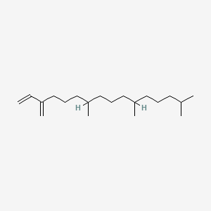 | 16.569 | 0.23 | It has a role as an anti-inflammatory agent, an antimicrobial agent, a plant metabolite and an algal metabolite.  (https://pubchem.ncbi.nlm.nih.gov/compound/Neophytadiene)
6. | Methyl group | Phytol, acetate  C₂₂H₄₂O₂ | 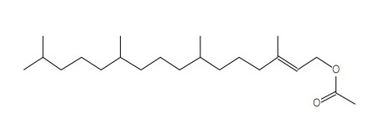 | 16.823 | 0.07 | Phytol has been investigated for its potential anxiolytic, metabolism-modulating, cytotoxic, antioxidant, autophagy- and apoptosis-inducing, antinociceptive, anti-inflammatory, immune-modulating, and antimicrobial effects. (https://pubchem.ncbi.nlm.nih.gov/compound/Phytyl-acetate)
6. | Methyl group | Geranyl linalool isomer b  C₂₀H₃₄O | 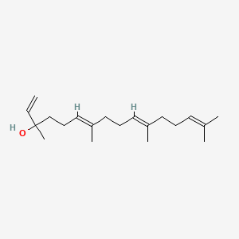 | 18.509 | 0.11 | Colorless waxy solid. It also used in the post-translational modification known as geranylgeranylation. Geranylgeraniol is a pheromone for bumblebees and a variety of other insects.  (https://pubchem.ncbi.nlm.nih.gov/compound/5365872)
6. | Methyl group | Undec-10-ynoicacid,tridec-2-yn-1-ylester  C₂₄H₄₀O₂ | 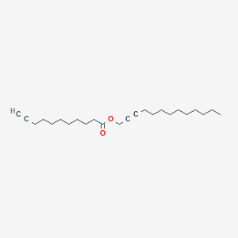 | 14.531 | 0.63 | Used by predators to locate blood or prey.  (https://pubchem.ncbi.nlm.nih.gov/compound/Undec-10-ynoic-acid_-tridec-2-yn-1-yl-ester)
6. | Methyl group | Phytol $$ 2-Hexadecen-1-ol, 3,7,11,15-tetramethyl-  C₂₀H₄₀O | 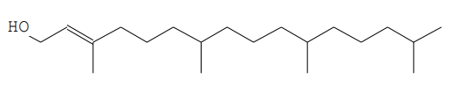 | 19.303 | 1.88 | Potential anxiolytic, metabolism-modulating, cytotoxic, antioxidant, autophagy- and apoptosis-inducing, antinociceptive, anti-inflammatory, immune-modulating, and antimicrobial effects.  (https://pubchem.ncbi.nlm.nih.gov/compound/Phytyl-acetate)
7. | Alkaloid group | 1H-purine-2,6-dione, 3,7-dihydro-1,3,7-trimeth / coffein  C₈H₁₀N₄O₂ | 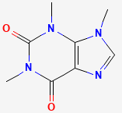 | 17.197 | 0.46 | Applied to various insects (milkweed bugs, caterpillars, mosquito larvae, etc.) cause agitation, reduce appetite, inhibit reproduction, and can even lead to death. Caffeine-treated mosquito larvae, for example, become so poorly coordinated that they can no longer swim and end up drowning. (https://laidbackgardener.blog/2017/11/29/caffeine-a-powerful-organic-insecticide/#:~:text=Caffeine%20extracts%20applied%20to%20various,swim%20and%20end%20up%20drowning.)
8. | Alkane hydrocarbon | Octadecane,1-isocyanato / Isocyanic acid, octadecyl ester  C₁₉H₃₇NO | 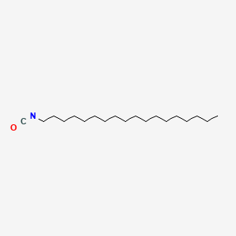 | 21.479 | 0.06 | Applications as auxiliary materials for wool fabric softeners and intermediates for synthetic auxiliaries. Also used for matrix interactions,to investigate in vitro hemocompatibility assay using freshly drawn human whole blood. (https://www.sigmaaldrich.com/IN/en/product/aldrich/305405)
9. | Monocarboxylic acid | 5Beta.-guaia-7(11),10(14)-dien-8.alpha.-ol, 5,8-epoxy-/isocurcumenol, (+)-  C₁₅H₂₂O₂ | 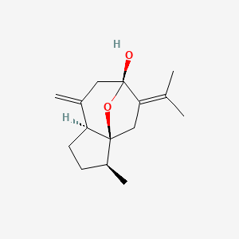 | 36.240 | 0.77 | Treating gastrointestinal disorders, pain, inflammatory conditions, wounds, and for cancer prevention and antiaging. (https://www.ncbi.nlm.nih.gov/pmc/articles/PMC6164907/)
10. | Triterpenoids | Squalene  C₃₀H₅₀ | 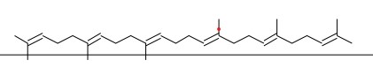 | 27.602 | 0.64 | It contains properties of anticancer, antioxidant, drug carrier, detoxifier, skin hydrating, and emollient activities. (https://pubmed.ncbi.nlm.nih.gov/22361190/#:~:text=Several%20studies%20exhibited%20results%20that,models%20and%20in%20vitro%20environments)

Table 3: Novel compounds found in GCMS analysis
S.No. | NAME OF COMPOUND | CHEMICAL STRUCTURE | RT | AREA%
1. | 2,4,7,14-Tetramethyl-4-vinyl-tricyclo[5.4.3.0(1,8)]tetradeca –  C₂₀H₃₄O | 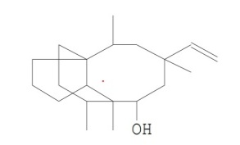 | 15.007 | 0.67
2. | 9-(3,3-Dimethyloxiran-2-yl)-2,7-dimethylnona-2,6-dien-1-o –  C₁₅H₂₆O₂ | 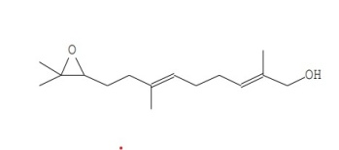 | 15.775 | 1.59
3. | Oxirane,hexadecyl-  C₁₈H₃₆O | 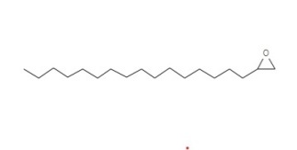 | 17.012 | 0.21
4. | Lanostan-3.beta.-ol,11.beta.,18-epoxy-19-iodo-,acetate –  C₃₂H₅₃IO₃ | 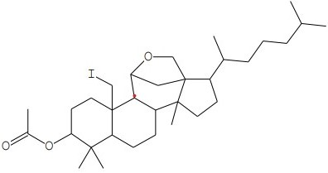 | 39.424 | 5.88

