Supplementary Information
Dual Ligand-Tuned Iron and Halogen-Contained Carboxylates-based Photocatalysis for Chloro/Fluoro-Polyhaloalkylation of Alkenes

Authors: Kui Jiang¹, Xuehan Yu¹, Yu Lan^{1,2,3}*, Wanru Han¹, Xiaoyu Jiang¹, Wei Yang¹, Zhenyan Zhao¹, Donghui Wei¹*, Shi-Jun Li^{1.2}*, and Linbin Niu^{1,2}*
Affiliations:
¹College of Chemistry, and Pingyuan Laboratory, Zhengzhou University, 100 Science Avenue, Zhengzhou 450001, Henan (P. R. China).
²State Key Laboratory of Antiviral Drugs, Pingyuan Laboratory, Henan Normal University, Xinxiang 453007, Henan (P. R. China).
³School of Chemistry and Chemical Engineering, Chongqing Key Laboratory of Chemical Theory and Mechanism, Chongqing University, Chongqing 401331 (P. R. China).
⁴These authors contributed equally to this work.
*Corresponding author. E-mail: lanyu@cqu.edu.cn, donghuiwei@zzu.edu.cn, lishijunzong@zzu.edu.cn, nlb@zzu.edu.cn.

Table of Contents
1. General information 3
2. Preparation of substrates 3
3. Experimental procedures for chloro/fluoro-polyhaloalkylation of alkenes 5
3.1 Stoichiometric Fe(CF₃CO₂)₃ promoting Chloro-trifluoromethylation of alkenes under UV light irradiation 5
3.2 General procedure for Standard condition A 6
3.3 General procedure for Standard condition B 7
3.4 Procedure for gram-scale synthesis 7
3.5 Procedure for TON experiments 8
3.6 Deviation from Standard condition A 8
3.7 Deviation from Standard condition B 10
4. Mechanistic studies 11
4.1 DFT calculations 11
4.1.1 Free energies for possible light-harvesting species 11
4.1.2 Cartesian coordination of the optimized structures 12
4.1.3 TD-DFT calculations 31
4.1.4 Free energies for the key species in the calculations 34
4.1.5 Cartesian coordination for the key species 36
4.2 General procedure for UV-Vis experiments 43
4.2.1 UV-Vis spectra for Fe(III) species 43
4.2.2 UV-Vis spectra for ligand-Fe(III) species 44
4.2.3 UV-Vis spectra for ligand-Fe(II) species 45
4.3 General procedure for radical probe experiments 45
5. Data for products 46
6. Reference 56
7. Copies of ¹H NMR, ¹³C NMR and ¹⁹F NMR Spectra 58

1. General information
All reagents and catalysts were purchased from commercial sources and used without further purification, and all manipulations were carried out by standard Schlenk techniques. LED irradiation was accomplished using the photochemical reactors (Figure S1), λ_{max}= 450 nm (Figure S2). Thin layer chromatography (TLC) employed glass 0.20 mm-0.25 mm silica gel plates. Purification of products was accomplished using flash chromatography on silica gel. All the new compounds were characterized by ¹H NMR, ¹³C NMR, ¹⁹F NMR and HRMS. The known compounds were characterized by ¹H NMR, ¹³C NMR, ¹⁹F NMR and HRMS. NMR spectra were recorded on a Bruker 400 instrument operating at 400, 101, and 376 MHz for ¹H NMR, ¹³C NMR and ¹⁹F NMR respectively. Chemical shifts (δ) were reported in ppm, and coupling constants (J) are in Hertz (Hz). Data was reported in ppm using CDCl₃ (¹H NMR δ 7.26, ¹³C NMR δ 77.16) or DMSO-d₆ (¹H NMR δ 2.50, ¹³C NMR δ 39.53) as solvent unless otherwise specified. High-resolution mass data was recorded on mass spectrometers in the ESI mode.
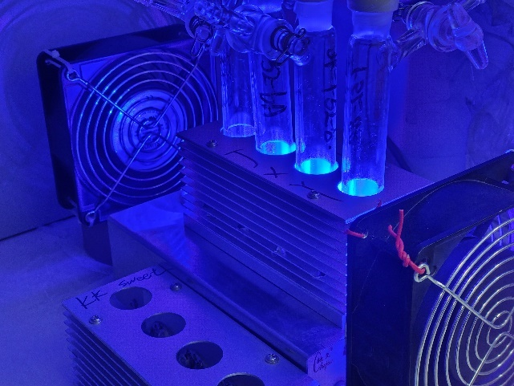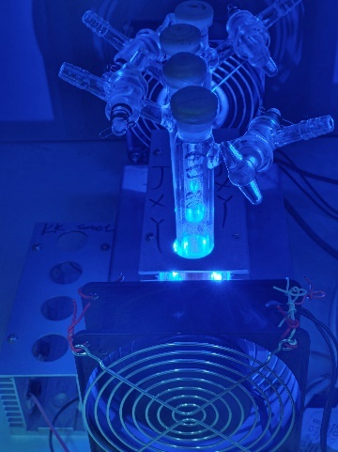
Figure S1. The photochemical reactors.
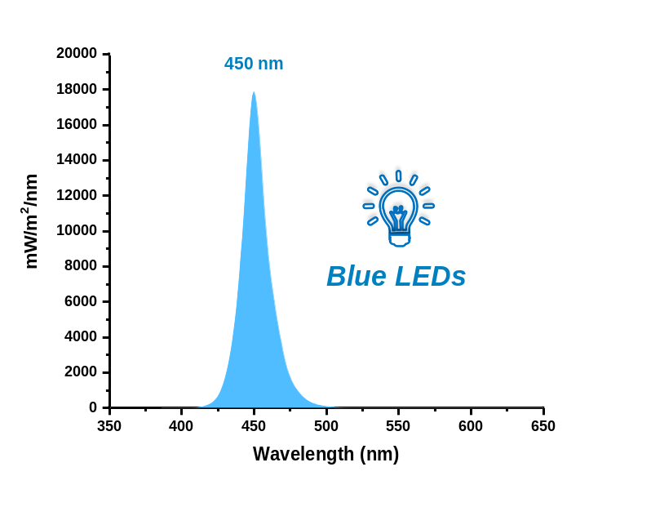
Figure S2. The wavelength spectrum of photochemical reactors.

2. Preparation of substrates
To the solution of the corresponding acid (3.0 mmol) in dry CH₂Cl₂ (28.0 mL) was added N,N'-dicyclohexylcarbodiimide (3.6 mmol), 4-dimethylaminopyridine (2.01 mmol) and alcohol (3.0 mmol). The reaction mixture was left stirring for 24 h. After full conversion, the precipitate was removed by filtration and the solvent was removed in vacuum. The residue was purified by silica gel column chromatography to afford the products (Figure S3)¹.
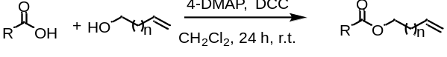
Figure S3. Method A for the synthesis of non-activated alkenes. DCC: Dicyclohexylcarbodiimide, 4-DMAP: 4-Dimethylaminopyridine.

To the solution of the corresponding phenol (0.5 mmol) and K₂CO₃ (1.0 mmol) in acetone (20.0 mL) was added allyl bromide (0.6 mmol). The resulting mixture was then stirred at reflux for 12 h and then filtered through a celite pad and washed with EtOAc. The filtrate was concentrated and the residue was purified by silica gel column chromatography using petroleum ether/EtOAc as the eluent to afford the products (Figure S4)¹.
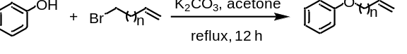
Figure S4. Method B for the synthesis of non-activated alkenes.

To the solution of the heterocycle derivative (5.0 mmol) and K₂CO₃ (10.0 mmol) in acetone (15.0 mL) was added allyl bromide (6.0 mmol). Heat to reaction to 60 ºC and stir for 2 h. After this time, quench the reaction with water. Extract the aqueous solution with ethyl acetone (×3), then wash the combined organic layers with brine and dry over Na₂SO₄, remove the organic solvent under reduced pressure. Subject the residue to flash column chromatography on silica gel with hexanes/ethyl acetate as the eluent to afford the products (Figure S5)².
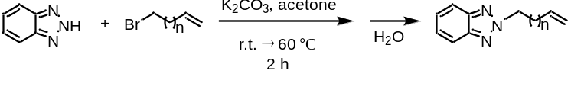
Figure S5. Method C for the synthesis of non-activated alkenes.

To a 50 mL Schlenk tube, iron(III) chloride (5.0 mmol) and silver trifluoroacetate (15.0 mmol) were dissolved in dichloroethane (15.0 mL) and reacted for 3 h at room temperature. The precipitate AgCl was filtered and the residue was washed with acetone. The corresponding filtrate was concentrated under reduced pressure and the resulting product was dried at 80 ºC for 1 h. Iron(III) trifluoroacetate was obtained as red solid (Figure S6)³.
Figure S6. The synthesis of Fe(CF₃COO)_{3.}

3. Experimental procedures for chloro/fluoro-polyhaloalkylation of alkenes

3.1 Stoichiometric Fe(CF₃CO₂)₃ promoting Chloro-trifluoromethylation of alkenes under UV light irradiation
A 25-mL Schlenk flask equipped with a magnetic bar was charged with Fe(CF₃CO₂)₃ (0.2 mmol). The flask was evacuated and refilled with N₂ for three times. The vessel was then charged with extra dry CH₃CN (1.0 mL), alkene 1 (0.2 mmol), Cl₃CCN (1.0 mL). The reaction mixture was stirred under nitrogen atmosphere and irradiated by 365 nm LEDs for 24 h. After completion of the reaction, the system was diluted with EtOAc. After concentrated under vacuum, the resulting residue was purified by silica gel flash column chromatography to give the product 2, and by-product (bp-1) (Figure S7).
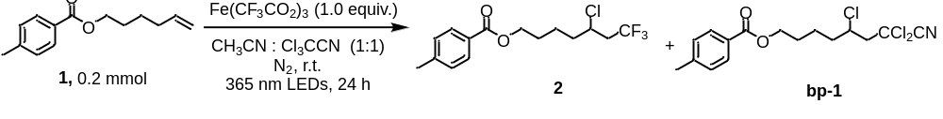
Figure S7. Chloro-trifluoromethylation of alkenes.

Data for bp-1:
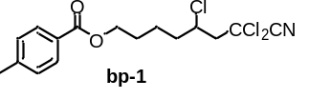
5,7,7-Trichloro-7-cyanoheptyl 4-methylbenzoate (bp-1): 18.2 mg colorless liquid was isolated, yield: 25%. ¹H NMR (400 MHz, Chloroform-d) δ 7.93 (d, J = 8.2 Hz, 2H), 7.24 (d, J = 8.0 Hz, 2H), 4.33 (t, J = 6.3 Hz, 1H), 4.26 – 4.19 (m, 1H), 3.08 – 2.98 (m, 1H), 2.92 – 2.82 (m, 1H), 2.41 (s, 3H), 1.99 – 1.63 (m, 6H). ¹³C NMR (101 MHz, Chloroform-d) δ 166.66, 143.67, 129.58, 129.12, 127.49, 115.11, 66.42, 64.18, 56.40, 55.07, 37.97, 28.03, 22.57, 21.68. HRMS (ESI) exact mass calculated for [C₁₆H₁₈Cl₃NO₂Na⁺]: 384.0295, found 384.0299.
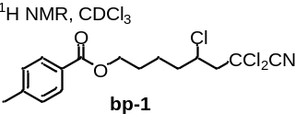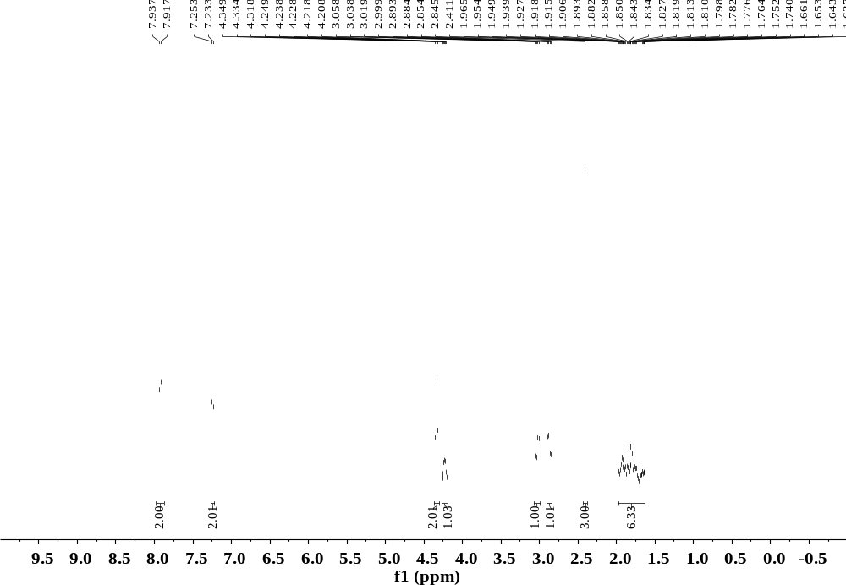
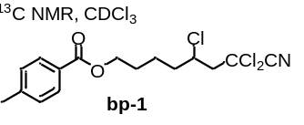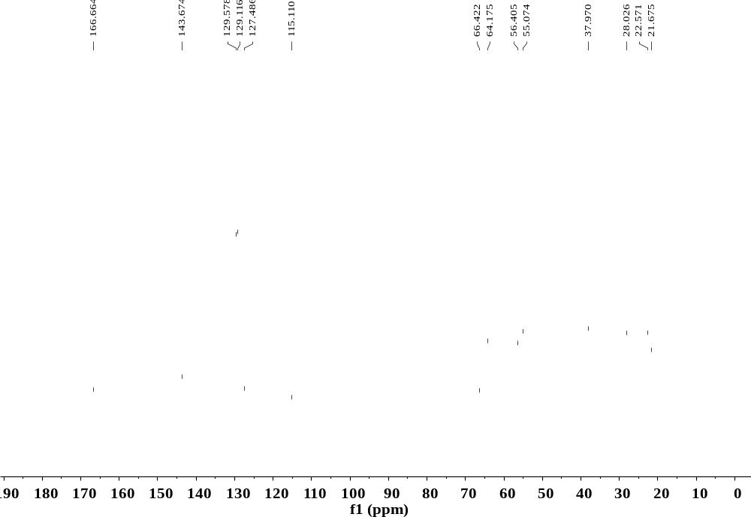

3.2 General procedure for Standard condition A
A 25-mL Schlenk flask equipped with a magnetic bar was charged with Fe(OTf)₃ (0.02 mmol) and L2 (0.03 mmol), CF₃COONa (0.6 mmol). The flask was evacuated and refilled with N₂ for three times. The vessel was then charged with extra dry CH₃CN (1.0 mL), alkene 1 (0.2 mmol), Cl₃CCN (1.0 mL). The reaction mixture was stirred under nitrogen atmosphere and irradiated by Blue LEDs for 24 h. After completion of the reaction, the system was diluted with EtOAc. After concentrated under vacuum, the resulting residue was purified by silica gel flash column chromatography to give the products (Figure S8).
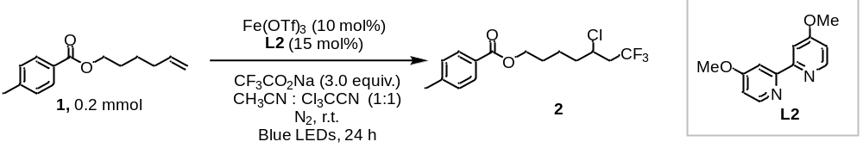
Figure S8. Iron LMCT photocatalysis for radical chlorotrifluoromethylation of non-activated alkenes.

3.3 General procedure for Standard condition B
A 25-mL Schlenk flask equipped with a magnetic bar was charged with Fe(OTf)₃ (0.02 mmol) and L4 (0.02 mmol), CClF₂COONa (0.6 mmol), selectfluor (0.3 mmol). The flask was evacuated and refilled with N₂ for three times. The vessel was then charged with extra dry CH₃CN (2.0 mL), alkene S3 (0.2 mmol), anisole (0.08 mmol). The reaction mixture was stirred under nitrogen atmosphere and irradiated by blue LEDs for 12 h. After completion of the reaction, the system was diluted with EtOAc. After concentrated under vacuum, the resulting residue was purified by silica gel flash column chromatography to give the products (Figure S9).
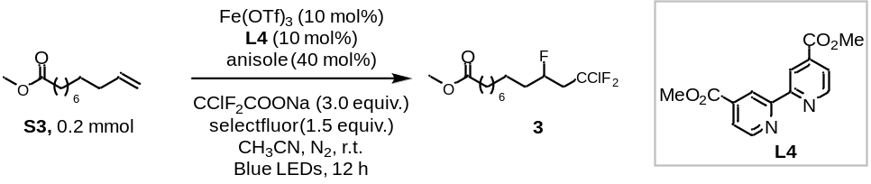
Figure S9. Iron LMCT photocatalysis for radical fluoro-chlorodifluoromethylation of non-activated alkenes.

3.4 Procedure for gram-scale synthesis
A 200-mL Schlenk flask equipped with a magnetic bar was charged with Fe(OTf)₃ (1.2 mmol) and L2 (1.8 mmol), CF₃COONa (36.0 mmol). The flask was evacuated and refilled with N₂ for three times. The vessel was then charged with extra dry CH₃CN (60.0 mL), alkene 1 (5.0 mmol), Cl₃CCN (60.0 mL). The reaction mixture was stirred under nitrogen atmosphere and irradiated by blue LEDs for 7 days. After completion of the reaction, the system was diluted with EtOAc. After concentrated under vacuum, the resulting residue was purified by silica gel flash column chromatography to give the product (Figure S10).
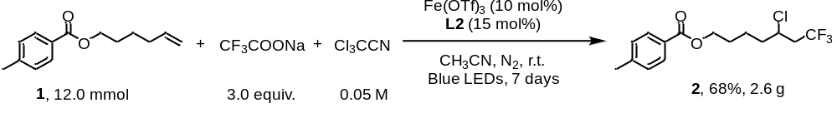
Figure S10. The gram-scale reaction.

3.5 Procedure for TON experiments
A 50-mL Schlenk flask equipped with a magnetic bar was charged with Fe(OTf)₃ (0.006 mmol) and L2 (0.009 mmol), CF₃COONa (6.0 mmol). The flask was evacuated and refilled with N₂ for three times. The vessel was then charged with extra dry CH₃CN (10.0 mL), alkene 1 (2.0 mmol), Cl₃CCN (10.0 mL). The reaction mixture was stirred under nitrogen atmosphere and irradiated by blue LEDs for 7 days. After completion of the reaction, the system was diluted with EtOAc. After concentrated under vacuum, the resulting residue was purified by silica gel flash column chromatography to give the product (Figure S11).
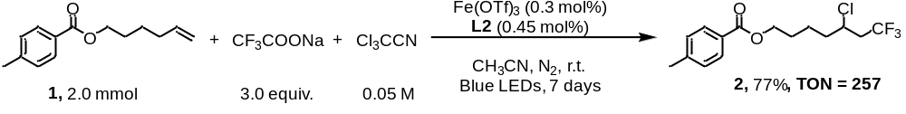
Figure S11. The TON experiments.

3.6 Deviation from Standard condition A
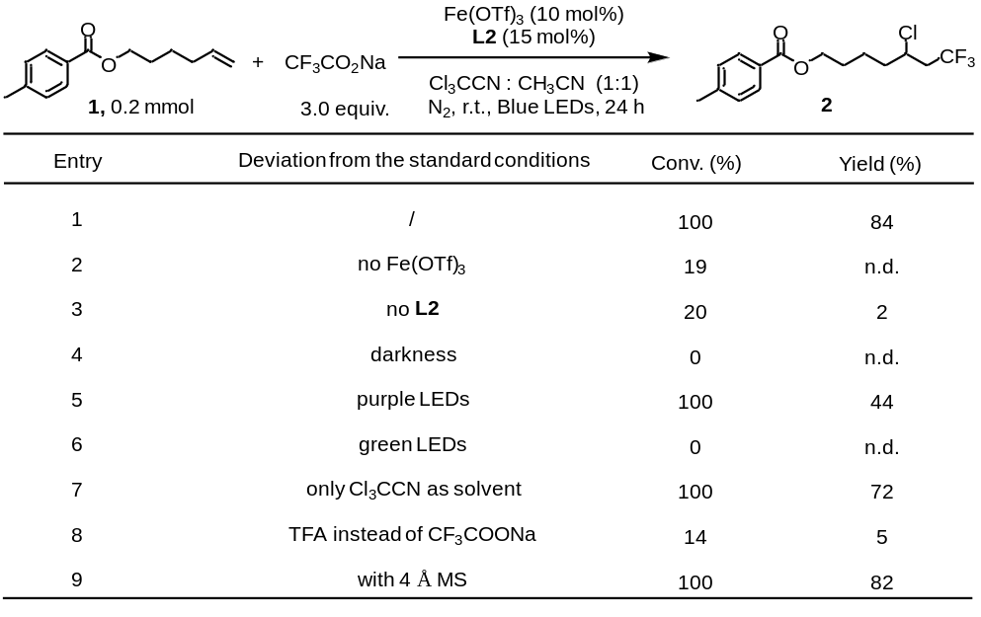
Figure S12. The results of deviation from Standard condition A. Yields and conversion rates were determined by GC analysis of the crude reaction mixture, using biphenyl as an internal standard.

Investigation of ligands：
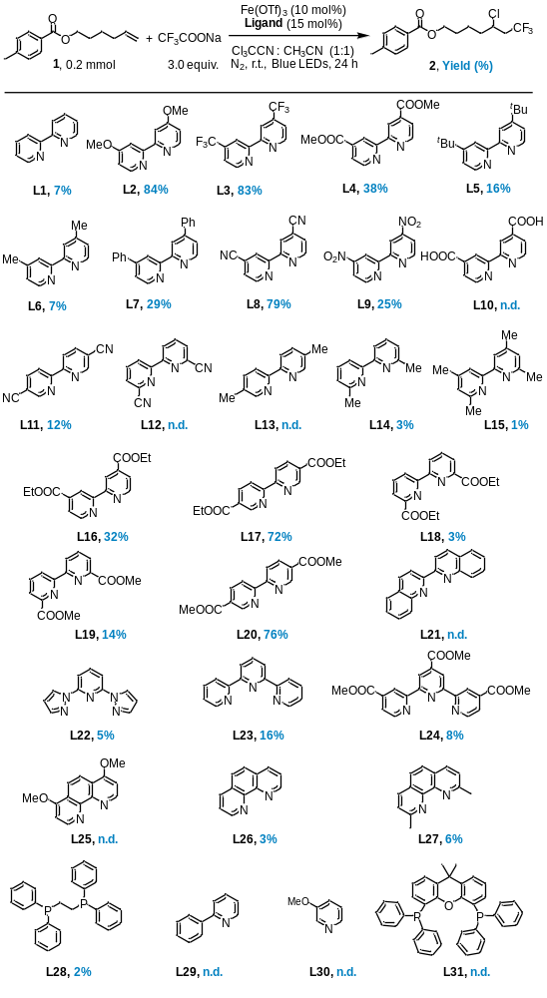
Figure S13. The results of investigation of ligands. Yields were determined by GC analysis of the crude reaction mixture, using biphenyl as an internal standard.
Investigation of solvents：
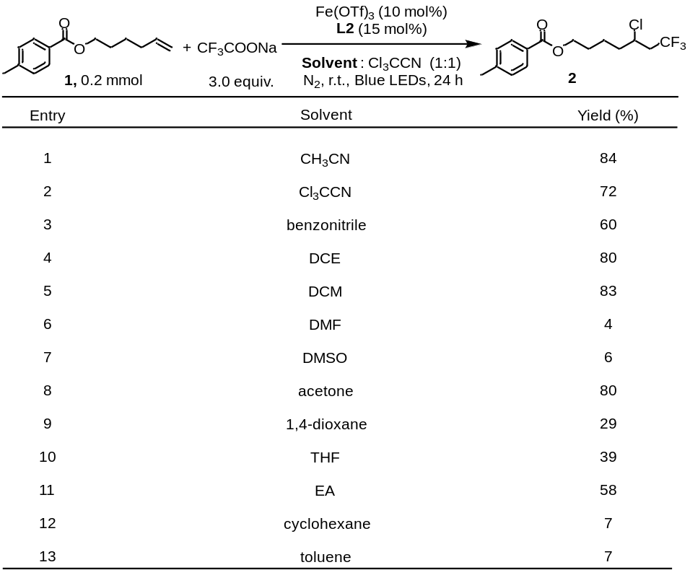
Figure S14. The results of investigation of solvent. Yields were determined by GC analysis of the crude reaction mixture, using biphenyl as an internal standard.

3.7 Deviation from Standard condition B
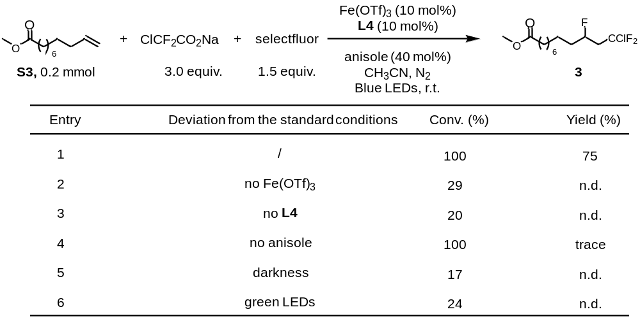
Figure S15. The results of deviation from Standard condition B. Yields and conversion rates were determined by GC analysis of the crude reaction mixture, using biphenyl as an internal standard.

As shown in Figure S15, under the standard condition, product 3 could be obtained in 75% yield and 100% conversion rate with anisole (Entry 1). However, there was trace amount of product detected in absence of anisole, but the conversion rate still remained 100% (Entry 4). Based on previous report⁴, anisole was considered to act as a redox buffer to reduce the reactivity of N radical cation generated from selectfluor to avoid alkene converting into aminated products (Figure S16).
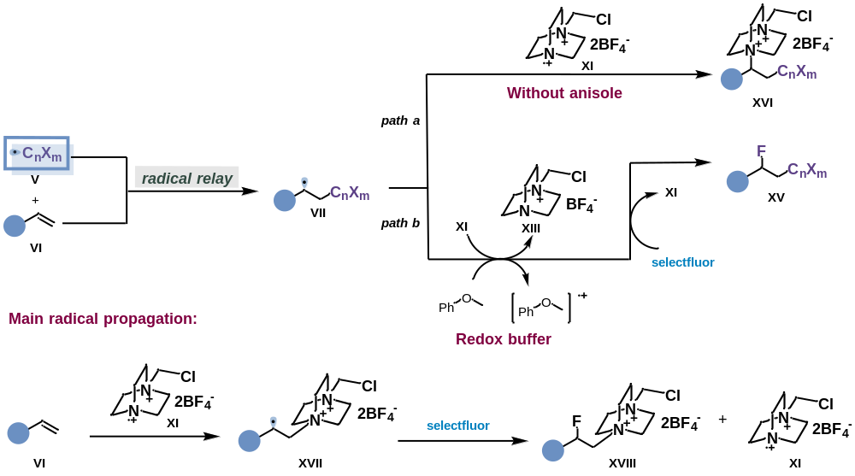
Figure S16. Anisole as a redox buffer.

4. Mechanistic studies

4.1 DFT calculations

4.1.1 Free energies for possible light-harvesting species

Species / ΔG（kcal/mol） | Gibbs free energy | Gibbs free energy with the Fang’s entropy correction
Fe(TFA)₃ (IntA) / 0.0 | -2842.263499 | -2842.24605
L2 | -724.277027 | -724.26669
CF₃CO₂⁻ | -526.333494 | -526.32218
CH₃CN | -132.745397 | -132.73426
CCl₃CN | -1511.510476 | -1511.49972
fetfa3-ome (IntE) / -42.2 | -3566.589872 | -3566.57998
fetfa2-ome (IntF) / -9.9 | -3040.216289 | -3040.20626
fetfa2-mecn-ome (IntG) / -16.5 | -3172.960958 | -3172.95109
fetfa2-mecn-b-ome  (IntG1) / -14.7 | -3172.958151 | -3172.94829
fetfa2-2mecn-b-ome  (IntB) / -20.8 | -3305.701959 | -3305.69224
fetfa2-2mecn-ome  (IntB1) / -20.9 | -3305.702152 | -3305.69244
fetfa2-2mecn-ome-c  (IntB2) / -15.9 | -3305.694061 | -3305.68434
fetfa2-mecn-ome-cl3  (IntD) / -7.8 | -4551.712437 | -4551.70268
fetfa2-2mecn-ome-bcl  (IntD1 / -6.0 | -6063.20919 | -6063.19964
fetfa2-mecn-ome-r1  (IntC) / -14.8 | -3695.4926 | -3695.48297
1 | -655.279172 | -655.26883
Table S1. Free energies for possible light-harvesting species.

4.1.2 Cartesian coordination of the optimized structures
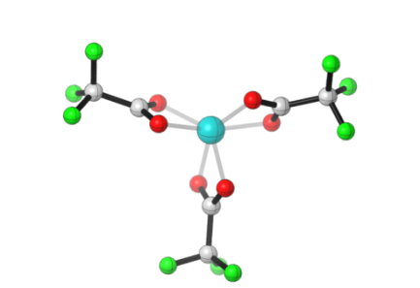
Fe(CF₃CO₂)₃
(IntA)
Fe -0.53682 -0.28552 0.91333
O -2.27761 -0.20829 -0.30283
C -2.59755 0.83104 0.33050
O -1.82692 1.27988 1.23478
O 0.60677 0.59827 -0.54727
C 0.77005 -0.53812 -1.09186
O 0.30095 -1.57113 -0.54475
O -0.16204 -0.38388 2.94826
C -0.88894 -1.42008 3.00944
O -1.42439 -1.87342 1.95968
C 1.46689 -0.63406 -2.45912
C -1.06988 -2.14651 4.35263
C -3.93965 1.53461 0.06949
F -3.78018 2.86353 0.09456
F -4.44398 1.17618 -1.11415
F -4.80713 1.18633 1.03496
F 2.38338 0.33031 -2.59413
F 2.05785 -1.82422 -2.60617
F 0.54181 -0.48902 -3.42413
F -0.11418 -3.08424 4.47047
F -0.95813 -1.28835 5.37175
F -2.26597 -2.74121 4.40896

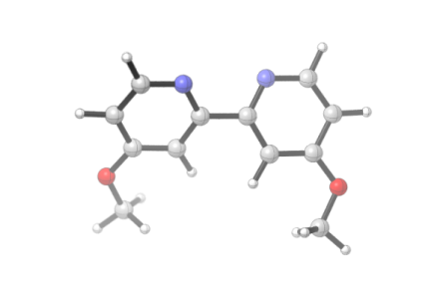
L2
C -1.26392 -2.66566 -0.55264
C -2.35527 -3.47760 -0.27746
C -3.54496 -2.86626 0.14354
C -3.57067 -1.47211 0.25956
C -2.41058 -0.74688 -0.05388
N -1.26531 -1.32738 -0.45043
H -0.32984 -3.11866 -0.87973
H -2.30140 -4.55587 -0.37593
H -4.45431 -0.95489 0.60831
C -2.41077 0.74713 0.05170
C -3.57079 1.47212 -0.26250
N -1.26587 1.32786 0.44900
C -3.54544 2.86628 -0.14646
H -4.45410 0.95473 -0.61182
C -1.26482 2.66614 0.55121
C -2.35615 3.47786 0.27532
H -0.33104 3.11933 0.87890
H -2.30256 4.55614 0.37382
O -4.58543 3.68643 -0.41917
O -4.58496 -3.68662 0.41557
C -5.82189 -3.10615 0.84095
H -6.22562 -2.43165 0.07860
H -6.50581 -3.94178 0.98639
H -5.70176 -2.56440 1.78489
C -5.82196 3.10571 -0.84538
H -6.22606 2.43113 -0.08329
H -6.50595 3.94121 -0.99127
H -5.70109 2.56399 -1.78924

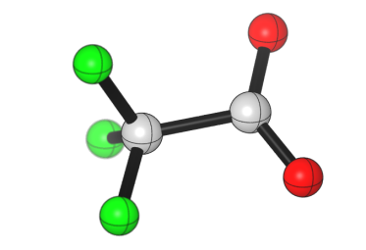
CF₃CO₂⁻
O -1.77903 -0.70500 1.32873
C -1.10276 -0.64742 2.37922
O 0.11612 -0.45547 2.56837
C -1.95920 -0.88489 3.66978
F -1.28450 -0.68401 4.82663
F -3.04838 -0.07207 3.71422
F -2.43252 -2.16142 3.71687

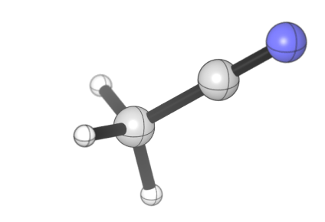
CH₃CN
C -0.23446 -0.61292 -3.65840
N -0.38236 -0.62883 -2.50688
C -0.04884 -0.59288 -5.10516
H -0.84193 -1.16563 -5.59240
H -0.07850 0.43608 -5.47229
H 0.91686 -1.03368 -5.36493

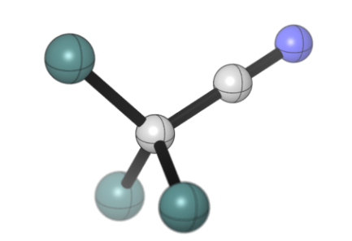
CCl₃CN
C -0.24899 -0.61426 -3.55447
N -0.40111 -0.63123 -2.40471
C -0.05889 -0.59373 -5.00417
Cl -1.37998 -1.54372 -5.77409
Cl -0.11516 1.11054 -5.57186
Cl 1.53490 -1.32546 -5.39077

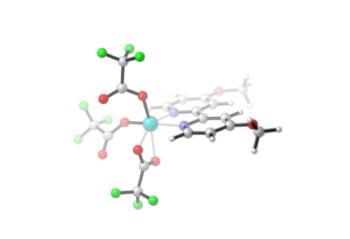
fetfa3-ome
(IntE)
C 1.67411 -2.37402 0.02045
C 3.00964 -2.74748 0.02442
C 3.97890 -1.73688 -0.06453
C 3.55329 -0.39840 -0.14966
C 2.19839 -0.11411 -0.14593
N 1.26685 -1.09863 -0.06588
H 0.89101 -3.12141 0.07829
H 3.26833 -3.79495 0.09494
H 4.30530 0.37685 -0.21238
C 1.64202 1.25971 -0.22428
C 2.43365 2.39641 -0.34830
N 0.29074 1.33194 -0.16903
C 1.81242 3.65360 -0.41960
H 3.50900 2.30838 -0.39102
C -0.30496 2.54210 -0.24658
C 0.40846 3.71530 -0.36985
H -1.38747 2.54000 -0.21257
H -0.09592 4.67172 -0.42874
Fe -0.77867 -0.47491 0.03337
O -0.83348 -0.80685 1.91757
C -1.81675 -1.19718 2.67627
O -2.86777 -1.71647 2.35150
O -2.46926 0.44504 -0.07792
C -3.57437 0.27452 -0.73504
O -3.88489 -0.62822 -1.49241
O -0.86299 -0.76278 -2.19951
C -1.29398 -1.90071 -1.91771
O -1.34918 -2.31894 -0.71619
C -1.50833 -0.92498 4.17076
C -4.57481 1.42263 -0.44408
C -1.72687 -2.86478 -3.03454
F -2.02436 -2.20240 -4.15991
F -0.71657 -3.71908 -3.30070
F -2.79657 -3.58412 -2.66566
F -5.68128 1.31990 -1.19216
F -4.00943 2.62463 -0.70099
F -4.94303 1.41497 0.85350
F -1.33860 0.39748 4.38362
F -2.50160 -1.34864 4.96456
F -0.37457 -1.55036 4.54896
O 2.45748 4.81781 -0.53669
C 3.89450 4.82724 -0.58974
H 4.31978 4.41446 0.32943
H 4.25537 4.26916 -1.45827
H 4.17300 5.87521 -0.68507
O 5.30140 -1.93342 -0.07447
C 5.80702 -3.27707 0.00890
H 5.49979 -3.74991 0.94588
H 5.46781 -3.87278 -0.84325
H 6.89095 -3.18066 -0.01703

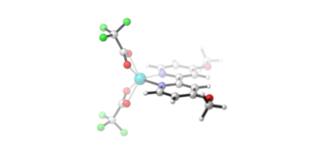
fetfa2-ome
(IntF)
C 0.27918 -2.42935 -0.95270
C 1.48086 -3.07332 -1.18788
C 2.67061 -2.34573 -1.01121
C 2.58943 -0.99729 -0.60813
C 1.34984 -0.42708 -0.39549
N 0.20447 -1.14306 -0.56721
H -0.66186 -2.95380 -1.07095
H 1.47518 -4.10973 -1.49541
H 3.50739 -0.44088 -0.47205
C 1.13446 0.97491 0.03073
C 2.14743 1.88935 0.24043
N -0.17307 1.31617 0.20276
C 1.82299 3.20188 0.63915
H 3.18946 1.63114 0.10515
C -0.48509 2.56742 0.58470
C 0.47032 3.54168 0.81508
H -1.53964 2.78768 0.70389
H 0.15596 4.53024 1.11964
Fe -1.57432 -0.16072 -0.18901
O -2.59675 0.16839 1.61439
C -2.72839 -1.08383 1.73875
O -2.27569 -1.85935 0.84980
O -2.79429 1.23329 -1.21189
C -2.93606 0.37838 -2.13020
O -2.39248 -0.76041 -2.02262
C -3.38666 -1.65895 3.00401
F -3.92277 -2.85862 2.75745
F -2.44917 -1.79252 3.95871
F -4.34198 -0.83700 3.45302
C -3.71571 0.73509 -3.40658
F -2.85435 1.21361 -4.32170
F -4.31822 -0.34798 -3.90997
F -4.63722 1.67028 -3.15397
O 2.85280 4.02710 0.81689
O 3.89906 -2.82631 -1.19310
C 4.06635 -4.19839 -1.59909
H 3.59667 -4.37262 -2.57069
H 5.14169 -4.34622 -1.67590
H 3.65065 -4.87533 -0.84818
C 2.60572 5.39005 1.21255
H 3.58921 5.84958 1.28853
H 2.01065 5.90835 0.45599
H 2.10298 5.42494 2.18261

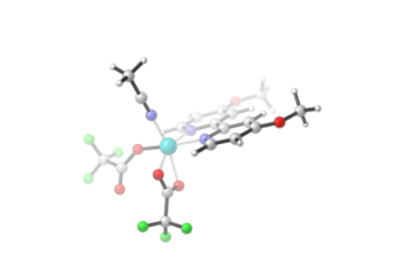
fetfa2-mecn-ome
(IntG)
C 1.82458 -2.33271 0.32981
C 3.15853 -2.64926 0.47230
C 4.11211 -1.61857 0.38727
C 3.66620 -0.30481 0.16238
C 2.30224 -0.07191 0.02984
N 1.39355 -1.07250 0.10981
H 1.05867 -3.09738 0.38288
H 3.47537 -3.66994 0.64619
H 4.36979 0.51164 0.09601
C 1.72041 1.27380 -0.20507
C 2.48269 2.42569 -0.34687
N 0.36532 1.30254 -0.27525
C 1.83085 3.65131 -0.57216
H 3.55985 2.37809 -0.28864
C -0.26036 2.48200 -0.49533
C 0.42566 3.66624 -0.64621
H -1.34123 2.44419 -0.55042
H -0.09941 4.59680 -0.82130
Fe -0.64218 -0.50174 -0.08651
O -2.37155 0.28450 -0.23081
C -3.43078 0.06592 -0.95919
O -3.65557 -0.87307 -1.69860
O -0.62362 -0.99865 -2.14846
C -1.03956 -2.14602 -1.83267
O -1.14571 -2.48084 -0.61678
C -4.47232 1.19843 -0.78104
C -1.37165 -3.16896 -2.93041
F -1.73426 -2.55578 -4.06285
F -0.27896 -3.91660 -3.17959
F -2.36153 -3.98142 -2.54057
F -3.92107 2.39637 -1.07974
F -5.53460 1.02021 -1.57422
F -4.89978 1.25018 0.49563
C -1.09936 -1.09365 3.07805
N -0.92146 -0.88697 1.95397
C -1.32176 -1.35659 4.48582
H -0.39080 -1.20196 5.03705
H -2.08940 -0.67785 4.86582
H -1.65389 -2.39021 4.61243
O 2.44699 4.82246 -0.72695
O 5.38947 -1.97568 0.53184
C 6.42017 -0.97433 0.45735
H 6.29244 -0.22711 1.24537
H 7.35463 -1.51156 0.60820
H 6.42464 -0.49442 -0.52525
C 3.88444 4.88313 -0.67397
H 4.32622 4.27224 -1.46578
H 4.13397 5.93035 -0.83341
H 4.24912 4.56046 0.30496

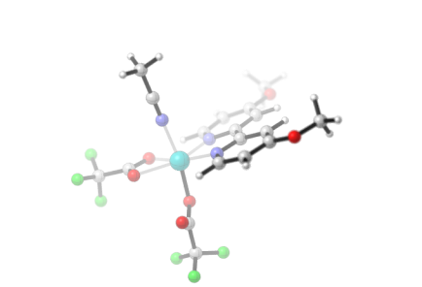
fetfa2-mecn-b-ome
(IntG1)
C 1.94882 -2.53285 -0.13941
C 3.26295 -2.90017 0.05567
C 4.24043 -1.89407 0.16337
C 3.83901 -0.55118 0.06749
C 2.49279 -0.26359 -0.12676
N 1.56205 -1.24182 -0.22613
H 1.17038 -3.27675 -0.25557
H 3.54694 -3.94314 0.11881
H 4.56123 0.24844 0.13722
C 1.96383 1.11537 -0.25372
C 2.75000 2.24834 -0.16045
N 0.62061 1.20084 -0.47464
C 2.15931 3.51929 -0.29798
H 3.81517 2.19427 0.02054
C 0.05897 2.41541 -0.61317
C 0.77802 3.59623 -0.53549
H -1.00907 2.42938 -0.78746
H 0.26126 4.53828 -0.65533
Fe -0.42496 -0.61303 -0.51381
O -2.20354 0.54391 -0.60610
C -2.89024 -0.51570 -0.51577
O -2.34064 -1.63764 -0.38471
O -0.42248 -1.04273 -2.37203
C -0.37567 -2.23651 -2.89529
O -0.25029 -3.29991 -2.31485
C -4.42149 -0.41306 -0.62068
C -0.49316 -2.18338 -4.43765
F -1.65070 -1.59771 -4.80321
F 0.51922 -1.46401 -4.96209
F -0.45644 -3.41027 -4.97238
F -4.76809 -0.27325 -1.91367
F -5.01416 -1.51059 -0.13672
F -4.87049 0.65421 0.05630
C -0.67817 -0.75691 2.76903
N -0.60427 -0.68084 1.61723
C -0.77322 -0.85283 4.21346
H 0.23044 -0.86591 4.64551
H -1.32542 0.00718 4.60049
H -1.29816 -1.77287 4.48256
O 2.98259 4.56201 -0.18659
C 2.44781 5.89410 -0.30107
H 2.00396 6.04878 -1.28815
H 1.70786 6.08106 0.48187
H 3.29979 6.55857 -0.17072
O 5.49776 -2.30201 0.34642
C 6.55104 -1.32720 0.45046
H 6.62175 -0.73379 -0.46536
H 6.39237 -0.67559 1.31414
H 7.46433 -1.90325 0.58704

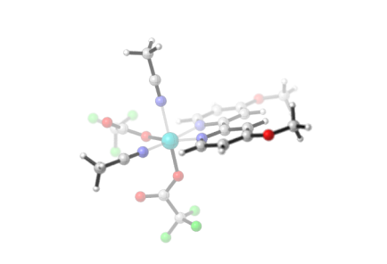
fetfa2-2mecn-b-ome
(IntB)
C 1.79897 -2.28718 1.26455
C 3.09188 -2.75002 1.39314
C 4.14909 -1.92854 0.96514
C 3.84370 -0.66935 0.42441
C 2.51068 -0.28040 0.32994
N 1.50027 -1.07896 0.74623
H 0.96045 -2.89339 1.58485
H 3.29675 -3.72634 1.81429
H 4.63003 -0.01102 0.08677
C 2.08758 1.03147 -0.22414
C 2.98217 1.98433 -0.70017
N 0.75107 1.24612 -0.22919
C 2.48316 3.20101 -1.19396
H 4.04407 1.78969 -0.68946
C 0.27215 2.41802 -0.69890
C 1.09298 3.41294 -1.18534
H -0.80370 2.53872 -0.66495
H 0.68252 4.34392 -1.55597
Fe -0.48612 -0.31780 0.44864
O -2.07003 0.73608 0.25320
C -3.15890 0.96177 0.92690
O -3.53402 0.44671 1.96256
O -0.60891 -1.20441 -1.24943
C -1.62357 -1.70613 -1.89259
O -2.75588 -1.90490 -1.49481
C -4.03353 2.02948 0.22058
C -1.22912 -2.07271 -3.34652
F -0.80684 -0.97790 -4.01340
F -0.22386 -2.97258 -3.35577
F -2.26229 -2.59664 -4.02016
F -4.48697 1.56172 -0.96017
F -5.09027 2.37543 0.96710
F -3.31615 3.14807 -0.03049
C -0.22247 0.95198 3.55604
N -0.27557 0.50059 2.49237
C -0.15787 1.51827 4.89230
H 0.72757 1.14062 5.40934
H -0.10149 2.60758 4.82597
H -1.05294 1.23582 5.45217
O 3.23460 4.19384 -1.67657
O 5.38349 -2.41915 1.10990
C 6.51054 -1.63122 0.68957
H 6.56592 -0.69825 1.25766
H 7.38574 -2.24272 0.90148
H 6.45860 -1.41980 -0.38216
C 4.66507 4.04778 -1.71052
H 4.95433 3.20452 -2.34378
H 5.03964 4.97517 -2.13991
H 5.06644 3.91954 -0.70129
C -2.13650 -2.73682 1.87962
N -1.37906 -1.97580 1.44935
C -3.08310 -3.69171 2.42197
H -3.84552 -3.15785 2.99499
H -3.55853 -4.23771 1.60335
H -2.56180 -4.39531 3.07579

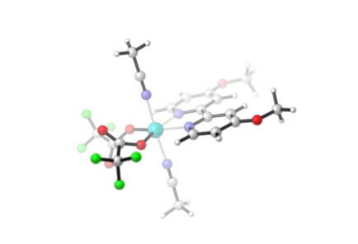
fetfa2-2mecn-ome
(IntB1)
C -1.14368 -2.65572 0.12719
C -2.24690 -3.48213 0.17132
C -3.52789 -2.90279 0.15077
C -3.63348 -1.50399 0.08256
C -2.46994 -0.74197 0.03819
N -1.24268 -1.31117 0.06358
H -0.13702 -3.05599 0.13950
H -2.13793 -4.55836 0.22170
H -4.60180 -1.02668 0.06646
C -2.47006 0.74222 -0.04057
C -3.63372 1.50401 -0.08575
N -1.24289 1.31168 -0.06501
C -3.52836 2.90283 -0.15376
H -4.60195 1.02650 -0.07040
C -1.14411 2.65624 -0.12847
C -2.24747 3.48243 -0.17338
H -0.13751 3.05671 -0.13995
H -2.13868 4.55869 -0.22362
Fe 0.44955 0.00046 0.00035
O 1.63822 1.50212 -0.07663
C 2.76507 1.79209 0.50655
O 3.38305 1.14869 1.33238
O 1.63850 -1.50098 0.07931
C 2.76462 -1.79201 -0.50476
O 3.38192 -1.14984 -1.33204
C 3.30064 3.15929 0.01089
C 3.30010 -3.15895 -0.00826
F 3.58320 -3.10603 1.30945
F 2.37305 -4.12661 -0.18949
F 4.41153 -3.52316 -0.66025
F 2.37376 4.12698 0.19264
F 4.41215 3.52297 0.66303
F 3.58370 3.10700 -1.30687
C 0.39388 -0.14439 -3.29601
N 0.37391 -0.08335 -2.14152
C 0.42022 -0.22169 -4.74512
H -0.44951 -0.78149 -5.09778
H 0.39843 0.78687 -5.16516
H 1.33358 -0.72896 -5.06568
O -4.56537 3.74429 -0.20127
O -4.56476 -3.74446 0.19766
C -5.90308 -3.21887 0.17690
H -6.08731 -2.66143 -0.74585
H -6.55589 -4.08893 0.21714
H -6.08380 -2.58135 1.04697
C -5.90359 3.21838 -0.18131
H -6.08818 2.66080 0.74128
H -6.55657 4.08829 -0.22183
H -6.08367 2.58091 -1.05154
C 0.38435 0.14356 3.29689
N 0.37021 0.08396 2.14224
C 0.40287 0.21861 4.74620
H 1.43081 0.35708 5.09020
H -0.20762 1.06273 5.07631
H 0.00078 -0.70690 5.16566

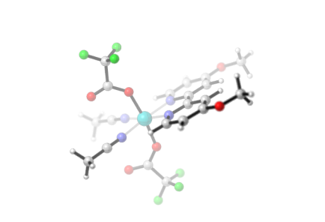
fetfa2-2mecn-ome-c
(IntB2)
C -0.80400 0.09856 -2.65922
C -1.90842 0.14157 -3.48329
C -3.18741 0.13152 -2.90030
C -3.28617 0.07693 -1.50073
C -2.12123 0.03185 -0.74149
N -0.89431 0.04414 -1.31410
H 0.19569 0.10729 -3.07438
H -1.80012 0.18394 -4.55981
H -4.25232 0.07335 -1.01911
C -2.12125 -0.03130 0.74145
C -3.28620 -0.07609 1.50068
N -0.89434 -0.04383 1.31408
C -3.18747 -0.13057 2.90026
H -4.25234 -0.07236 1.01904
C -0.80405 -0.09816 2.65923
C -1.90850 -0.14085 3.48327
H 0.19562 -0.10708 3.07441
H -1.80023 -0.18312 4.55980
Fe 0.77165 -0.00016 0.00013
O 0.89802 1.92877 0.05005
C 1.86817 2.79126 0.07667
O 3.06969 2.59229 0.07747
O 0.89719 -1.92912 -0.05026
C 1.86705 -2.79194 -0.07693
O 3.06864 -2.59337 -0.07800
C 1.31839 4.24083 0.11155
C 1.31677 -4.24133 -0.11157
F 0.55028 -4.48613 0.97227
F 0.55163 -4.43386 -1.20694
F 2.30606 -5.14562 -0.13254
F 0.55306 4.43343 1.20678
F 2.30799 5.14477 0.13293
F 0.55223 4.48612 -0.97241
C 3.11475 -0.04261 2.32061
N 2.19328 -0.04051 1.62169
C 4.26439 -0.04457 3.20499
H 4.86524 0.84987 3.02289
H 3.92483 -0.04858 4.24391
H 4.86838 -0.93559 3.01691
O -4.22670 -0.17499 3.73757
O -4.22661 0.17631 -3.73762
C -5.56348 0.16569 -3.20678
H -5.73808 1.04263 -2.57714
H -6.21898 0.20023 -4.07499
H -5.74862 -0.75119 -2.64022
C -5.56357 -0.16391 3.20671
H -5.73848 -1.04079 2.57709
H -6.21909 -0.19818 4.07492
H -5.74835 0.75304 2.64012
C 3.11496 0.04184 -2.32039
N 2.19335 0.03972 -1.62167
C 4.26479 0.04374 -3.20454
H 4.86855 0.93496 -3.01666
H 4.86580 -0.85050 -3.02198
H 3.92544 0.04725 -4.24353

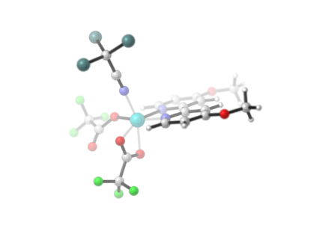
fetfa2-mecn-ome-cl3
(IntD)
C 1.82878 -2.30730 0.33518
C 3.16016 -2.62300 0.49715
C 4.11609 -1.59410 0.41304
C 3.67411 -0.28171 0.16976
C 2.31291 -0.04834 0.01957
N 1.40110 -1.04810 0.09766
H 1.06218 -3.07124 0.38688
H 3.47363 -3.64221 0.68492
H 4.37958 0.53292 0.10118
C 1.73539 1.29542 -0.23483
C 2.49682 2.44856 -0.36248
N 0.38135 1.32044 -0.33612
C 1.84622 3.67166 -0.60815
H 3.57229 2.40516 -0.27692
C -0.24374 2.49793 -0.57279
C 0.44243 3.68267 -0.71326
H -1.32344 2.45784 -0.64637
H -0.08090 4.61150 -0.90193
Fe -0.61525 -0.47939 -0.17663
O -2.35159 0.28414 -0.21691
C -3.43589 0.05538 -0.90874
O -3.68112 -0.89620 -1.62366
O -0.65744 -1.03027 -2.18244
C -1.05868 -2.18048 -1.83902
O -1.12850 -2.49338 -0.61813
C -4.46652 1.19570 -0.72143
C -1.41377 -3.21437 -2.91920
F -1.86542 -2.61175 -4.02471
F -0.30895 -3.91648 -3.23381
F -2.34634 -4.06373 -2.47389
F -3.92481 2.37910 -1.08781
F -5.56305 0.99290 -1.45928
F -4.83428 1.29389 0.57021
C -1.10289 -1.12762 3.05150
N -0.91228 -0.89636 1.93710
C -1.34811 -1.42989 4.46787
O 2.46198 4.84291 -0.75315
O 5.39020 -1.95068 0.57568
C 6.42421 -0.95165 0.50522
H 6.28807 -0.19797 1.28553
H 7.35534 -1.48986 0.67181
H 6.44114 -0.48050 -0.48133
C 3.89797 4.90966 -0.66460
H 4.36114 4.29701 -1.44256
H 4.14685 5.95720 -0.82244
H 4.23852 4.59267 0.32475
Cl -2.35669 -0.11669 5.14867
Cl 0.23641 -1.51526 5.29812
Cl -2.20112 -3.00207 4.55143

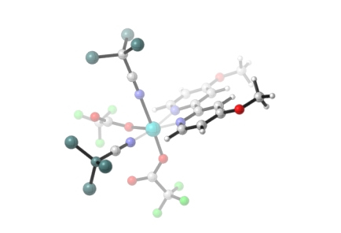
fetfa2-2mecn-ome-bcl
(IntD1)
C 0.92575 -0.43756 2.82260
C 1.78932 -0.39824 3.89616
C 3.17366 -0.43158 3.65226
C 3.61883 -0.50816 2.32217
C 2.68059 -0.54555 1.29688
N 1.34765 -0.50702 1.54254
H -0.14556 -0.41131 2.97857
H 1.41585 -0.34181 4.91087
H 4.67441 -0.53742 2.09753
C 3.05264 -0.62439 -0.13862
C 4.36554 -0.67571 -0.59051
N 2.00542 -0.63626 -0.99876
C 4.60868 -0.73882 -1.97368
H 5.18590 -0.66729 0.11116
C 2.23853 -0.68826 -2.32925
C 3.51091 -0.74025 -2.85406
H 1.36288 -0.67668 -2.96670
H 3.67215 -0.78151 -3.92394
Fe 0.10085 -0.65224 -0.17088
O -0.77826 -0.39298 -1.82532
C -1.68755 0.37282 -2.36111
O -2.36953 1.21972 -1.82029
O -0.15814 -2.51926 0.02163
C -1.16505 -3.29299 -0.28996
O -2.29966 -2.97048 -0.57813
C -1.84883 0.06695 -3.87122
C -0.75043 -4.78495 -0.24372
F 0.25705 -5.02095 -1.10856
F -0.32337 -5.11966 0.99032
F -1.77413 -5.58576 -0.56468
F -2.33669 -1.17664 -4.04814
F -2.68027 0.93359 -4.46103
F -0.65506 0.13458 -4.50120
C 0.30010 2.83117 -0.11657
N 0.23948 1.67812 -0.08565
C 0.37430 4.29562 -0.15865
O 5.81842 -0.79448 -2.53113
O 3.97034 -0.38680 4.72147
C 5.39816 -0.40937 4.54317
H 5.72971 0.45588 3.96236
H 5.81456 -0.36011 5.54749
H 5.71362 -1.33680 4.05735
C 6.98894 -0.79463 -1.69333
H 6.98879 -1.66218 -1.02779
H 7.83254 -0.85601 -2.37815
H 7.05007 0.13042 -1.11341
C -2.81305 -0.08147 1.34271
N -1.72196 -0.22249 0.99321
C -4.19983 0.09797 1.79005
Cl 1.02056 4.86993 1.41252
Cl 1.46869 4.75869 -1.50174
Cl -1.27659 4.93392 -0.43688
Cl -4.84041 1.58774 1.03202
Cl -4.18760 0.24511 3.57691
Cl -5.13944 -1.33603 1.27543

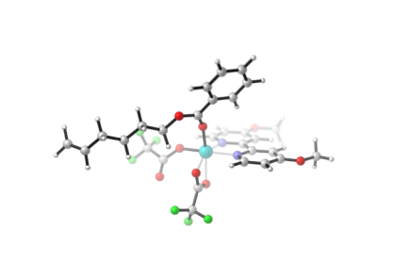
fetfa2-mecn-ome-s1
(IntC)
C 2.49131 -1.96743 0.48780
C 3.85432 -2.15434 0.58019
C 4.70566 -1.06372 0.32713
C 4.13234 0.17440 -0.00749
C 2.74740 0.27682 -0.07988
N 1.93780 -0.78034 0.16282
H 1.80195 -2.78424 0.66661
H 4.26989 -3.11948 0.84154
H 4.75524 1.03415 -0.20351
C 2.03818 1.53705 -0.41794
C 2.69114 2.72348 -0.72749
N 0.68480 1.45078 -0.40365
C 1.92667 3.86353 -1.03088
H 3.77000 2.76554 -0.73627
C -0.04951 2.54724 -0.69951
C 0.52364 3.76025 -1.01186
H -1.12470 2.41821 -0.68114
H -0.08792 4.62327 -1.24327
Fe -0.15207 -0.40906 0.02286
O -1.94609 0.20233 -0.27127
C -2.96226 -0.17713 -0.99022
O -3.06542 -1.15978 -1.70055
O -0.04410 -1.10876 -2.02143
C -0.38823 -2.23334 -1.58352
O -0.50201 -2.43857 -0.33462
C -4.16040 0.78875 -0.81213
C -0.62288 -3.40343 -2.55162
F -0.93272 -2.96153 -3.77548
F 0.50409 -4.13788 -2.63503
F -1.61112 -4.19408 -2.11313
F -3.78645 2.07009 -1.00619
F -5.15390 0.50882 -1.66152
F -4.64392 0.69059 0.44913
O 2.43155 5.05737 -1.34327
O 6.01677 -1.29327 0.42799
C 6.94402 -0.22247 0.17550
H 6.79365 0.59635 0.88474
H 7.93170 -0.65659 0.31909
H 6.84581 0.14156 -0.85108
C 3.85898 5.23529 -1.39305
H 4.30288 4.59032 -2.15640
H 4.00946 6.27948 -1.66038
H 4.30871 5.03509 -0.41679
C 2.39826 0.04460 5.13812
C 1.51555 -0.10748 4.07401
C 0.33680 -0.85305 4.24587
C 0.04854 -1.44187 5.49015
C 0.93856 -1.28658 6.54750
C 2.11147 -0.54514 6.37291
H 3.30762 0.62156 5.00761
H 1.72499 0.34955 3.11415
H -0.86203 -2.01469 5.61782
H 0.71982 -1.74196 7.50755
H 2.80263 -0.42597 7.20144
C -0.58299 -1.00737 3.11044
O -0.33764 -0.51081 1.98424
O -1.67742 -1.67961 3.36133
C -2.69442 -1.83493 2.31539
C -3.89857 -2.51070 2.94348
H -2.25835 -2.43321 1.51208
H -2.93592 -0.84024 1.93693
C -5.02093 -2.69860 1.91233
H -3.59796 -3.48156 3.35413
H -4.25629 -1.89950 3.78025
C -6.27666 -3.34898 2.52178
H -5.28956 -1.72824 1.47737
H -4.65687 -3.31971 1.08333
H -5.98588 -4.30820 2.97463
H -6.66245 -2.72021 3.33353
C -7.35856 -3.58789 1.50414
C -8.58461 -3.06435 1.54668
H -7.08940 -4.23918 0.67100
H -9.32257 -3.27366 0.77756
H -8.89631 -2.40838 2.35670

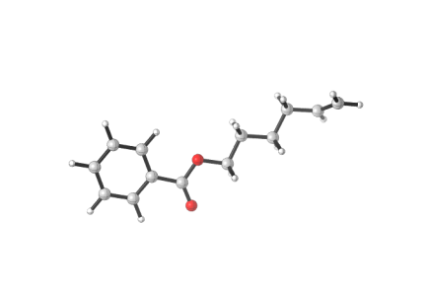
1
C 0.26672 2.10723 1.09541
C 1.63864 1.86713 1.09282
C 2.40242 2.15593 -0.04710
C 1.77964 2.68806 -1.18584
C 0.40621 2.92687 -1.17938
C -0.35101 2.63746 -0.04100
H -0.32077 1.88222 1.98011
H 2.13526 1.45635 1.96499
H 2.37070 2.91097 -2.06631
H -0.07368 3.33862 -2.06179
H -1.42064 2.82473 -0.03938
C 3.86663 1.87974 0.00275
O 4.44410 1.41439 0.97218
O 4.49454 2.19972 -1.14445
C 5.92361 1.96359 -1.18631
C 6.41991 2.38445 -2.55961
H 6.11099 0.90271 -0.99232
H 6.39926 2.54026 -0.38668
C 7.93139 2.17352 -2.71282
H 5.88382 1.81020 -3.32524
H 6.17177 3.44070 -2.72096
C 8.45107 2.60166 -4.09809
H 8.46585 2.73887 -1.93863
H 8.17369 1.11535 -2.54634
H 7.89242 2.04522 -4.86513
H 8.23662 3.66506 -4.26139
C 9.92303 2.34648 -4.27406
C 10.84257 3.27937 -4.52621
H 10.23836 1.30649 -4.17403
H 11.89385 3.03039 -4.63961
H 10.57538 4.32869 -4.63199

Table S2. Cartesian coordinates of the optimized structures.

4.1.3 TD-DFT calculations

For active species (IntB): The strongest absorption peak in range of experimental Blue LEDs.
Excited State 9: 2.7293 eV 454.27 nm f=0.0269 <S**2>=8.830
140B ->146B -0.29224
140B ->147B -0.13503
141B ->145B 0.47187
141B ->146B 0.24184
141B ->147B -0.24184
142B ->145B -0.37854
142B ->146B -0.44382
142B ->147B -0.25705
143B ->145B 0.24768
143B ->146B -0.17240
143B ->147B 0.18416
Table S3. TD-DFT calculations for active species IntB.

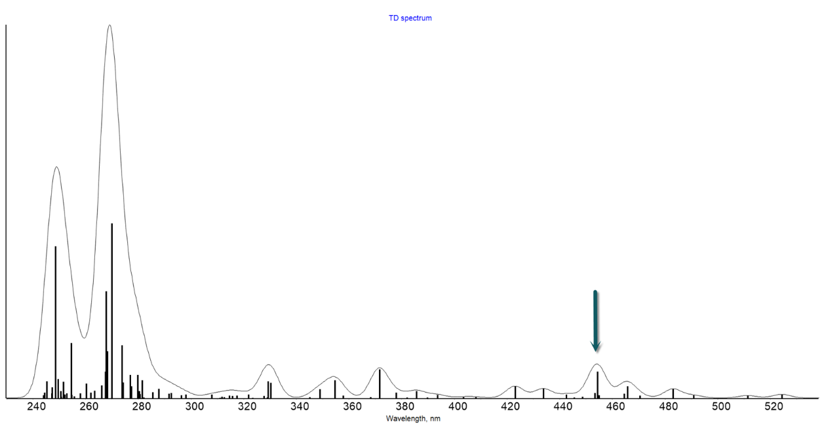
Figure S17. The calculated UV-Vis absorption spectrum for IntB.
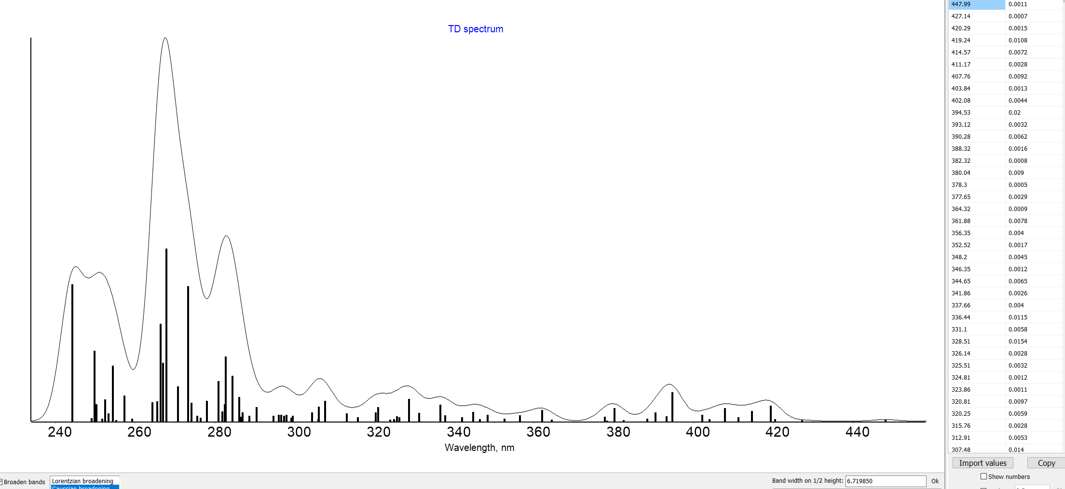
Figure S18. The calculated UV-Vis absorption spectrum for IntE.
The neutral species IntE did not show obvious blue light absorption (Figure S18), and its excited state would not undergo effective LMCT due to the weak oxidizing ability.

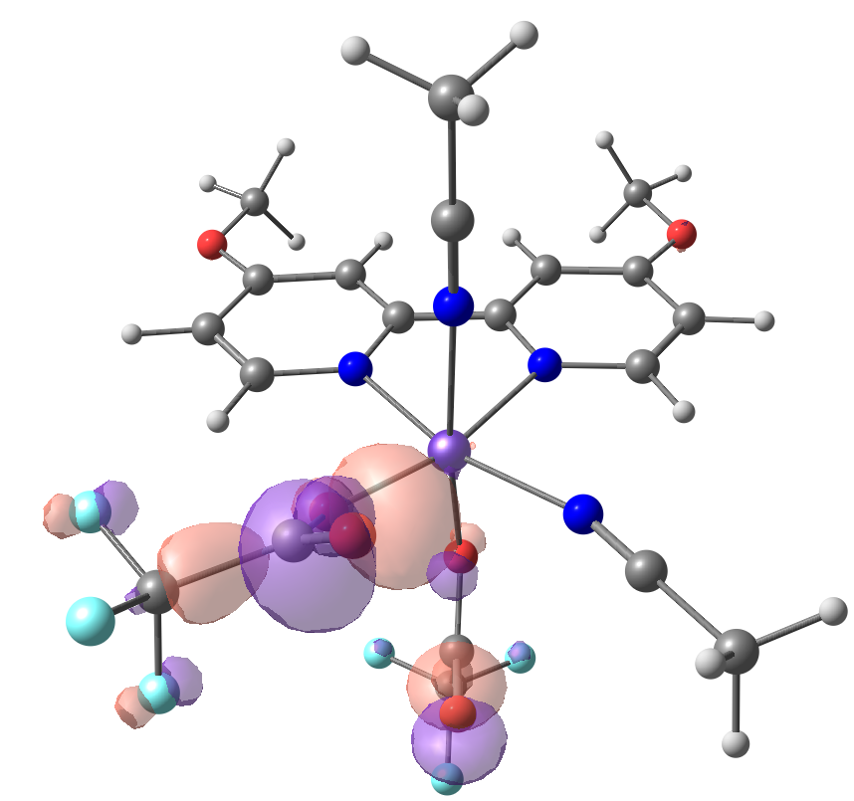  140-beta | 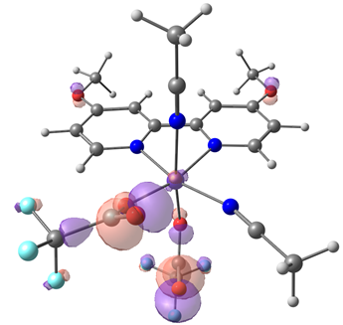  141-beta
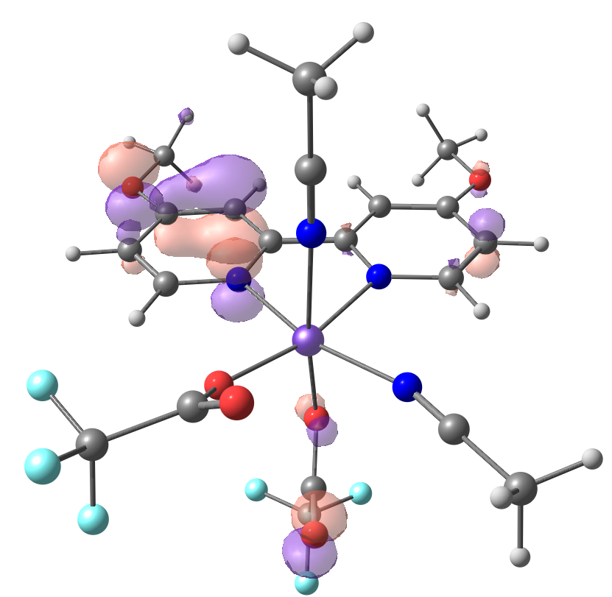  142-beta | 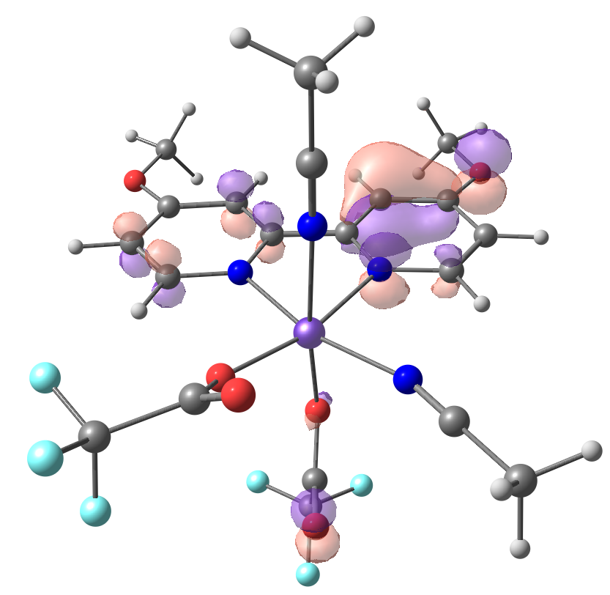  143-beta
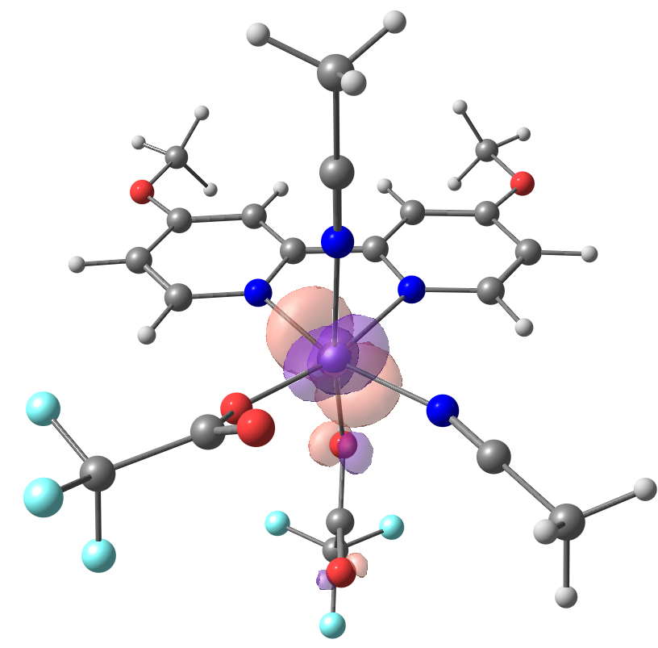  145-beta | 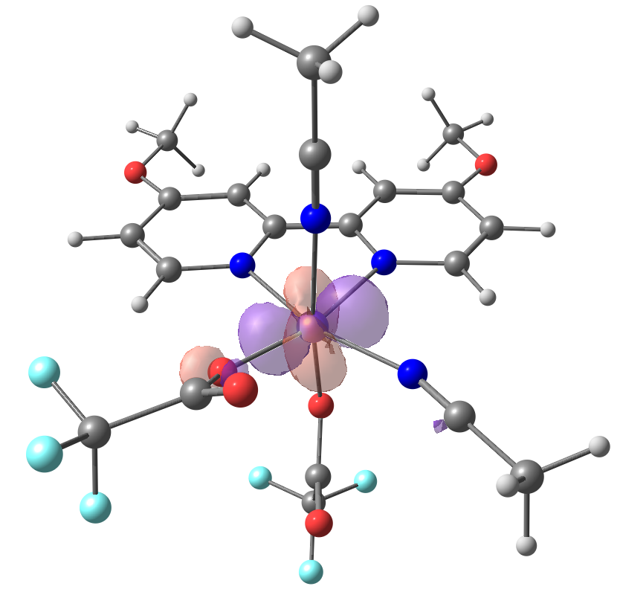  146-beta
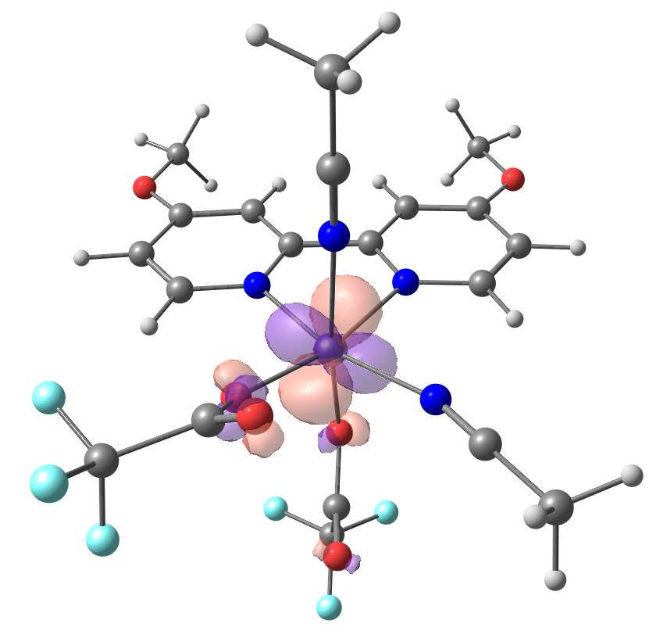
147-beta
Figure S19. The key orbitals for the most possible absorption peak.

4.1.4 Free energies for the key species in the calculations
Species | Gibbs free energy | Gibbs free energy with the Fang’s entropy correction
(IntB) | -3305.701959 | -3305.69224
fetfa2-2mecn-b-ome-decf3co2 | -2779.530112 | -2779.5203
CF₃. | -337.56521 | -337.55589
CO₂ | -188.590143 | -188.5811435
Int1 | -655.279172 | -655.26883
2-ts | -992.83103 | -992.82083
Int3 | -992.88293 | -992.87267
Int4 | -1511.51048 | -1511.49973
5-ts | -2504.37128 | -2504.36133
Int6 | -1051.29444 | -1051.28358
Product 2 | -1453.13961 | -1453.12941
7-ts | -1706.53846 | -1706.52833
Table S4. Free energies for the key species in the calculation.

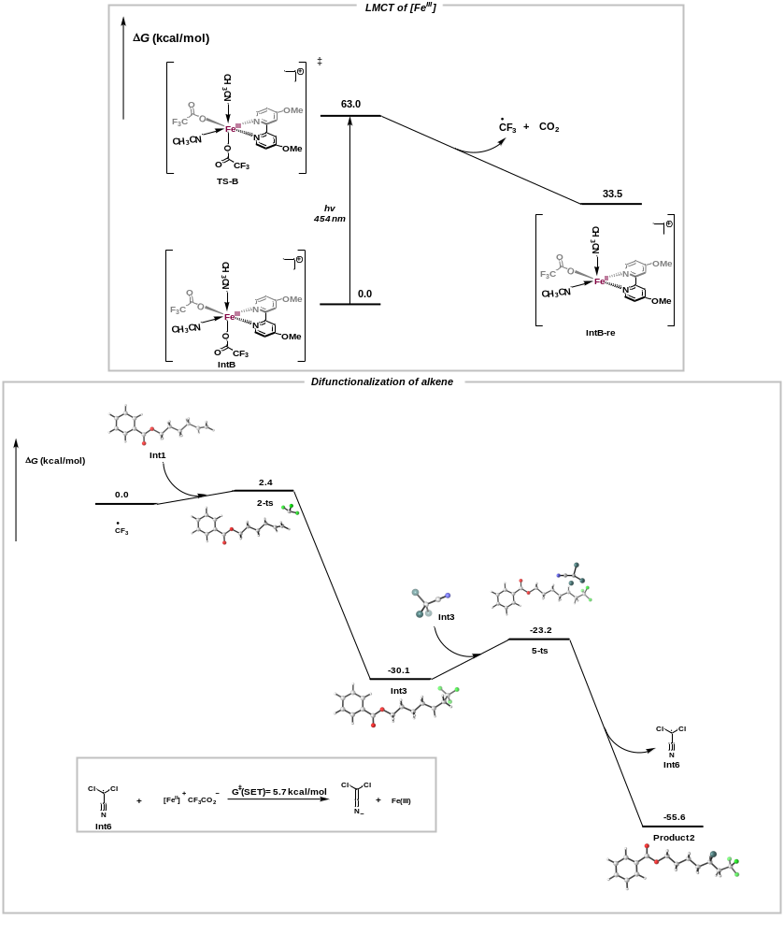
Figure S20. DFT calculated mechanism.

Species | Energy
IntB | -2779.802282
IntB-re | -3306.15977
Int6 | -1051.278898
Product 2 | -1051.423348
IntB-ox | -3305.990416
Table S5. Energy for the relevant species.

4.1.5 Cartesian coordination for the key species
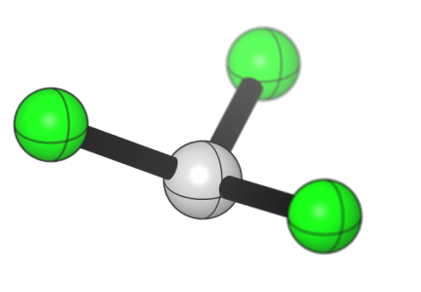
CF₃.
C -0.07951 0.96759 -3.78974
F -0.19969 2.28854 -3.82591
F 1.08347 0.57756 -4.29574
F -1.09408 0.37638 -4.40765

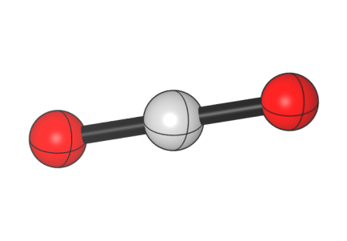
CO₂
O -1.35731 0.21979 -2.17243
C -0.22717 0.40175 -1.93515
O 0.90278 0.58339 -1.69692

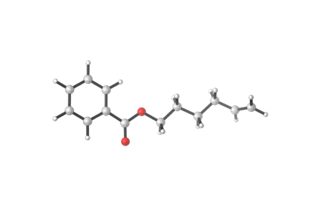
Int1
C 0.26672 2.10723 1.09541
C 1.63864 1.86713 1.09282
C 2.40242 2.15593 -0.04710
C 1.77964 2.68806 -1.18584
C 0.40621 2.92687 -1.17938
C -0.35101 2.63746 -0.04100
H -0.32077 1.88222 1.98011
H 2.13526 1.45635 1.96499
H 2.37070 2.91097 -2.06631
H -0.07368 3.33862 -2.06179
H -1.42064 2.82473 -0.03938
C 3.86663 1.87974 0.00275
O 4.44410 1.41439 0.97218
O 4.49454 2.19972 -1.14445
C 5.92361 1.96359 -1.18631
C 6.41991 2.38445 -2.55961
H 6.11099 0.90271 -0.99232
H 6.39926 2.54026 -0.38668
C 7.93139 2.17352 -2.71282
H 5.88382 1.81020 -3.32524
H 6.17177 3.44070 -2.72096
C 8.45107 2.60166 -4.09809
H 8.46585 2.73887 -1.93863
H 8.17369 1.11535 -2.54634
H 7.89242 2.04522 -4.86513
H 8.23662 3.66506 -4.26139
C 9.92303 2.34648 -4.27406
C 10.84257 3.27937 -4.52621
H 10.23836 1.30649 -4.17403
H 11.89385 3.03039 -4.63961
H 10.57538 4.32869 -4.63199

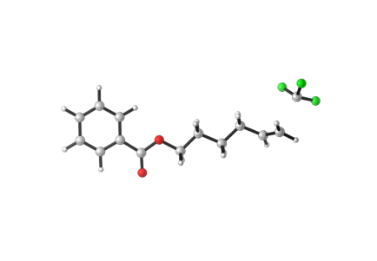
2-ts
C 7.15945 0.06788 0.34764
C 6.04774 0.90685 0.35295
C 4.75515 0.36409 0.32340
C 4.58535 -1.02794 0.28842
C 5.70057 -1.86433 0.28314
C 6.98692 -1.31891 0.31268
H 8.15833 0.49235 0.37063
H 6.16181 1.98496 0.37987
H 3.58613 -1.44656 0.26568
H 5.56672 -2.94128 0.25600
H 7.85343 -1.97336 0.30850
C 3.59977 1.30625 0.33075
O 3.70605 2.52180 0.36036
O 2.41250 0.67161 0.30119
C 1.23126 1.51045 0.30714
C 0.01782 0.59636 0.26649
H 1.26829 2.17744 -0.55999
H 1.24426 2.13064 1.20902
C -1.29584 1.38795 0.27260
H 0.07126 -0.03008 -0.63236
H 0.05068 -0.07983 1.12949
C -2.53484 0.47362 0.23217
H -1.34427 2.02025 1.16826
H -1.32011 2.06807 -0.58913
H -2.46593 -0.16782 -0.65962
H -2.53186 -0.19651 1.10051
C -3.82544 1.23678 0.18165
C -4.85437 1.07201 1.04008
H -3.93652 1.93978 -0.64446
H -5.74351 1.69210 0.98217
H -4.75588 0.44312 1.92115
C -6.13890 -0.79522 0.05884
F -7.21620 -0.33746 -0.58584
F -6.51586 -1.64280 1.02215
F -5.33111 -1.42093 -0.80101

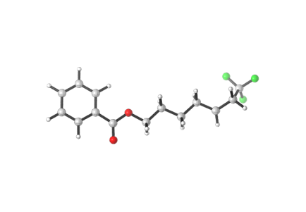
Int3
C 0.14643 2.22592 1.14119
C 1.50800 1.93346 1.16101
C 2.30195 2.19791 0.03583
C 1.71975 2.75829 -1.11081
C 0.35655 3.04945 -1.12677
C -0.43078 2.78435 -0.00299
H -0.46451 2.01970 2.01450
H 1.97338 1.49988 2.03940
H 2.33406 2.96211 -1.97989
H -0.09191 3.48296 -2.01527
H -1.49233 3.01244 -0.01875
C 3.75348 1.86595 0.10952
O 4.29600 1.37564 1.08677
O 4.41311 2.16567 -1.02539
C 5.83228 1.87392 -1.04321
C 6.36829 2.27607 -2.40709
H 5.97467 0.80638 -0.84769
H 6.31631 2.43083 -0.23461
C 7.87213 2.00460 -2.53390
H 5.82299 1.72440 -3.18275
H 6.16519 3.34153 -2.57093
C 8.43320 2.40495 -3.90788
H 8.41485 2.54879 -1.75049
H 8.06871 0.93779 -2.36296
H 7.85137 1.88479 -4.69060
H 8.25572 3.47539 -4.08627
C 9.88674 2.10148 -4.06667
C 10.74588 2.81624 -5.06092
H 10.28788 1.20654 -3.59760
H 11.80750 2.72504 -4.80960
H 10.50295 3.88477 -5.10244
C 10.59748 2.29538 -6.48209
F 10.91897 0.98457 -6.57966
F 11.39734 2.96542 -7.34553
F 9.32795 2.42477 -6.93980

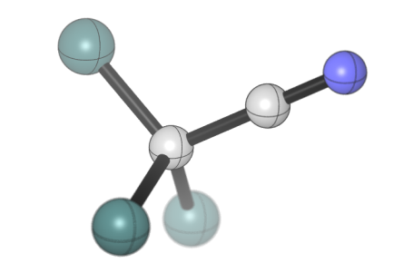
Int4
C -0.81019 1.09728 0.00580
N 0.34969 1.09807 0.00495
C -2.27266 1.09708 0.00531
Cl -2.85192 -0.60364 -0.05964
Cl -2.85228 1.89122 1.51068
Cl -2.85143 2.00354 -1.43526

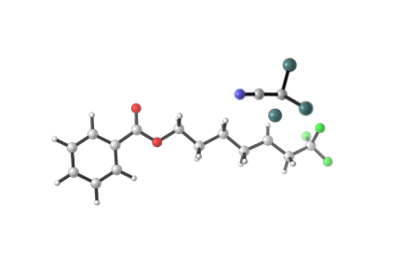
5-ts
C -7.09199 0.33838 -0.08247
C -5.87091 1.00740 -0.04883
C -4.67031 0.28294 -0.05030
C -4.70312 -1.11901 -0.08561
C -5.92734 -1.78494 -0.11914
C -7.12139 -1.05879 -0.11765
H -8.01912 0.90307 -0.08121
H -5.82817 2.09068 -0.02114
H -3.77477 -1.67797 -0.08668
H -5.95041 -2.86993 -0.14642
H -8.07323 -1.58077 -0.14385
C -3.39142 1.04778 -0.01392
O -3.32066 2.26574 0.01662
O -2.30770 0.24788 -0.01879
C -1.01950 0.90836 0.01363
C 0.04989 -0.17134 -0.01609
H -0.95794 1.51805 0.92064
H -0.94491 1.57928 -0.84796
C 1.46179 0.42722 0.01044
H -0.09030 -0.83739 0.84393
H -0.08299 -0.78103 -0.91810
C 2.54862 -0.65426 -0.01516
H 1.59670 1.09263 -0.85207
H 1.58461 1.04498 0.90665
H 2.45050 -1.32688 0.84708
H 2.39201 -1.29637 -0.90102
C 3.95207 -0.14493 -0.10853
C 5.06416 -1.15237 -0.13518
H 4.10836 0.76681 -0.68130
H 4.82931 -1.91536 -0.89156
H 5.15127 -1.68404 0.81790
C 6.42353 -0.59588 -0.50212
F 6.38257 0.08158 -1.67437
F 7.32289 -1.59470 -0.64666
F 6.91622 0.25219 0.42514
C 4.50988 1.88820 3.80320
C 3.19401 1.92474 4.39752
N 2.12161 1.93758 4.84597
Cl 5.13509 3.52350 3.51753
Cl 4.25558 0.98812 1.99526
Cl 5.62324 0.89247 4.76001

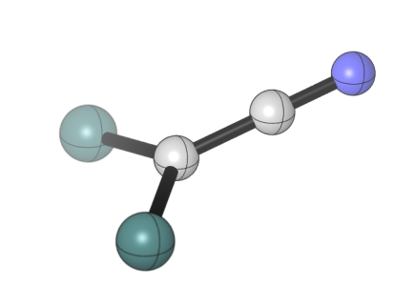
Int6
C -3.64616 2.84247 -0.25751
C -2.35786 3.26561 -0.56035
N -1.27062 3.62380 -0.81635
Cl -4.18799 2.81267 1.36750
Cl -4.71032 2.34420 -1.50413

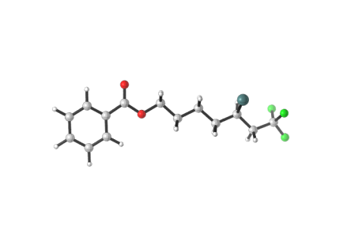
Product 2
C 8.68152 0.49170 0.09723
C 7.43767 0.66702 0.69877
C 6.29677 0.06839 0.14532
C 6.41235 -0.70825 -1.01711
C 7.65911 -0.88131 -1.61623
C 8.79347 -0.28284 -1.06112
H 9.56228 0.95684 0.52892
H 7.33111 1.26424 1.59772
H 5.53001 -1.17032 -1.44399
H 7.74632 -1.48270 -2.51578
H 9.76311 -0.41976 -1.53039
C 4.99024 0.28761 0.82856
O 4.84822 0.95677 1.83928
O 3.96940 -0.33587 0.20955
C 2.65981 -0.17691 0.80711
C 1.66958 -0.95469 -0.04421
H 2.41573 0.88942 0.84421
H 2.69371 -0.54988 1.83569
C 0.24150 -0.85039 0.50704
H 1.70265 -0.57100 -1.07115
H 1.98153 -2.00536 -0.08509
C -0.76279 -1.63027 -0.34784
H 0.21482 -1.23388 1.53567
H -0.05692 0.20268 0.55683
H -0.76428 -1.25141 -1.37698
H -0.44743 -2.68093 -0.39982
C -2.19366 -1.63537 0.18927
C -3.10789 -2.54898 -0.62673
H -2.20755 -1.93428 1.23889
H -2.59996 -3.51261 -0.73595
H -3.27469 -2.14948 -1.63022
C -4.45499 -2.85980 -0.00733
F -4.33304 -3.26386 1.28018
F -5.06057 -3.86308 -0.68502
F -5.30752 -1.81348 -0.01422
Cl -2.86558 0.08676 0.20782
Table S6. The coordination for the key species involved.

Computational details:
All the calculations have been performed using the Gaussian Program (Gaussian 16)⁵. The geometry optimization was conducted with the B3LYP functional and standard 6-31G(d) basis set. The solvent effect was considered by IEFPCM^{6,7}. Harmonic vibrational frequency calculations were performed for all stationary points to confirm whether they are local minima or transition state structures and to derive the thermochemical corrections for the enthalpies and free energies. Furthermore, the entropy in the solution model have been recalculated by the THERMO program⁸ which affords a new solution translational entropy.

4.2 General procedure for UV-Vis experiments

4.2.1 UV-Vis spectra for Fe(III) species
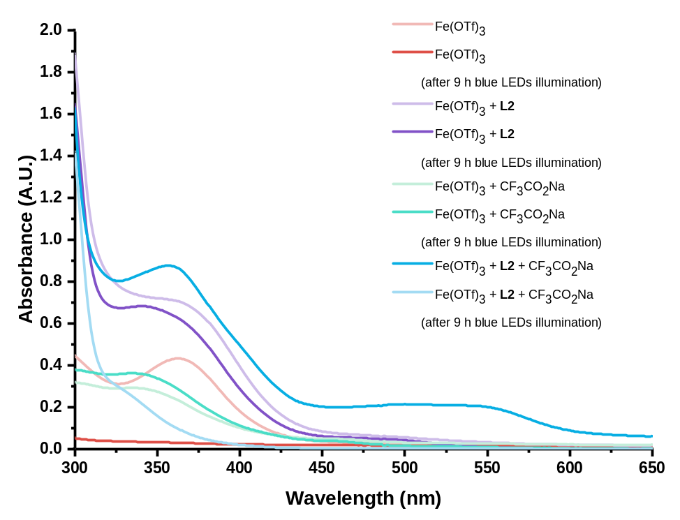
Figure S21. Fe(OTf)₃ (0.01 mmol), L2 (0.01 mmol), CF₃CO₂Na (0.02 mmol) in 1.0 mL CH₃CN. The solution was stirred under darkness or 450 nm Blue LEDs illumination, and was diluted before measurement.

4.2.2 UV-Vis spectra for ligand-Fe(III) species
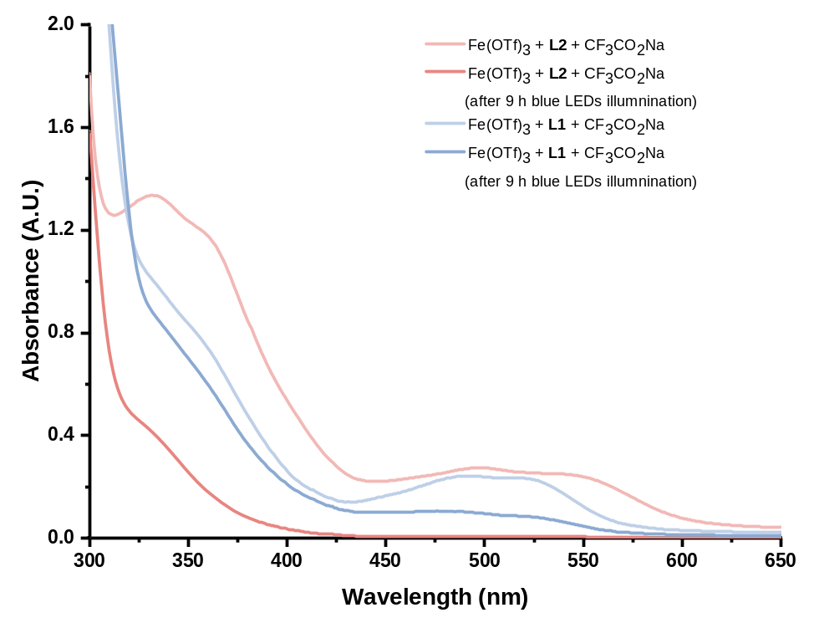
Figure S22. Fe(OTf)₃ (0.01 mmol), L1 or L2 (0.01 mmol), CF₃CO₂Na (0.02 mmol) in 1.0 mL CH₃CN. The solution was stirred under darkness or 450 nm blue LEDs illumination, and was diluted before measurement.

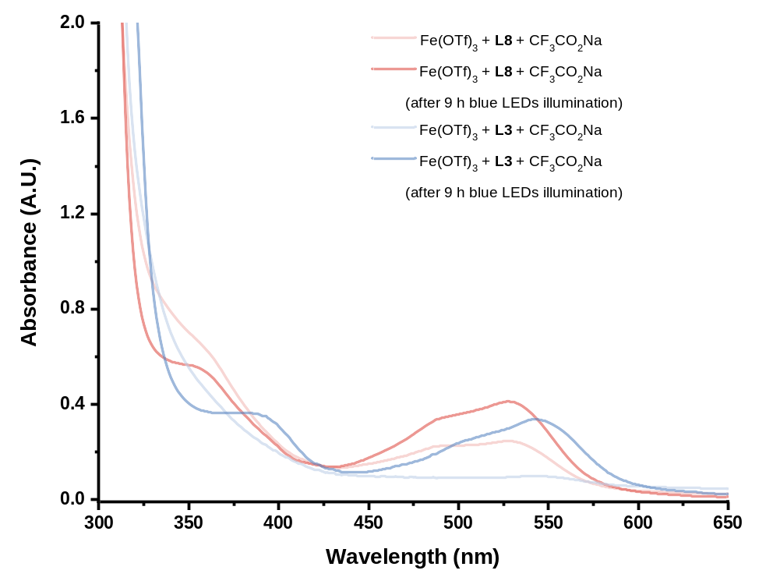
Figure S23. Fe(OTf)₃ (0.01 mmol), L3 or L8 (0.01 mmol), CF₃CO₂Na (0.02 mmol) in 1.0 mL CH₃CN. The solution was stirred under darkness or 450 nm blue LEDs illumination, and was diluted before measurement.

4.2.3 UV-Vis spectra for ligand-Fe(II) species
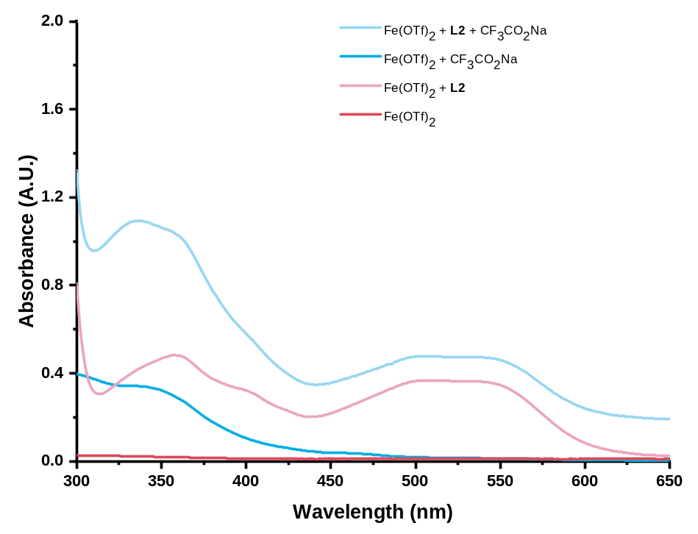
Figure S24. Fe(OTf)₂ (0.01 mmol), L2 (0.01 mmol), CF₃CO₂Na (0.02 mmol) in 1.0 mL CH₃CN. The solution was stirred under darkness or 450 nm blue LEDs illumination, and was diluted before measurement.

4.3 General procedure for radical probe experiments
General procedure for radical trapping experiments: A 25-mL Schlenk flask equipped with magneton was charged with Fe(OTf)₃ (0.02 mmol), L2 (0.03 mmol), CF₃CO₂Na (0.6 mmol), 2,2,6,6-tetramethyl-1-piperidinyloxy (TEMPO) (0.6 mmol) or butylated hydroxytoluene (BHT) (0.6 mmol). The flask was evacuated and refilled with N₂ for three times. The vessel was then charged with Cl₃CCN (1.0 mL), dry CH₃CN (1.0 mL), alkene 1 (0.2 mmol). The reaction mixture was stirred under nitrogen atmosphere and irradiated by blue LEDs. After completion of the reaction, the system was diluted with EtOAc. Yields and conversion rates were determined by GC analysis of the crude reaction mixture, using biphenyl as an internal standard. Then crude reaction mixture was used for HRMS (ESI) detection. BHT-CF₃: HRMS (ESI) exact mass calculated for [C₁₆H₂₃F₃ONa⁺]: 311.1593, found 311.1608 (Figure S25).
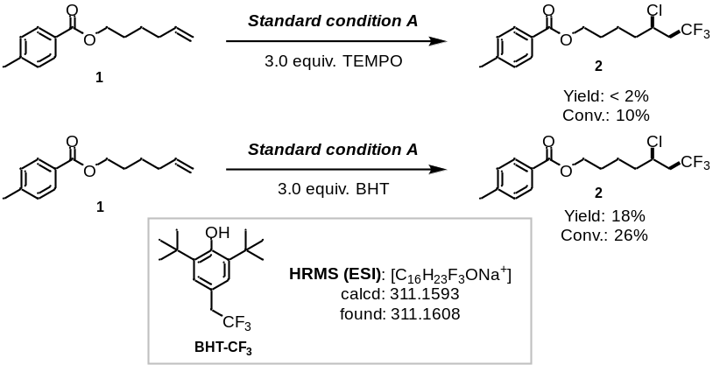
Figure S25. Standard condition A: alkene 1 (0.2 mmol), CF₃CO₂Na (0.6 mmol), Fe(OTf)₃ (0.02 mmol), L2 (0.03 mmol), TEMPO or BHT (3.0 equiv.), Cl₃CCN (1.0 mL) and CH₃CN (1.0 mL), N₂, Blue LEDs, 24 h reaction time.

General procedure for light on/off experiments: A 25-mL Schlenk flask equipped with magneton was charged with Fe(OTf)₃ (0.02 mmol), L2 (0.03 mmol) and CF₃CO₂Na (0.6 mmol). The flask was evacuated and refilled with N₂ for three times. The vessel was then charged with Cl₃CCN (1.0 mL), dry CH₃CN (1.0 mL), alkene 1 (0.2 mmol). The reaction mixture was stirred under nitrogen atmosphere. Keep blue LEDs lights on in light-on time span and turn off for light-off time span. After completion of the reaction, the system was diluted with EtOAc. Yields were determined by GC analysis of the crude reaction mixture, using biphenyl as an internal standard. Observed product 2 formation occurred only during periods of light irradiation, which ruled out a radical chain mechanism.

General procedure for kinetic study of [Fe^{III}] (Fe^{III}/L2) complexes: A 25-mL Schlenk flask equipped with magneton was charged with Fe(OTf)₃ (n mol%), L2 (1.5n mol%), and CF₃CO₂Na (82.2 mg, 0.6 mmol). The flask was evacuated and refilled with N₂ for three times. The vessel was then charged with Cl₃CCN, dry CH₃CN (1.0 mL), alkene 1 (0.2 mmol). The reaction mixture was stirred under nitrogen atmosphere and irradiated by blue LEDs. After completion of the reaction, the system was diluted with EtOAc. Yields were determined by GC analysis of the crude reaction mixture, using biphenyl as an internal standard (Table S7).
n | [Fe^{III}] (mol*L⁻¹) | Yield (%) | Initial rate (mol*L⁻¹*h⁻¹)
0 | 0 | 0 | 0
1 | 0.001 | 7 | 0.000875
3 | 0.003 | 15 | 0.001875
5 | 0.005 | 18 | 0.00225
6 | 0.006 | 20 | 0.0025
7 | 0.007 | 24 | 0.003
9 | 0.009 | 27 | 0.003375
10 | 0.01 | 30 | 0.00375
12 | 0.012 | 34 | 0.00425
Table S7. The kinetic study of [Fe^{III}] complexes.

5. Data for products
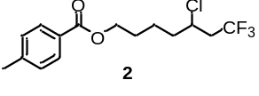
5-Chloro-7,7,7-trifluoroheptyl 4-methylbenzoate (2): 46.4 mg colorless liquid was isolated, yield: 84%. ¹H NMR (400 MHz, Chloroform-d) δ 7.96 – 7.89 (m, 2H), 7.24 (d, J = 8.0 Hz, 2H), 4.32 (t, J = 6.3 Hz, 2H), 4.19 – 4.08 (m, 1H), 2.71 – 2.45 (m, 2H), 2.41 (s, 3H), 1.97 – 1.87 (m, 1H), 1.86 – 1.72 (m, 4H), 1.64 – 1.56 (m, 1H). ¹³C NMR (101 MHz, Chloroform-d) δ 166.80, 143.75, 129.69, 129.22, 127.66, 125.35 (q, J = 277.6 Hz), 64.41, 54.04 (q, J = 3.3 Hz), 42.58 (q, J = 28.4 Hz), 37.73, 28.18, 22.78, 21.78. ¹⁹F NMR (376 MHz, Chloroform-d) δ -63.79 (s, 3F). HRMS (ESI) exact mass calculated for [C₁₅H₁₉ClF₃O₂⁺]: 323.1020, found 323.1033.
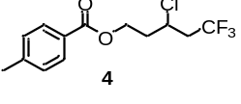
3-Chloro-5,5,5-trifluoropentyl 4-methylbenzoate (4): 49.4 mg colorless liquid was isolated, yield: 84%. ¹H NMR (400 MHz, Chloroform-d) δ 8.02 – 7.91 (m, 2H), 6.96 – 6.88 (m, 2H), 4.58 – 4.39 (m, 2H), 4.39 – 4.28 (m, 1H), 3.85 (s, 3H), 2.81 – 2.52 (m, 2H), 2.42 – 2.29 (m, 1H), 2.29 – 2.06 (m, 1H). ¹³C NMR (101 MHz, Chloroform-d) δ 166.44, 144.04, 129.69, 129.29, 127.18, 125.21 (q, J = 277.6 Hz), 61.05, 50.83 (q, J = 3.2 Hz), 42.57 (q, J = 28.7 Hz), 37.10, 21.74. ¹⁹F NMR (376 MHz, Chloroform-d) δ -63.98 (s, 3F). HRMS (ESI) exact mass calculated for [C₁₃H₁₄ClF₃O₂Na⁺]: 317.0527, found 317.0536.
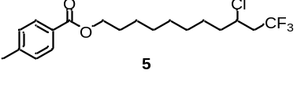
9-Chloro-11,11,11-trifluoroundecyl 4-methylbenzoate (5): 62.1 mg colorless liquid was isolated, yield: 82%. ¹H NMR (400 MHz, Chloroform-d) δ 7.93 (d, J = 8.2 Hz, 2H), 7.23 (d, J = 8.1 Hz, 2H), 4.30 (t, J = 6.6 Hz, 2H), 4.15 – 4.04 (m, 1H), 2.69 – 2.51 (m, 2H), 2.40 (s, 3H), 1.88 – 1.63 (m, 4H), 1.53 – 1.22 (m, 10H). ¹³C NMR (101 MHz, Chloroform-d) δ 166.84, 143.54, 129.66, 129.13, 127.89, 125.42 (q, J = 277.6 Hz), 64.96, 54.27 (d, J = 3.1 Hz), 42.53 (q, J = 28.4 Hz), 38.15, 29.37, 29.23, 28.87, 28.82, 26.09, 25.97, 21.72. ¹⁹F NMR (376 MHz, Chloroform-d) δ -63.82 (s, 3F). HRMS (ESI) exact mass calculated for [C₁₉H₂₆ClF₃O₂Na⁺]: 401.1466, found 401.1465.
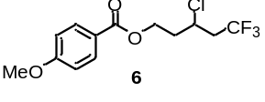
3-Chloro-5,5,5-trifluoropentyl 4-methoxybenzoate (6): 49.0 mg colorless liquid was isolated, yield: 79%. ¹H NMR (400 MHz, Chloroform-d) δ 8.00 – 7.95 (m, 2H), 6.95 – 6.90 (m, 2H), 4.57 – 4.42 (m, 2H), 4.38 – 4.29 (m, 1H), 3.85 (s, 3H), 2.79 – 2.56 (m, 2H), 2.41 – 2.31 (m, 1H), 2.18 – 2.08 (m, 1H). ¹³C NMR (101 MHz, Chloroform-d) δ 166.06, 163.64, 131.67, 125.21 (q, J = 277.6 Hz), 122.27, 113.80, 60.90, 55.48, 50.84 (q, J = 3.3 Hz), 42.52 (q, J = 28.6 Hz), 37.12. ¹⁹F NMR (376 MHz, Chloroform-d) δ -63.65 (s, 3F). HRMS (ESI) exact mass calculated for [C₁₃H₁₄ClF₃O₃Na⁺]: 333.0476, found 333.0475.
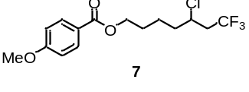
5-Chloro-7,7,7-trifluoroheptyl 4-methoxybenzoate (7): 46.6 mg colorless liquid was isolated, yield: 69%. ¹H NMR (400 MHz, Chloroform-d) δ 8.05 – 7.94 (m, 2H), 6.95 – 6.87 (m, 2H), 4.30 (t, J = 6.2 Hz, 2H), 4.18 – 4.01 (m, 1H), 3.84 (s, 3H), 2.72 – 2.44 (m, 2H), 1.96 – 1.85 (m, 1H), 1.84 – 1.67 (m, 4H), 1.65 – 1.53 (m, 1H). ¹³C NMR (101 MHz, Chloroform-d) δ 166.37, 163.44, 131.60, 125.33 (q, J = 277.6 Hz), 122.75, 113.68, 64.22, 55.44, 54.00 (q, J = 3.1 Hz), 42.45 (q, J = 28.4 Hz), 37.66, 28.13, 22.70. ¹⁹F NMR (376 MHz, Chloroform-d) δ -63.66 (s, 3F). HRMS (ESI) exact mass calculated for [C₁₅H₁₈ClF₃O₃Na⁺]: 361.0789, found 361.0788.
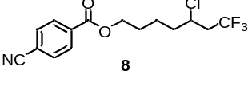
5-Chloro-7,7,7-trifluoroheptyl 4-cyanobenzoate (8): 52.6 mg colorless liquid was isolated, yield: 79%. ¹H NMR (400 MHz, Chloroform-d) δ 8.12 – 8.07 (m, 2H), 7.75 – 7.67 (m, 2H), 4.34 (t, J = 6.3 Hz, 2H), 4.16 – 4.07 (m, 1H), 2.69 – 2.44 (m, 2H), 1.94 – 1.85 (m, 1H), 1.84 – 1.66 (m, 4H), 1.64 – 1.51 (m, 1H). ¹³C NMR (101 MHz, Chloroform-d) δ 164.82, 134.02, 132.17, 129.98, 125.22 (q, J = 277.6 Hz), 117.90, 116.29, 65.23, 53.88 (q, J = 3.0 Hz), 42.27 (q, J = 28.4 Hz), 37.42, 27.83, 22.48. ¹⁹F NMR (376 MHz, Chloroform-d) δ -63.75 (s, 3F). HRMS (ESI) exact mass calculated for [C₁₅H₁₆ClF₃NO₂⁺]: 334.0816, found 334.0828.
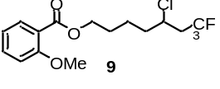
5-Chloro-7,7,7-trifluoroheptyl 2-methoxybenzoate (9): 41.2 mg colorless liquid was isolated, yield: 61%. ¹H NMR (400 MHz, Chloroform-d) δ 7.77 (dd, J = 7.9, 1.8 Hz, 1H), 7.50 – 7.41 (m, 1H), 7.01 – 6.92 (m, 2H), 4.31 (t, J = 6.2 Hz, 2H), 4.16 – 4.07 (m, 1H), 3.88 (s, 3H), 2.71 – 2.44 (m, 2H), 1.95 – 1.85 (m, 1H), 1.84 – 1.70 (m, 4H), 1.65 – 1.56 (m, 1H). ¹³C NMR (101 MHz, Chloroform-d) δ 166.34, 159.18, 133.53, 131.55, 125.32 (q, J = 277.6 Hz), 120.30, 120.17, 112.09, 64.34, 55.97, 54.03 (q, J = 3.1 Hz), 42.45 (q, J = 28.4 Hz), 37.66, 28.07, 22.69. ¹⁹F NMR (376 MHz, Chloroform-d) δ -63.79 (s, 3F). HRMS (ESI) exact mass calculated for [C₁₅H₁₈ClF₃O₃Na⁺]: 361.1789, found 361.0799.
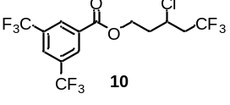
3-Chloro-5,5,5-trifluoropentyl 3,5-bis(trifluoromethyl)benzoate (10): 60.0 mg colorless liquid was isolated, yield: 72%. ¹H NMR (400 MHz, Chloroform-d) δ 8.46 (s, 2H), 8.07 (s, 1H), 4.70 – 4.55 (m, 2H), 4.36 – 4.27 (m, 1H), 2.83 – 2.56 (m, 2H), 2.51 – 2.36 (m, 1H), 2.27 – 2.14 (m, 1H). ¹³C NMR (101 MHz, Chloroform-d) δ 163.83, 132.49 (q, J = 34.1 Hz), 132.17, 129.85 (d, J = 2.9 Hz), 126.72 (dt, J = 7.3, 3.6 Hz), 125.16 (q, J = 277.5 Hz), 122.99 (q, J = 272.8 Hz), 62.65, 50.63 (q, J = 3.2 Hz), 42.63 (q, J = 28.8 Hz), 36.83. ¹⁹F NMR (376 MHz, Chloroform-d) δ -63.32 (s, 6F), -63.97 (s, 3F). HRMS (ESI) exact mass calculated for [C₁₄H₁₀ClF₉O₂Na⁺]: 439.0118, found 439.0119.
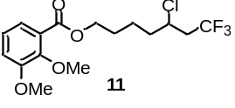
5-Chloro-7,7,7-trifluoroheptyl 3,5-dimethoxybenzoate (11): 61.8 mg colorless liquid was isolated, yield: 84%. ¹ H NMR (400 MHz, Chloroform-d) δ 7.66 (dd, J = 8.4, 1.9 Hz, 1H), 7.52 (d, J = 1.9 Hz, 1H), 6.87 (d, J = 8.4 Hz, 1H), 4.30 (t, J = 6.2 Hz, 2H), 4.17 – 4.06 (m, 1H), 3.91 (s, 3H), 3.91 (s, 3H), 2.71 – 2.44 (m, 2H), 1.97 – 1.85 (m, 1H), 1.84 – 1.66 (m, 4H), 1.64 – 1.52 (m, 1H). ¹³C NMR (101 MHz, Chloroform-d) δ 166.41, 153.07, 148.70, 125.29 (q, J = 277.6 Hz), 123.57, 122.84, 112.01, 110.32, 64.35, 56.07, 56.04, 54.00 (q, J = 3.3 Hz), 42.47 (q, J = 28.4 Hz), 37.62, 28.14, 22.66. ¹⁹F NMR (376 MHz, Chloroform-d) δ -63.79 (s, 3F). HRMS (ESI) exact mass calculated for [C₁₆H₂₀ClF₃O₄Na⁺]: 391.0894, found 391.0891.
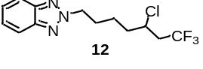
2-(5-Chloro-7,7,7-trifluoroheptyl)-2H-benzo[d][1,2,3]triazole (12): 45.1 mg colorless liquid was isolated, yield: 74%. ¹H NMR (400 MHz, Chloroform-d) δ 7.85 (dd, J = 6.5, 3.1 Hz, 1H), 7.36 (dd, J = 6.6, 3.1 Hz, 1H), 4.73 (t, J = 7.0 Hz, 2H), 4.11 – 4.00 (m, 1H), 2.67 – 2.38 (m, 2H), 2.25 – 2.04 (m, 2H), 1.89 – 1.70 (m, 2H), 1.69 – 1.57 (m, 1H), 1.55 – 1.42 (m, 1H). ¹³C NMR (101 MHz, Chloroform-d) δ 144.39, 126.37, 125.24 (q, J = 277.6 Hz), 118.02, 56.14, 53.72 (q, J = 3.1 Hz), 42.40 (q, J = 28.5 Hz), 37.35, 29.24, 23.12. ¹⁹F NMR (376 MHz, Chloroform-d) δ -63.79 (s, 3F). HRMS (ESI) exact mass calculated for [C₁₃H₁₆ClF₃N₃⁺]: 306.0979, found 306.0985.
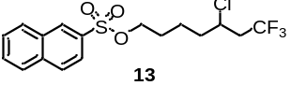
5-Chloro-7,7,7-trifluoroheptyl naphthalene-2-sulfonate (13): 53.6 mg colorless liquid was isolated, yield: 68%. ¹H NMR (400 MHz, Chloroform-d) δ 8.49 (s, 1H), 7.99 (t, J = 7.8 Hz, 2H), 7.93 (d, J = 8.0 Hz, 1H), 7.86 (d, J = 8.6 Hz, 1H), 7.73 – 7.60 (m, 2H), 4.09 (t, J = 6.2 Hz, 2H), 4.01 (tt, J = 8.9, 5.3 Hz, 1H), 2.66 – 2.33 (m, 2H), 1.87 – 1.51 (m, 5H), 1.53 – 1.37 (m, 1H). ¹³C NMR (101 MHz, Chloroform-d) δ 135.33, 132.82, 131.99, 129.81, 129.73, 129.49, 129.36, 128.07, 127.95, 125.23 (d, J = 277.6 Hz), 122.51, 70.39, 53.75 (q, J = 3.1 Hz), 42.28 (q, J = 28.4 Hz), 37.25, 28.18, 22.08. ¹⁹F NMR (376 MHz, Chloroform-d) δ -63.73 (s, 3F). HRMS (ESI) exact mass calculated for [C₁₇H₁₈ClF₃O₃SNa⁺]: 417.0509, found 417.0512
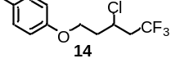
1-((3-Chloro-5,5,5-trifluoropentyl)oxy)-4-methylbenzene (14): 41.5 mg colorless liquid was isolated, yield: 78%. ¹H NMR (400 MHz, Chloroform-d) δ 7.10 (d, J = 8.3 Hz, 2H), 6.82 (d, J = 8.5 Hz, 2H), 4.50 – 4.41 (m, 1H), 4.21 – 4.10 (m, 2H), 2.75 – 2.62 (m, 2H), 2.40 – 2.33 (m, 1H), 2.30 (s, 3H), 2.18 – 2.08 (m, 1H). ¹³C NMR (101 MHz, Chloroform-d) δ 156.50, 130.54, 130.11, 125.35 (q, J = 277.6 Hz), 114.56, 64.11, 51.14 (q, J = 3.3 Hz), 42.69 (q, J = 28.6 Hz), 37.85, 20.60. ¹⁹F NMR (376 MHz, Chloroform-d) δ -63.61 (s, 3F). HRMS (ESI) exact mass calculated for [C₁₂H₁₅ClF₃O⁺]: 267.1758, found 267.0756.
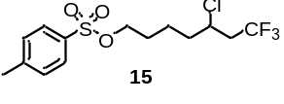
5-Chloro-7,7,7-trifluoroheptyl 4-methylbenzenesulfonate (15): 48.0 mg colorless liquid was isolated, yield: 67%. ¹H NMR (400 MHz, Chloroform-d) δ 7.76 (d, J = 8.3 Hz, 2H), 7.33 (d, J = 8.0 Hz, 2H), 4.09 – 3.98 (m, 3H), 2.63 – 2.44 (m, 2H), 2.42 (s, 3H), 1.80 – 1.70 (m, 1H), 1.70 – 1.50 (m, 4H), 1.49 – 1.38 (m, 1H). ¹³C NMR (101 MHz, Chloroform-d) δ 144.97, 132.99, 129.95, 127.87, 125.25 (q, J = 277.6 Hz), 70.09, 53.78 (q, J = 3.1 Hz), 42.27 (q, J = 28.4 Hz), 37.25, 28.11, 22.05, 21.60. ¹⁹F NMR (376 MHz, Chloroform-d) δ -63.79 (s, 3F). HRMS (ESI) exact mass calculated for [C₁₄H₁₈ClF₃O₃SNa⁺]: 381.0509, found 381.0508.
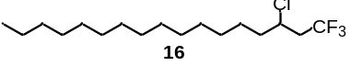
3-Chloro-1,1,1-trifluoroheptadecane (16): 44.0 mg colorless liquid was isolated, yield: 67%. ¹H NMR (400 MHz, Chloroform-d) δ 4.15 – 4.07 (m, 1H), 2.69 – 2.45 (m, 2H), 1.88 – 1.68 (m, 2H), 1.60 – 1.50 (m, 1H), 1.48 – 1.39 (m, 1H), 1.31 – 1.24 (m, 22H), 0.89 (t, J = 6.8 Hz, 3H). ¹³C NMR (101 MHz, Chloroform-d) δ 125.48 (q, J = 277.5 Hz), 54.34 (q, J = 3.1 Hz), 42.62 (q, J = 28.3 Hz), 38.26, 32.11, 29.87, 29.85, 29.83, 29.82, 29.78, 29.68, 29.57, 29.54, 29.04, 26.08, 22.87, 14.26. ¹⁹F NMR (376 MHz, Chloroform-d) δ -63.89 (s, 3F). HRMS (ESI) exact mass calculated for [C₁₇H₃₂ClF₃Na⁺]: 351.2037, found 351.2039.
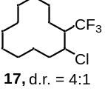
1-Chloro-2-(trifluoromethyl)cyclododecane (17): 34.0 mg colorless liquid was isolated, yield: 63%, d.r. = 4:1. Characterization data for a mixture of rotamers: ¹H NMR (400 MHz, Chloroform-d) δ 4.28 – 4.12 (m, 1H), 2.64 – 2.51 (m, 1H), 2.20 – 1.95 (m, 1H), 1.84 – 1.59 (m, 4H), 1.55 – 1.22 (m, 15H). ¹³C NMR (101 MHz, Chloroform-d) δ 127.71 (q, J = 281.6 Hz), 55.23, 44.10 (q, J = 24.6 Hz), 34.96, 24.80, 23.52, 22.91, 22.87, 22.82, 22.65, 22.48, 21.72, 21.23. ¹⁹F NMR (376 MHz, Chloroform-d) δ -64.30 (s, 3F). HRMS (ESI) exact mass calculated for [C₁₃H₂₂ClF₃Na⁺]: 293.1254, found 293.1270.
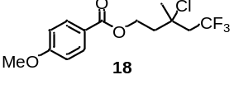
3-Chloro-5,5,5-trifluoro-3-methylpentyl 4-methoxybenzoate (18): 44.1 mg colorless liquid was isolated, yield: 66%. ¹H NMR (400 MHz, Chloroform-d) δ 8.00 – 7.94 (m, 2H), 6.95 – 6.87 (m, 2H), 4.62 – 4.49 (m, 2H), 3.85 (s, 3H), 2.87 – 2.69 (m, 2H), 2.44 – 2.26 (m, 2H), 1.78 (s, 3H). ¹³C NMR (101 MHz, Chloroform-d) δ 166.15, 163.61, 131.68, 125.02 (q, J = 278.7 Hz), 122.39, 113.79, 65.55 (q, J = 2.1 Hz), 61.12, 55.50, 47.13 (q, J = 27.8 Hz), 42.30, 30.49. ¹⁹F NMR (376 MHz, Chloroform-d) δ -60.53 (s, 3F). HRMS (ESI) exact mass calculated for [C₁₄H₁₆ClF₃O₃Na⁺]: 347.0632, found 347.0631.
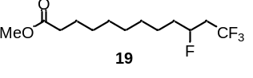
Methyl 10,12,12,12-tetrafluorododecanoate (19): 30.9 mg white solid was isolated, yield: 54%. ¹H NMR (400 MHz, Chloroform-d) δ 4.89 – 4.65 (m, 1H), 3.66 (s, 3H), 2.58 – 2.39 (m, 1H), 2.38 – 2.20 (m, 3H), 1.80 – 1.67 (m, 1H), 1.65 – 1.55 (m, 3H), 1.51 – 1.28 (m, 10H). ¹³C NMR (101 MHz, Chloroform-d) δ 174.41, 125.64 (dq, J = 3.3, 276.8 Hz), 87.74 (dq, J = 172.0, 3.2 Hz), 51.58, 39.52 (qd, J = 28.4, 23.0 Hz), 35.12 (d, J = 20.7 Hz), 34.19, 29.32, 29.23, 29.22, 29.19, 25.03, 24.68 (d, J = 4.3 Hz). ¹⁹F NMR (376 MHz, Chloroform-d) δ -64.18 (d, J = 7.6 Hz, 3F), -181.82 (q, J = 7.6 Hz, 1F). HRMS (ESI) exact mass calculated for [C₁₃H₂₂F₄O₂Na⁺]: 309.1448, found 309.1456.
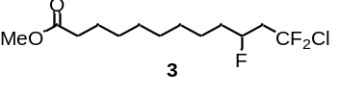
Methyl 12-chloro-10,12,12-trifluorododecanoate (3): 45.3 mg white solid was isolated, yield: 75%. ¹H NMR (400 MHz, Chloroform-d) δ 4.96 – 4.72 (m, 1H), 3.66 (s, 3H), 2.82 – 2.37 (m, 2H), 2.30 (t, J = 7.5 Hz, 2H), 1.74 – 1.66 (m, 1H), 1.66 – 1.58 (m, 3H), 1.46 – 1.28 (m, 10H). ¹³C NMR (101 MHz, Chloroform-d) δ 174.42, 127.96 (dt, J = 2.6, 292.5, Hz), 88.55 (dt, J = 172.6, 3.0 Hz), 51.60, 47.14 (dd, J = 22.9, 23.9 Hz), 35.16 (d, J = 20.7 Hz), 34.21, 29.33, 29.24, 29.23, 29.20, 25.04, 24.68 (d, J = 4.3 Hz). ¹⁹F NMR (376 MHz, Chloroform-d) δ -48.57 – -50.37 (m, 2F), -181.11 – -181.18 (m, 1F). HRMS (ESI) exact mass calculated for [C₁₃H₂₂ClF₃O₂Na⁺]: 325.1153, found 325.1156.
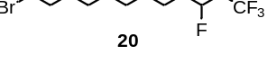
12-Bromo-1,1,1,3-tetrafluorododecane (20): 30.1 mg colorless liquid was isolated, yield: 47%. ¹H NMR (400 MHz, DMSO-d₆) δ 4.90 – 4.69 (m, 1H), 3.52 (t, J = 6.7 Hz, 2H), 2.82 – 2.57 (m, 2H), 1.84 – 1.73 (m, 2H), 1.70 – 1.51 (m, 2H), 1.46 – 1.23 (m, 12H). ¹³C NMR (101 MHz, Chloroform-d) δ 125.64 (qd, J = 276.8, 3.2 Hz), 87.73 (dq, J = 172.0, 3.2 Hz), 39.52 (qd, J = 28.4, 23.0 Hz), 35.13 (d, J = 20.8 Hz), 34.11, 32.93, 29.43, 29.41, 29.27, 28.83, 28.26, 24.70 (d, J = 4.2 Hz). ¹⁹F NMR (376 MHz, DMSO-d₆) δ -62.45 (d, J = 7.8 Hz, 3F), -181.90 (q, J = 7.9 Hz, 1F). HRMS (ESI) exact mass calculated for [C₁₂H₂₂BrF₄⁺]: 321.0836, found 321.0823.
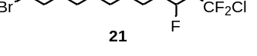
12-Bromo-1-chloro-1,1,3-trifluorododecane (21): 34.9 mg colorless liquid was isolated, yield: 52%. ¹H NMR (400 MHz, Chloroform-d) δ 4.96 – 4.74 (m, 1H), 3.41 (t, J = 6.8 Hz, 2H), 2.83 – 2.39 (m, 2H), 1.91 – 1.80 (m, 2H), 1.76 – 1.52 (m, 2H), 1.51 – 1.27 (m, 12H). ¹³C NMR (101 MHz, Chloroform-d) δ 127.96 (td, J = 292.4, 2.5 Hz), 88.55 (dt, J = 172.6, 2.9 Hz), 47.14 (q, J = 23.8 Hz), 35.17 (d, J = 20.8 Hz), 34.15, 32.93, 29.43, 29.41, 29.28, 28.84, 28.26, 24.69 (d, J = 4.3 Hz). ¹⁹F NMR (376 MHz, Chloroform-d) δ -48.48 – -50.41 (m, 2F), -181.10 – -181.18 (m, 1F). HRMS (ESI) exact mass calculated for [C₁₂H₂₂BrClF₃⁺]: 337.0540, found 337.0544.
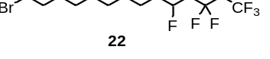
13-Bromo-1,1,1,2,2,4-hexafluorotridecane (22): 42.2 mg colorless liquid was isolated, yield: 57%. ¹H NMR (400 MHz, DMSO-d₆) δ 4.99 – 4.78 (m, 1H), 3.52 (t, J = 6.7 Hz, 2H), 2.75 – 2.51 (m, 2H), 1.84 – 1.74 (m, 2H), 1.74 – 1.54 (m, 2H), 1.46 – 1.24 (m, 12H). ¹³C NMR (101 MHz, Chloroform-d) δ 119.01 (qt, J = 285.4, 35.7 Hz), 114.67 (dqt, J = 2.0, 38.0, 254.5 Hz), 86.95 (dt, J = 172.8, 3.2 Hz), 36.47 (dt, J = 23.2, 21.4 Hz), 35.64 (d, J = 20.8 Hz), 34.10, 32.94, 29.43, 29.42, 29.27, 28.84, 28.27, 24.71 (d, J = 4.2 Hz). ¹⁹F NMR (376 MHz, Chloroform-d) δ -80.23 (d, J = 3.5 Hz, 3F), -109.70 – -112.17 (m, 2F), -175.64 – -175.75 (m, 1F). HRMS (ESI) exact mass calculated for [C₁₃H₂₁BrF₆K⁺]: 409.0362, found 409.0365.
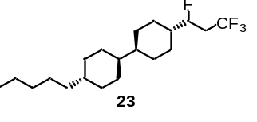
(1s,1'S,4S,4'R)-4-Pentyl-4'-((S)-1,3,3,3-tetrafluoropropyl)-1,1'-bi(cyclohexane) (23): 49.7 mg white solid was isolated, yield: 71%. ¹H NMR (400 MHz, Chloroform-d) δ 4.67 – 4.45 (m, 1H), 2.54 – 2.20 (m, 2H), 1.92 – 1.65 (m, 8H), 1.54 – 1.42 (m, 1H), 1.33 – 1.18 (m, 7H), 1.17 – 1.08 (m, 4H), 1.04 – 0.93 (m, 6H), 0.89 – 0.79 (m, 5H). ¹³C NMR (101 MHz, Chloroform-d) δ 126.11 (q, J = 276.9 Hz), 91.15 (dq, J = 174.2, 2.8 Hz), 43.39, 43.12, 42.31, 42.12, 38.04, 37.60, 37.14 (qd, J = 28.4, 23.0 Hz), 33.73, 32.40, 30.20, 29.36 (d, J = 16.7 Hz), 28.56 (d, J = 4.3 Hz), 27.24 (d, J = 5.7 Hz), 26.83, 22.87, 14.26. ¹⁹F NMR (376 MHz, Chloroform-d) δ -64.25 (d, J = 7.8 Hz, 3F), -187.38 (q, J = 7.9 Hz, 1F). HRMS (ESI) exact mass calculated for [C₂₀H₃₅F₄⁺]: 351.2669, found 351.2679.
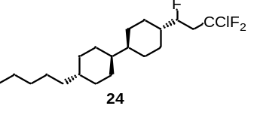
(1S,1's,4R,4'S)-4-((S)-3-Chloro-1,3,3-trifluoropropyl)-4'-pentyl-1,1'-bi(cyclohexane) (24): 46.9 mg white solid was isolated, yield: 64%. ¹H NMR (400 MHz, Chloroform-d) δ 4.74 – 4.47 (m, 1H), 2.77 – 2.37 (m, 2H), 1.90 – 1.66 (m, 8H), 1.54 – 1.42 (m, 1H), 1.37 – 1.19 (m, 7H), 1.18 – 1.10 (m, 4H), 1.08 – 0.95 (m, 6H), 0.91 – 0.82 (m, 5H). ¹³C NMR (101 MHz, Chloroform-d) δ 128.58 (t, J = 293.9 Hz), 91.91 (dt, J = 175.3, 2.7 Hz), 44.90 (q, J = 23.7 Hz), 43.40, 43.14, 42.42, 42.22, 38.06, 37.62, 33.74, 32.41, 30.20, 29.39 (d, J = 15.7 Hz), 28.60 (d, J = 4.1 Hz), 27.23 (d, J = 5.8 Hz), 26.85, 22.88, 14.27. ¹⁹F NMR (376 MHz, Chloroform-d) δ -48.27 – -50.66 (m, 2F), -186.67 (t, J = 9.3 Hz, 1F). HRMS (ESI) exact mass calculated for [C₂₀H₃₄ClF₃Na⁺]: 389.2193, found 389.2210.
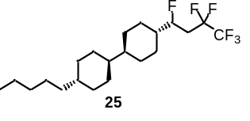
(1S,1's,4R,4'S)-4-((S)-1,3,3,4,4,4-Hexafluorobutyl)-4'-pentyl-1,1'-bi(cyclohexane) (25): 64.8 mg white solid was isolated, yield: 81%. ¹H NMR (400 MHz, Chloroform-d) δ 4.77 – 4.54 (m, 1H), 2.51 – 2.12 (m, 2H), 1.94 – 1.65 (m, 8H), 1.54 – 1.42 (m, 1H), 1.38 – 1.20 (m, 7H), 1.19 – 1.09 (m, 4H), 1.08 – 0.94 (m, 6H), 0.94 – 0.82 (m, 5H). ¹³C NMR (101 MHz, Chloroform-d) δ 119.13 (tq, J = 35.8, 285.0 Hz), 115.02 (qt, J = 38.4, 255.5 Hz), 90.21 (dt, J = 175.2, 2.9 Hz), 43.43, 43.16, 42.71, 42.52, 38.09, 37.65, 34.14 (q, J = 22.6 Hz), 33.76, 32.45, 30.23, 29.40 (d, J = 16.8 Hz), 28.63 (d, J = 4.0 Hz), 27.16 (d, J = 5.8 Hz), 26.88, 22.90, 14.24. ¹⁹F NMR (376 MHz, Chloroform-d) δ -85.86 (d, J = 3.2 Hz, 3F), -117.15 – -117.36 (m, 2F), -185.50 – -185.65 (m, 1F). HRMS (ESI) exact mass calculated for [C₂₁H₃₅F₆⁺]: 401.2637, found 401.2633.
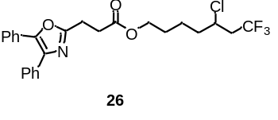
5-Chloro-7,7,7-trifluoroheptyl 3-(4,5-diphenyloxazol-2-yl)propanoate (26): 56.5 mg colorless liquid was isolated, yield: 59%. ¹H NMR (400 MHz, Chloroform-d) δ 7.67 – 7.61 (m, 2H), 7.60 – 7.55 (m, 2H), 7.40 – 7.28 (m, 6H), 4.15 (t, J = 6.3 Hz, 2H), 4.10 – 4.03 (m, 1H), 3.20 (t, J = 7.4 Hz, 2H), 2.93 (t, J = 7.4 Hz, 2H), 2.69 – 2.40 (m, 2H), 1.88 – 1.75 (m, 1H), 1.75 – 1.59 (m, 4H), 1.55 – 1.42 (m, 1H). ¹³C NMR (101 MHz, Chloroform-d) δ 172.07, 161.80, 145.48, 135.19, 132.53, 129.04, 128.72, 128.63, 128.55, 128.15, 127.95, 126.53, 125.29 (q, J = 277.5 Hz), 64.39, 53.93 (q, J = 3.1 Hz), 42.44 (q, J = 28.4 Hz), 37.57, 31.20, 27.97, 23.63, 22.55. ¹⁹F NMR (376 MHz, Chloroform-d) δ -63.69 (s, 3F). HRMS (ESI) exact mass calculated for [C₂₅H₂₅ClF₃NO₃Na⁺]: 502.1367, found 502.1378.
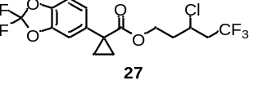
3-Chloro-5,5,5-trifluoropentyl 2-(2,2-difluorobenzo[d][1,3]dioxol-5-yl)cyclopropane-1-carboxylate (27): 66.4 mg colorless liquid was isolated, yield: 83%. ¹H NMR (400 MHz, Chloroform-d) δ 7.08 – 7.03 (m, 2H), 6.99 – 6.96 (m, 1H), 4.29 – 4.17 (m, 2H), 4.02 – 3.94 (m, 1H), 2.61 – 2.33 (m, 2H), 2.15 – 2.05 (m, 1H), 1.97 – 1.87 (m, 1H), 1.64 – 1.61 (m, 2H), 1.22 – 1.19 (m, 2H). ¹³C NMR (101 MHz, Chloroform-d) δ 173.80, 143.59, 143.02, 135.60, 131.80 (t, J = 255.1 Hz), 125.78, 125.09 (q, J = 277.6 Hz), 111.96, 109.05, 61.43, 50.60 (q, J = 3.3 Hz), 42.35 (q, J = 28.6 Hz), 36.72, 29.05, 17.28, 17.13. ¹⁹F NMR (376 MHz, Chloroform-d) δ -50.08 (s, 2F), -64.21 (s, 3F). HRMS (ESI) exact mass calculated for [C₁₆H₁₄ClF₅O₄Na⁺]: 432.0393, found 432.0399.
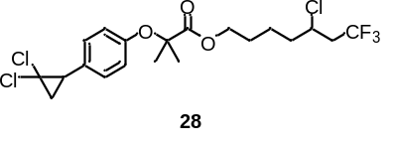
5-Chloro-7,7,7-trifluoroheptyl 2-(3-(2,2-dichlorocyclopropyl)phenoxy)-2-methylpropanoate (28): 53.2 mg colorless liquid was isolated, yield: 56%. ¹H NMR (400 MHz, Chloroform-d) δ 7.14 – 7.06 (m, 2H), 6.83 – 6.75 (m, 2H), 4.16 (t, J = 6.3 Hz, 2H), 4.06 – 3.95 (m, 1H), 2.82 (dd, J = 10.3, 8.7 Hz, 1H), 2.65 – 2.36 (m, 2H), 1.93 (dd, J = 10.7, 7.4 Hz, 1H), 1.80 – 1.73 (m, 2H), 1.72 – 1.62 (m, 3H), 1.60 (s, 6H), 1.55 – 1.45 (m, 1H), 1.42 – 1.32 (m, 1H). ¹³C NMR (101 MHz, Chloroform-d) δ 174.33, 155.11, 129.74, 128.14, 125.31 (q, J = 277.5 Hz), 118.40, 79.20, 65.05, 61.00, 53.89 (q, J = 2.9 Hz), 42.41 (q, J = 28.4 Hz), 37.54, 34.90, 27.81, 25.91, 25.54, 25.52, 25.50, 22.47. ¹⁹F NMR (376 MHz, Chloroform-d) δ -63.74 (d, J = 2.3 Hz, 3F). HRMS (ESI) exact mass calculated for [C₂₀H₂₄Cl₃F₃O₃Na⁺]: 497.0635, found 497.0631.
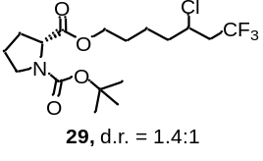
1-(Tert-butyl) 2-(5-chloro-7,7,7-trifluoroheptyl) (2R)-pyrrolidine-1,2-dicarboxylate (29): 56.1 mg colorless liquid was isolated, yield: 70%, dr = 1.4:1. ¹H NMR (400 MHz, Chloroform-d, a mixture of rotamers) δ 4.29-4.17 (m, 1H), 4.15 – 4.03 (m, 3H), 3.56 – 3.31 (m, 2H), 2.71 – 2.40 (m, 2H), 2.25 – 2.09 (m, 1H), 1.97 – 1.79 (m, 4H), 1.77 – 1.58 (m, 4H), 1.55 – 1.46 (m, 1H), [1.42(s, 3.72H), 1.38 (s, 5.22H), 9H]. ¹³C NMR (101 MHz, Chloroform-d, characterization data for the major isomer) δ 173.30, 153.85, 125.26 (q, J = 277.7 Hz), 79.89, 64.47, 59.23, 53.94, 46.3, 42.50 (q, J = 28.8 Hz), 37.56, 31.00, 28.39, 28.01, 23.68, 22.57. ¹⁹F NMR (376 MHz, Chloroform-d) δ -63.85 (s, 3F). HRMS (ESI) exact mass calculated for [C₁₇H₂₇ClF₃NO₄Na⁺]: 424.1473, found 424.1472.
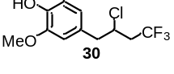
4-(2-Chloro-4,4,4-trifluorobutyl)-2-methoxyphenol (30): 23.0 mg colorless liquid was isolated, yield: 43%. ¹H NMR (400 MHz, Chloroform-d) δ 6.88 (d, J = 8.2 Hz, 1H), 6.75 – 6.68 (m, 2H), 5.61 (s, 1H), 4.34 – 4.22 (m, 1H), 3.90 (s, 3H), 3.04 (d, J = 6.9 Hz, 2H), 2.64 – 2.47 (m, 2H). ¹³C NMR (101 MHz, Chloroform-d) δ 146.68, 145.03, 128.20, 125.50 (q, J = 277.5 Hz), 122.39, 114.62, 111.92, 56.07, 54.41 (q, J = 2.9 Hz), 44.28, 41.29 (q, J = 28.6 Hz). ¹⁹F NMR (376 MHz, Chloroform-d) δ -63.55 (s, 3F). HRMS (ESI) exact mass calculated for [C₁₁H₁₂ClF₃O₂Na⁺]: 291.0370, found 291.0381.
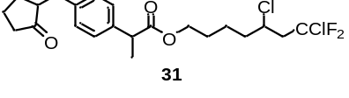
5,7-Dichloro-7,7-difluoroheptyl 2-(4-((2-oxocyclopentyl)methyl)phenyl)propanoate (31): 63.6 mg colorless liquid was isolated, yield: 71%. ¹H NMR (400 MHz, Chloroform-d) δ 7.18 (d, J = 8.1 Hz, 2H), 7.09 (d, J = 8.2 Hz, 2H), 4.16 – 3.94 (m, 3H), 3.66 (q, J = 7.1 Hz, 1H), 3.08 (dd, J = 13.9, 4.1 Hz, 1H), 2.83 – 2.57 (m, 2H), 2.47 (dd, J = 13.9, 9.5 Hz, 1H), 2.35 – 2.23 (m, 2H), 2.12 – 2.01 (m, 2H), 1.96 – 1.87 (m, 1H), 1.80 – 1.48 (m, 7H), 1.44 (d, J = 7.2 Hz, 3H), 1.41 – 1.32 (m, 1H). ¹³C NMR (101 MHz, Chloroform-d) δ 219.81, 174.42, 138.80, 138.31 (d, J = 2.0 Hz), 129.02, 127.72 (t, J = 293.3 Hz), 127.41, 64.02, 54.87 (t, J = 2.1 Hz), 50.83, 49.57 (t, J = 23.8 Hz), 45.05, 38.04, 37.38, 35.10, 29.15, 27.73 (d, J = 1.4 Hz), 22.22, 20.45, 18.34 (d, J = 2.1 Hz). ¹⁹F NMR (376 MHz, Chloroform-d) δ -48.44 – -49.76 (m, 2F). HRMS (ESI) exact mass calculated for [C₂₂H₂₈Cl₂F₂O₃Na⁺]: 471.1276, found 471.1285.
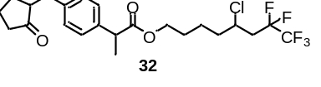
5-Chloro-7,7,8,8,8-pentafluorooctyl 2-(4-((2-oxocyclopentyl)methyl)phenyl)propanoate (32): 60.7 mg colorless liquid was isolated, yield: 63%. ¹H NMR (400 MHz, Chloroform-d) δ 7.19 (d, J = 8.0 Hz, 2H), 7.10 (d, J = 8.0 Hz, 2H), 4.17 – 4.10 (m, 1H), 4.10 – 4.03 (m, 2H), 3.67 (q, J = 7.1 Hz, 1H), 3.12-3.07 (m, 1H), 2.63 – 2.37 (m, 3H), 2.36 – 2.26 (m, 2H), 2.14 – 2.01 (m, 2H), 1.98 – 1.88 (m, 1H), 1.87 – 1.76 (m, 1H), 1.76 – 1.65 (m, 2H), 1.65 – 1.49 (m, 4H), 1.46 (d, J = 7.2 Hz, 3H), 1.42 – 1.31 (m, 1H). ¹³C NMR (101 MHz, Chloroform-d) δ 219.91, 174.50, 138.86, 138.36 (d, J = 2.0 Hz), 129.06, 127.46, 118.74 (qt, J = 285.5, 35.6 Hz), 114.45 (dt, J = 38.0, 254.3 Hz), 64.06, 53.04, 50.90, 45.11, 38.99 (t, J = 20.7 Hz), 38.08, 37.95, 35.15, 29.20, 27.77, 22.33, 20.48, 18.35. ¹⁹F NMR (376 MHz, Chloroform-d) δ -85.93 (d, J = 7.2 Hz, 3F), -116.45 – -118.13 (m, 2F). HRMS (ESI) exact mass calculated for [C₂₃H₂₈ClF₅O₃Na⁺]: 505.1539, found 505.1550.
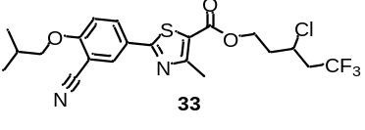
3-Chloro-5,5,5-trifluoropentyl-2-(3-cyano-4-isobutoxyphenyl)-4-methylthiazole-5-carboxylate (33): 77.8 mg white solid was isolated, yield: 82%. ¹H NMR (400 MHz, Chloroform-d) δ 8.08 (d, J = 2.2 Hz, 1H), 8.00 (dd, J = 8.8, 2.3 Hz, 1H), 6.96 (d, J = 8.9 Hz, 1H), 4.54 – 4.39 (m, 2H), 4.34 – 4.24 (m, 1H), 3.86 (d, J = 6.5 Hz, 2H), 2.78 – 2.58 (m, 5H), 2.40 – 2.27 (m, 1H), 2.21 – 2.05 (m, 2H), 1.05 (d, J = 6.7 Hz, 6H). ¹³C NMR (101 MHz, Chloroform-d) δ 167.44, 162.55, 161.67, 161.58, 132.59, 131.98, 125.78, 125.10 (q, J = 277.6 Hz), 121.06, 115.35, 112.66, 102.91, 75.71, 61.50, 50.64 (q, J = 3.1 Hz), 42.46 (q, J = 28.7 Hz), 36.83, 28.17, 19.03, 17.50. ¹⁹F NMR (376 MHz, Chloroform-d) δ -63.58 (s, 3F). HRMS (ESI) exact mass calculated for [C₂₁H₂₃ClF₃N₂O₃S⁺]: 475.1065, found 475.1068.
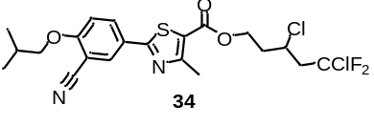
3,5-Dichloro-5,5-difluoropentyl-2-(3-cyano-4-isobutoxyphenyl)-4-methylthiazole-5-carboxylate (34): 76.4 mg white solid was isolated, yield: 78%. ¹H NMR (400 MHz, Chloroform-d) δ 8.16 (d, J = 2.2 Hz, 1H), 8.07 (dd, J = 8.8, 2.3 Hz, 1H), 7.01 (d, J = 8.9 Hz, 1H), 4.58 – 4.44 (m, 2H), 4.42 – 4.34 (m, 1H), 3.89 (d, J = 6.5 Hz, 2H), 3.02 – 2.78 (m, 2H), 2.75 (s, 3H), 2.43 – 2.32 (m, 1H), 2.25 – 2.06 (m, 2H), 1.08 (d, J = 6.7 Hz, 6H). ¹³C NMR (101 MHz, Chloroform-d) δ 167.64, 162.68, 161.82, 161.75, 132.74, 132.21, 127.59 (t, J = 293.2 Hz), 125.92, 121.20, 115.48, 112.75, 103.06, 75.81, 61.62, 51.73 (t, J = 2.6 Hz), 49.91 (t, J = 24.1 Hz), 36.91, 28.25, 19.15, 17.65. ¹⁹F NMR (376 MHz, Chloroform-d) δ -49.17 (dd, J = 18.4, 3.1 Hz, 2F). HRMS (ESI) exact mass calculated for [C₂₁H₂₃Cl₂F₂N₂O₃S⁺]: 491.0769, found 491.0766.
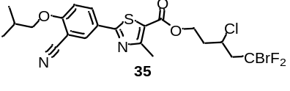
5-Bromo-3-chloro-5,5-difluoropentyl-2-(3-cyano-4-isobutoxyphenyl)-4-methylthiazole-5-carboxylate (35): 70.5 mg yellow solid was isolated, yield: 66%. ¹H NMR (400 MHz, Chloroform-d) δ 8.14 – 7.94 (m, 2H), 7.03 – 6.92 (m, 1H), 4.59 – 4.27 (m, 3H), 3.90 – 3.79 (m, 2H), 3.09 – 2.81 (m, 2H), 2.77 – 2.64 (m, 3H), 2.42 – 2.27 (m, 1H), 2.28 – 2.02 (m, 2H), 1.11 – 1.00 (m, 6H). ¹³C NMR (101 MHz, Chloroform-d) δ 167.34, 162.47, 161.54, 161.49, 132.53, 131.88, 125.70, 121.06, 119.98 (t, J = 306.7 Hz), 115.29, 112.63, 102.82, 75.65, 61.46, 52.24 (t, J = 2.4 Hz), 51.94 (t, J = 21.6 Hz), 36.73, 28.11, 19.00, 17.51. ¹⁹F NMR (376 MHz, Chloroform-d) δ -42.92 – -43.40 (m, 2F). HRMS (ESI) exact mass calculated for [C₂₁H₂₃BrClF₂N₂O₃S⁺]: 535.0264, found 535.0270.
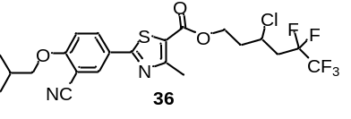
3-Chloro-5,5,6,6,6-pentafluorohexyl-2-(3-cyano-4-isobutoxyphenyl)-4-methylthiazole-5-carboxylate (36): 83.8 mg yellow solid was isolated, yield: 81%. ¹H NMR (400 MHz, Chloroform-d) δ 8.08 (d, J = 2.2 Hz, 1H), 8.00 (dd, J = 8.8, 2.2 Hz, 1H), 6.97 (d, J = 8.9 Hz, 1H), 4.56 – 4.34 (m, 3H), 3.86 (d, J = 6.5 Hz, 2H), 2.70 (s, 3H), 2.67 – 2.49 (m, 2H), 2.44 – 2.31 (m, 2H), 2.26 – 2.06 (m, 2H), 1.05 (d, J = 6.7 Hz, 6H). ¹³C NMR (101 MHz, Chloroform-d) δ 167.27, 162.45, 161.53, 161.44, 132.46, 131.78, 125.67, 120.98, 118.68 (qt, J = 286.1, 35.8 Hz), 115.24, 114.38 (tq, J = 254.6, 38.0 Hz), 112.59, 102.78, 75.63, 61.45, 49.85, 39.10 (t, J = 20.7 Hz), 37.26, 28.10, 18.90, 17.37. ¹⁹F NMR (376 MHz, Chloroform-d) δ -85.79 – -85.86 (m, 3F), -116.78 – -117.34 (m, 2F). HRMS (ESI) exact mass calculated for [C₂₂H₂₃ClF₅N₂O₃S⁺]: 525.1033, found 525.1041.
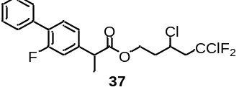
5,7-Dichloro-7,7-difluoroheptyl 2-(2-fluoro-[1,1'-biphenyl]-4-yl)propanoate (37): 61.9 mg colorless liquid was isolated, yield: 74%. ¹H NMR (400 MHz, Chloroform-d) δ 7.57 (d, J = 7.6 Hz, 2H), 7.51 – 7.33 (m, 4H), 7.16 (t, J = 9.1 Hz, 2H), 4.45 – 4.26 (m, 2H), 4.26 – 4.13 (m, 1H), 3.85 – 3.74 (m, 1H), 2.93 – 2.60 (m, 2H), 2.31 – 2.14 (m, 1H), 2.04 – 1.91 (m, 1H), 1.58 (d, J = 7.2 Hz, 3H). ¹³C NMR (101 MHz, Chloroform-d) δ 173.61 (d, J = 1.7 Hz), 159.75 (d, J = 248.5 Hz), 141.62 (dd, J = 7.5, 3.5 Hz), 135.44 , 130.96 (d, J = 4.0 Hz), 128.97 (d, J = 2.8 Hz), 128.50 , 128.00 (dd, J = 1.0, 13.1 Hz), 127.75, 127.57 (td, J = 293.3, 2.4 Hz), 123.54, 115.22 (dd, J = 23.7, 3.7 Hz), 61.09 (d, J = 2.9 Hz), 51.61 (dt, J = 5.7, 2.3 Hz), 49.64 (t, J = 24.0 Hz), 45.00 (dd, J = 1.0, 8.1 Hz), 36.78 (d, J = 5.0 Hz), 18.19 (d, J = 0.9 Hz). ¹⁹F NMR (376 MHz, Chloroform-d) δ -48.45 – -49.79 (m, 2F), -117.32 (d, J = 10.3 Hz, 1F). HRMS (ESI) exact mass calculated for [C₂₀H₁₉Cl₂F₃O₂Na⁺]: 441.0606, found 441.0613.
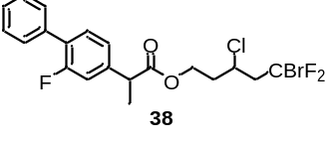
5-Bromo-3-chloro-5,5-difluoropentyl 2-(2-fluoro-[1,1'-biphenyl]-4-yl)propanoate (38): 62.8 mg colorless liquid was isolated, yield: 68%. ¹H NMR (400 MHz, Chloroform-d) δ 7.57 (d, J = 7.5 Hz, 2H), 7.51 – 7.36 (m, 4H), 7.17 (t, J = 8.9 Hz, 2H), 4.44 – 4.27 (m, 2H), 4.26 – 4.15 (m, 1H), 3.85 – 3.75 (m, 1H), 2.99 – 2.70 (m, 2H), 2.28 – 2.14 (m, 1H), 2.04 – 1.92 (m, 1H), 1.58 (d, J = 7.2 Hz, 3H). ¹³C NMR (101 MHz, Chloroform-d) δ 173.54, 159.71 (d, J = 248.5 Hz), 141.61 (dd, J = 7.3, 3.8 Hz), 135.39, 130.93 (d, J = 3.9 Hz), 128.94 (d, J = 2.8 Hz), 128.48, 127.93 (dd, J = 0.9, 13.5 Hz), 127.72, 123.53, 120.06 (t, J = 306.9 Hz), 115.21 (dd, J = 23.6, 2.5 Hz), 61.04 (d, J = 3.0 Hz), 52.18 (t, J = 2.7 Hz), 51.80 (t, J = 21.6 Hz), 44.96 (d, J = 7.1 Hz), 36.67 (d, J = 4.0 Hz), 18.19 (d, J = 1.1 Hz). ¹⁹F NMR (376 MHz, Chloroform-d) δ -41.90 – -43.50 (m, 2F), -117.24 (d, J = 10.4 Hz, 1F). HRMS (ESI) exact mass calculated for [C₂₀H₁₉BrClF₃O₂Na⁺]: 485.0101, found 485.0101.
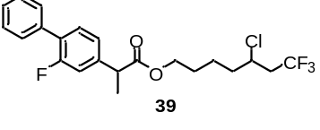
5-Chloro-7,7,7-trifluoroheptyl 2-(2-fluoro-[1,1'-biphenyl]-4-yl)propanoate (39): 68.0 mg colorless liquid was isolated, yield: 79%. ¹H NMR (400 MHz, Chloroform-d) δ 7.60 – 7.53 (m, 2H), 7.49 – 7.34 (m, 4H), 7.21 – 7.13 (m, 2H), 4.14 (t, J = 6.3 Hz, 2H), 4.11 – 4.04 (m, 1H), 3.78 (q, J = 7.2 Hz, 1H), 2.68 – 2.41 (m, 2H), 1.88 – 1.60 (m, 5H), 1.57 (d, J = 7.2 Hz, 3H), 1.51 – 1.40 (m, 1H). ¹³C NMR (101 MHz, Chloroform-d) δ 173.98, 159.75 (d, J = 248.3 Hz), 141.96 (dd, J = 7.7, 1.3 Hz), 135.51, 130.86 (d, J = 4.0 Hz), 128.99 (d, J = 2.9 Hz), 128.52, 127.88 (d, J = 13.5 Hz), 127.75, 125.30 (q, J = 277.6 Hz), 123.63 (d, J = 3.3 Hz), 115.30 (d, J = 23.6 Hz), 64.50, 53.93 (d, J = 2.5 Hz), 45.13, 42.38 (q, J = 28.3 Hz), 37.50, 27.89, 22.44 (d, J = 1.6 Hz), 18.35. ¹⁹F NMR (376 MHz, Chloroform-d) δ -63.73 (s, 3F), -117.58 (s, 1F). HRMS (ESI) exact mass calculated for [C₂₂H₂₃ClF₄O₂Na⁺]: 453.1215, found 453.1216.
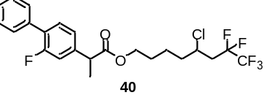
5-Chloro-7,7,8,8,8-pentafluorooctyl 2-(2-fluoro-[1,1'-biphenyl]-4-yl)propanoate (40): 71.1 mg colorless liquid was isolated, yield: 74%. ¹H NMR (400 MHz, Chloroform-d) δ 7.61 – 7.55 (m, 2H), 7.50 – 7.41 (m, 3H), 7.41 – 7.36 (m, 1H), 7.23 – 7.15 (m, 2H), 4.25 – 4.19 (m, 1H), 4.16 (t, J = 6.2 Hz, 2H), 3.80 (q, J = 7.1 Hz, 1H), 2.70 – 2.38 (m, 2H), 1.94 – 1.61 (m, 5H), 1.58 (d, J = 7.2 Hz, 3H), 1.54 – 1.43 (m, 1H). ¹³C NMR (101 MHz, Chloroform-d) δ 173.93, 159.75 (d, J = 248.2 Hz), 141.97 (dd, J = 0.8, 7.7 Hz), 135.51, 130.82 (d, J = 3.9 Hz), 128.96 (d, J = 2.9 Hz), 128.48, 127.85 (d, J = 13.5 Hz), 127.70, 123.60 (d, J = 2.6 Hz), 118.83 (dt, J = 285.5, 35.6 Hz), 115.27 (d, J = 23.7 Hz), 114.54 (td, J = 254.1, 37.9 Hz), 64.43 (d, J = 1.3 Hz), 53.10, 45.10, 39.07 (t, J = 20.7 Hz), 38.01, 27.84, 22.43, 18.28. ¹⁹F NMR (376 MHz, Chloroform-d) δ -85.90 (d, J = 7.2 Hz， 3F), -117.09 – -117.20 (m, 3F). HRMS (ESI) exact mass calculated for [C₂₃H₂₃ClF₆O₂Na⁺]: 503.1183, found 503.1189.
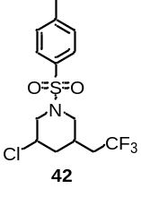
3-Chloro-1-tosyl-5-(2,2,2-trifluoroethyl)piperidine (42): 44.7 mg colorless liquid was isolated, yield: 63%. ¹H NMR (400 MHz, Chloroform-d) δ 7.71 (d, J = 8.2 Hz, 2H), 7.34 (d, J = 8.0 Hz, 2H), 3.48 (dd, J = 10.3, 7.0 Hz, 1H), 3.39 (d, J = 4.6 Hz, 2H), 3.36 (d, J = 5.4 Hz, 1H), 3.20 – 3.02 (m, 2H), 2.57 – 2.45 (m, 2H), 2.43 (s, 3H), 2.28 – 2.11 (m, 1H), 2.05 – 1.86 (m, 1H). ¹³C NMR (101 MHz, Chloroform-d) δ 144.05, 133.38, 129.96, 127.51, 126.33 (q, J = 278.0 Hz), 51.16 (d, J = 1.6 Hz), 50.39, 43.33, 42.13, 35.03 (q, J = 2.5 Hz), 31.93 (q, J = 29.1 Hz), 21.63. ¹⁹F NMR (376 MHz, Chloroform-d) δ -63.71 (s, 3F). HRMS (ESI) exact mass calculated for [C₁₅H₁₈ClF₃O_{2S}Na⁺]: 377.0560, found 377.0565.

6. Reference
- Ouyang, Y., Xu, X. H., Qing, F. L. Hydrotrifluoromethylthiolation of Unactivated Alkenes and Alkynes with Trifluoromethanesulfonic Anhydride through Deoxygenative Reduction and Photoredox Radical Processes. Angew. Chem. Int. Ed. 58, 18508-18512 (2019).
- Zhang, Y., Torker, S., Sigrist, M., Bregovic, N., Dydio, P. Binuclear Pd(Ⅰ)-Pd(Ⅰ) Catalysis Assisted by Iodide Ligands for Selective Hydroformylation of Alkenes and Alkynes. J. Am. Chem. Soc. 142, 18251-18265 (2020).
- Min Seok Jung, W. S. K., Ye, H. S., Ha, J. J., Young, S. K., and, Kang, E. J. Chemoselective Activities of Fe(Ⅲ) Catalysts in the Hydrofunctionalization of Allenes. Org. Lett. 14, 6262-6265 (2012).
- Pirzer, A. S., Alvarez, E. M., Friedrich, H. & Heinrich, M. R. Radical Carbofluorination of Alkenes with Arylhydrazines and Selectfluor: Additives, Mechanistic Pathways, and Polar Effects. Chem. Eur. J. 25, 2786-2792 (2019).
- Frisch, M. J.; Trucks, G. W.; Schlegel, H. B.; Scuseria, G. E.; Robb, M. A.; Cheeseman, J. R.; Scalmani, G.; Barone, V.; Petersson, G. A.; Nakatsuji, H.; Li, X.; Caricato, M.; Marenich, A. V.; Bloino, J.; Janesko, B. G.; Gomperts, R.; Mennucci, B.; Hratchian, H. P.; Ortiz, J. V.; Izmaylov, A. F.; Sonnenberg, J. L.; Williams-Young, D.; Ding, F.; Lipparini, F.; Egidi, F.; Goings, J.; Peng, B.; Petrone, A.; Henderson, T.; Ranasinghe, D.; Zakrzewski, V. G.; Gao, J.; Rega, N.; Zheng, G.; Liang, W.; Hada, M.; Ehara, M.; Toyota, K.; Fukuda, R.; Hasegawa, J.; Ishida, M.; Nakajima, T.; Honda, Y.; Kitao, O.; Nakai, H.; Vreven, T.; Throssell, K.; Montgomery Jr., J. A.; Peralta, J. E.; Ogliaro, F.; Bearpark, M. J.; Heyd, J. J.; Brothers, E. N.; Kudin, K. N.; Staroverov, V. N.; Keith, T. A.; Kobayashi ,R.; Normand, J.; Raghavachari, K.; Rendell, A. P.; Burant, J. C.; Iyengar, S. S.; Tomasi,J.; Cossi, M.; Millam, J. M.; Klene, M. ; Adamo,C.; Cammi,R.; Ochterski, J. W.; Martin, R. L.; Morokuma,K.; Farkas,O.; Foresman, J. B.; Fox, D. J. Gaussian16, Gaussian, Inc., Wallingford, CT, (2016).
- Furche, F. & Ahlrichs, R. Adiabatic time-dependent density functional methods for excited state properties. J. Chem. Phys. 117, 7433-7447, (2002).
- Scalmani, G. et al. Geometries and properties of excited states in the gas phase and in solution: Theory and application of a time-dependent density functional theory polarizable continuum model. J. Chem. Phys. 24, 094107: 1-15 (2006).
- D.-C. Fang, THERMO, Beijing Normal University, Beijing, China, (2013).

7. Copies of ¹H NMR, ¹³C NMR and ¹⁹F NMR Spectra
