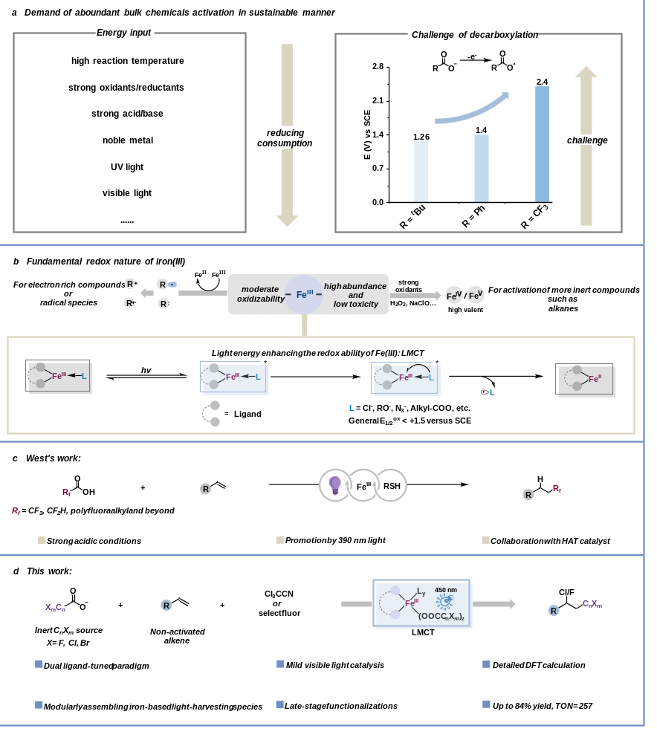Scheme 1. a) Pursuing the activation of inert chemicals under milder conditions. b) The redox character of iron(III) catalyst. c) Decarboxylation of TFA promoted by purple light. d) Our work: iron-based photocatalyzed decarboxylation paradigm for chloro/fluoro-polyhaloalkylation of alkenes.

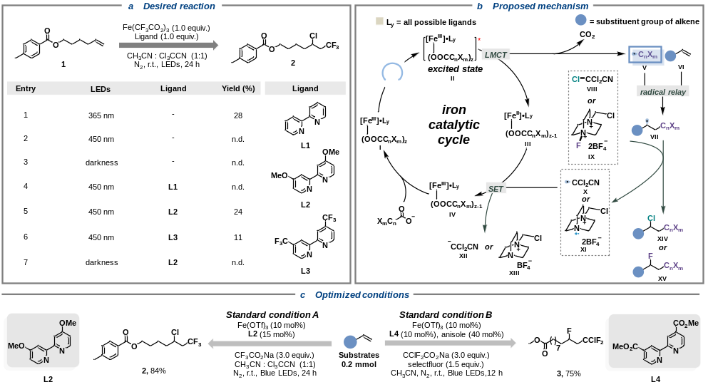Scheme 2. a) Alkene 1 (0.2 mmol), Fe(CF₃CO₂)₃ (0.2 mmol), ligand (0.2 mmol), CH₃CN (1.0 mL), Cl₃CCN (1.0 mL), N₂, illuminated by LEDs, 24 h reaction time. The yields of 2 and 3 refers to GC yields. b) Proposed mechanism for photo-induced iron catalyzed chloro/fluoro-polyhaloalkylation. c) Optimized conditions. Anisole in Standard condition B is served as redox buffer to promise desired fluoro-polyhaloalkylation of alkenes. (See Figure S15, S16 for further discussion.)

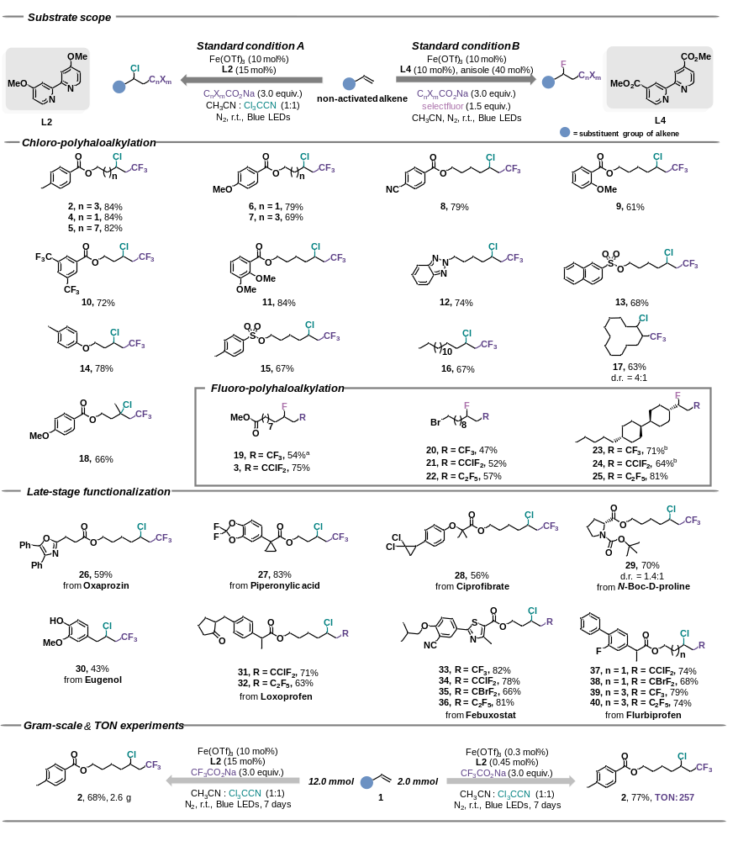Scheme 3. Substrate scope. Standard condition A: Alkene (0.2 mmol), C_{n}X_{m}COONa (0.6 mmol), Cl₃CCN (1.0 mL), Fe(OTf)₃ (0.02 mmol), L2 (0.03 mmol), and CH₃CN (1.0 mL), N₂, blue LEDs (λ_{max} = 450 nm), 24 h reaction time. Standard condition B: Alkene (0.2 mmol), C_{n}X_{m}CO₂Na (0.6 mmol), selectfluor (0.3 mmol), Fe(OTf)₃ (0.02 mmol), L4 (0.02 mmol), anisole (0.08 mmol) and CH₃CN (2.0 mL), N₂, blue LEDs (λ_{max} = 450 nm), 12 h reaction time. ª24 h reaction time. ^{b}Selectfluor (0.5 mmol) instead of selectfluor (0.3 mmol). Isolated yields.

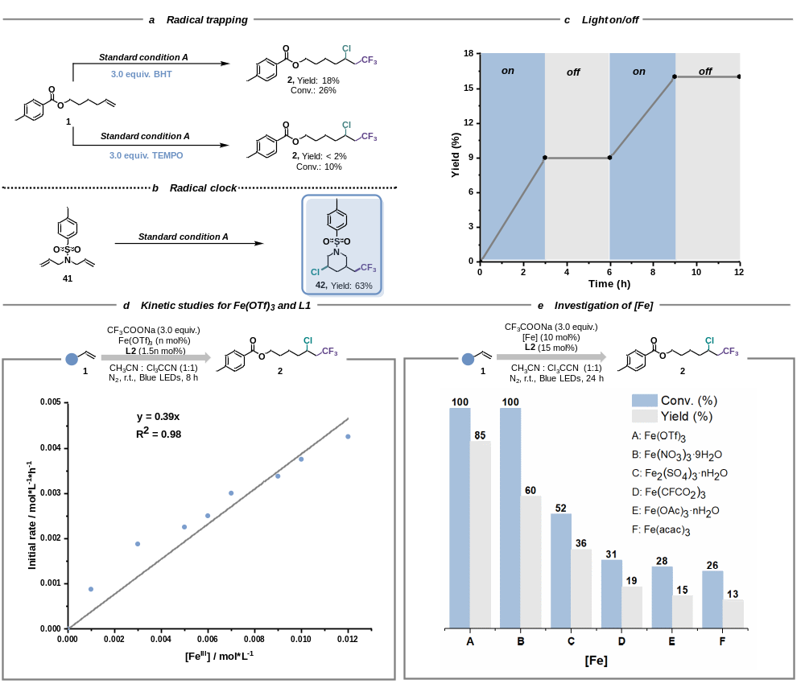 Scheme 4. Mechanistic studies. a) Radical trapping experiments. TEMPO: 2,2,6,6-Tetramethylpiperidinooxy. BHT: Butylated Hydroxytoluene. b) Radical clock experiments. c) Light on/off experiments. d) Kinetic studies of [Fe^{III}] (Fe^{III}/L2), n= 0, 0.1, 0.2, 0.3, 0.5, 0.6, 0.7, 0.9, 1.0, 1.2. e) Contrast different iron salts.

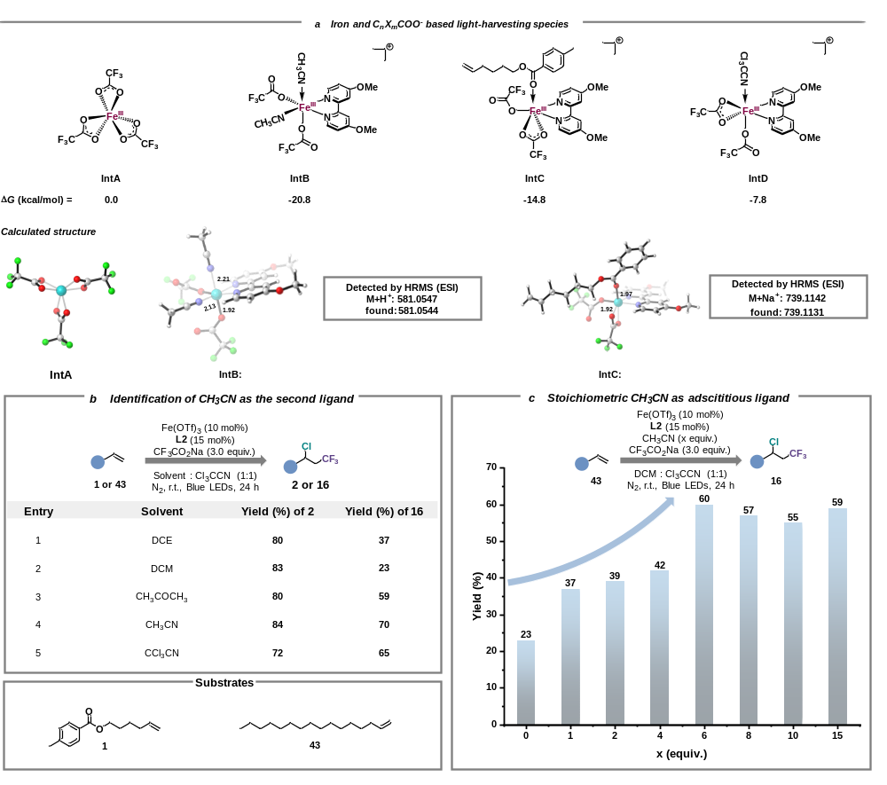Scheme 5. a) DFT calculations on iron and C_{n}X_{m}COO⁻-based light-harvesting species. b) Identification of the second ligand CH₃CN. c) CH₃CN as external additive to enhance the reactivity.

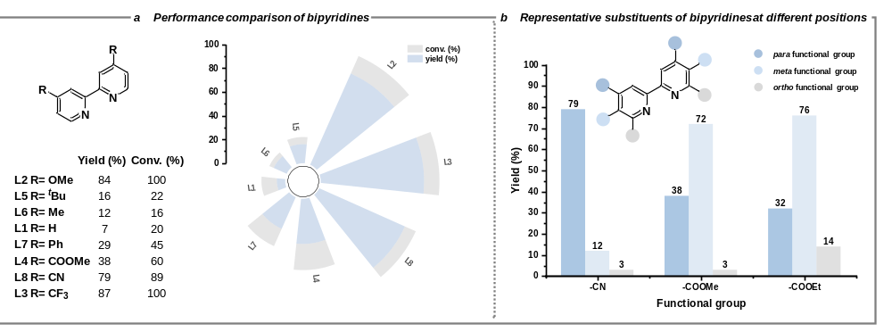Scheme 6. a) Substituent effect of bipyridines. b) Tuning ability of substituent group placed at different positions. The yields of product 2 refer to GC yields.

