Supplementary Information

Unveiling the Forces Behind BSA Aggregation in a Microfluidic Chip
Zahra Haghparasª, Mohammadjavad Bouloorchi Tabalvandani^{b}, Payam Arghavaniª, Soroush Behjati Hosseiniª, Majid Badieirostami^{b*}, Mehran Habibi-Rezaei^{c}, Ali Akbar Moosavi-Movahedi^{a*}

ªInstitute of Biochemistry and Biophysics, University of Tehran, Tehran, Iran
^{b}MEMS Lab, School of Electrical and Computer Engineering, College of Engineering, University of Tehran, Tehran, Iran
^{c}School of Biology, College of Science, University of Tehran, Tehran, Iran

*Corresponding authors: mbadiei@ut.ac.ir (M. Badieirostami) and moosavi@ut.ac.ir (A.A. Moosavi-Movahedi)

Purpose-built heating plate
A purpose-built heating plate was fabricated using a heating element, a thermocouple, and a digital thermostat to apply the desired temperature to the microfluidic chip. Approximately 5 meters of thermal element were employed for this purpose, enabling the plate's temperature to be elevated to around 400 °C without requiring a voltage converter and utilizing 220 V electricity. A thermocouple and a digital thermostat were also utilized to set and monitor the desired temperature. The heating element was spirally affixed between two Pyrex glasses using silicone thermal glue, creating a space in the middle for a slide. This design allowed for real-time microscopic imaging within the microchannel while maintaining the desired temperature. The schematic picture of the constructed thermal plate is shown in Figure 1.
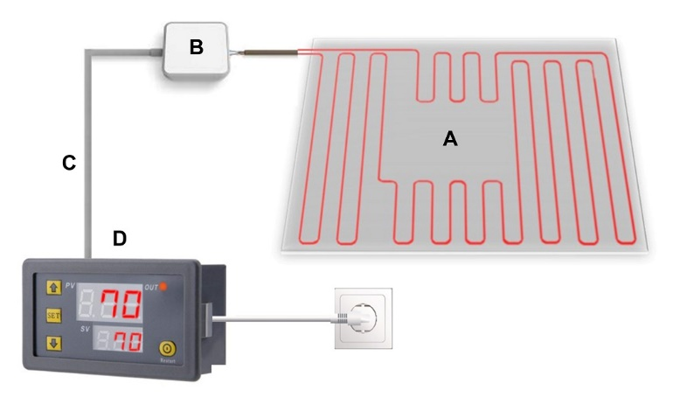
Figure 1. The purpose-built hotplate contains (A) a glass hotplate, (B) an adaptor, (C) a thermocouple, and (D) a digital thermostat.

Microscopic visualization of BSA aggregation in vial
The protein aggregation process within the vial was meticulously examined by acquiring microscopic images, featured in Figure 2. Figures 2A and B capture moments at the 5-minute and 10-minute marks, respectively, following exposure to a temperature of 70 °C. Figure 2C showcases the structures formed after a 30-minute temperature exposure, while Figure 2D vividly displays fiber-like structures arising after 6 hours of incubation. The fluorescence microscopy images on the left show no evidence of ThT intensity in Figures 2A and B. However, a slight ThT emission exists in Figure 2C, and there is a notable ThT emission along with the emergence of fiber structures in Figure 2D. Meanwhile, in the SEM images on the right panels of Figures 2A, B, and C, one can observe the formation of clusters before the appearance of amyloid-like structures. On the other hand, the right panel of Figure 2D provides a clear visualization of these structures in the vial after 6 hours of incubation.
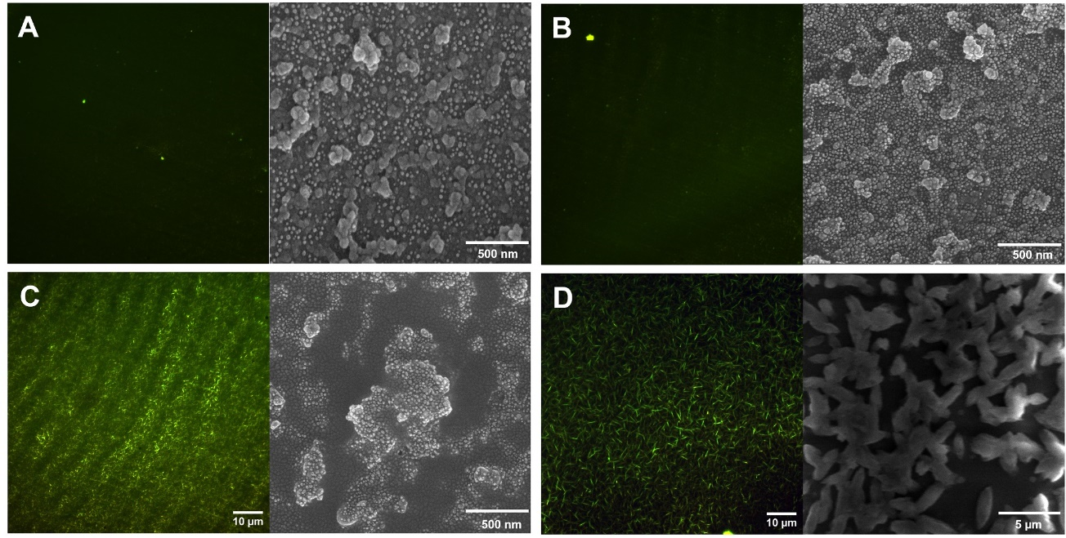
Figure 2. Microscopic visualization of 2.5 mg.ml^{˗1} BSA aggregation pathway following exposure to 70 °C temperature after (A) 5 minutes, (B) 10 minutes, (C) 30 minutes, (D) 360 minutes. The images on the left side are captured using fluorescence microscopy with 5 mM ThT staining, while SEM obtains the images on the right side.

Measurement of the contact angle of a native BSA droplet
The contact angles of a BSA droplet on both the vial and PDMS surfaces were determined and are depicted in Figure 3. The contact angles for PDMS and vial surfaces were calculated as 89 ± 0.5º and 61.5 ± 1º, respectively. This reveals that the PDMS surface exhibits higher hydrophobicity than the vial surface when in contact with BSA.
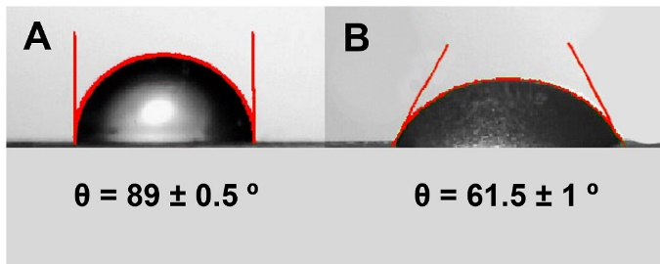
Figure 3. The contact angles of a native BSA droplet on (A) PDMS and (B) vial surfaces.

Ionic concentration
Native BSA was dissolved in a 100 mM phosphate buffer with a pH of 7.4. The ionic concentration of this solution was determined using the Henderson-Hasselbalch Equation ¹, as illustrated in Equation 1, with a fixed pKa value of 7.2.
$$pH = pKa + \log{\frac{\left[A^{-}\right]}{\left[HA\right]}} (1)$$
As a result, the concentrations of [H₂PO₄⁻], [HPO₄²⁻], and [Na⁺] were calculated to be 38.61 mM, 61.39 mM, and 161.39 mM, respectively, indicating a total ionic concentration of 261.39 mM for the solution.

Heat transfer simulation
To ensure the required energy was available to drive the protein aggregation inside the microfluidic chip, heat transfer inside the channel was simulated using COMSOL Multiphysics. The heat transfer in the fluid was employed in the steady state regime to demonstrate the heat exchange inside the device. For this purpose, the initial temperature of the channel and the incoming fluid was set to 25 ºC. In comparison, the bottom boundary of the channel was assigned a constant temperature of 70 ºC to account for the regulated temperature of the purpose-built hotplate placed beneath. The remaining boundaries were thermally isolated, inhibiting heat dissipation between the channel and the surroundings. Given PDMS's sufficiently tiny heat transfer coefficient, this can be assumed as a justified simplification. The heat transfer inside the fluid flowing through the channel was then solved using equations 2 and 3 as described below:
$$ρC_{p}u.∇T+∇.q=Q+Q_{vd} (2)$$
$$q= -k∇T (3)$$
where $ρ$ is the density of the fluid, $C_{p}$ is the specific heat capacity, q is the heat flux by conduction, $Q_{vd}$ is the viscous dissipation in the fluid, $Q$ contains heat sources other than viscous dissipation, k is the thermal conductivity, and $∇T$ is the temperature gradient across the boundary. The temperature profile inside the initial part of the channel is shown in Figure 4. As can be seen, the fluid inside the channel instantaneously reached the desired temperature. It remained the same throughout the channel, thus rendering sufficient energy for the aggregation process.
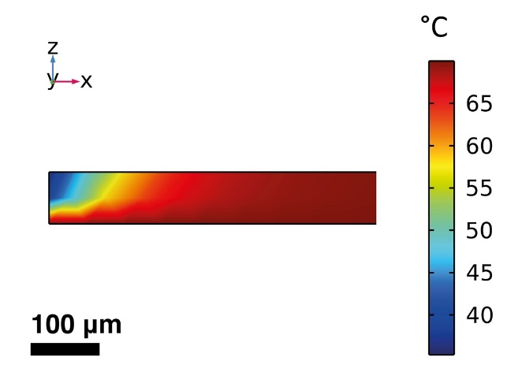
Figure 4. The temperature profile inside the microfluidic channel's initial section shows the abrupt transition to the desired temperature.

Cross-sectional volume and molecular count
Given that the dimensions of the microchannels are 50 µm in width and 60 µm in height, the cross-sectional area can be calculated as 50 $×$ 50 $×$ 60 µm³, resulting in a volume of 15 $×$ 10^{˗5} μl or 0.15 nl. The concentration of the moving BSA within the microfluidic chip was 2.5 mg.ml^{˗1}, with 66500 gr.mol^{˗1} molecular weight, when used in conjunction with Avogadro's number, yielded an approximate count of 0.2263 $×$ 10¹⁴ BSA monomer molecules per µl. Considering that the surface area of the cross-section in the microfluidic chip represented a volume equivalent to 0.15 nl, approximately 3 billion BSA monomer molecules flowed through each microchannel cross-section at any given moment.

Gibbs free energy
The Gibbs free energy for thermal denaturation of BSA (aggregation in bulk system) was determined for two-state systems N and U using equation 4 ².
$$∆_{N}^{U}G= ∆_{N}^{U}H\left(T\right)-T∆_{N}^{U}S\left(T\right) (4)$$
The enthalpy and entropy were by equations 5 and 6, respectively, ².
$$∆H\left(T\right)= ∆H\left(T_{e}\right)+ \int_{T_{e}}^{T}{∆_{N}^{U}C_{p} dT } \left(5\right)$$
$$∆S\left(T\right)=\frac{∆H\left(T_{e}\right)}{T_{e}}+ \int_{T_{e}}^{T}{∆_{N}^{U}C_{p} d\ln{T}} (6)$$
Here, T_{e} represented the temperature at which both states had an equal probability. Assuming $∆_{N}^{U}C_{p}$ to be independent of temperature, driven by the following ²:
$$∆_{N}^{U}G\left(T\right)= ∆_{N}^{U}H\left(T_{e}\right)\left(1- \frac{T}{T_{e}}\right)- ∆_{N}^{U}C_{p}\left(T_{e}\right)\left(T_{e}-T+T\ln{\frac{T}{T_{e}}}\right) (7)$$
Ling Fu et al. conducted an investigation and determined that T_{e} was equal to 110 °C, ΔH(T_{e}) amounted to 44 kJ.mol˗¹, and ΔC_{p}(T_{e}) equated to 0.32 kJ.K˗¹.mol˗¹ for BSA ². Consequently, employing equation 7, the value of $∆_{N}^{U}G(T)$ at a temperature of 70 °C was computed to be 3.9 kJ.mol˗¹.

Thermal unfolding energy for molecules in the microfluidic chip
Given the BSA concentration within the microfluidic chip (2.5 mg.ml^{˗1}) and its molecular weight (66500 gr.mol^{˗1}), along with the calculated Gibbs free energy for BSA thermal unfolding (3.9 kJ.mol^{˗1}), and the volume of the microchannel cross-section (0.15 nl), we determined that the required thermal unfolding energy to activate molecules within the microfluidic system amounted to 22 pJ per cross-section.

Simulation of BSA clusters behavior in the microfluidic chip
To visualize the BSA clusters' behavior inside the channel, an ensemble of 200 particles was uniformly distributed throughout the serpentine microchannels at t = 0. The simulation results demonstrated the gradual deposition of the clusters onto the sidewalls as time passed (Movie 1). Accordingly, Stokes’ drag force, Brownian motion, and interparticle interactions were simulated to investigate the behavior of the BSA clusters in the microfluidic chip. The simulated Brownian and Stokes’ drag forces are shown in equations 8 and 9, respectively.
$$F_{B}= ζ\sqrt{\frac{12πK_{B}μTr_{p}}{Δt}} (8)$$
$$F_{D}=\left(\frac{1}{τ_{p}}\right)m_{p}\left(u-v\right) (9)$$
where 𝜉 denotes a random number with the normal distribution (zero mean and standard deviation of one), K_{𝐵} signifies Boltzmann constant, 𝜇 stands for the dynamic viscosity of the fluid, 𝑇 illustrates the temperature of the fluid in Kelvin, 𝑟_{𝑝} represents the particle radius, and Δ𝑡 is the time step taken by the solver. The parameters of equation 9 are defined as follows: 𝑚_{𝑝} is the particle mass, 𝜏_{𝑝} represents the particle velocity response time, 𝐮 symbolizes the fluid velocity, and 𝐯 corresponds to the particle velocity. For the case of Stokes’ drag law, the particle velocity response time is calculated as equation 10.
$$τ_{p}= \frac{ρ_{p}d_{p}^{2}}{18μ} (10)$$
Where 𝜌_{𝑝} and 𝑑_{𝑝}² are particle density and diameter, respectively, and 𝜇 denotes the fluid's dynamic viscosity.
Movie 1. The BSA cluster’s behavior in the microfluidic chip is shown here, which is downloadable using the below link. The cold-spectrum refers to slower particles, and the hot-spectrum refers to faster clusters.
https://drive.google.com/file/d/1r2wpbTvCtuHLc3SOWV-IgTWzwoIFqVIM/view?usp=sharing

Lennard-Jones parameters versus various particle diameters
The DLVO pair potential was visualized for clusters with various diameters using MATLAB (the graphs are not shown). Consequently, the Lennard-Jones parameters were extracted from the graphs and shown in Table 1. The strong relation between particle diameter and interaction strength is visible.

Table 1. The Lennard-Jones potential for clusters with different diameters.
Clusters Diameter (nm) | 100 nm | 200 nm | 300 nm
Intermolecular Distance (nm) | 109 | 207.24 | 306
Interaction Strength (mV) | ˗0.62 $×$ 10^{˗21} | ˗2.46 $×$ 10^{˗21} | ˗5.02 $×$ 10^{˗21}

Kinetics of BSA aggregation using ANS assay
The kinetics of BSA aggregation was measured using ANS fluorescence intensity. A 2.5 mg.ml^{˗1} BSA in 100 mM phosphate buffer with pH 7.4 was heated at 70 °C for various interval times (0, 5, 10, 15, 30, 45, 60, 120, 240, 360, 780 min) which stained by 280 µM ANS. The ANS fluorescence intensity versus time was recorded at 490 nm (excited at 350 nm), shown in Figure 5.
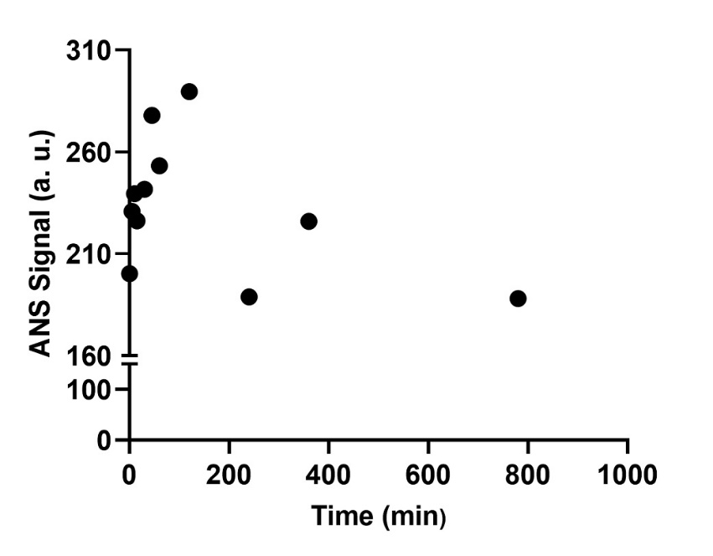
Figure 5. BSA aggregation kinetics at 70 °C in a microtube using ANS assay.

References
1. Henry N. Po and N. M. Senozan. The Henderson–Hasselbalch Equation: Its History and Limitations. J. Chem. Educ. 78, 1499–1503 (2001).
2. Fu, L., Villette, S., Petoud, S., Fernandez-Alonso, F. & Saboungi, M. L. H/D isotope effects in protein thermal denaturation: The case of bovine serum albumin. J. Phys. Chem. B 115, 1881–1888 (2011).

