Table S1. Patient characteristics
Characteristics | Number | N (%)
Median Age | 49(23-71)
Median BMI | 25.2(19.2-30.8)
Menstrual state | Postmenopausal | 18(40.0)
 | Premenopausal | 27(60.0)
Tumour stage | Stage II | 10(22.2)
 | Stage III | 35(77.8)
Type of surgery done | MRM | 36(80.0)
 | BCS | 9(20.0)
Cardiac risk factors | Yes | 10(22.2)
 | No | 35(77.8)
Received anthracycline based chemotherapy | Yes | 28(62.2)
 | No | 17(37.8)
Anti-Her-2 targeted therapy | Yes | 19(42.2)
 | No | 26(57.8)

BMI, body mass index; MRM, modified radical mastectomy; BCS, breast conserving surgery; Her-2, human epidermal growth factor receptor 2

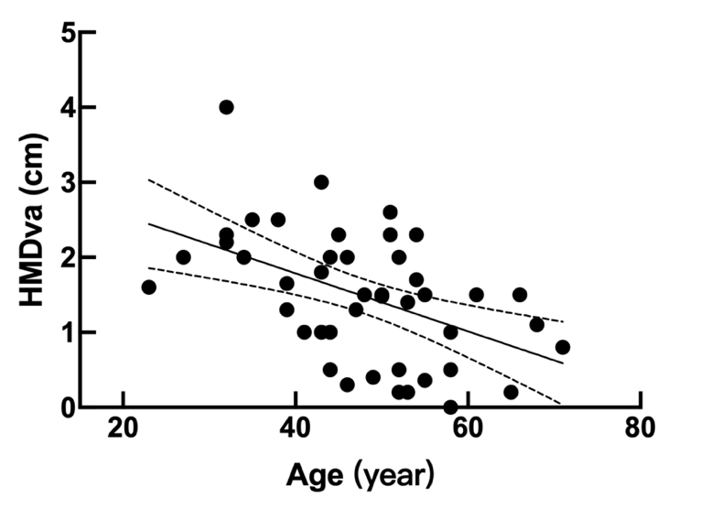
Fig. S1 Correlation analysis between age and HMDva (r = -0.48, P < 0.05).
MHDva, Heart movement distance in the vertical axis

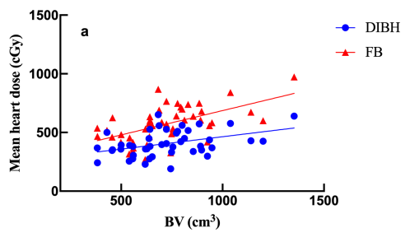
Fig. S2 Correlation analysis between BV and mean heart dose (FB, r = 0.57, P < 0.05; DIBH, r = 0.41, P < 0.05).
FB, free breathing; DIBH, deep inspiratory breath hold; BV, breast volume
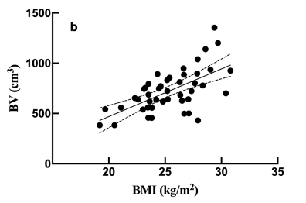
Fig. S3 Correlation analysis between BMI and BV (r = 0.621, P < 0.001).
BV, breast volume; BMI, body mass index

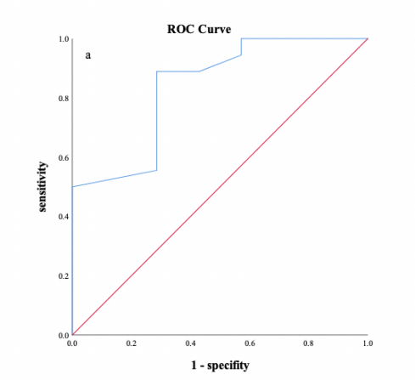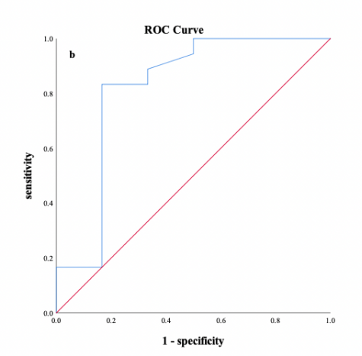
Fig. S4 ROC curve for FB-MHD predicting for >20% reduction in mean heart dose (a, AUC = 0.84); FB-HVIF (b, AUC = 0.82).
FB, free breathing; MHD, maximum heart depth; HVIF, heart volume in field

