(a)
(b)
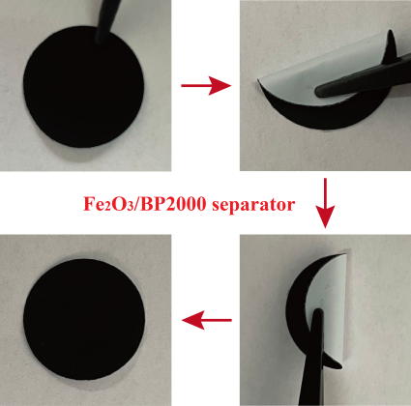

Figure S1. (a) the photo of the Fe₂O₃/BP2000 coated PE separator, (b) cross section SEM image of Fe₂O₃/BP2000 coated PE separator.

The fabrication process of symmetric cell:
Fe₂O₃/BP2000 and PVDF were mixed with a mass ratio of 8:2 using NMP as the dispersant, after vigorous stirring, the slurry was homogeneously coated on Al foil to act as the symmetric electrode. Then the symmetric cell was assemble in a Ar filled glove box. For comparison, BP2000 symmetric cell was fabricated using the same process. the symmetric cell is composed of two symmetric electrodes, PE separator and L₂S₆ electrolyte, the schematic diagram of the symmetric cell is shown below.
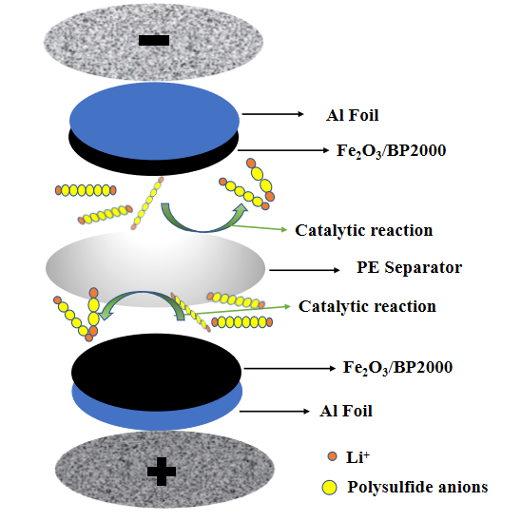
Figure S2. schematic diagram of the Fe₂O₃/BP2000 symmetric cell.

