Supplemental figure 1. Venn diagrams describing the RNA-seq derived databases. The number of specific and common.
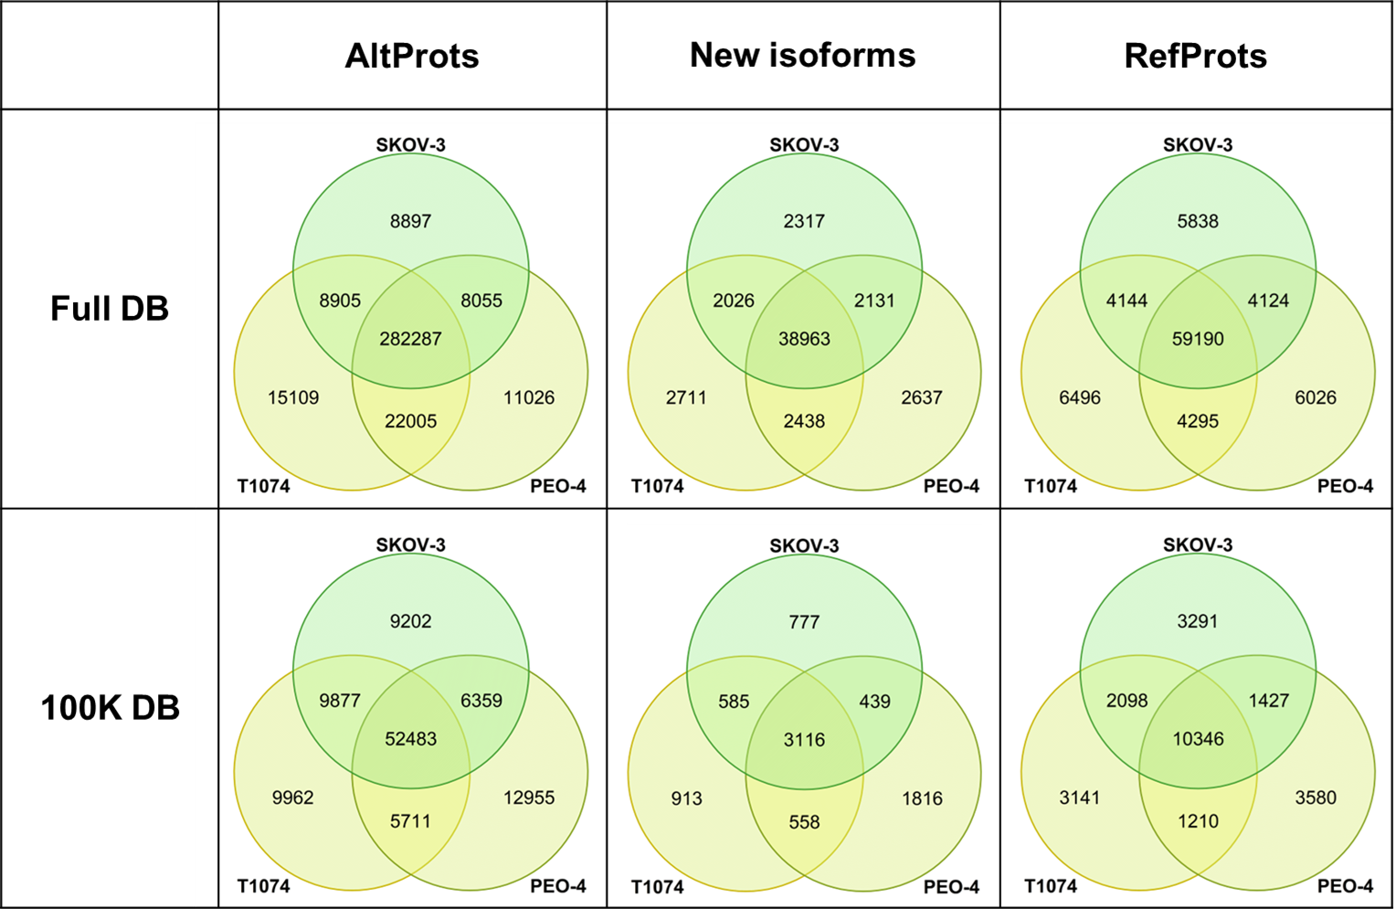

Supplemental figure 2. (A) Hierarchical clustering heatmap showing the different RefProt clusters that can be observed among the three cell lines. Z-score range from -1.349 (green) to 1.307 (red).(B) Hierarchical clustering heatmap showing the different novel isoforms clusters that can be observed among the three cell lines. Z-score range from -1.348 (green) to 1.273 (red).
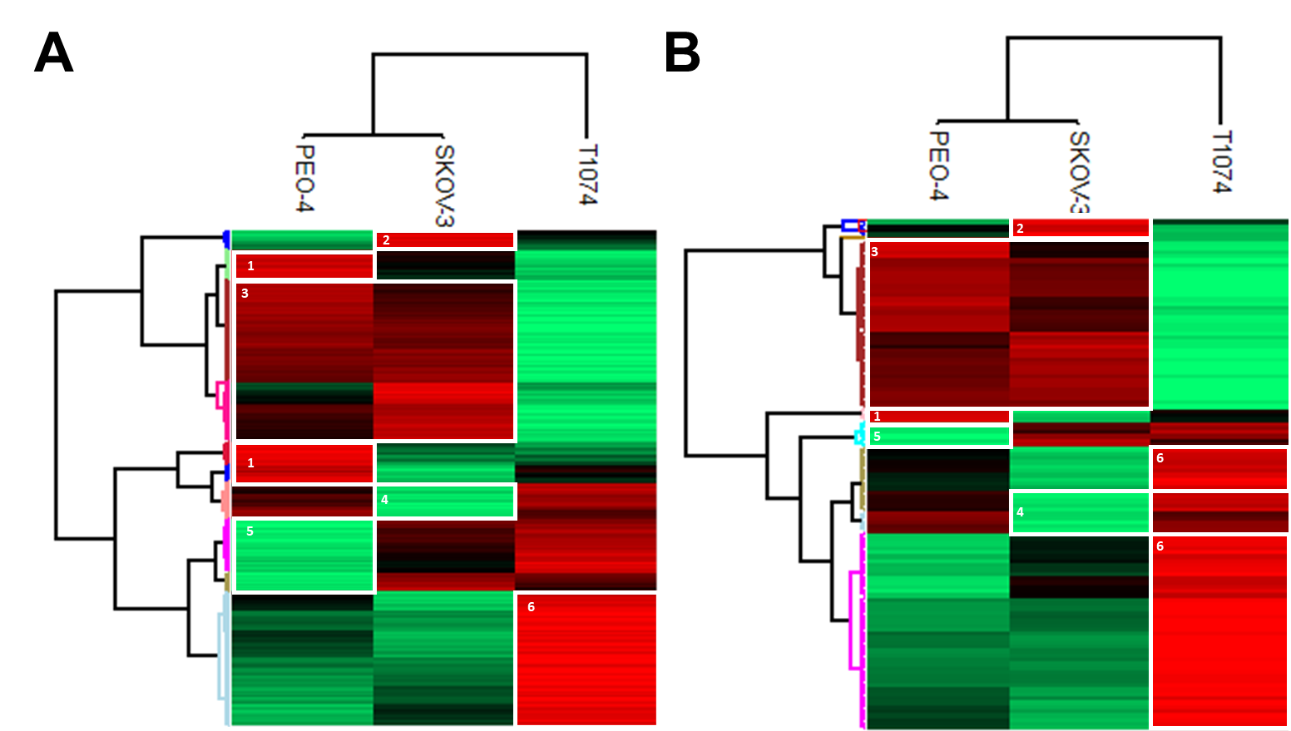

Supplemental figure 3. Raw crosslink network in which AltProts are marked in orange and RefProts are marked in blue. Crosslinks are marked in dark blue (SKOV-3 cells), purple (PEO-4 cells) and green (T1074 cells) dashed lines.
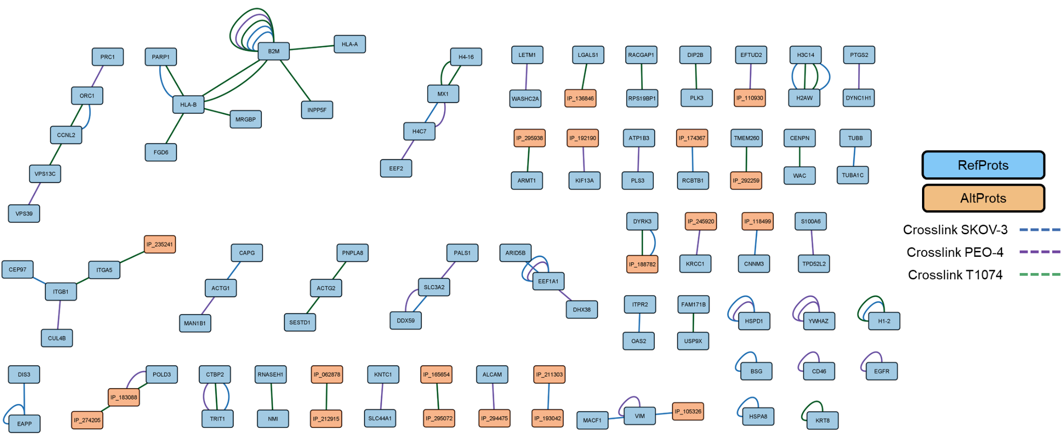

Supplemental figure 4. Crosslink network in which AltProts are marked in orange and RefProts are in blue. Crosslinks are marked in dark blue (SKOV-3 cells), purple (PEO-4 cells) and green (T1074 cells) dashed lines. Enriched by the STRING interactions (gray lines) retrieved. For the RefProts that did not present a referenced STRING interaction, an enrichment was performed to expand the network.
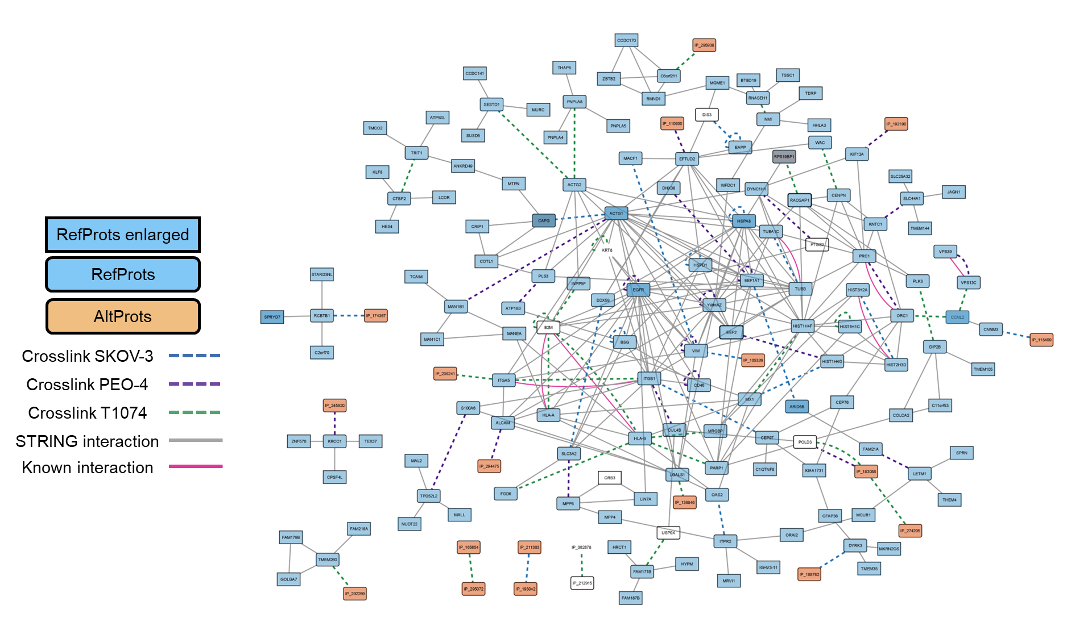

Supplemental figure 5. Predicted interaction models docked in ClusPro for the RefProts (blue) and AltProts (orange). The distance between the residues crosslinked are given for each interaction.
