Supplementary Information
Delivery rate alters the effect of tire wear particles on soil microbial activities

Yanjie Zhu, Shin Woong Kim*, Huiying Li, Matthias C. Rillig
Institute of Biology, Freie Universität Berlin, 14195 Berlin, Germany
Berlin-Brandenburg Institute of Advanced Biodiversity Research. 14195 Berlin, Germany
* Corresponding author: swkim@zedat.fu-berlin.de

Submitted to Environmental Sciences Europe

4 pages

3 figures

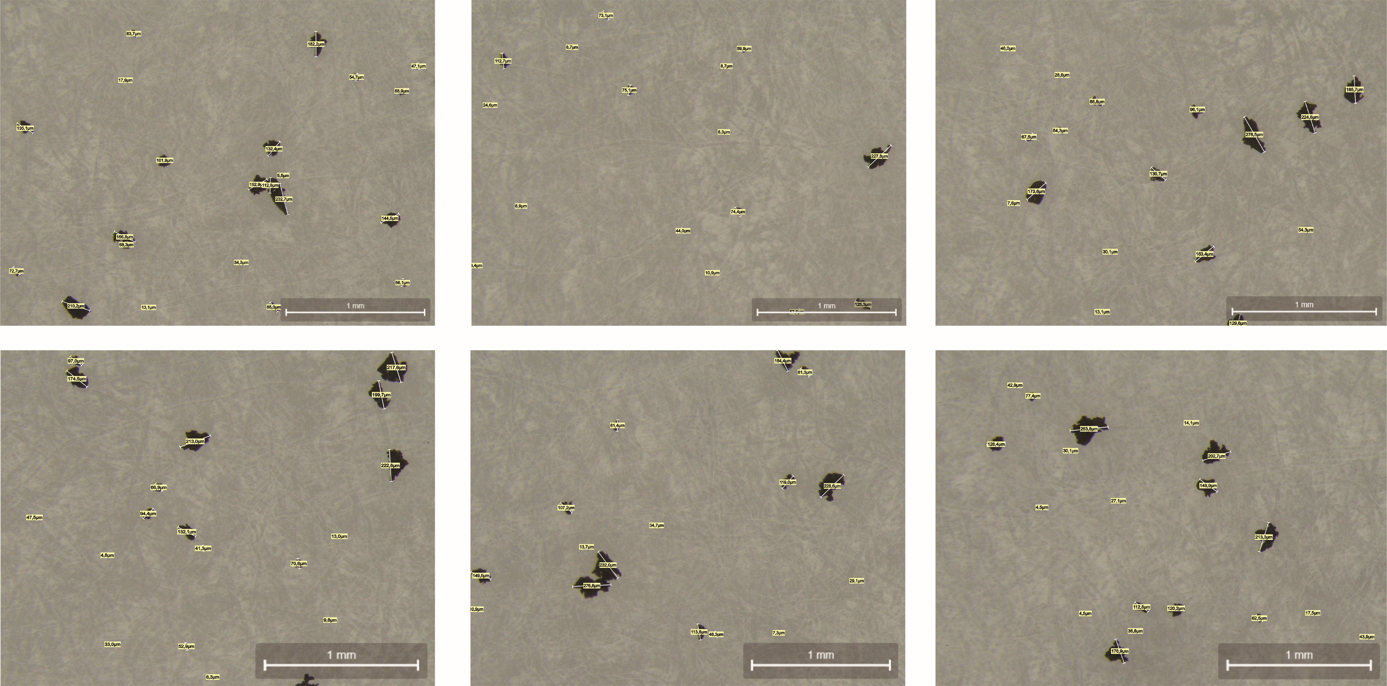
Fig. S1. Photographic processing of tire wear particle sizes to determine average diameter and size range.

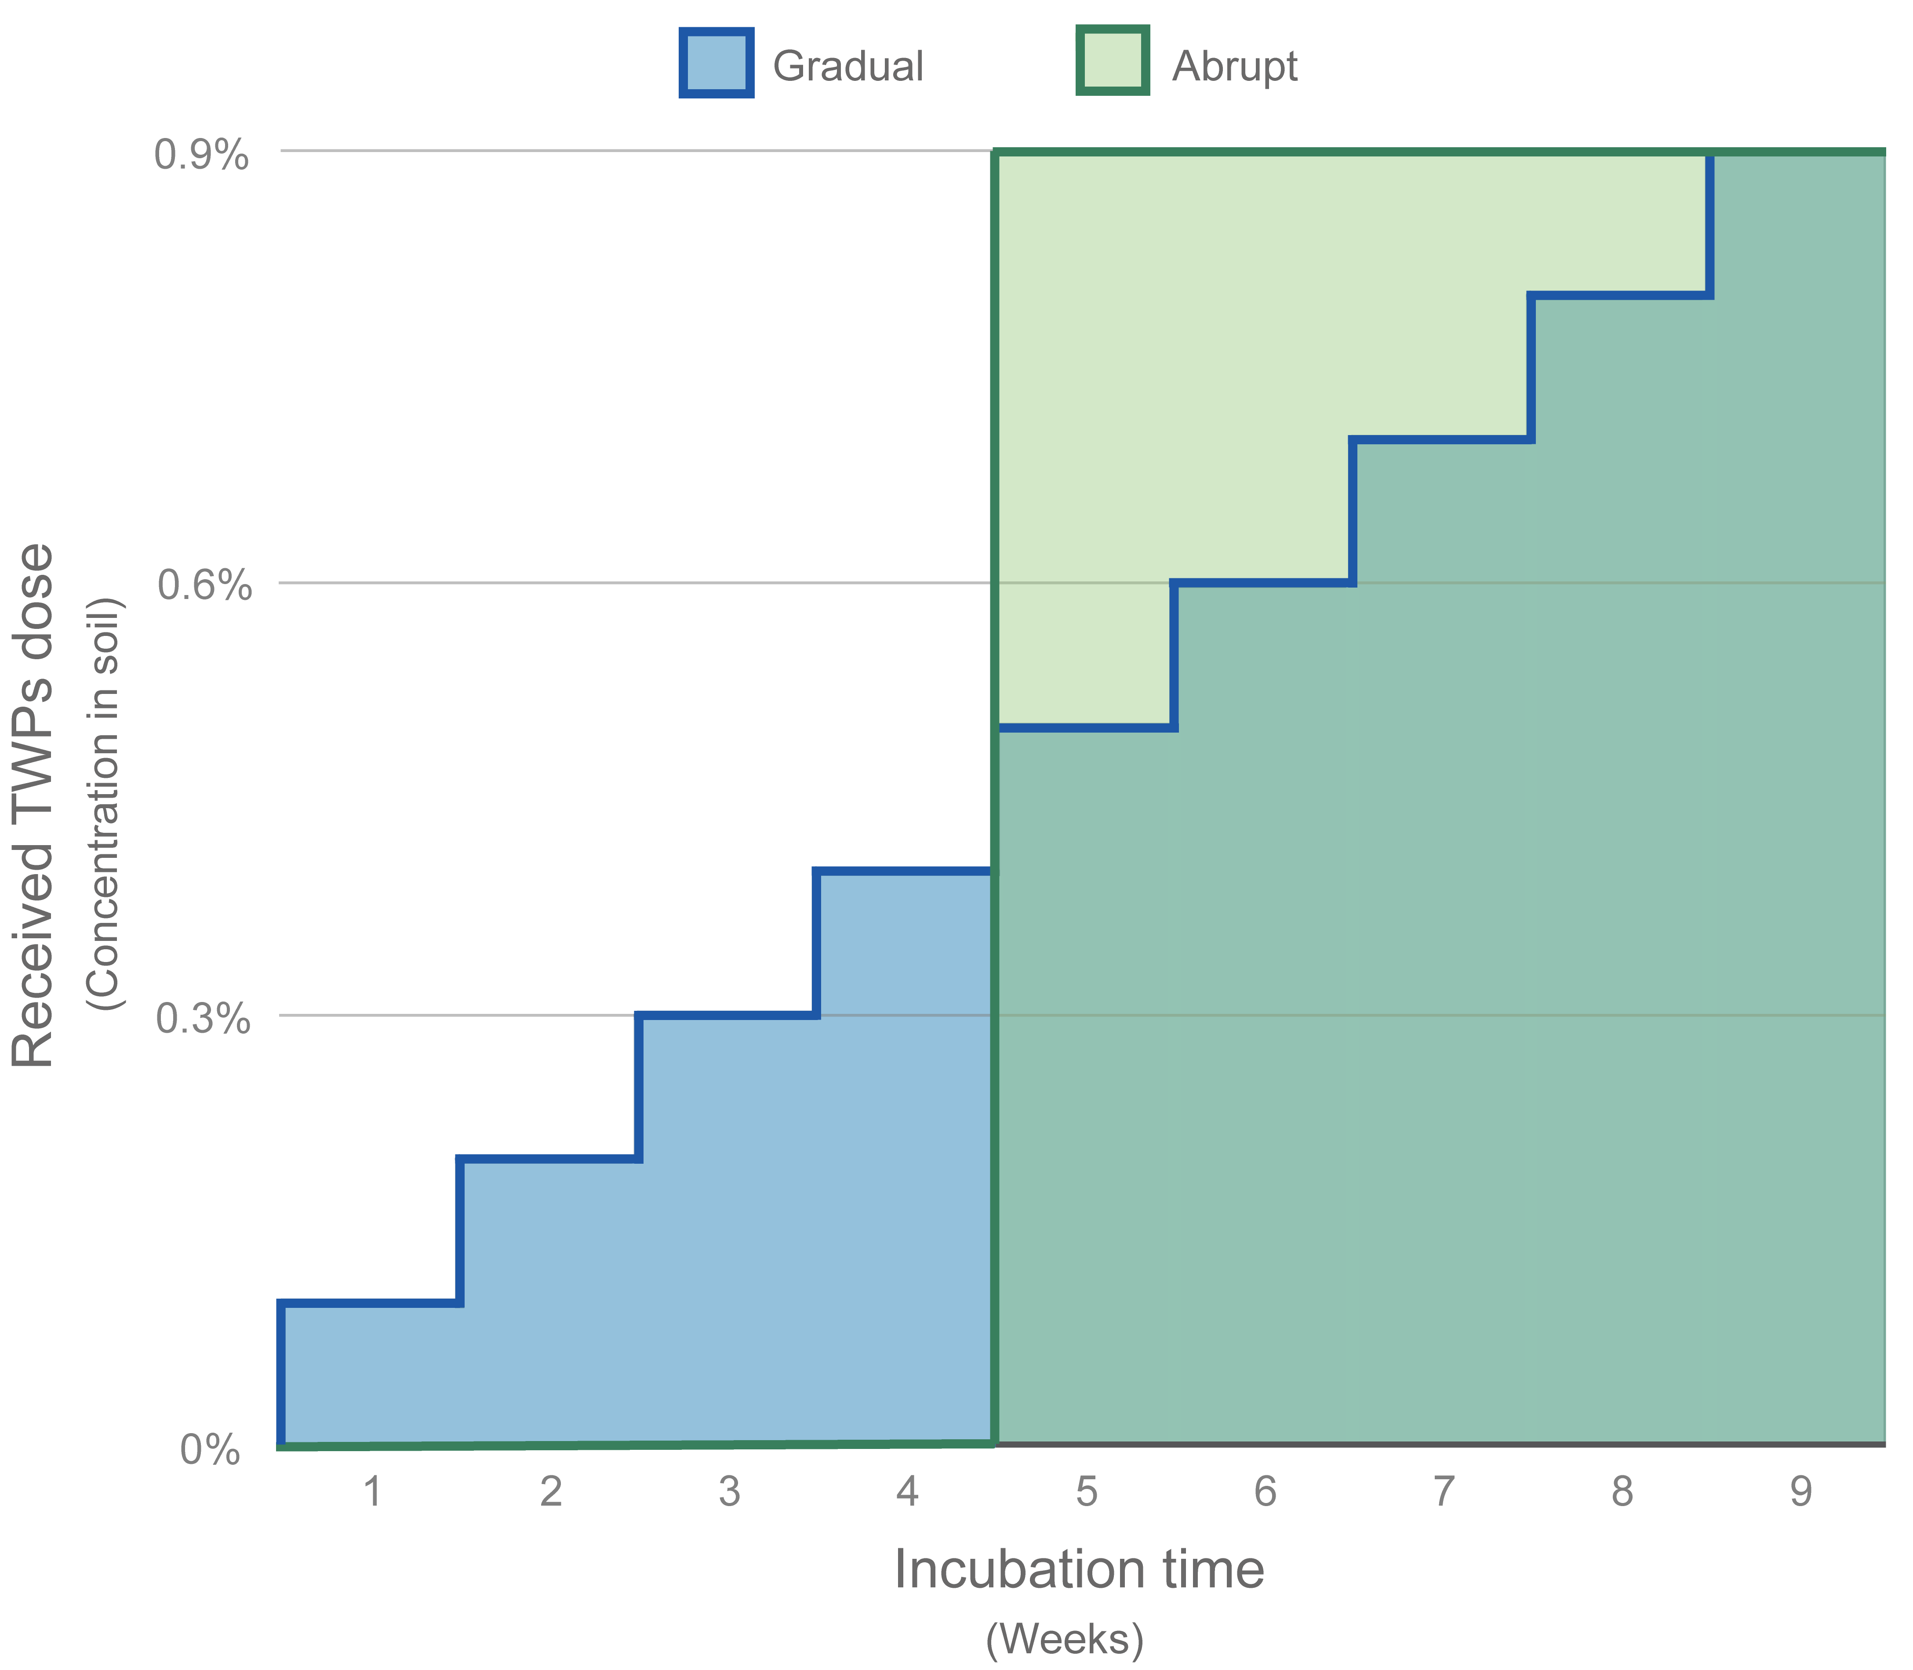

Fig. S2. Scheme of the gradual and abrupt TWPs delivery treatments based on the “week-dose” principle.

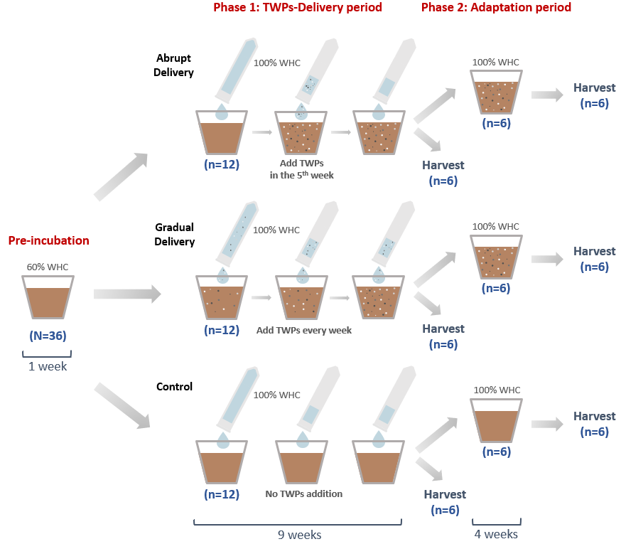
Fig. S3. Experimental design.

