Supplementary information

S-1. The maximum tumor diameter was defined as the maximum length diameter of the largest tumor layer in the lung window. The ground glass density was defined as the lesion density slightly increased compared with the surrounding lung parenchyma, and the bronchi and blood vessel contours in the lesion were visible. Air bronchial sign is defined as columnar air structure in tumor. Lobulation is defined as the curved or wavy structure of the tumor surface. Spiculation is defined as a needle-like projection on the edge of a tumor. Pleural indentation is defined as the adhesion of tumor burrs or tumor itself to the pleura. Cavitation is defined as the gas-containing transparent shadow within 5mm; A cavity is defined as a cavity larger than 5mm. Emphysema is defined as increased transparency of lung tissue on chest CT images. Pleural effusion is defined as the presence of fluid density shadows in the chest cavity.

S-2. The Rad-score calculation formula.
intratumoral region:
Rad-score = 0.01673934 - 0.318725588 × original.firstorder.Skewness + 0.230645047 × original.ngtdm.Complexity-0.036965608 × log_sigma_0_5_mm_3D.firstorder.Kurtosis - 0.259028479 × log_sigma_1_0_mm_3D.gldm.LargeDependenceHighGrayLevelEmphasis + 0.271502222 × log_sigma_1_5_mm_3D.glcm.InverseVariance + 0.091982589 × log_sigma_1_5_mm_3D.gldm.LargeDependenceLowGrayLevelEmphasis + 0.001796035 × log_sigma_2_5_mm_3D.firstorder.Minimum + 0.041929414 × log_sigma_2_5_mm_3D.glszm.SizeZoneNonUniformityNormalized - 0.145891134 × wavelet_LLH.firstorder.Skewness - 0.006582555 × wavelet_LHH.firstorder.Kurtosis - 0.003377279 × wavelet_LHH.glcm.MCC + 0.004055298 × wavelet_HLL.glcm.Correlation + 0.063933601 × wavelet_HLH.firstorder.Mean + 0.161591413 × wavelet_HHL.glcm.Correlation + 0.300245988 × wavelet_LLL.firstorder.Maximum

peritumoral region:
Rad-score = - 0.1072524 + 1.286561075 × P.original.glcm.Correlation ＋ 0.037011870 × P.log_sigma_1_0_mm_3D.glcm.ClusterShade - 0.223964286 × P.wavelet_LLH.glcm.Correlation - 0.095028655 × P.wavelet_LLH.glcm.MCC - 0.124097260 × P.wavelet_LHL.glcm.ClusterShade + 0.097078383 × P.wavelet_LHH.glcm.ClusterShade - 0.266711342 × P.wavelet_LHH.gldm.SmallDependenceLowGrayLevelEmphasis - 0.311212275 × P.wavelet_HLL.firstorder.Skewness - 0.003601358 × P.wavelet_HLL.ngtdm.Contrast + 0.061460241 × P.wavelet_HHL.glcm.MCC

intra- and peritumoral regions:
Rad-score = 0.1314511 - 0.04890262 × log_sigma_0_5_mm_3D.firstorder.Kurtosis + 0.03187544 × log_sigma_1_0_mm_3D.glszm.SizeZoneNonUniformityNormalized - 0.01900297 × log_sigma_1_5_mm_3D.gldm.LargeDependenceLowGrayLevelEmphasis + 0.03628006 × log_sigma_2_5_mm_3D.glszm.SizeZoneNonUniformityNormalized + 0.01729782 × wavelet_LLH.glszm.SizeZoneNonUniformityNormalized + 0.23594851 × wavelet_LHH.glszm.SizeZoneNonUniformityNormalized + 0.09841607 × wavelet_HLH.firstorder.Mean + 1.16894336 × P.original.glcm.Correlation + 0.01404431 × P.wavelet_LHH.glcm.ClusterShade - 0.15968528 × P.wavelet_LHH.gldm.SmallDependenceLowGrayLevelEmphasis - 0.02968641 × P.wavelet_HLL.firstorder.Skewness

Note: P, peritumoral

Appendix figures
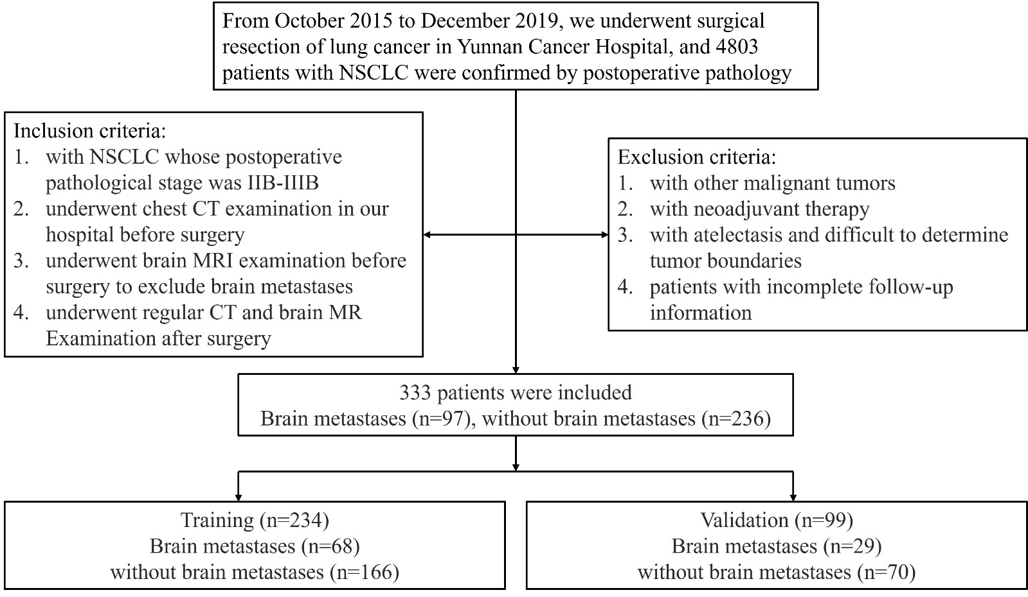
Fig. S1 Study the inclusion and exclusion of standard flow charts

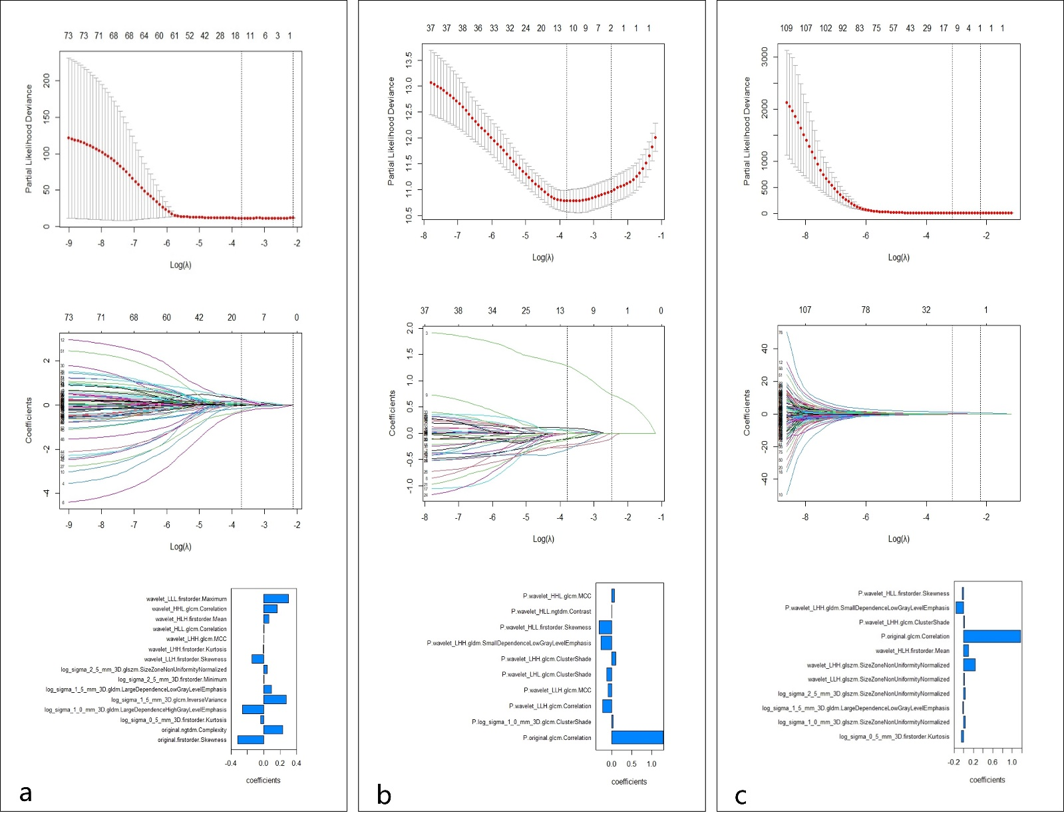Fig. S2 Optimal features selected using LASSO approach: (a) 15 optimal features selected from the intratumoral region; (b) 10 optimal features selected from the peritumoral region; and (c) 11 optimal features selected from intra- and peritumoral regions

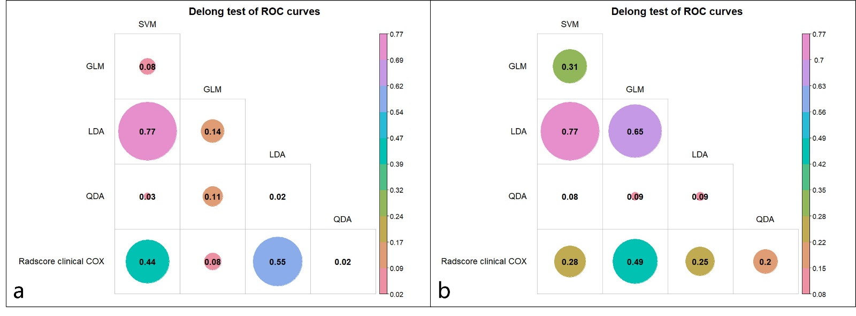
Fig. S3 Delong test results of the receiver operating characteristic curves between different algorithms of combined model (a) training set; (b) validation set. ROC, receiver operating characteristic curves; SVM, support vector machine; GLM, generalize linear model; LDA, linear discriminant analysis; QDA, quadratic discriminant analysis

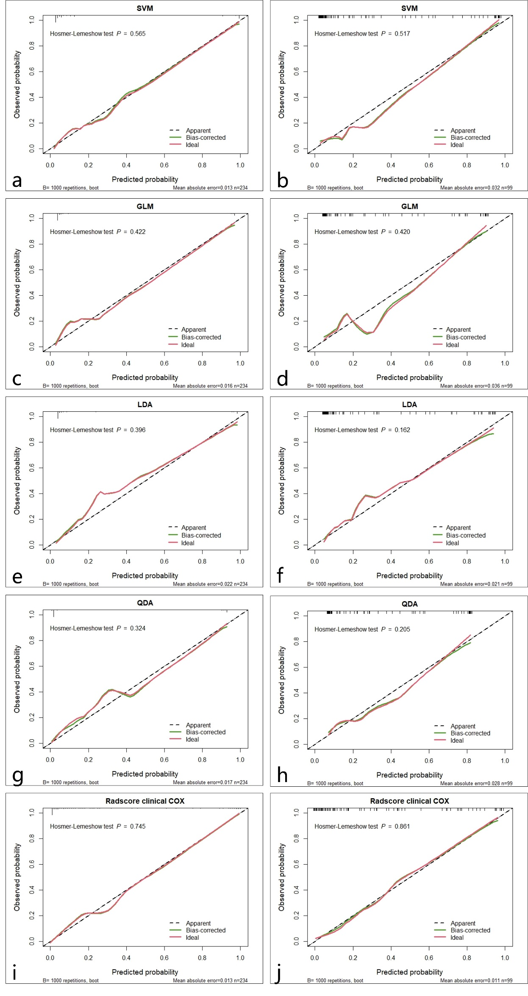
Fig. S4 The calibration curve describes the agreement between the prediction probability of SVM, GLM, LDA, QDA, COX combined model and the observed probability of BM in the training cohort (a, c, e, g, i) and the validation set (b, d, f, h, j).
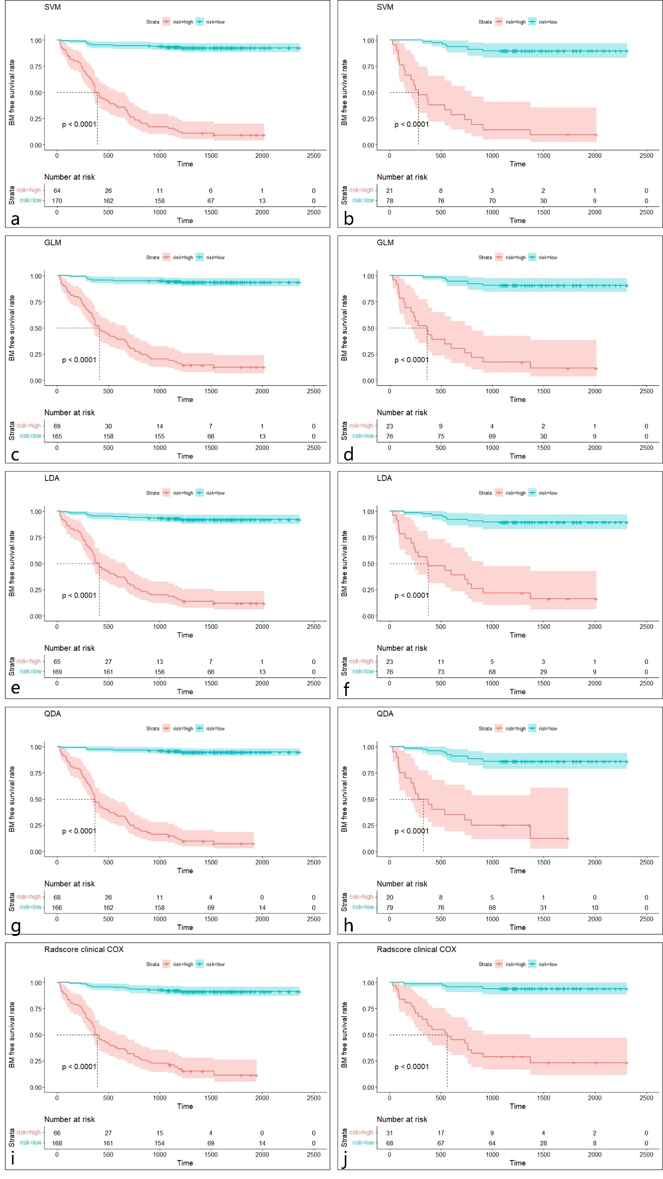
Fig. S5 The Kaplan-Meier survival curve of the combined model constructed by different algorithms in training cohort (a, c, e, g, i) and validation cohort (b, d, f, h, j). The p values of Kaplan-Meier analysis were calculated using the weighted log-rank test for trend (two-sided)
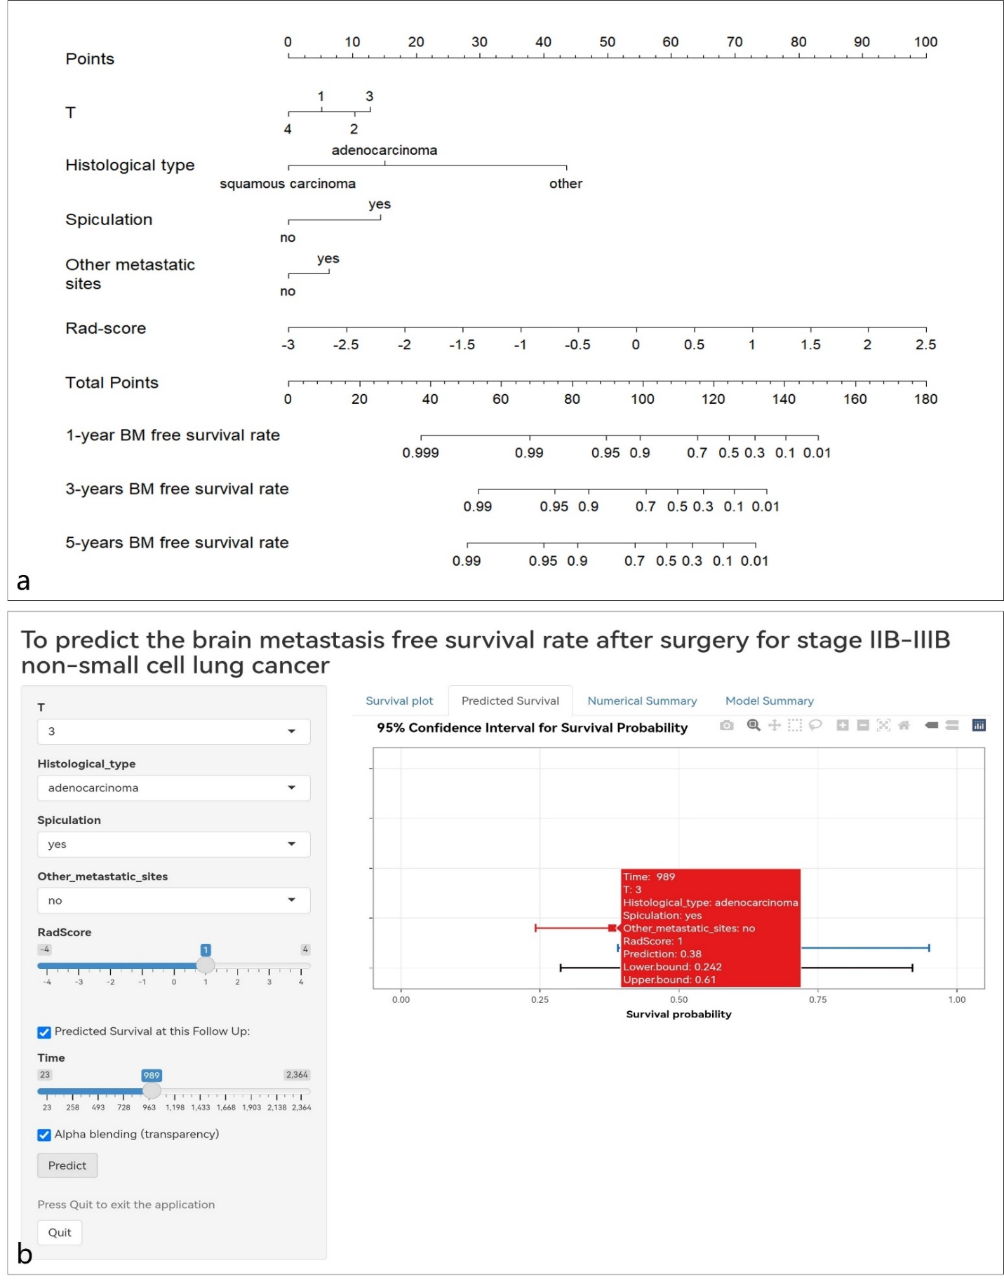
Fig. S6 a. The nomogram was developed on the training cohort, with the T stage, histological of tumor, spiculation, other metastatic and rad-score. b. Web dynamic nomogram calculator. The figure shows an example of stage T3 with adenocarcinoma as the pathological type, no metastases to other sites, the Radscore was 1. At 989 days follow-up, the survival rate without brain metastases was 0.38 (95%CI, 0.242, 0.610).

