Supplementary material: Morphological and Physiological Monitoring of Gouty Arthritis Response to Low-Level Light Therapy
Yizhou Tan^{#1,2}, Min Zhang^{#1,3}, Zhifeng Wu^{#4}, Jingqing Chen⁴, Ying Wang¹, Chengbo Liu*⁴, Ying Gu*^{1,2}

#These authors contributed equally: Yizhou Tan, Min Zhang, Zhifeng Wu
*Share correspondence: Chengbo Liu, Ying Gu

¹Department of Laser Medicine, the First Medical Center, Chinese PLA General Hospital, Beijing 100853, China.
²Laser Medicine Center, Hainan Hospital, Chinese PLA General Hospital, Sanya, 572013, China.
³Medical School of Chinese PLA, Beijing 100853, China.
⁴Research Center for Biomedical Optics and Molecular Imaging, Key Laboratory of Biomedical Imaging Science and System, Shenzhen Institute of Advanced Technology, Chinese Academy of Sciences, Shenzhen, 518055, China.

Corresponding authors:
Ying Gu, Department of Laser Medicine, the First Medical Center, Chinese PLA General Hospital, Beijing 100853, China.
Email: guyinglaser301@163.com
Phone: +86-0898-37330984
Chengbo Liu, Research Center for Biomedical Optics and Molecular Imaging, Key Laboratory of Biomedical imaging Science and System, Shenzhen Institute of Advanced Technology, Chinese Academy of Sciences, Shenzhen, 518055,China
Email: cb.liu@siat.ac.cn
Phone: +86-15118079512

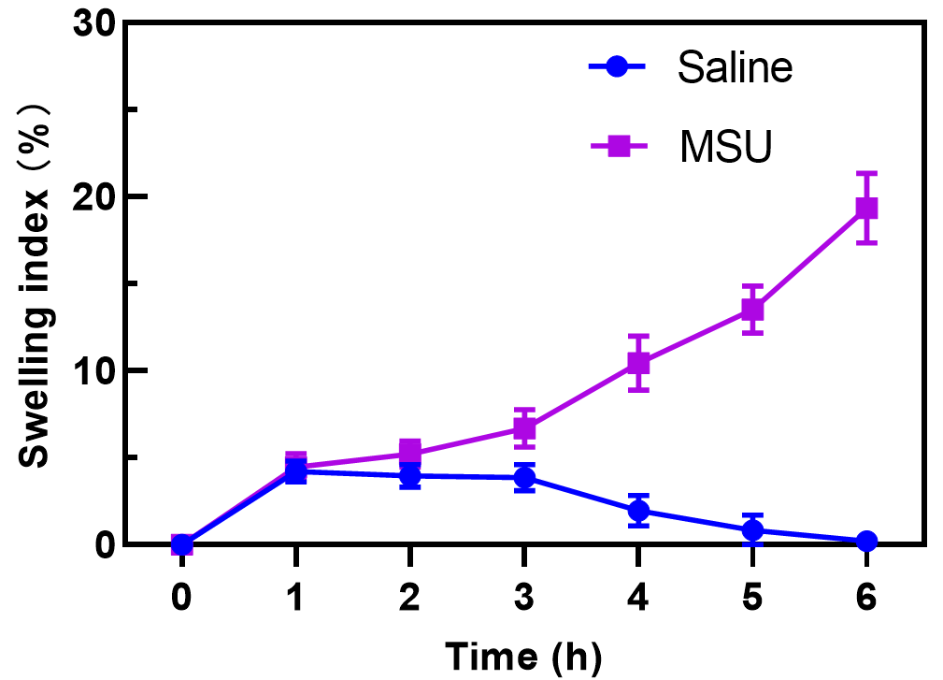
SFig.1 Swelling index (SI) of ankle joints after injecting the same amount of saline and monosodium urate (MSU). (N = 6 in both groups).

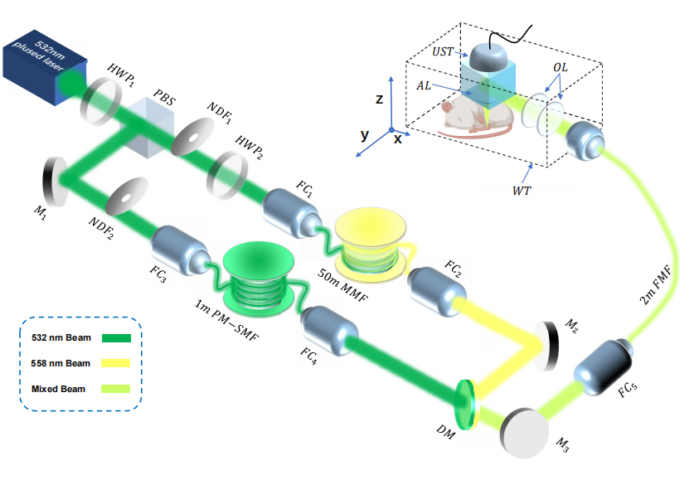
SFig.2. Optical path diagram of optical-resolution photoacoustic microscopy system. (HWF: half-wave plate, PBS: polarizing beam splitter, M: mirror; FC: fiber coupler, DM: dichroic mirror, MMF: graded-index multimode fiber, PM-SMF: polarization-maintaining single-mode fiber, FMF: few-mode optical fiber, OL: optical lens, UST: ultrasonic transducer, AL: acoustic lens, WT: water tank).

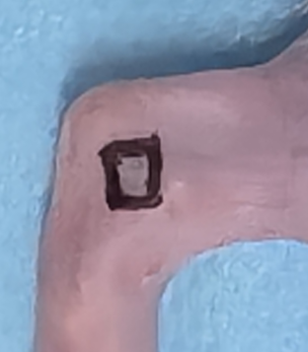
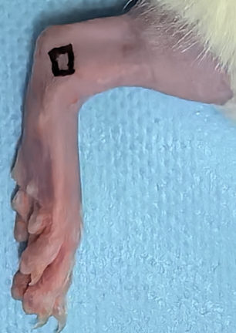

SFig.3. Marker on ankle joint for PAM.

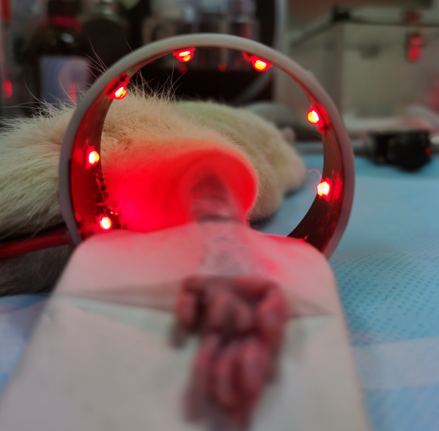

SFig.4. LLLT device for treating GA joints.

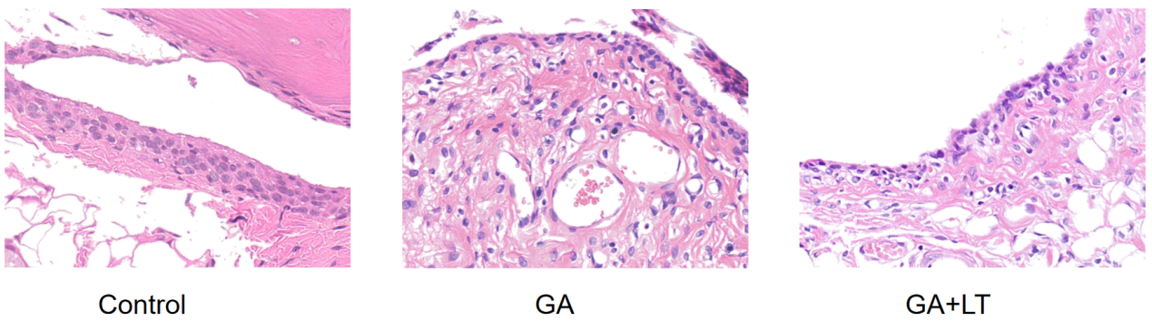

SFig.5. Histopathological results of a normal synovium from control group, synovium from GA group and synovium from GA+LT group (HE $×400$). Inflammatory cells were found occasionally in normal joint tissue from control group. However, synovial tissue of GA group was hyperplasia with a large number of inflammatory cells infiltrated into synovial tissue and angiogenesis. Compared with the GA group, the joint tissue of GA+LT rats had fibroplasia, but the infiltration of inflammatory cells into synovial tissue was significantly reduced.

