Supplementary figures
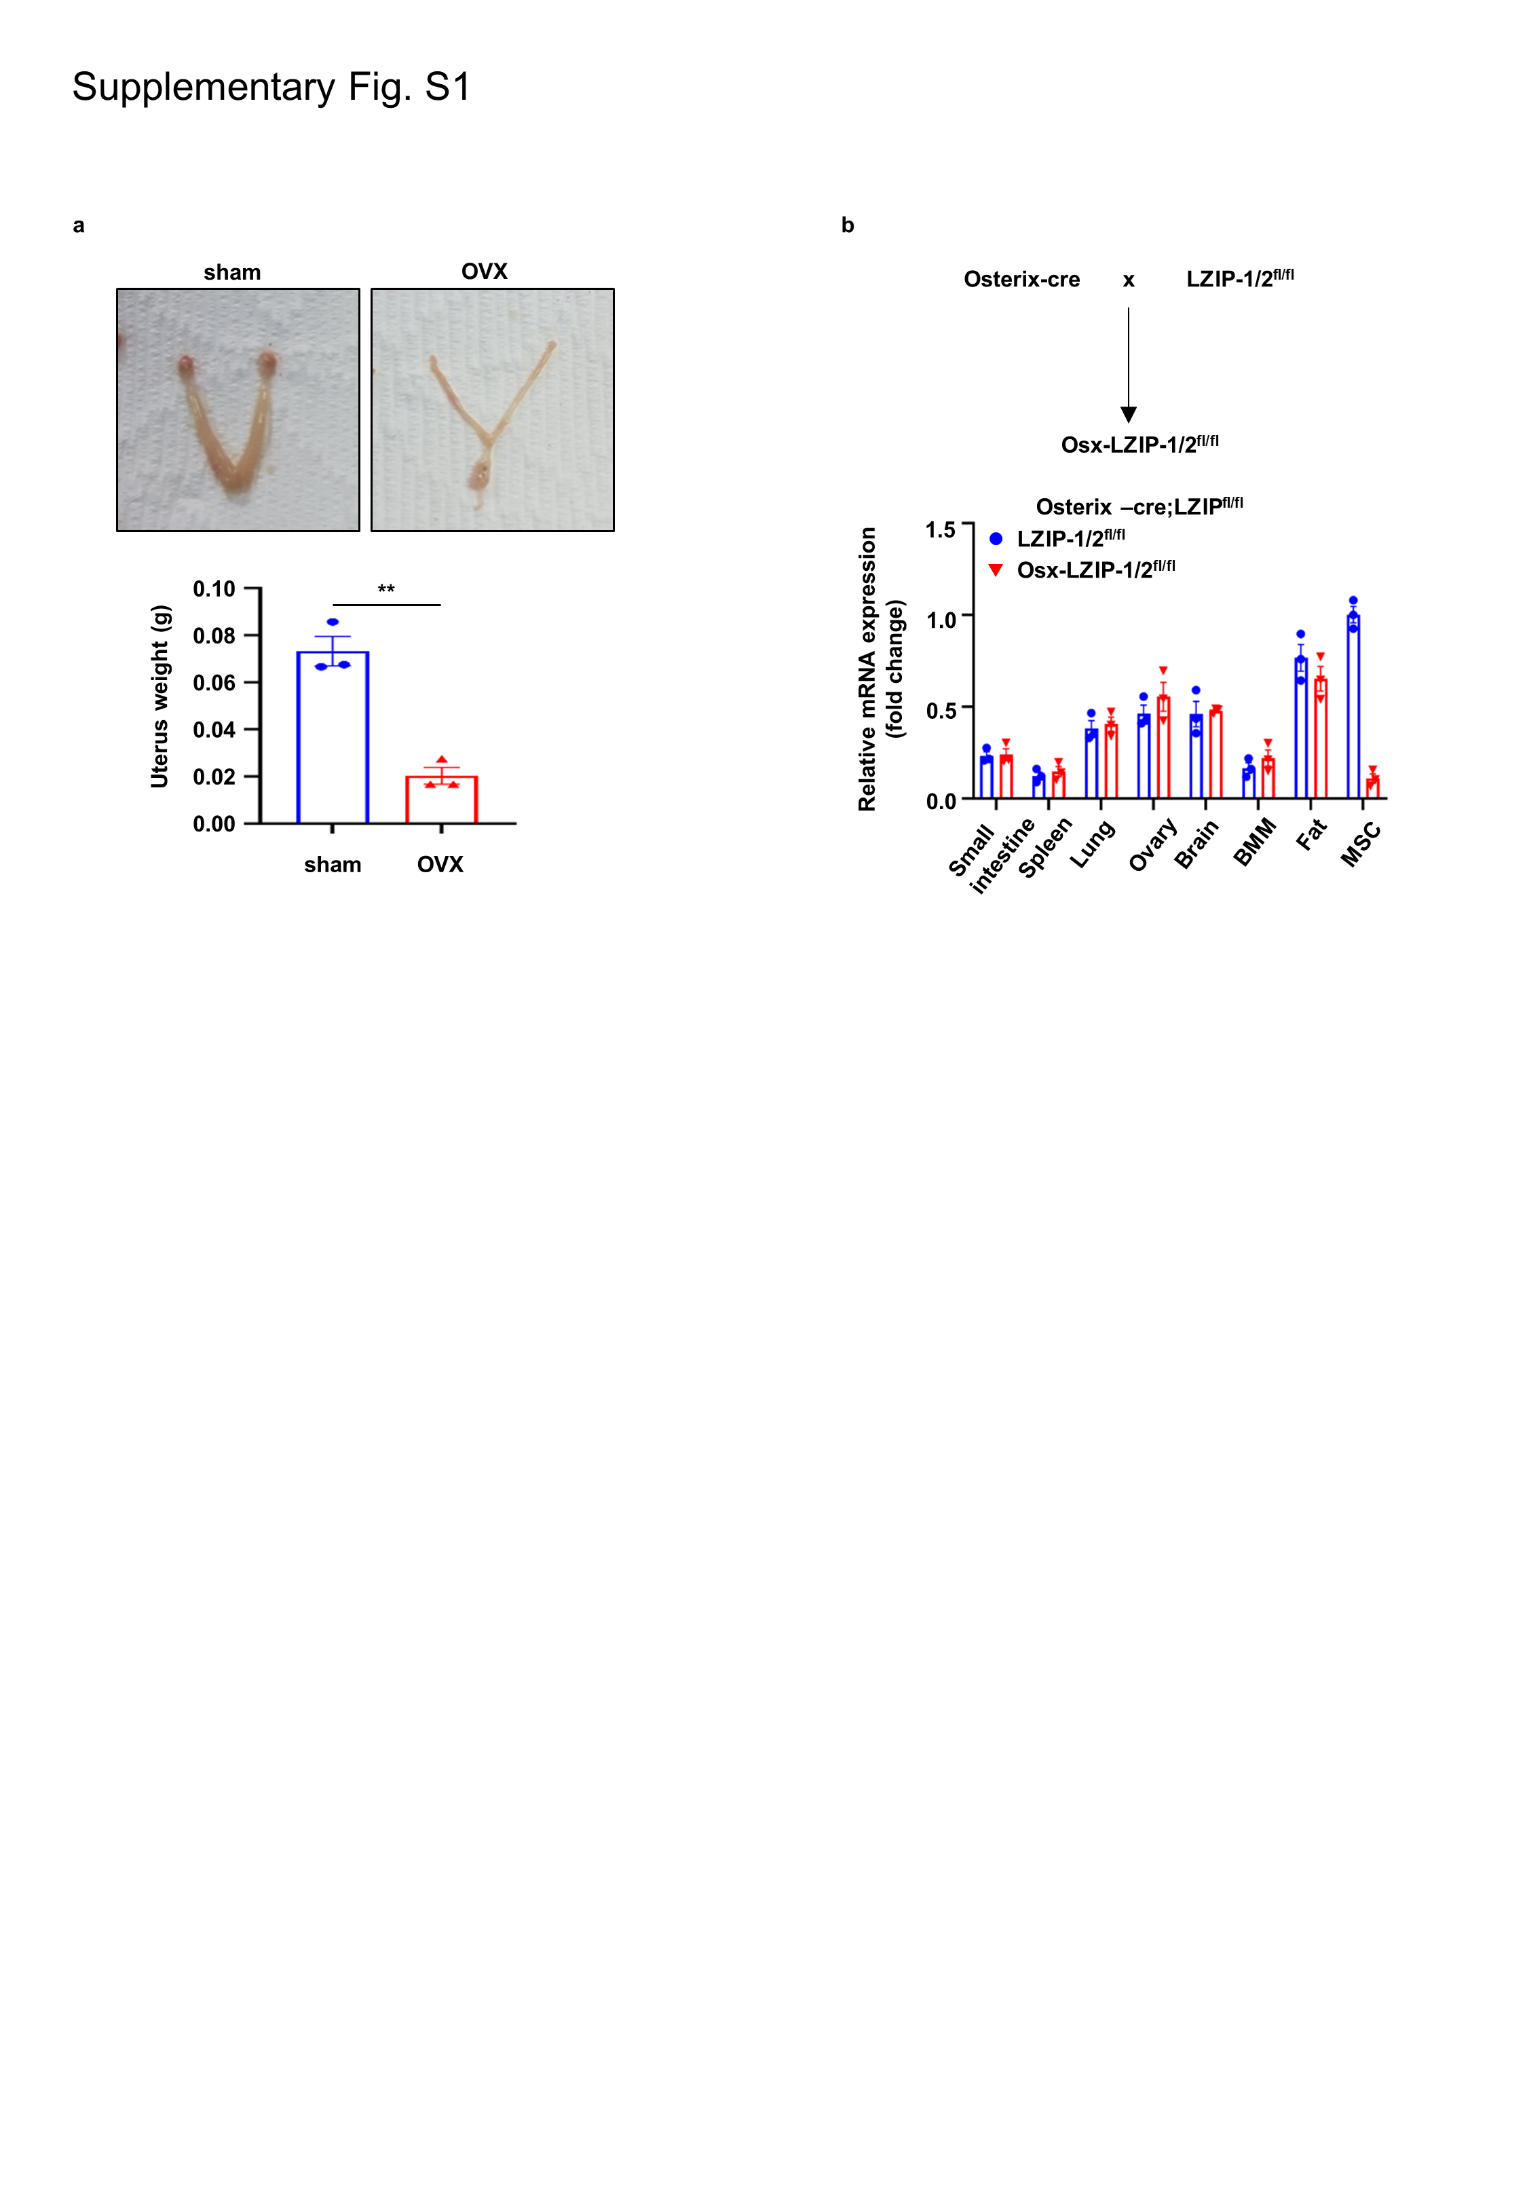
a The uteri were harvested seven weeks after OVX surgery and weighed. b Osx-LZIP-1/2^{fl/fl} mice were generated by crossing Osx-cre mice and LZIP-1/2^{fl/fl} mice and tissues were isolated. The mRNA expression of murine LZIP-1/2 was determined by qRT-PCR. Error bars: mean ± SEM., **p < 0.01 (unpaired, two-tailed student’s t-test).
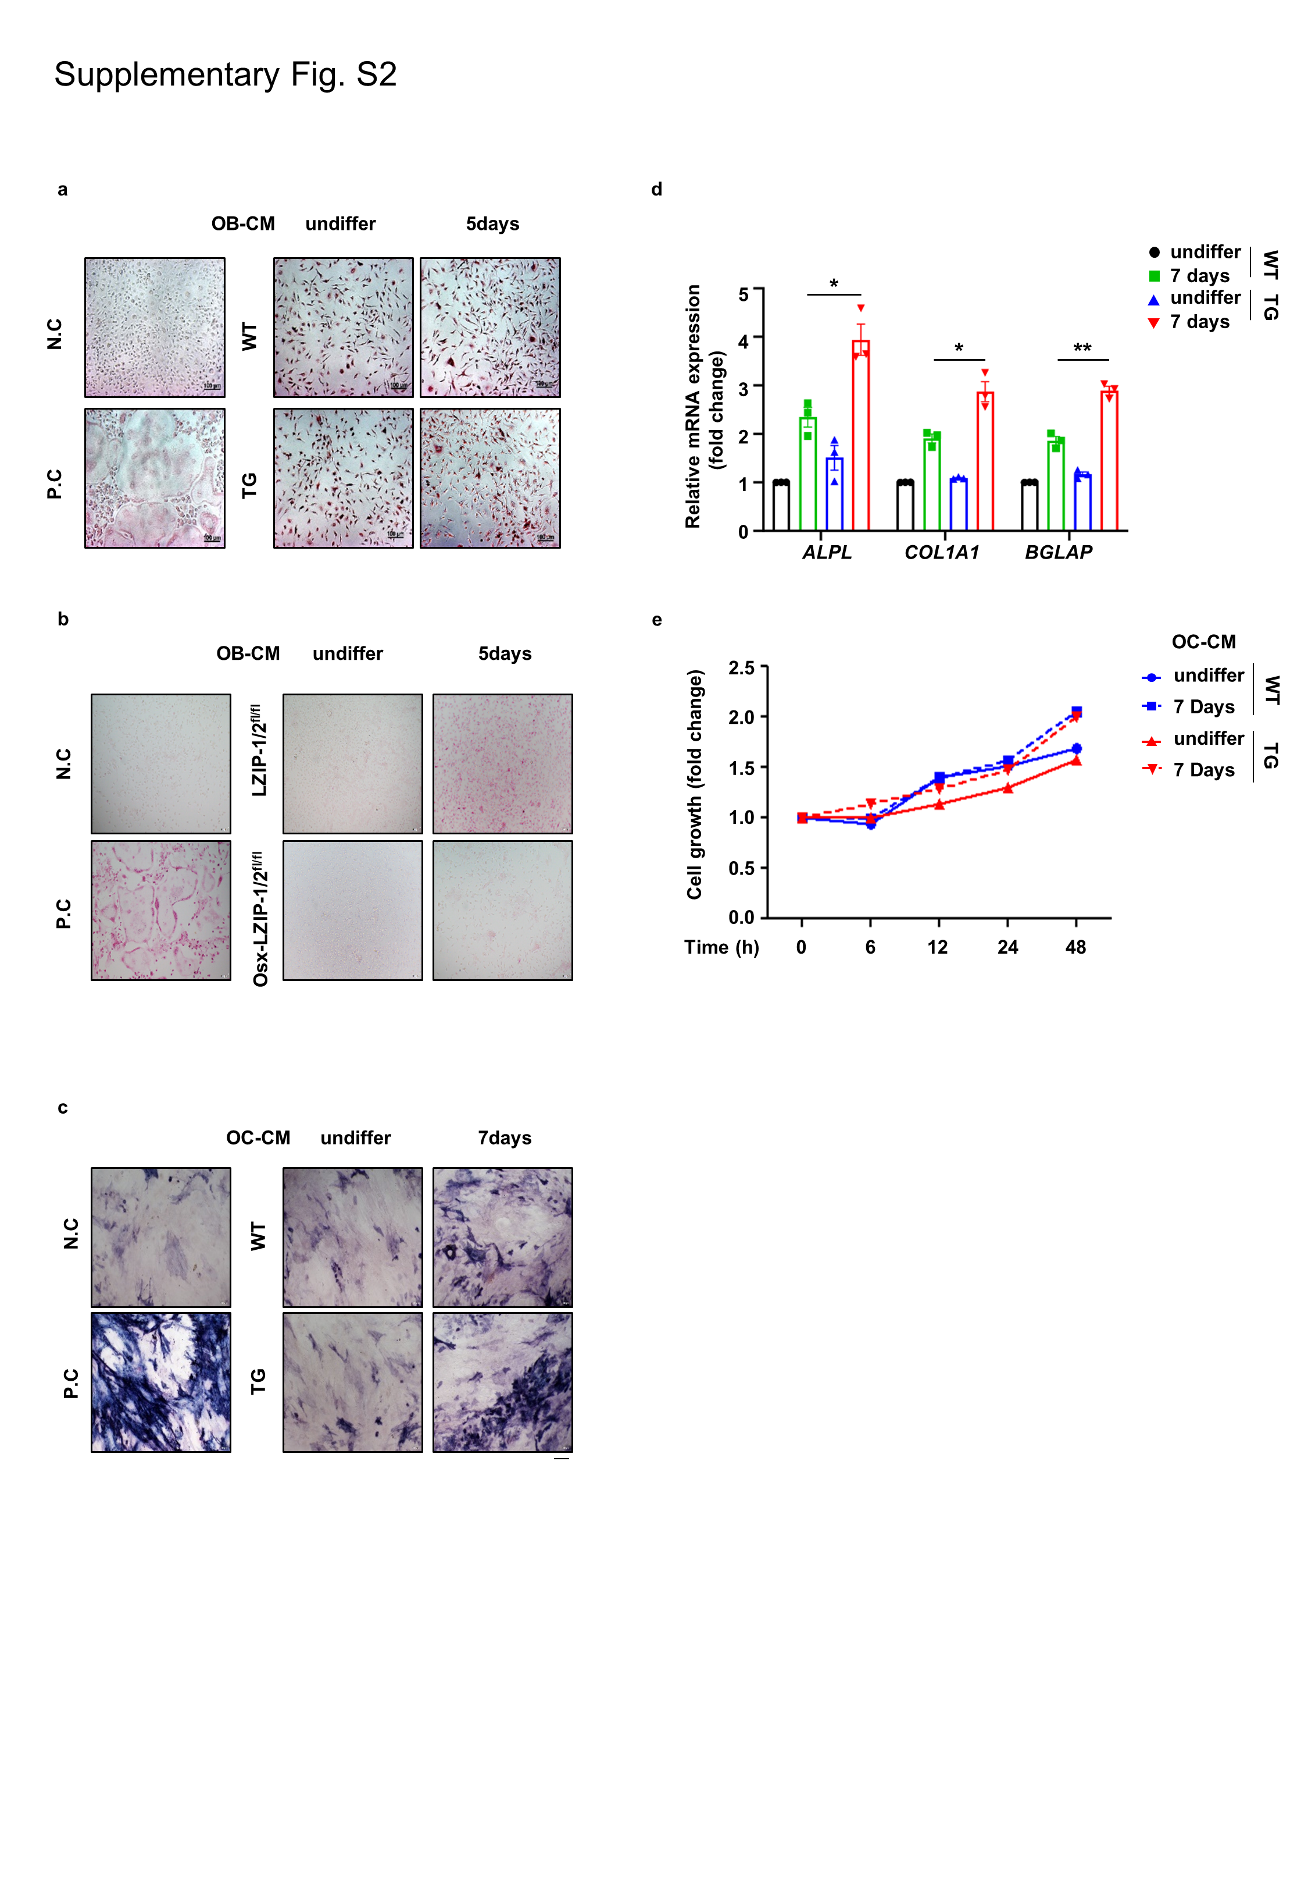
a-e ADSCs isolated from mice were seeded at a density of 8 × 10⁴ cells/well in 12-well culture plates and differentiated into mature OBs for 5 days. CM was collected from mature OBs. BMMs isolated from mice were seeded at a density of 2 × 10⁵ cells/well in 12-well culture plates and differentiated into mature OCs for 7 days. CM was collected from mature OCs. a,b BMMs isolated from WT mice were seeded at a density of 1 × 10⁴ cells/well in 96-well culture plates and cultured in α-MEM with OB-CM and 30 ng/ml M-CSF for 7 days. Cells were then subjected to TRAP staining. Negative control (N.C) cells were cultured in α-MEM with 30 ng/ml M-CSF for 7 days and positive control (P.C) cells were cultured in α-MEM with 30 ng/ml M-CSF and 50 ng/ml RANKL for 7 days. c-d ADSCs isolated from WT mice were seeded at a density of 1 × 10⁴ cells/well in 96-well culture plates or 2 × 10⁵ cells/well in 12-well culture plates, and exposed to OC-CM for 7 days. c Cells were then subjected to ALP staining. d The mRNA level was determined using qRT-PCR analysis. e The proliferation of ADSCs (3 × 10³ cells/well) incubated with OC-CM was measured using the MTT assay. Cells were treated with water-soluble tetrazolium salt solution and incubated at 37˚C for 30 min, and the absorbance was measured at 450 nm. Error bars: mean ± SEM. *p < 0.05, **p < 0.01 (unpaired, two-tailed student’s t-test).
a OVX surgery was performed using WT mice, and each type of ADSC cells (1 × 10⁶ cells/mouse) was injected intravenously after 7 weeks. After 10 days, the mice femur was analyzed μCT. b Representative 2D and 3D images were generated from μCT analysis. Quantification of cortical thickness (Ct.Th) and tissue mineral density (TMD) were analyzed using the μCT program (CTAn). c Representative 2D images were generated from μCT analysis. Trabecular bone volume per total bone volume (BV/TV), trabecular bone thickness (Tb.Th), trabecular number (Tb. N), and trabecular separation (Tb.Sp) were quantified using the μCT program (CTAn). Error bars: mean ± SEM. *p < 0.05, **p < 0.01 (unpaired, two-tailed student’s t-test).
2. Western blot raw data
Fig 6b. raw data
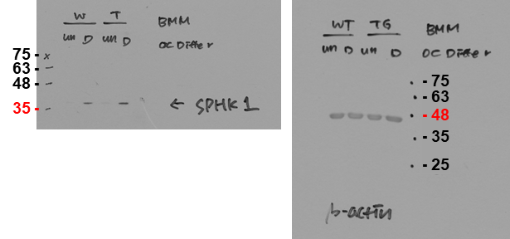
Fig 6e. raw data
- 63
- 48
- 35
- 25
- 75
75 -
63 -
48 -
35 -

Fig 6f. raw data
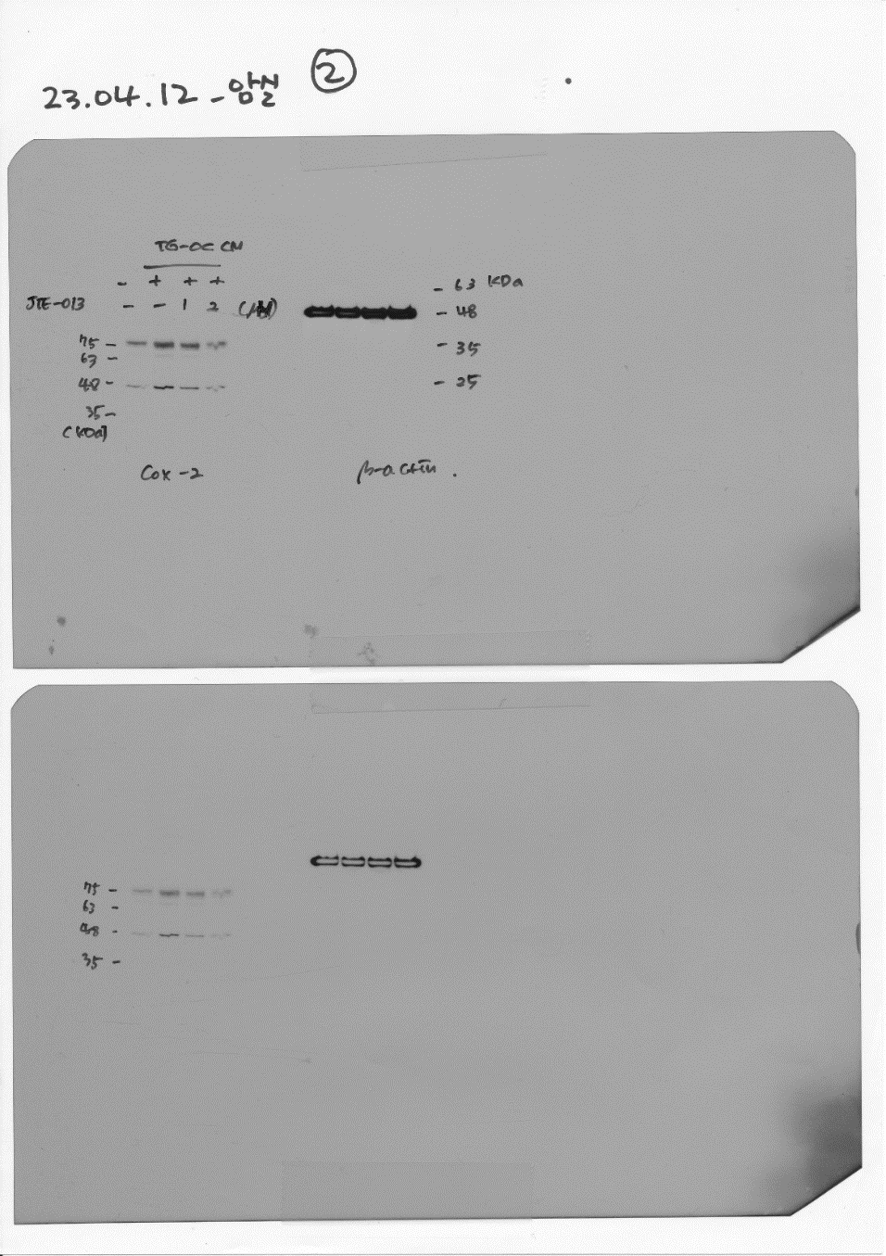
COX-2

