Lightening the Mind: Comparing Audiovisual Stimulation and Meditation for Mood and Cognition Enhancement

SUPPLEMENTAL MATERIALS

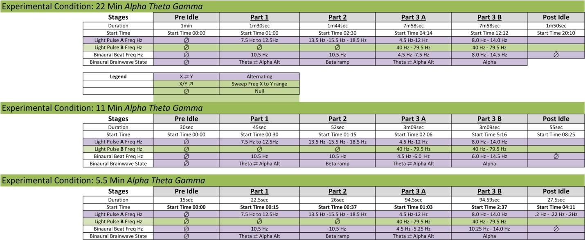
Supplemental Materials 1. ELA1 experiential composition for 5.5, 11, and 22minute experiences

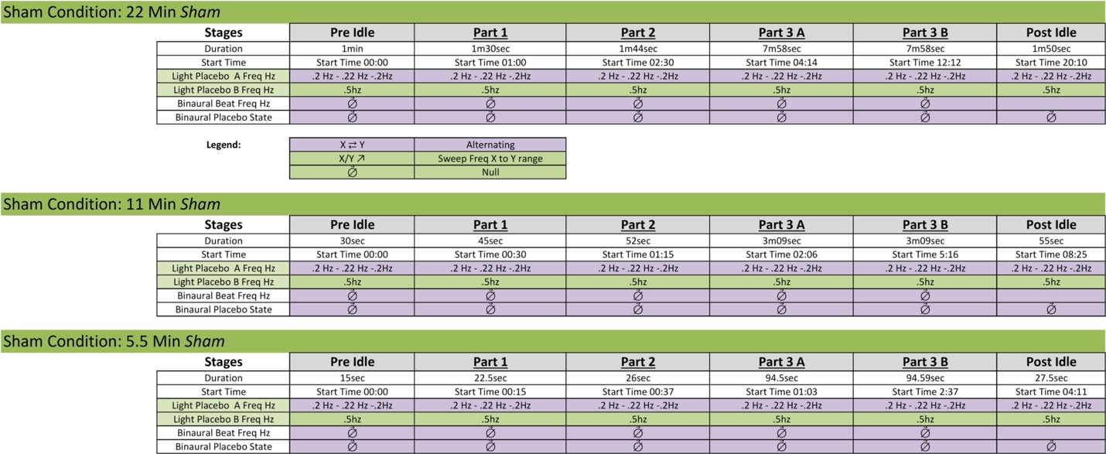
Supplemental Materials 2. ELA2 experiential composition for 5.5, 11, and 22minute experiences

Breath Focused Meditation Instructions

For the [5.5,11,22] minutes, we would like for you to close your eyes and focus on your breath. Specifically, breathe in and out through your nose and try to focus on the sensation of the air hitting your nostrils. Notice the difference of the cold air coming in with each inhale and the slightly warmer air going out with each exhale. Follow the natural and spontaneous movement of the breath, not trying to change it in any way. Just pay attention to it. If you find that your attention has wandered to something else, gently but firmly bring it back to the physical sensation of the breath. If you are unable to focus on your breath hitting your nostrils, focus on rise and fall of abdomen. Try your best not to fall asleep throughout this exercise.

