Supplementary Information for
An ensemble method utilising multiple thinking styles that boosts the wisdom of the inner crowd effect
*Itsuki Fujisaki, Lingxi Yu, Yuki Tsukamura, Kunhao Yang & *Kazuhiro Ueda

*Itsuki Fujisaki & Kazuhiro Ueda
Email: bpmx3ngj@gmail.com (I.F), ueda@g.ecc.u-tokyo.ac.jp (U.K)

This PDF file includes:

Supplementary text
Figures S1 to S9
Tables S1 to S3

S1. Optimal weighting in Experiment 1
Here, we calculated the optimal weighting of the Intuition and Deliberation opinions using the following equation:

MSE = (w × Intuition + (100 - w) × Deliberation) / 100

where w represents the weighted percentage of a giver’s own opinion. We varied w from 0 to 100 in increments of one. Specifically, we set 101 levels (w = 0, 1.... .99, and 100) and calculated the MSE for each w.
Fig. S1 shows the results. It indicates the relationship between w and the MSE. The red dotted line represents the optimal weighting w = 47.
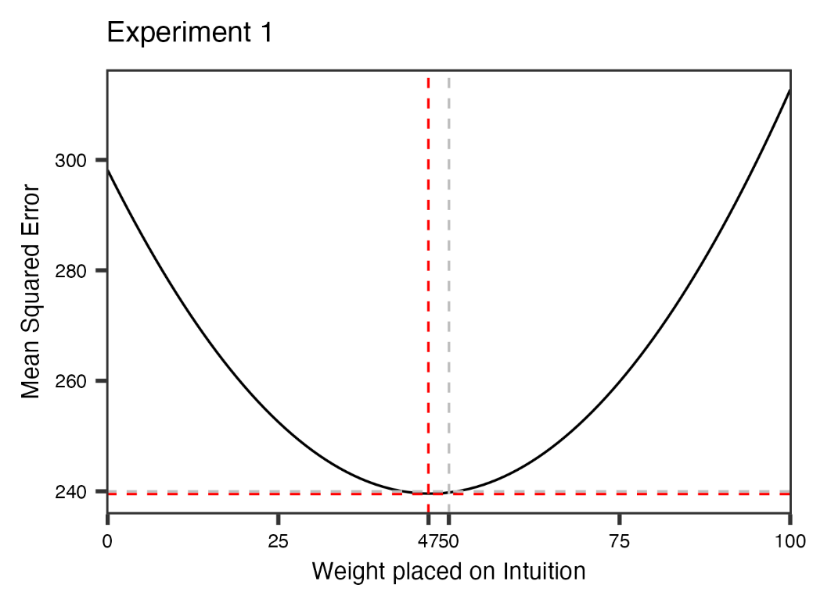
The figure also shows a dotted grey line for the average (w = 50). It can be observed that these MSEs are almost the same as that in the optimal weighting (0.084% higher). Subsequently, we assumed that the averaging method is a robust strategy.

Fig. S1. Results of the optimal weighting in Experiment 1.

S2. Optimal weighting in Experiment 2

Here, we focus on the Ensemble method condition in Experiment 2. Optimal weighting is expressed as follows:

MSE = (a × Intuition + b × Deliberation + c × Dialectic + d × General crowd + e × Disagree-other) / 100
a + b + c + d + e = 100

For simplicity, we varied a, b, c, d, e from 0 to 100 in steps of 10. Specifically, we set 11 levels (a, b, c, d, e = 0, 10.... .90, and 100) and calculated the MSE for each combination of the variables.
These results are summarised in Table S1. It can be observed that the MSE in averaging was almost the same as that in optimal weighting (0.77% higher), as in Experiment 1. Subsequently, we assumed that the averaging method is a robust strategy.
More importantly, for optimal weighting, all variables were above 0. Thus, to exploit accurate estimates, all estimates are needed.

Table. S1. Summary of the analysis.
 | a | b | c | d | e | MSE
Optimal weighting | 20 | 30 | 20 | 20 | 10 | 224.58
Averaging | 20 | 20 | 20 | 20 | 20 | 226.30

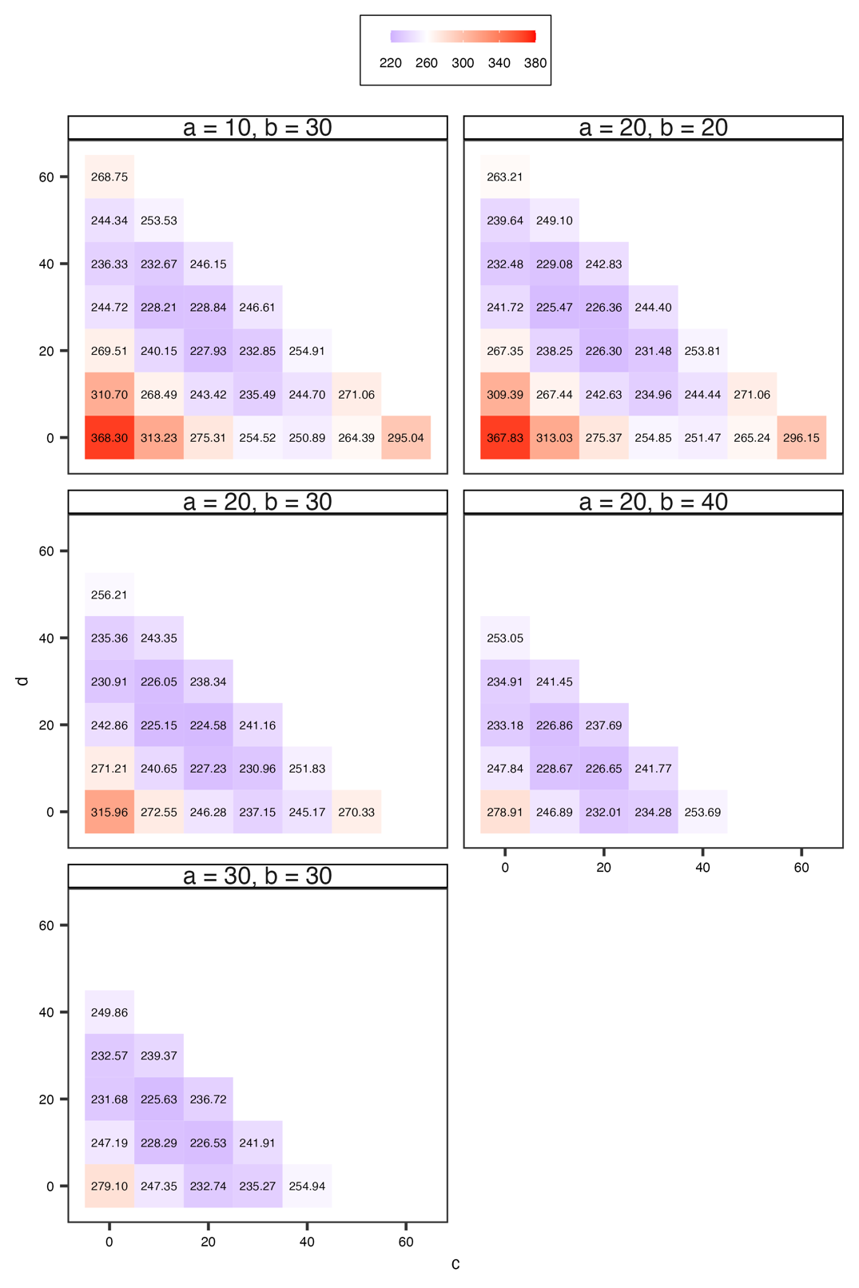
Fig. S2. Results of the optimal weighting in Experiment 2. The x axis indicates c and the y axis represents d. Note that e is determined by other 4 variables. As shown, the optimal weighting is when a = 20, b = 30, c = 20, d = 20, e = 10.

S3. Analysis on confidence in Experiment 1

Fujisaki et al. (2023)¹ indicated that confidence in the first estimate influenced the effectiveness of their method. Therefore, we analysed participants’ confidence. As mentioned in the Materials and Methods section of the main manuscript, participants answered with confidence in the first estimate (i.e. Intuition) between the first and second estimates. Participants rated their confidence on a scale ranging from 0 (I am not confident in my answer at all) to 100 (I am very confident in my answer).

First, we conducted a mixed-effects analysis to examine the influence of confidence. We set MSE_{average} - MSE_{Intuition} (i.e. the effectiveness of this method) as the dependent variable based on Fujisaki et al. (2023)¹, confidence as the independent variable, and the participants and questions as random variables. The results show no significant effect (t = 0.33, p = 0.74).

Additionally, we conducted another mixed-effects analysis with MSE_{Deriberation}, confidence, and participants/questions as the dependent, independent, and random variables, respectively. The results showed no significant effect (t = 0.69, p = 0.49).

In short, the results indicated that confidence did not influence the effectiveness of this method.

S4. Analysis on the correlations between estimates in Experiment 2
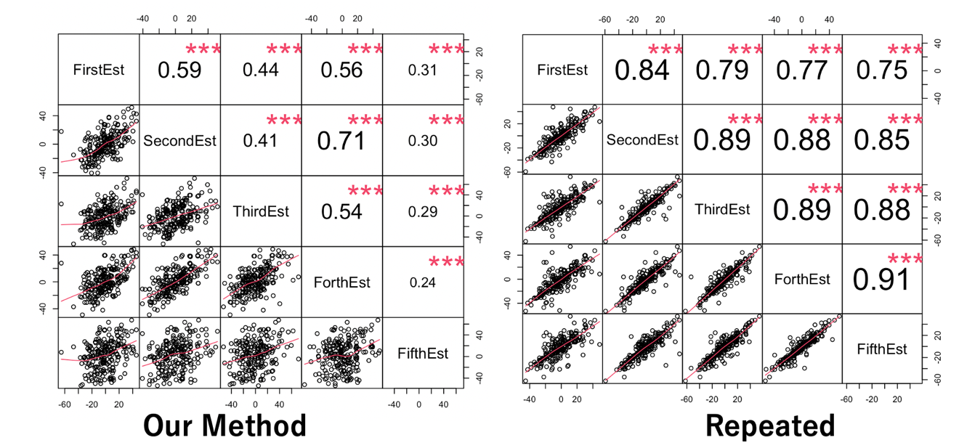

Fig. S3. Results of the analysis. Note that the font size represents the absolute value of correlation coefficient. Our method indicates Ensemble Method condition and Repeated represents Repeated condition, respectively.

S5. Analysis on the accuracy of each estimate in Experiment 2
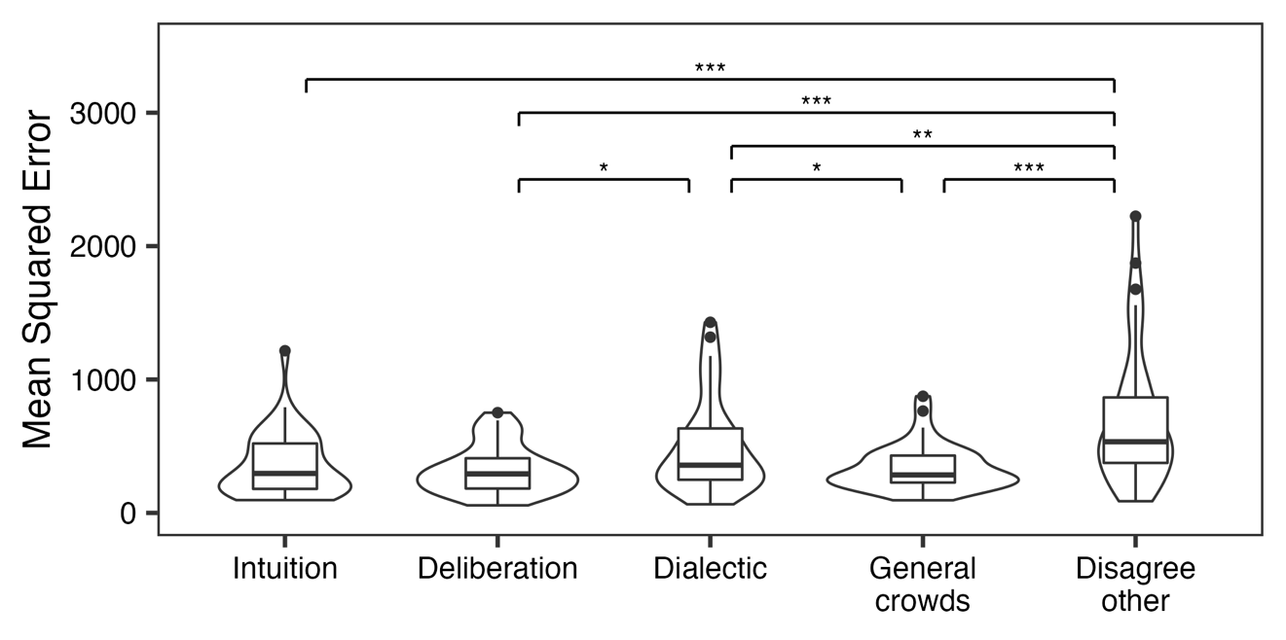

Fig. S4. Results of the analysis. This figure also indicated the results of ANOVA.

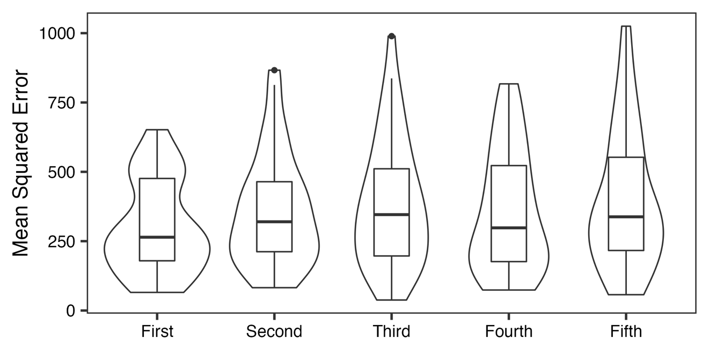

Fig. S5. Results of the analysis. This figure also indicated the results of ANOVA (i.e. we found no significant effects).

S6. The parameter estimation in Experiment 2

We first regarded T (the number of estimates) as the independent variable and MSE as the dependent variable. We then conducted a parameter estimation (slope a and intercept b) based on Equation Level 1. Subsequently, we set participant (s) and question (i) as crossed random variables and then estimated the parameters a and b (Level 2).

$$Level 1. {MSE}_{si }= \frac{a}{T_{si}} + b + ε_{si} s∈\{1, ...,38\}; i∈\{1,...,6\}$$

$$Level 2. a =γ_{s}^{(a)}+S_{s}^{(a)}+I_{s}^{(a)}$$

$$b = γ_{s}^{(b)}+S_{s}^{(b)}+I_{s}^{(b)}$$

Note that Rauhut & Lorenz, (2011)² indicated that, theoretically, slope a corresponds to diversity, and intercept b corresponds to collective performance (MSE). We assumed that the parameters a and b follow a normal distribution. Subsequently, we set the mean of each prior distribution as the diversity and collective performance when the number of estimates was five. We also set the variance of the prior distributions to 300.

$$a \sim Norm(Diversity_T5, 300)$$

$$b \sim Norm(Collective performance_T5, 300)$$

In each estimate, we set the number of chains to four, the number of samplings for each chain to 5,000, the warm-up period to 2,000, and the value of the seed to one. Consequently, we confirmed the convergence of parameters a and b (R < 1.1). We used brms package of R in parameter estimation.

S7. Categorization on the estimates

Experiment 1

Table S1. Results of the analysis.
 | Overestimate  (%) | Underestimate  (%) | Correct  (%) | Not estimate  (%)
Intuition | 53.13% | 44.84% | 0.47% | 1.56%
Deliberation | 48.59% | 51.25% | 0.16% | 0.00%

Note: For the ‘Not estimate’, we excluded from the analysis in the main text.

Experiment 2

Table S2. Results of the analysis.
 | Overestimate  (%) | Underestimate  (%) | Correct  (%) | Not estimate  (%)
Intuition | 33.33 | 61.40 | 0 | 5.26
Deliberation | 29.39 | 70.61 | 0 | 0
Dialectic | 39.47 | 60.53 | 0 | 0
General crowd's perspective | 38.59 | 61.40 | 0 | 0
Disagree-other's perspective | 44.74 | 55.26 | 0 | 0

Table S3. Results of the analysis.

 | Overestimate (%) | Underestimate  (%) | Correct  (%) | Not estimate  (%)
1st estimate | 22.37 | 77.63 | 0 | 0
2nd estimate | 26.75 | 72.80 | 0 | 0.44
3rd estimate | 28.07 | 71.93 | 0 | 0
4th estimate | 25.88 | 74.12 | 0 | 0
5th estimate | 24.12 | 75.87 | 0 | 0

S8. Estimated values in Experiment 1 (Analysis 1)

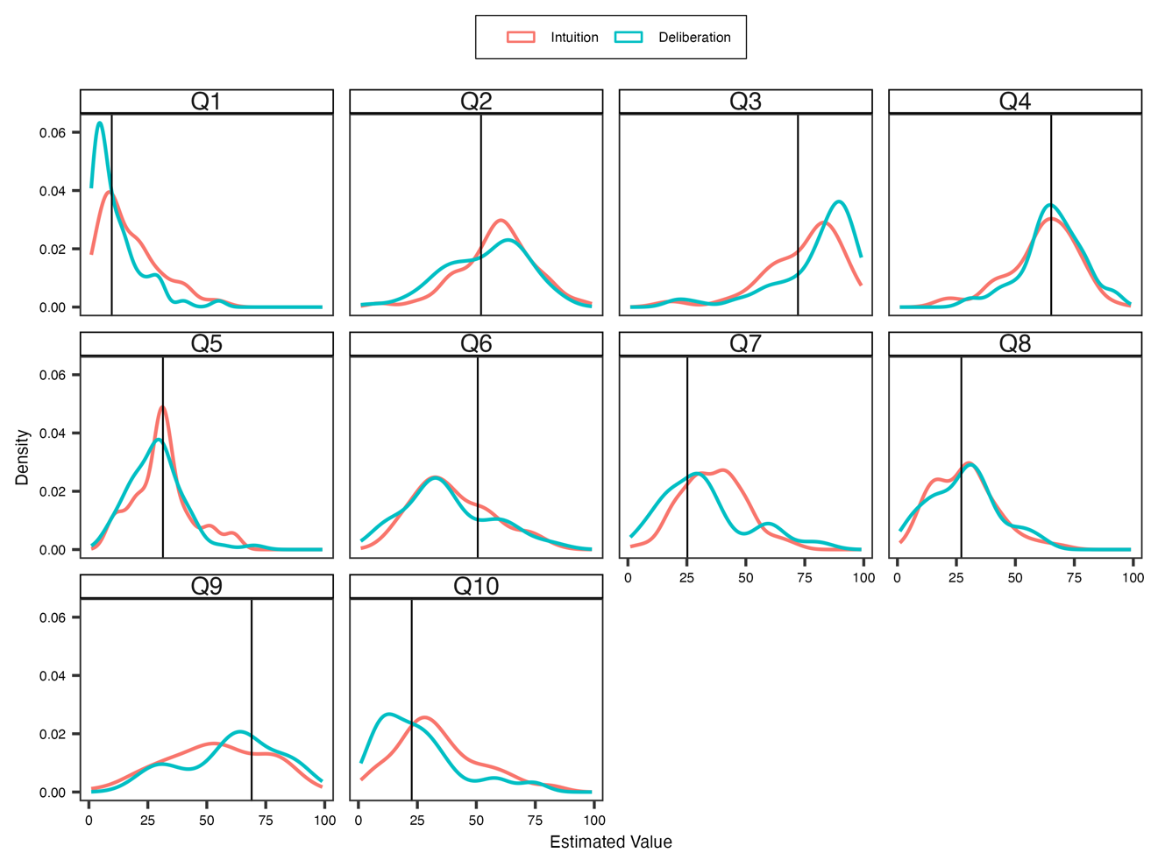
Fig. S6. Result of the estimated values. Each black line indicates the correct answer.

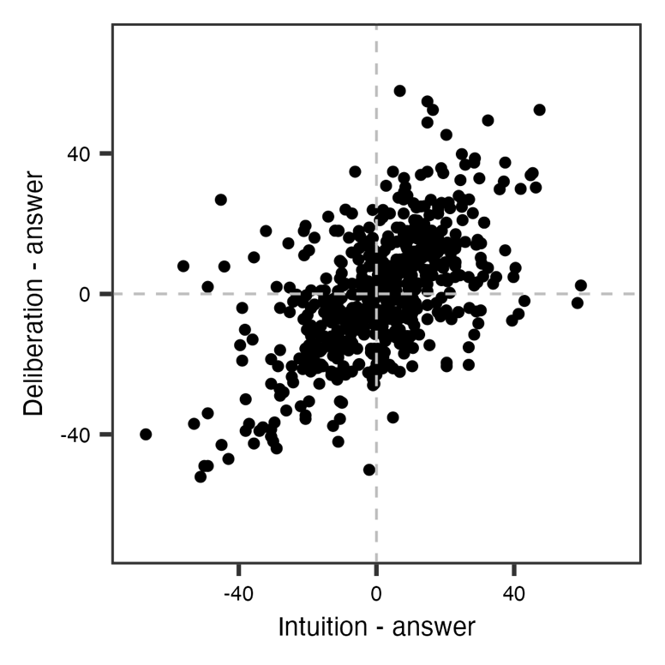
S9. Estimated values in Experiment 1 (Analysis 2)

Fig. S7. Result of the analysis. The grey dotted lines indicate that Intuition or Deliberation are equal to the correct answer.

S10. Estimated values in Experiment 2

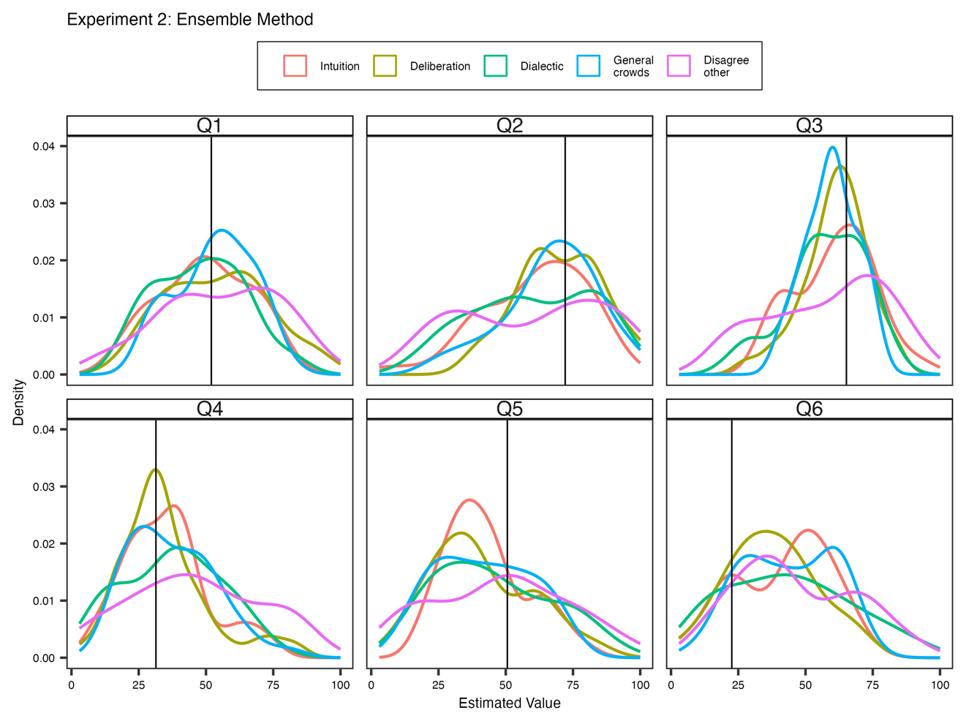
Fig. S8. Result of the estimated values in the Ensemble method condition.

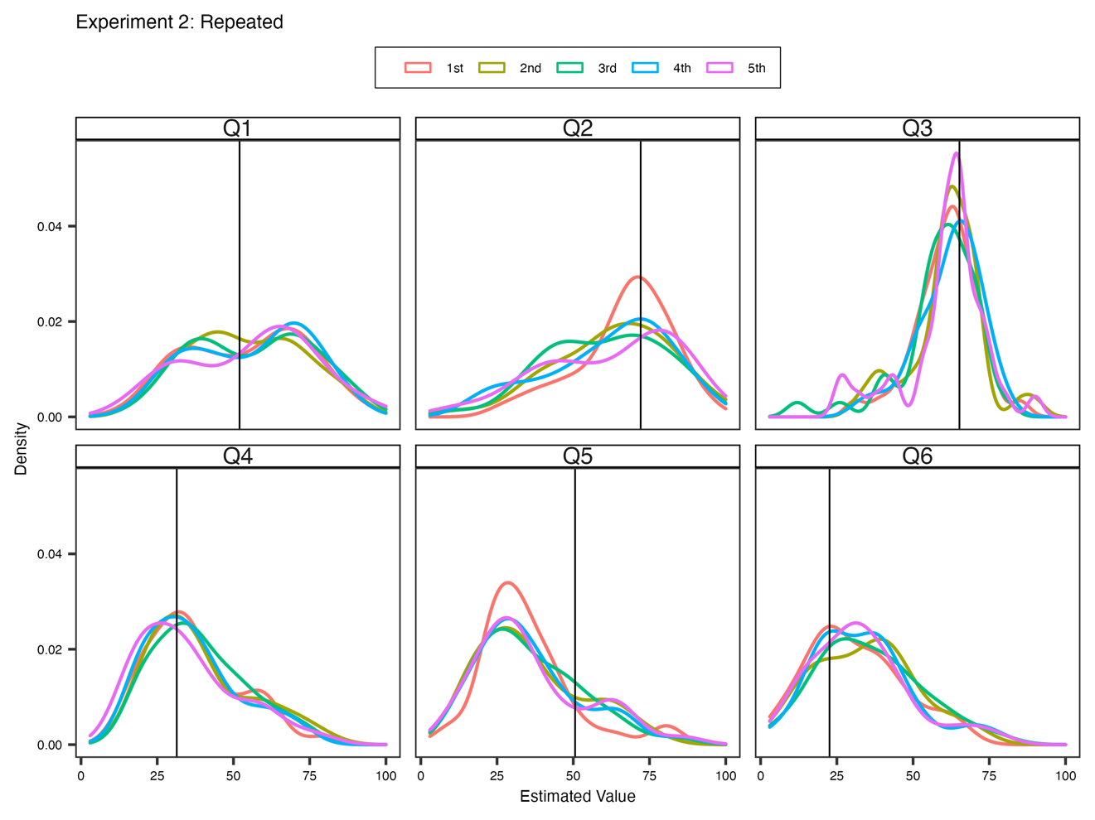

Fig. S9. Result of the estimated values in the Repeated condition.

1. Fujisaki I, Yang K, Ueda K. (2023) On an effective and efficient method for exploiting the wisdom of the inner crowd. Sci. Rep. 13:3608. (doi: 10.1038/s41598-023-30599-8)

2. Rauhut H, Lorenz J. (2011) The wisdom of crowds in one mind: How individuals can simulate the knowledge of diverse societies to reach better decisions. J. Math. Psychol. 55:191–197. (doi:10.1016/j.jmp.2010.10.002)

