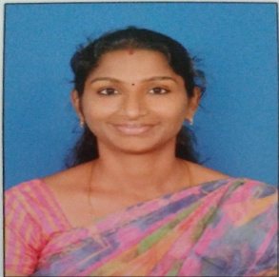
Mrs.P.Divya Banu is presently working as Assistant Professor, Department of Electrical and Electronics Engineering, SNS College of Engineering and Technology, Coimbatore, Tamil Nadu, India. She has completed her UG degree in Electrical and Electronics Engineering, PG in Power Electronics and Drives and pursuing Research in part time, Anna University, Chennai. Her area of interests is Power Electronics and Power Systems. Published a book “Contemporary Research in Engineering and Technology” in Notion Press. Published “ Engineering Practices Lab Manual “ in Notion Press. Published 4 papers in IEEE Conference.
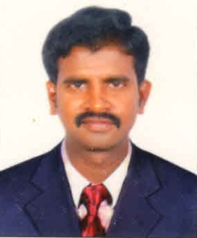

Dr.G.Sundar is presently as Professor, Department of Electrical & Electronics Engineering, Sri Shakthi Insititute of Engineering & Technology, Coimbatore, TamilNadu,India. He has completed his UG degree in Electrical and Electronics Engineering and Post-Graduation in Power systems Engineering. He obtained his Ph.D in the field of Power systems Engineering. He is a recognized R&D Supervisior in Anna University, Chennai under faculty of Electrical Engineering. His areas of interest are Power System and Renweable Energy. He has teaching experience of more than 20 years in the area of Electrical Engineering.
He has published more than fourty research papers in the reputed International and National Journals. He has participated and presented fourty six international and national conferences in various reputed organizations like Anna university, IGCAR and IISC Bangalore. He is a member of SIEEE, MIE, MISTE, IAENG, IACSI & UACEE.He shared his knowledge with various students’ community as resource person at conferences and symposiums.

