Supplementary Information

Template-free method synthesized Na_{x}Ca_{2.38-x}Al₂Si_{57.2}O_{118.59} zeolite particles for enhanced stability
Yuan Xia^{a,*}, Liuyang Maª, Jishu Qin^{c}, Lie Liu^{c}, Wenwen Zhaoª, Yuna Xueª, Hongmin Jiaª, Guojuan Haiª, Jiaming Zhu^{b}, Beibei Wang^{b}, Xiaojie Liu^{b}

ª School of Materials Science and Engineering, Xi’an Shiyou University, Xi’an, Shaanxi Province 710065, PR China
^{b} Institute of Photonics & Photon-Technology, Northwest University, Xi’an 710069, PR China
^{c} Shaanxi Rongbaohan Biopharmaceutical Technology Co., Ltd, Xi’an, Shaanxi Province 710065, PR China

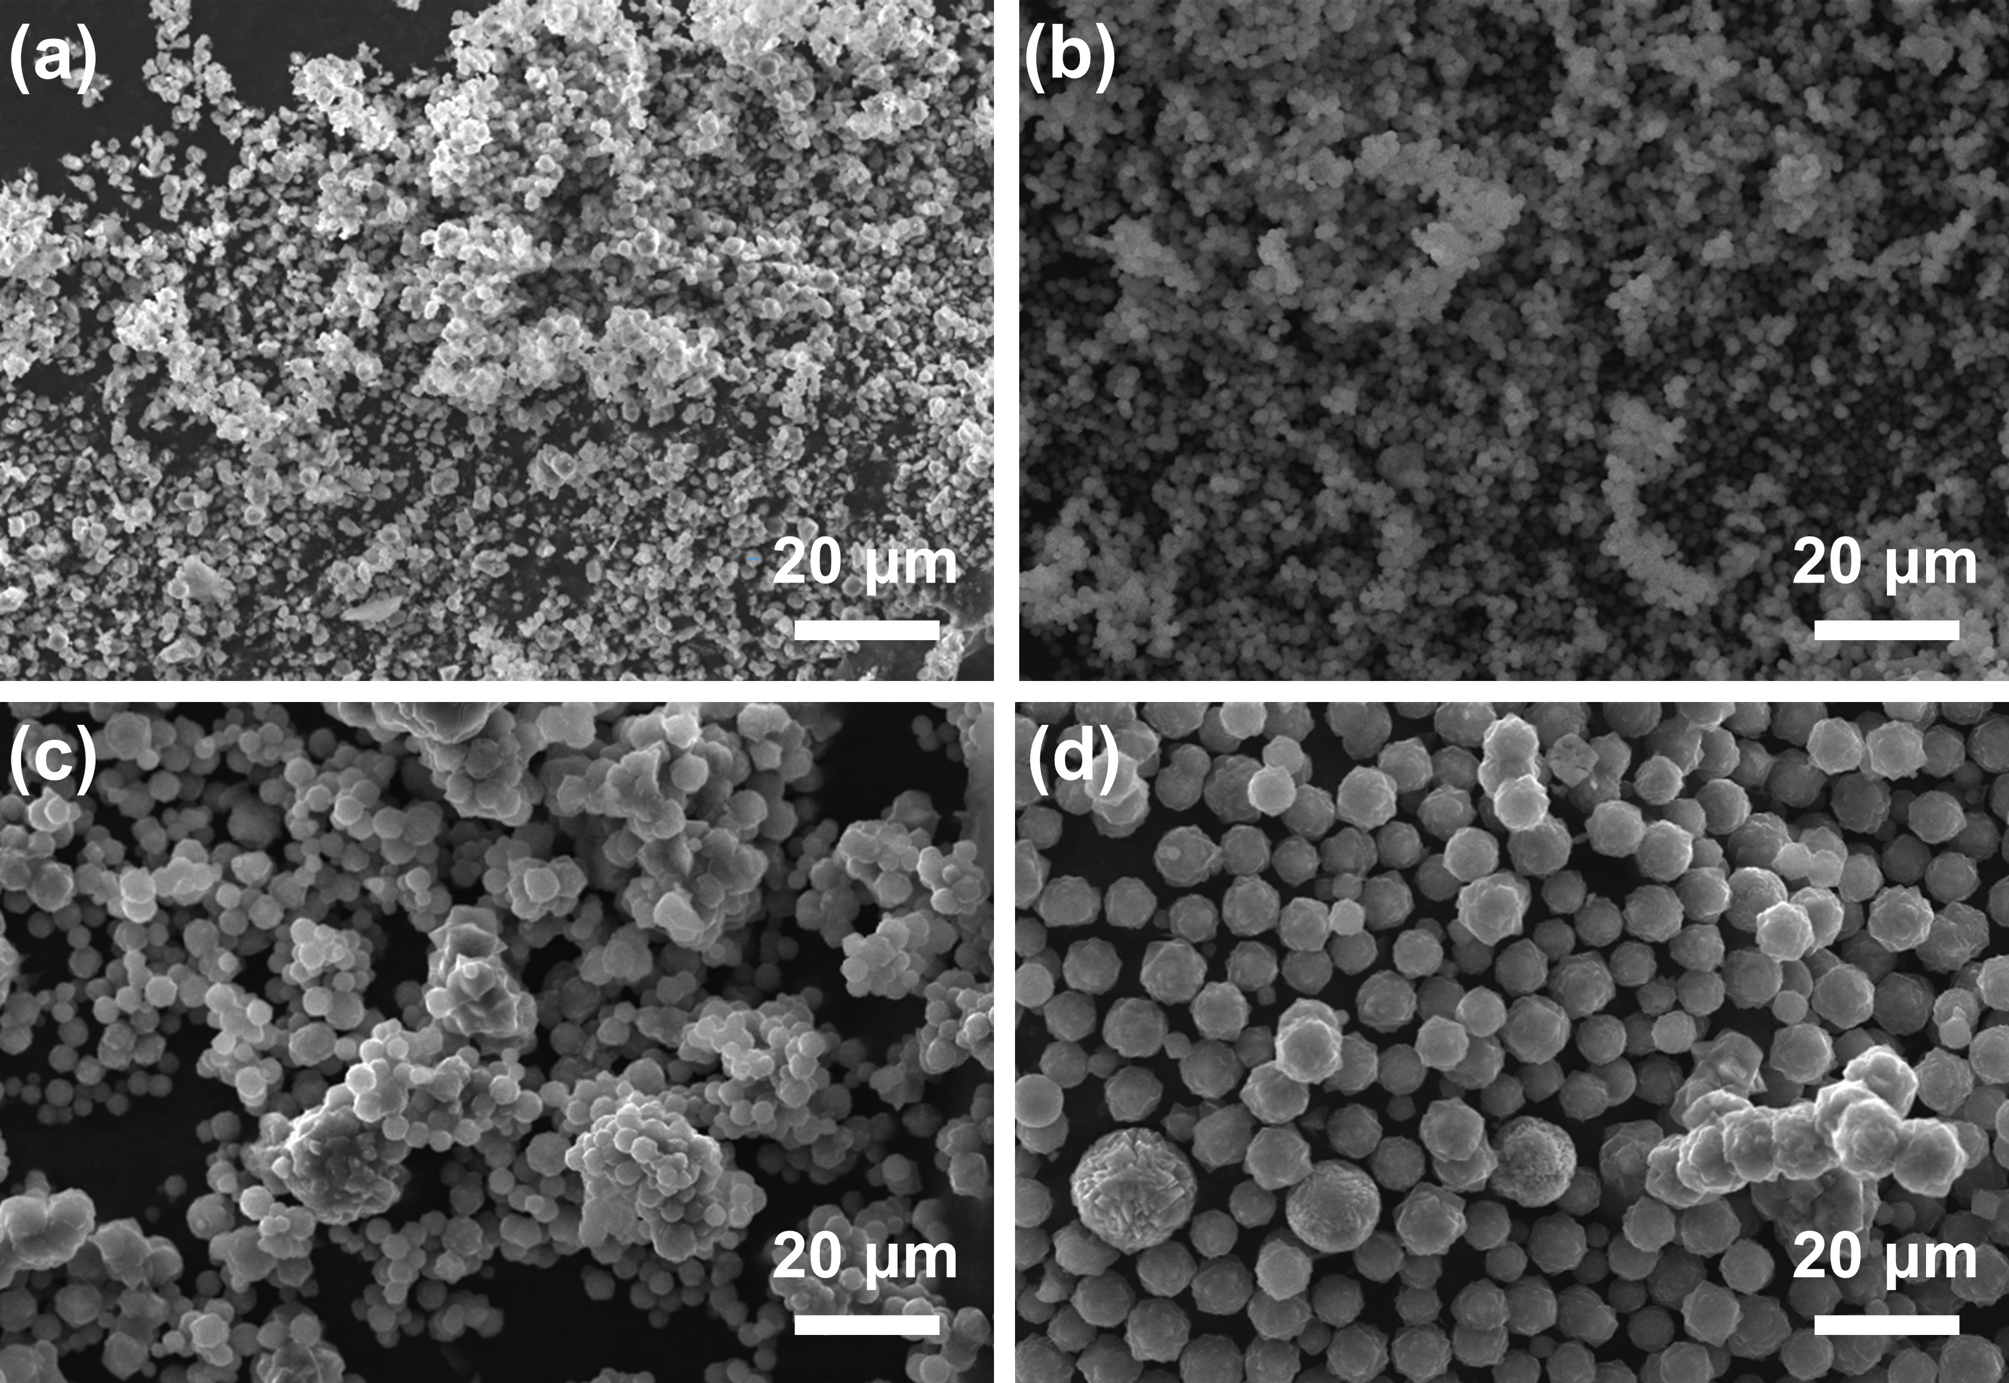
Figure S1. SEM images of the zeolites with different particle size. (a) ~1 μm; (b) ~2 μm; (c) ~4 μm; (d) ~8 μm.

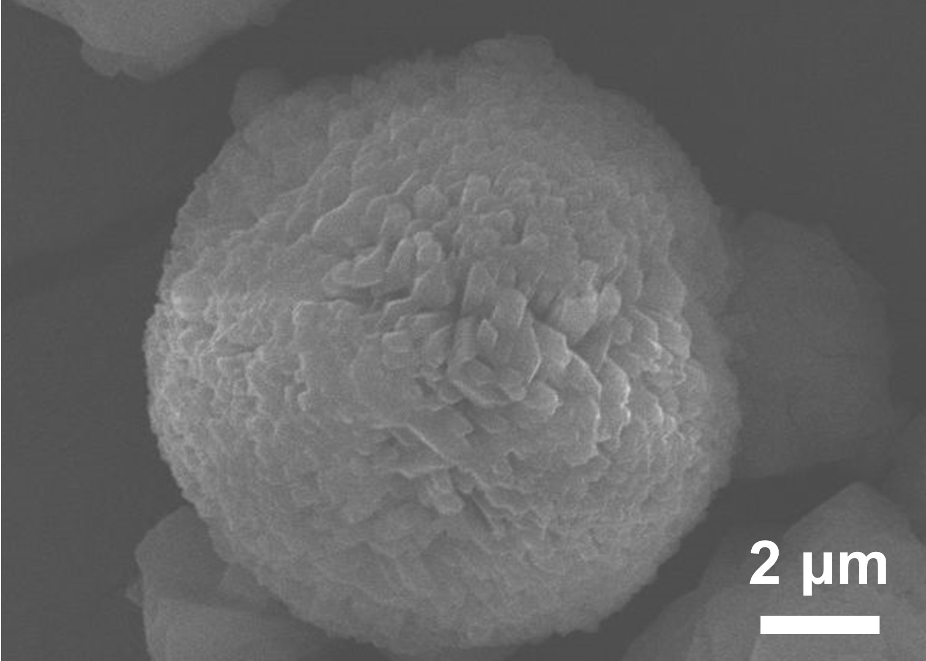
Figure S2. SEM images of the zeolites of ~8 μm zeolite particle.

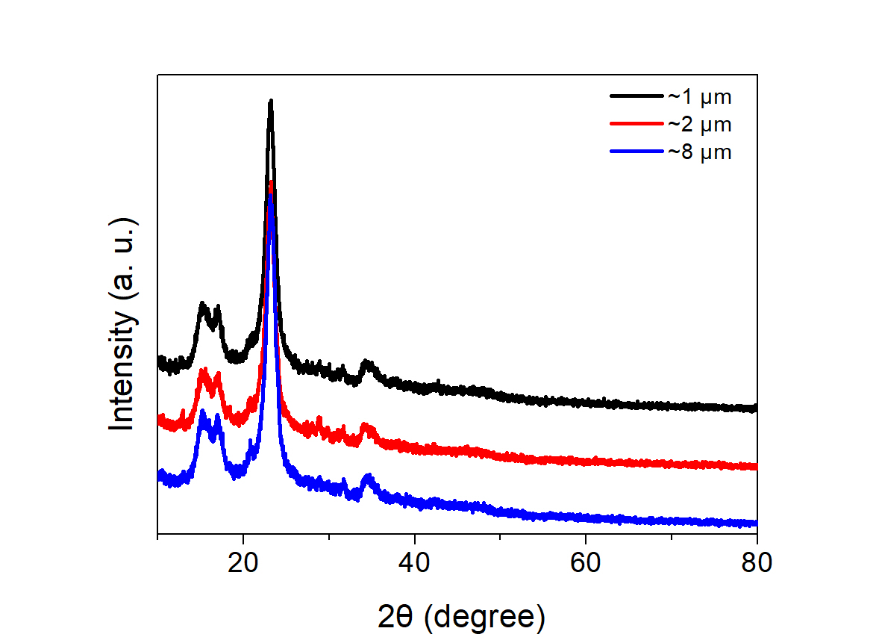
Figure S3. XRD patterns of the zeolites with different particle size.

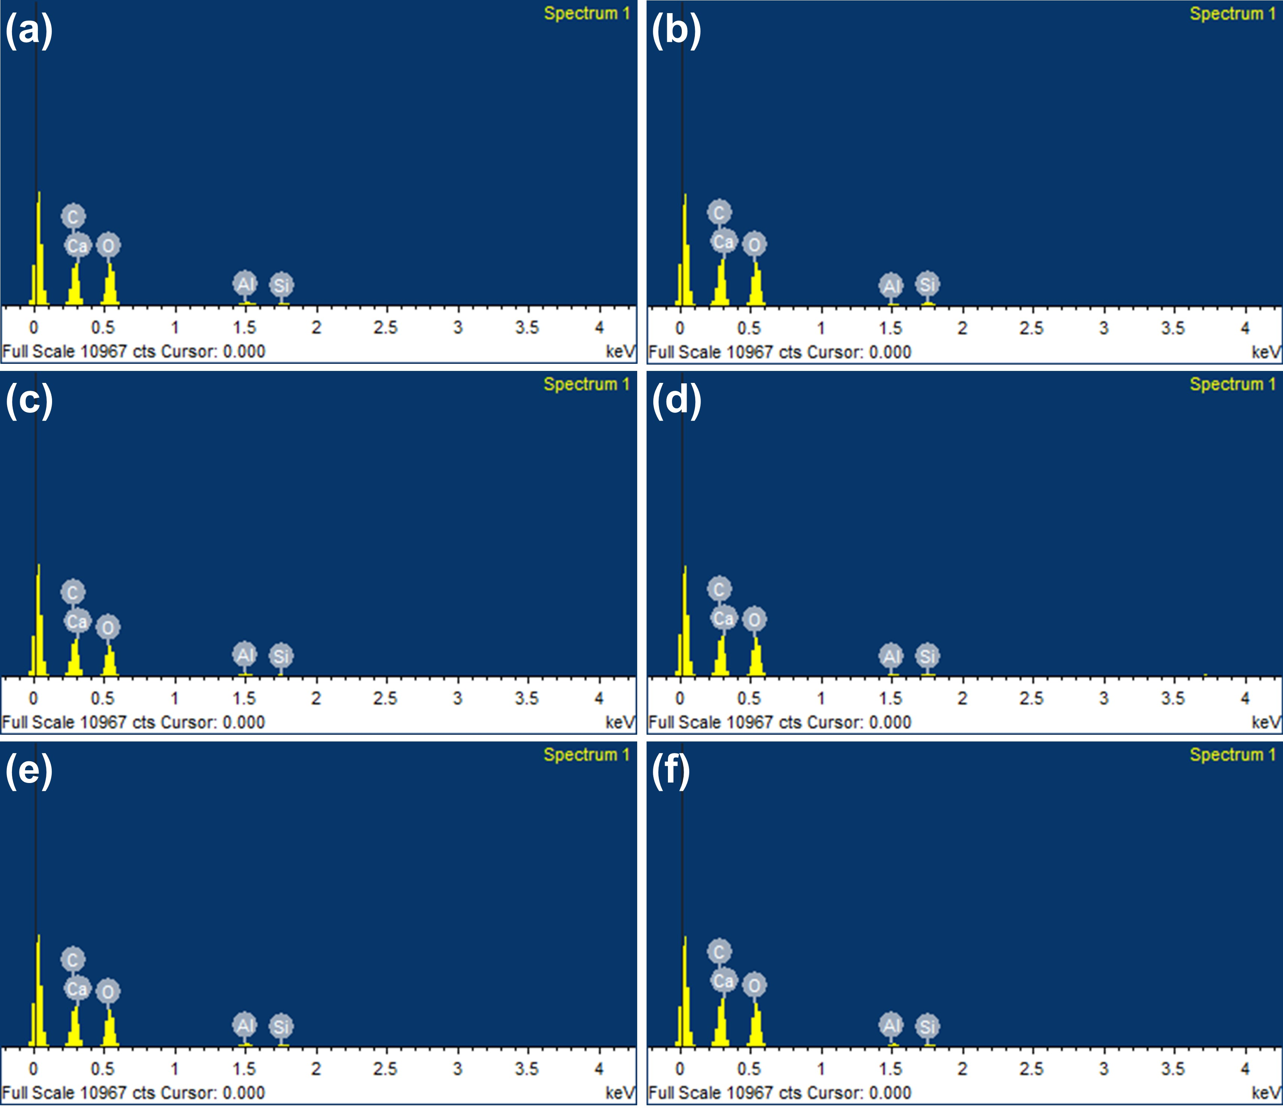

Figure S4. EDS results of the synthesized zeolites with different particle size. (a) ~1 μm, (b) ~2 μm, (c) ~4 μm, (d) ~8 μm.

Table S1. Atomic ratio of the synthesized zeolites with different particle size estimate by EDS results.
Particle size | Na element/% | Ca element/% | Al element/% | Si element/% | O element/%
~1 μm | 0.38 | 2.02 | 2.56 | 28.75 | 66.29
~2 μm | 0.45 | 1.90 | 2.78 | 24.65 | 70.22
~4 μm | 0.44 | 2.32 | 2.43 | 23.25 | 71.56
~8 μm | 0.43 | 2.81 | 2.32 | 28.99 | 65.45

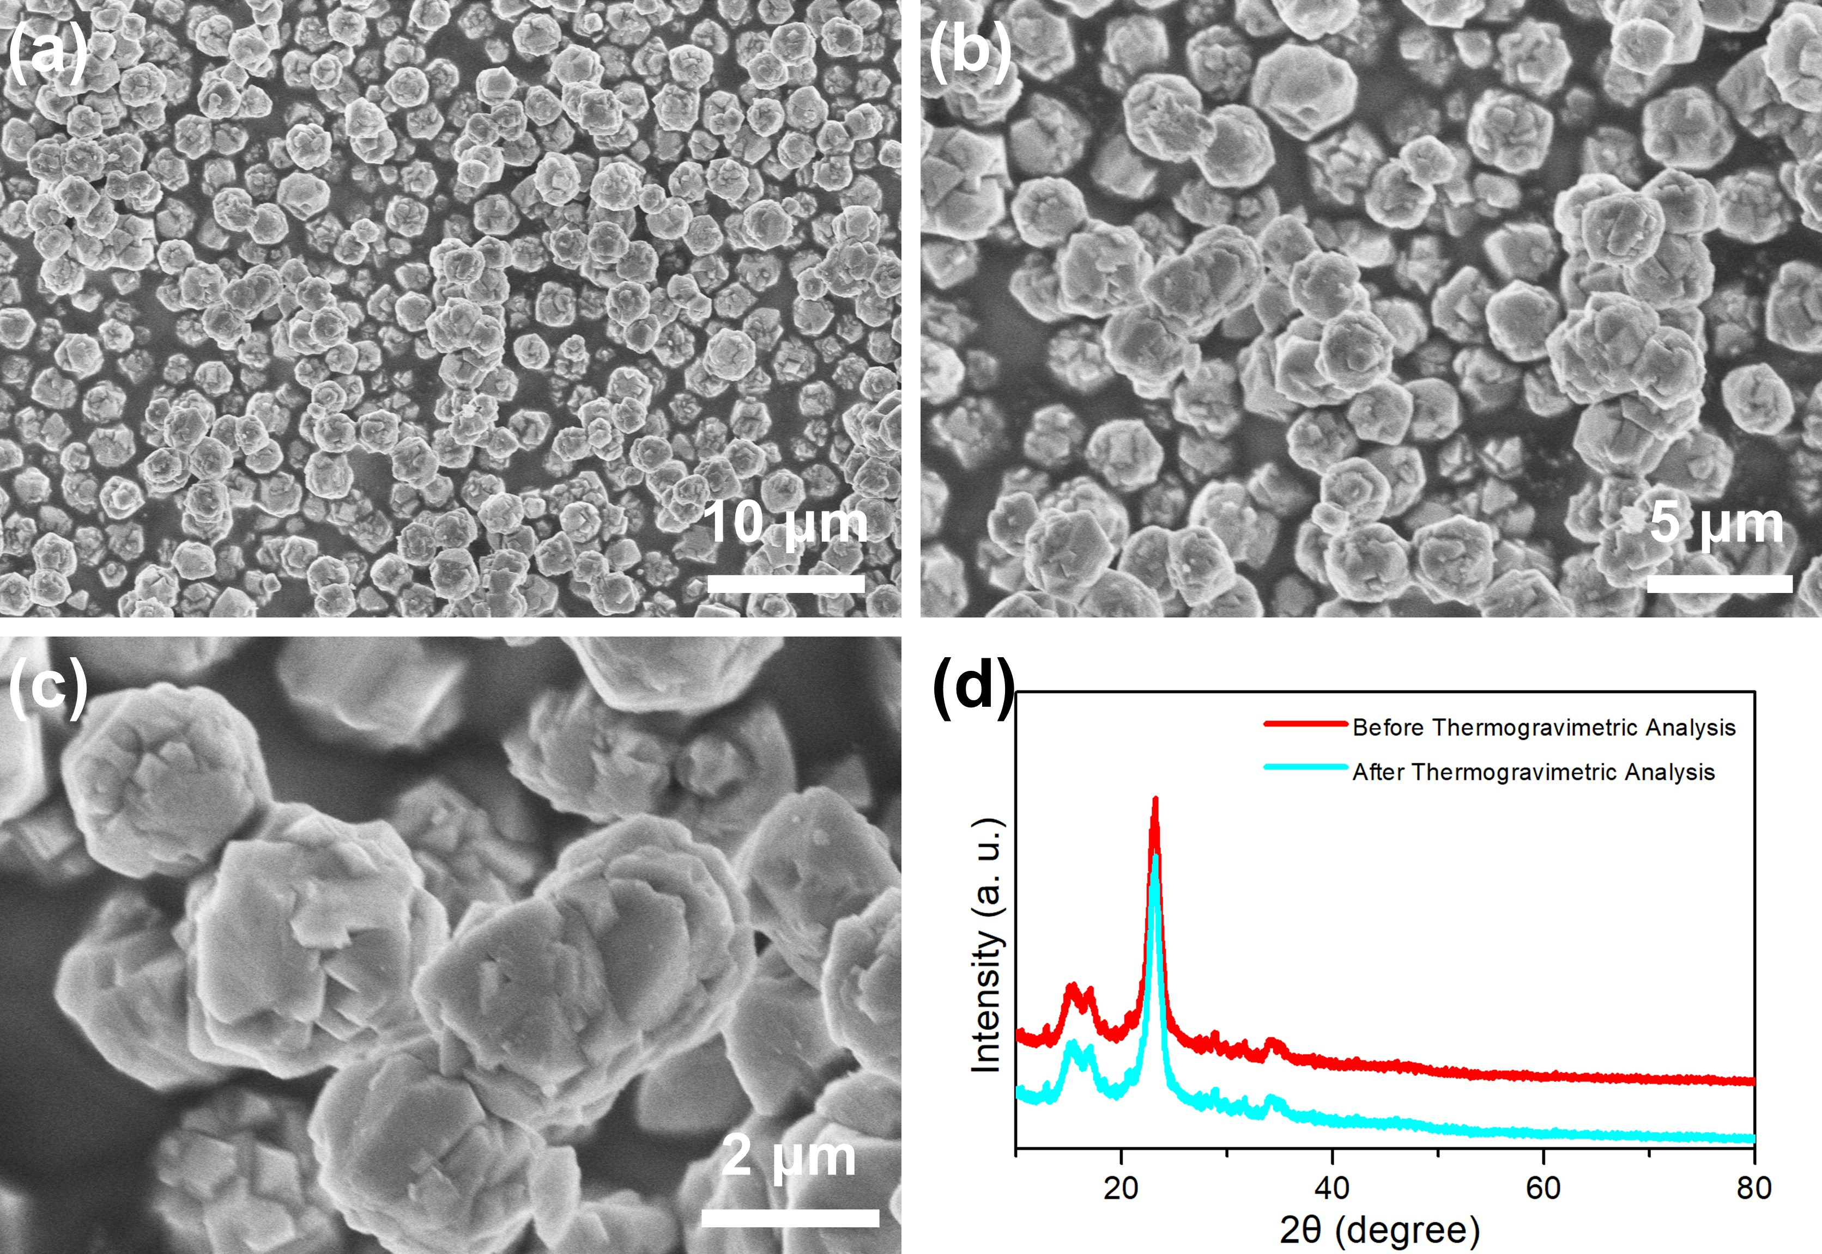
Figure S5. The morphology and structure of the samples subjected to thermogravimetric testing. (a-c) SEM images, (d) XRD patterns.

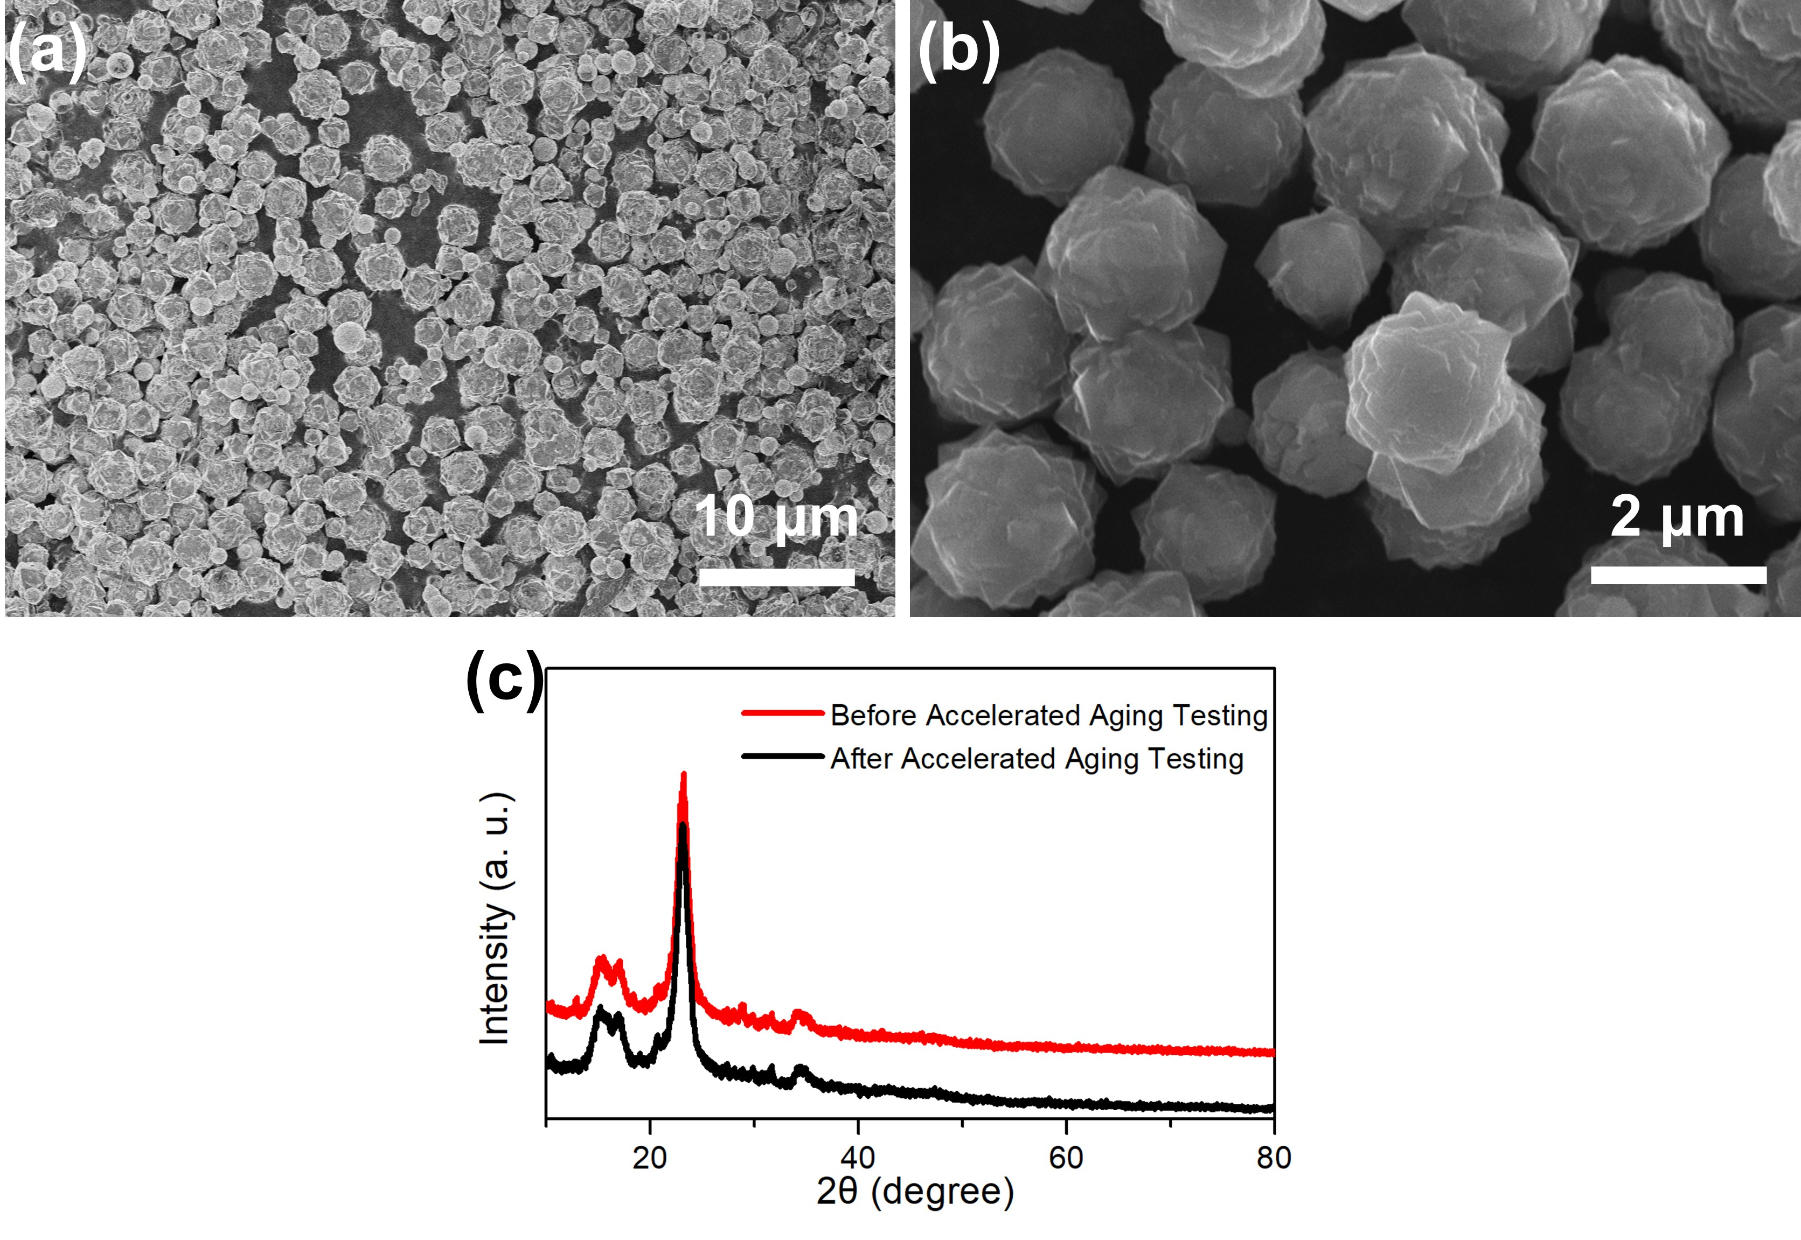
Figure S6. The morphology and structure of the samples after accelerated ageing test. (a, b) SEM images, (c) XRD patterns.

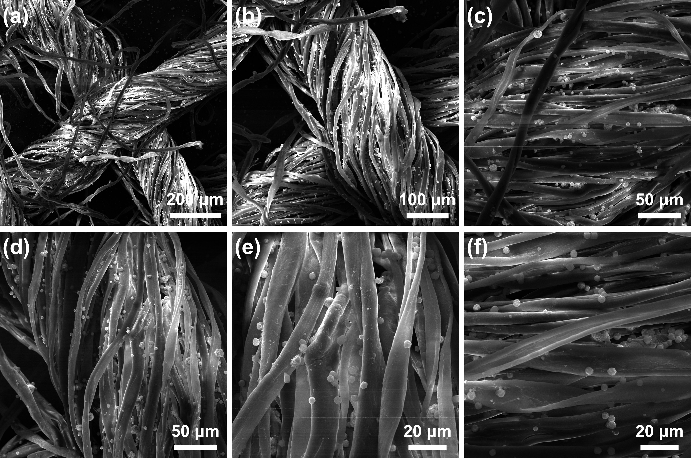
Figure S7. SEM images of cotton fibers loaded with zeolite particles.

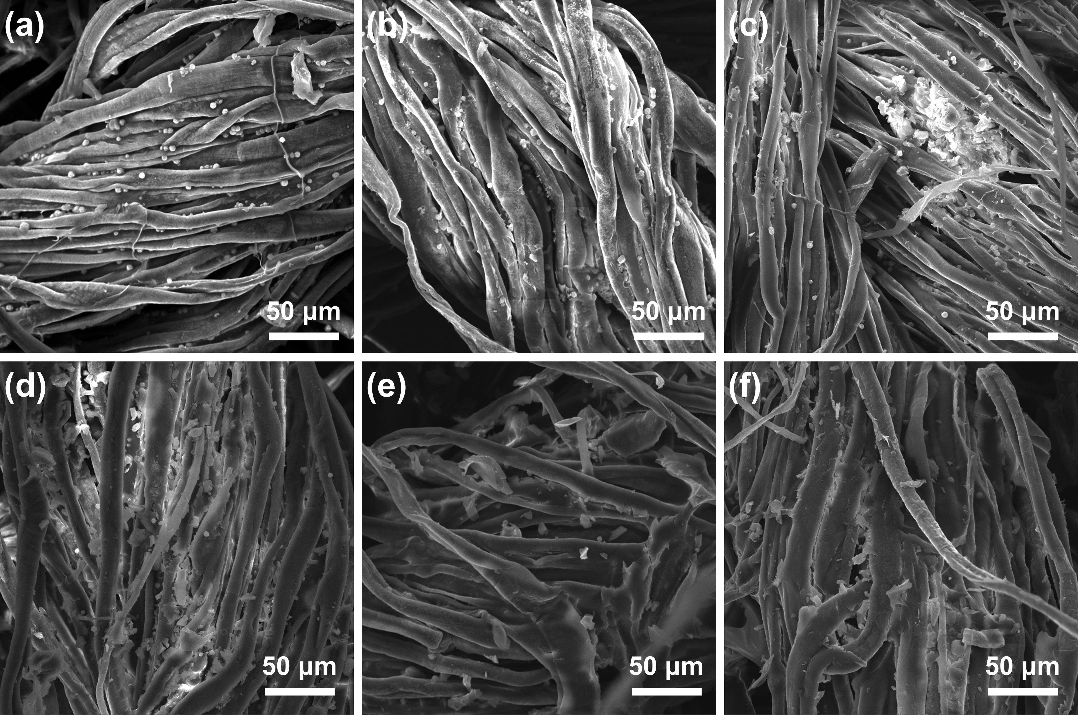
Figure S8. SEM images of cotton fibers loaded with zeolite particles immersion in serum for different times. (a) 5s, (b) 15s, (c) 60s, (d) 120s, (e) 250s, (f) 600s.

