Supplementary Information for
Ni-catalyzed acceptorless dehydrogenative aromatization of cyclohexanones enabled by concerted catalysis specific to supported nanoparticles

Takehiro Matsuyama,¹ Takafumi Yatabe,^{1,2}* Tomohiro Yabe,¹ and Kazuya Yamaguchi¹*

¹Department of Applied Chemistry, School of Engineering, The University of Tokyo, 7-3-1 Hongo, Bunkyo-ku, Tokyo 113-8656, Japan.
²Precursory Research for Embryonic Science and Technology (PRESTO), Japan Science and Technology Agency (JST), 4-1-8 Honcho, Kawaguchi, Saitama 332-0012, Japan.
*e-mail: kyama@appchem.t.u-tokyo.ac.jp, yatabe@appchem.t.u-tokyo.ac.jp

Table of Contents

Experimental Methods S2–S4

Spectral Data of Products S5–S16

Supplementary Figures S17–S26

Supplementary Tables S27–S31

Supplementary References S32–S33

NMR Spectra S34–S54

Experimental Methods
Instrumental and Reagents
Gas chromatography (GC) analyses were conducted on Shimadzu GC-2014 equipped with a flame ionization detector (FID) and an InertCap-5 (30 m) using Shimadzu C-R8A Chromatopac Data Processor for area calculations. GC mass spectrometry (GC-MS) spectra were performed by Shimadzu GCMS-QP2020 equipped with an InertCap-5 MS/NP capillary column (30 m) at an ionization voltage of 70 eV. For the gas phase analysis, GC analyses were conducted on Shimadzu GC-2010 Plus equipped with barrier discharge ionization detector (BID) and a SHINCARBON-ST. Liquid-state NMR spectra were recorded on JEOL JNM-ECA-500. ¹H, ²H, and ¹³C NMR spectra were measured at 500.16, 76.78, and 125.77 MHz, respectively. ¹H, ²H, and ¹³C NMR chemical shifts were referenced to tetramethylsilane (TMS) signal (δ = 0 ppm) or solvent signals. ICP-AES analyses were conducted by Shimadzu ICPS-8100. Scanning transmission electron microscopy (STEM) observations were performed on a JEOL JEM-ARM200F. XRD patterns were recorded on a Rigaku SmartLab diffractometer (Cu Kα, λ = 1.5405 Å, 45 kV, 20 mA). X-ray absorption spectroscopy (XAS) was carried out at the BL14B2 beamline of SPring-8 (Proposal No. 2022A1803). Ni K-edge X-ray absorption fine structure (XAFS) measurements were conducted in fluorescence mode using a Si (311) crystal monochromator. Each sample was formed into a pellet, doubly wrapped in an Al laminate pack, and heat-sealed in an Ar-filled glovebox. Ni foil and Ni(OH)₂ were used as standard samples. X-ray absorption near-edge structure (XANES) and extended X-ray absorption fine structure (EXAFS) data were analyzed using Athena and Artemis software (Demeter, ver. 0.9.025; Bruce Ravel). The data reduction procedure for EXAFS consisted briefly of the following steps: pre-edge subtraction, background determination, normalization, and spectra averaging. The edge position is defined to be the first inflection point on the leading absorption peak. The energy was calibrated using Ni foil. The background in the EXAFS region was approximated using a cubic spline routine and optimized according to the criteria described by Cook and Sayers.^{S1} Then, the spectra were normalized by the edge-step at 50 eV after the absorption edge. The k³-weighted EXAFS functions were Fourier transformed, filtered, and fitted in R-space in the range of 3–12 Å⁻¹. Fourier filtering was used to isolate the contributions of specific shells and to eliminate low frequency background and high frequency noise. Fourier filtering was done by choosing a window in the Fourier transform spectrum and calculating the inverse Fourier Transform of the selected R-range. To create the fitting model, a path model was created by FEFF6 based on Ni and Ni(OH)₂ data obtained from the literatures.^{S2,S3} In the fitting parameters, C.N., R, ΔE_{j0}, and σ represent coordination number, interatomic distance, energy correction value, and Debye-Waller factor, respectively. The XPS spectra were measured on an Ulvac-Phi PHI5000 VersaProbe at the Advanced Characterization Nanotechnology Platform of the University of Tokyo. The samples were embedded in In foil and brought in the introduction chamber without exposing them to air by using the transfer vessel. The binding energies were calibrated by using the C 1s signal at 284.8 eV. Diffuse reflectance infrared Fourier transform spectroscopy (DRIFT) was performed using FT/IR-6700spectrometer (JASCO). Ni/CeO₂-NaNaph was exposed to 16 Torr of CO and followed by evacuation for 1 min, and then, the DRIFT measurement of CO adsorbed on Ni/CeO₂-NaNaph was performed. The backgrounds measured in vacuo were subtracted. CeO₂ (BET: 50 m²g⁻¹, Cat. No. 544841-25G, Aldrich), Al₂O₃ (BET: 204 m²g⁻¹, Cat. No. JRC-ALO-9, Nippon Light Metal Company, Ltd.), TiO₂ (BET: 316 m²g⁻¹, Cat. No. ST-01, Ishihara Sangyo Kaisya), ZrO₂ (BET: 100.5 m²g⁻¹, Cat. No. JRC-ZRO-6, DAIICHI KIGENSO KAGAKU KOGYO CO., LTD.), and hydroxyapatite (HAP, BET: 11 m²g⁻¹, Cat. No. 011-14882, FUJIFILM Wako Pure Chemical) were acquired from commercial sources. Column chromatography on silica gel was performed by using Biotage Isolera. Solvents and substrates were obtained from Tokyo Chemical Industry, Aldrich, Kanto Chemical, or FUJIFILM Wako Pure Chemical (reagent grade), and purified prior to being used, if necessary.

Preparation of Supported Metal Catalysts
Pd/CeO₂-NaNaph was prepared based on our previous reports.^{S4,S5} First, CeO₂ (2.0 g) was added to a 60 mL aqueous solution of PdCl₂ (8.3 mM) and KCl (4 equivalents with respect to PdCl₂, 33.3 mM). After stirring vigorously for 15 min at room temperature, 1 M NaOH aq. was added dropwise to adjust the pH of the solution to 10.0. The resulting slurry was further stirred at room temperature overnight. The solid was then filtered off, washed with a large amount of water (3 L), and dried to afford Pd(OH)_{x}/CeO₂. Pd(OH)_{x}/CeO₂ was reduced via the same method as Ni/CeO₂-NaNaph to afford Pd/CeO₂-NaNaph as black powder. Other metal catalysts, such as Ni/CeO₂-0.3NaNaph, Fe/CeO₂-0.3NaNaph, Co/CeO₂-0.3NaNaph, Zn/CeO₂-0.3NaNaph, Mn/CeO₂-0.3NaNaph and Cu/CeO₂-0.3NaNaph were prepared based on our previous work^{S4} using NiCl₂·6H₂O, FeCl₃·6H₂O, CoCl₂·6H₂O, ZnCl₂, MnCl₂·4H₂O and CuCl₂·2H₂O as a metal source, respectively.

A Typical Procedure for Ni-complexes-catalyzed Dehydrogenative Aromatization
In an Ar-filled glovebox, Ni(cod)₂ (3.3 mol%), ligands (6.7 mol%), cyclohexanones (0.3 mmol), n-hexadecane (0.1 mmol, internal standard), N,N-dimethylacetamide (2.0 mL), and a Teflon-coated magnetic stir bar were placed in a Pyrex glass reactor (volume: ~20 mL). The mixture was stirred at 50 °C for 5 min followed by being stirred at 160 °C for 24 h, then the mixture was cooled down to room temperature. Conversions and product yields were determined by GC analysis using n-hexadecane as an internal standard.

Leaching Test
In an Ar-filled glovebox, Ni/CeO₂-NaNaoh (10 mol%, 80 mg), 3,5-dimethylcyclohexanone (0.2 mmol), n-hexadecane (0.1 mmol, internal standard), N,N-dimethylacetamide (2.0 mL), and a Teflon-coated magnetic stir bar were placed in a Pyrex glass reactor (volume: ~20 mL). The reaction was carried out at 170 °C in an Ar-filled glovebox. 90 minutes after starting the reaction, half of the reaction solution was filtered by hot filtration using a disposable syringe with a PTFE membrane filter into another test tube that had been previously heated to 170 °C with a magnetic stir bar. Then, the reactions were continued for additional 22.5 h.
To determine the amount of the Ni species leached into the solution during the reaction, the following experiment was carried out. The reaction was prepared as described above, and the solution 90 min after the start of the reaction was filtered by hot filtration using a disposable syringe with a PTFE membrane filter. The DMA solvent was removed from 1 mL of the reaction solution using a rotary evaporator before aqua regia (1 mL) was added, and the amount of Ni species leached into the reaction solution was measured by ICP-AES. The measurement wavelength was 221.647 nm.

Synthesis of Cyclohexanone-α,γ-d₆
For the synthesis of cyclohexanone-α,γ-d₆, we referred to an previous report with some modifications.^{S6} Cyclohexanone-d₁₀ (1.9 mmol), K₂CO₃ (3.5 eq.), deionized water (1.5 mL), and a Teflon-coated magnetic stir bar were placed in a Pyrex glass reactor (volume: ~20 mL). The mixture was stirred at 110 °C under an air atmosphere for 18 h. After the reaction, reaction mixture was extracted with diethyl ether (5 mL), and the organic layer was washed with deionized water (5 mL×3). Then, the organic layer was concentrated using rotary evaporator to afford cyclohexanone-β,γ-d₆ in ~20% yield (deuterium rate of the α-position was 4%).

Identification of the Byproducts as 2-Methylated Phenols
In order to determine the methylated position and the mechanism of the methylated phenol formation, we conducted several experiments. First, 2a′ was hardly observed when using 2a as the starting material (Supplementary Fig. 19), suggesting 2a was not the intermediate for 2a′. The DMA solvent was likely the methyl source because 2a′ was not observed in other investigated solvents (Supplementary Table 4). As for the methylated position, the GC retention time of 2a′ was different from that of 2f, and after dehydrogenative aromatization of 1h, we successfully isolated 2-methylated 4-tert-butyl phenol in addition to 2h (Supplementary Fig. 20). On the basis of these results, the proposed mechanism of 2-methylated phenol formation is shown in Supplementary Fig. 21. Briefly, aldol condensation occurs between cyclohexanones and formaldehyde, which was produced via the decomposition of DMA in the presence of water, followed by isomerization to cyclohexenones and dehydrogenative aromatization to 2-methylated phenols.^{S7}

Spectral Data of Products
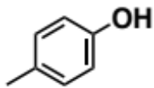
p-cresol (CAS No. 106-44-5, 2a) 74% (starting from 1a), 63% (starting from 3a) GC yield, 83% isolated yield (starting from 1a). GC conditions and analysis: InertCap5 capillary column, 0.25 mm × 30 m, GL Science Inc.; carrier gas (N₂) flow rate, 1.7 mL·min^{–1}; initial column temp., 80 °C final column temp., 280 °C, progress rate, 80 °C for 5 min, 10 °C·min^{–1} (20 min), 280 °C for 5 min, injection temp., 250 °C detection temp., 280 °C; retention time, 7.4 min; relative sensitivity for quantification (vs n-hexadecane, internal standard), 0.352 (calculated by calibration curve). ¹H NMR (500 MHz, CDCl₃): δ 7.01–7.05 (m, 2H), 6.71–6.75 (m, 2H), 4,75 (brs, 1H), 2.27 (s, 3H); ¹³C NMR (125 MHz, CDCl₃): δ 153.2, 130.1, 130.0, 115.1, 20.5. MS (EI): m/z (%): 109 (7), 108 (84) [M⁺], 107 (100), 90 (7), 80 (9), 79 (21), 78 (6), 77 (29), 63 (5), 53 (8), 52 (5), 51 (9), 50 (6), 39 (11).^{S8}

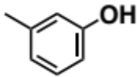
m-cresol (CAS No. 108-39-4, 2b) 54% (starting from 1b), 64% (starting from 1p), 68% (starting from 3b) GC yield, 54% isolated yield (starting from 1b). GC conditions and analysis: InertCap5 capillary column, 0.25 mm × 30 m, GL Science Inc.; carrier gas (N₂) flow rate, 1.7 mL·min^{–1}; initial column temp., 80 °C final column temp., 280 °C, progress rate, 80 °C for 5 min, 10 °C·min^{–1} (20 min), 280 °C for 5 min, injection temp., 250 °C detection temp., 280 °C; retention time, 7.3 min; relative sensitivity for quantification (vs n-hexadecane, internal standard), 0.352 (estimated to be equal to that of 2a). ¹H NMR (500 MHz, CDCl₃): δ 7.10–7.14 (m, 1H), 6.63–6.67 (m, 1H), 6.61–6.67 (m, 2H), 4.72 (brs, 1H), 2.31 (s, 3H); ¹³C NMR (125 MHz, CDCl₃): δ 155.4, 139.8, 129.4, 121.6, 116.0, 112.3, 21.3. MS (EI): m/z (%): 109 (8), 108 (100) [M⁺], 107 (93), 91 (6), 90 (13), 89 (5), 80 (15), 79 (36), 78 (7), 77 (32), 63 (6), 54 (5), 53 (10), 52 (6), 51 (10), 50 (5), 39 (16).^{S8}

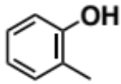
o-cresol (CAS No. 95-48-7, 2c) 60% (starting from 1c), 56% (starting from 3c) GC yield. GC conditions and analysis: InertCap5 capillary column, 0.25 mm × 30 m, GL Science Inc.; carrier gas (N₂) flow rate, 1.7 mL·min^{–1}; initial column temp., 80 °C final column temp., 280 °C, progress rate, 80 °C for 5 min, 10 °C·min^{–1} (20 min), 280 °C for 5 min, injection temp., 250 °C detection temp., 280 °C; retention time, 7.1 min; relative sensitivity for quantification (vs n-hexadecane, internal standard), 0.352 (estimated to be equal to that of 2a). ¹H NMR (500 MHz, CDCl₃): δ 7.06–7.14 (m, 2H), 6.82–6.87 (m, 1H), 6.75–6.79 (m, 1H), 4.82 (s, 1H), 2.25 (s, 3H); ¹³C NMR (125 MHz, CDCl₃): δ 153.8, 131.0, 127.1, 123.7, 120.7, 114.9, 15.7. MS (EI): m/z (%): 109 (7), 108 (100) [M⁺], 107 (83), 91 (7), 90 (24), 89 (14), 80 (19), 79 (40), 78 (8), 77 (37), 63 (7), 54 (6), 53 (11), 52 (7), 51 (14), 50 (8), 39 (16).^{S8}

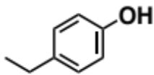
4-ethylphenol (CAS No. 123-07-4, 2d) 77% (starting from 1d), 71% (starting from 3d) GC yield, 36% isolated yield (starting from 1d). GC conditions and analysis: InertCap5 capillary column, 0.25 mm × 30 m, GL Science Inc.; carrier gas (N₂) flow rate, 1.7 mL·min^{–1}; initial column temp., 80 °C final column temp., 280 °C, progress rate, 80 °C for 5 min, 10 °C·min^{–1} (20 min), 280 °C for 5 min, injection temp., 250 °C detection temp., 280 °C; retention time, 9.4 min; relative sensitivity for quantification (vs n-hexadecane, internal standard), 0.415 (estimated by the effective carbon number concept). ¹H NMR (500 MHz, CDCl₃): δ 7.05–7.08 (m, 2H), 6.74–6.77 (m, 2H), 4.61 (brs, 1H), 2.58 (q, J = 7.0 Hz, 2H), 1.20 (t, J = 7.5 Hz, 3H); ¹³C NMR (125 MHz, CDCl₃): δ 153.4, 136.6, 128.9, 115.1, 28.0, 15.9. MS (EI): m/z (%): 122 (36) [M⁺], 108 (8), 107 (100), 91 (6), 77 (19), 51 (5), 39 (7).^{S8}

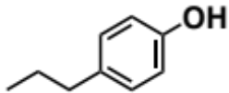
4-propylphenol (CAS No. 645-56-7, 2e) 70% GC yield, 54% isolated yield. GC conditions and analysis: InertCap5 capillary column, 0.25 mm × 30 m, GL Science Inc.; carrier gas (N₂) flow rate, 1.7 mL·min^{–1}; initial column temp., 80 °C final column temp., 280 °C, progress rate, 80 °C for 5 min, 10 °C·min^{–1} (20 min), 280 °C for 5 min, injection temp., 250 °C detection temp., 280 °C; retention time, 11.1 min; relative sensitivity for quantification (vs n-hexadecane, internal standard), 0.477 (estimated by the effective carbon number concept). ¹H NMR (500 MHz, CDCl₃): δ 7.01–7.06 (m, 2H), 6.72–6.77 (m, 2H), 4.85 (brs, 1H), 2.51 (t, J = 7.5 Hz, 2H), 1.57–1.63 (m, 2H), 0.92 (t, J = 7.5 Hz, 3H); ¹³C NMR (125 MHz, CDCl₃): δ 153.4, 135.0, 129.5, 115.0, 37.1, 24.8, 13.8. MS (EI): m/z (%): 136 (24) [M⁺], 108 (8), 107 (100), 79 (4), 78 (3), 77 (14), 65 (3), 53 (3), 51 (3), 39 (4).^{S9}

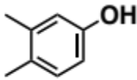
3,4-dimethylphenol (CAS No. 645-56-7, 2f) 70% GC yield, 54% isolated yield. GC conditions and analysis: InertCap5 capillary column, 0.25 mm × 30 m, GL Science Inc.; carrier gas (N₂) flow rate, 1.7 mL·min^{–1}; initial column temp., 80 °C final column temp., 280 °C, progress rate, 80 °C for 5 min, 10 °C·min^{–1} (20 min), 280 °C for 5 min, injection temp., 250 °C detection temp., 280 °C; retention time, 9.9 min; relative sensitivity for quantification (vs n-hexadecane, internal standard), 0.415 (estimated by the effective carbon number concept). ¹H NMR (500 MHz, CDCl₃): δ 6.95–7.00 (m, 1H), 6.62–6.66 (m, 1H), 6.55–6.60 (m, 1H), 4.63 (brs, 1H), 2.21 (s, 3H), 2.18 (s, 3H); ¹³C NMR (125 MHz, CDCl₃): δ 153.5, 138.0, 130.5, 128.6, 116.6, 112.3, 19.9, 18.8. MS (EI): m/z (%): 123 (6), 122 (69) [M⁺], 121 (35), 108 (8), 107 (100), 91 (15), 79 (10), 78 (5), 77 (23), 65 (6), 53 (6), 51 (8), 39 (9).^{S8}

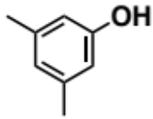
3,5-dimethylphenol (CAS No. 108-68-9, 2g) 82% (starting from 1g), 95 % (starting from 3g) GC yield, 75% isolated yield (starting from 1g). GC conditions and analysis: InertCap5 capillary column, 0.25 mm × 30 m, GL Science Inc.; carrier gas (N₂) flow rate, 1.7 mL·min^{–1}; initial column temp., 80 °C final column temp., 280 °C, progress rate, 80 °C for 5 min, 10 °C·min^{–1} (20 min), 280 °C for 5 min, injection temp., 250 °C detection temp., 280 °C; retention time, 9.5 min; relative sensitivity for quantification (vs n-hexadecane, internal standard), 0.415 (estimated by the effective carbon number concept). ¹H NMR (500 MHz, CDCl₃): δ 6.56–6.58 (m, 1H), 6.45–6.47 (m, 2H), 5.20 (brs, 1H), 2.25 (s, 6H); ¹³C NMR (125 MHz, CDCl₃): δ 155.4, 139.5, 122.5, 113.1, 21.2. MS (EI): m/z (%): 123 (9), 122 (98) [M⁺], 121 (35), 108 (8), 107 (100), 91 (17), 79 (18), 78 (7), 77 (28), 65 (6), 53 (7), 51 (9), 39 (11).^{S10}

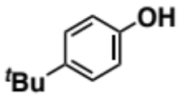
4-tert-butylphenol (CAS No. 98-54-4, 2h) 63% (starting from 1h), 64% (starting from 3h) GC yield, 40% isolated yield (starting from 1h). GC conditions and analysis: InertCap5 capillary column, 0.25 mm × 30 m, GL Science Inc.; carrier gas (N₂) flow rate, 1.7 mL·min^{–1}; initial column temp., 80 °C final column temp., 280 °C, progress rate, 80 °C for 5 min, 10 °C·min^{–1} (20 min), 280 °C for 5 min, injection temp., 250 °C detection temp., 280 °C; retention time, 11.7 min; relative sensitivity for quantification (vs n-hexadecane, internal standard), 0.540 (estimated by the effective carbon number concept). ¹H NMR (500 MHz, CDCl₃): δ 7.24–7.27 (m, 2H), 6.75–6.79 (m, 2H), 4.76 (brs, 1H), 1.29 (s, 9H); ¹³C NMR (125 MHz, CDCl₃): δ 153.1, 143.5, 126.4, 114.7, 34.1, 31.5. MS (EI): m/z (%): 150 (20) [M⁺], 136 (10), 135 (100), 119 (5), 107 (58), 95 (16), 91 (16), 79 (6), 77 (19), 65 (13), 63 (6), 53 (5), 51 (7), 41 (25), 39 (25).^{S8}

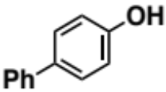
4-hydroxybiphenyl (CAS No. 92-69-3, 2i) 62% GC yield, 64% isolated yield. GC conditions and analysis: InertCap5 capillary column, 0.25 mm × 30 m, GL Science Inc.; carrier gas (N₂) flow rate, 1.7 mL·min^{–1}; initial column temp., 80 °C final column temp., 280 °C, progress rate, 80 °C for 5 min, 10 °C·min^{–1} (20 min), 280 °C for 5 min, injection temp., 250 °C detection temp., 280 °C; retention time, 17.2 min; relative sensitivity for quantification (vs n-hexadecane, internal standard), 0.665 (estimated by the effective carbon number concept). ¹H NMR (500 MHz, CDCl₃): δ 7.52–7.55 (m, 2H), 7.46–7.49 (m, 2H), 7.39–7.43 (m, 2H), 7.28–7.32 (m, 1H), 6.87–6.93 (m, 2H), 5.00 (brs, 1H); ¹³C NMR (125 MHz, CDCl₃): δ 155.1, 140.8, 134.0, 128.7, 128.4, 126.7, 115.7. MS (EI): m/z (%): 171 (14), 170 (100) [M⁺], 169 (9), 141 (27), 139 (8), 115 (31), 89 (7), 85 (6), 77 (5), 76 (5), 63 (9), 51 (7), 50 (5), 39 (12).^{S8}

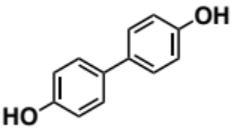
4,4′-dihydroxybiphenyl (CAS No. 92-88-6, 2j) 36% GC yield. GC conditions and analysis: InertCap5 capillary column, 0.25 mm × 30 m, GL Science Inc.; carrier gas (N₂) flow rate, 1.7 mL·min^{–1}; initial column temp., 80 °C final column temp., 280 °C, progress rate, 80 °C for 5 min, 10 °C·min^{–1} (20 min), 280 °C for 5 min, injection temp., 250 °C detection temp., 280 °C; retention time, 20.7 min; relative sensitivity for quantification (vs n-hexadecane, internal standard), 0.579 (estimated by the effective carbon number concept). MS (EI): m/z (%): 187 (13), 186 (100) [M⁺], 185 (5), 157 (15), 131 (16), 129 (9), 128 (16), 127 (6), 118 (7), 115 (10), 102 (8), 101 (5), 93 (13), 86 (5), 77 (11), 76 (6), 74 (5), 65 (8), 64 (6), 63 (8), 50 (6), 39 (17).^{S11}

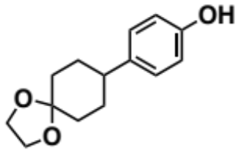
4-(1,4-dioxaspiro[4.5]dec-8-yl)phenol (CAS No. 142256-87-9, 2k) 23% GC yield. GC conditions and analysis: InertCap5 capillary column, 0.25 mm × 30 m, GL Science Inc.; carrier gas (N₂) flow rate, 1.7 mL·min^{–1}; initial column temp., 80 °C final column temp., 280 °C, progress rate, 80 °C for 5 min, 10 °C·min^{–1} (20 min), 280 °C for 5 min, injection temp., 250 °C detection temp., 280 °C; retention time, 20.9 min; relative sensitivity for quantification (vs n-hexadecane, internal standard), 0.665 (estimated by the effective carbon number concept). MS (EI): m/z (%): 234 (4) [M⁺], 133 (5), 120 (25), 119 (6), 107 (7), 100 (7), 99 (100), 91 (8), 87 (10), 86 (13), 77 (6), 55 (10), 43 (7), 42 (11), 39 (6).^{S8}

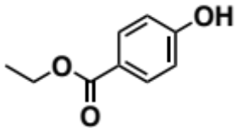
ethylparaben (CAS No. 120-47-8, 2l) 24% GC yield. GC conditions and analysis: InertCap5 capillary column, 0.25 mm × 30 m, GL Science Inc.; carrier gas (N₂) flow rate, 1.7 mL·min^{–1}; initial column temp., 80 °C final column temp., 280 °C, progress rate, 80 °C for 5 min, 10 °C·min^{–1} (20 min), 280 °C for 5 min, injection temp., 250 °C detection temp., 280 °C; retention time, 14.9 min; relative sensitivity for quantification (vs n-hexadecane, internal standard), 0.352 (estimated by the effective carbon number concept). MS (EI): m/z (%): 166 (17) [M⁺], 138 (17), 122 (12), 121 (100), 93 (10), 65 (26), 64 (5), 39 (26), 30 (6).^{S8}

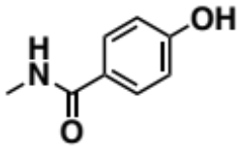
4-hydroxy-N-methylbenzamide (CAS No. 27642-27-9, 2m) 35% GC yield. GC conditions and analysis: InertCap5 capillary column, 0.25 mm × 30 m, GL Science Inc.; carrier gas (N₂) flow rate, 1.7 mL·min^{–1}; initial column temp., 80 °C final column temp., 280 °C, progress rate, 80 °C for 5 min, 10 °C·min^{–1} (20 min), 280 °C for 5 min, injection temp., 250 °C detection temp., 280 °C; retention time, 17.3 min; relative sensitivity for quantification (vs n-hexadecane, internal standard), 0.305 (estimated by the effective carbon number concept). MS (EI): m/z (%): 151 (27) [M⁺], 110 (7), 109 (100), 108 (9), 81 (20), 80 (36), 53 (15), 52 (13), 51 (5), 43 (41), 42 (10), 39 (7).^{S8}

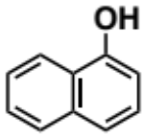
1-naphthol (CAS No. 90-15-3, 2n) 72% (starting from 1n), 68% (starting from 3n) GC yield, 67% isolated yield (starting from 1n). GC conditions and analysis: InertCap5 capillary column, 0.25 mm × 30 m, GL Science Inc.; carrier gas (N₂) flow rate, 1.7 mL·min^{–1}; initial column temp., 80 °C final column temp., 280 °C, progress rate, 80 °C for 5 min, 10 °C·min^{–1} (20 min), 280 °C for 5 min, injection temp., 250 °C detection temp., 280 °C; retention time, 14.8 min; relative sensitivity for quantification (vs n-hexadecane, internal standard), 0.540 (estimated by the effective carbon number concept). ¹H NMR (500 MHz, CDCl₃): δ 8.15–8.20 (m, 1H), 7.78–7.84 (m, 1H), 7.46–7.52 (m, 2H), 7.42–7.46 (m, 1H), 7.28–7.33 (m, 1H), 6.79–6.83 (m, 1H), 5.31 (s, 1H); ¹³C NMR (125 MHz, CDCl₃): δ 151.3, 134.7, 127.7, 126.4, 125.8, 125.3, 124.3, 121.5, 120.7, 108.6. MS (EI): m/z (%): 145 (11), 144 (100) [M⁺], 117 (6), 116 (62), 115 (99), 89 (16), 72 (9), 65 (5), 63 (12), 62 (5), 58 (12), 57 (6), 39 (6).^{S12}

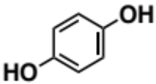
hydroquinone (CAS No. 123-31-9, 2o) 73% (starting from 1o), 63% (starting from 3o) GC yield. GC conditions and analysis: InertCap5 capillary column, 0.25 mm × 30 m, GL Science Inc.; carrier gas (N₂) flow rate, 1.7 mL·min^{–1}; initial column temp., 80 °C final column temp., 280 °C, progress rate, 80 °C for 5 min, 10 °C·min^{–1} (20 min), 280 °C for 5 min, injection temp., 250 °C detection temp., 280 °C; retention time, 11.3 min; relative sensitivity for quantification (vs n-hexadecane, internal standard), 0.204 (estimated by the effective carbon number concept). MS (EI): m/z (%): 111 (6), 110 (100) [M⁺], 109 (6), 82 (21), 81 (41), 63 (8), 62 (5), 55 (19), 54 (18), 53 (32), 52 (8), 51 (9), 50 (6), 39 (28), 38 (7), 37 (5).^{S13}

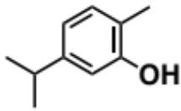
carvacrol (CAS No. 499-75-2, 2q) 93% GC yield. GC conditions and analysis: InertCap5 capillary column, 0.25 mm × 30 m, GL Science Inc.; carrier gas (N₂) flow rate, 1.7 mL·min^{–1}; initial column temp., 80 °C final column temp., 280 °C, progress rate, 80 °C for 5 min, 10 °C·min^{–1} (20 min), 280 °C for 5 min, injection temp., 250 °C detection temp., 280 °C; retention time, 11.8 min; relative sensitivity for quantification (vs n-hexadecane, internal standard), 0.540 (estimated by the effective carbon number concept). MS (EI): m/z (%): 150 (37) [M⁺], 136 (10), 135 (100), 117 (7), 115 (11), 107 (18), 105 (7), 91 (21), 79 (8), 77 (10), 39 (5).^{S10}

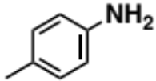
p-toluidine (CAS No. 106-49-0, 5a) 58% GC yield, 40% isolated yield. GC conditions and analysis: InertCap5 capillary column, 0.25 mm × 30 m, GL Science Inc.; carrier gas (N₂) flow rate, 1.7 mL·min^{–1}; initial column temp., 80 °C final column temp., 280 °C, progress rate, 80 °C for 5 min, 10 °C·min^{–1} (20 min), 280 °C for 5 min, injection temp., 250 °C detection temp., 280 °C; retention time, 7.5 min; relative sensitivity for quantification (vs n-hexadecane, internal standard), 0.406 (estimated by the effective carbon number concept). ¹H NMR (500 MHz, CDCl₃): δ 6.94–6.98 (m, 2H), 6.59–6.63 (m, 2H), 3.27 (brs, 2H), 2.24 (s, 3H); ¹³C NMR (125 MHz, CDCl₃): δ 143.7, 129.8, 127.9, 115.3, 20.5. MS (EI): m/z (%): 108 (5), 107 (68) [M⁺], 106 (100), 80 (6), 79 (10), 78 (6), 77 (16), 53 (8), 52 (9), 51 (9), 50 (5), 39 (6).^{S14}

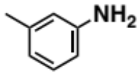
m-toluidine (CAS No. 108-44-1, 5b) 77% GC yield. GC conditions and analysis: InertCap5 capillary column, 0.25 mm × 30 m, GL Science Inc.; carrier gas (N₂) flow rate, 1.7 mL·min^{–1}; initial column temp., 80 °C final column temp., 280 °C, progress rate, 80 °C for 5 min, 10 °C·min^{–1} (20 min), 280 °C for 5 min, injection temp., 250 °C detection temp., 280 °C; retention time, 7.6 min; relative sensitivity for quantification (vs n-hexadecane, internal standard), 0.406 (estimated by the effective carbon number concept). ¹H NMR (500 MHz, CDCl₃): δ 7.02–7.06 (m, 1H), 6.57–6.60 (m, 1H), 6.48–6.53 (m, 2H), 3.39 (brs, 2H), 2.26 (s, 3H); ¹³C NMR (125 MHz, CDCl₃): δ 146.2, 139.1, 129.2, 119.5, 116.0, 112.3, 21.4. MS (EI): m/z (%): 108 (7), 107 (97) [M⁺], 106 (100), 80 (6), 79 (21), 78 (6), 77 (20), 65 (5), 53 (8), 52 (6), 51 (6), 39 (10).^{S14}

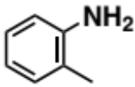
o-toluidine (CAS No. 95-53-4, 5c) 17% GC yield. GC conditions and analysis: InertCap5 capillary column, 0.25 mm × 30 m, GL Science Inc.; carrier gas (N₂) flow rate, 1.7 mL·min^{–1}; initial column temp., 80 °C final column temp., 280 °C, progress rate, 80 °C for 5 min, 10 °C·min^{–1} (20 min), 280 °C for 5 min, injection temp., 250 °C detection temp., 280 °C; retention time, 7.5 min; relative sensitivity for quantification (vs n-hexadecane, internal standard), 0.406 (estimated by the effective carbon number concept). MS (EI): m/z (%): 108 (6), 107 (78) [M⁺], 106 (100), 89 (7), 80 (5), 79 (18), 78 (7), 77 (20), 53 (8), 52 (7), 51 (7), 39 (8).^{S14}

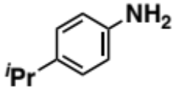
4-isopropylaniline (CAS No. 99-88-7, 5c) 72% GC yield. GC conditions and analysis: InertCap5 capillary column, 0.25 mm × 30 m, GL Science Inc.; carrier gas (N₂) flow rate, 1.7 mL·min^{–1}; initial column temp., 80 °C final column temp., 280 °C, progress rate, 80 °C for 5 min, 10 °C·min^{–1} (20 min), 280 °C for 5 min, injection temp., 250 °C detection temp., 280 °C; retention time, 10.6 min; relative sensitivity for quantification (vs n-hexadecane, internal standard), 0.531 (estimated by the effective carbon number concept). MS (EI): m/z (%): 135 (27) [M⁺], 121 (9), 120 (100), 119 (5), 118 (8), 103 (9), 94 (5), 93 (9), 91 (9), 77 (9), 65 (6).^{S10}

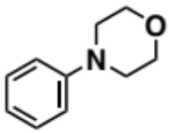
4-phenylmorpholine (CAS No. 92-53-5, 7a) 87% GC yield, 84% isolated yield. GC conditions and analysis: InertCap5 capillary column, 0.25 mm × 30 m, GL Science Inc.; carrier gas (N₂) flow rate, 1.7 mL·min^{–1}; initial column temp., 80 °C final column temp., 280 °C, progress rate, 80 °C for 5 min, 10 °C·min^{–1} (20 min), 280 °C for 5 min, injection temp., 250 °C detection temp., 280 °C; retention time, 13.8 min; relative sensitivity for quantification (vs n-hexadecane, internal standard), 0.574 (estimated by the effective carbon number concept). ¹H NMR (500 MHz, CDCl₃): δ 7.25–7.30 (m, 2H), 6.86–6.93 (m, 3H), 3.85–3.87 (m, 4H), 3.14–3.16 (m, 4H); ¹³C NMR (125 MHz, CDCl₃): δ 151.3, 129.2, 120.1, 115.7, 66.9, 49.4. MS (EI): m/z (%): 164 (8), 163 (66) [M⁺], 162 (6), 132 (6), 106 (10), 105 (100), 104 (40), 91 (5), 77 (28), 51 (11).^{S15}

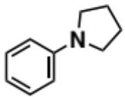
1-phenylpyrrolidine (CAS No. 4096-21-3, 7b) 82% GC yield, 54% isolated yield. GC conditions and analysis: InertCap5 capillary column, 0.25 mm × 30 m, GL Science Inc.; carrier gas (N₂) flow rate, 1.7 mL·min^{–1}; initial column temp., 80 °C final column temp., 280 °C, progress rate, 80 °C for 5 min, 10 °C·min^{–1} (20 min), 280 °C for 5 min, injection temp., 250 °C detection temp., 280 °C; retention time, 13.4 min; relative sensitivity for quantification (vs n-hexadecane, internal standard), 0.574 (estimated by the effective carbon number concept). ¹H NMR (500 MHz, CDCl₃): δ 7.20–7.25 (m, 2H), 6.63–6.68 (m, 1H), 6.54–6.59 (m, 2H), 3.25–3.31 (m, 4H), 1.97–2.02 (m, 4H); ¹³C NMR (125 MHz, CDCl₃): δ 148.0, 129.1, 115.4, 111.6, 47.6, 25.5. MS (EI): m/z (%): 148 (8), 147 (75) [M⁺], 146 (100), 144 (6), 119 (9), 118 (7), 117 (5), 105 (6), 104 (24), 92 (6), 91 (63), 77 (34), 65 (6), 51 (13), 43 (8), 41 (5), 39 (5).^{S15}

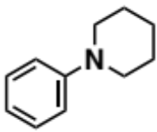
N-phenylpiperidine (CAS No. 4096-20-2, 7c) 80% GC yield, 84% isolated yield. GC conditions and analysis: InertCap5 capillary column, 0.25 mm × 30 m, GL Science Inc.; carrier gas (N₂) flow rate, 1.7 mL·min^{–1}; initial column temp., 80 °C final column temp., 280 °C, progress rate, 80 °C for 5 min, 10 °C·min^{–1} (20 min), 280 °C for 5 min, injection temp., 250 °C detection temp., 280 °C; retention time, 13.5 min; relative sensitivity for quantification (vs n-hexadecane, internal standard), 0.672 (estimated by the effective carbon number concept). ¹H NMR (500 MHz, CDCl₃): δ 7.22–7.27 (m, 2H), 6.92–6.96 (m, 2H), 6.80–6.84 (m, 1H), 3.13–3.17 (m, 4H), 1.68–1.74 (m, 4H), 1.54–1.60 (m, 2H); ¹³C NMR (125 MHz, CDCl₃): δ 152.3, 129.0, 119.2, 116.5, 50.7, 25.9, 24.3. MS (EI): m/z (%): 162 (8), 161 (70) [M⁺], 160 (100), 132 (15), 120 (18), 118 (5), 106 (8), 105 (32), 104 (28), 91 (9), 77 (27), 51 (9).^{S16}

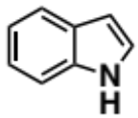
indole (CAS No. 120-72-9, 9a) >99% GC yield, 93% isolated yield. GC conditions and analysis: InertCap5 capillary column, 0.25 mm × 30 m, GL Science Inc.; carrier gas (N₂) flow rate, 1.7 mL·min^{–1}; initial column temp., 80 °C final column temp., 280 °C, progress rate, 80 °C for 5 min, 10 °C·min^{–1} (20 min), 280 °C for 5 min, injection temp., 250 °C detection temp., 280 °C; retention time, 11.1 min; relative sensitivity for quantification (vs n-hexadecane, internal standard), 0.447 (estimated by the effective carbon number concept). ¹H NMR (500 MHz, CDCl₃): δ 8.08 (brs, 1H), 7.63–7.66 (m, 1H), 7.36–7.39 (m, 1H), 7.16–7.23 (m, 2H), 7.10–7.14 (m, 1H), 6.54–6.56 (m, 1H); ¹³C NMR (125 MHz, CDCl₃): δ 135.7, 127.8, 124.1, 122.0, 120.7, 119.8, 111.0, 102.6. MS (EI): m/z (%): 118 (10), 117 (100) [M⁺], 116 (8), 91 (4), 90 (47), 89 (32), 64 (4), 63 (12), 62 (4), 59 (10), 51 (3), 39 (5).^{S17,S18}

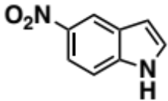
5-nitroindole (CAS No. 6146-52-7, 9b) 32% GC yield. GC conditions and analysis: InertCap5 capillary column, 0.25 mm × 30 m, GL Science Inc.; carrier gas (N₂) flow rate, 1.7 mL·min^{–1}; initial column temp., 80 °C final column temp., 280 °C, progress rate, 80 °C for 5 min, 10 °C·min^{–1} (20 min), 280 °C for 5 min, injection temp., 250 °C detection temp., 280 °C; retention time, 19.4 min; relative sensitivity for quantification (vs n-hexadecane, internal standard), 0.447 (estimated by the effective carbon number concept). MS (EI): m/z (%): 163 (9), 162 (92) [M⁺], 146 (5), 133 (7), 132 (72), 131 (8), 117 (10), 116 (93), 115 (10), 114 (8), 105 (9), 104 (42), 103 (5), 90 (13), 89 (100), 88 (14), 87 (8), 86 (5), 78 (9), 77 (14), 76 (9), 75 (5), 65 (7), 64 (7), 63 (39), 62 (19), 61 (5), 52 (7), 51 (13), 50 (10), 44 (5), 39 (14), 38 (6), 32 (6), 30 (5).^{S18}

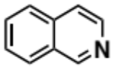
isoquinoline (CAS No. 119-65-3, 9c) 97% GC yield, 64% isolated yield. GC conditions and analysis: InertCap5 capillary column, 0.25 mm × 30 m, GL Science Inc.; carrier gas (N₂) flow rate, 1.7 mL·min^{–1}; initial column temp., 80 °C final column temp., 280 °C, progress rate, 80 °C for 5 min, 10 °C·min^{–1} (20 min), 280 °C for 5 min, injection temp., 250 °C detection temp., 280 °C; retention time, 11.8 min; relative sensitivity for quantification (vs n-hexadecane, internal standard), 0.547 (c estimated by the effective carbon number concept). ¹H NMR (500 MHz, CDCl₃): δ 9.25–9.28 (m, 1H), 8.51–8.55 (m, 1H), 7.96–8.00 (m, 1H), 7.81–7.85 (m, 1H), 7.68–7.72 (m, 1H), 7.65–7.67 (m, 1H), 7.60–7.64 (m, 1H); ¹³C NMR (125 MHz, CDCl₃): δ 152.5, 143.0, 135.8, 130.4, 128.7, 127.7, 127.3, 126.5, 120.5. MS (EI): m/z (%): 130 (10), 129 (100) [M⁺], 128 (20), 103 (10), 102 (37), 101 (9), 77 (5), 76 (12), 75 (11), 74 (7), 63 (5), 51 (16), 50 (9).^{S17}

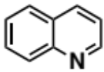
quinoline (CAS No. 91-22-5, 9d) 28% GC yield, 35% isolated yield. GC conditions and analysis: InertCap5 capillary column, 0.25 mm × 30 m, GL Science Inc.; carrier gas (N₂) flow rate, 1.7 mL·min^{–1}; initial column temp., 80 °C final column temp., 280 °C, progress rate, 80 °C for 5 min, 10 °C·min^{–1} (20 min), 280 °C for 5 min, injection temp., 250 °C detection temp., 280 °C; retention time, 10.8 min; relative sensitivity for quantification (vs n-hexadecane, internal standard), 0.547 (estimated by the effective carbon number concept). ¹H NMR (500 MHz, CDCl₃): δ 8.91–8.95 (m, 1H), 8.15–8.18 (m, 1H), 8.11–8.13 (m, 1H), 7.81–7.84 (m, 1H), 7.70–7.75 (m, 1H), 7.53–7.58 (m, 1H), 7.39–7.43 (m, 1H); ¹³C NMR (125 MHz, CDCl₃): δ 150.4, 148.3, 136.1, 129.5, 129.4, 128.3, 127.8, 126.6, 121.1. MS (EI): m/z (%): 130 (10), 129 (100) [M⁺], 128 (18), 103 (9), 102 (34), 101 (8), 76 (12), 75 (10), 74 (6), 65 (5), 63 (5), 51 (15), 50 (9).^{S17,S18}

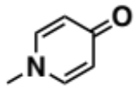
1-methyl-4(1H)-pyridinone (CAS No. 695-19-2, 11a) 93% GC yield. GC conditions and analysis: InertCap5 capillary column, 0.25 mm × 30 m, GL Science Inc.; carrier gas (N₂) flow rate, 1.7 mL·min^{–1}; initial column temp., 80 °C final column temp., 280 °C, progress rate, 80 °C for 5 min, 10 °C·min^{–1} (20 min), 280 °C for 5 min, injection temp., 250 °C detection temp., 280 °C; retention time, 15.6 min; relative sensitivity for quantification (vs n-hexadecane, internal standard), 0.284 (estimated by the effective carbon number concept). ¹H NMR (500 MHz, CDCl₃): δ 7.26–7.30 (m, 2H), 6.36–6.41 (m, 2H), 3.66 (s, 3H); ¹³C NMR (125 MHz, CDCl₃): δ 178.7, 140.6, 118.8, 43.6. MS (EI): m/z (%): 110 (6), 109 (80) [M⁺], 82 (20), 81 (100), 80 (62), 66 (5), 55 (18), 54 (12), 53 (16), 52 (10), 51 (7), 42 (44), 41 (10), 40 (11), 39 (29), 38 (12), 37 (5).^{S19}

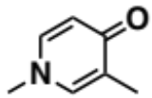
1,3-dimethyl-4(1H)-pyridinone (CAS No. 143798-69-0, 11b) 79% GC yield. GC conditions and analysis: InertCap5 capillary column, 0.25 mm × 30 m, GL Science Inc.; carrier gas (N₂) flow rate, 1.7 mL·min^{–1}; initial column temp., 80 °C final column temp., 280 °C, progress rate, 80 °C for 5 min, 10 °C·min^{–1} (20 min), 280 °C for 5 min, injection temp., 250 °C detection temp., 280 °C; retention time, 15.5 min; relative sensitivity for quantification (vs n-hexadecane, internal standard), 0.347 (estimated by the effective carbon number concept). ¹H NMR (500 MHz, CDCl₃): δ 7.22–7.26 (m, 2H), 6.30–6.34 (m, 1H), 3.64 (s, 3H), 2.03 (s, 3H); ¹³C NMR (125 MHz, CDCl₃): δ 178.4, 139.7, 138.0, 127.7, 116.3, 43.5, 14.1. MS (EI): m/z (%): 124 (9), 123 (100) [M⁺],108 (13), 95 (19), 94 (89), 80 (5), 68 (8), 67 (5), 55 (9), 54 (5), 53 (14), 52 (6), 42 (24), 41 (6), 39 (9).^{S19}

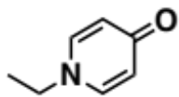
1-ethyl-4(1H)-pyridinone (CAS No. 39076-99-8, 11c) 63% GC yield. GC conditions and analysis: InertCap5 capillary column, 0.25 mm × 30 m, GL Science Inc.; carrier gas (N₂) flow rate, 1.7 mL·min^{–1}; initial column temp., 80 °C final column temp., 280 °C, progress rate, 80 °C for 5 min, 10 °C·min^{–1} (20 min), 280 °C for 5 min, injection temp., 250 °C detection temp., 280 °C; retention time, 16.7 min; relative sensitivity for quantification (vs n-hexadecane, internal standard), 0.347 (estimated by the effective carbon number concept). ¹H NMR (500 MHz, CDCl₃): δ 7.31–7.35 (m, 2H), 6.36–6.40 (m, 2H), 3.85 (q, J = 7.5 Hz, 2H), 1.45 (t, J = 7.5 Hz, 3H); ¹³C NMR (125 MHz, CDCl₃): δ 178.9, 139.6, 118.9, 51.9, 16.3. MS (EI): m/z (%): 124 (8), 123 (100) [M⁺], 108 (27), 96 (9), 95 (43), 94 (7), 82 (19), 81 (5), 80 (89), 68 (9), 67 (20), 66 (5), 54 (7), 53 (13), 52 (6), 42 (8), 41 (16), 40 (12), 39 (16).

Supplementary Figures
(a)
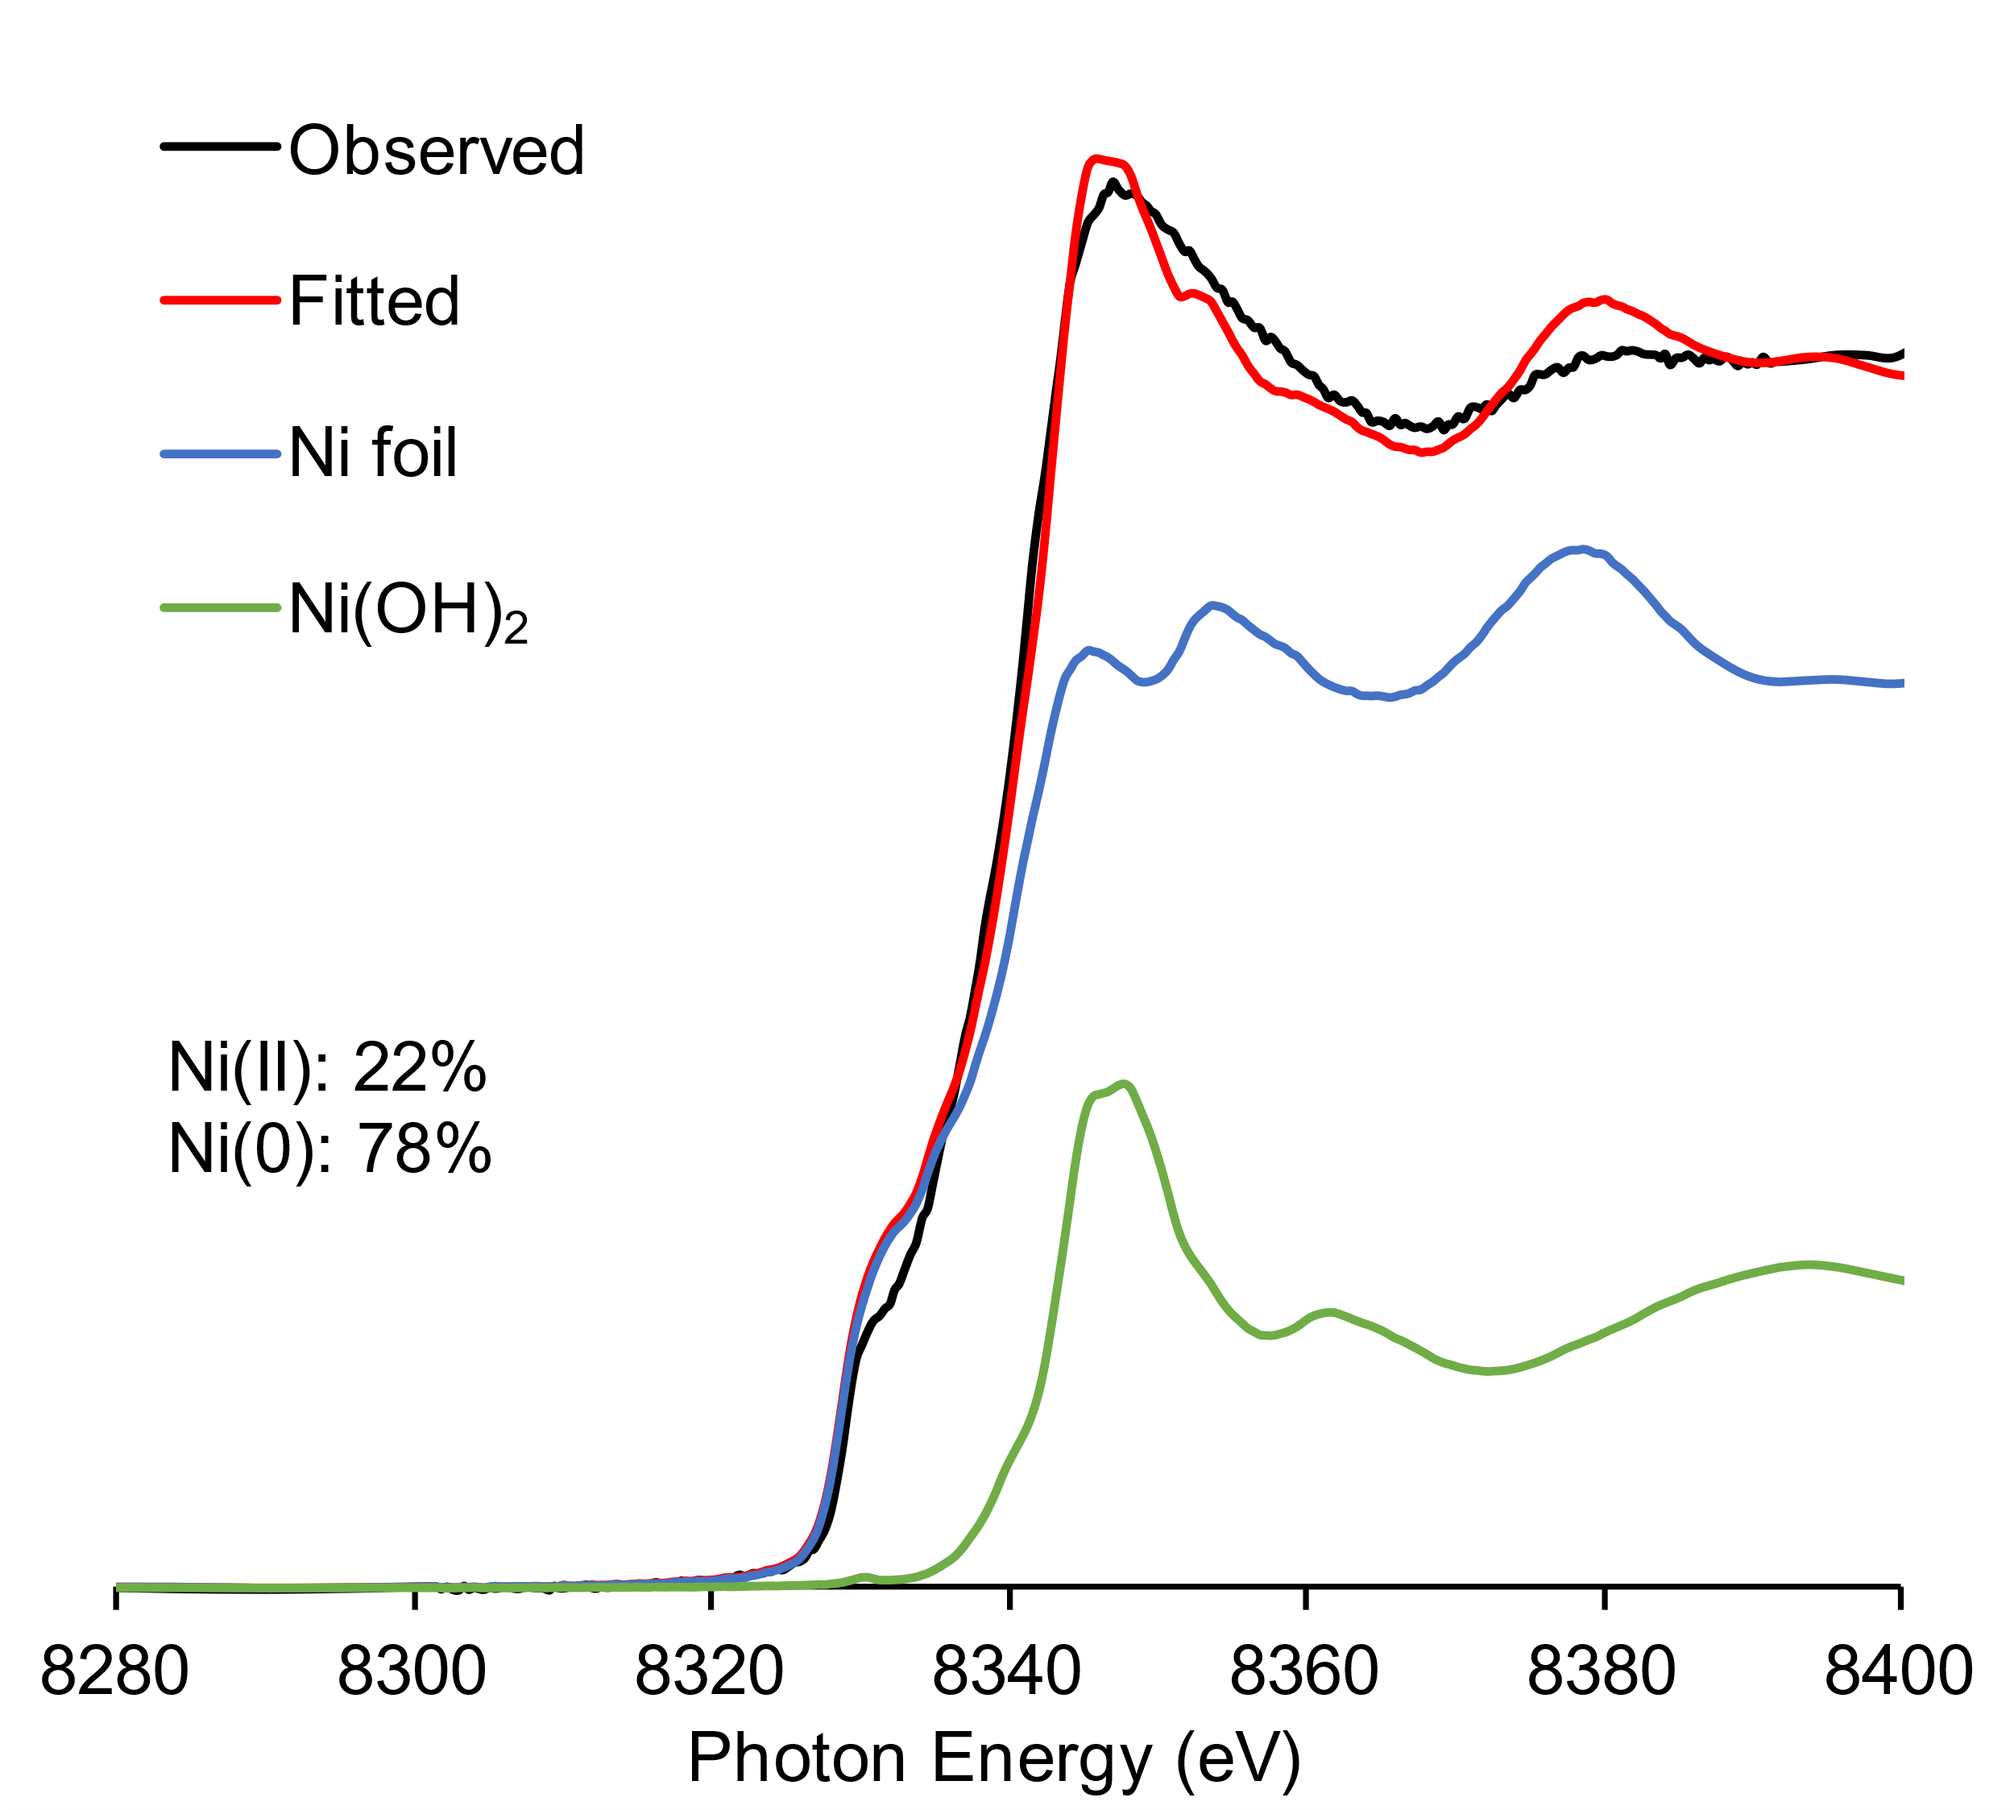
(b)
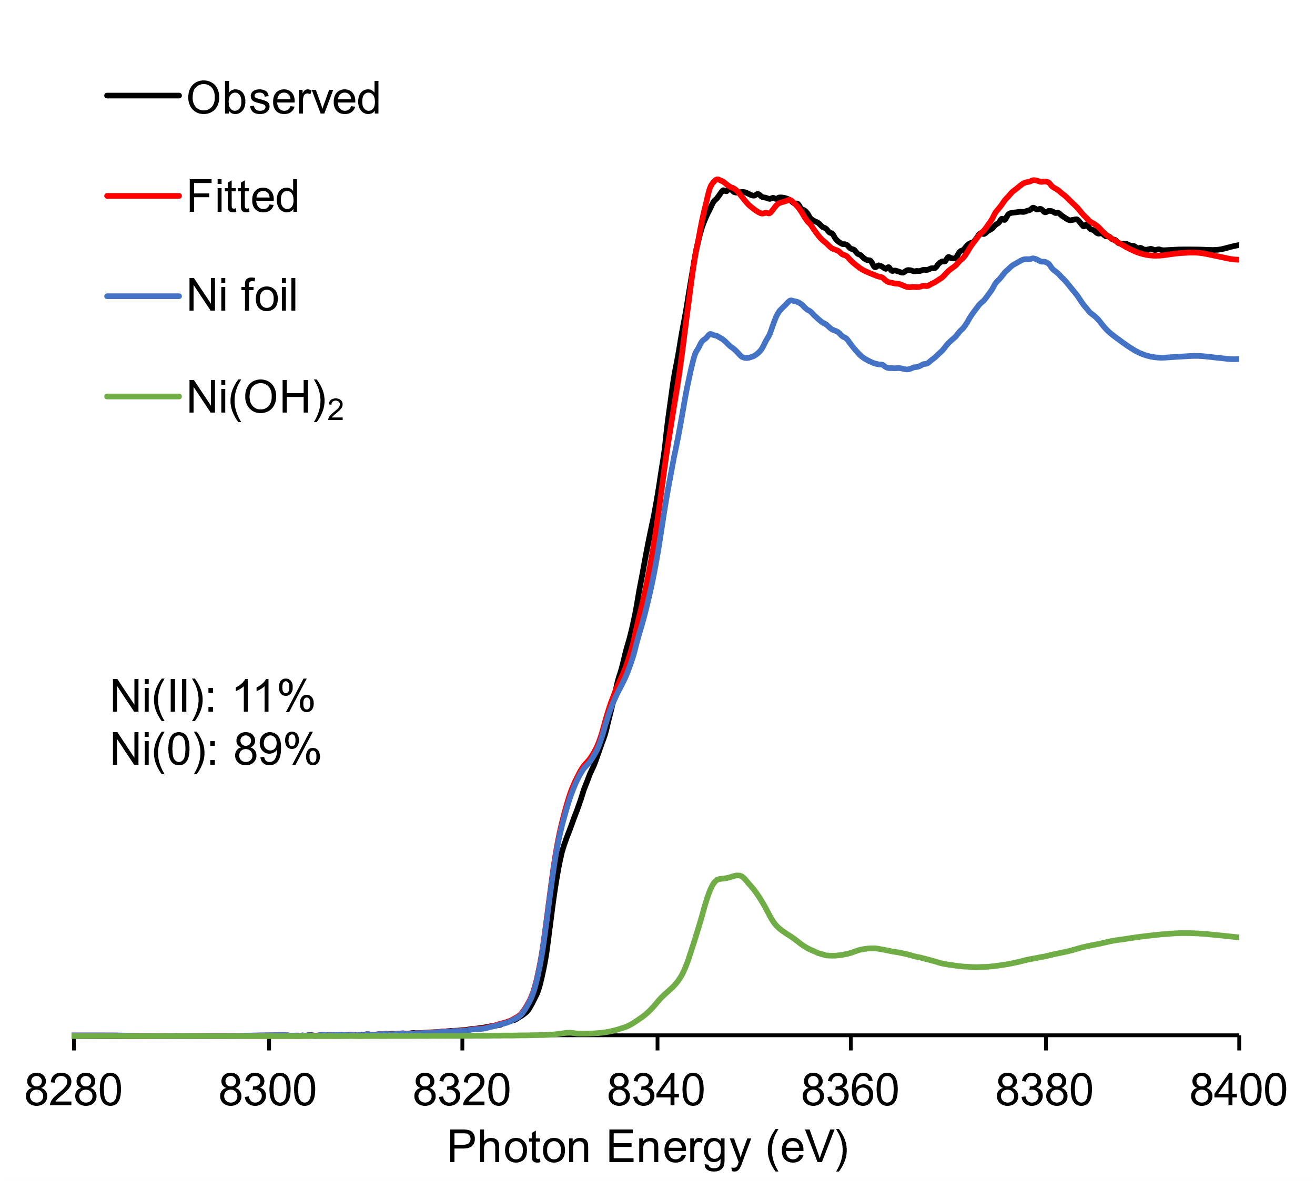
Supplementary Fig. 1: Linear combination fittings of Ni K-edge XANES spectra of (a) Ni/CeO₂-NaNaph and (b) Ni/HAP-NaNaph.

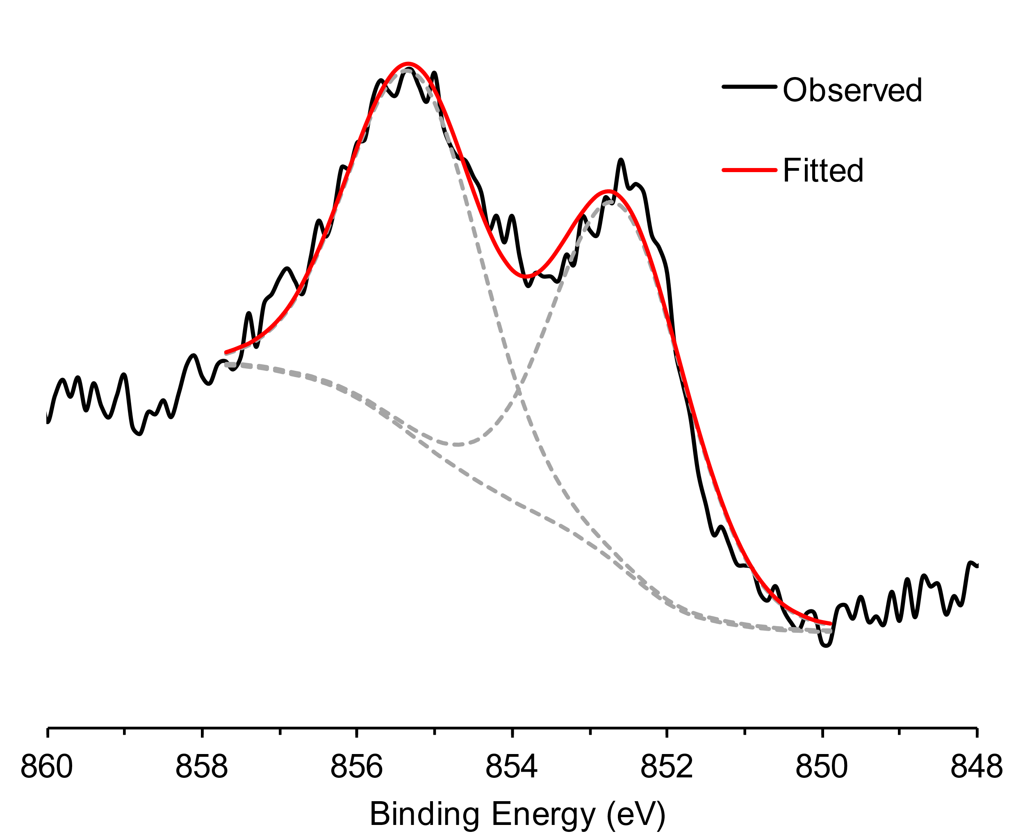
Supplementary Fig. 2: Ni 2p XPS spectrum of Ni/CeO₂-NaNaph; the black solid line indicates the data points; the gray broken lines indicate the deconvoluted signals; the red solid line indicates the sum of the deconvoluted signals.

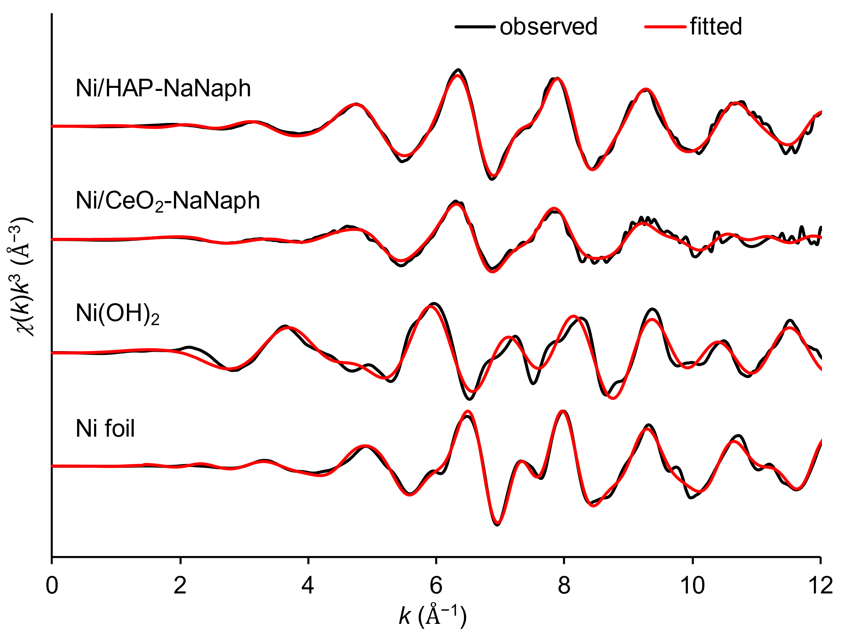
Supplementary Fig. 3: k³-weighted k-space Ni K-edge EXAFS spectra of Ni foil, Ni(OH)₂, Ni/CeO₂-NaNaph, and Ni/HAP-NaNaph.

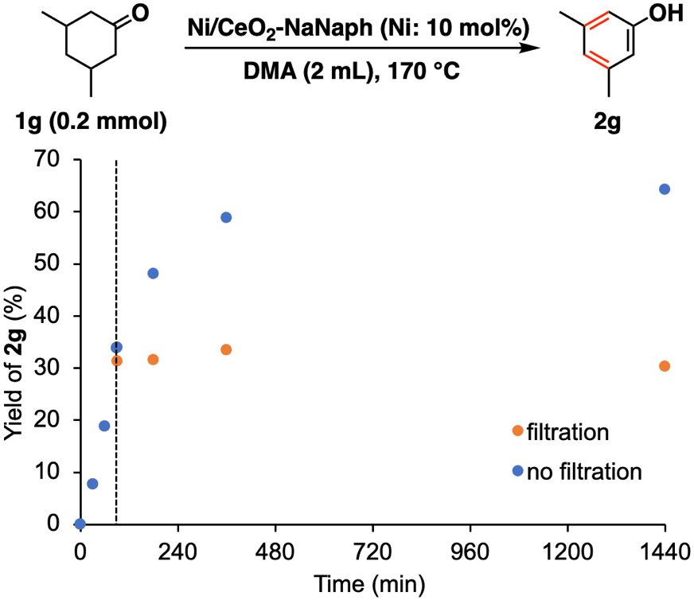
Supplementary Fig. 4: Effect of removal of Ni/CeO₂-NaNaph catalyst on the dehydrogenative aromatization of 1g. Reaction conditions: 1g (0.2 mmol), Ni/CeO₂-NaNaph (10 mol%), DMA (2 mL), Ar (1 atm), 170 °C. Yields were determined by GC analysis using n-hexadecane as an internal standard.

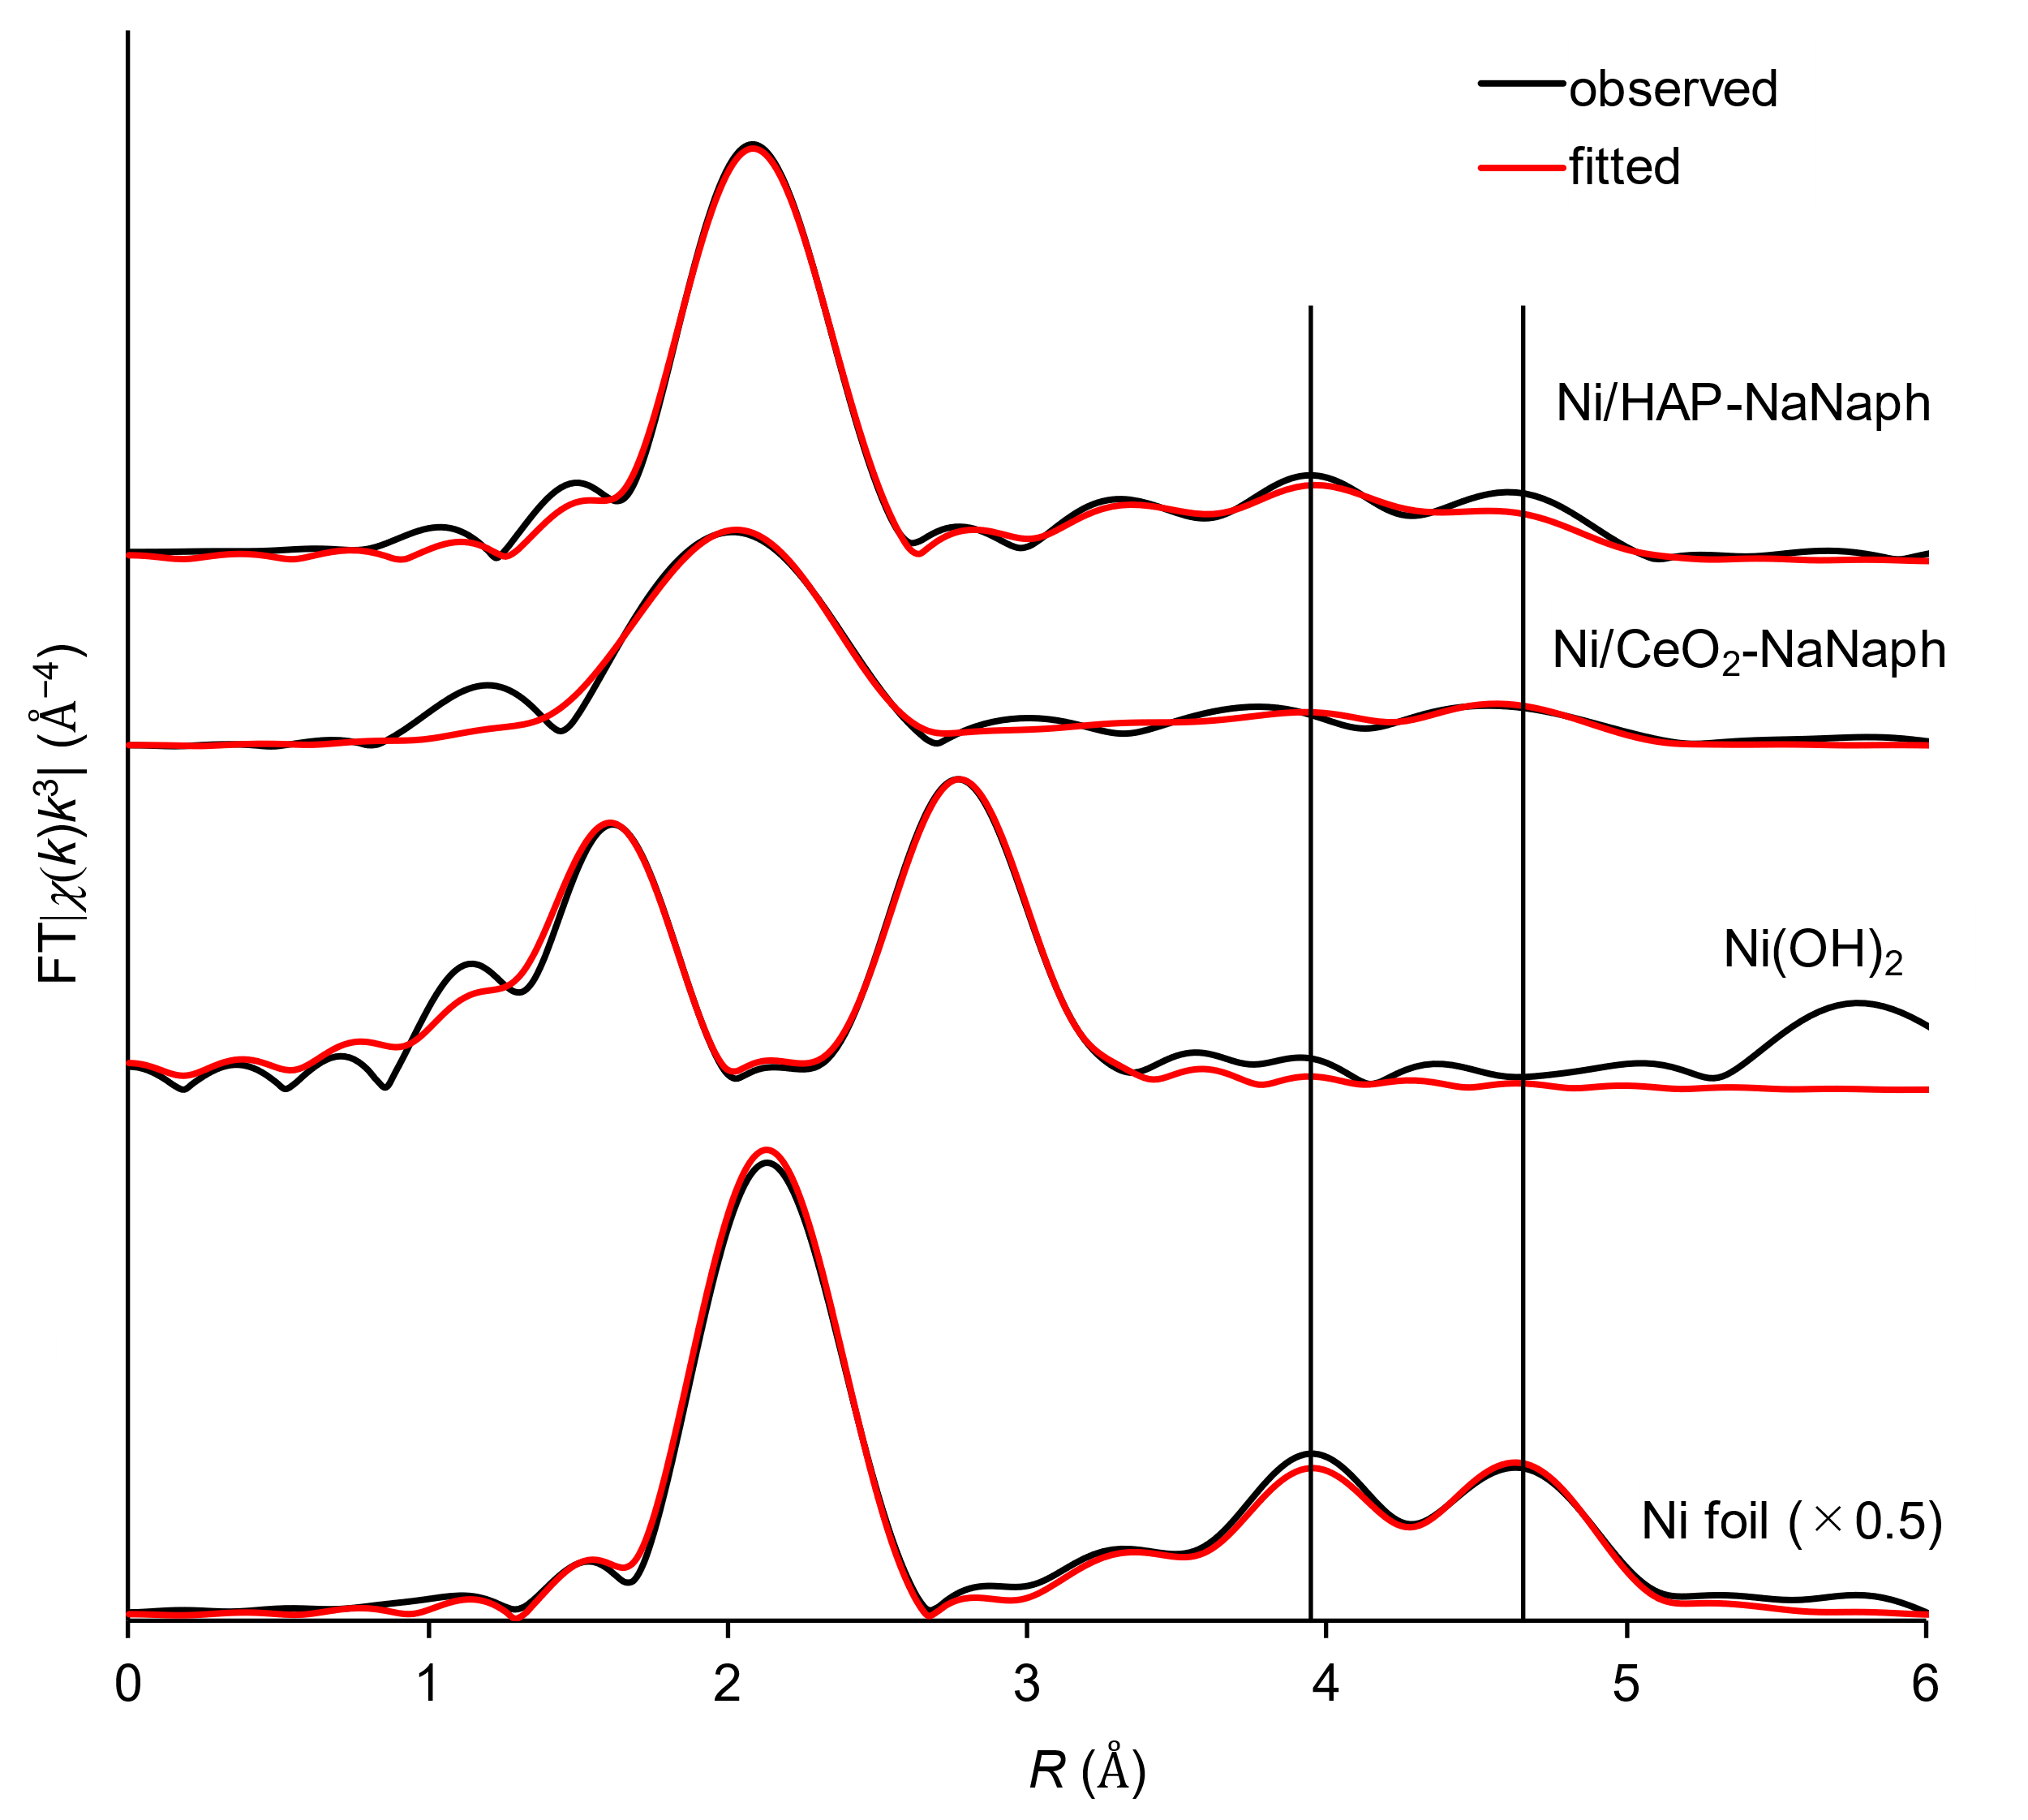
Supplementary Fig. 5: k³-weighted Fourier-transformed Ni K-edge EXAFS spectra of Ni foil, Ni(OH)₂, Ni/CeO₂-NaNaph, and Ni/HAP-NaNaph. FFT parameters, k-range: 3–12, window: Hanning k³-weighted. All R-space spectra are shown without phase correction.
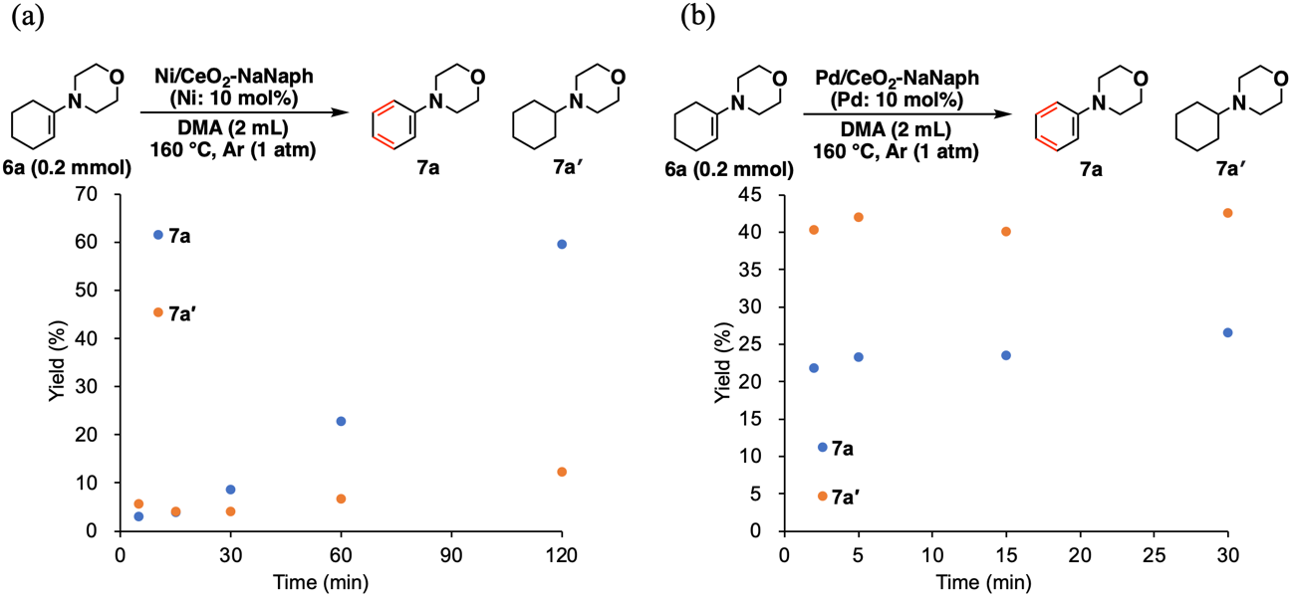
Supplementary Fig. 6: Time course plots of dehydrogenative aromatization of 8a in the presence of (a) Ni/CeO₂-NaNaph or (b) Pd/CeO₂-NaNaph. The reaction conditions were indicated in the figure.

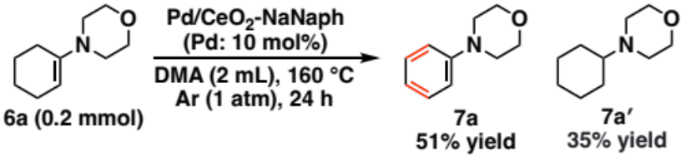
Supplementary Fig. 7: Dehydrogenative aromatization of 8a in the presence of Pd/CeO₂-NaNaph. The reaction conditions are indicated in the figure.

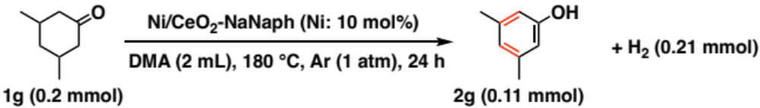
Supplementary Fig. 8: Determination of molecular hydrogen amount after dehydrogenative aromatization of 1g by GC-BID. The reaction conditions are indicated in the figure.

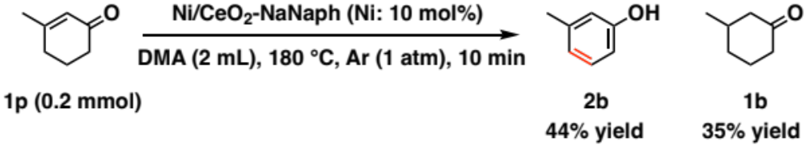
Supplementary Fig. 9: Disproportionation of 1p in the presence of Ni/CeO₂-NaNaph. The reaction conditions are indicated in the figure.

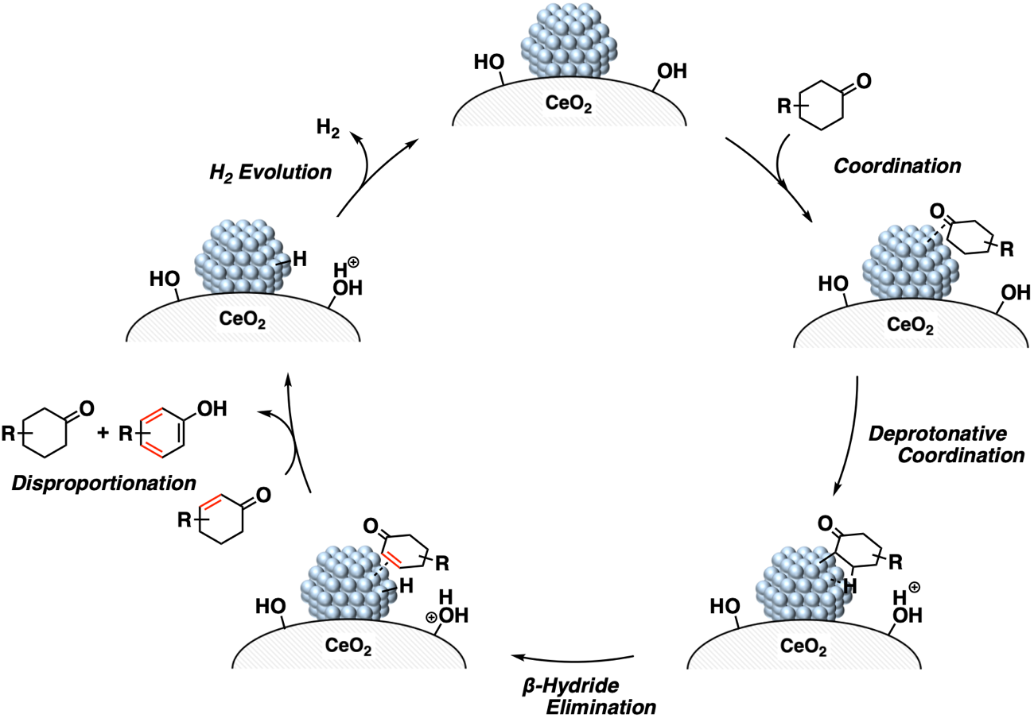
Supplementary Fig. 10: Proposed reaction mechanism of Ni/CeO₂-NaNaph-catalyzed dehydrogenative aromatization of cyclohexanones.

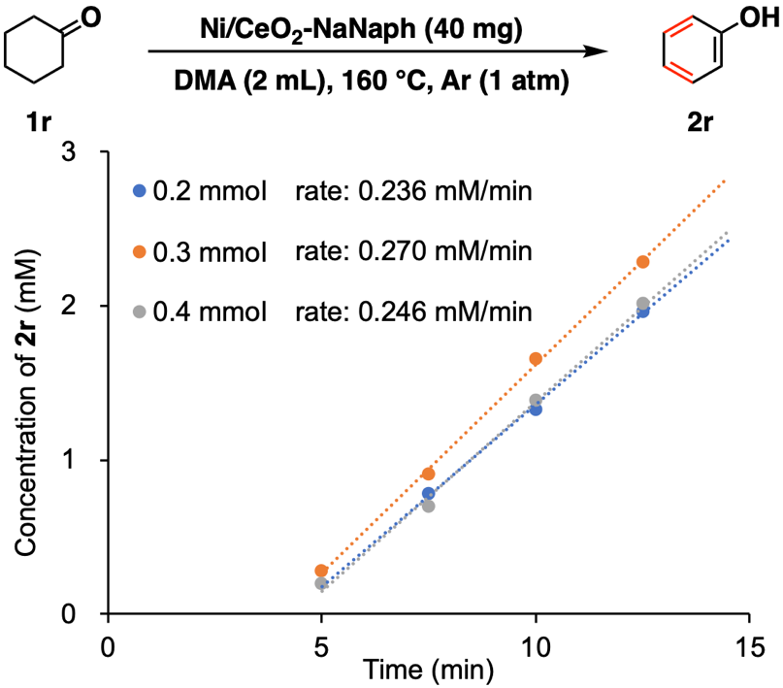
Supplementary Fig. 11: Dependence of initial production rate of 2r on the initial amount of 1r. The reaction conditions are indicated in this figure.

(a)
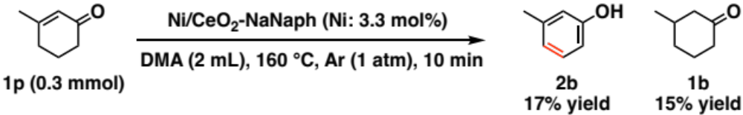
(b)
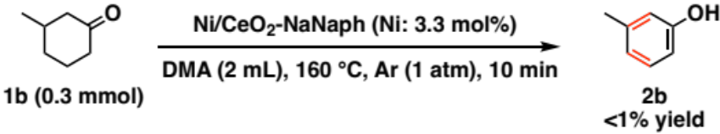
Supplementary Fig. 12: Ni/CeO₂-NaNaph-catalyzed dehydrogenative aromatization starting from (a) 1p or (b) 1b. The reaction conditions are indicated in the figure.

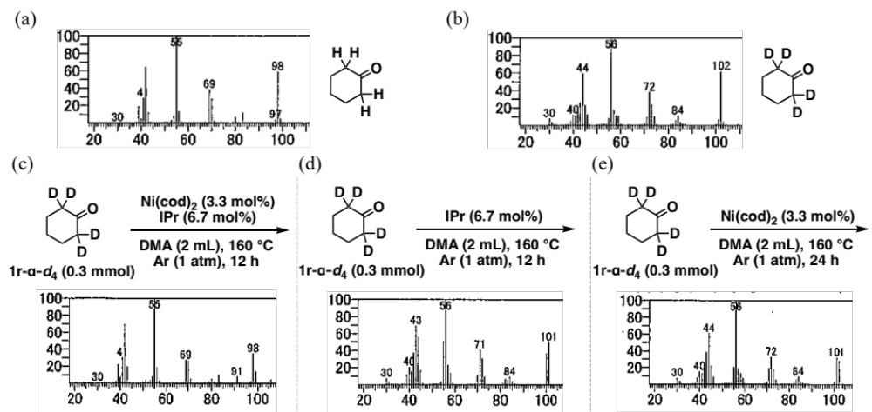
Supplementary Fig. 13: GC-MS spectra of (a) cyclohexanone (1r), (b) cyclohexanone-α-d₄ (1r-α-d₄), and 1r-α-d₄ after stirring in the presence of (c) the Ni−IPr complex, (d) IPr, or (e) Ni(cod)₂. The reaction conditions are indicated in the figure. The deuteration rate after the reaction in Fig. 4c was calculated according to the following formula, using the peak area corresponding to the molecular ion peak of 1r-α-d_{n} (n = 0–4) in the GC-MS spectrum (S_{n}), the area ratio of m/z = 99 and 98 in the GC-MS spectrum of 1r (t = 0.070), and corrected peak area A_{n} = S_{n} – t×A_{n−1} (n = 1–4, A₀ = S₀).
$$Deuteration rate (atom\%D)= \frac{\sum_{n=0}^{4}{n×A_{n}}}{\sum_{n=0}^{4}{4×A_{n}}}$$
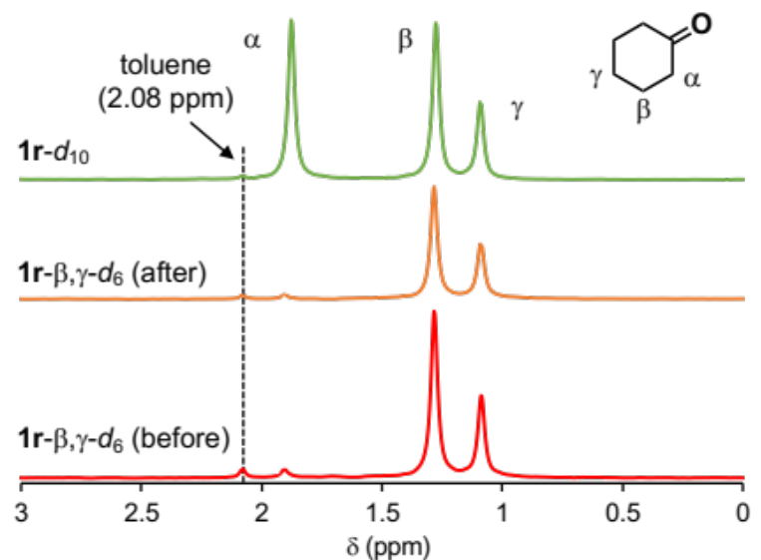
Supplementary Fig. 14: ²H NMR spectra of cyclohexanone-d₁₀ and cyclohexanone-β,γ-d₆ in toluene before and after stirring in the presence of Ni(cod)₂ and IPr. Chemical shifts were referenced to CH₃ signal of toluene (δ = 2.08 ppm). The reaction conditions are indicated in Fig. 4d.

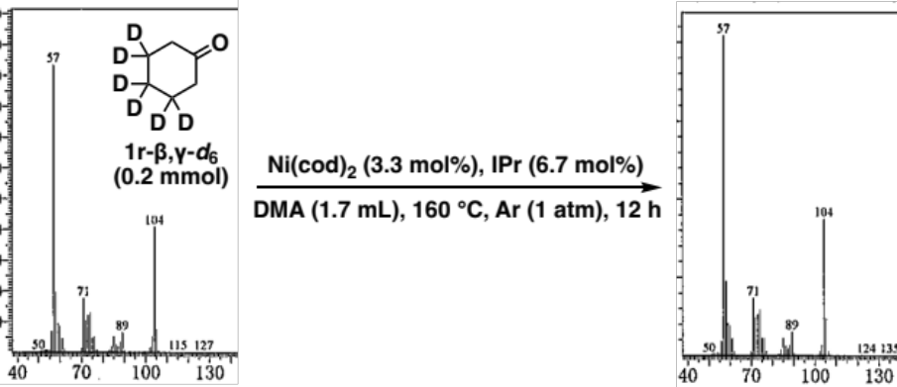
Supplementary Fig. 15: GC-MS spectra of cyclohexanone-β,γ-d₆ before and after stirring in the presence of the Ni−IPr complex. The reaction conditions are indicated in the figure.

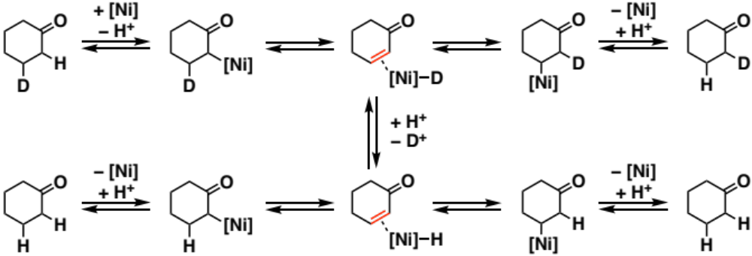
Supplementary Fig. 16: Proposed reaction mechanism of decrease of D from β-deuterated cyclohexanone and H/D scrambling between α- and β-position.

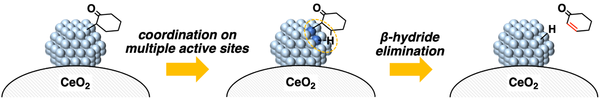
Supplementary Fig. 17: Proposed β-hydride elimination mechanism on the multiple active sites of Ni nanoparticles.

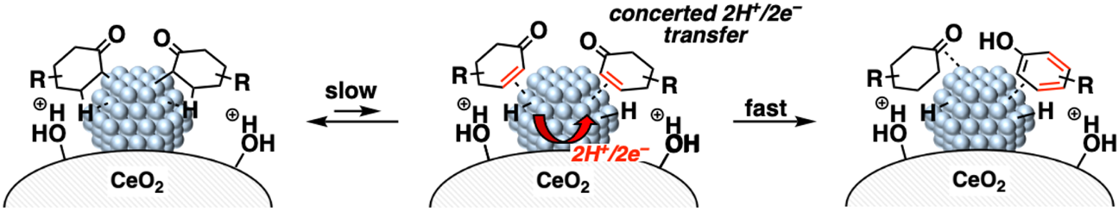
Supplementary Fig. 18: Proposed disproportionation mechanism on the multiple active sites of Ni nanoparticles.

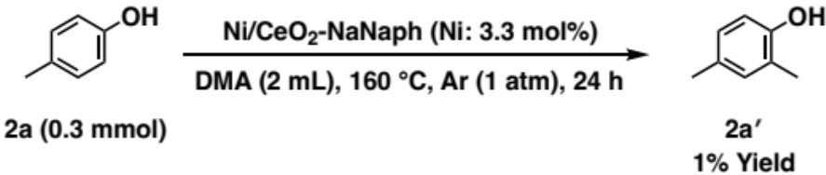
Supplementary Fig. 19: Control experiments using 2a as a starting material in the presence of Ni/CeO₂-NaNaph. The reaction conditions are indicated in the figure.

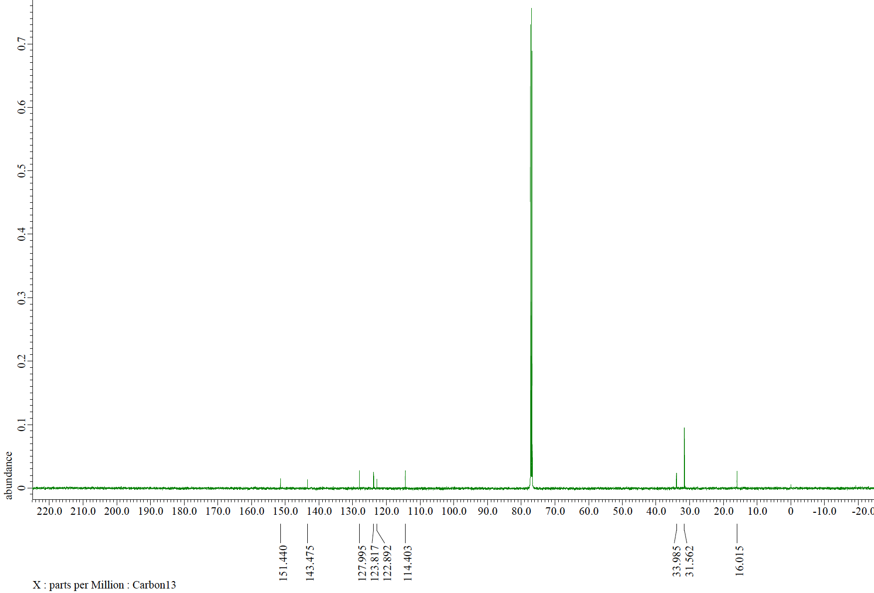
Supplementary Fig. 20: ¹³C NMR spectrum of isolated methylated tert-butyl phenol (2h′). This spectrum was corresponded to that of ortho-methylated tert-butyl phenol but not meta-methylated one.^{S20,S21} Reaction conditions: 1h (0.2 mmol), Ni/CeO₂-NaNaph (10 mol%), DMA (2 mL), Ar (1 atm), 180 °C, 24 h.

(a)
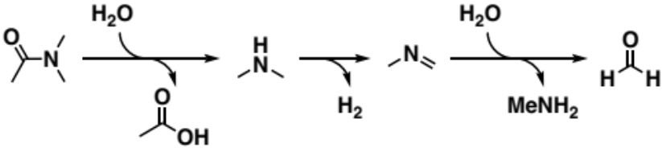
(b)
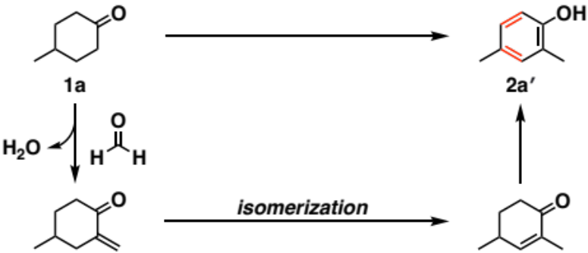
Supplementary Fig. 21: Proposed reaction mechanism of (a) DMA decomposition and (b) proposed 2a' formation path from 1a using formaldehyde derived from DMA.^{S22}

Supplementary Tables
Supplementary Table 1: The assignments of the peaks in the Ni 2p XPS spectrum of Ni/CeO₂-NaNaph.^{S23,S24}
Sample | Assignment | Position (eV) | Area (%)
Ni/CeO₂-NaNaph | Ni(0) | 852.6 | 49.8
Ni/CeO₂-NaNaph | Ni(OH)₂ | 855.3 | 50.2

Supplementary Table 2: Fitted parameters from Ni K-edge EXAFS of Ni/CeO₂-NaNaph and Ni/HAP-NaNaph.

Ni/CeO₂-NaNaph
Shell | C.N. | R (Å) | ΔE_{j0}  (eV) | σ²×10²  (Å²) | R-factor  (%)
Ni−O (in Ni(OH)₂) | 1.1±0.2 | 2.08 | 0.77 (fixed) | 0.30 | 1.14
Ni−Ni (in Ni foil) | 6.0±0.8 | 2.49 | −7.17 (fixed) | 1.31 | 1.14
Ni−Ni (in Ni foil) | 5.4±0.4 | 3.58 | 1.42 (fixed) | 2.61 | 1.14
Ni−Ni (in Ni foil) | 3.3±3.0 | 4.32 | −10 (fixed) | 1.24 | 1.14
forward scattering (in Ni foil) | 3.2±1.9 | 5.05 | −10 (fixed) | 1.00 | 1.14

Ni/HAP-NaNaph
Shell | C.N. | R (Å) | ΔE_{j0}  (eV) | σ²×10²  (Å²) | R-factor  (%)
Ni−Ni (in Ni foil) | 5.9±0.4 | 2.47 | −9.34 (fixed) | 0.80 | 0.47
Ni−Ni (in Ni foil) | 5.3±1.0 | 3.58 | 1.95 (fixed) | 1.75 | 0.47
Ni−Ni (in Ni foil) | 9.1±3.8 | 4.35 | −6.21 (fixed) | 1.36 | 0.47
forward scattering (in Ni foil) | 4.5±1.9 | 5.04 | −8.59 (fixed) | 0.96 | 0.47

Supplementary Table 3: Effect of Ni loadings on dehydrogenative aromatization of 1a.ª
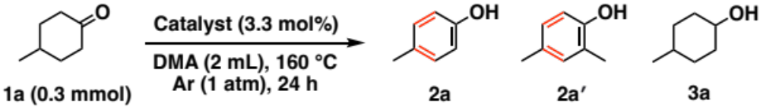
Entry | Catalyst | Yield (%)
Entry | Catalyst | 2a | 2a′ | 3a
1 | 0.75wt% Ni/CeO₂-0.3NaNaph | 51 | 1 | 12
2 | 1.5wt% Ni/CeO₂-0.3NaNaph | 50 | 3 | 13
3 | 3.0wt% Ni/CeO₂-0.3NaNaph | 41 | <1 | 14
ªReaction conditions: 2a (0.3 mmol), catalyst (Ni: 3.3 mol%), DMA (2 mL), 180 °C, 24 h in pressure tube. Yields and conversions were determined by GC analysis using n-hexadecane as an internal standard.

Supplementary Table 4: Effect of solvents on dehydrogenative aromatization of 1a.ª
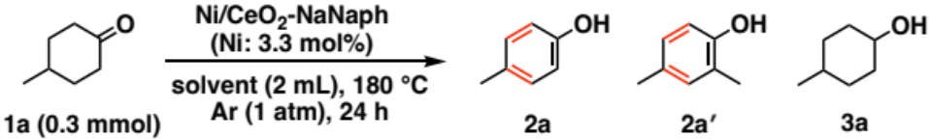
Entry | Solvent | Yield (%)
Entry | Solvent | 2a | 2a′ | 3a
1 | DMA | 74 | 13 | 3
2 | NMP | 26 | <1 | <1
3 | 1,4-dioxane | 19 | <1 | <1
4 | CPME | 9 | <1 | <1
5 | heptane | 5 | <1 | 43
6 | MCH | 4 | <1 | <1
ªReaction conditions: 2a (0.3 mmol), Ni/CeO₂-NaNaph (Ni: 3.3 mol%), solvent (2 mL), 180 °C, 24 h in pressure tube. Yields and conversions were determined by GC analysis using n-hexadecane as an internal standard. NMP = 1-Methyl-2-pyrrolidone. CPME = Cyclopentyl methyl ether. MCH = Methyl cyclohexane.

Supplementary Table 5: Detailed information of products for the transformations demonstrated in Fig. 3.
Phenol synthesis from cyclohexanones or cyclohexanolsª
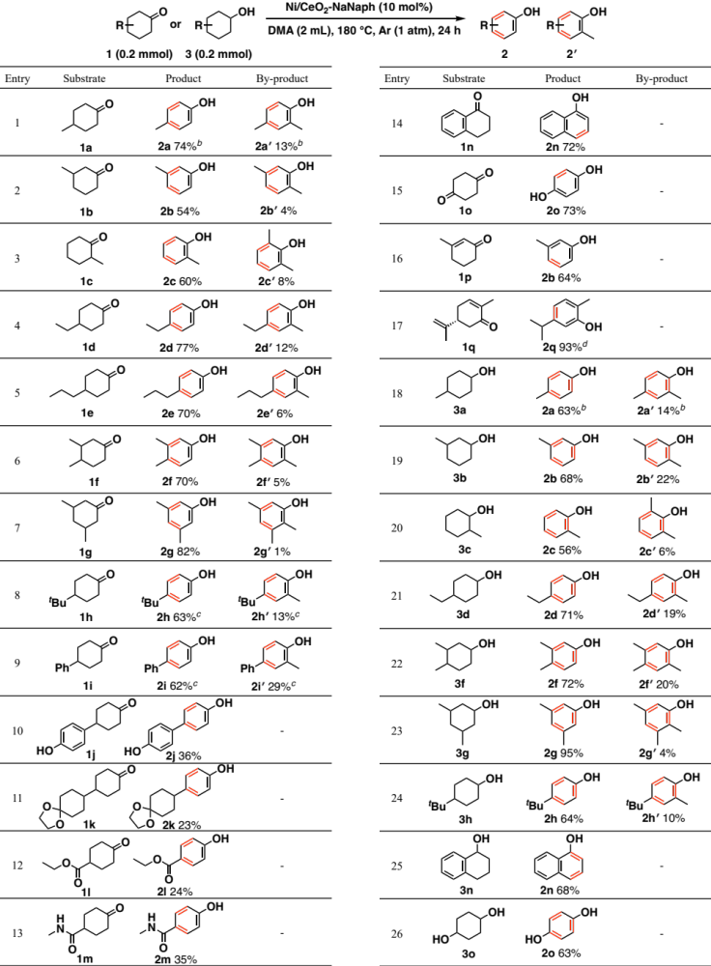
ªReaction conditions: 1 or 3 (0.2 mmol), Ni/CeO₂-NaNaph (Ni: 10 mol%), DMA (2 mL), Ar (1 atm), 180 °C, 24 h in pressure tube. Conversions and yields were determined by GC analysis using n-hexadecane as an internal standard. ^{b}1 or 3 (0.3 mmol), Ni/CeO₂-NaNaph (Ni: 3.3 mol%). ^{c}1 (0.3 mmol), Ni/CeO₂-NaNaph (Ni: 10 mol%). ^{d}Yield of intramolecular disproportionated product is shown.
Supplementary Table 5 (continued): Detailed information of products for the transformations demonstrated in Fig. 3.
Aniline synthesis from cyclohexylamines or enamines^{e}
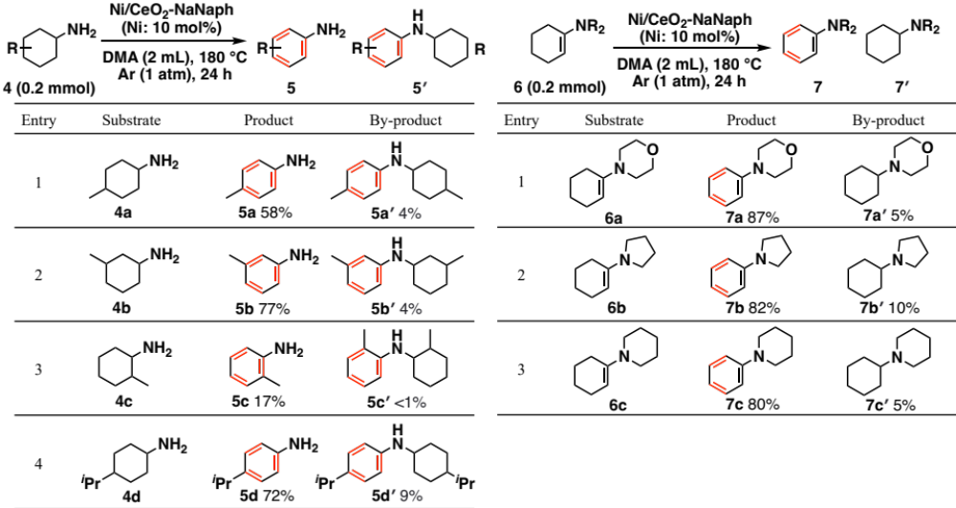
^{e}Reaction conditions: 4 or 6 (0.2 mmol), Ni/CeO₂-NaNaph (Ni: 10 mol%), DMA (2 mL), Ar (1 atm), 180 °C, 24 h in pressure tube.

(1H)-Pyridinone synthesis from piperidones^{f}
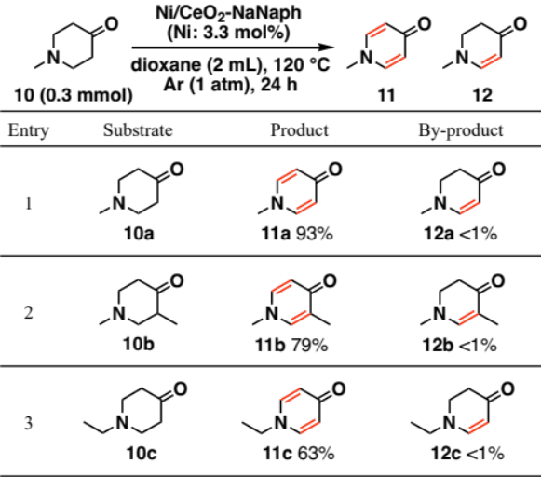
^{f}Reaction conditions: 10 (0.3 mmol), Ni/CeO₂-NaNaph (Ni: 3.3 mol%), 1,4-dioxane (2 mL), Ar (1 atm), 120 °C, 24 h in test tube.

Supplementary Table 6: Effect of active metal species on dehydrogenative aromatization starting from 3a.ª
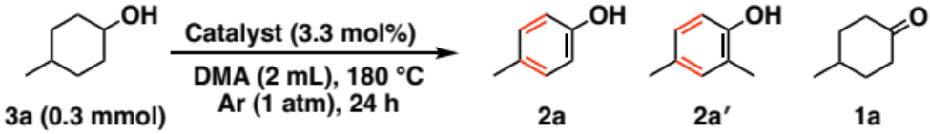
Entry | Catalyst | Yield (%)
Entry | Catalyst | 2a | 2a′ | 1a
1 | Ni/CeO₂-NaNaph | 63 | 14 | <1
2 | Pd/CeO₂-NaNaph | 9 | <1 | 9
ªReaction conditions: 3a (0.3 mmol), catalyst (3.3 mol%), DMA (2 mL), 180 °C, 24 h in pressure tube. Yields and conversions were determined by GC analysis using n-hexadecane as an internal standard.

Supplementary Table 7: Effect of Ni catalysts on dehydrogenative aromatization starting from 1a.ª
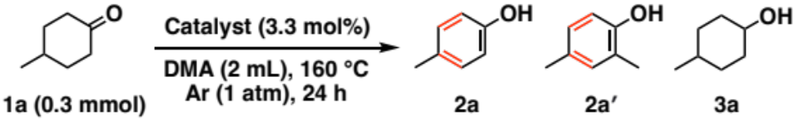
Entry | Catalyst | base | Yield (%)
Entry | Catalyst | base | 2a | 2a′ | 3a
1 | NiCl₂ + IPr | — | <1 | <1 | <1
2 | NiCl₂ + PCy₃ | — | <1 | <1 | <1
3 | Ni(acac)₂ + IPr | — | <1 | <1 | <1
4 | Ni(acac)₂ + PCy₃ | — | <1 | <1 | <1
5 | Ni(cod)₂ + IPr | — | 3 | <1 | <1
6 | Ni(cod)₂ + PCy₃ | — | <1 | <1 | <1
7 | Ni(cod)₂ + IPr | DMAP | <1 | <1 | <1
8 | Ni(cod)₂ + IPr | DBU | <1 | <1 | <1
9 | Ni(cod)₂ + IPr | Na₂CO₃ | <1 | <1 | <1
ªReaction conditions: 1a (0.3 mmol), Ni catalyst (3.3 mol%), ligand (6.7 mol%), base (0.3 mmol), DMA (2 mL), 180 °C, 24 h in pressure tube. Yields and conversions were determined by GC analysis using n-hexadecane as an internal standard. PCy₃ = tricyclohexylphosphine. IPr = 1,3-bis(2,6-diisopropylphenyl)imidazol-2-ylidene. acac = acetylacetonate. cod = 1,5-cyclooctadiene. DMAP = 4-dimethylaminopyridine. DBU = 1,8-diazabicyclo[5.4.0]undec-7-ene.

Supplementary References
S1. Cook Jr., J. W. & Sayers, D. E. Criteria for automatic X‐ray absorption fine structure background removal. J. Appl. Phys. 52, 5024−5031 (1981).
S2. Cable, J. W. & Tsunoda, Y. Magnetic moments and short-range order in CoMn and NiMn alloys. J. Magn. Magn. Mater. 140−144, 93−94 (1995).
S3. Enoki, T., & Tsujikawa, I. Magnetic behaviours of a random magnet, Ni_{p}Mg_{(1−p)}(OH₂). J. Phys. Soc. Jpn. 39, 317−323 (1975).
S4. Matsuyama, T., Yatabe, T., Yabe, T. & Yamaguchi, K. Heterogeneously catalyzed selective decarbonylation of aldehydes by CeO₂‐supported highly dispersed non-electron-rich Ni(0) nanospecies. ACS Catal. 11, 13745−13751 (2021).
S5. Matsuyama, T., Yatabe, T. & Yamaguchi, K. Heterogeneously catalyzed decarbonylation of thioesters by supported Ni, Pd, or Rh nanoparticle catalysts. Org. Biomol. Chem. 22, 579−584 (2024).
S6. Sloane, S. E., Vang, Z. P., Nelson, G., Qi, L., Sonstrom, R. E., Alansari, I. Y., Behlow, K. T., Pate, B. H., Neufeldt, S. R. & Clark, J. R. Catalytic deuterium incorporation within metabolically stable β-amino C–H bonds of drug molecules. J. Am. Chem. Soc. 141, 14570–14575 (2019).
S7. Zeng, H., Yu, J. & Li, C.-J. Palladium-catalyzed aerobic synthesis of ortho-substituted phenols from cyclohexanones and primary alcohols. Chem. Commun. 56, 1239−1242 (2020).
S8. Jin, X., Taniguchi, K., Yamaguchi, K. & Mizuno, N. Au–Pd alloy nanoparticles supported on layered double hydroxide for heterogeneously catalyzed aerobic oxidative dehydrogenation of cyclohexanols and cyclohexanones to phenols. Chem. Sci. 7, 5371−5383 (2016).
S9. Nakamura, R., Obora, Y. & Ishii, Y. Selective one-pot synthesis of various phenols from diarylethanes. Chem. Commun. 3417−3419 (2008).
S10. Jin, X., Taniguchi, K., Yamaguchi, K. Nozaki, K. & Mizuno, N. A Ni–Mg–Al layered triple hydroxide-supported Pd catalyst for heterogeneous acceptorless dehydrogenative aromatization. Chem. Commun. 53, 5267−5270 (2017).
S11. Yuan, B., Pan, Y., Li, Y., Yin, B. & Jiang, H. A highly active heterogeneous palladium catalyst for the Suzuki–Miyaura and Ullmann coupling reactions of aryl chlorides in aqueous media. Angew. Chem. Int. Ed. 49, 4054−4058 (2010).
S12. Maurer, S., Liu, W., Zhang, X., Jiang, Y. & Ma, D. An efficient synthesis of phenol via CuI/8-hydroxyquinoline-catalyzed hydroxylation of aryl halides and potassium hydroxide. Synlett 6, 976−978 (2010).
S13. Jia, J., Jiang, C., Zhang, X., Jiang, Y. & Ma, D. CuI-catalyzed hydroxylation of aryl bromides under the assistance of 5-bromo-2-(1H-imidazol-2-yl)pyridine and related ligands. Tetrahedron Lett. 52, 5593−5595 (2011).
S14. Li, H., Yatabe, T., Takayama, S. & Yamaguchi, K. Heterogeneously catalyzed selective acceptorless dehydrogenative aromatization to primary anilines from ammonia via concerted catalysis and adsorption control. JACS Au 3, 1376−1384 (2023).
S15. Cano, R., Ramón, D. J. & Yus, M. Transition-metal-free O-, S-, and N-arylation of alcohols, thiols, amides, amines, and related heterocycles J. Org. Chem. 76, 654–660 (2011).
S16. Ishikawa, T., Uedo, E., Tani, R. & Saito, S. Aromatization of enamines promoted by a stoichiometric amount of palladium(II) salts: a novel method for the synthesis of aromatic amines. J. Org. Chem. 66, 186–191 (2001).
S17. Wang, Y., Li, C. & Huang, J. External-ligand-free aerobic oxidation of N- and C-containing cyclic systems under Pd-catalyzed conditions. Asian J. Org. Chem. 6, 44−46 (2017).
S18. Kamata, K., Kasai, J., Yamaguchi, K. & Mizuno, N. Efficient heterogeneous oxidation of alkylarenes with molecular oxygen. Org. Lett. 6, 3577–3580 (2004).
S19. Yi, X., Chen, J., Xu, X. & Ma, Y. Solvent and substituent effects on the conversion of 4-methoxypyridines to N-methyl-4-pyridones. Synth. Commun. 47, 872−877 (2017).
S20. Bayguzina, A. R., Makhiyanova, R. A., Khazipova, A. N. & Khusnutdinov, R. I. Alkylation of phenols with tert-butanol catalyzed by H-form of Y zeolites with a hierarchical porous structure. Russ. J. Gen. Chem. 89, 1554−1559 (2019).
S21. Gao, Z., Lim, Y. H., Tredwell, M., Li, L., Verhoog, S., Hopkinson, M., Kaluza, W., Collier, T. L., Passchier, J., Huiban, M. & Gouverneur, V. Metal-free oxidative fluorination of phenols with [¹⁸F]fluoride. Angew. Chem. Int. Ed. 51, 6733−6737 (2012).
S22. Zeng, H., Yu, J. & Li, C.-J. Palladium-catalyzed aerobic synthesis of ortho-substituted phenols from cyclohexanones and primary alcohols. Chem. Commun. 56, 1239−1242 (2020).
S23. Bertone, M. E., Meyer, C. I., Regenhardt, S. A., Sebastian, V., Garetto, T. F. & Marchi, A. J. Highly selective conversion of maleic anhydride to γ-butyrolactone over Ni-supported catalysts prepared by precipitation–deposition method. Appl. Catal. A 503, 135–146 (2015).
S24. Yan, H., Bai, J., Wang, J., Zhang, X., Wang, B., Liu, Q. & Liu, L. Graphene homogeneously anchored with Ni(OH)₂ nanoparticles as advanced supercapacitor electrodes. CrystEngComm 15, 10007–10015 (2013).

NMR Spectra
¹H NMR spectrum (500 MHz, CDCl₃) of 2a
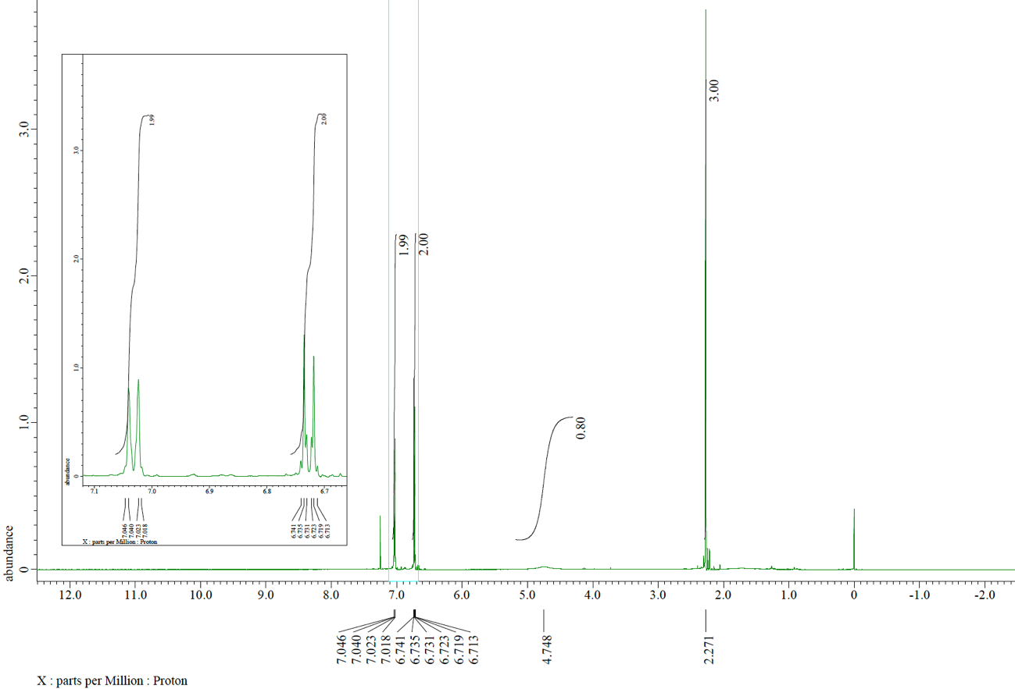
¹³C NMR spectrum (125 MHz, CDCl₃) of 2a
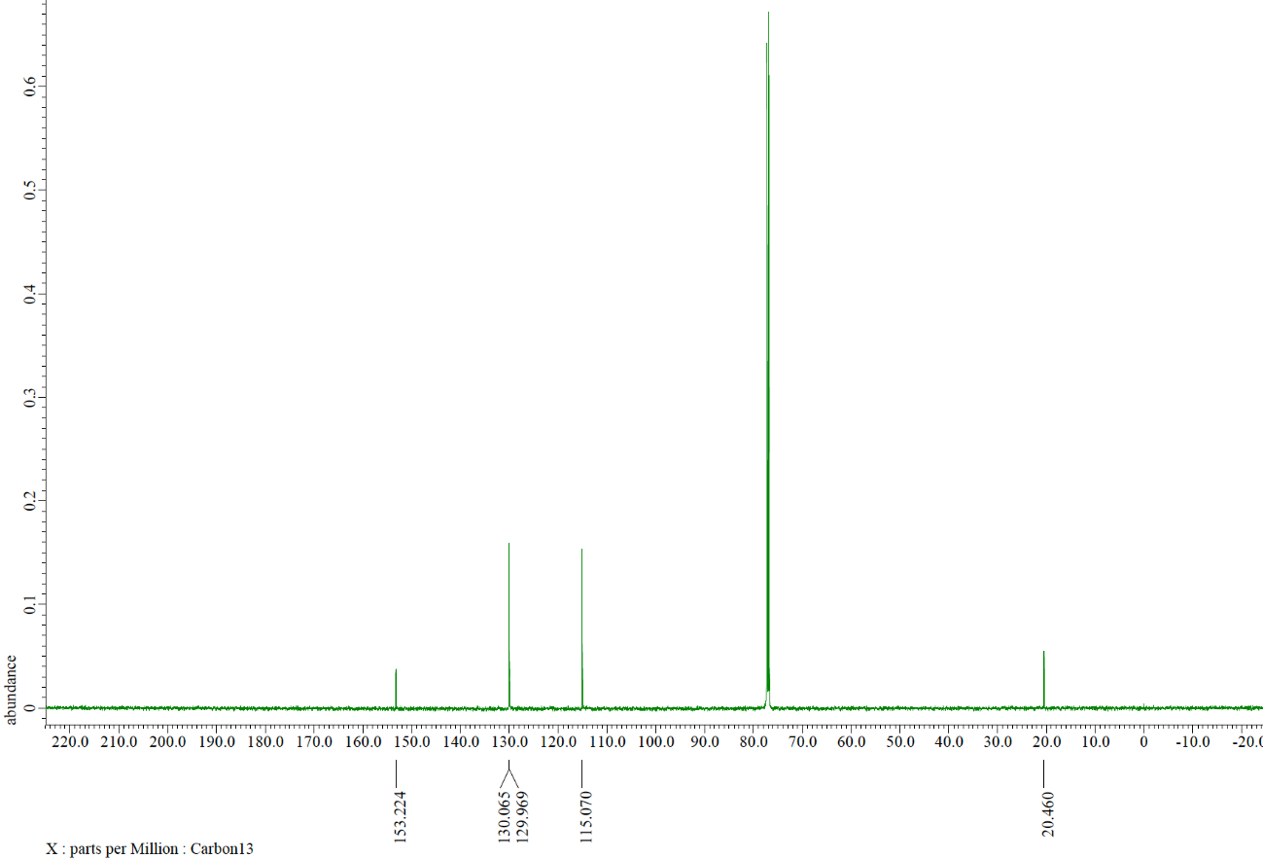
¹H NMR spectrum (500 MHz, CDCl₃) of 2b
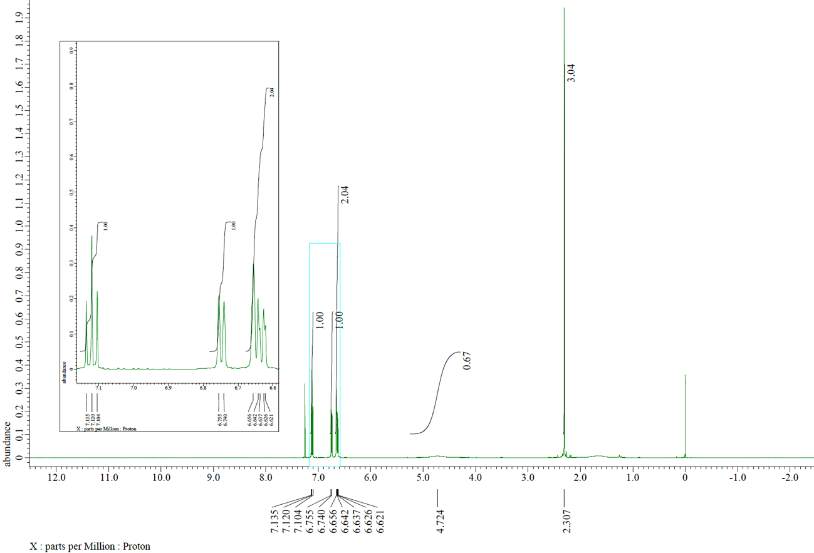
¹³C NMR spectrum (125 MHz, CDCl₃) of 2b
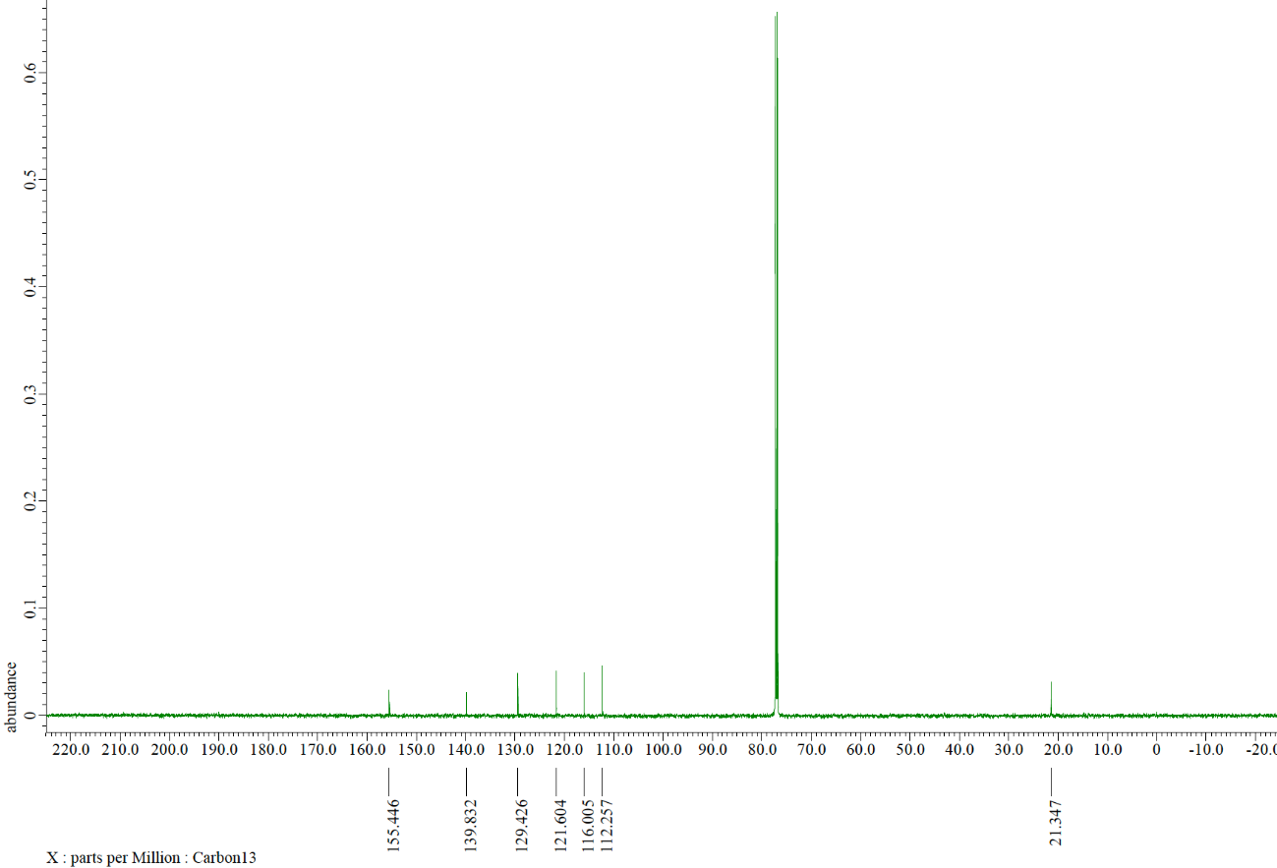
¹H NMR spectrum (500 MHz, CDCl₃) of 2c
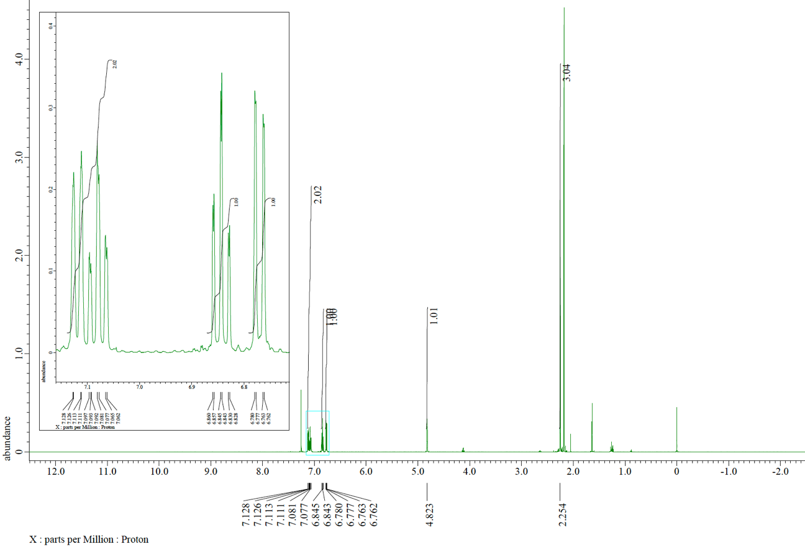
¹³C NMR spectrum (125 MHz, CDCl₃) of 2c
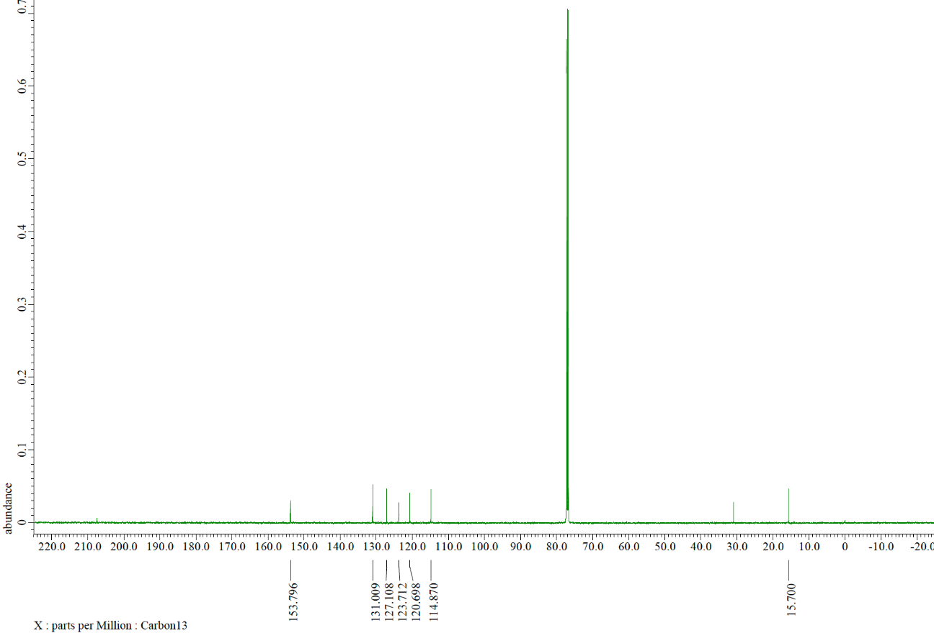
¹H NMR spectrum (500 MHz, CDCl₃) of 2d
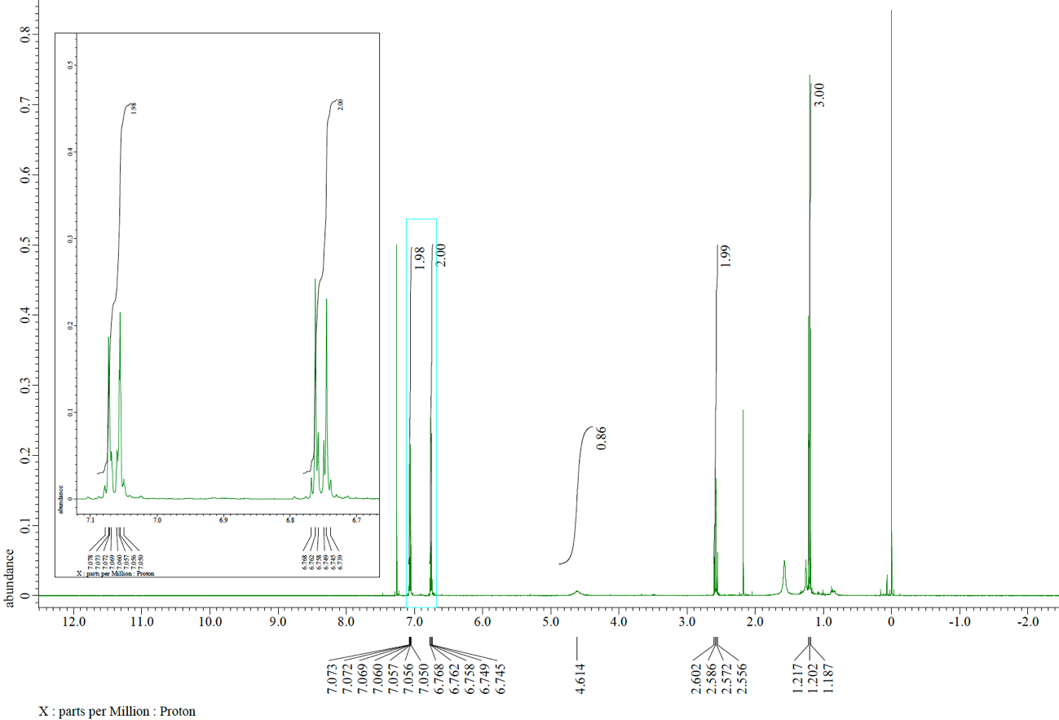
¹³C NMR spectrum (125 MHz, CDCl₃) of 2d
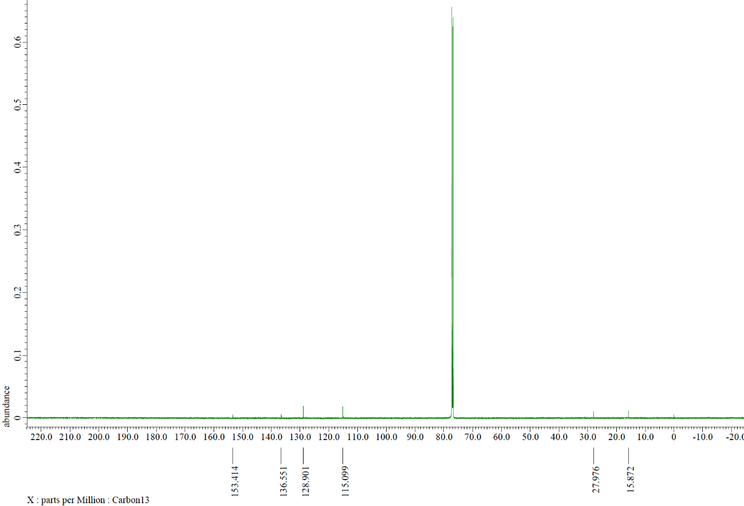
¹H NMR spectrum (500 MHz, CDCl₃) of 2e
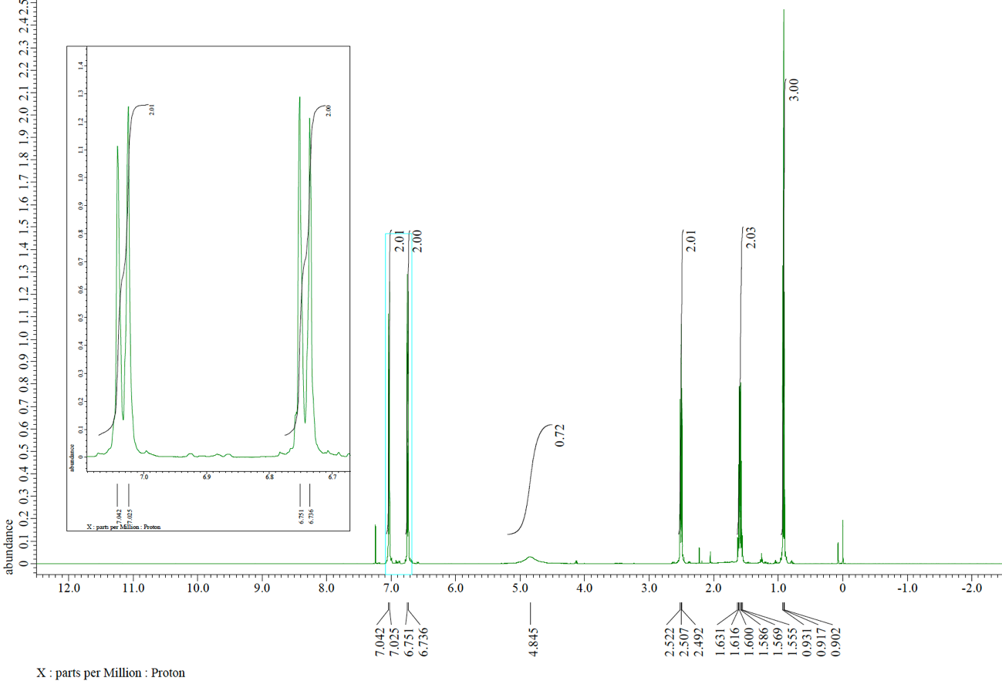
¹³C NMR spectrum (125 MHz, CDCl₃) of 2e
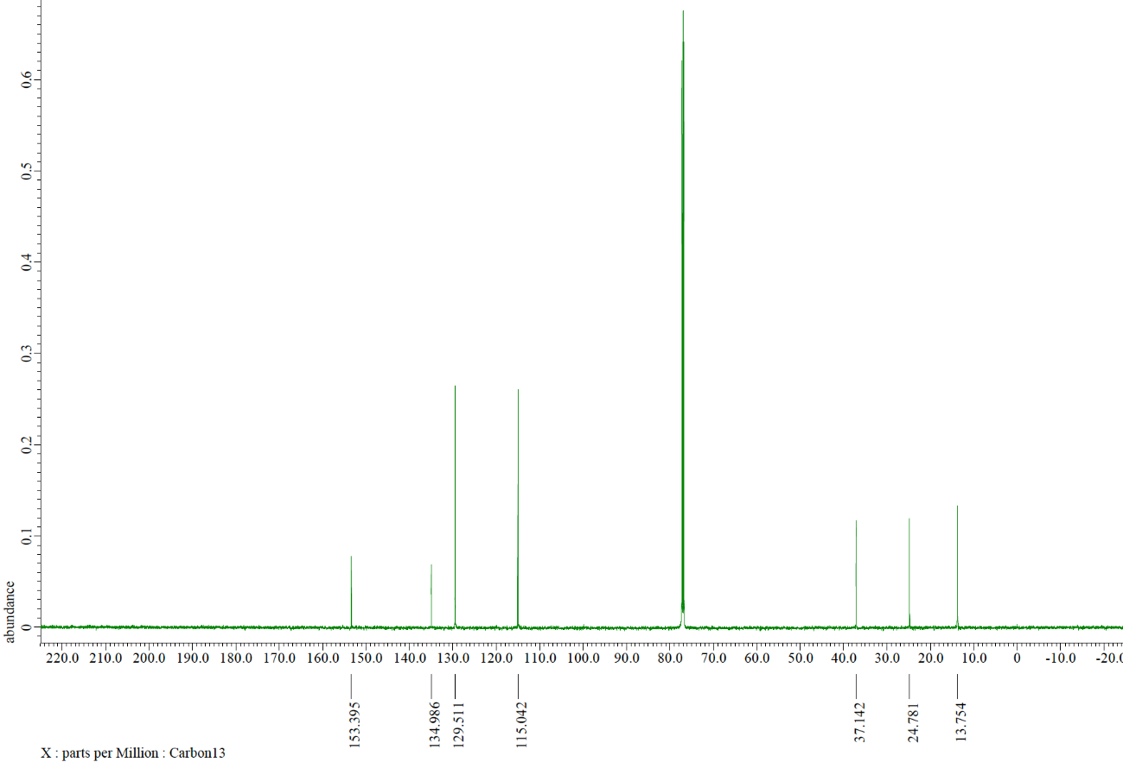
¹H NMR spectrum (500 MHz, CDCl₃) of 2f
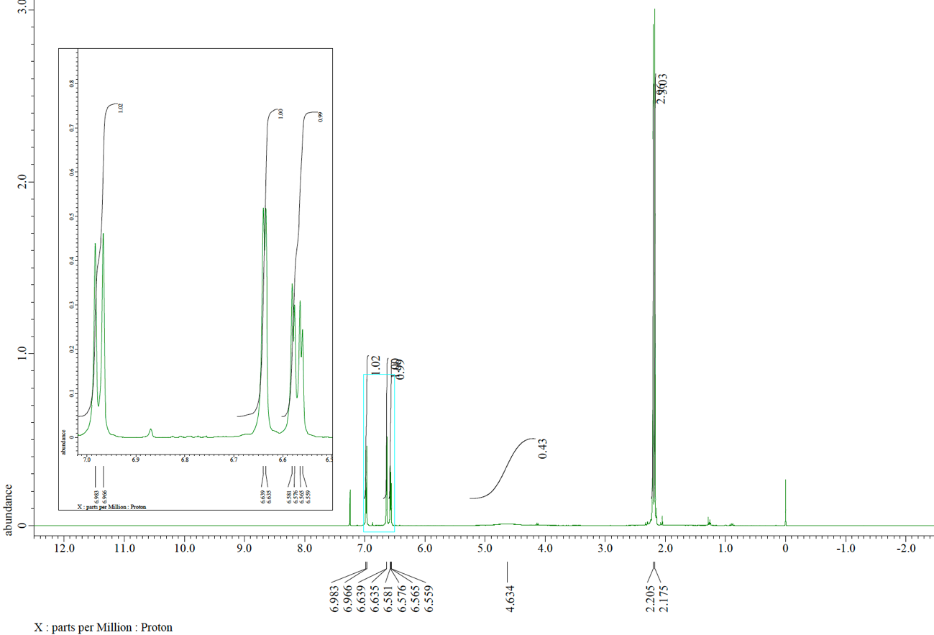
¹³C NMR spectrum (125 MHz, CDCl₃) of 2f
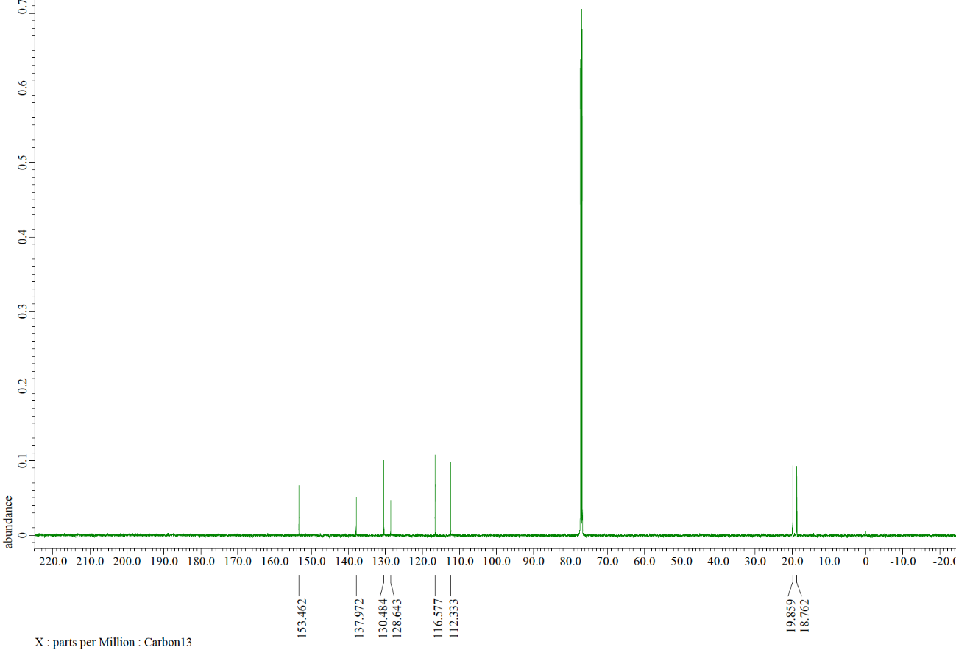
¹H NMR spectrum (500 MHz, CDCl₃) of 2g
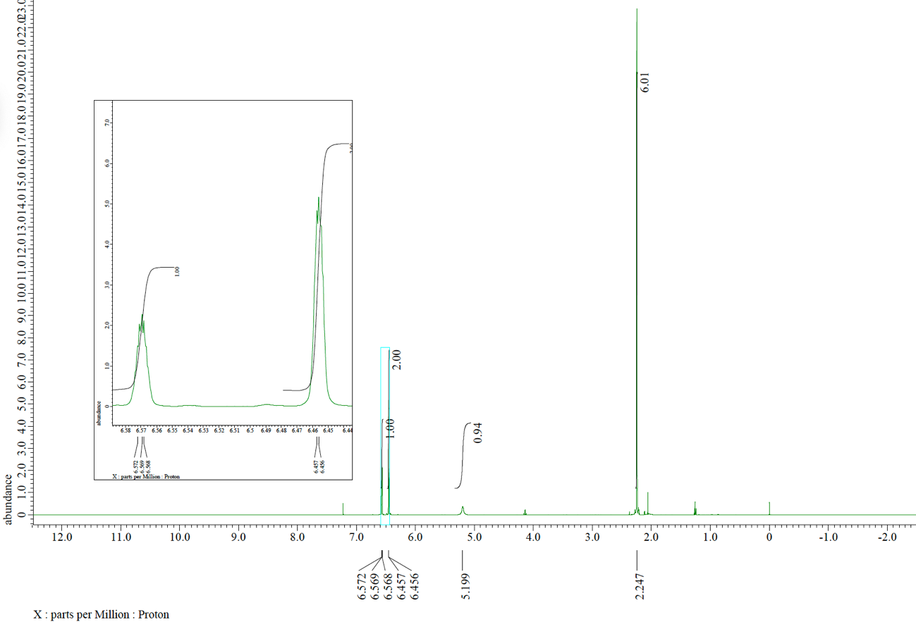
¹³C NMR spectrum (125 MHz, CDCl₃) of 2g
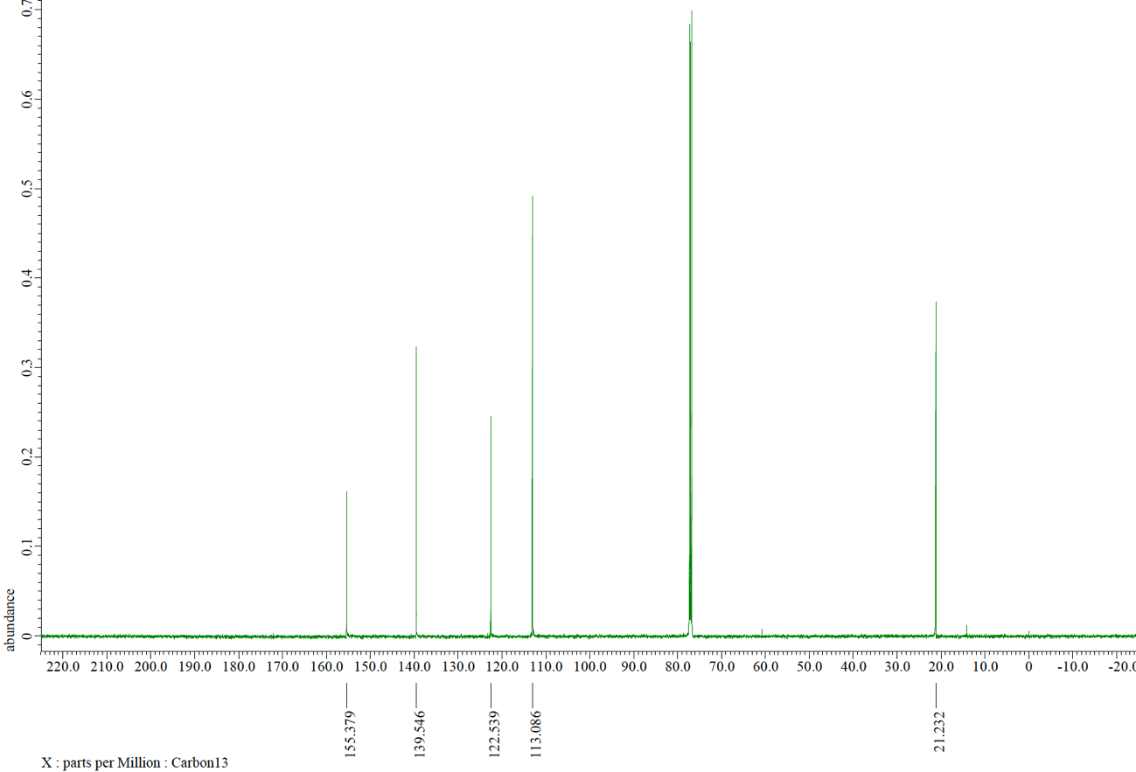
¹H NMR spectrum (500 MHz, CDCl₃) of 2h
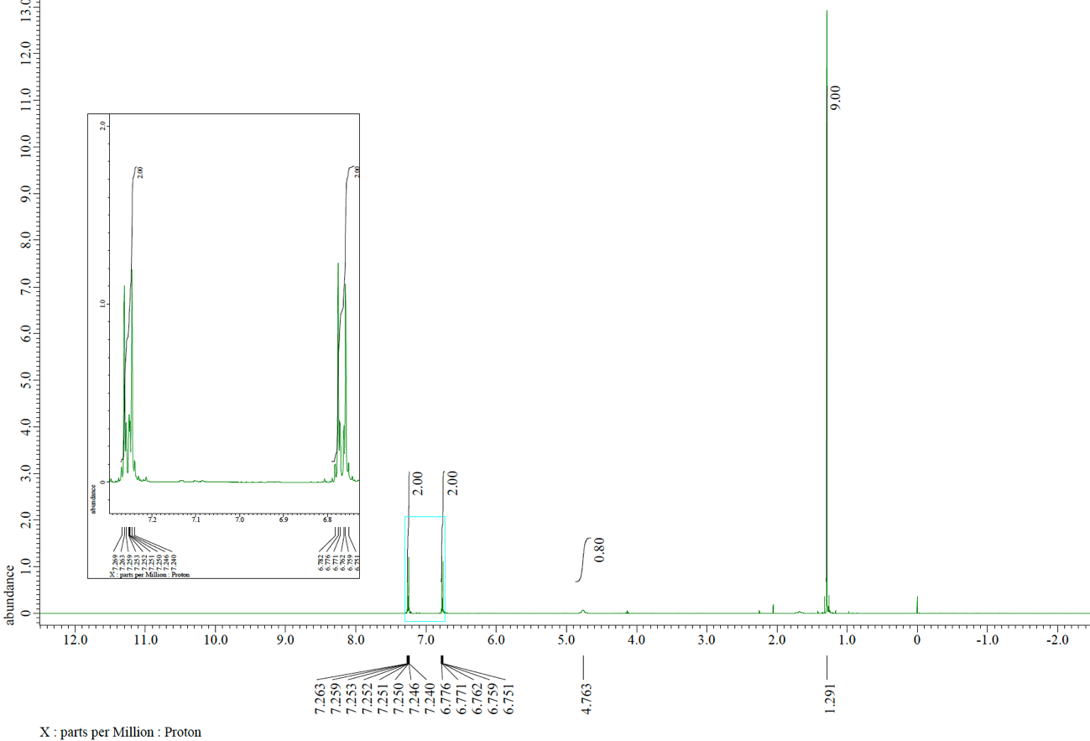
¹³C NMR spectrum (125 MHz, CDCl₃) of 2h
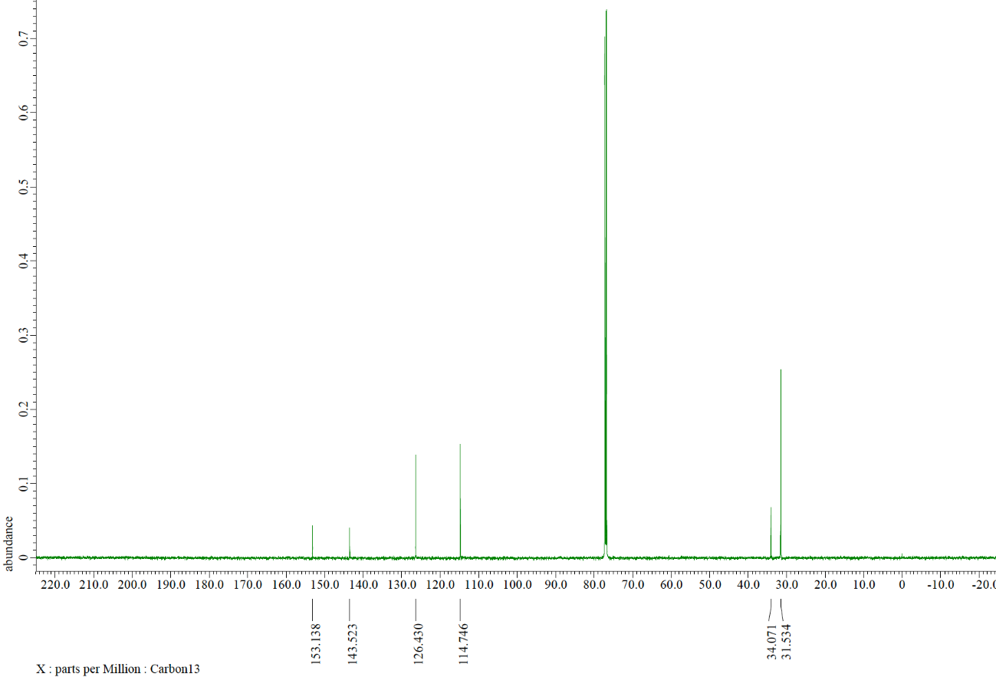
¹H NMR spectrum (500 MHz, CDCl₃) of 2i
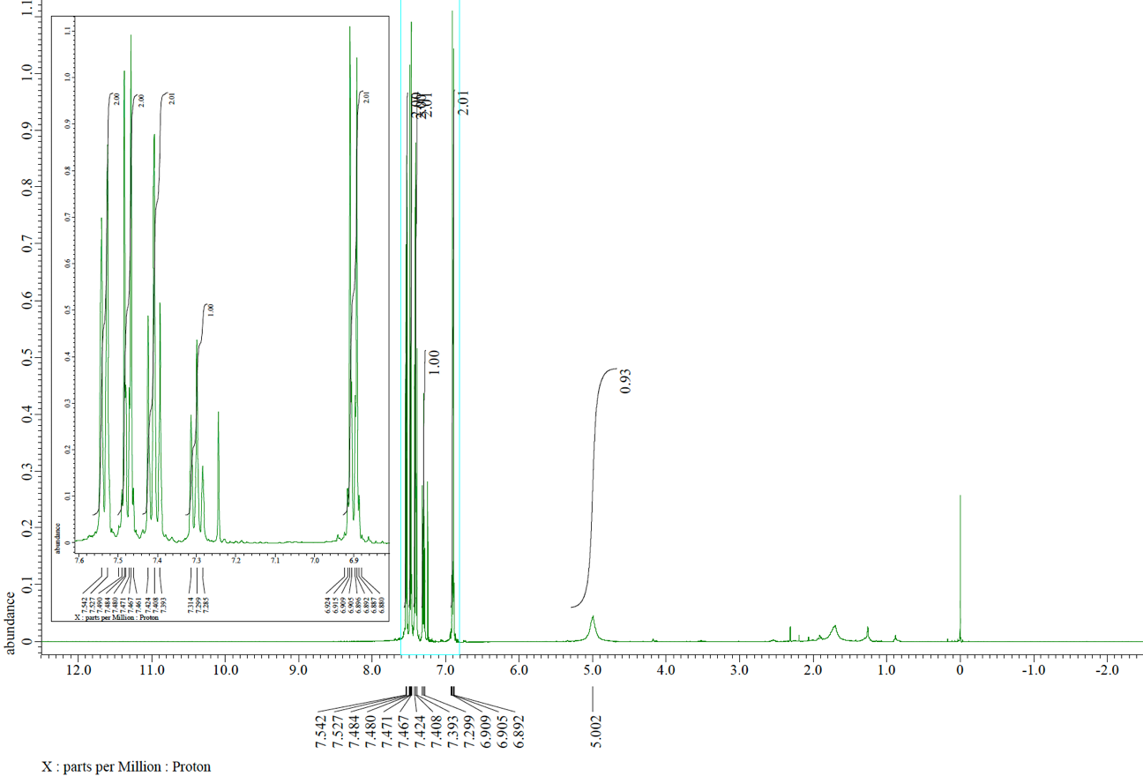
¹³C NMR spectrum (125 MHz, CDCl₃) of 2i
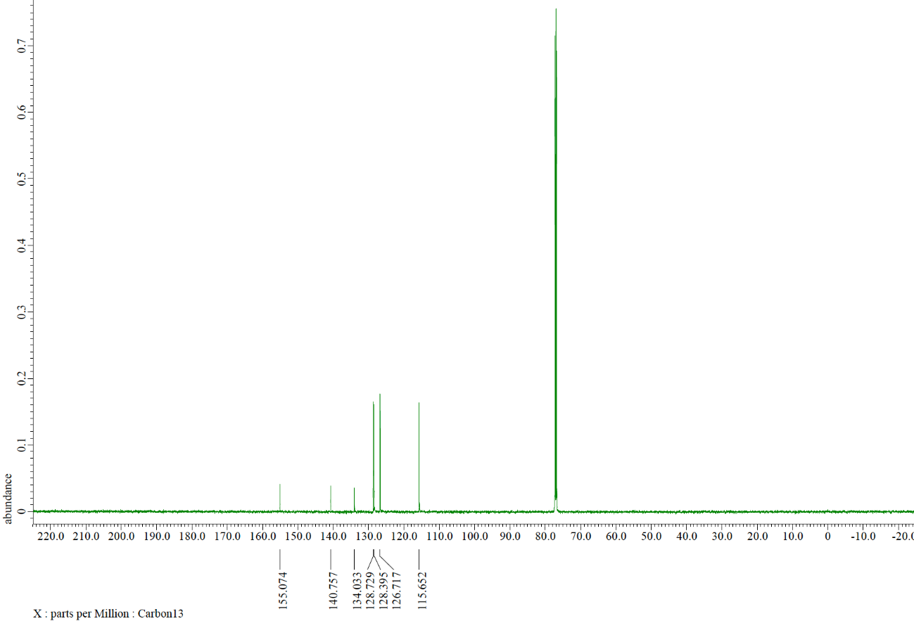
¹H NMR spectrum (500 MHz, CDCl₃) of 2n
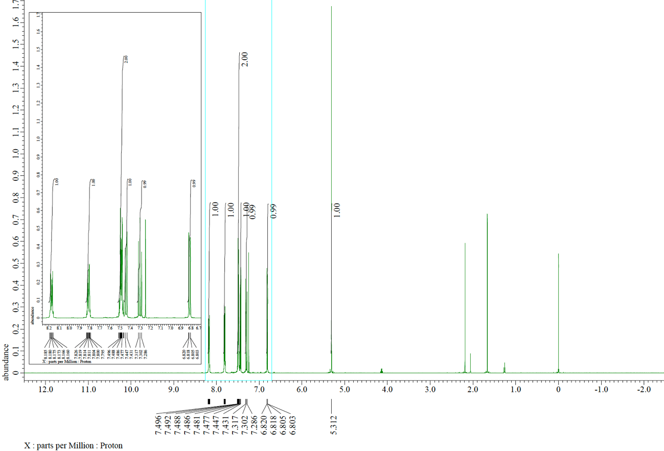
¹³C NMR spectrum (125 MHz, CDCl₃) of 2n
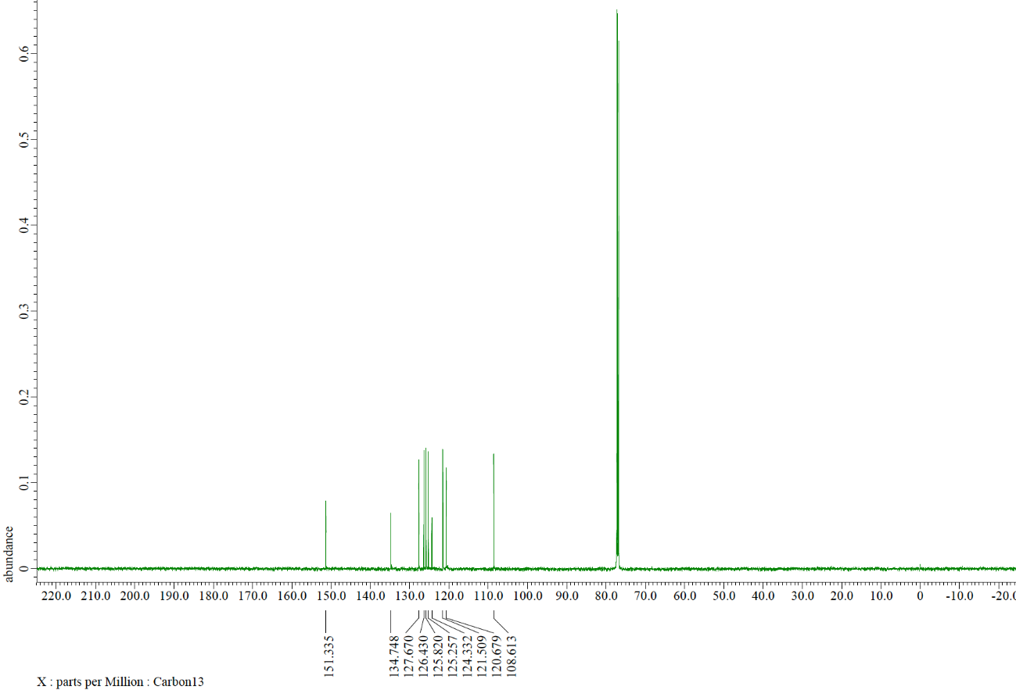
¹H NMR spectrum (500 MHz, CDCl₃) of 5a
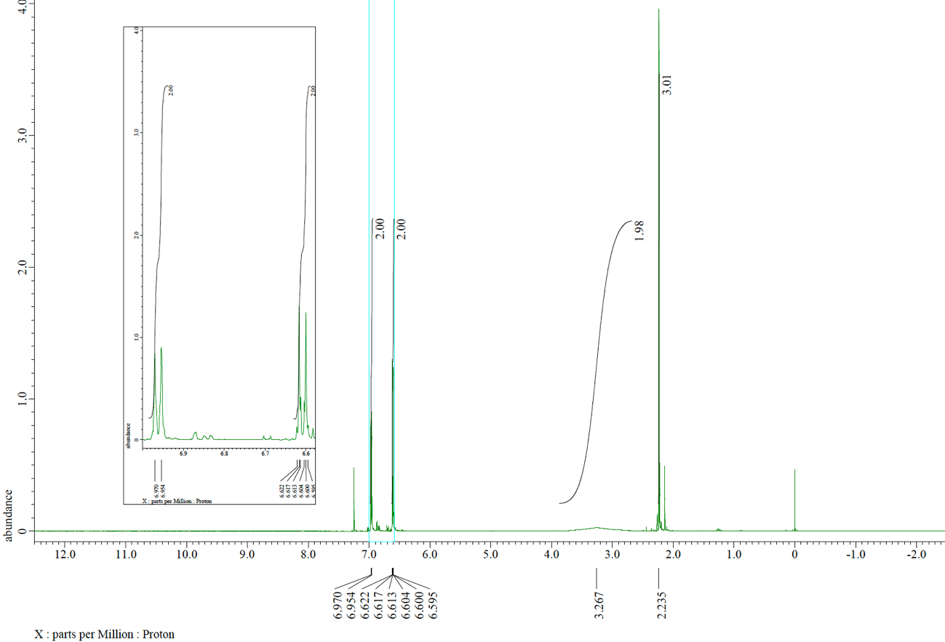
¹³C NMR spectrum (125 MHz, CDCl₃) of 5a
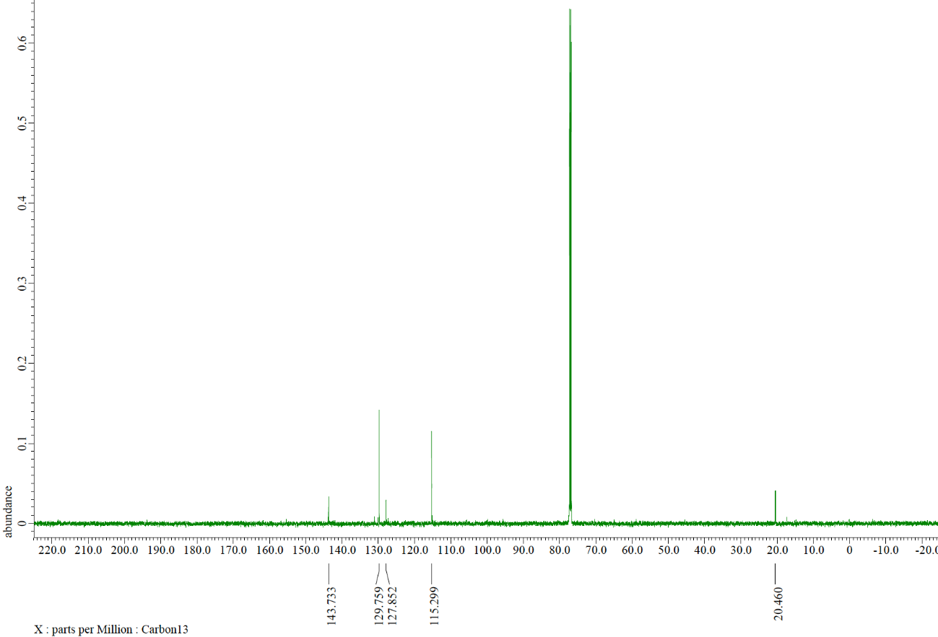
¹H NMR spectrum (500 MHz, CDCl₃) of 5b
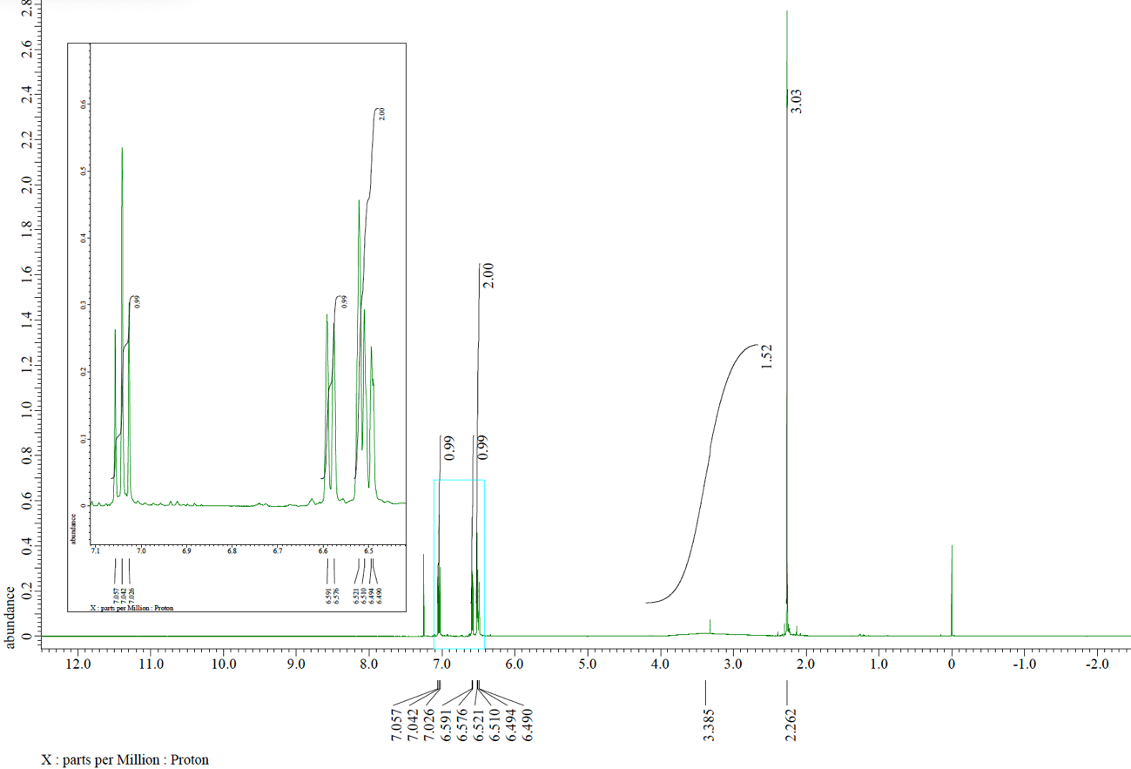
¹³C NMR spectrum (125 MHz, CDCl₃) of 5b
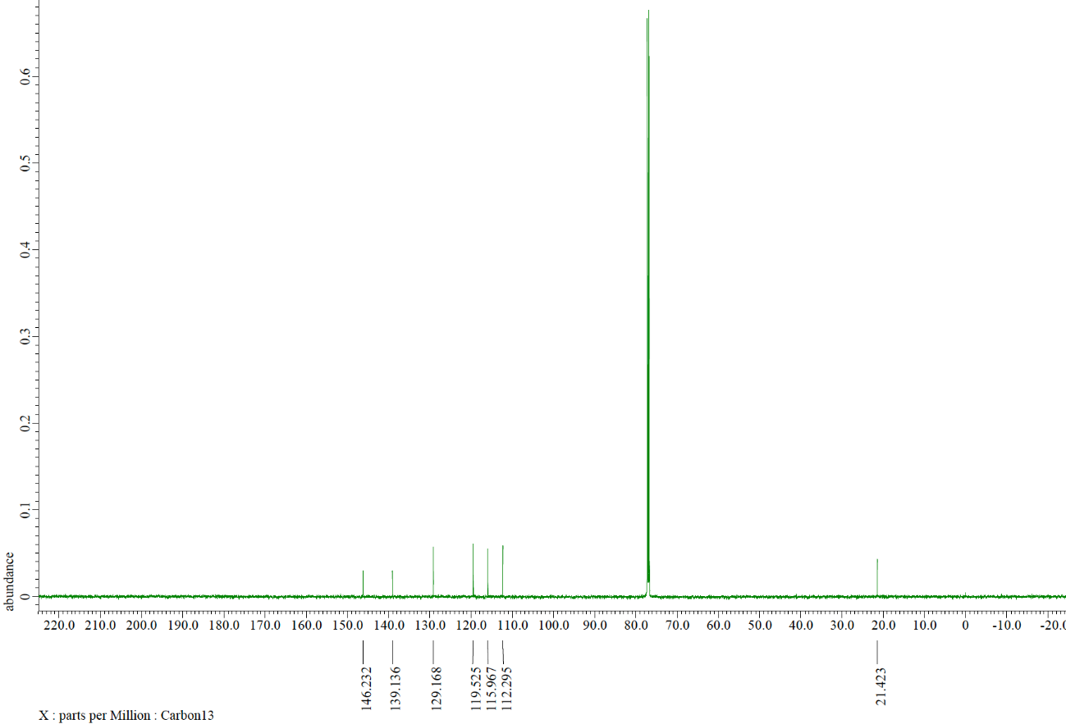
¹H NMR spectrum (500 MHz, CDCl₃) of 7a
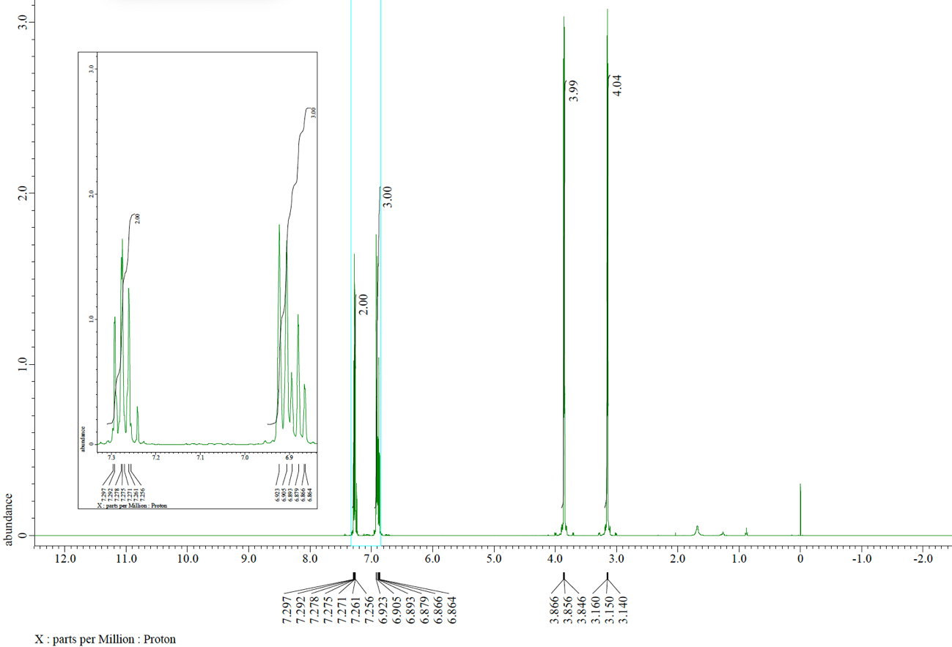
¹³C NMR spectrum (125 MHz, CDCl₃) of 7a
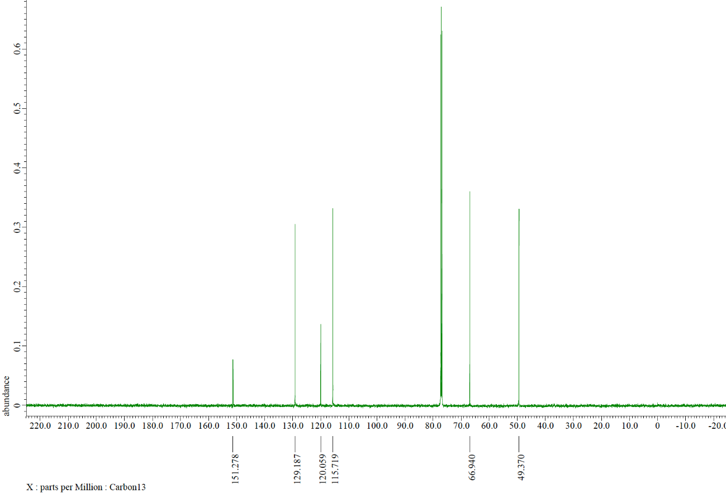
¹H NMR spectrum (500 MHz, CDCl₃) of 7b
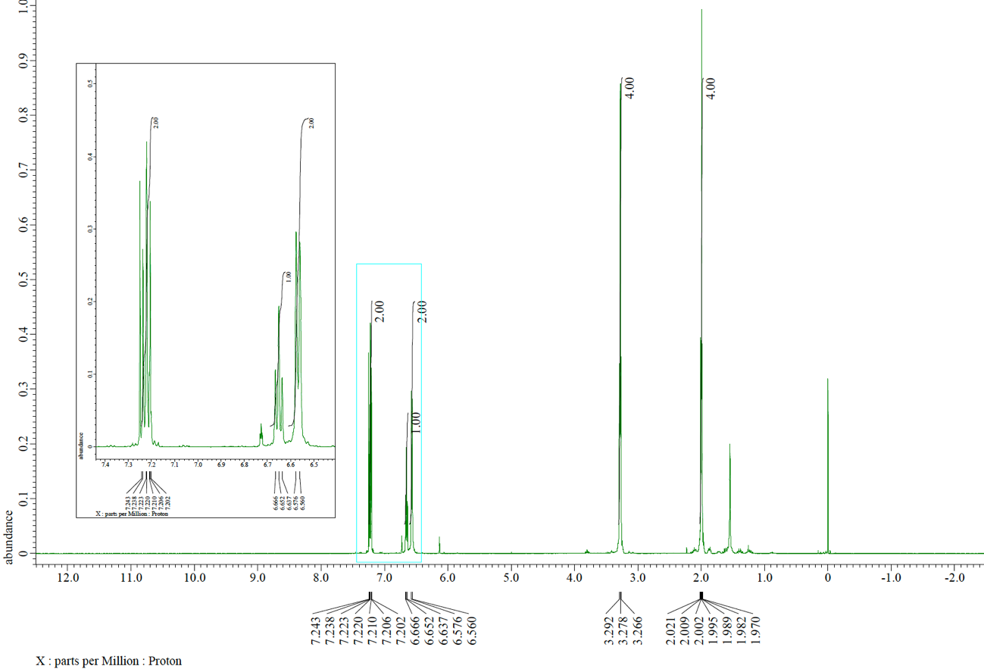
¹³C NMR spectrum (125 MHz, CDCl₃) of 7b
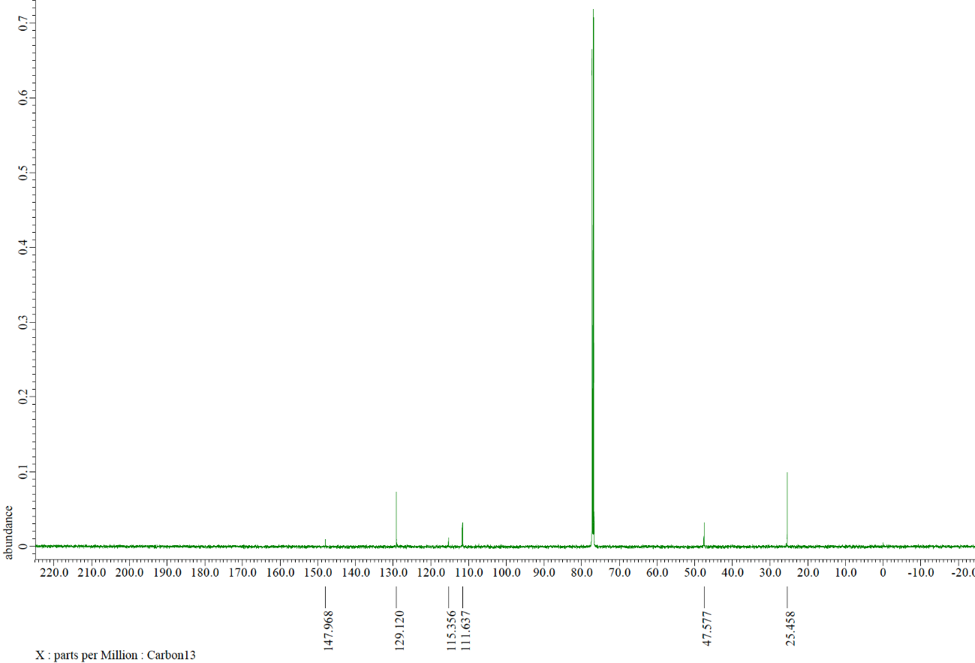
¹H NMR spectrum (500 MHz, CDCl₃) of 7c
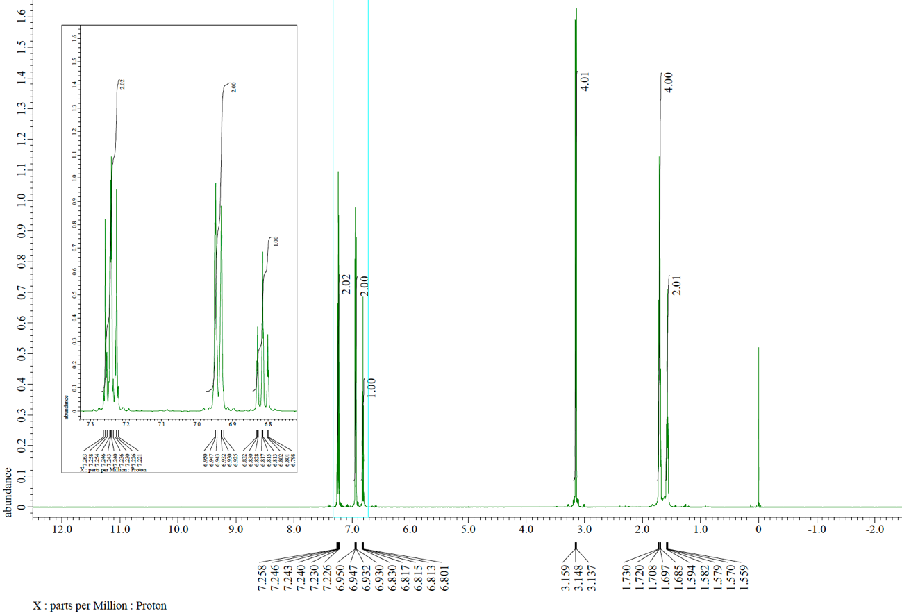
¹³C NMR spectrum (125 MHz, CDCl₃) of 7c
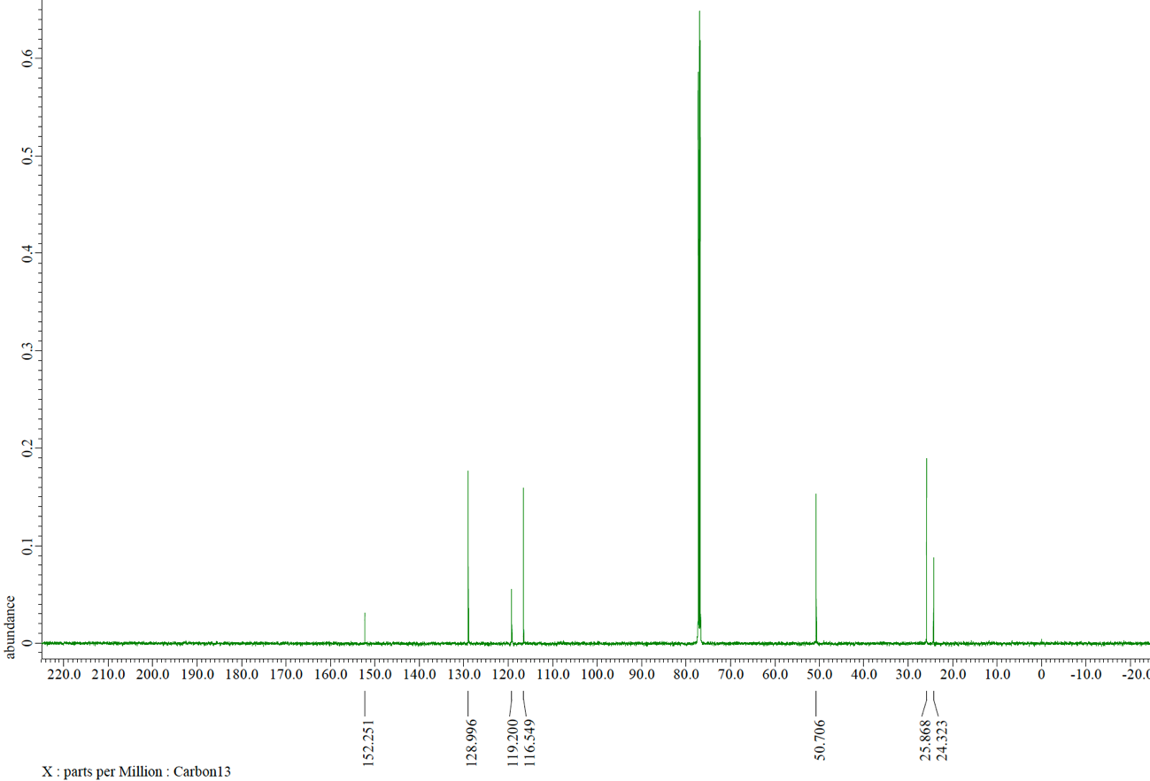
¹H NMR spectrum (500 MHz, CDCl₃) of 9a
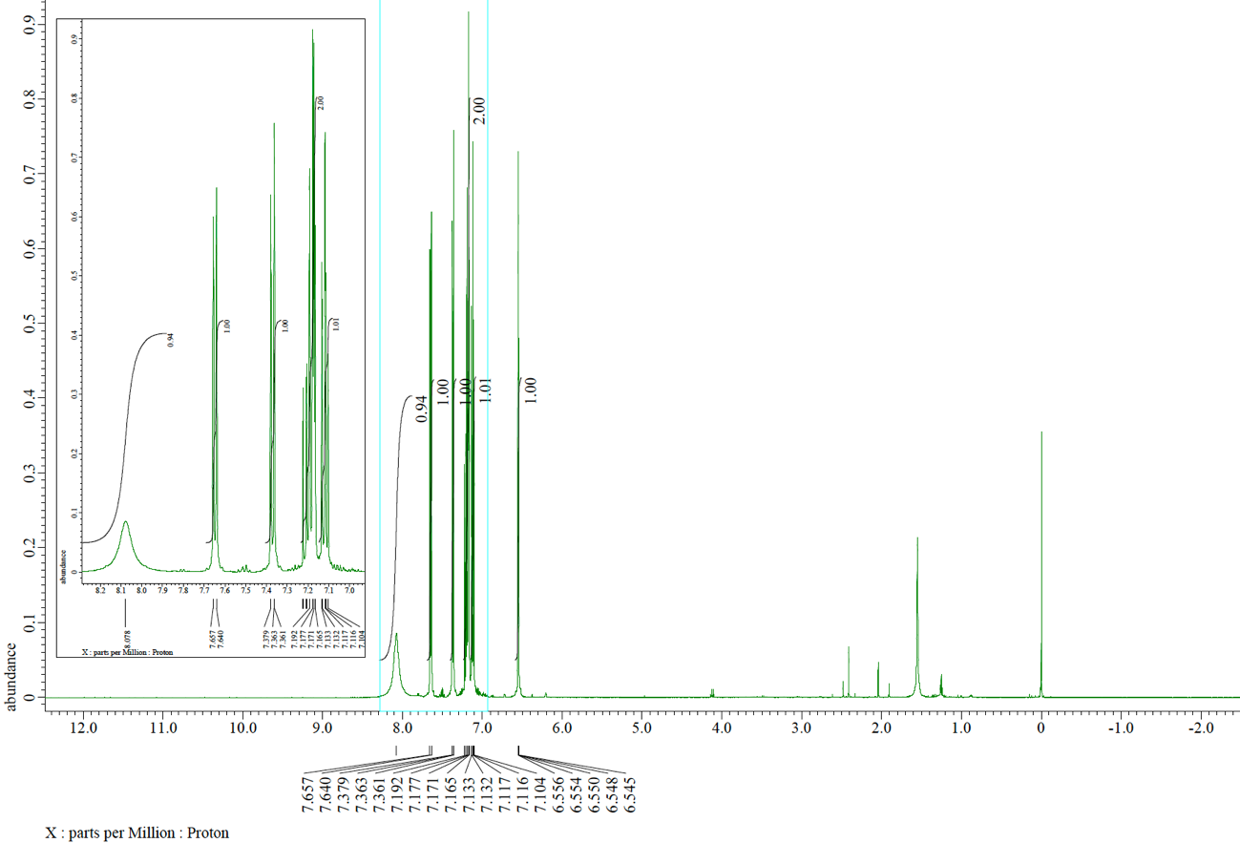
¹³C NMR spectrum (125 MHz, CDCl₃) of 9a
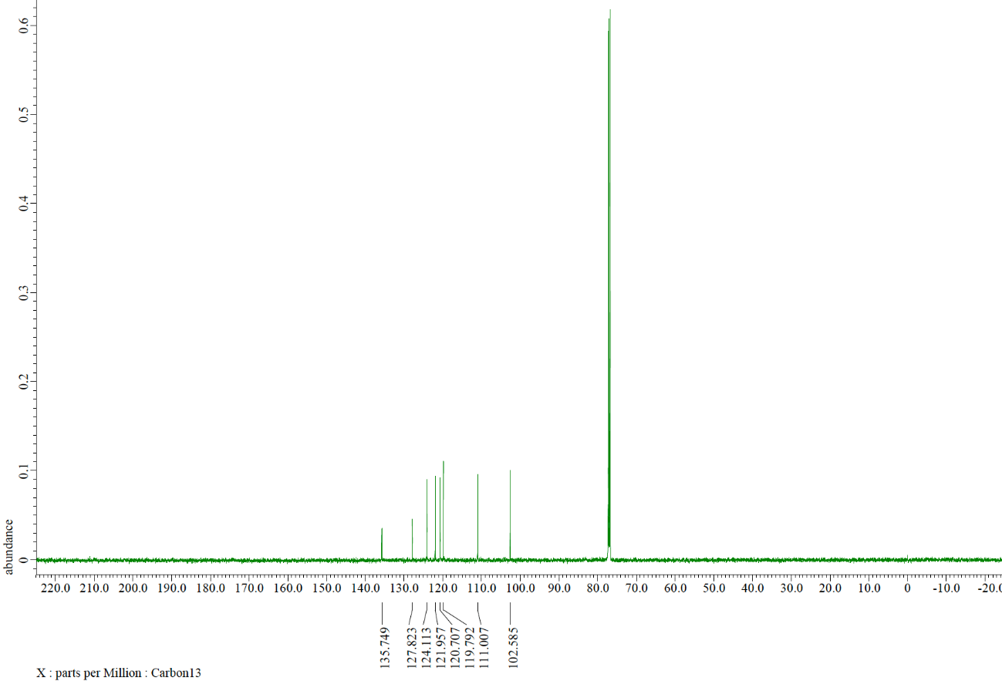
¹H NMR spectrum (500 MHz, CDCl₃) of 9c
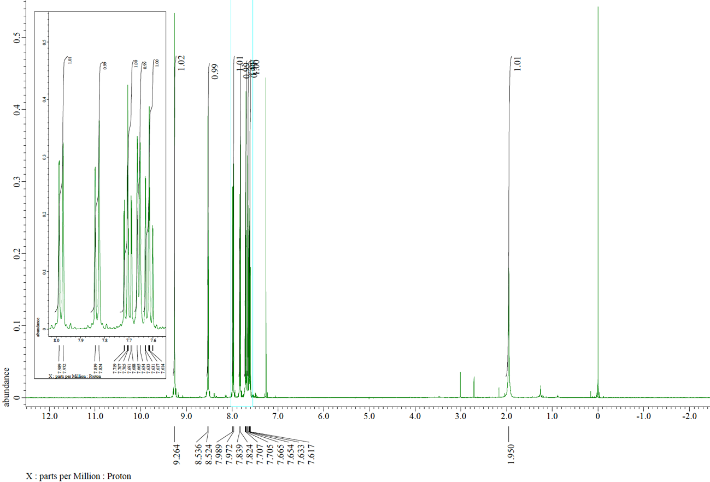
¹³C NMR spectrum (125 MHz, CDCl₃) of 9c
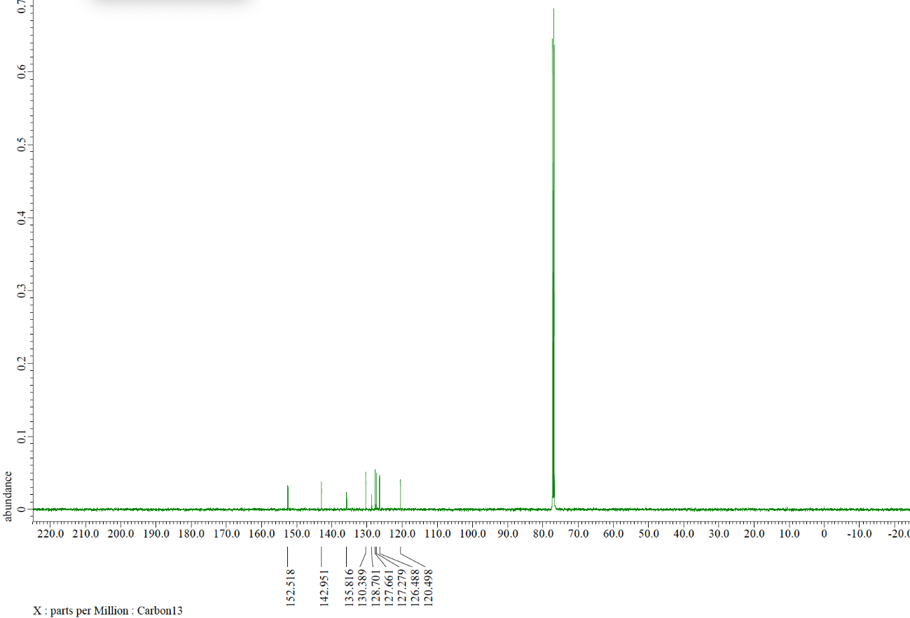
¹H NMR spectrum (500 MHz, CDCl₃) of 9d
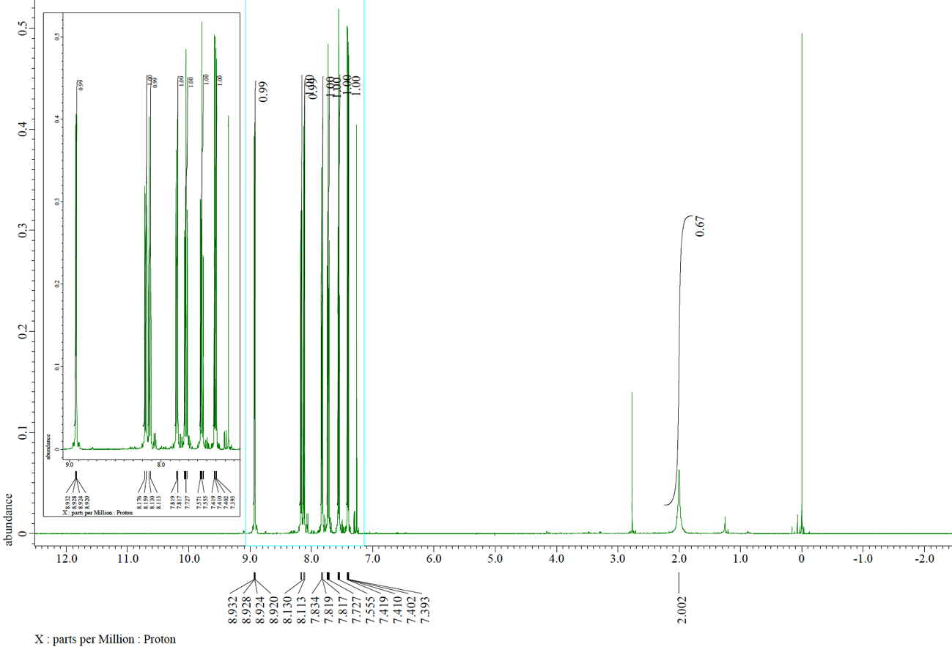
¹³C NMR spectrum (125 MHz, CDCl₃) of 9d
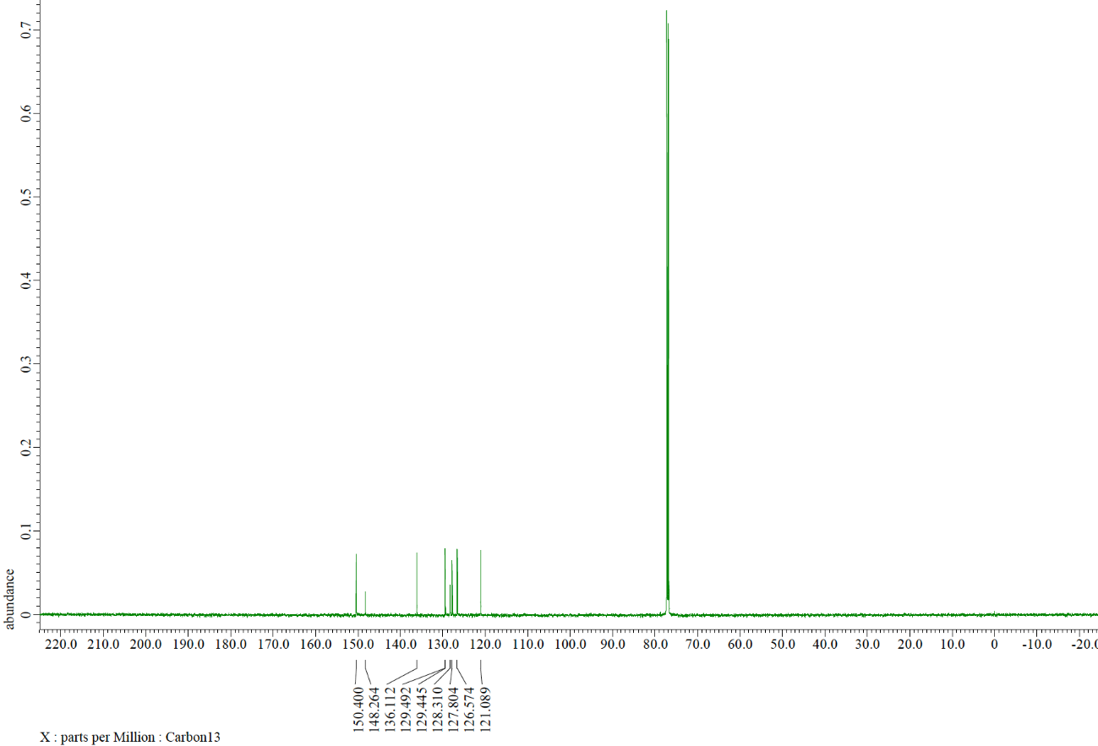
¹H NMR spectrum (500 MHz, CDCl₃) of 11a
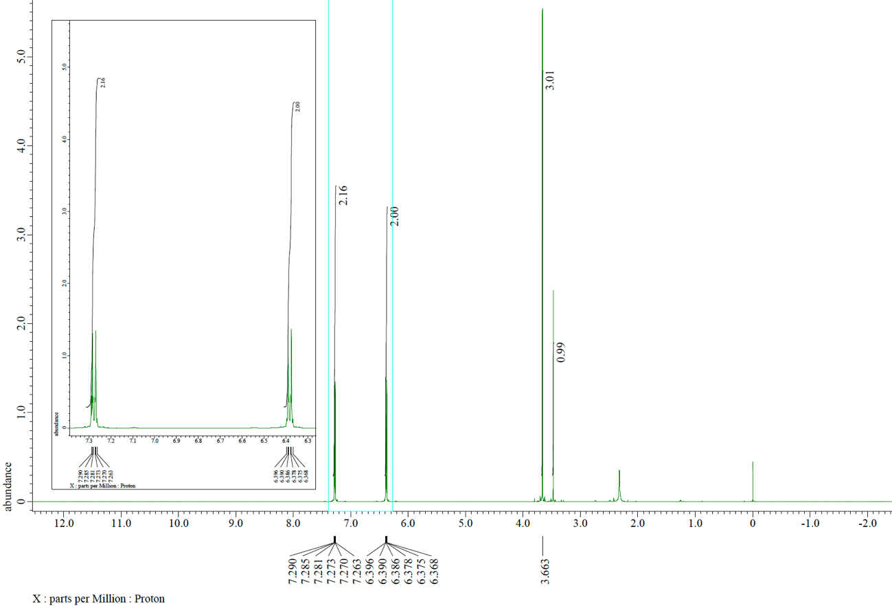
¹³C NMR spectrum (125 MHz, CDCl₃) of 11a
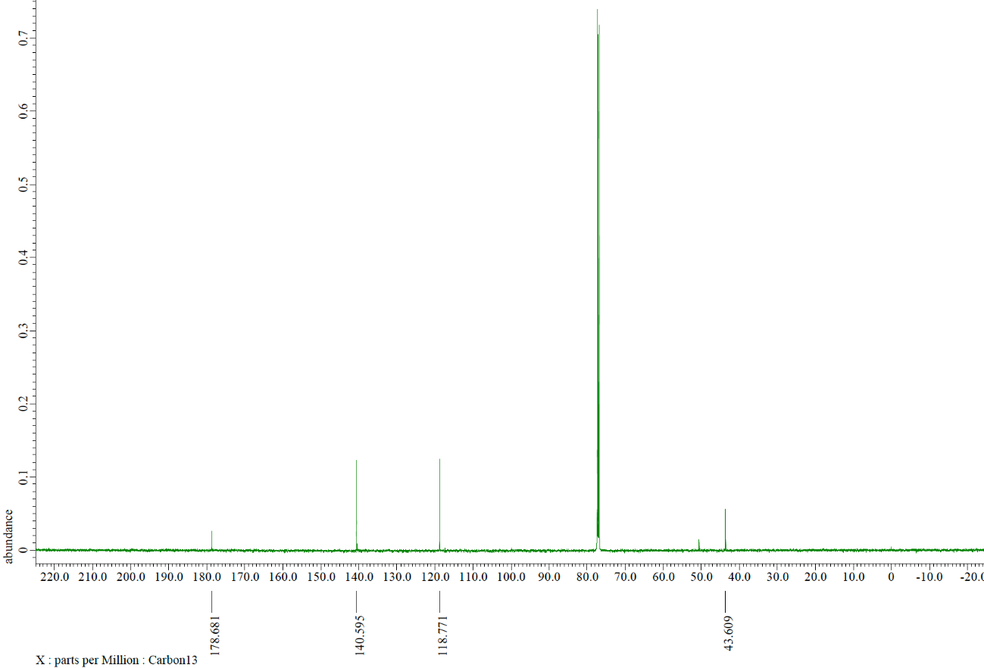
¹H NMR spectrum (500 MHz, CDCl₃) of 11b
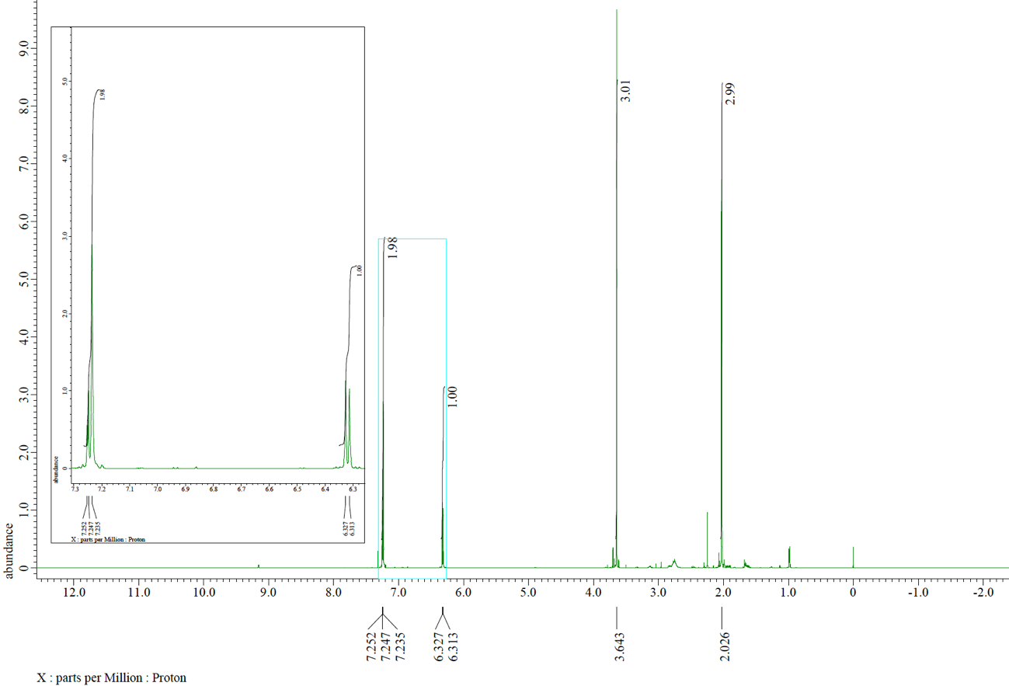
¹³C NMR spectrum (125 MHz, CDCl₃) of 11b

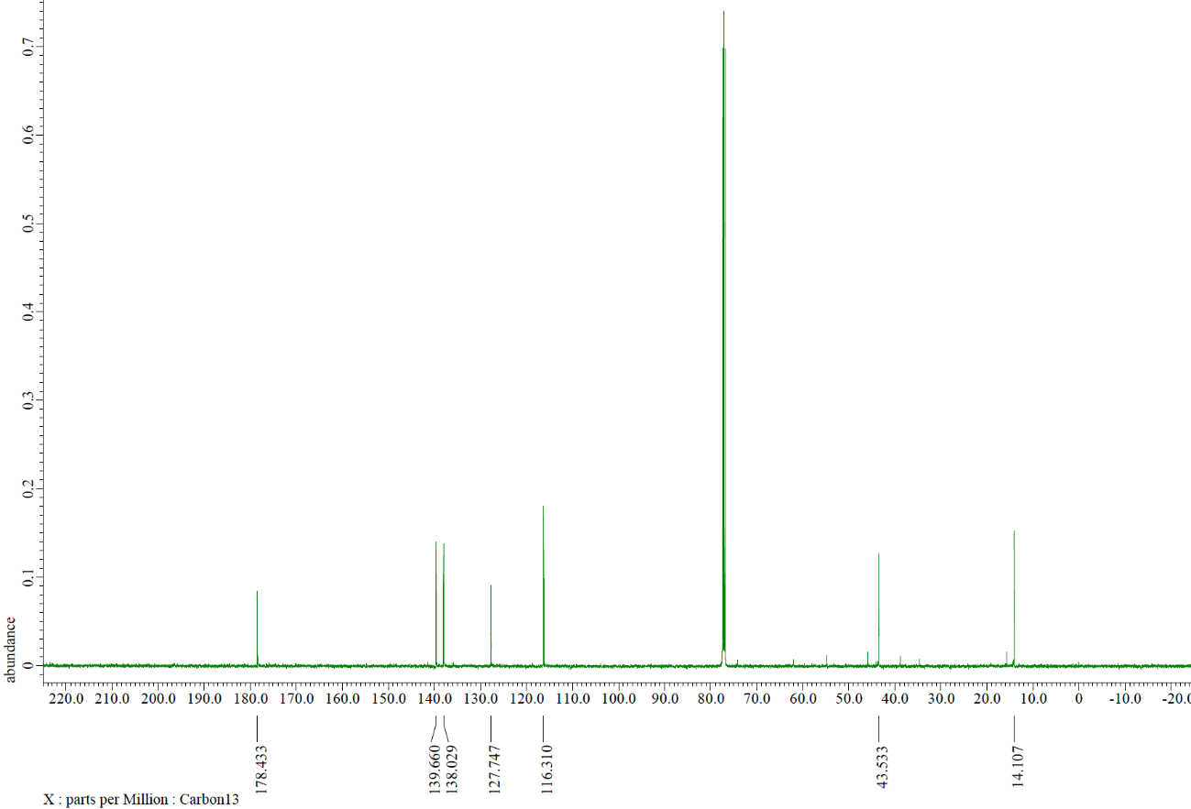
¹H NMR spectrum (500 MHz, CDCl₃) of 11c
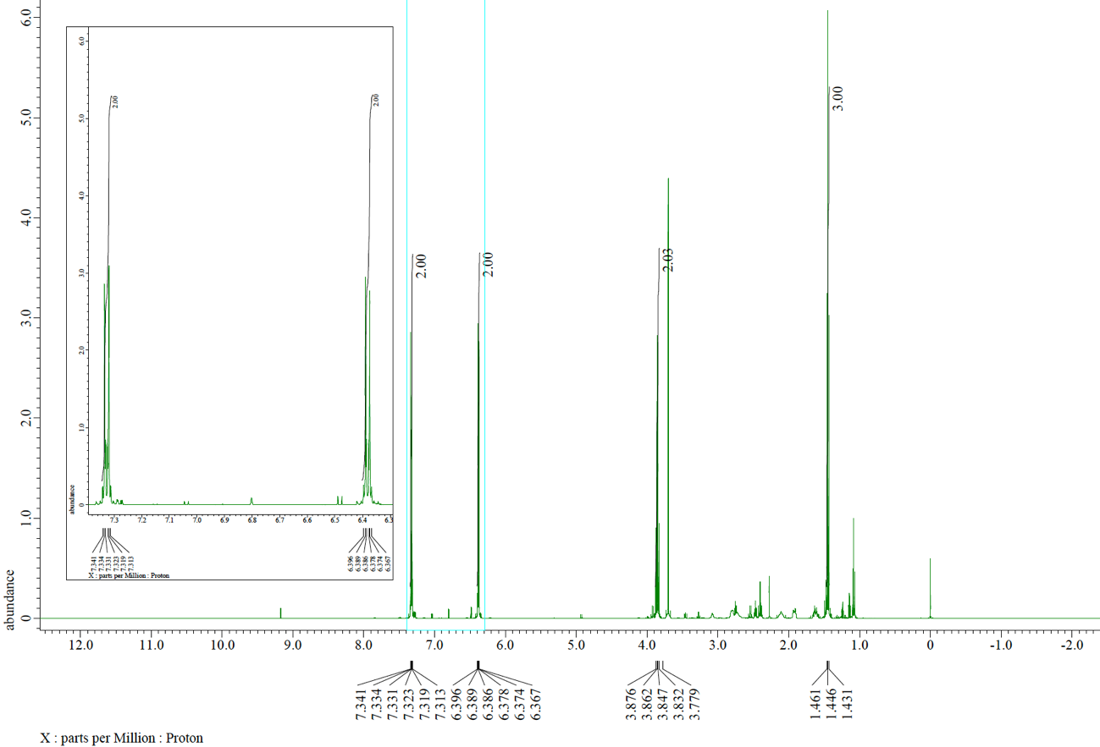
¹³C NMR spectrum (125 MHz, CDCl₃) of 11c
