Enhanced catalysis through structurally modified hybrid 2-D boron nitride nanosheets comprising of complexed 2-hydroxy-4-methoxybenzophenone motif
Pooja Rana¹, Ranjana Dixit¹, Shivani Sharma¹, Sriparna Dutta¹, Sneha Yadav¹, Aditi Sharma¹, Bhawna Kaushik¹, Pooja Rana¹, Alok Adholeya²* and Rakesh K. Sharma¹*
¹ Green Chemistry Network Centre, Department of Chemistry, University of Delhi, NewDelhi-110007, India. Fax: +91-011-27666250; Tel: 011-276666250 Email: rksharmagreenchem@hotmail.com
²TERI-Deakin Nanobiotechnology Centre, TERI Gram, The Energy and Resources Institute, Gurugram 122102, India

Table of Contents

S. No. | Content | Page No.
1. | Results and Discussion | S3
 | FT-IR analysis | S3
 | XPS analysis | S4
 | EDS, ED-XRF | S5
2. | Tables | S6
 | Table S1 Screening of various catalysts for the synthesis of tetrazoles | S6
 | Table S2 Comparison of the catalytic activity of h-BN@APTES@BP@Cu with previously reported protocols | S7
3. | Recyclability tests | S8
4. | GC-MS spectra | S9-S22

Results and Discussion
FT-IR analysis
Figure S1. FT-IR spectra of (a) h-BN, (b) h-BN@OH, (c) h-BN@APTES, (d) h- BN@APTES@BP and (e) h-BN@APTES@BP@Cu.

XPS analysis
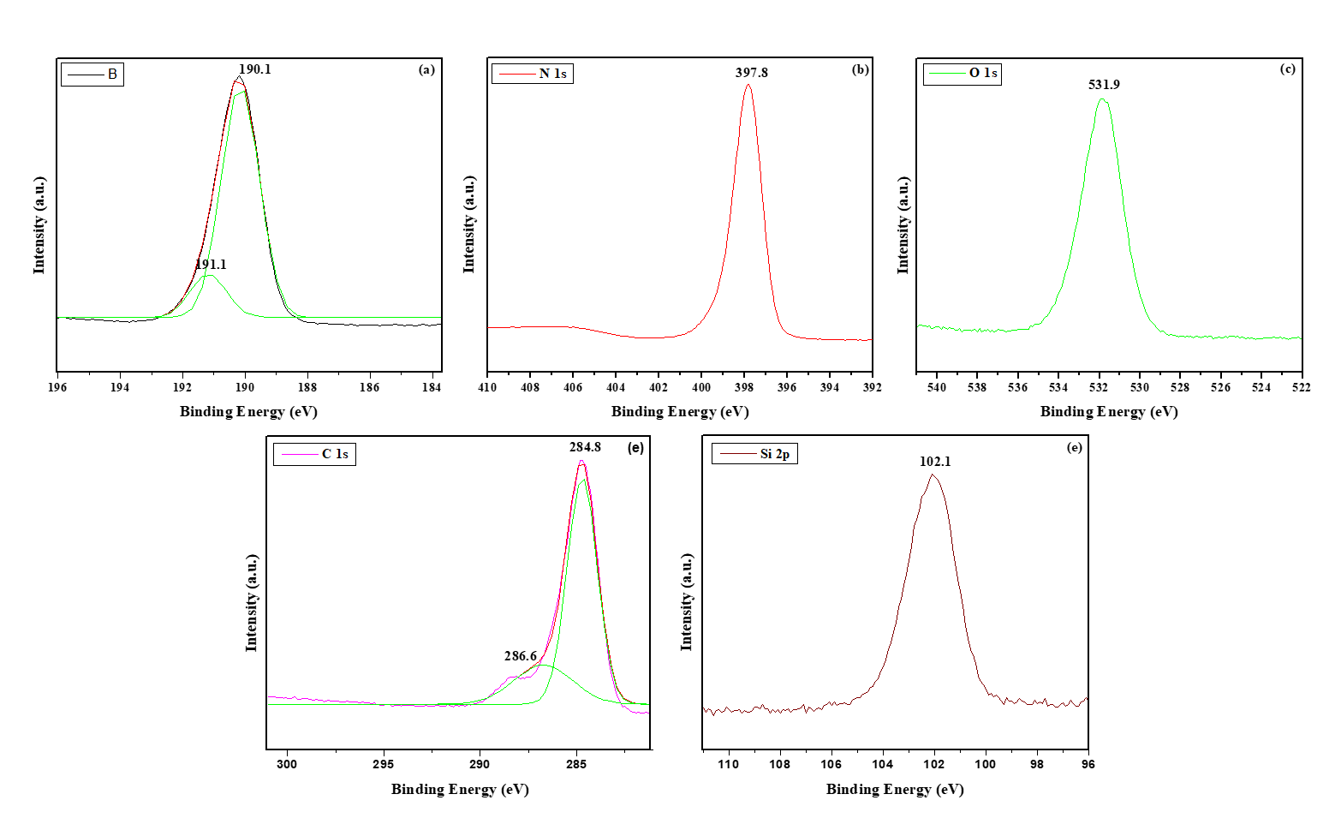
Figure S2. Core level region XPS spectra of (a) B 1s, (b) N 1s, (c) O 1s, (d) C 1s and (e) Si 2p.

EDS
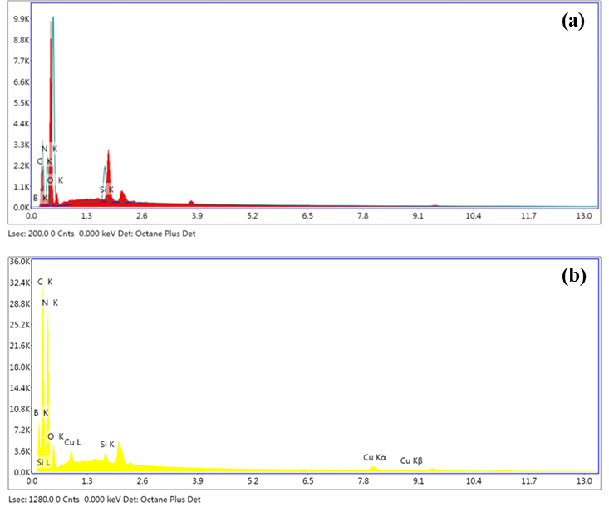
Figure S3. The EDS spectra of (a) h-BN@APTES and (b) h-BN@APTES@BP@Cu.
ED-XRF
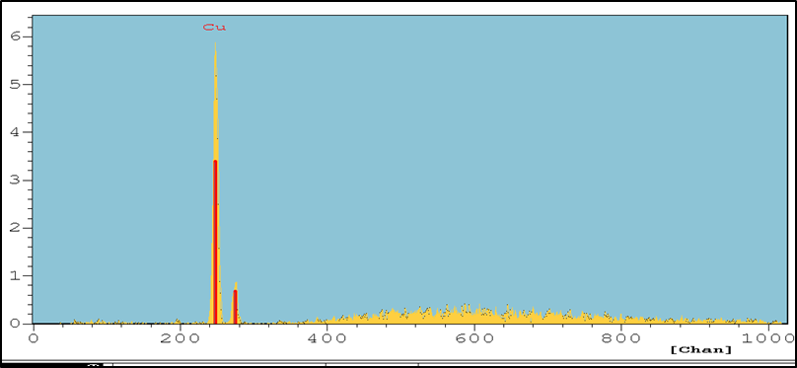
Figure S4. ED-XRF spectrum of h-BN@APTES@BP@Cu.

Table S1. Screening of various catalysts for the synthesis of 5-phenyl 1H-tetrazoles via [3+2] cycloaddition of benzonitrile and sodium azideª.
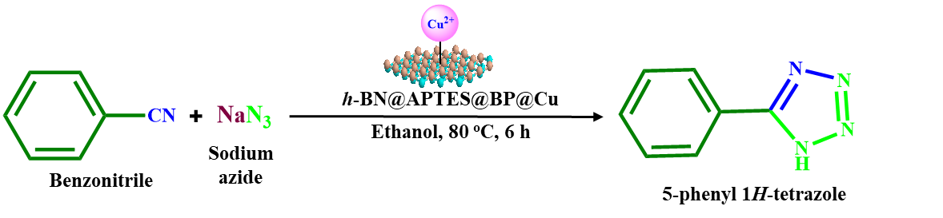
Entry | Catalyst | Conversion % ^{b}
1. | No catalyst | Trace amount
2. | Cobalt chloride | 93
3. | Nickel chloride | 86
4. | h-BN@OH | Trace amount
5. | h-BN@APTES | Trace amount
6. | h-BN@APTES@BP | Trace amount
7. | h-BN@APTES@BP@Cu | 100
ªReaction conditions: benzonitrile (1 mmol), sodium azide (2 mmol), catalyst (20 mg), ethanol (1 mL), 6 h, 80 ºC. ^{b}Conversion percentage were determined via GC-MS.

Table S2. Comparison of the catalytic activity of h-BN@APTES@BP@Cu nanocatalyst with other previously reported catalysts for [3+2] cycloaddition of benzonitrile and sodium azide.
Entry | Aryl nitrile | Sodium azide | Catalytic conditions | Yield (%) | Reference
1. |  | NaN₃ | CoY, DMF, 120 ºC, 14 h | 90 | 39
2. |  | NaN₃ | 3D Porous ZnO, DMF, 125 °C, 14 h | 87 | 40
3. |  | NaN₃ | ZnO/Co₃O₄, DMF, 120 ºC, 12 h | 90 | 41
4. |  | NaN₃ | β-CD, NH₄Cl, DMF, 120 °C, 0.75 h | 89 | 42
5. |  | NaN₃ | Pt NPs@GO, DMF, 75 °C, 2 h | 96 | 43
6. |  | NaN₃ | h-BN@APTES@BP@Cu, ethanol,  80 ºC, 6 h | 99 (100)ª | Present study
ªConversion percentage was determined via GC-MS.

Recyclability tests
Figure S5. SEM image of recovered h-BN@APTES@BP@Cu catalyst.
Figure S6. XRD spectrum of recovered h-BN@APTES@BP@Cu catalyst.

GC-MS spectra
Figure S7. GC spectrum of 5-Phenyl-1H-tetrazole, Table 1, Entry 1.
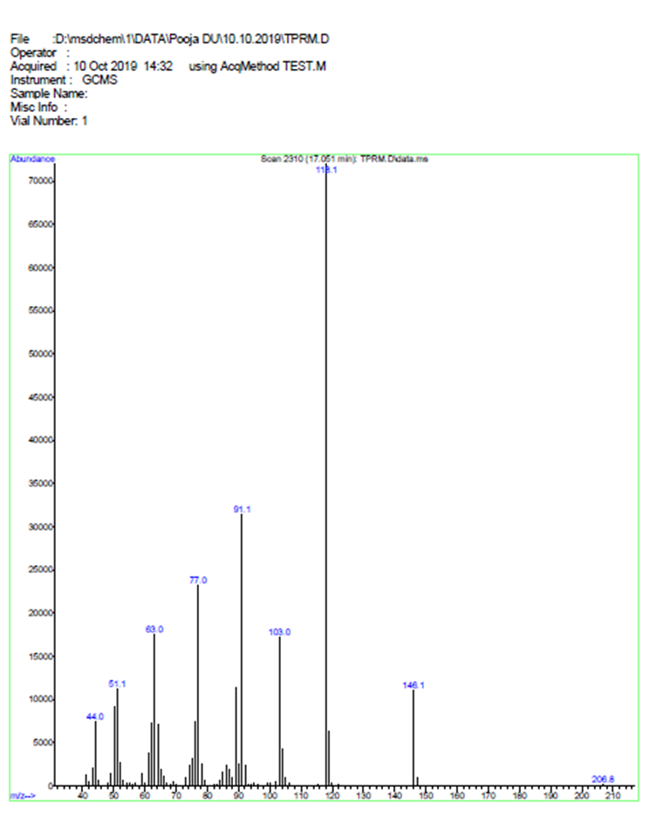
Figure S8. MS spectrum of 5-Phenyl-1H-tetrazole, Table 1, Entry 1.

Figure S9. GC spectrum of 5-(4-Cyanophenyl)-1H-tetrazole, Table 1, Entry 2.
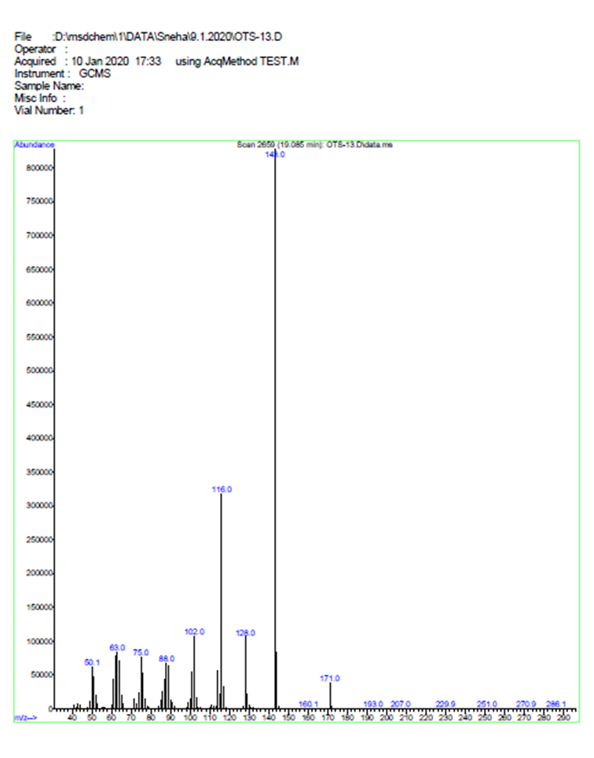Figure S10. MS spectrum of 5-(4-Cyanophenyl)-1H-tetrazole, Table 1, Entry 2.

Figure S11. GC spectrum of 5-(4-Nitrophenyl)-1H-tetrazole, Table 1, Entry 3.

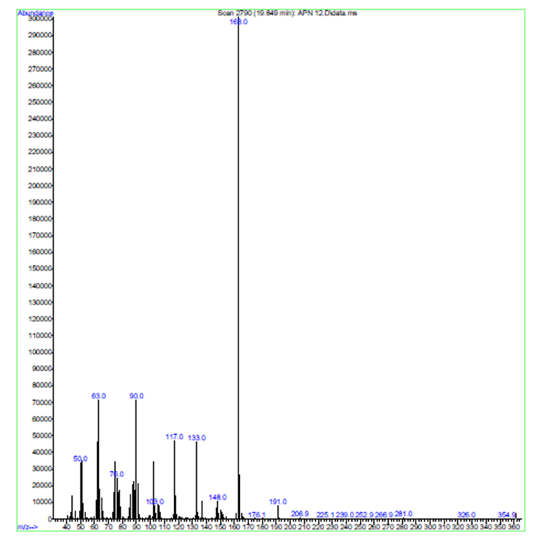
Figure S12. MS spectrum of 5-(4-Nitrophenyl)-1H-tetrazole, Table 1, Entry 3.

Figure S13. GC spectrum of 5-(2-Chlorophenyl)-1H-tetrazole, Table 1, Entry 4.

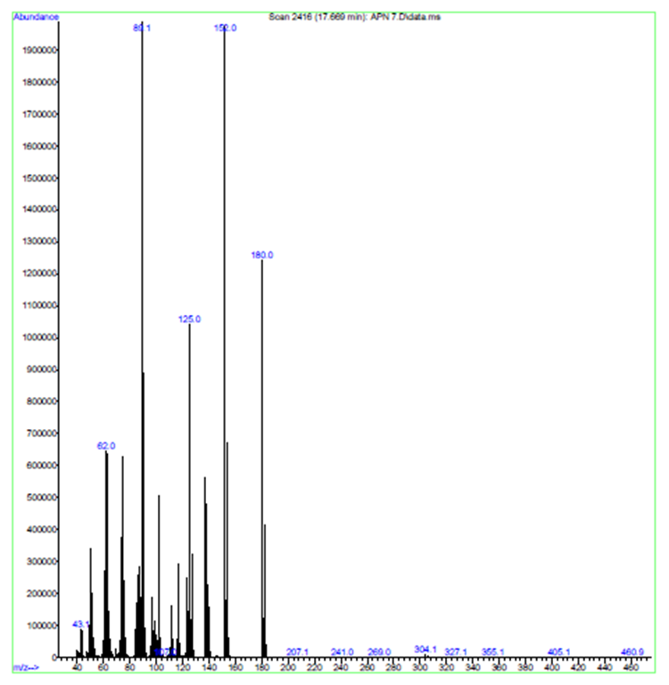
Figure S14. MS spectrum of 5-(2-Chlorophenyl)-1H-tetrazole, Table 1, Entry 4.

Figure S15. GC spectrum of 5-(4-Methylphenyl)-1H-tetrazole, Table 1, Entry 5.

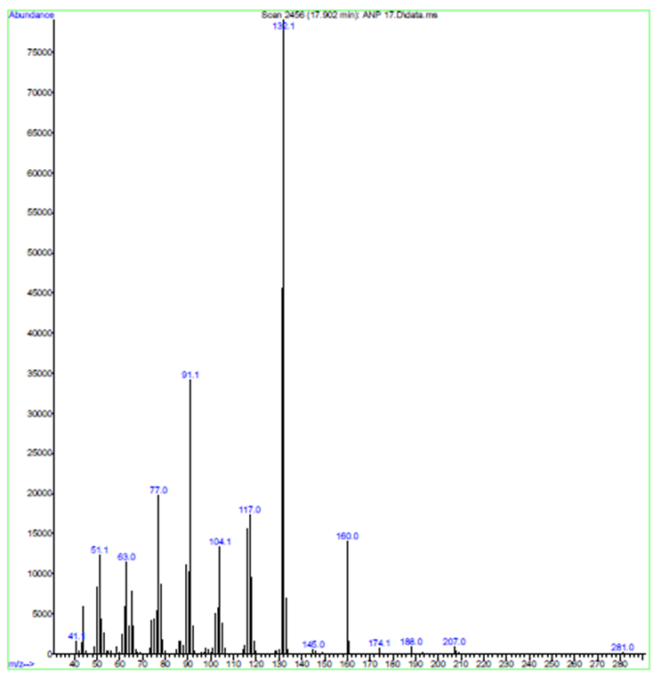
Figure S16. MS spectrum of 5-(4-Methylphenyl)-1H-tetrazole, Table 1, Entry 5.

Figure S17. GC spectrum of 5-(4-Methoxyphenyl)-1H-tetrazole, Table 1, Entry 6.

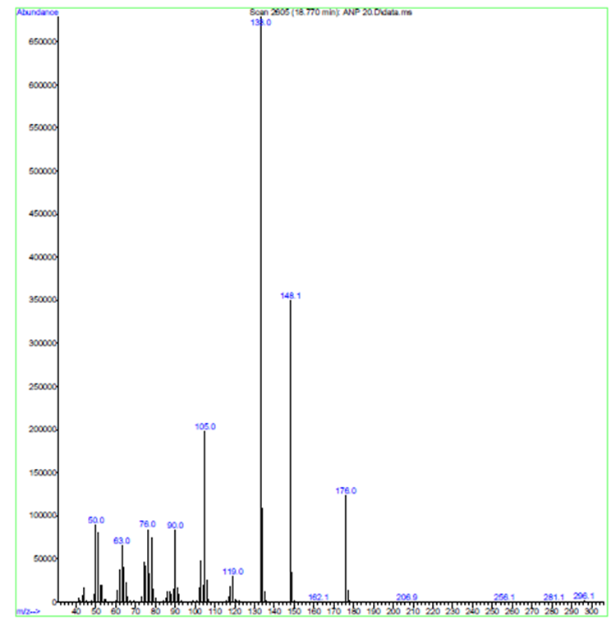
Figure S18. MS spectrum of 5-(4-Methoxyphenyl)-1H-tetrazole, Table 1, Entry 6.

Figure S19. GC spectrum of 5-(3-Chlorophenyl)-1H-tetrazole, Table 1, Entry 7.

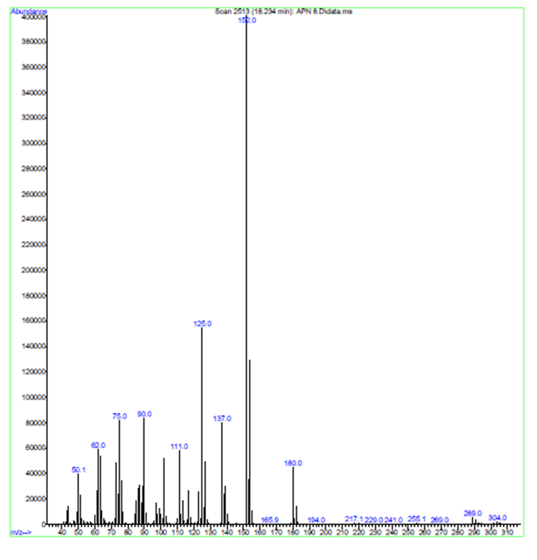
Figure S20. MS spectrum of 5-(3-Chlorophenyl)-1H-tetrazole, Table 1, Entry 7.

