Tailoring Schottky Barriers and Active Sites in Bi-metallic Cluster Mesoporous Carbon Nitride Heterostructures nanocomposite for Hydrogen Evolution with In-situ insights
V Navakoteswara Rao^{1*$}, Hyunguk Kwon^{2$}, M Nagaveni³, P Ravi⁴, Yonghee Lee¹, Seong Jae Lee⁵, Kyeounghak Kim^{5*}, M V Shankar^{3*}, Jung Ho Yoo¹, Chiwon Ahn¹, San-jae Kim⁶*, and Jun Mo Yang^{1*}
¹National Nanofab Center, 291 Daehak-ro, Yuseong-gu, Daejeon 34141, Republic of Korea.
²Department of Future Energy Convergence, Seoul National University of Science & Technology, Seoul 01811, Republic of Korea.
³Nanocatalysis and Solar Fuels Research Laboratory, Department of Materials Science & Nanotechnology, Yogi Vemana University, Kadapa 516005, Andhra Pradesh, India
⁴Bio-nano Research Institute, Gachon University, 1342 Seongnamdaero, Sujeong-gu, Seongnam-si 13120, Republic of Korea
⁵Department of Chemical Engineering, Hanyang University, 222, Wangsimni-ro, Seongdong-gu, Seoul 04763, Republic of Korea
⁶Nanomaterials & System Laboratory, Major of Mechatronics Engineering, Faculty of Applied Energy System, Jeju National University, Jeju 63243, Republic of Korea

$These authors contributed equally to this work.
*Corresponding authors: V Navakoteswara Rao (navakotinano@nnfc.re.kr), Kyeounghak Kim (chemekim@hanyang.ac.kr), Sanjae Kim (kimsangj@jejunu.ac.kr), M V Shankar (shankarnano@yvu.edu.in), Jun Mo Yang (jmyang@nnfc.re.kr)

1. Materials characterization
Various characterization techniques were employed to analyze the synthesized materials. X-ray diffraction (XRD) patterns were recorded within the 2θ range of 20–65° using a Bruker D8 ADVANCE X-ray diffractometer, utilizing Cu Kα radiation (λ = 1.5418 Å). Raman spectroscopic measurements were conducted using a Horiba Lab RAM high-resolution instrument, with a 532 nm laser serving as the excitation source. For diffuse reflectance UV-visible spectra, samples were examined using a Varian Cary 5000 UV-Vis-NIR spectrophotometer. Morphological analyses and energy-dispersive X-ray spectroscopy (EDX). The Surface area measurements were performed using the BET tool from Micromeritics (ASA2020). Photoluminescence (PL) spectra were collected utilizing a spectrofluorometer (FP8500, JASCO) with an excitation wavelength of 230 nm, facilitating the assessment of charge carrier lifetime. To examine oxidation states and surface compositions, X-ray photoelectron spectroscopy (XPS) was employed, and the analysis was carried out with an ESCALAB 250 Xi-XPS instrument, employing Al Kα radiation. Gas chromatography for quantitative analysis of hydrogen production (SchimanZu-2014).
2. Photocatalytic hydrogen Experiments
Initially, a 10 mg portion of the photocatalyst was suspended in a 50 mL solution containing 10% v/v TEOA (triethanolamine). The resulting reaction solution was introduced into a quartz glass reactor with a capacity of 185 mL. Before initiating the photocatalytic reaction, the reactor underwent degassing using a vacuum pump (30 min.), followed by purging (30 min) with nitrogen (N₂) until all other gases were expelled. Simulated solar light, filtered to wavelengths longer than 420 nm, served as the light source (Newport, USA). Throughout the photocatalytic process, a magnetic stirrer vigorously agitated the reaction slurry, while the reaction temperature remained under control through the circulation of cooling water. Following each reaction, the hydrogen gas (H₂) produced was quantified using a Shimadzu 2014 gas chromatograph, which was equipped with a thermal conductivity detector (TCD) and a packed column. Nitrogen (N₂) serves as the carrier gas. To maintain the desired pH levels in the reaction solution, adjustments were made by the addition of dilute solution of hydrochloric acid or sodium hydroxide.
3. Photoelectrochemical experiment analysis
To conduct photoelectrochemical water decomposition analysis, we initiated the process by preparing slurries of various samples. This involved combining 5 mg of photocatalyst with 20 µL of Nafion and 180 µL of ethanol. Subsequently, we applied 20 µL of this slurry onto an FTO glass substrate, allowing it to air dry to create a functioning electrode. In our experimentation, we performed transient photocurrent measurements using a three-electrode cell setup. Saturated Ag/AgCl served as the reference electrode, while platinum foil acted as the counter electrode. The electrolyte used was an aqueous solution containing 0.5 M Na₂SO₄, which resulted in a pH level of approximately 6.46. To collect transient photocurrents, we employed a 300 W Xenon (Xe) lamp as the light source, maintaining a bias of 0.8 V versus Ag/AgCl. Furthermore, we conducted Electrochemical Impedance Spectroscopy (EIS) measurements in the frequency range of 0.1 to 104 Hz for Ag/AgCl. These measurements were performed with an amplitude of 0.01 V and a bias of 0.5 V.
4. Time-resolved photoluminescence spectroscopy
TR-PL spectroscopy was carried out using a confocal microscope (MicroTime-200, Pico quant, Germany). The lifetime measurements were performed at the Korea Basic Science Institute (KBSI), Daegu Center, South Korea. A single-mode pulsed diode laser (375 nm with a 30 ps pulse width and an average power of 0.1–20 μW) was used as an excitation source. The pulsed laser line was focused on samples through a 40× objective. Emitted photons were directed through a dichroic mirror (Z375RDC, AHF), a long-pass filter (HQ405lp, AHF), a 100 μm pinhole, and a mirror, and they were finally collected by an avalanche photodiode detector (PDM series, MPD). A time-correlated single-photon counting system (PicoHarp300, Pico Quant GmbH, and Germany) was used to count emitted photons. Photoluminescence (PL) lifetime images with dimensions of 200 × 200 pixels were recorded using the time-tagged time-resolved (TTTR) data acquisition method. The obtained emission decays were fitted with an exponential function using the Symphotime-64 software (Ver. 2.2). Steady-state PL spectra were obtained by dividing and guiding emitted photons through an optical fiber to the external spectrometer (F-7000, Hitachi, Japan).

5. Work function of the photocatalyst
The work function of a material is a fundamental property that characterizes the energy required to remove an electron from the Fermi level of the material and move it to a point just outside the material (in vacuum). The work function is typically denoted by the symbol Φ and is measured in electrinos Volts (eV). It is an important parameter in understanding electron emission, Schottky barriers, and the behavior of materials in electronic devices.
To determine the work function of the Ag-Ni/g-C₃N₄ structure, you would need to consider the work functions of each material in the stack (g-C₃N₄, Ag, and Ni) and the energy band alignment at the interfaces.
Work Function of g-C₃N₄ (Φ_g-C₃N₄): This can vary depending on the specific form of g-C3N4 and its doping level. It typically falls within a range of 4 to 5 eV.

Work Function of Ag (Φ_Ag): The work function of silver is around 4.26 eV.

Work Function of Ni (Φ_Ni): The work function of nickel is approximately 5.15 eV.

let's consider the work function at each interface:

g-C₃N₄ to Ag Interface: The work function difference between g-C3N4 and Ag at this interface would be Φ_g-C3N4 - Φ_Ag.

Ag to Ni Interface: The work function difference between Ag and Ni at this interface would be Φ_Ag - Φ_Ni.

To calculate the overall work function of the Ag-Ni/g-C₃N₄ structure, need to consider the cumulative effect of these work function differences at each interface. The work function of the entire structure (work function structure) can be calculated as follows:
Φ_structure = Φ_g-C₃N₄ - ΦAg + ΦAg - ΦNi = Φg-C₃N₄ - ΦNi
So, the work function of the Ag-Ni/g-C₃N₄ structure is equal to the difference in work functions between g-C₃N₄ and Ni.

Figure S1 Schematic representation of the optimized photocatalyst (CAN-2) charge transfer reaction mechanism according to the work function.
6. Uv-visible to Hydrogen conversion efficiency (UTH)

$$The UV-visible light to H₂ energy conversion efficiency \%$$
$$= \frac{output energy as H₂ /J}{ The energy density of incident Uv-visible light / J{Cm}^{-2}×irradiated area {Cm}^{2}}×10$$

Table S1. UV-visible-to-hydrogen conversion efficiency (UTH) of the pristine Bi₂S₃, BN, BI, and BT photocatalysts.
Sample No. | Name of the photocatalyst | Rate of H₂ generation (µmol.h⁻¹. g_{cat}⁻¹) | Light intensity (mW/cm²) | UTH
1 | g-C₃N₄ | 135 | 404 | 0.34
2 | GCNN-3 | 638 | 404 | 1.62
3 | CAN-2 | 2507 | 404 | 6.37

7. Apparent Quantum Efficiency
The apparent quantum efficiency (AQE) of the optimized CAN-2 photocatalyst was calculated using the following equation, and it is found to be 25.5 % at 1.5 G air mass filter with a mean wavelength 768.6 nm under the irradiation of simulated solar light.
$$Apparent Quantum efficiency\left(Ø\right)=\frac{2RH_{2}N_{A}mt1}{N_{p}}×100$$
$$N_{p}=\frac{ρ×λ×t2}{h×c}$$
$$ρ=E×A_{g}$$
where RH₂ is the rate of photocatalytic H₂ generation, N_{A} is the Avogadro number, t₁ is the period for irradiation on the catalyst surface, Np is the number of incident photons irradiated (AM 1.5G solar light with the mean wavelength of 768.6 nm), P is the light radiation flux, E is the intensity of the radiation (468.2mW/cm²), A_{g} is the reactor by illumination area. Ag's value was detected by measuring the area of the light spot, and t₂ refers to the irradiation time (3600 s). The E value was recognized by a light power meter. The detector was put into the reactor, and the distance between the reactor and the light source was fixed when the value of E was set to 468.2 mW/cm ².
RH₂ = 547 ×10⁻⁶ mol converts to 0.015407 mol
N_{A} = 6.022 × 10²³ mol⁻¹
t = 3,600 S
P = 768.6 nm to 768.6 × 10⁻⁷ cm
E = 468.2 mW/cm²
A_{g} = 3.14x10⁻² cm²
Speed of light c=3 × 10¹⁰ Cm/s.

Planks constant = 6.63 × 10⁻³⁴ Js.
$$Quantumefficiency\left(Ø\right)=\frac{2× 547×{10}^{-6}×0.005×6.022×{10}^{23}×6.63×{10}^{-34}×3×{10}^{10}}{468.2 ×{10}^{-3}×768.6×{10}^{-7}×3.14×{10}^{-2}×3,600 }×100$$
$= \frac{18454.13×{10}^{-7}}{40657.23 ×{10}^{-7}}×100$
$=$1.67 %
Figure S2 Real time visualization In-situ TEM water splitting under electron beam light irradiation different time.

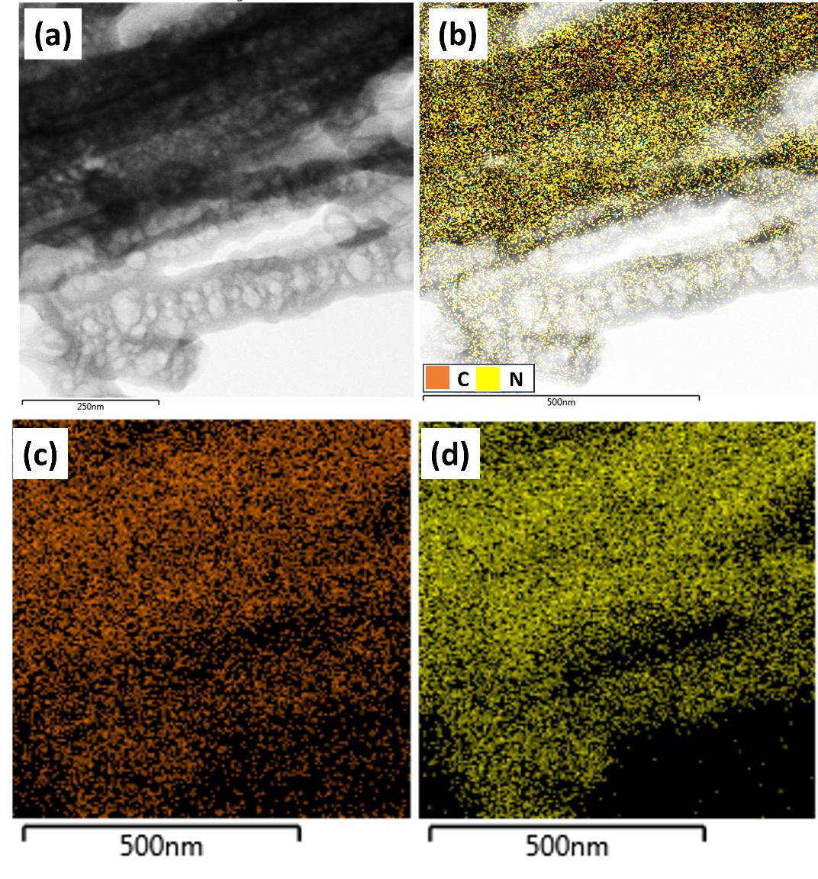
Figure S3 Elemental mapping of the Pristine g-C₃N₄ photocatalyst.

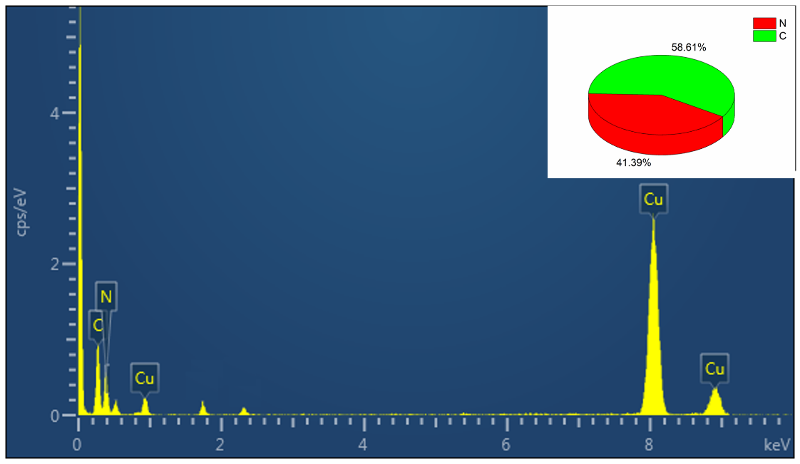
Figure S4 EDAX of the pristine g-C₃N₄ photocatalyst.

Figure S5 (a-c) HR-TEM images of the optimized photocatalyst CAN-2 with different resolution (d) Elemental mapping of the optimized CAN-2 photocatalyst, (e) C, (f) N, (g) O, (h) Ni, (i) Ag.

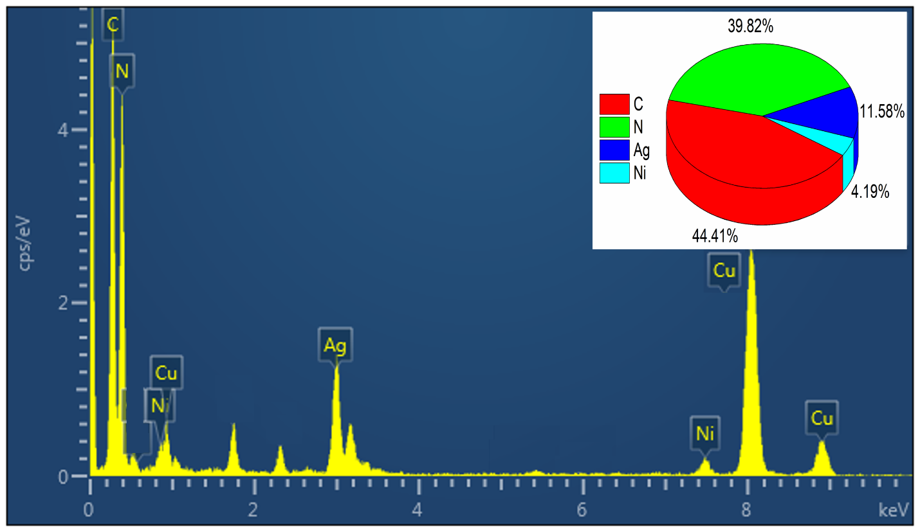
Figure S6 EDAX of the CAN-2 hybrid nanostructured photocatalyst.

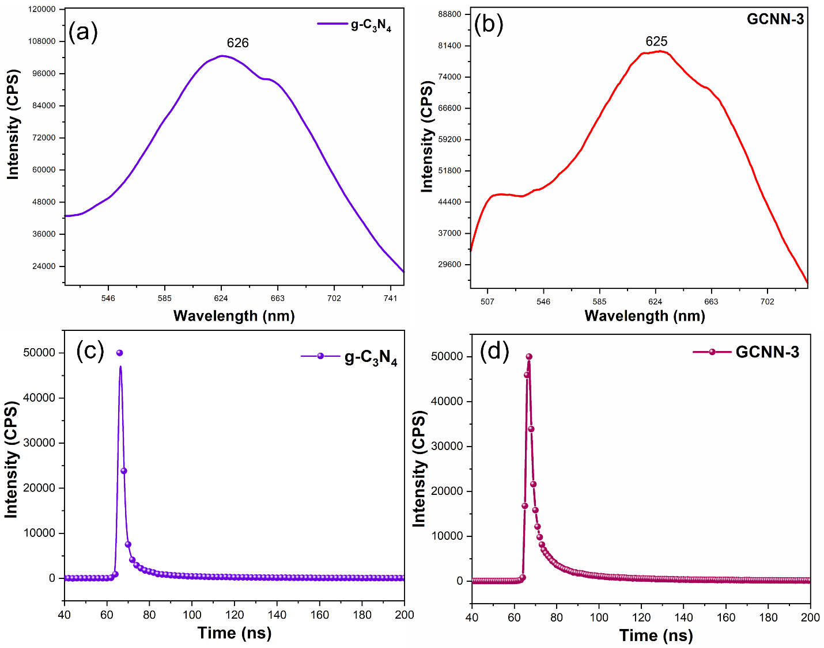 Figure S7 Photolumiscience spectrophotometry analysis of the (a-b) g-C3N4, and GCNN-3 photocatalyst. Lifetime of the photocatalyst (c-d) g-C₃N₄, GCNN-3, nanohybrid materials.

Figure S8 XPS Full scan survey spectrum of the CAN-2 hybrid photocatalyst.

8. Modeling of metal-deposited CAN-2 composites for DFT calculation
To model the metal-deposited CAN-2 composite structures, the geometry of a metal nanocluster was initially optimized in a vacuum and then re-optimized on the g-C₃N₄ substrate. The icosahedron Ni₁₃ cluster, determined to be the most stable structure of the Ni₁₃ cluster according to the literature[1] was selected as a representative model to emulate the Ni nanoparticle deposited in the experiment because it exposes (111) planes identified in the XRD data (reported in the main manuscript). There are two potential deposition sites on the g-C₃N₄: the cavity and the g-C₃N₄ surface. It was found that the deposition on the cavity site is energetically 1.39 eV more favorable than the deposition on the GCN surface site. On the cavity, the Ni₁₃ cluster forms three bonds with Ni atoms and electron-rich N_{edge} atoms (Figure S5(b-c)). On the other hand, when the Ni₁₃ nanocluster was placed on the GCN surface site, it underwent significant reconstruction to create bonds with electron rich N_{edge}, rendering this deposition less favorable (Figure S6). According to the literature, the collective presence of electron-rich N_{edge} atoms at the cavity edge creates an electron-rich environment in nature (called nitrogen pot), making the cavity a favorable site for the deposition of positively charged transition metals[2,3]. To mimic the Ag-Ni/g-C₃N₄ composite, six Ag atoms were blended with the Ni₁₃ cluster, creating a Ni₇Ag₆ bimetallic cluster that was subsequently deposited on the cavity site of the GCN (Figure S5(d-e)). Two Ni atoms and one Ag atom each form bonds with three electrons rich N_{edge} atoms, as shown in Figure S5(e). The ratio of Ni to Ag in the bimetallic cluster was chosen to be close to that of CAN-2 sample (Ni 0.3 M: Ag 0.2 M), the most active catalyst among the investigated CAN samples. The structural configuration of the Ni₇Ag₆ bimetallic nanocluster was created under the assumption that the Ag atoms are positioned at maximal spatial separation from each other.
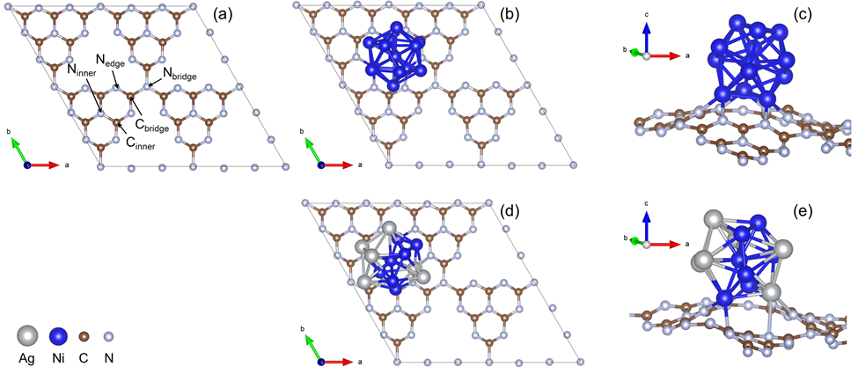
Figure S9 (a) A unit cell of the g-C₃N₄ model. (b-c) The top and side views of the Ni/ g-C₃N₄ model. The generated g-C₃N₄ model contains three types of nitrogen atoms (N_{edge}, N_{bridge}, and N_{inner}) and two types of carbon atoms (C_{bridge} and C_{inner}). The N_{edge} atoms are 2-fold coordinated with C_{bridge} and C_{inner} atoms. The N_{bridge} and N_{inner} atoms are 3-fold coordinated with three C_{bridge} and C_{inner} atoms, respectively. The C_{bridge} atom is 3-fold coordinated with two N_{edge} atoms and one N_{bridge}, whereas the C_{inner} atom is 3-fold coordinated with two N_{edge} atoms and one N_{inner}. (d-e) The top and side views of the Ag-Ni/ g-C₃N₄ model.
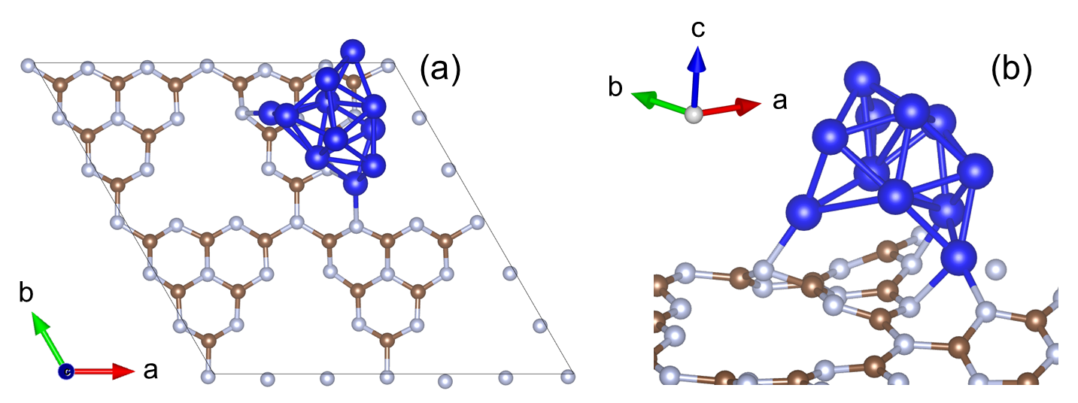
Figure S10 Two possible deposition sites of Ni₁₃ nanoparticle on the g-C₃N₄ surface. (a) Cavity site and (b) Surface site of g-C₃N₄.

Table S2 Average lifetime analysis of the pristine g-C₃N_{4,} GCNN-3, and CAN-2 photocatalyst.
Average lifetime (ns) | g-C₃N₄ | GCNN-3 | CAN-2
τ₁ | 0.39 | 5.2 | 6.4
τ₂ | 2.5 | 20 | 25
τ ₂ | 13.3 | 104 | 128
τ ₄ | 35.5 | 208 | 256
Average lifetime | 12.9 | 84.3 | 103.85

