Supplementary Material
The questionnaire used and patients’ answers were in Norwegian
English translation
Survey on Living with Irritable Bowel Syndrome (IBS)
2,727 Replies 13:34 Average completion time Closed Status
- Sex

Male 297
Female 2,430
- Age
Under 13 | 5
13-17 years | 20
18-24 years | 166
25-29 years | 272
30-34 years | 300
35-39 years | 301
40-44 years | 321
45-49 years | 332
50-54 years | 344
55-59 years | 249
60-64 years | 188
65-69 years | 113
70-74 years | 86
75-79 years | 25
80-84 years | 2
85-89 years | 3
Over 90 | 0

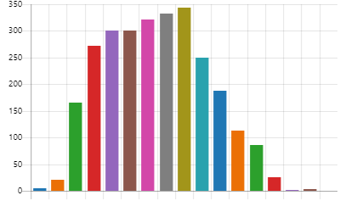

- Place of abode
Eastern Norway | 1,269
Western Norway | 626
Southern Norway | 168
Central Norway | 369
Northern Norway | 286
I don't live in Norway | 9
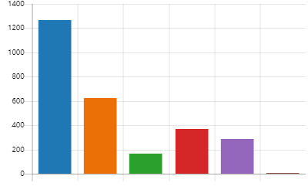
- Employment status
Employed | 1,437
Student | 217
Incapacitated (100%) | 478
Partially incapacitated | 166
On sick leave (100%) | 100
Partially on sick leave | 96
Old age pensioner | 186
School pupil | 38
Homemaker | 18
Receiving a work assessment allowance | 218
Work placement | 26
Unemployed | 15
Laid off from work | 7
Other | 57


- Estimate the average number of days per year that you are/have been absent from work or education due to your irritable bowel.
0 days | 831
1-9 days | 802
10-19 days | 398
20-29 days | 185
30-39 days | 125
40-49 days | 49
50-59 days | 42
60-69 days | 57
70-79 days | 16
80-89 days | 21
3-4 months | 51
5-6 months | 35
7-8 months | 21
9-10 months | 9
11-12 months | 85


- Are you incapacitated, on sick leave or receiving a work assessment allowance because of your irritable bowel?
Yes, IBS is the main reason I am incapacitated, on sick leave or receiving a work assessment allowance 170
Yes, IBS is one of the reasons why I am incapacitated, on sick leave or receiving a work assessment allowance 580

No 1,977

- Have you been diagnosed with irritable bowel syndrome?
Yes, it was diagnosed by my GP. | 805
Yes, it was diagnosed by a gastrointestinal specialist. | 1,437
Yes, it was diagnosed by another doctor (not a GP or gastrointestinal specialist). | 158
No, I haven't received a diagnosis from the health service, I arrived at this conclusion on my own. | 205
I don't have irritable bowel syndrome. | 26
Other | 96

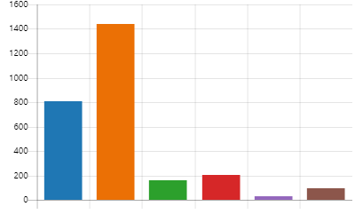

- What irritable bowel symptoms do you have?
Diarrhoea | 1,999
Constipation | 1,703
Stomach pain | 2,299
Bloated stomach | 2,438
Headache | 1,153
Chronic fatigue | 1,721
Other | 378


- Approximately how long ago is it since you first developed symptoms of irritable bowel syndrome?
Less than six months ago | 12
6-12 months | 24
1-2 years | 100
3-5 years | 343
6-10 years | 500
11-14 years | 394
15-19 years | 362
20-24 years | 277
25-29 years | 214
Over 30 years ago | 475
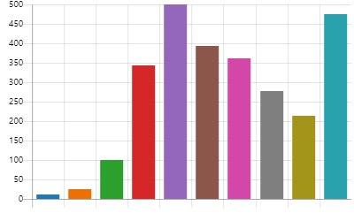

- If a doctor has diagnosed you with irritable bowel syndrome, approximately how long ago did you receive the diagnosis?
Less than six months ago | 116
6-12 months | 124
1-2 years | 340
3-5 years | 645
6-10 years | 603
11-14 years | 237
15-19 years | 171
20-24 years | 110
25-29 years | 56
Over 30 years ago | 50
I haven't been diagnosed by a doctor | 249

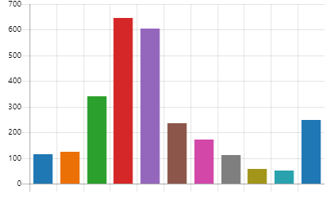

- To what extent does irritable bowel syndrome impair your quality of life?

Not at all 2
To a small degree 76
To some extent 938
To a great extent 1,194
To a very great extent 491

- How often do you feel your quality of life is reduced because of your irritable bowel?

Never 24
Monthly 448
Weekly 1,058
Daily 940
Always 231
- To what extent does irritable bowel syndrome impair your work/studies?

Not at all 171
To a small degree 396
To some extent 1,158
To a great extent 631
To a very great extent 345
- To what extent does irritable bowel syndrome impair your social life?

Not at all 30
To a small degree 227
To some extent 1,062
To a great extent 938
To a very great extent 444

- To what extent does irritable bowel syndrome impair your sex life?

Not at all 299
To a small degree 530
To some extent 1,041
To a great extent 574
To a very great extent 257

- Are you often tired because of your irritable bowel?

Not at all 46
To a small degree 226
To some extent 831
To a great extent 1,017
To a very great extent 581
- Do you feel repulsed by your irritable bowel?


Not at all 307
To a small degree 506
To some extent 877
To a great extent 609
To a very great extent 402
- Approximately how long did it take before you visited a doctor after the onset of the first symptoms of irritable bowel syndrome?
- A couple of days | 22
- 1 week | 43
2-4 weeks | 143
1-3 months | 272
4-6 months | 211
6-12 months | 245
1-2 years | 324
2-3 years | 255
4-5 years | 160
More than 5 years | 588
I haven't seen a doctor because of this. | 80
Don’t know | 358

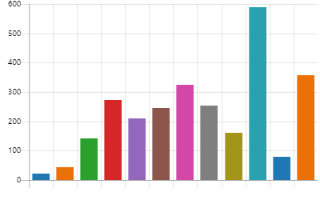

- Approximately how many times have you discussed your intestinal problems with your GP?
Once | 85
2-3 times | 358
4-5 times | 474
6-9 times | 415
10-14 times | 375
15-19 times | 197
20-49 times | 278
50 times or more | 246
I’ve never mentioned my intestinal problems to my GP. | 32
Don’t know | 241

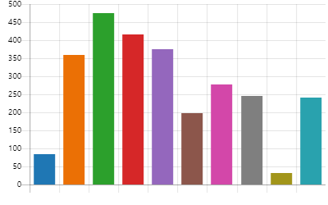

- Approximately how many times did you discuss your intestinal problems with your GP before he/she sent you to a specialist?
- Once | 267
- 2-3 times | 564
4-5 times | 407
6-9 times | 239
10-14 times | 175
15-29 times | 87
30 times or more | 99
I’ve never mentioned my intestinal problems to my GP. | 20
My GP has never sent me to a specialist. | 604
Don’t know | 239

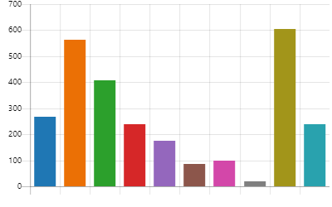

- Have you had to change your GP to be referred to a medical specialist?

Yes 451
No 2,250

- How long did it take before you saw a specialist after your GP sent a referral?
1 day | 17
2-3 days | 23
Approx. one week | 56
Approx. 14 days | 119
Approx. one month | 406
2-3 months | 566
4-6 months | 322
7-12 months | 116
More than one year | 63
More than two years | 29
Don’t know | 335
My GP has never sent me to a specialist. | 649

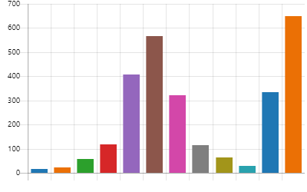

- Have you seen a private specialist at your own expense for your intestinal problems?

Yes 743
No 1,958

- Overall, approximately how long did it take from the time when you first saw a doctor until you were diagnosed with IBS?
- Less than one week | 98
- 1-3 weeks | 80
Approx. one month | 142
2-3 months | 235
4-6 months | 218
7-12 months | 204
1-2 years | 305
3-4 years | 221
5 years or more | 615
I haven't received a diagnosis from the health service, I arrived at this conclusion on my own. | 230
I haven't spoken to a doctor about my intestinal problems. | 7
Don’t know | 346

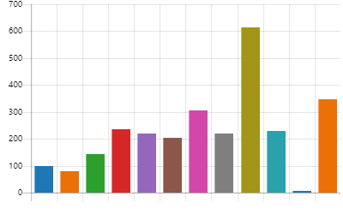

- What tests and examinations were carried out when investigating irritable bowel syndrome? (you can select more than one option)
Gastroscopy | 1,531
- Colonoscopy | 1,808
Blood tests | 1,961
Stool samples | 2,103
MRI | 342
X-ray | 280
Ultrasound | 532
CT | 399
Food allergy test | 917
Food intolerance tests | 1,046
Investigation for celiac disease | 1,168
Don’t know | 50
No tests have been taken | 125
Other | 136


- How satisfied are you with the help you have received from the GP service for your irritable bowel?
Very dissatisfied 290
Dissatisfied 428
Slightly dissatisfied 484
Neither dissatisfied nor satisfied 560
Somewhat satisfied 280
Satisfied 457
Very satisfied 202

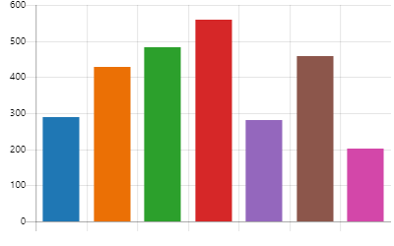

- Have you experienced your GP not believing you when you’ve told him/her about your stomach problems?

Yes 949
No 1,456
Don’t know 296

- In all encounters with your GP, how often have you experienced that he/she has not believed you when you’ve told him/her about your stomach problems?
- Never | 936
- Very rarely | 426
Rarely | 599
Often | 490
Very often | 197
Always | 53

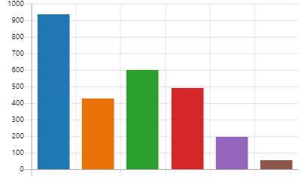


- Has this experience changed since the first time you told your GP about your stomach problems?
Yes, I find that my GP believes me more now than he/or she did during the first consultation. 905
Yes, I find that my GP believes me less now than during the first consultation. 88
No, I find that my GP is still the same as during the first consultation. 1,630
I haven't spoken to my GP about my stomach problems. 78

- Have you experienced that your GP hasn't prioritised helping you when you've told him/her about your stomach problems?

Yes 931
No 1,359
Don’t know 411

- In all encounters with your GP, how often have you experienced that he/she has prioritised helping you when you’ve told him/her about your stomach problems?
Never | 853
Very rarely | 428
Rarely | 615
Often | 578
Very often | 178
Always | 49

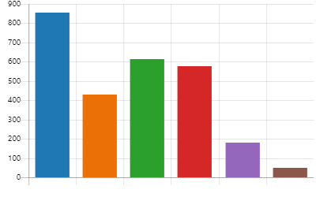

- Has this experience changed since the first time you told your GP about your stomach problems?
Yes, I find that my GP prioritises helping me more today than during the first consultation. 694
Yes, I find that my GP prioritises helping me less today than during the first consultation. 176
No, I find that my GP is still the same as during the first consultation. 1,757
I haven't spoken to my GP about my stomach problems. 74

- How often do you find that your GP meets you with courtesy and respect when you tell him/her about your stomach problems?
Never | 37
Very rarely | 65
Rarely | 307
Often | 910
Very often | 380
Always | 1,002

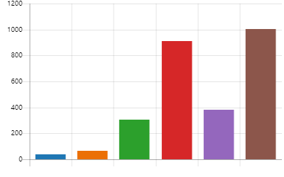

- To what extent do you agree or disagree with the following statement:
I find that the GP service has sufficient expertise on irritable bowel syndrome.
- Totally disagree | 709
- Disagree | 645
Slightly disagree | 434
Neither disagree nor agree | 427
Slightly agree | 208
Agree | 195
Totally agree | 83



- Have you been in contact with the specialist health service for your stomach problems?

Yes 1,653
No 1,048

- How satisfied are you with the help you have received from the specialist health service for your irritable bowel?
Very dissatisfied 127
Dissatisfied 204
Slightly dissatisfied 226
Neither dissatisfied nor satisfied 305
Somewhat satisfied 275
Satisfied 373
Very satisfied 143



- Have you experienced that health professionals in the specialist health service have not believed you when you’ve told them about your stomach problems?

Yes 387
No 1,111
Don’t know 155

- In all your encounters with the specialist health service, how often have you experienced that health professionals have not believed you when you’ve told them about your stomach problems?

- Never | 688
- Very rarely | 278
Rarely | 369
Often | 228
Very often | 71
Always | 19

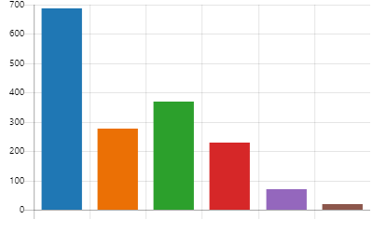

- Has this experience changed since the first time you told health professionals in the specialist health service about your stomach problems?
Yes, I find that health professionals in the specialist health service believe me more today than during the first consultation. 320
Yes, I find that health professionals in the specialist health service believe me less today than during the first consultation. 64
No, I have the same experience of health professionals in the specialist health service today as during the first consultation. 1,269


- Have you experienced that health professionals in the specialist health service have not prioritised helping you when you’ve told them about your stomach problems?
Yes 444
No 957
Don’t know 252

- In all your encounters with the specialist health service, how often have you experienced that health professionals have not prioritised helping you when you’ve told them about your stomach problems?
Never | 622
Very rarely | 263
Rarely | 412
Often | 257
Very often | 66
Always | 33

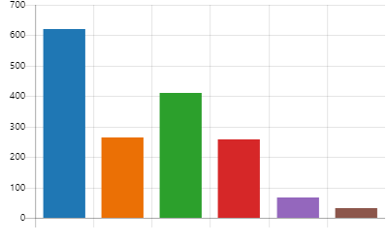

- Has this experience changed since the first time you told the specialist health service about your stomach problems?
Yes, I find that the specialist health service prioritises helping me more today than during the first consultation. 238
Yes, I find that the specialist health service prioritises helping me less today than during the first consultation. 106

No, I my experience of the specialist health service is the same today as during the first consultation. 1,309

Never | 15
Very rarely | 43
Rarely | 186
Often | 595
Very often | 308
Always | 506
- How often do you find that the specialist health service meets you with courtesy and respect when you tell health professionals about your stomach problems?

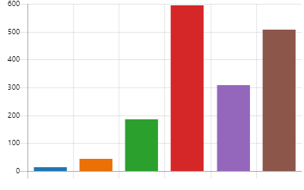
- To what extent do you agree or disagree with the following statement:
I find that health professionals in the specialist health service have sufficient expertise on irritable bowel syndrome.

Totally disagree | 165
Disagree | 212
Slightly disagree | 257
Neither disagree nor agree | 315
Slightly agree | 206
Agree | 376
Totally agree | 122
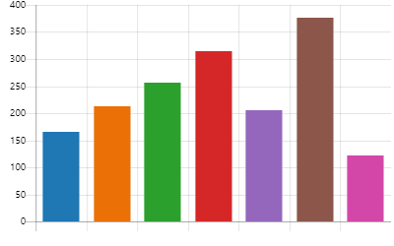

- To what extent do you agree or disagree with the following statement:
During my schooling and education, I have experienced that the educational institutions have shown little understanding and willingness to make adaptions for my stomach problems.

Totally disagree | 55
Disagree | 65
Slightly disagree | 58
Neither disagree nor agree | 274
Slightly agree | 131
Agree | 160
Totally agree | 181
I haven't told my school or educational institution about my stomach problems. | 978
I haven't had any (major) problems with my irritable bowel during my schooling and education. | 799
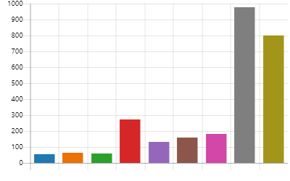
- To what extent do you agree or disagree with the following statement:
Over the course of my professional life, I have experienced that employers have shown little understanding and willingness to make adaptations for my stomach problems.

Totally disagree | 144
Disagree | 229
Slightly disagree | 122
Neither disagree nor agree | 319
Slightly agree | 262
Agree | 239
Totally agree | 227
I haven't told my employer about my stomach problems. | 884
I haven't had any (major) problems with my irritable bowel during my professional life | 195
I haven't worked in the labour market | 80

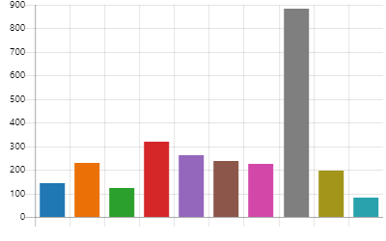

- What treatment options and measures have you received from the public health service?
(you can select more than one option)
Dietary guidance from a clinical nutritionist | 778
Information about diet from a doctor/nurse | 1,014
Hypnosis | 10
Faecal transplant | 77
Physiotherapy | 140
Psychologist | 265
Lactic acid bacteria (probiotics) | 524
Prebiotics | 154
Imodium | 644
Enema/Laxatives | 404
Non-prescription drugs for flatulence | 543
Prescription painkillers | 441
Non-prescription painkillers | 336
Fibre supplements | 457
Gastric acid neutralising drugs (reduces acid) | 839
Gastric acid supplements (increases acid) | 36
Medicinal cannabis | 2
Constella | 256
Resolor | 55
Ondansetron | 12
Eluxadoline: Truberzi/Viberzi | 12
Visiblin | 897
Other | 528
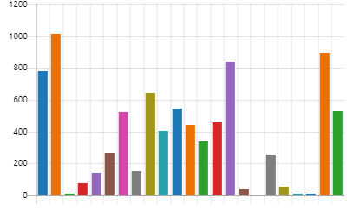

- To what extent do you agree or disagree with the following statement:
I feel that the treatment offered by the public health service has helped me with my irritable bowel.

Totally disagree | 843
Disagree | 595
Slightly disagree | 260
Neither disagree nor agree | 431
Slightly agree | 328
Agree | 187
Totally agree | 57

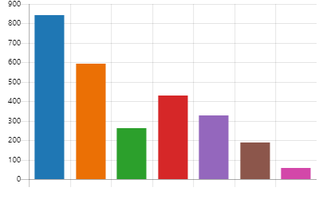

- What types of treatment or measures have you tried out on your own without help from the public health service? (you can select more than one option)
Dietary guidance | 1,231
Diet | 2,034
Hypnosis | 62
Faecal transplant | 114
Physiotherapy | 291
Psychologist | 343
Lactic acid bacteria (probiotics) | 1,363
Prebiotics | 649
Imodium | 748
Enema/Laxatives | 538
Non-prescription drugs for flatulence | 995
Prescription painkillers | 279
Non-prescription painkillers | 765
Fibre supplements | 753
Acupuncture | 328
Colon cleansing | 165
Digestive enzymes | 506
Dietary supplements | 1,146
Healing | 163
Foot reflexology | 200
Homeopathy | 226
Fleawort | 394
Functional medicine | 129
Gastric acid neutralising drugs (reduces acid) | 629
Gastric acid supplements (increases acid) | 162
Medicinal cannabis | 25
Visiblin | 600
Other | 282
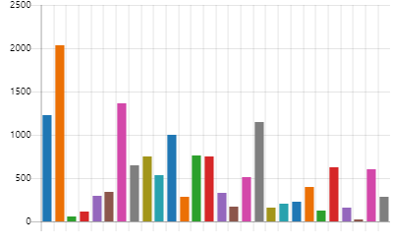

- To what extent do you agree or disagree with the following statement:
I feel that the treatment I tried on my own has helped my irritable bowel.

Totally disagree | 236
Disagree | 292
Slightly disagree | 197
Neither disagree nor agree | 517
Slightly agree | 768
Agree | 470
Totally agree | 221

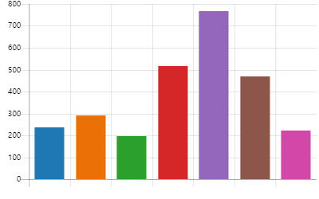

- At an estimate, how much money do you spend each year on treatment for your IBS that is not subsidised by the public health service?

NOK 0 | 235
NOK 1,000 | 332
NOK 2,000 | 307
NOK 3,000 | 299
NOK 4,000 | 214
NOK 5,000 | 316
NOK 6,000 | 134
NOK 7,000 | 97
NOK 8,000 | 57
NOK 9,000 | 49
NOK 10,000-14,000 | 359
NOK 15,000-19,000 | 78
NOK 20,000-24,000 | 85
NOK 25,000-29,000 | 37
NOK 30,000-34,000 | 18
NOK 35,000-39,000 | 17
NOK 40,000-44,000 | 14
NOK 45,000-49,000 | 4
NOK 50,000-54,000 | 16
NOK 55,000-59,000 | 5
NOK 60,000-64,000 | 1
NOK 65,000-69,000 | 1
NOK 70,000-74,000 | 3
NOK 75,000-79,000 | 0
NOK 80,000-84,000 | 3
NOK 85,000-89,000 | 1
NOK 90,000-94,000 | 0
NOK 95,000-99,000 | 4
NOK 100,000-109,000 | 6
NOK 110,000-119,000 | 1
NOK 120,000-129,000 | 2
NOK 130,000-139,000 | 0
NOK 140,000-149,000 | 2
NOK 150,000-159,000 | 0
NOK 160,000-169,000 | 1
NOK 170,000-179,000 | 0
NOK 180,000-189,000 | 0
NOK 190,000-199,000 | 1
NOK 200,000-249,000 | 2
NOK 250,000-299,000 | 0
More than NOK 300 000 | 0



- What measures or types of treatment do you feel have helped you the most with your irritable bowel?
2701 answers “none”

