Operando Probing of the Fischer-Tropsch Reaction on
Co Single Crystal Surfaces up to 1 bar
Patrick Lömker^{1,2} *, David Degerman¹, Christopher M. Goodwin^{1,7}, Mikhail Shipilin¹, Peter Amann^{1,#}, Gabriel L.S. Rodrigues¹, Fernando Garcia-Martinez², Raffael Rameshan⁴, Jörgen Gladh^{1,5}, Hsin-Yi Wang¹, Markus Soldemo¹, Alexander Holm^{1,6,7}, Steffen Tober⁸, Jan-Christian Schober⁸, Leon Jacobse⁸, Vedran Vonk⁸, Robert Gleissner⁸, Heshmat Noei⁸, Zoltan Hegedues², Andreas Stierle^{8,9}, Christoph Schlueter², Anders Nilsson¹*
¹ Department of Physics, Stockholm University, 10691 Stockholm, Sweden
² Photon Science, Deutsches Elektronen-Synchrotron DESY, 22607 Hamburg, Germany
³ ALBA Synchrotron Light Facility, Carrer de la Llum 2, 26, 08290 Cerdanyola del Vallés, Spain
⁴ Lehrstuhl für Physikalische Chemie, Montanuniversität Leoben, 8700 Leoben, Austria
⁵ PULSE Institute, SLAC National Accelerator Laboratory, Menlo Park, 94305 California, USA
⁶ Department of Materials and Environmental Chemistry, Stockholm University, 106 91 Stockholm, Sweden.
⁷ Laboratory of Organic Electronics, Department of Science and Technology (ITN), Linköping University, SE-60174, Norrköping, Sweden
⁸ Centre for X-Ray and Nanoscience CXNS, Deutsches Elektronen-Synchrotron DESY, ﻿22607, Hamburg, Germany
⁹ Physics Department, University of Hamburg, 20148 Hamburg, Germany
# present address: Scienta Omicron, Limburgerstrasse 75, 65232 Taunusstein, Germany

Keywords: Fischer-Tropsch, Cobalt, Hydrogenation, Heterogeneous Catalysis.

Supplementary Materials
- Samples and Gases
The experiments were performed on two hat shaped cobalt crystals (N4.7) with the flat (0001) and the stepped ($10\overline{1}4$) direction exposed on the surface (R_{a}<30nm, miscut < 0.1°) with a top surface of 7mm diameter (Surface Preparation Laboratory, SPL). It is worth noting that the stepped crystal exposes a high density of B5 ^{S1} sites that are regarded as an active site for the Co based Fischer-Tropsch reaction^{S2}. The gases were obtained with a purity of 5N for all gases except CO where the purity available could not exceed 4.7N. For the X-ray photoelectron spectroscopy (XPS) experiments the gases were purified in appropriate apparatus (SAES Getters/Entegris). Under the measurements we recorded the temperature at the back of the sample with a type N thermocouple. Sample front temperature has been calibrated under various gas loads for a comparable specimen with a thermocouple spot-welded to the front. We expect that our temperature measurements agree to better than $ΔT<15\text{K}$.
- POLARIS XPS Experimental Setup
The POLARIS setup is placed at beamline P22, DESY. The spectrometer utilizes a virtual cell approach, where a gas stream is directed onto a flat specimen and X-rays reach the interaction volume under grazing incidence conditions of 0.3°.^{S3} In this way a radially symmetric local high-pressure cushion is formed (d~2mm), while the rest of the chamber experiences much lower pressures (i.e. when the pressure in the probed volume is ~1000mbar the chamber pressure is 10mbar). The excited electrons are collected at distances of approximately 30µm by a line array of circular apertures, well matching the stretched-out X-ray footprint due to the grazing incidence geometry.
For the XPS experiment we used a double bounce monochromator with Si(311) crystals tuning the photon energy to 4600eV. The electron analyzer was used with an 800µm curved slit and a pass energy of 100eV. The total energy resolution where the expected photon energy bandwidth and the electron analyser resolution is folded together account for $ΔE_{FWMH}≤300\text{meV}$. The beamline optics use a horizontally bent elliptical mirror and a vertical cylindrical focusing mirror to achieve a beam foot print on the order of $15×15µm^{2}$, which was measured with a polished YAG crystal at regular intervals during the experiment.
Due to the specific design of this experimental setup (i.e. an outward flowing gas jet), no contamination from the heater or chamber can reach the sample surface when gas flow is applied.
The pressure in the virtual pressure cell was estimated from a calibration done by a previously used method, further illustrated in S10 and in the literature^{S3}.
All XPS spectra were acquired in an add-dimension mode indicating that a list of short C 1s, O 1s, Co 2p_{3/2} spectra are recorded repeatedly and summed together for statistics. This method allows to distribute slow surface changes under the reactions into all three spectra in similar weights such that distortions between spectra are expected to be negligible and developments can be traced quasi simultaneously in several core-levels.
- XPS Data Processing
All spectra are recorded with a binding energy calibration to the Fermi edge of a clean metal. A correction for the adsorbate binding energies due to the recoil effect has been neglected (see S6.d). The spectra were first converted to counts per second and were plotted in each panel with offsets for visibility. For comparison we normalized the spectra as described in S6.c.
We observe 4 distinct peaks in O 1s spectra. These are observed at 532.5 eV, 531.7 eV, 530.2 eV, and 529.1 eV. The first two peaks were assigned to H₂O and CO_{top} respectively, whereas the last two are tentatively assigned to chemisorbed O and OH states, which, however are not observed in an appreciable quantity.
In the C 1s spectra we notice 5 distinct features observed at 285.7 eV, 284.7 eV, 284.1 eV, 283.5 eV and 283.2 eV.
The quantification of the peaks is performed by applying a global fit model that finds a maximum likelihood optimization using the Levenberg-Marquardt algorithm of the peak positions and shapes for all spectra of a set. . The constraints of the fitting parameters are given in Table S1 (for the C 1s region), Table S2 (for the O 1s region) and Table S3 (for the Co 2p region). The background estimation has been performed by subtracting a Shirley function where the Shirley parameter is a free variable in every spectrum^{S4}.
Table S1 Peak Model for the quantification of C 1s peaks
Name | Center (eV) | Gaussian FWHM (eV) | Lorentzian FWHM (eV) | Type
C | 283.00..283.20 | 0.30..0.45 | 0.20..0.50 | Pseudo-Voigt^{S5}
CH₂ | 283.3..283.55 | 0.5..0.8 | 0.2..0.3 | Pseudo-Voigt^{S6}
CH_{surf} | 283.80..284.10 | 0.20..1.00 | 0.00..0.50 | Pseudo-Voigt
CH | 284.00..284.70 | 0.75..0.90 | 0.00..0.50 | Pseudo-Voigt
COtop | 285.65..285.85 | 0.20..1.50 | 0.00..0.50 | Pseudo-Voigt

Table S2 Peak Model for the quantification of O 1s peaks.
Name | Center (eV) | Gaussian FWHM (eV) | Lorentzian FWHM (eV) | Type
O | 529.10..529.30 | 1.20..1.40 | 0.15 | Pseudo-Voigt
OH | 529.80..530.20 | 0.40..2.00 | 0.15 | Pseudo-Voigt
COtop | 531.60..532.20 | 1.70..1.90 | 0.15 | Pseudo-Voigt
C | 532.80..533.20 | 0.90..1.60 | 0.15 | Pseudo-Voigt

Table S3 Peak Model for the quantification of the Co 2p_{3/2} peak.
Name | Center (eV) | Lorentzian FWHM (eV) | Asymmetry (a.u.) | Type
Co Metal | 777.5..778.3 | 0.0..1.0 | 0.18..0.40 | Doniach- Sunjic^{S6}

- SXRD Experimental Setup
The surface X-ray diffraction (SXRD) experiment^{S7} was performed at beamline P21.2 at DESY using a beam with ~3x10µm (VxH) FWHM, an energy of 67.4keV and a glancing angle of 0.05°^{S8,9}. The detector (VAREX XRD 4343CT, 150µm pixel size) was placed 1.4 m away from the interaction zone. The sample temperature was controlled using a BN encapsulated graphite heater. The gases of 5N purity for Ar, and H₂ and 4.7N purity CO (same purities as in the XPS experiment) were delivered to an X-ray transparent Be dome and therein directed onto the same Co(0001) single crystal as for the XPS experiment. The CO gas was additionally purified from Ni(CO)₄ using a copper carbonyl trap. The experimental setup is in details described elsewhere^{S7}. Scans were taken over a range of 105°.
- Compiled SXRD Data
In this section we present the compiled SXRD data of the Co(0001) crystal, which was omitted from the main text due to space restrictions. For the discussion and analysis, we use the bulk hexagonal coordinate system of cobalt, with a=b=2.505 A, c = 4.089 A $α=β$=90°, $γ$ =120°. The reciprocal lattice coordinates are given in units of a*=b*= 2.896 A⁻¹ and c*=1.537 A⁻¹ ($α^{*}=β^{*}$ =90°, $γ^{*}$=60°). The fits were performed with the ANAROD package^{S10}. For the fit the following parameters were used: a scale factor, surface displacement parameter of the first Co surface layer, displacement and occupation parameter for CO. A change of the occupation of the topmost CO layers did not improve the fit, indicative for an atomically smooth surface. The structure factors were extracted from the high energy XRD data following the procedure described in the literature^{S9}. We first show the maximum projected images of the four conditions we have studied in Figure S1. The images under the different conditions almost look identical, as the changes of the crystal surface are minute and reflect the findings that Co stays metallic and does not form surface reconstructions during the reaction or major deposits that make other structures appear (i.e. carbides) in line with previous studies^{S11}. The used gas mixture is a total pressure of 1bar distributed between 1:2 mix of CO and H₂ of the specified partial pressure and the remainder being Ar. For example 200mbar indicates 1:2 CO:H₂ mixture of 200mbar with 800mbar of Ar. The flows were set to 10mln/min total applying flow ratios based on the described partial pressures relative to 1bar total pressure.
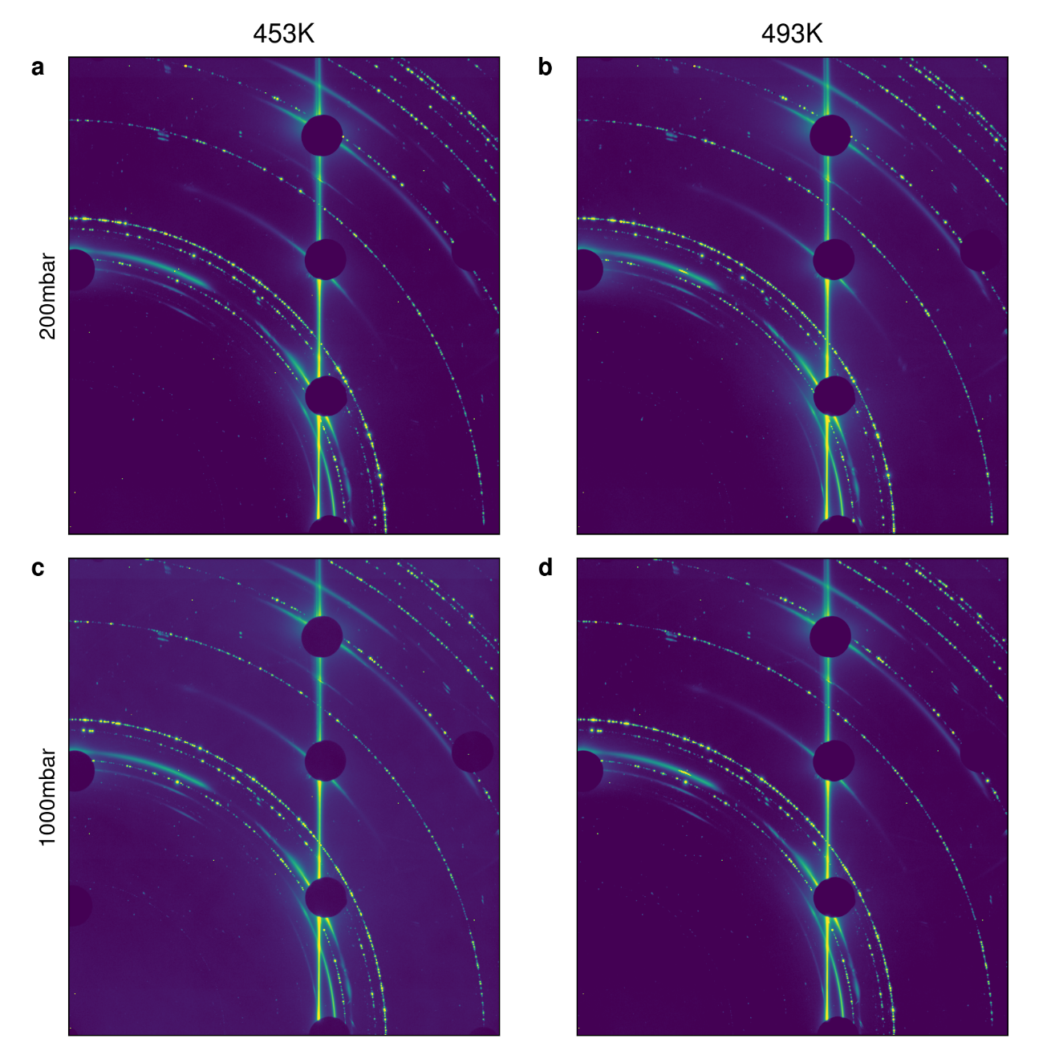
Figure S1 SXRD images of the Co(0001) surface under the indicated conditions in a 1:2 CO:H₂ reaction mixture. Clear (1,0) rods are observed together with powder rings from surficial imperfections. All conditions resemble each other remarkably well, in line with the established observation that the Co substrate does not change under the reaction. Image is cropped to the top right quadrant of the detector, the direct beam behind beam stop is in the bottom left conrer of. Presented in log-intensity.
In Figure S2 we show the integrated structure factor from the four indicated conditions (200mbar and 1000mbar reactants at 456K and 496K). Comparing these lines, it is obvious that we observe no obvious differences. There seems to be an outlier at 1000mbar 456K around 2.5 r.l.u. (reciprocal lattice unit). The structure factor is higher around 0.5 r.l.u. for the 493K samples indicating an annealing like behavior under the reaction at the elevated temperatures. Peaks at ~0.7 and ~1.4 r.l.u. indicate a small and approximately constant amount of fcc Co powder rings that are identifiable in the max projected images of Figure S1. The fcc contribution can be attributed to the fact that the annealing temperature of the Co crystal is not too far away from the hcp->fcc transition temperature of 693K and thus a small fraction of the crystal surface might already undergo this transition. We estimate that significantly less than 10% of the crystal surface is reconstructed to the fcc-lattice based on the intensity of the fcc-related peaks and thus deem their influence on the reaction to be negligible.
At 1000mbar and 503K the intensity of the rod decays slower which can be understood as a smoother surface.
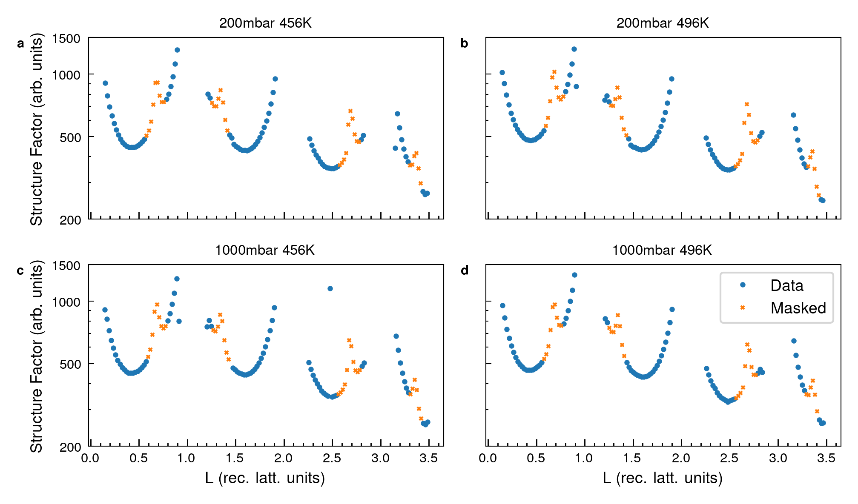
Figure S2 Integrated structure factor of the indicated conditions. Around 1.0 and 2.0 rlu a beam stop was utilized, thus this region is ignored. The small FCC like Co peaks are plotted in yellow and are masked out for the fit analysis in the main manuscript.

- Compiled XPS Data

In S6.a and b we show the O 1s and Co 2p spectra that were omitted in the main text for the reader’s convenience.
  - O1s
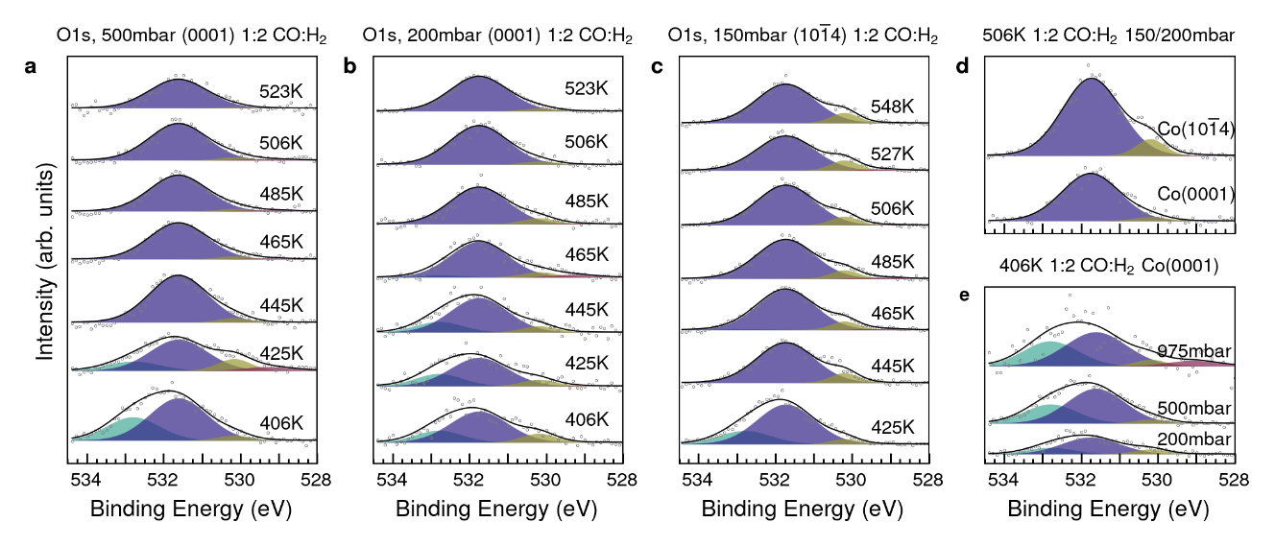
Figure S3 Compiled O 1s data for the indicated conditions.
  - Co 2p3/2
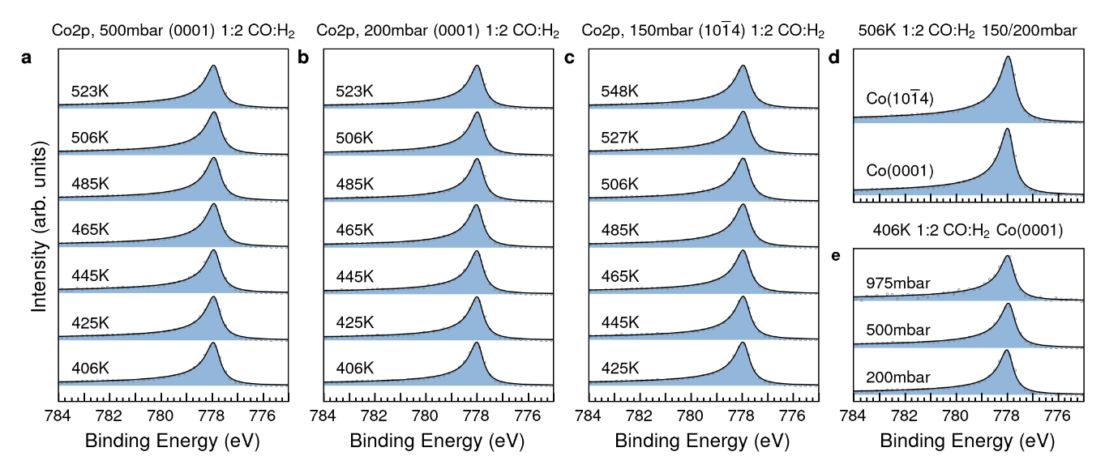
Figure S4 Compiled Co 2p_{3/2} data for the indicated conditions.
  - Quantification of C and O Species
To quantify the surfacial coverages of C and O on the flat/stepped Co surfaces we utilize a bilayer model that we have described in our previous works^{S12}. The inputs are the unit cell of the material^{S13}, photoionization cross-sections^{S14}, X-ray penetration depth^{S15,16}, photoelectron inelastic mean free paths^{S17}, total scattering cross-section of the gas mixture^{S18,19}, incidence angle and detector geometry. In accordance with previous reports using this procedure we estimate a large error bar on the absolute value of these calculations of about 50% but very small (i.e. 5%) between spectra at different temperatures, pressures, and substrates^{S12,20}. The repeatability of the measurements we estimate to be on the order of 10% and thus allowing us to make good comparisons, especially within an isobar. In our analysis we notice a strong pressure for the total signal, yet a minor variation for CO_{top}. Thus, we utilize the observed small T dependence of CO_{top} to calibrate the absolute coverages to the known value of 1/3 ML for this species by averaging the obtained coverages through our model for $T∈ [425\text{K}, 506\text{K}].$ This single number division ensures compatibility of average coverages but retains trends observed in the data. The C 1s data in Fig. 2 of the main text is normalized in this way to enable a representative comparison of the surface species.
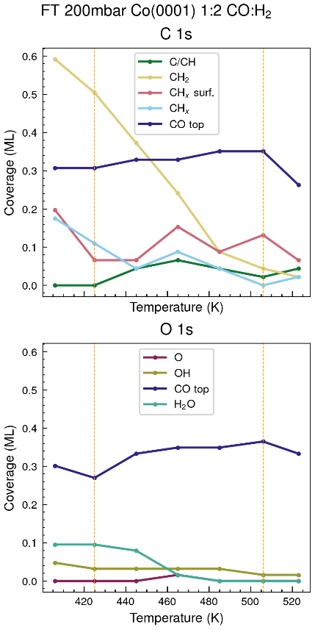
Figure S5 Coverages of the 200mbar experiments detailing the CO_{top} coverage as function of temperature for C 1s (top) and O 1s (bottom) spectra. The trend that the coverage of this species is stable is found in all experiments and forms the basis for the recalibration by its average in the T region defined in the text. The vertical lines indicate the averaging T interval applied for the normalization.
  - Negligible influence of Recoil on the XPS Measurements
In our work we have carefully evaluated binding energy positions of known peaks and find that they do not exhibit a noticeable effect of the photoelectron recoil^{S21}. The expected value for recoil energies should be $E_{recoil}≈200\text{meV}$ for C 1s photo electrons emitted after excitation with a photon energy of 4600eV. This value is to be taken relative to the Fermi Energy shift of the substrate, Co which is much heavier indicating we should expect an even smaller shift from it, if any. We thus assume that the observed metal Fermi level energy position is so close to the undisturbed value that we do not observe it in our measurement. However, our observed peaks in CO_{top} fit the literature values very well^{S22}. We explain this finding, that we are at temperatures where the surface layer’s Debye temperature $Θ_{D}$ is significantly larger than our experimental temperature. This criterion is previously found to drastically increase the probability of a recoilless emission^{S23}. The CO layer can be seen as a very stiff surface, comparable in compressibility to Pb on Ag(111)^{S24}. The speed of sound is proportional to the compressibility and that in turn is directly proportional to the Debye temperature, which qualitatively shows that our assumption of the experiments being conducted significantly below $Θ_{D}$ likely is true. Thus, we accept that recoil only plays a minor role in our analysis. This is further supported by observing that the energy width ($≈300\text{meV}$) is larger than the recoil effect.
  - Mitigation of X-ray Induced Changes
To mitigate X-ray beam induced effects on our sample studies have been performed in each beam time where we find the cut-off where accumulation of beam induced species (i.e. graphite at 284.9-285.0eV), was observed. This criterion has been achieved by attenuating the full beam of P22 by a factor of 5x. As this species is not a peak in all our reported spectra the effectiveness of this method is shown. We perform this analysis directly after focusing the beam horizontally. Small beam pointing errors in the beamline can lead to a focus shift and consequently a larger beam. This acts like a further attenuation, as larger beams have a smaller fluence and to a reduction of beam damage and thus is not further considered problematic to the interpretation of the data. For the much higher energy work at P21 we used the full beam as it is expected that the exponentially smaller photoionization cross-sections at 10x higher energy will lead to negligible influences on the surface structure.
- Mass Spectrometry.
Mass-spectrometry is limited in its applicability as the flows are very high and the production rates which are very low. In other works we have shown that our sensitivity for the pressures studied here is on the order of TOF comparable to 10s of turnovers per site and second.^{S25,26} The accepted rates on B5 rich surfaces of hydrogenation on Co are 300x lower $(3×{10}^{-2}\frac{1}{site⋅s}) ADDIN ZOTERO_ITEM CSL_CITATION \{"citationID":"xicJuqan","properties":\{"formattedCitation":"\backslash \backslash super S27\backslash \backslash nosupersub\{\}","plainCitation":"S27","noteIndex":0\},"citationItems":[\{"id":106,"uris":["http://zotero.org/users/3172003/items/EKHIGI38"],"itemData":\{"id":106,"type":"article-journal","container-title":"Catalysis Today","DOI":"10.1016/j.cattod.2016.04.004","ISSN":"09205861","language":"en","page":"100-110","source":"Crossref","title":"Reflections on the Fischer-Tropsch synthesis: Mechanistic issues from a surface science perspective","title-short":"Reflections on the Fischer-Tropsch synthesis","volume":"275","author":[\{"family":"Weststrate","given":"C.J."\},\{"family":"Helden","given":"P.","non-dropping-particle":"van"\},\{"family":"Niemantsverdriet","given":"J.W."\}],"issued":\{"date-parts":[["2016",10]]\},"citation-key":"weststrateReflectionsFischerTropschSynthesis2016"\}\}],"schema":"https://github.com/citation-style-language/schema/raw/master/csl-citation.json"\}$^{S27}. Thus, operando quantification of the product distribution is all but impossible in the current setup for single crystal Co based Fischer-Tropsch synthesis.
- Computational Details.
Density-Functional Theory (DFT) calculations were performed with the GPAW (generalized plane augmented wave)^{S28,29} software for a ¼ ML coverage using PAW:s with an explicit core-hole. The finite-difference mode with grid spacing of 0.2 Å was used in conjunction with a Monkhorst–Pack k-point sampling density of 2.5 k-points/Å³ in the supercell and the revised Perdew-Burke-Ernzerhof (RPBE) exchange-correlation functional^{S30}. For excited-state calculations we must make sure the supercell is big enough (in our experience larger than 8 Å on each dimension) so core-hole interactions with its periodic images are reduced.
The absolute XPS binding energies (BE) are calculated using generated core-ionized PAW:s (explicit core-hole) representing the final or excited state and the BE is obtained from the equation
$$BE=E_{final}-E_{gs}$$
where $E_{final}$ is the total electronic energy of the final or excited state, and $E_{gs}$ is the total electronic energy of the initial or ground state. The BE are then shifted according to the binding energy position of CO_{top}.
- Sample Cleaning
Prior to the reaction studies the Co(0001) and Co($10\overline{1}4$) samples were cleaned by established procedures of repeated sputtering (1keV, ~1µA, 30min) and annealing (523K, 30min) processes in ultra-high vacuum. In the XPS experiments the single crystals were also chemically cleaned by dosing of 0.16 liter per minute O₂ for 5s followed by annealing in 1 liter per minute H₂ at a sample distance of 30µm and 473K. In between each measurement the samples were kept in H₂ flows greater or equal 0.16lpm (p<50mbar, negligible scattering in gas) to limit contamination from the vacuum environment, while we evaluated the surface cleanliness of C 1s, O 1s, S 1s, Si 1s containing species. The intensity sum of these was kept below 5at% of the Co2p_{3/2} signal. The Si 1s peak is orders of magnitude more sensitive to hard X-rays (by about a factor 100x) than both Si2p core-levels combined.
- Pressure Calibration
The pressure in the reaction zone is calibrated according to established procedures^{S3}. In lieu of a micro pressure sensor that would be able to directly probe the conditions in the ~30µm sized virtual cell, we instead calibrate the pressure observed in the first differential pumping stage with the 1:2 CO:H₂ gas mixture and pressures in the chamber. An example graph of this pressure calibration is given in Figure S6. The error of this measurement is estimated to be within the reproducibility of the two gauges involved (Pfeiffer RPT 200 PB, full scale accuracy $±0.3\%$) resulting in a net uncertainty of $±0.42\%$ which amounts to about 4 mbar at 1000mbar. Due to the particular style of recording used close to the end of the region 20mbar steps are taken, which further limits the uncertainty of the absolute pressure.
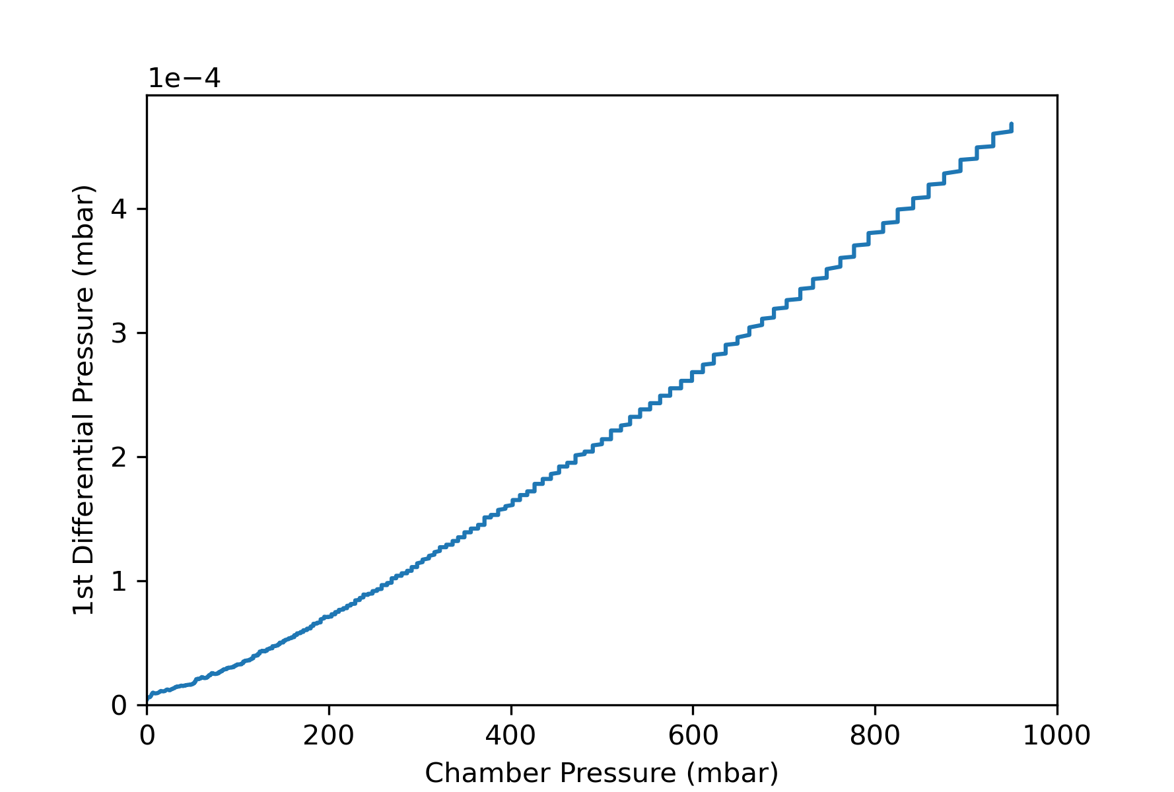
Figure S6 Pressure calibration for 1:2 CO:H₂ mixture comparing the chamber pressure and the pressure of the first differential pumping stage.

AUTHOR INFORMATION
Corresponding Authors
*E-mail for P.L..: patrick.loemker@fysik.su.se
*E-Mail for A.N.: andersn@fysik.su.se
Author Contributions
P.L. with input from A.N. planned the experiments at Petra III. P.L., D.D., M.S., C.M.G., J.G., H.-Y.W., A.H., R.R. A.S., C.S., A.N., P.A. participated in the XPS experimental work, while Z.H., A.S., H.N., V.V., J.-C.S., R.G., S.T. and L.J. participated in the SXRD measurements. P.L. extracted and plotted the SXRD data and A.S. fitted it. G.L.S.R. performed theoretical calculations. P.L. and M.S. developed the data analysis software and P.L. did the data analysis. P.L. and AN wrote the manuscript. All authors contributed to the literature research, result discussion and manuscript improvement.
Notes
The authors declare no competing financial interests.

ACKNOWLEDGEMENTS
The work was supported by the Swedish Research Council (Vetenskapsrådet, VR, project 2017-00559 and project 2013-8823), the Knut & Alice Wallenberg (KAW, grant nr. 2016.0042) foundation as well as the Swedish Foundation for strategic research (Stiftelsen för Strategisk Forskning, SSF, Proj. ITM 17-0034). The research leading to this result has also been supported by the project CALIPSO plus under Grant Agreement 730872 from the EU Framework Program for Research and Innovation HORIZON 2020. The experimental part of this research was carried out at P22 and P21 beamlines at DESY, a member of the Helmholtz Association (HGF). Beamtime was given for in house research proposals. The DFT calculations were performed using resources provided by the Swedish National Infrastructure for Computing (SNIC) at the HPC2N center. The authors would like to acknowledge the help of the P22 beamline engineer Katrin Ederer, and the Technical Division at Stockholm University.
References
S1. van Hardeveld, R. & van Montfoort, A. The influence of crystallite size on the adsorption of molecular nitrogen on nickel, palladium and platinum. Surf. Sci. 4, 396–430 (1966).
S2. Banerjee, A., van Bavel, A. P., Kuipers, H. P. C. E. & Saeys, M. CO Activation on Realistic Cobalt Surfaces: Kinetic Role of Hydrogen. ACS Catal. 7, 5289–5293 (2017).
S3. Amann, P. et al. A high-pressure x-ray photoelectron spectroscopy instrument for studies of industrially relevant catalytic reactions at pressures of several bars. Rev. Sci. Instrum. 90, 103102 (2019).
S4. Shirley, D. A. High-Resolution X-Ray Photoemission Spectrum of the Valence Bands of Gold. Phys. Rev. B 5, 4709–4714 (1972).
S5. Ida, T., Ando, M. & Toraya, H. Extended pseudo-Voigt function for approximating the Voigt profile. J. Appl. Crystallogr. 33, 1311–1316 (2000).
S6. Doniach, S. & Sunjic, M. Many-electron singularity in X-ray photoemission and X-ray line spectra from metals. J. Phys. C Solid State Phys. 3, 285–291 (1970).
S7. van Rijn, R. et al. Ultrahigh vacuum/high-pressure flow reactor for surface x-ray diffraction and grazing incidence small angle x-ray scattering studies close to conditions for industrial catalysis. Rev. Sci. Instrum. 81, 014101 (2010).
S8. Hejral, U. et al. High-energy x-ray diffraction from surfaces and nanoparticles. Phys. Rev. B 96, 195433 (2017).
S9. Gustafson, J. et al. High-Energy Surface X-ray Diffraction for Fast Surface Structure Determination. Science 343, 758–761 (2014).
S10. Vlieg, E. ROD : a program for surface X-ray crystallography. J. Appl. Crystallogr. 33, 401–405 (2000).
S11. Böller, B., Durner, K. M. & Wintterlin, J. The active sites of a working Fischer–Tropsch catalyst revealed by operando scanning tunnelling microscopy. Nat. Catal. 2, 1027 (2019).
S12. Degerman, D. et al. State of the Surface During CO Hydrogenation over Ni(111) and Ni(211) Probed by Operando X-ray Photoelectron Spectroscopy. J. Phys. Chem. C acs.jpcc.2c07650 (2023) doi:10.1021/acs.jpcc.2c07650.
S13. None Available. Materials Data on Co by Materials Project. (2020) doi:10.17188/1263614.
S14. Trzhaskovskaya, M. B. & Yarzhemsky, V. G. Dirac–Fock photoionization parameters for HAXPES applications. At. Data Nucl. Data Tables 119, 99–174 (2018).
S15. Parratt, L. G. Surface studies of solids by total reflection of x-rays. Phys. Rev. 95, 359–369 (1954).
S16. Henke, B. L., Gullikson, E. M. & Davis, J. C. X-Ray Interactions: Photoabsorption, Scattering, Transmission, and Reflection at E = 50-30,000 eV, Z = 1-92. At. Data Nucl. Data Tables 54, 181–342 (1993).
S17. Shinotsuka, H., Tanuma, S., Powell, C. J. & Penn, D. R. Calculations of electron inelastic mean free paths. X. Data for 41 elemental solids over the 50 eV to 200 keV range with the relativistic full Penn algorithm: Calculations of electron inelastic mean free paths. X. Surf. Interface Anal. 47, 871–888 (2015).
S18. Danilatos, G. D. Optimum beam transfer in the environmental scanning electron microscope. J. Microsc. 234, 26–37 (2009).
S19. García, G., Roteta, M. & Manero, F. Electron scattering by N2 and CO at intermediate energies: 1–10 keV. Chem. Phys. Lett. 264, 589–595 (1997).
S20. Shipilin, M. et al. In Situ Surface-Sensitive Investigation of Multiple Carbon Phases on Fe(110) in the Fischer–Tropsch Synthesis. ACS Catal. 12, 7609–7621 (2022).
S21. Takata, Y. et al. Recoil effects of photoelectrons in a solid. Phys. Rev. B 75, 233404 (2007).
S22. Weststrate, C. J. (Kees-J. et al. Mechanistic insight into carbon-carbon bond formation on cobalt under simulated Fischer-Tropsch synthesis conditions. Nat. Commun. 11, 750 (2020).
S23. Suga, S. et al. Do all nuclei recoil on photoemission in compounds? New J. Phys. 11, 073025 (2009).
S24. Quiros, C., Robach, O., Isern, H., Ordejón, P. & Ferrer, S. Compressibility of CO adsorbed on Ni from 10−6 mbar to 1.2 bar ambient CO pressures investigated with X-ray diffraction. Surf. Sci. 522, 161–166 (2003).
S25. Degerman, D. et al. Operando Observation of Oxygenated Intermediates during CO Hydrogenation on Rh Single Crystals. J. Am. Chem. Soc. 144, 7038–7042 (2022).
S26. Amann, P. et al. The state of zinc in methanol synthesis over a Zn/ZnO/Cu(211) model catalyst. Science 376, 603–608 (2022).
S27. Weststrate, C. J., van Helden, P. & Niemantsverdriet, J. W. Reflections on the Fischer-Tropsch synthesis: Mechanistic issues from a surface science perspective. Catal. Today 275, 100–110 (2016).
S28. Enkovaara, J. et al. Electronic structure calculations with GPAW: a real-space implementation of the projector augmented-wave method. J. Phys. Condens. Matter 22, 253202 (2010).
S29. Mortensen, J. J., Hansen, L. B. & Jacobsen, K. W. Real-space grid implementation of the projector augmented wave method. Phys. Rev. B 71, 035109 (2005).
S30. Hammer, B., Hansen, L. B. & Nørskov, J. K. Improved adsorption energetics within density-functional theory using revised Perdew-Burke-Ernzerhof functionals. Phys. Rev. B 59, 7413–7421 (1999).

