Structural and functional determination of peptide versus small molecule ligand binding at the apelin receptor

Thomas L. Williams¹*, Grégory Verdon²*, Rhoda E. Kuc¹, Heather Currinn², Brian Bender², Nicolae Solcan², Oliver Schlenker², Robyn G.C. Macrae^{1,3}, Jason Brown², Marco Schütz², Andrei Zhukov², Sanjay Sinha³, Chris de Graaf^{2§}, Stefan Gräf^{4,5,6§}, Janet J. Maguire^{1§}, Alastair J.H. Brown^{2§}, Anthony P. Davenport^{1§}

1. Experimental Medicine & Immunotherapeutics, University of Cambridge, Cambridge CB2 0QQ, UK
2. Sosei Heptares, Steinmetz Building, Granta Park, Cambridge CB21 6GT, UK
3. Wellcome-MRC Cambridge Stem Cell Institute, Jeffrey Cheah Biomedical Centre, University of Cambridge, Cambridge CB2 0AW, UK
4. NIHR BioResource for Translational Research – Rare Diseases, Cambridge Biomedical Campus, Cambridge CB2 0QQ, UK
5. Department of Haematology, NHS Blood and Transplant, Long Road, University of Cambridge, Cambridge CB2 0PT, UK
6. Victor Phillip Dahdaleh Heart and Lung Research Institute, University of Cambridge, Cambridge Biomedical Campus, Cambridge CB2 0BB, UK

*Joint first authors
§Joint senior authors

Author(s) for Correspondence:

Anthony P. Davenport (apd10@medschl.cam.ac.uk)
Experimental Medicine and Immunotherapeutics
University of Cambridge
Level 6, Addenbrooke’s Centre for Clinical Investigation (ACCI)
Box 110, Addenbrooke's Hospital, Cambridge, UK, CB2 0QQ

Alastair J.H. Brown (Alastair.Brown@SoseiHeptares.com)
Sosei Heptares
Steinmetz Building
Granta Park, Cambridge, UK, CB21 6GT

Supplementary Information

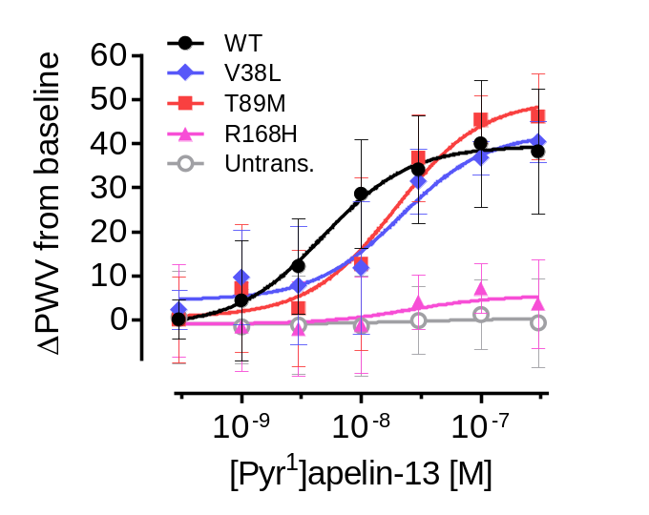
Fig. S1: The R/H168^{4.64} apelin receptor variant is unresponsive to [Pyr¹]apelin-13 in a functional dynamic mass redistribution assay. Concentration-response curves showing response to endogenous [Pyr¹]apelin-13 peptide in CHO-K1 cells transfected with wild-type or variant apelin receptor (as indicated in figure). Data are expressed as mean ± SD, n = 3 independent experiments.

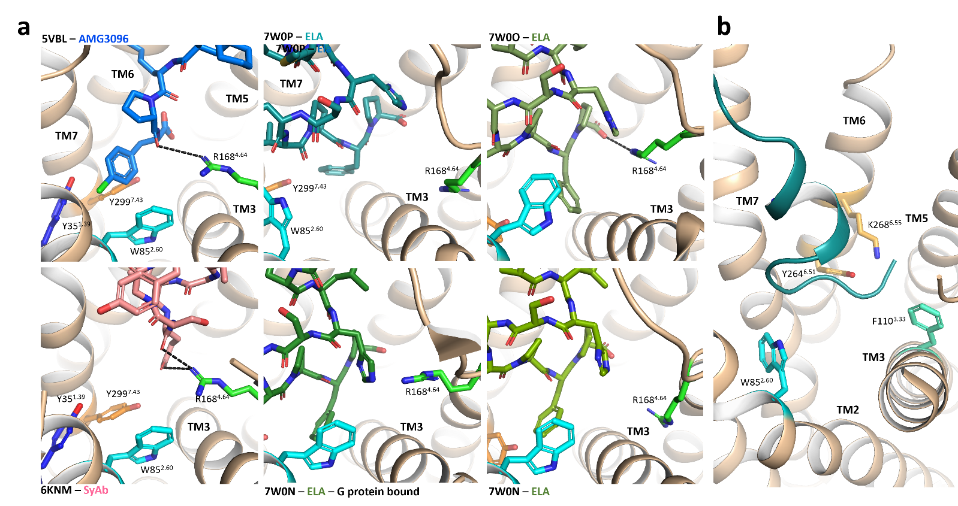

Fig. S2. Close-up view of peptide C-termini and relative position of R168^{4.64} side chain in previously reported crystal and cryoEM structures of the human apelin receptor. a Cartoon representation of previously reported apelin receptor structures bound to bound the synthetic agonist peptide AMG3054 (top left), synthetic antagonist antibody JN241 (bottom left), and to ELA (middle and right panels); b Cartoon representation of ELA engagement to the apelin receptor in 7w0p.

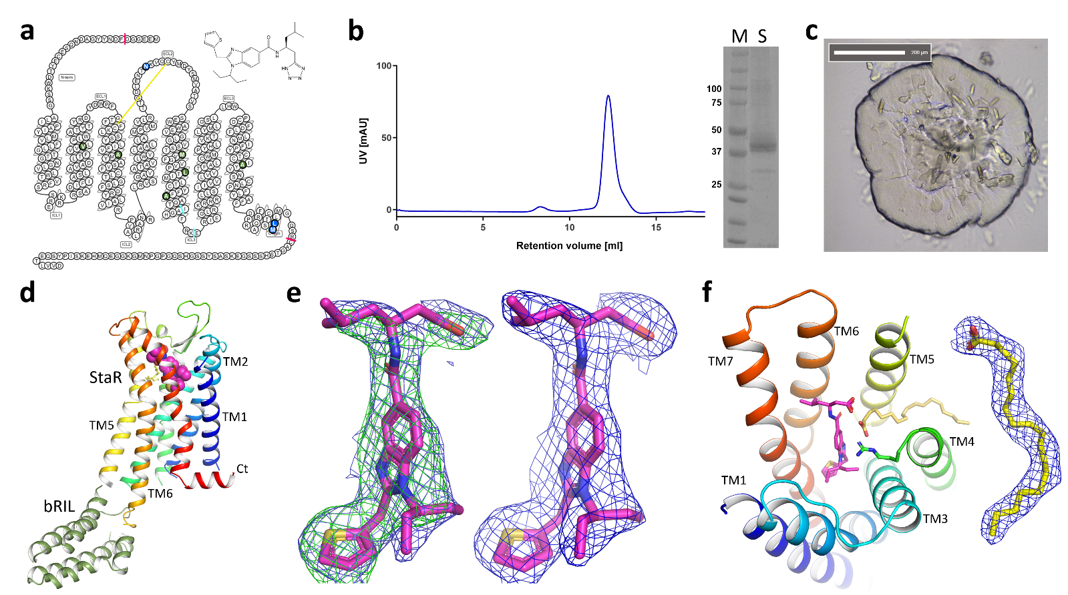
Fig. S3: Apelin receptor StaR generation to crystal structure of with the small synthetic G protein-biased agonist CMF-019. a Snake plot of the protein sequence of the apelin receptor StaR used for the crystal structure determination as generated by GPCRdb (https//:gpcrdb.org). The 6 thermostabilising and 3 post-translational modification removal mutations are highlighted in green and blue, respectively. The two cysteine residues making a disulfide bond are linked with a solid yellow line. N- and C-terminal truncation and optimised bRIL fusion insertion points are highlighted with small red and cyan bars, respectively. b UV absorption profile at 280 nm of the elution crystallisation construct from a SEC200 Sephadex 10/300 column (left), and SDS-PAGE analysis of a sample used for crystallisation (S) along molecular weight markers (M), for which relevant values in kDa on the left (right). c Bright-field image of a bolus of mesophase with crystals of the apelin receptor StaR bRIL CMF-019 complex. d Cartoon representation of the crystal structure of the apelin receptor StaR (rainbow) with the bRIL fusion (green) in complex with CMF-019 (spheres). e Residual 2Fo-Fc (blue mesh, 1σ) and Fo-Fc (green mesh, 3σ) electron density maps obtained after refinement of the apelin receptor StaR bRIL chimera without (left) and with CMF-019 (right) on the refined pose of CMF-019 in stick representation. f Top view of the apelin receptor StaR structure in cartoon representation with CMF-019 (magenta) and the molecule of oleic acid (yellow) represented as sticks, and 2Fo-Fc (blue mesh, 1σ) electron density map around the oleic acid molecule.

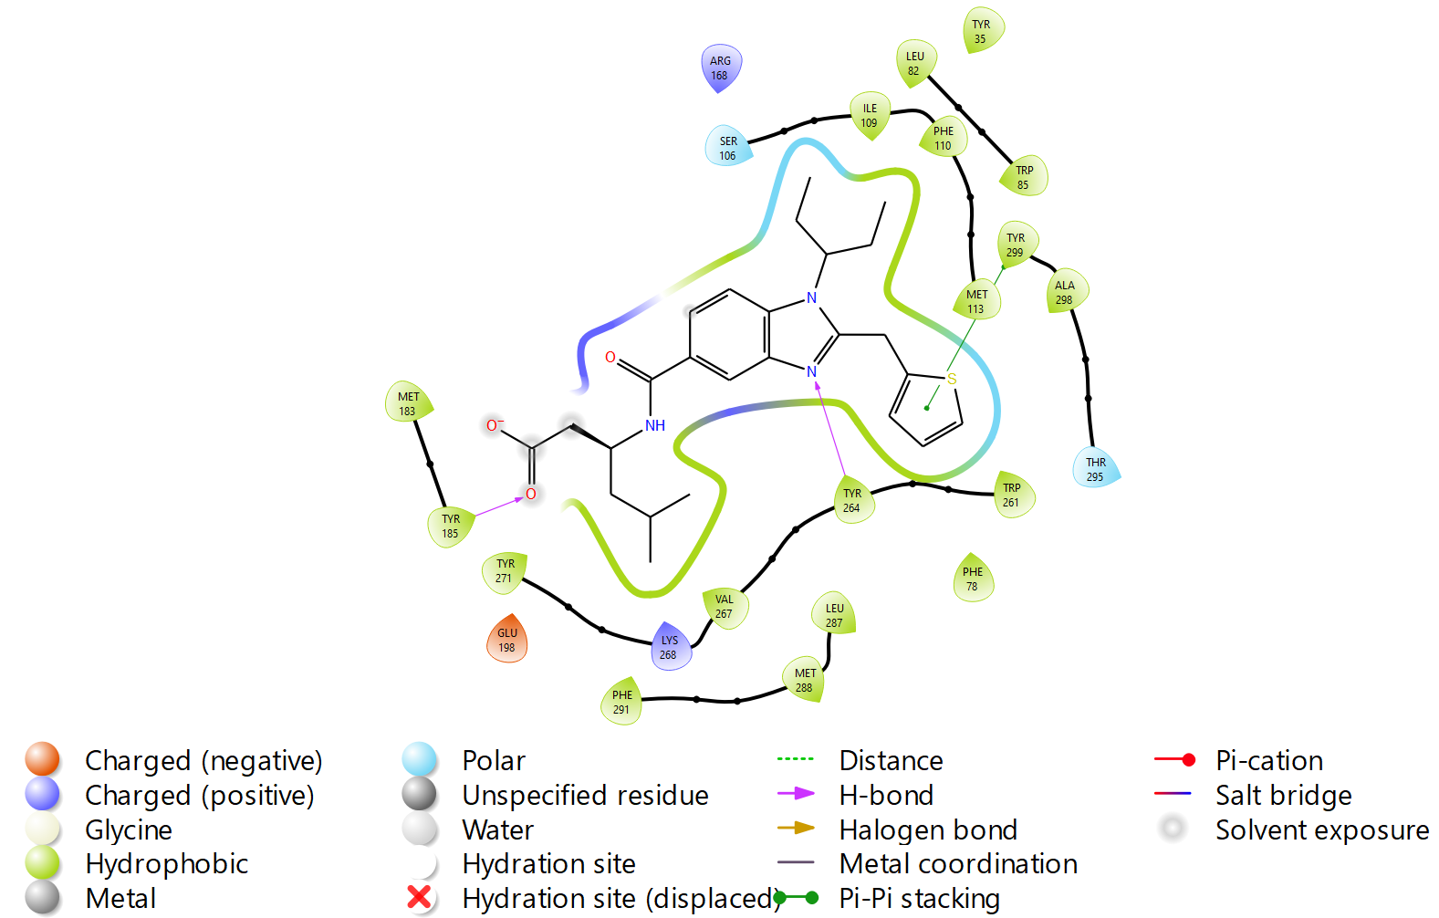
Fig. S4: Two-dimensional representation of the amino acid and small synthetic, G protein-biased CMF-019 interactions in the apelin receptor StaR crystal structure.

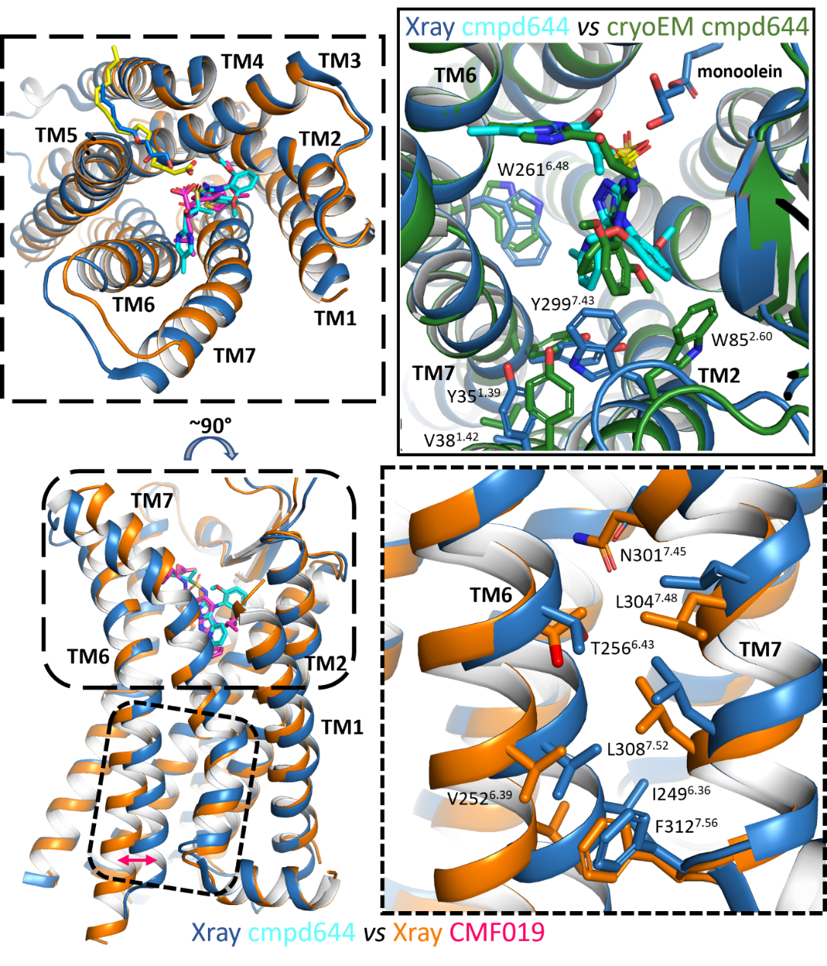

Fig. S5: Comparison of apelin receptor small synthetic agonist crystal structures highlights the CMF-019 complex structure’s more active-like conformation. Views of an overlay of apelin receptor StaR crystal structure (orange) in complex with CMF-019 (magenta), with the cmpd644 crystal structure (cyan or green) in cartoon representation. Small molecule agonists and relevant amino acid side chains are represented as sticks. Left panels show top-down and side views, with close-up view (right panels) of TM6-TM7 interface, and cmpd644 binding poses (top-right) in previous crystal and cryoEM structures.

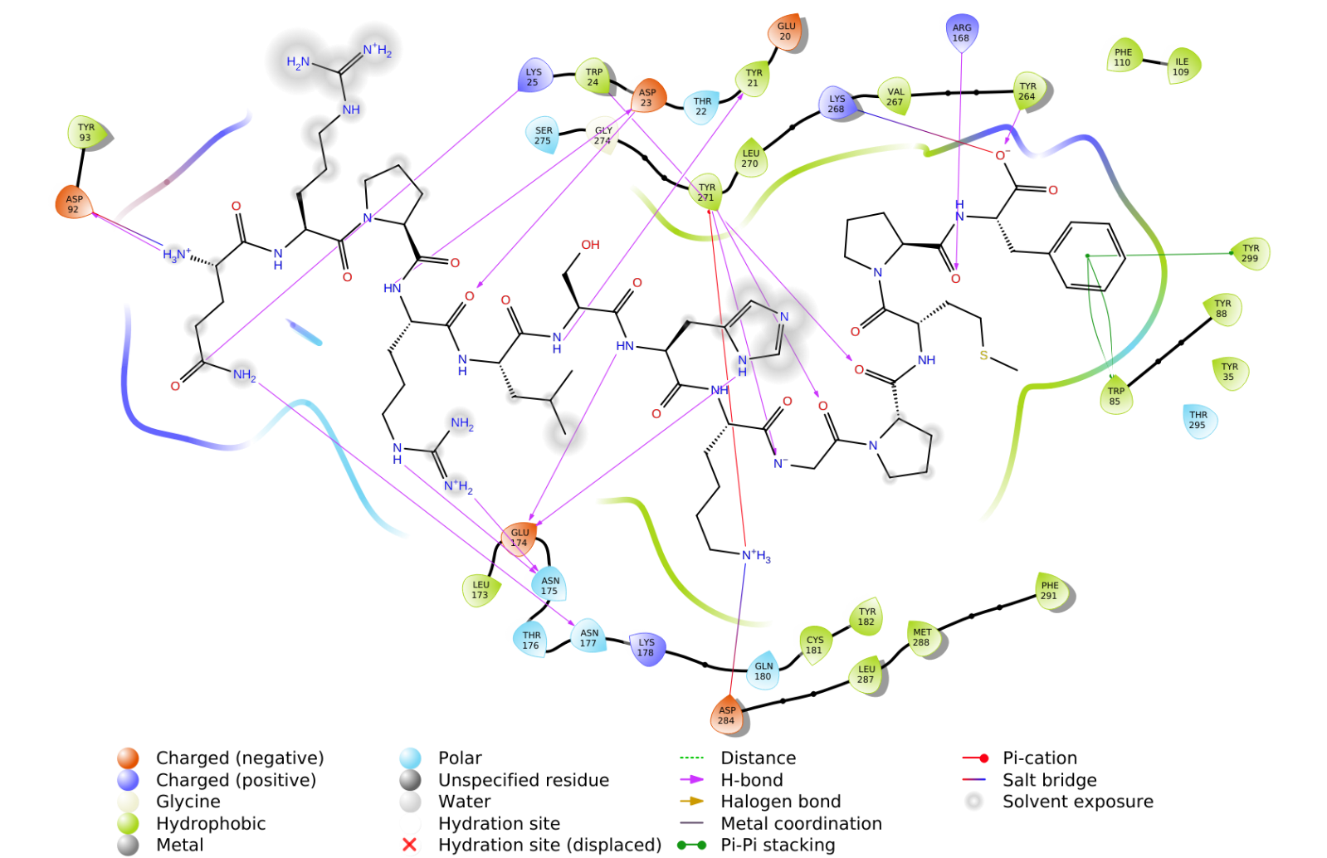
Fig. S6. Two-dimensional representation of the amino acid and apelin peptide interactions in our AlphaFold2 apelin receptor apelin peptide complex model.

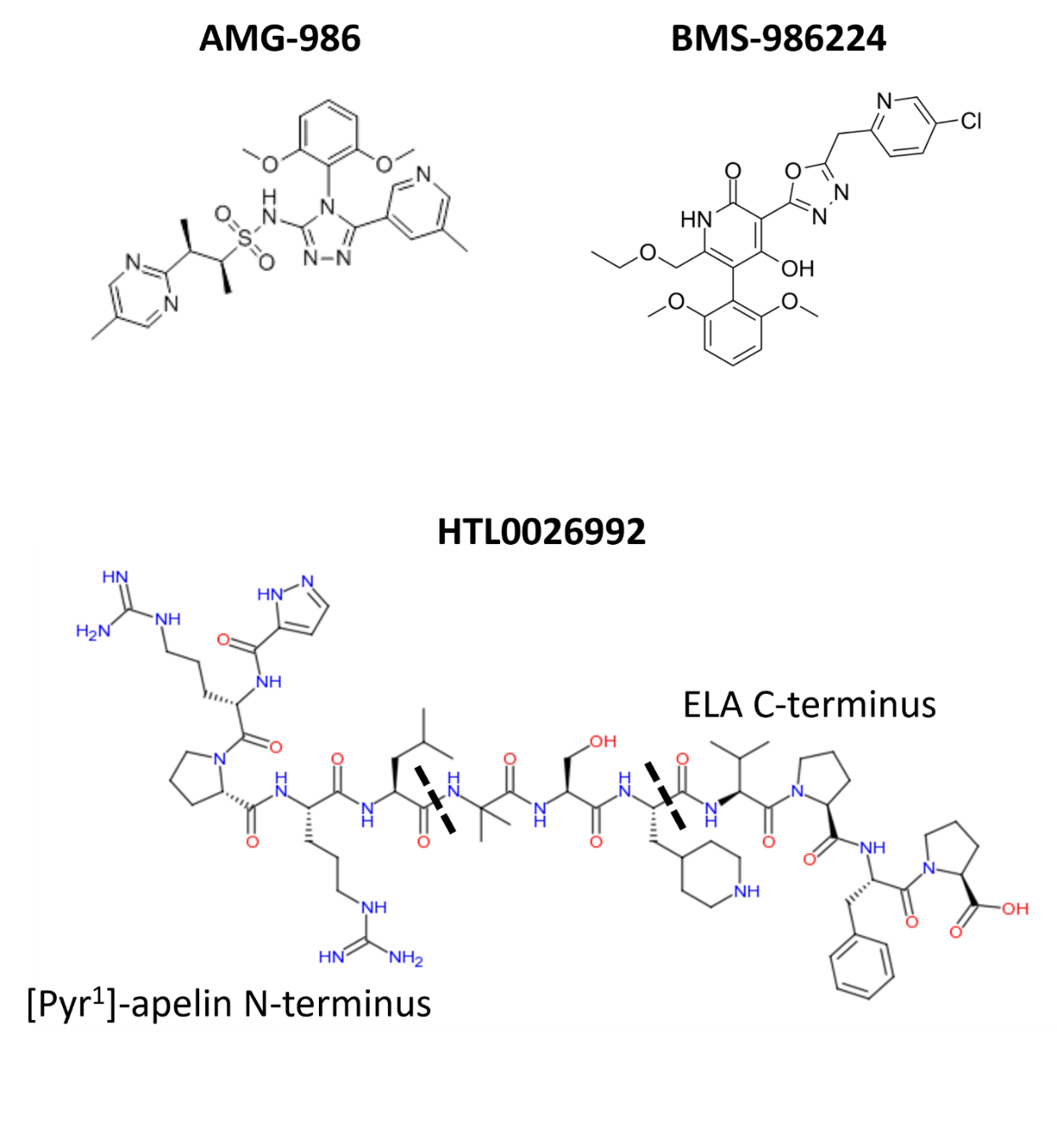

Fig. S7: Chemical structures of the small synthetic agonists AMG-986 and BMS-986224, and of HTL0026992, the chimera of the apelin and ELA peptides used in SPR experiments.

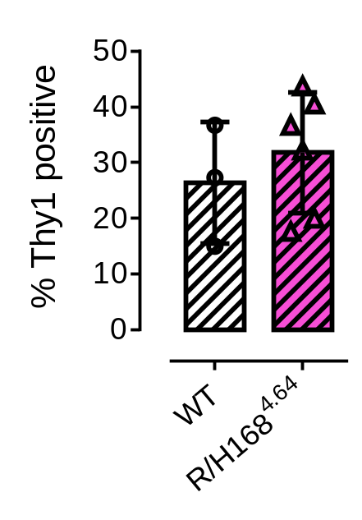

Fig. S8: Thy1 (fibroblast marker) expression in R/H168^{4.64} variant hESC-CMs. Bar chart shows % hESC-CM population staining positive for the fibroblast marker Thy1.

Table S1: Summary of apelin receptor residues that interact with the small synthetic agonists CMF-019 and cmpd644, and the endogenous peptides apelin and ELA.

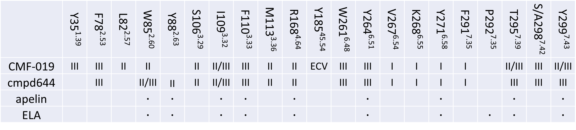

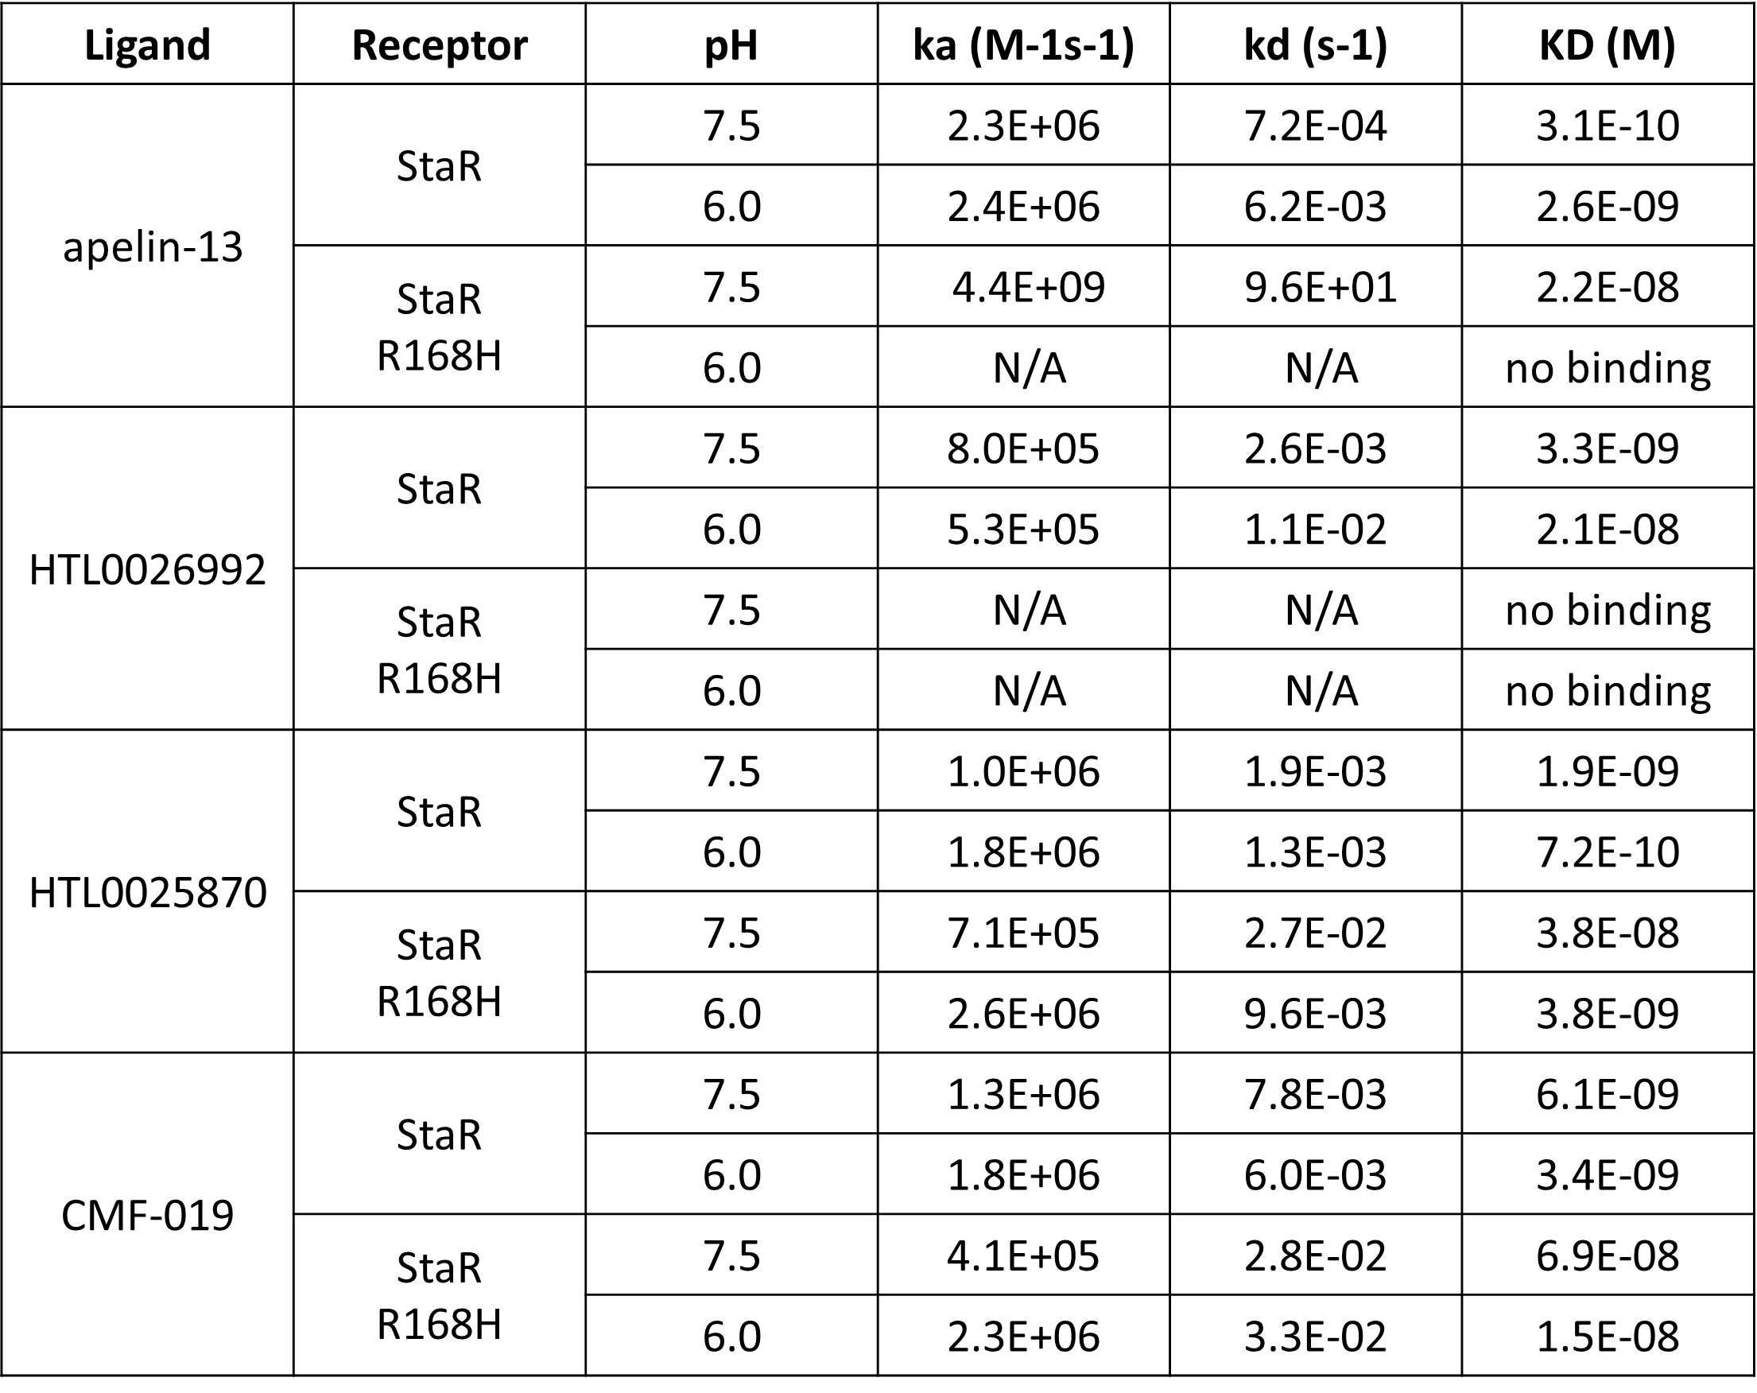
Table S2: Summary table of SPR data for the apelin receptor StaR and R168H variant binding to apelin, chimeric peptide HTL0026992, tool ligand HTL0025870, and CMF-019, tested at pH 7.5 and 6.0.

 | StaR-CMF-019
Data collection
Number of crystals | 7
Space group | C222₁
Cell dimensions  a, b, c (Å) | 65.82, 153.95, 111.65
α, β, γ (°) | 90, 90, 90
Resolution (Å)  No. reflections | 76.97-2.58 (3.03-2.58)*  9698 (223)*
R_{pim} (all I⁺ & I⁻) | 0.029 (0.145)*
I/σ(I) | 7.1 (1.5)*
CC_{1/2} | 0.923 (0.497)*
Completeness (%)  spherical  ellipsoidal | 54.5 (4.3)*  90.1 (38.6)*
Redundancy | 14.8 (18.4)*
Refinement
Resolution (Å) | 76.97-2.58
R_{work} / R_{free} | 0.224/0.278
No. atoms
Protein | 3016
Ligand | 32
Other | 76
B factors
Protein | 66.75
Ligand | 45.56
Other | 43.65
R.m.s. deviations  Bond lengths (Å) | 0.01
Bond angles (°) | 1.05
* Values in parentheses are the for highest-resolution shell.

Table S3: Crystallographic X-ray data collection & structure refinement statistics.

