Supplementary figure 1.
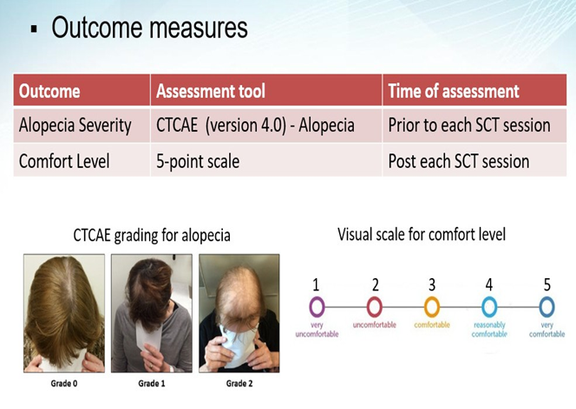

Supplementary figure 2.
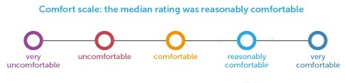
5
4
3
2
1

