Graph 1. Divorce Rate per 1,000 Population from 1940 to 2020
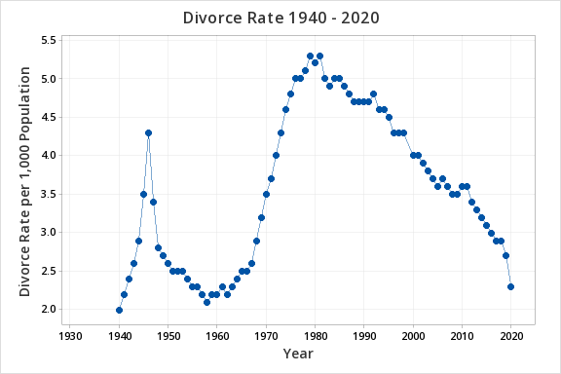

Graph 2. Total Providers by Year

Pie Chart 1. State Proportions in 2003 V.S. Proportions in 2017 (Parental Involvement)
Graph 3. Average Waiting Time by Year

Graph 4. Survival Graph for Marriage by Year
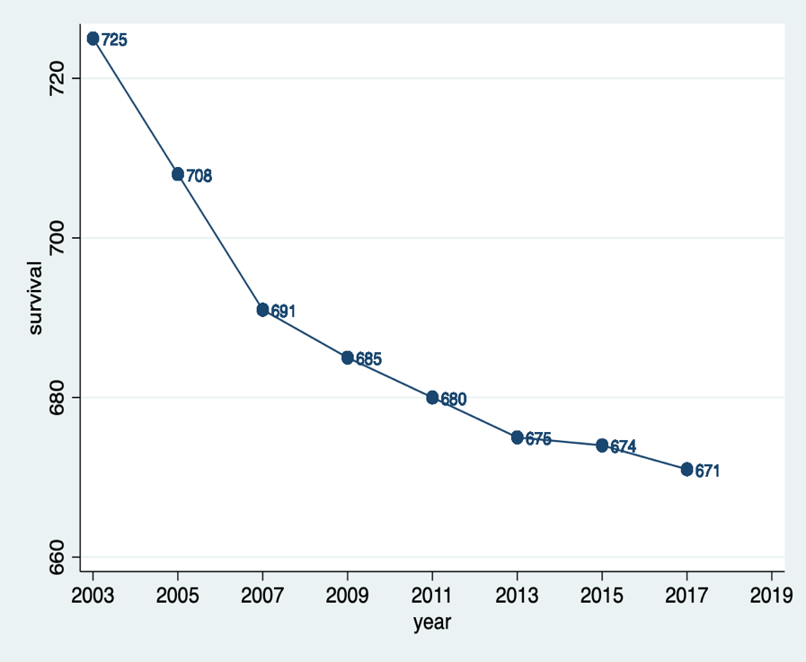

Graph 5. Average State Divorce Rate by Year

