Supporting Supplemental Material

EXPERIMENTAL SECTION
General Experiments
The ¹H, ¹³C, DEPT, COSY, HSQC, HMBC, TOCSY NOESY, and ROESY spectra of all congeners were measured on a Bruker Avance or a Varian INOVA 600 MHz NMR equipped with a 3 mm probe.

NMR Processing Procedures
Comprehensive NMR data sets were collected for every KmTx sample available. Individual experiments were then compared to the known KmTx2 standard data set. Utilizing the NMR processing software MestReNova v.7.1.0-9185, both the 1D and the 2D data sets were overlaid. The 2D HSQC experiments were the most useful in identifying the major differences in the structure. Once a region of the molecule was identified that differed from the standard, additional NMR experiments were used to assign and confirm the new KmTx structures.

Computational Calculations
The calculation procedures were referenced with previous studies.30a, 40 All conformational searches were conducted employing Macromodel (Version 9.9, Schrodinger LLC.) program with “Mixed torsional/Low Mode sampling” in MMFF force field. The searches were performed in the gas phase with a 50 kJ/mol energy window limit and 10,000 maximum number of steps to fully explore all low-energy conformers. All minimization processes were carried out utilizing Polak-Ribiere Conjugate Gradient (PRCG) method, 10,000 maximum iterations and a 0.001 convergence threshold. For the conformational search, NMR experimental data was incorporated for the generation of constraints as followed. 1) The bonds of each diastereomer were constrained with a 1,000 force constant unless observed homo- and hetero-coupling constants associated with the bonds exhibited the “medium” ranges.9 2) The pyran rings were constrained to reflect their actual conformation that matched with the observed NMR data based on a distance deduced from the NOE spectrum. The GIAO shielding constants of all conformers within 10 kJ/mol of the global minimum were calculated utilizing Gaussian 09 package (Gaussian Inc.) at the B3LYP/6-31G(d,p) level in the gas phase. The CS values were calculated according to the equations described in previous studies.30a, 40 The calculation of DP4 probability was facilitated using an applet available at “http://www-jmg.ch.cam.ac.uk/tools/nmr/DP4/”. The predicted CS values of diastereotopic protons were compared with the closet experimental values of those protons unless sufficient NMR information was available for the assignment of each proton.

Congener Data
Karlotoxin 2 (1): Colorless oil; 1H and 13C NMR Table 2; UV (MeOH) λmax 237 nm; [α]22D +18 (c 0.001, MeOH); C67H121O24Cl HRESIMS Obsd. [M+Na]+ m/z 1367.7844 (Calcd. [M+Na]+ m/z 1367.7834; error = -0.8 ppm).
59-E-Chloro-Abbotoxin (3): Colorless oil. 1H and 13C NMR Table 2; UV (MeOH) λmax 237 nm; C62H112O22Cl based on HRESIMS Obsd. [M+Na]+ m/z 1265.7252 (Calcd for [M+Na]+ m/z 1265.7153; error = -8.2 ppm.
Abbotoxin (4): Colorless oil. 1H and 13C NMR Table 2; UV (MeOH) λmax 228 nm; C62H112O22 based on HRESIMS Obsd. [M+Na]+ m/z 1231.7631 (Calcd. for [M+Na]+ 1231.7543; error = -7.6 ppm).
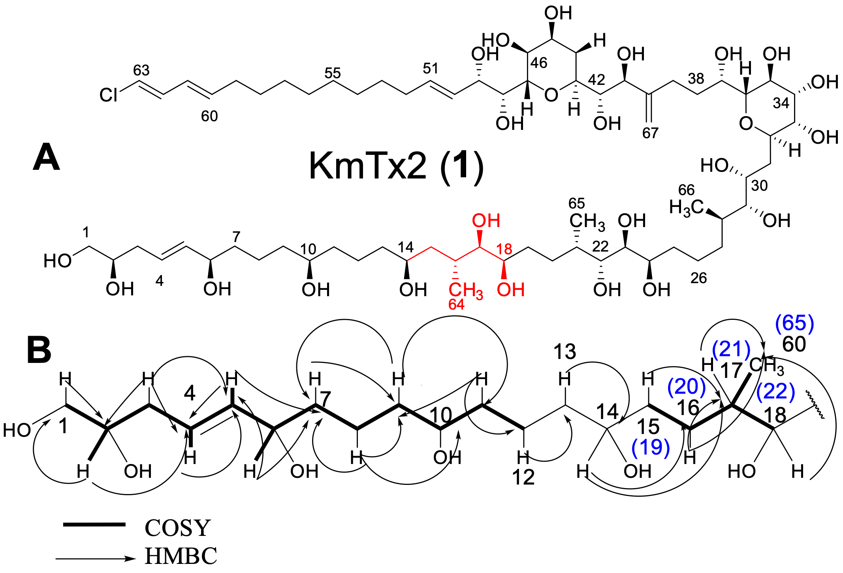

Figure S1. Similarities of KmTx2 (1) with Abbotoxin (3).
A) Structure of KmTx2 with deleted carbons for Abbotoxin like congeners shown in red.
B) Key HMBC and COSY correlations for 4 and 3. The HSQC overlay indicates that the rest of the molecule (C22-C63 and C65-67 [KmTx2 numbering]) is identical to 1. The blue numbers are the corresponding carbon numbers for 1.

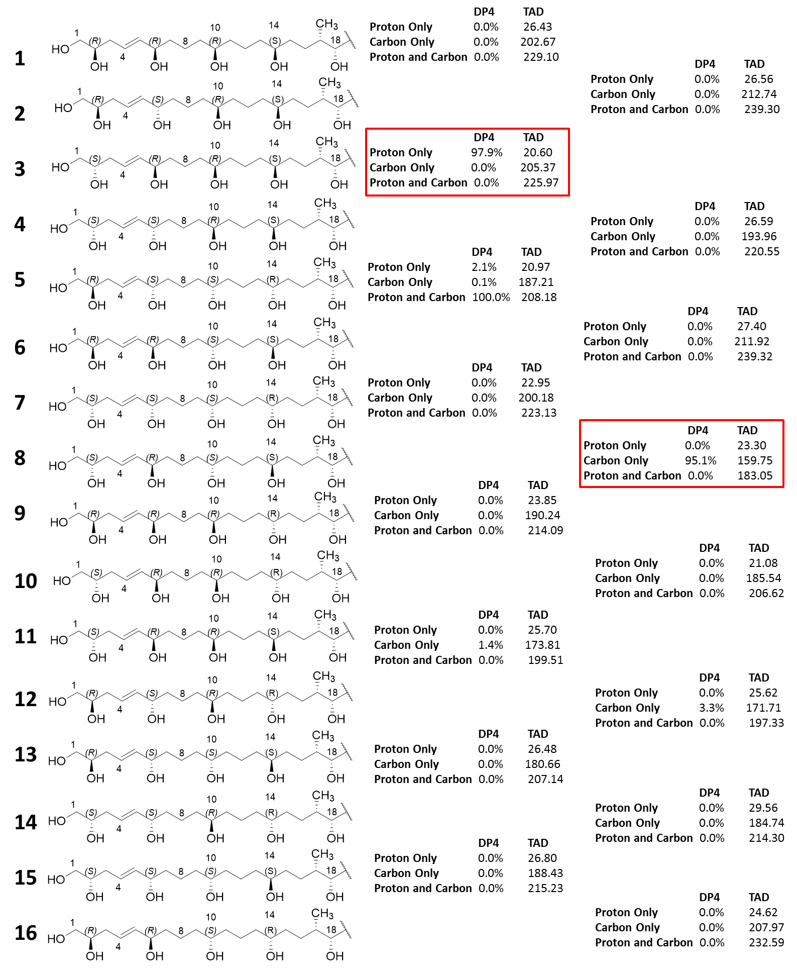
Figure S2. Assignment of relative configuration of the polyol for 59-E-Chloro-Abbotoxin.
Conformer 3 (2S, 6R, 10R, 14S) shows the lowest TAD and highest DP4 percentage for proton and conformer 8 (2S, 6R, 10S, 14S) shows the lowest TAD and highest DP4 for carbon. Based on this data the relative configuration for C2, C6, and C14 can be established, but C10 remains ambiguous.

Table S1. NMR Assignment for 1 (Karlotoxin 2), 3 (59-E-Chloro-Abbotoxin), and 4 (Abbotoxin).
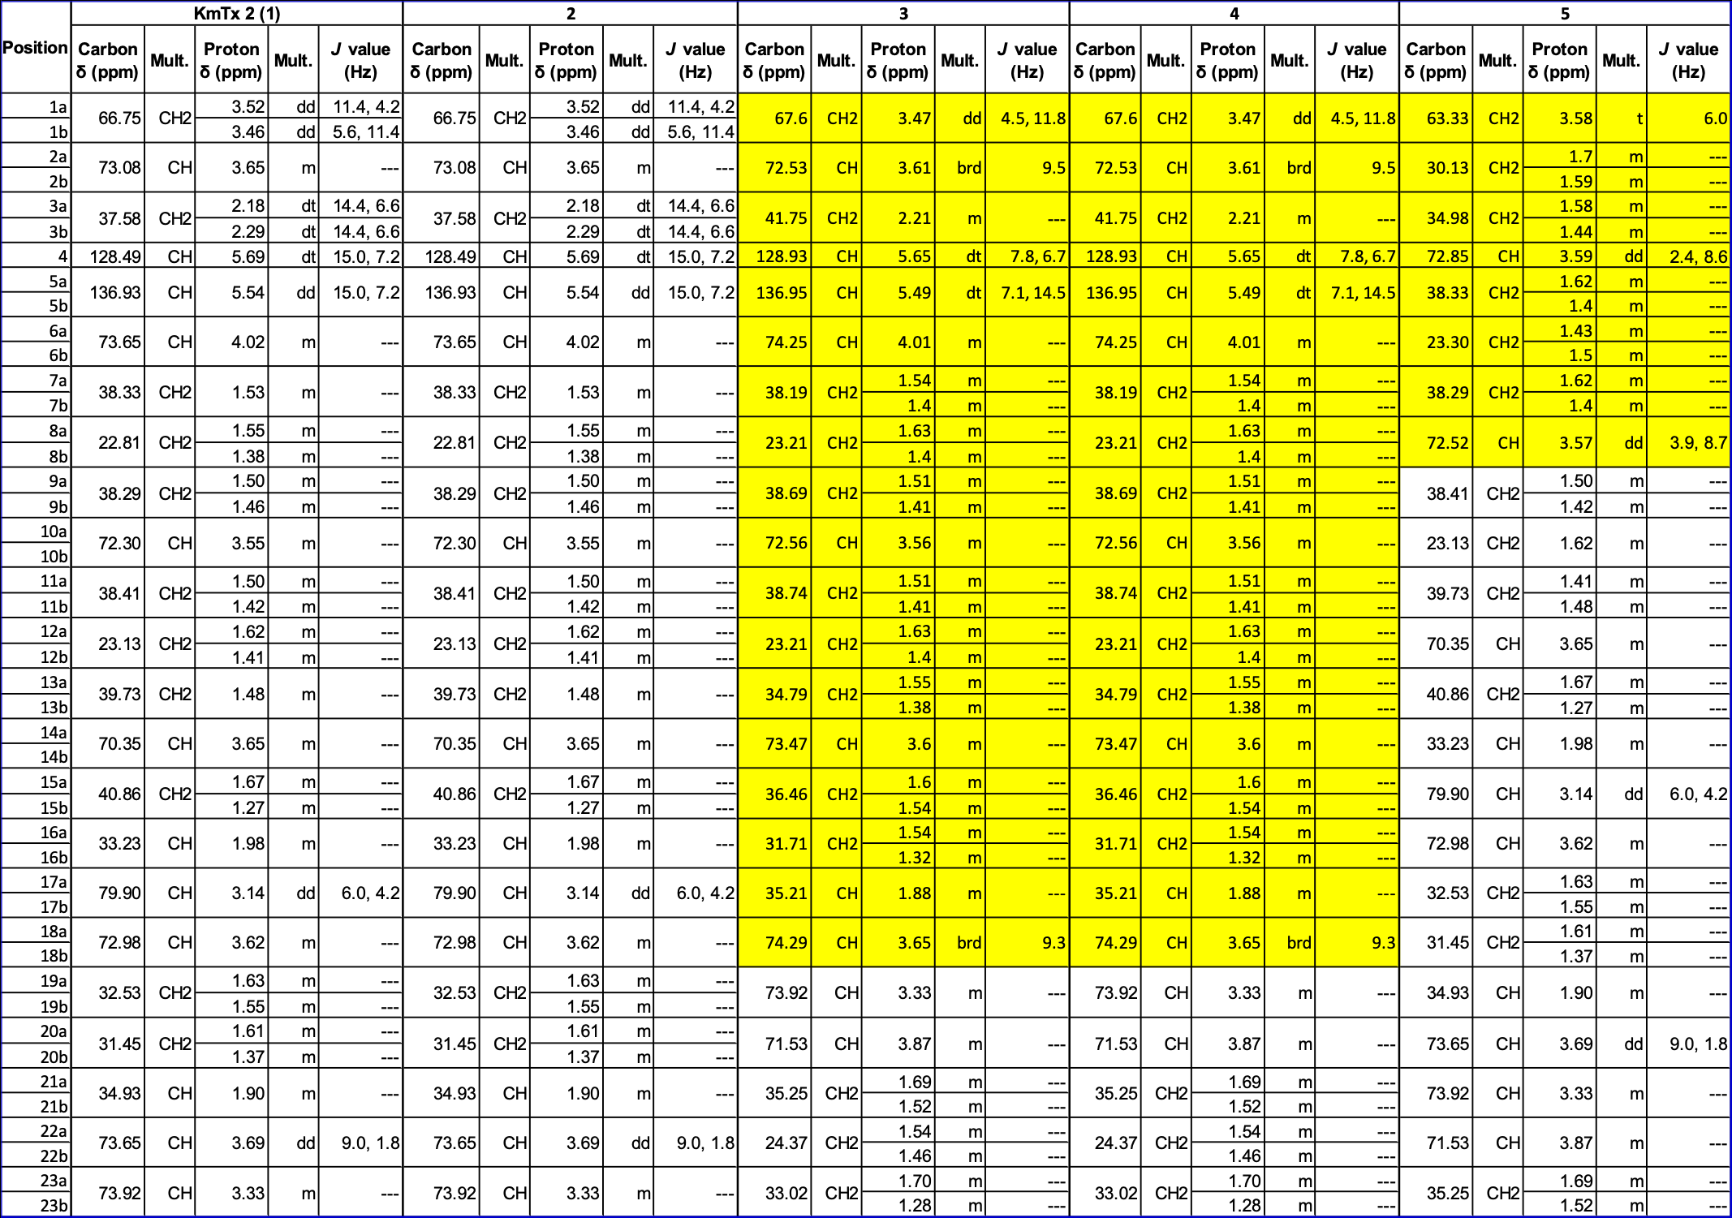
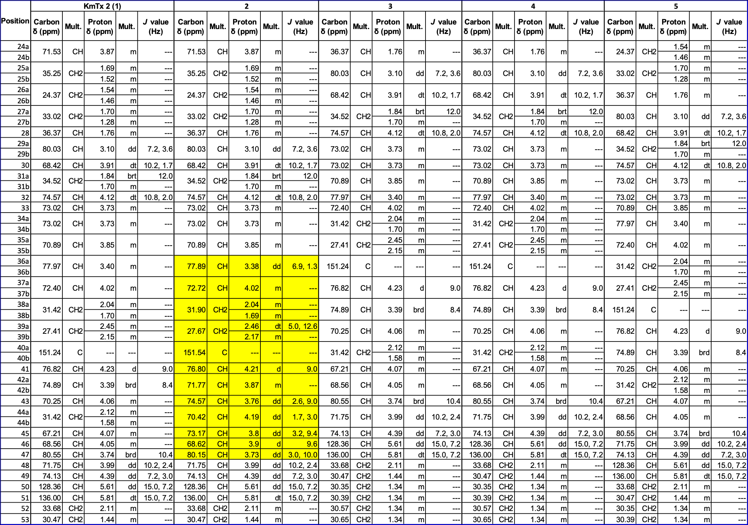
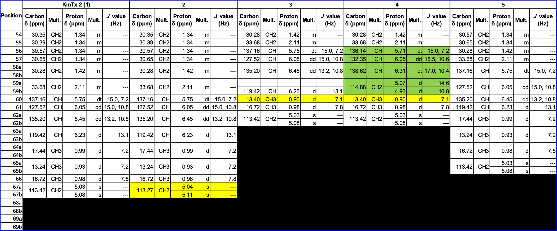

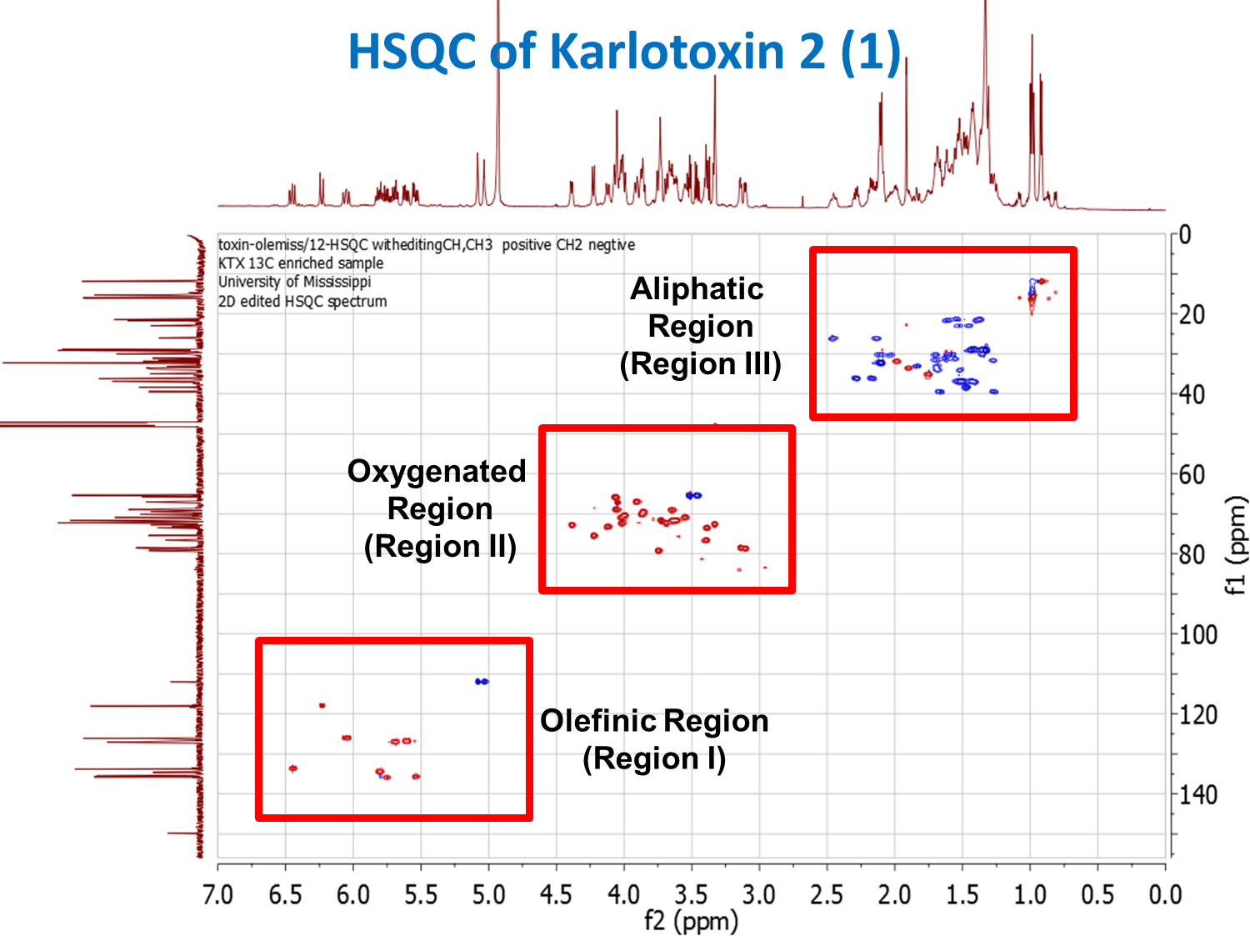
Figure S3. HSQC of KmTx2 with the key overlay regions outlined in red.
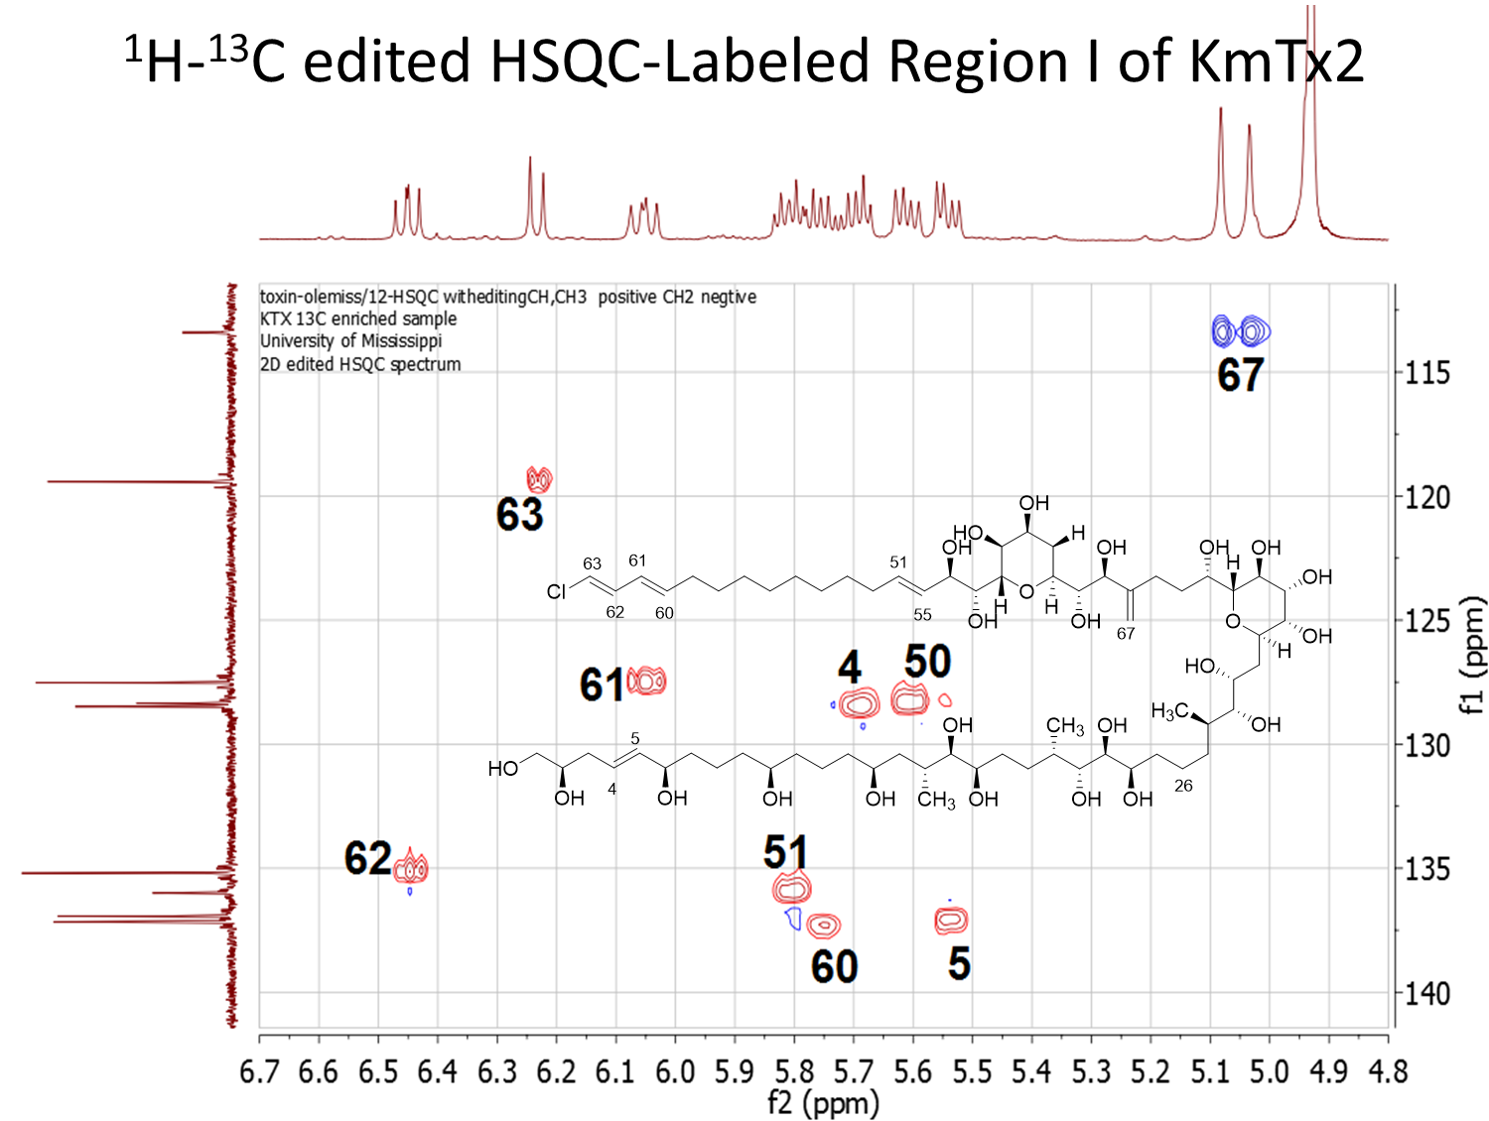
Figure S4. Detailed HSQC assignment of KmTx2 for region I.
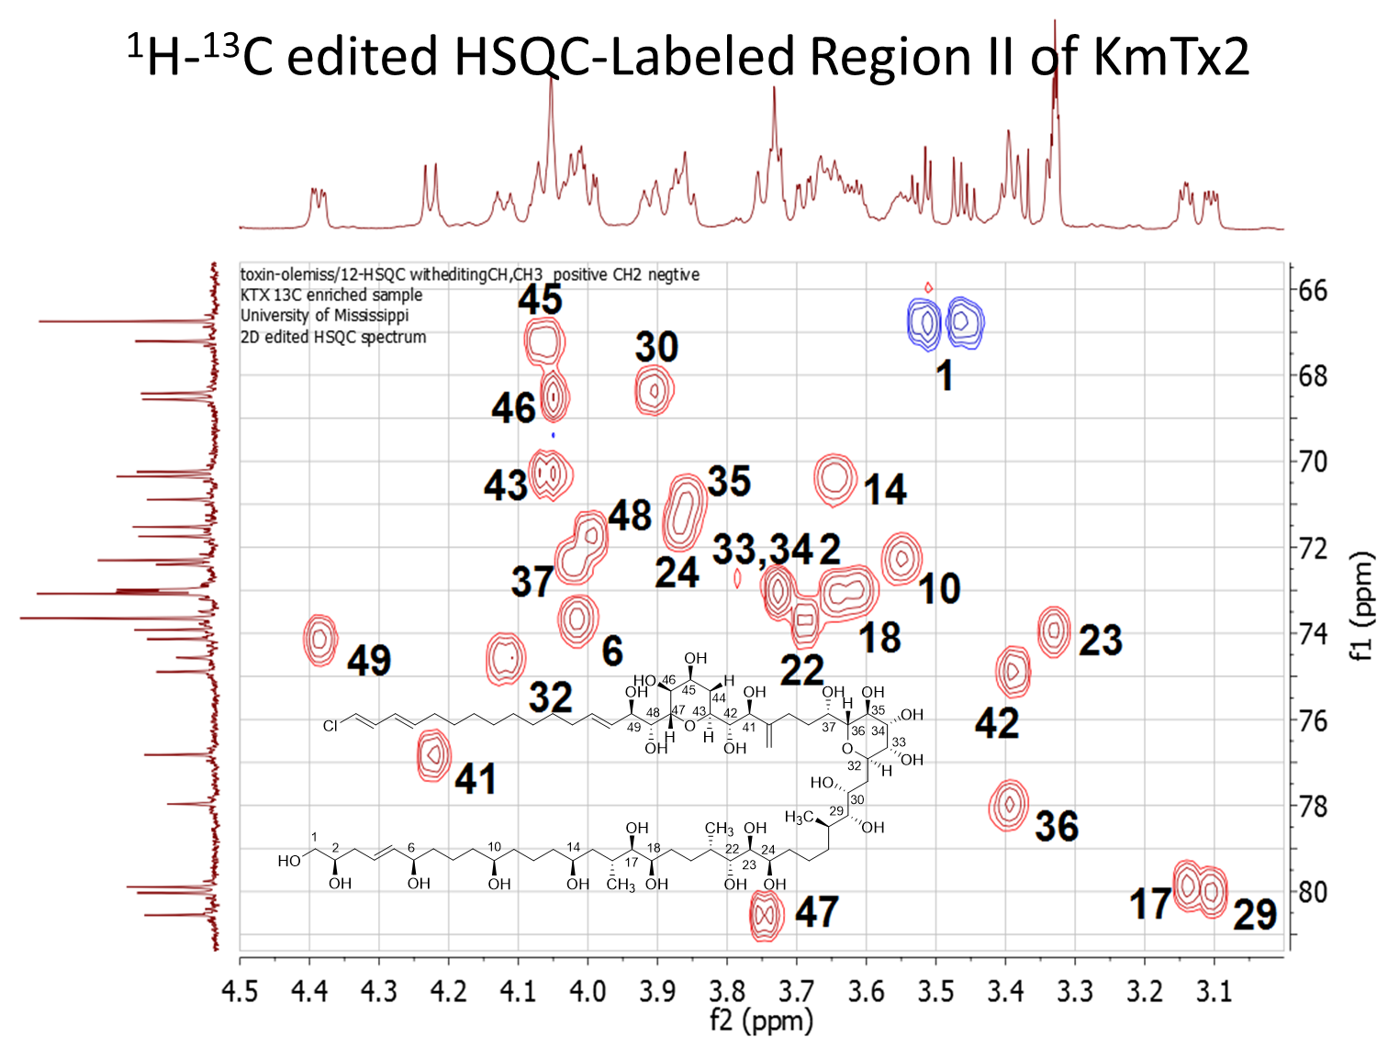
Figure S5. Detailed HSQC assignment of KmTx2 for region II.
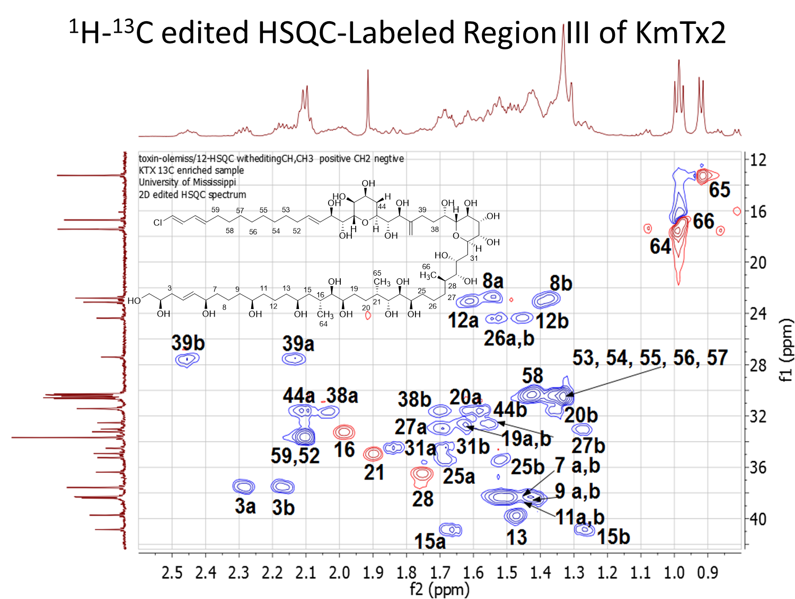
Figure S6. Detailed HSQC assignment of KmTx2 for region III.

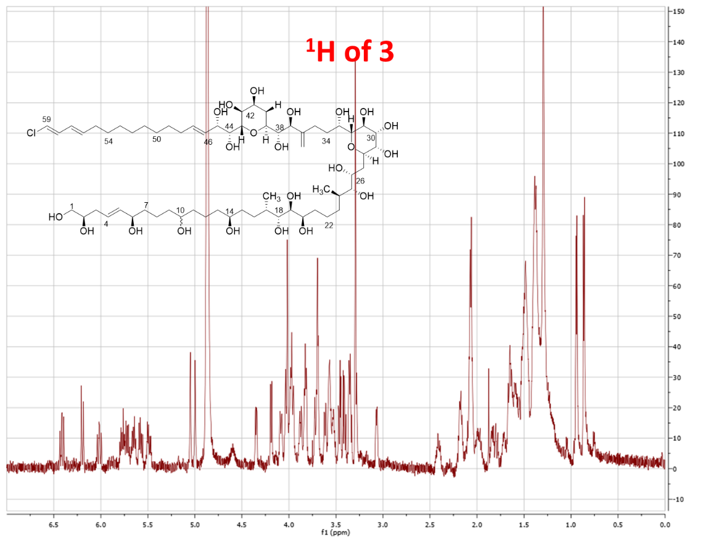
Figure S7. ¹H of 3.
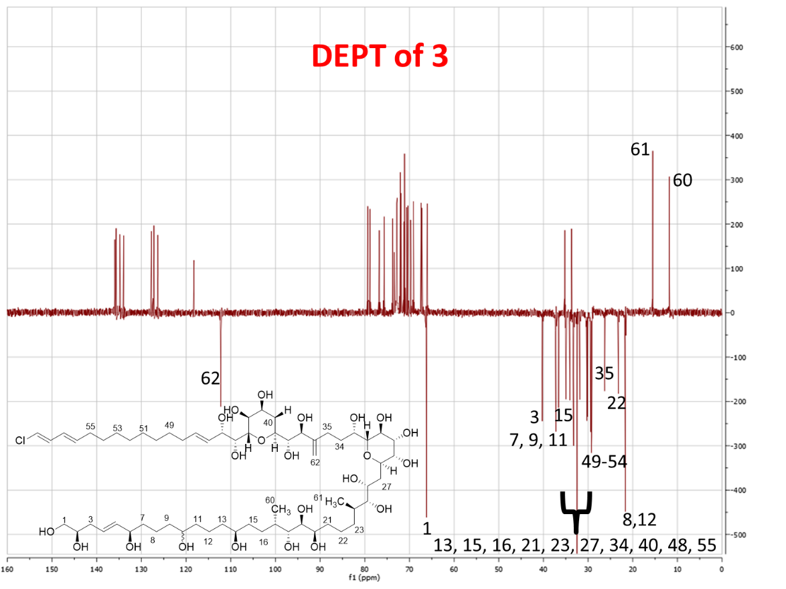
Figure S8. DEPT of 3.
For the 2D HSQC overlay experiments KmTx2 (1) is always depicted in blue. The compound that is being overlaid with KmTx 2 is always in red. Signals that are the same for both structures are circled in black. When a compound is being compared to something other than KmTx 2 the colors are defined in the first page of the compound data.

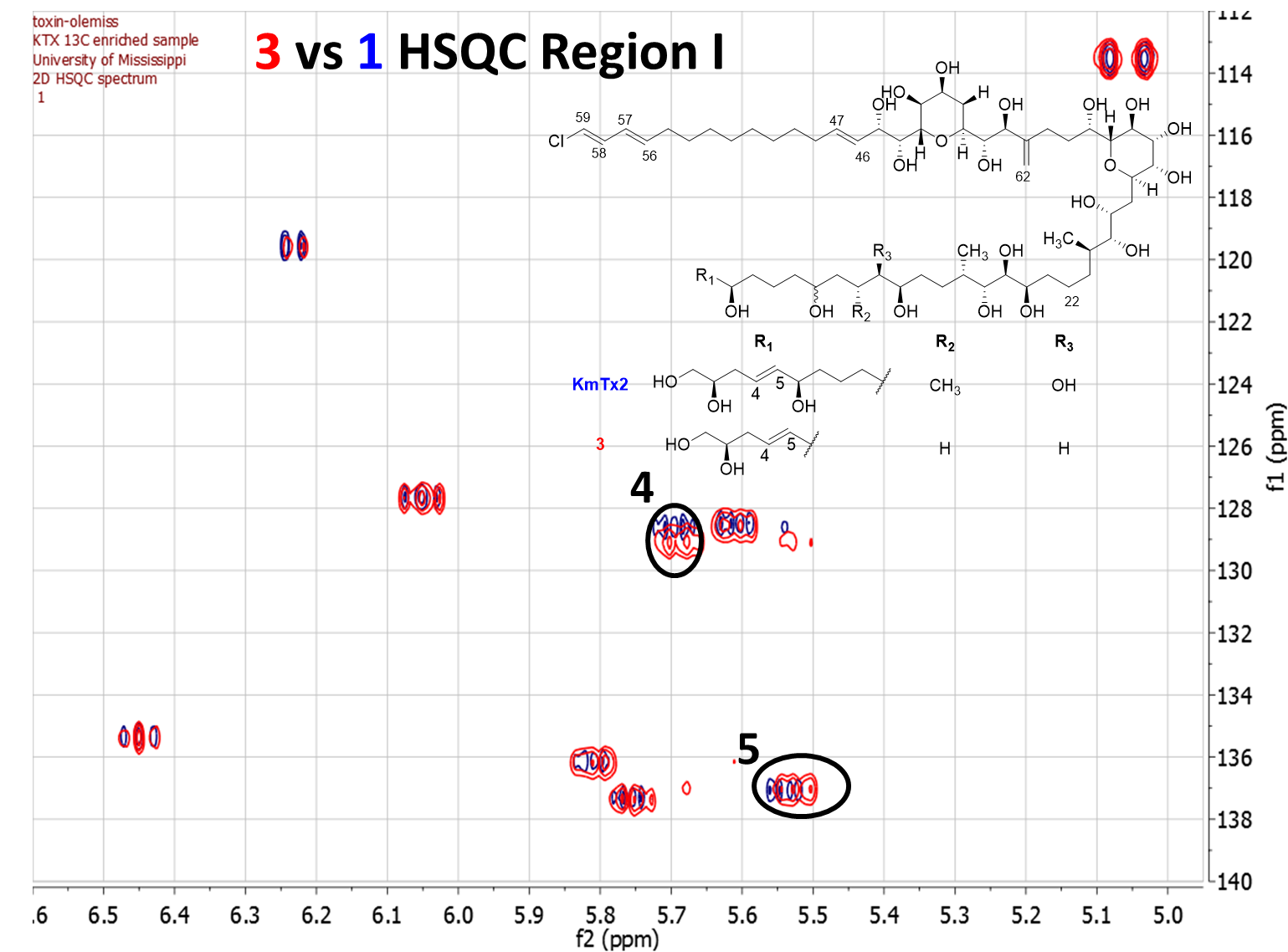
Figure S9. Congener 3 vs 1 HSQC overlay for region I.
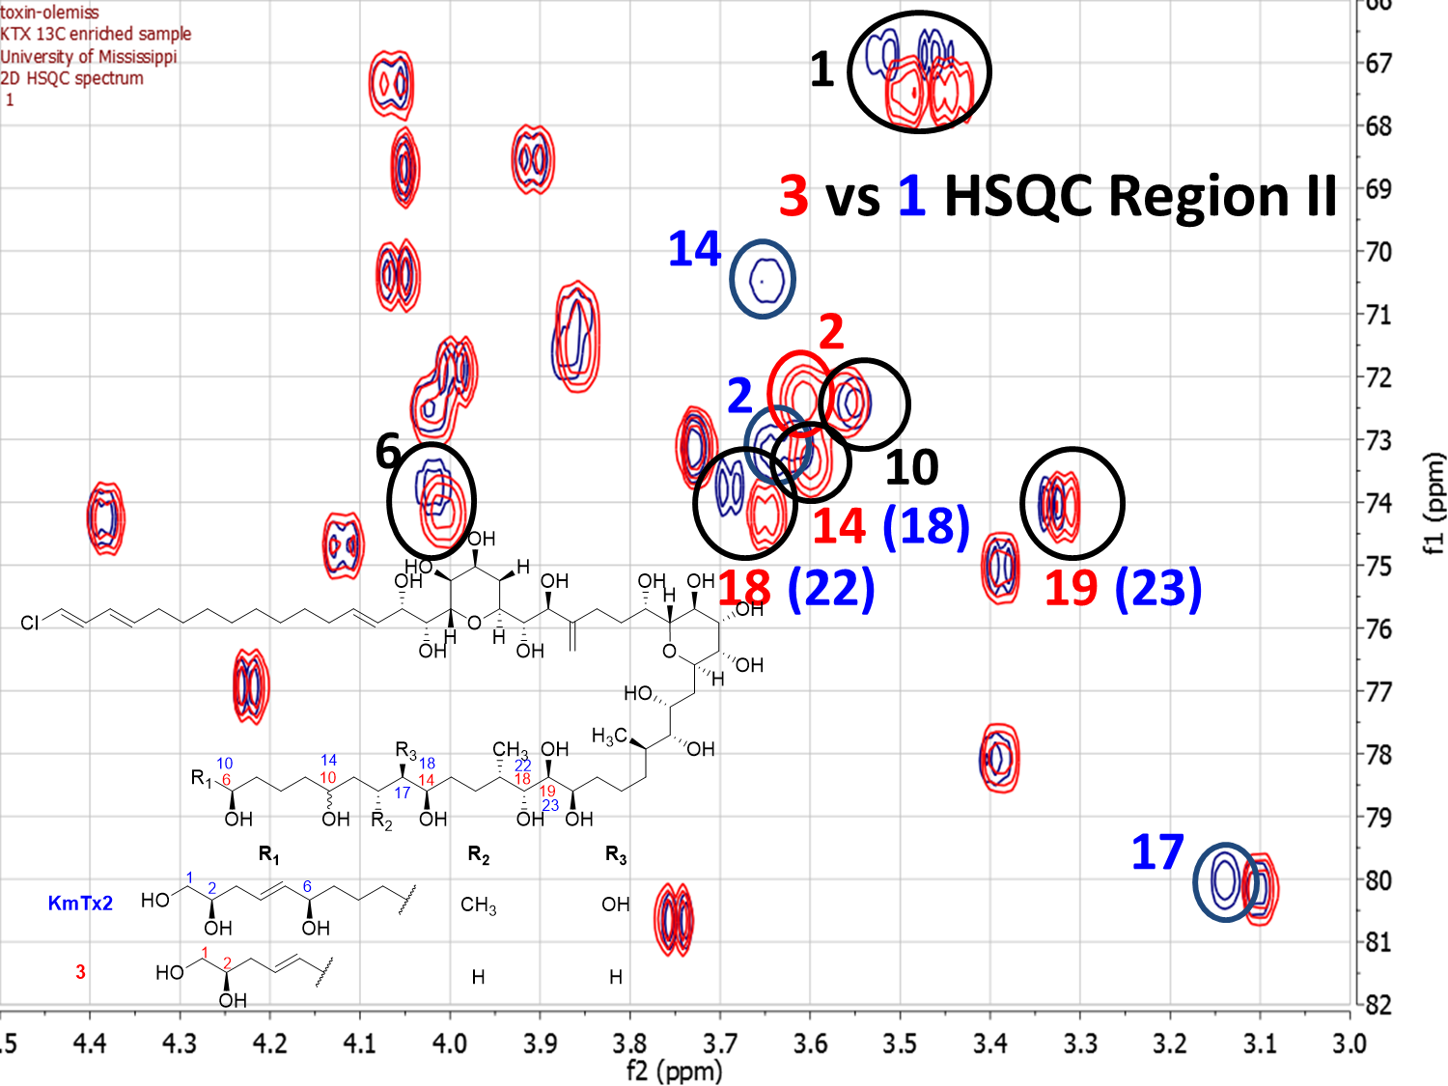
Figure S10. Congener 3 vs 1 HSQC overlay for region II.
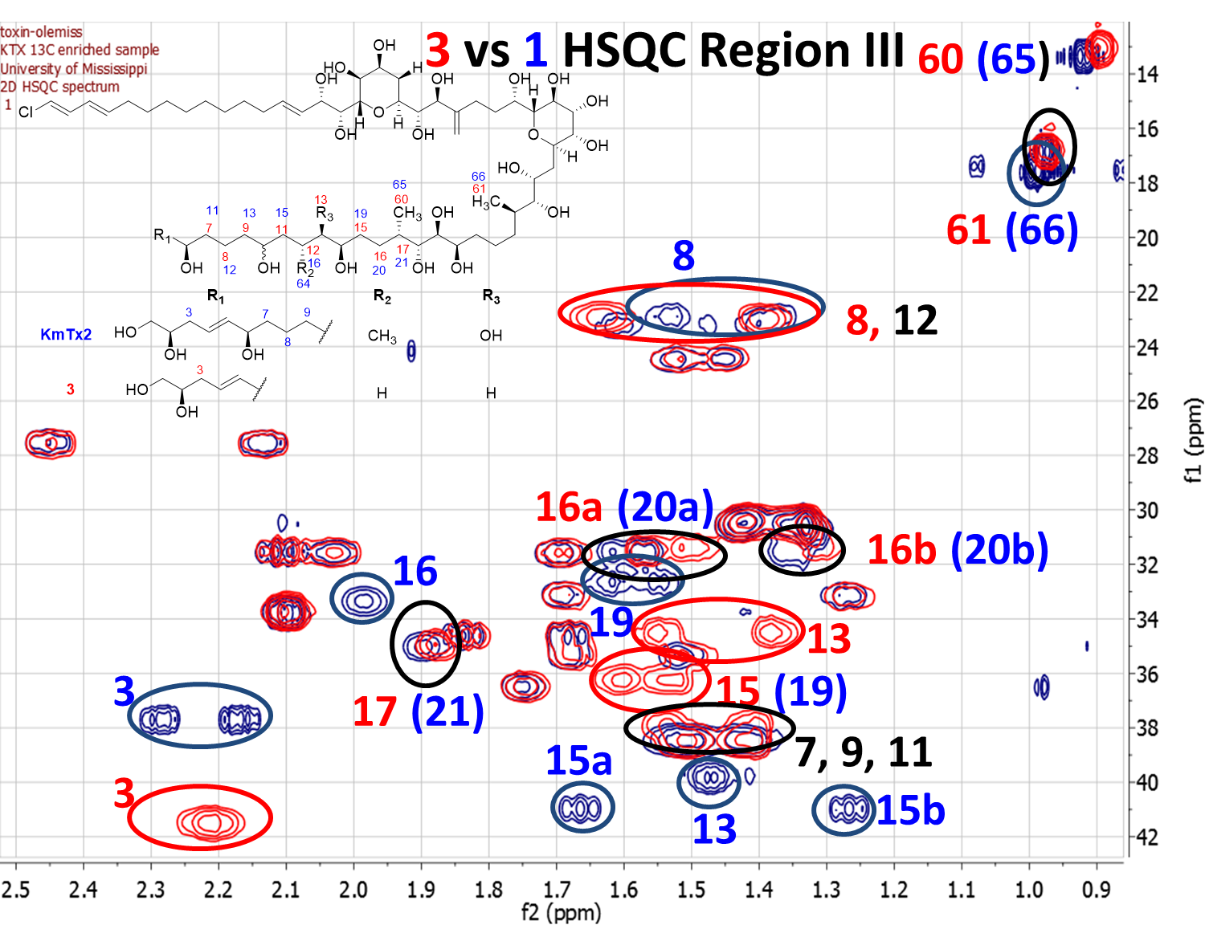
Figure S11. Congener 3 vs 1 HSQC overlay for region III.

Table S2. Table of Significant NMR Correlations for 3.
Position  (KmTx2) | KmTx 2 (1) |  |  |  |  |  | 59-E-Chloro-KmTx 4 (3)
Position  (KmTx2) | Carbon δ  (ppm) | Mult. | Proton δ  (ppm) | Mult. | J value  (Hz) |  | Carbon δ  (ppm) | Mult. | Proton δ  (ppm) | Mult. | J value  (Hz) | HMBC | COSY
1a | 66.75 | CH2 | 3.52 | dd | 11.4, 4.2 |  | 67.6 | CH2 | 3.47 | dd | 4.5, 11.8 | C2 | H2
1b | 66.75 | CH2 | 3.46 | dd | 5.6, 11.4
2 | 73.08 | CH | 3.65 | m | --- |  | 72.53 | CH | 3.61 | brd | 9.5 | C1 | H1, H3
3a | 37.58 | CH2 | 2.18 | dt | 14.4, 6.6 |  | 41.75 | CH2 | 2.21 | m | --- | C2, C4, C5 | H2, H4
3b | 37.58 | CH2 | 2.29 | dt | 14.4, 6.6
4 | 128.49 | CH | 5.69 | dt | 15.0, 7.2 |  | 128.93 | CH | 5.65 | dt | 7.8, 6.7 | C5 | H3, H5
5 | 136.93 | CH | 5.54 | dd | 15.0, 7.2 |  | 136.95 | CH | 5.49 | dt | 7.1, 14.5 | C7 | H4, H6
6 | 73.65 | CH | 4.02 | m | --- |  | 74.25 | CH | 4.01 | d | 11.3 | C4, C5 | H5, H7
7a | 38.33 | CH2 | 1.53 | m | --- |  | 38.19 | CH2 | 1.54 | m | --- | C8 | H6, H8
7b |  |  |  |  |  |  |  |  | 1.4 | m | --- | C8 | H6, H8
8a | 22.81 | CH2 | 1.55 | m | --- |  | 23.21 | CH2 | 1.63 | m | --- | C7, C9, C10 | H7, H9
8b | 22.81 | CH2 | 1.38 | m | --- |  | 23.21 | CH2 | 1.4 | m | --- | C7, C9, C10 | H7, H9
9a | 38.29 | CH2 | 1.50 | m | --- |  | 38.69 | CH2 | 1.51 | m | --- | C7, C11 | H8, H10
9b | 38.29 | CH2 | 1.46 | m | --- |  | 38.69 | CH2 | 1.41 | m | --- | C7, C11 | H8, H10
10 | 72.30 | CH | 3.55 | m | --- |  | 72.56 | CH | 3.56 | m | --- |  | H9, H11
11a | 38.41 | CH2 | 1.50 | m | --- |  | 38.74 | CH2 | 1.51 | m | --- | C9, C12 | H10, H12
11b | 38.41 | CH2 | 1.42 | m | --- |  | 38.74 | CH2 | 1.41 | m | --- | C9, C12 | H10, H12
12a | 23.13 | CH2 | 1.62 | m | --- |  | 23.21 | CH2 | 1.63 | m | --- | C13 | H11
12b | 23.13 | CH2 | 1.41 | m | --- |  | 23.21 | CH2 | 1.4 | m | --- | C13 | H11
13a | 39.73 | CH2 | 1.48 | m | --- |  | 34.79 | CH2 | 1.55 | m | --- | C14
13b |  |  |  |  |  |  |  |  | 1.38 | m | --- | C14
14 | 70.35 | CH | 3.65 | m | --- |  | 73.47 | CH | 3.6 | dd | 1.8, 9.2 | C16, C17
15a (19a) | 32.53 | CH2 | 1.63 | m | --- |  | 36.46 | CH2 | 1.6 | m | --- | C16
15b (19b) | 32.53 | CH2 | 1.55 | m | --- |  | 36.46 | CH2 | 1.54 | m | --- | C16
16a (20a) | 31.45 | CH2 | 1.61 | m | --- |  | 31.71 | CH2 | 1.54 | m | --- | C17, C60 | H15, H17
16b (20b) | 31.45 | CH2 | 1.37 |  |  |  |  |  | 1.32 | m | --- | C17, C60 | H15, H17
17 (21) | 34.93 | CH | 1.90 | m | --- |  | 35.21 | CH | 1.88 | dt | 2.0, 6.5 | C60 | H16, H18, H60
18 (22) | 73.65 | CH | 3.69 | m | --- |  | 74.29 | CH | 3.65 | brd | 9.3 | C60 | H17
19 (23) | 73.92 | CH | 3.33 | m | --- |  | 73.92 | CH | 3.33 | m | --- | No Significant Change  in NMR overlay
60 (65) | 137.16 | CH | 5.75 | dt | 15.0, 7.2 |  | 13.40 | CH3 | 0.90 | d | 7.1 |  | H17

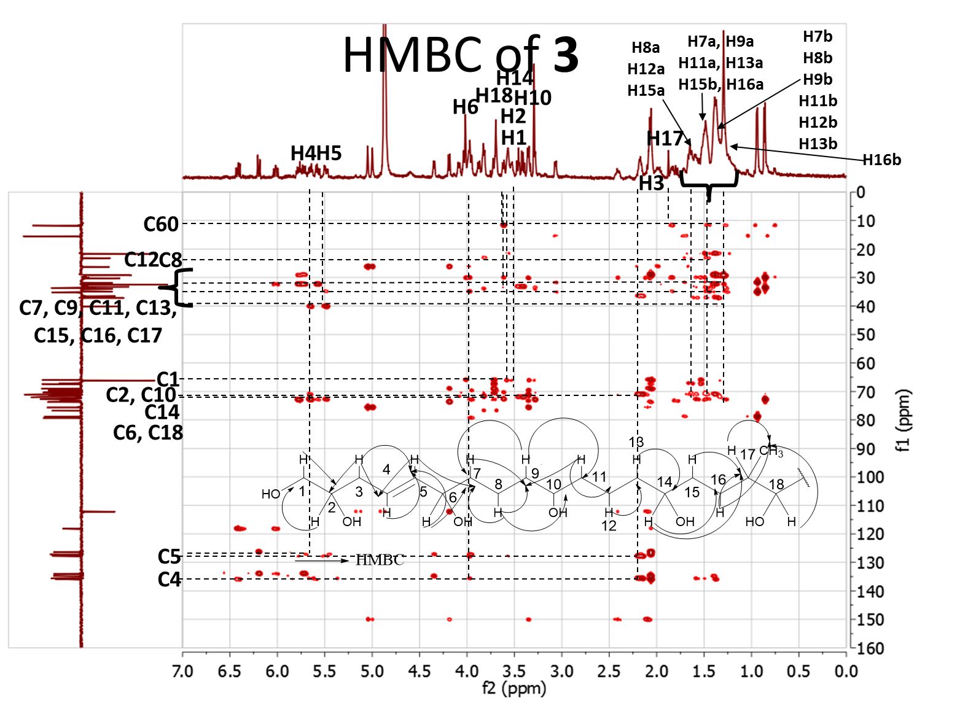
Figure S12. HMBC of 3.
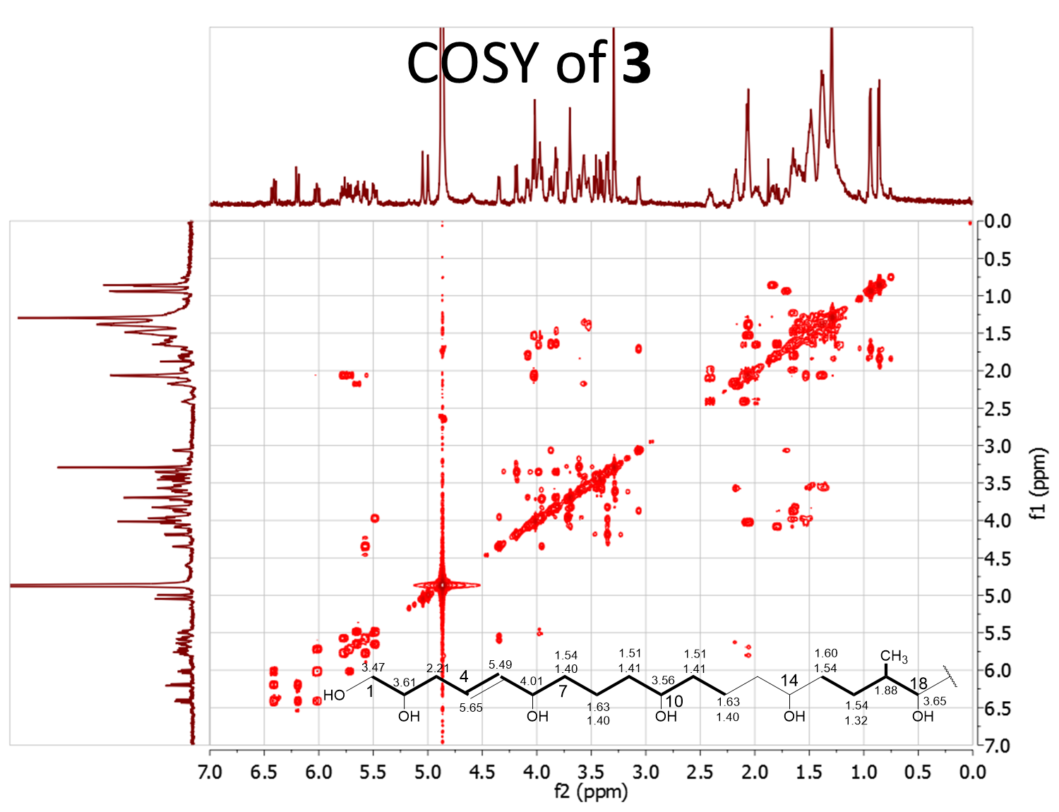
Figure S13. COSY of 3.
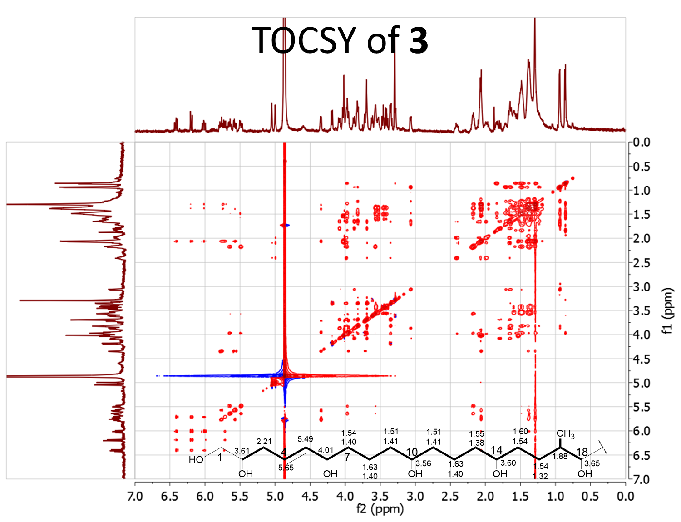
Figure S14. TOCSY of 3.

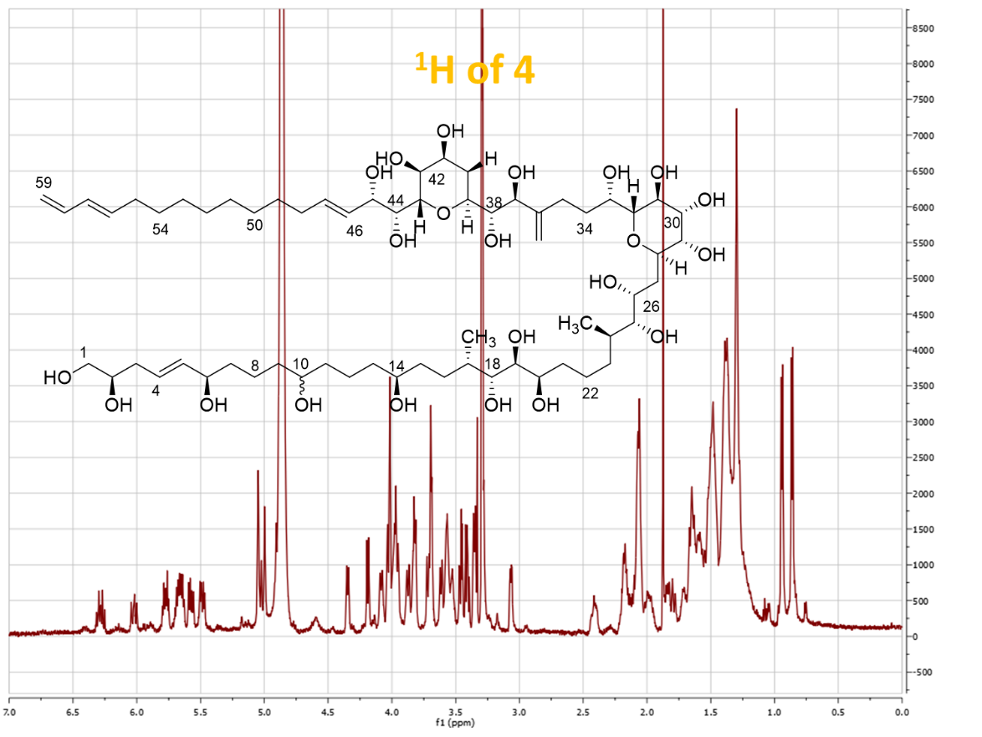
Figure S15. ¹H of 4.

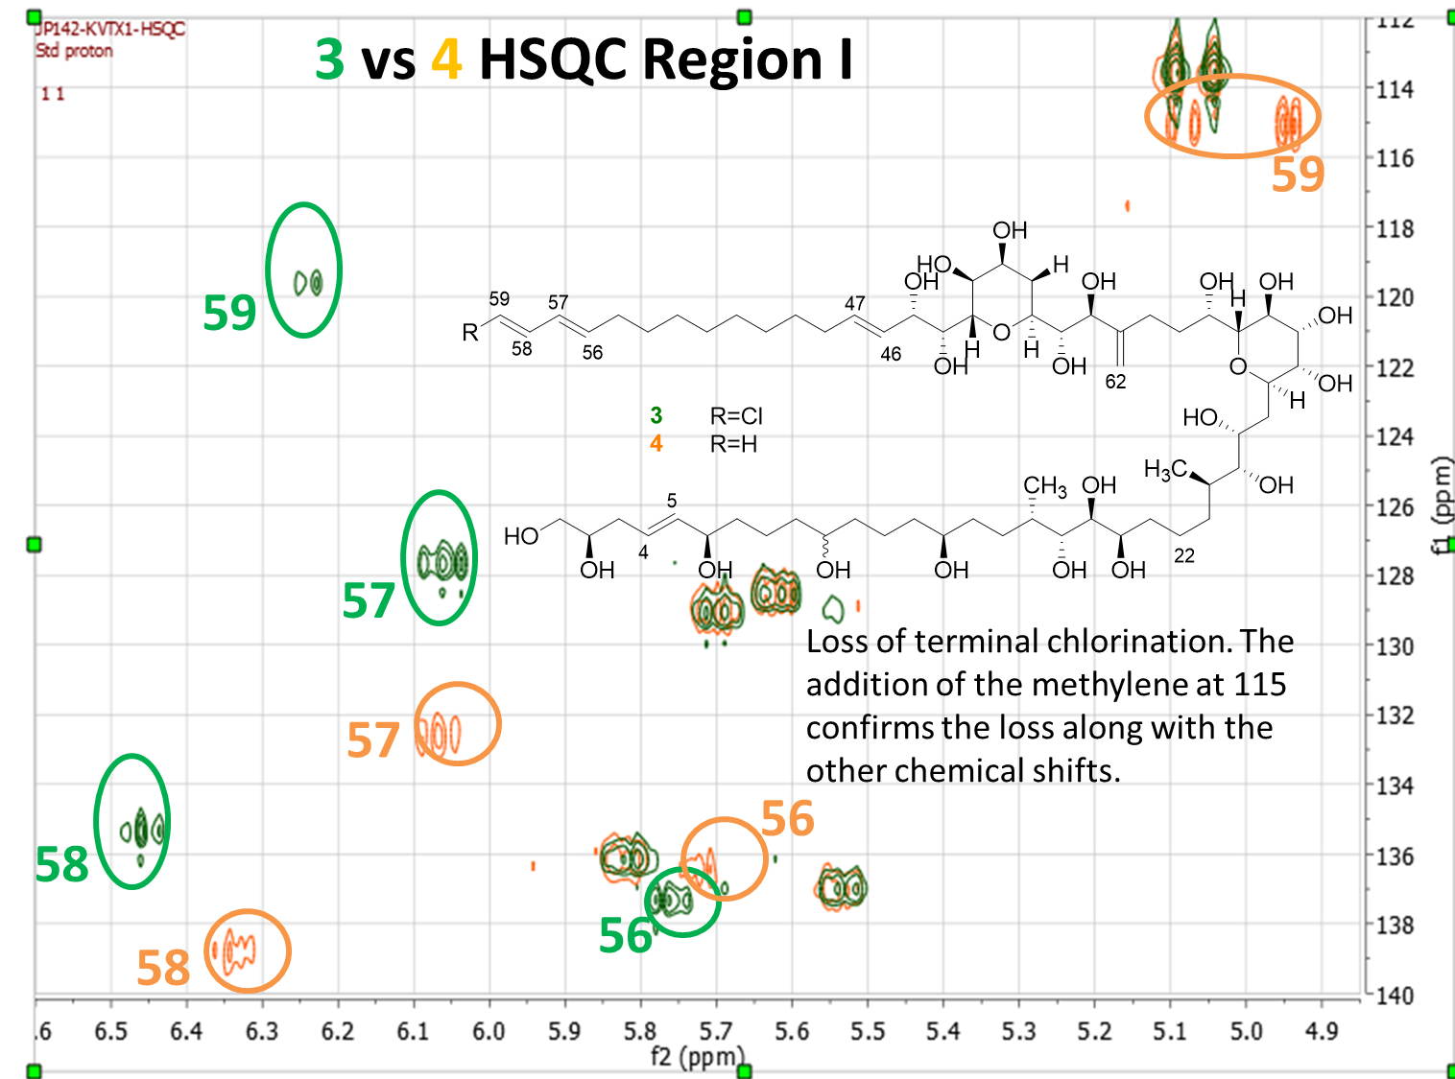
Figure S16. Congener 3 vs 4 HSQC for region I.

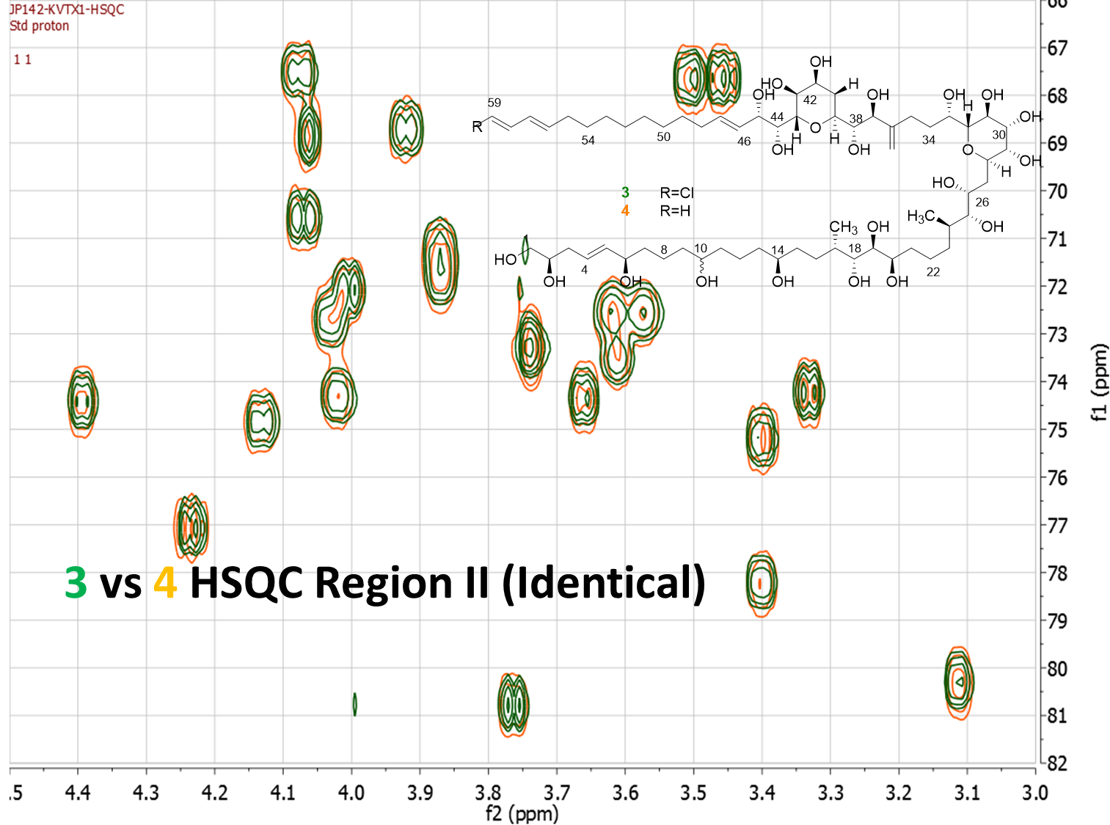
Figure S17. Congener 3 vs 4 HSQC for region II.
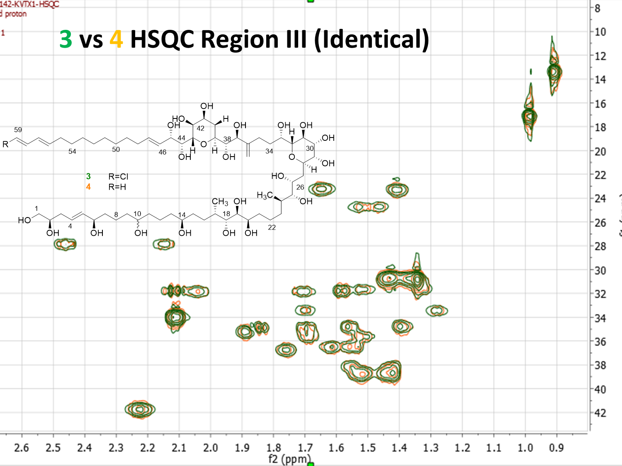
Figure S18. Congener 3 vs 4 HSQC for region III.

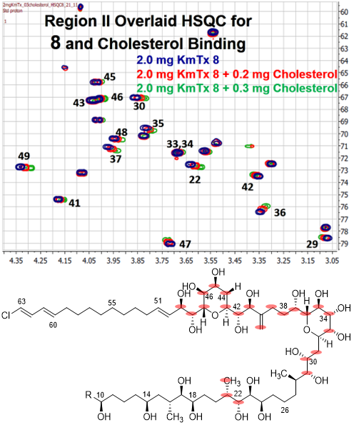

Figure S19 Preliminary Cholesterol Binding Studies. A) HSQC overlay experiments for KmTx with varying amounts of cholesterol. B) Structure of KmTx with atoms perturbed by the cholesterol binding highlighted in pink.
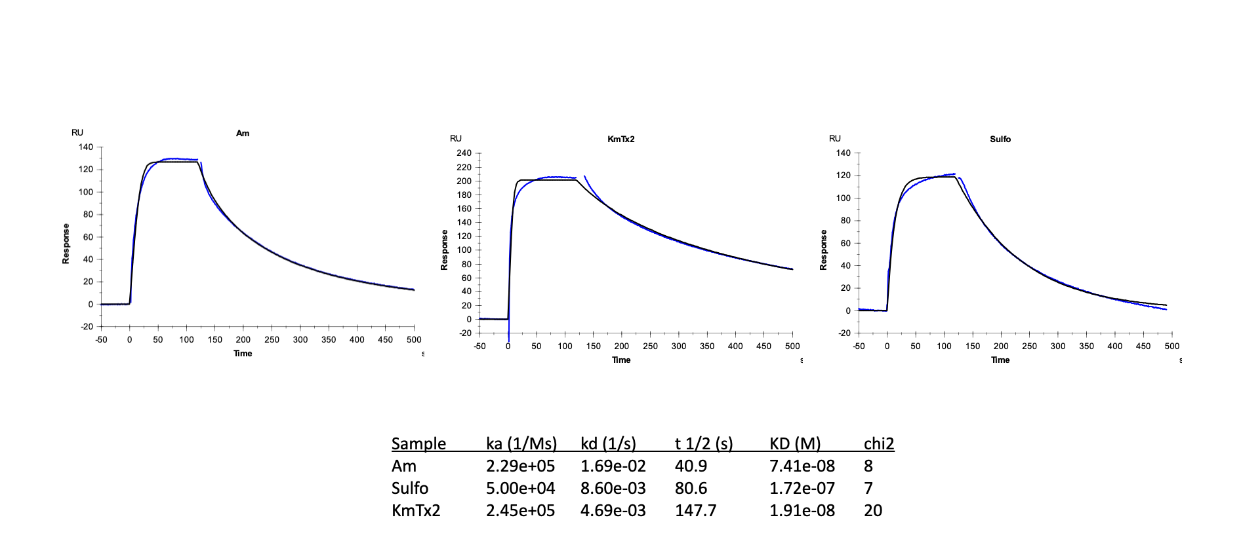
Figure S20 Toxin binding specificity, as well as approximate kinetics and affinity were measured using a single concentration of 1.5 uM toxin injected over all four flow cells at 10 uL/minute. Reference subtracted and blank subtracted binding responses were fitted using a 1:1 model, with responses in blue and fitted curves in black.

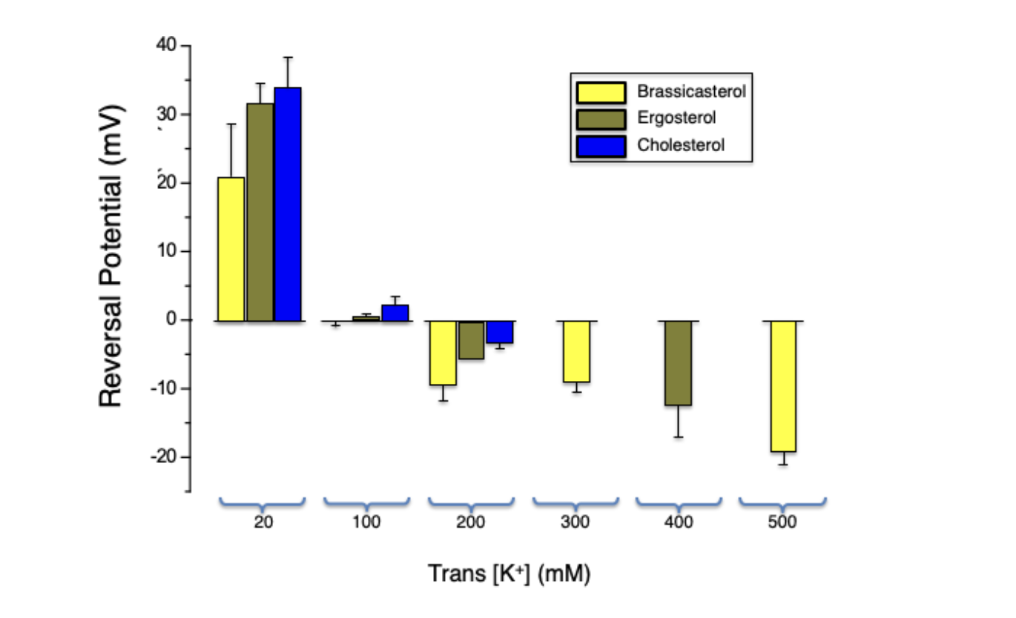
Figure S21. KmTx2 Forms a K+-Permeable Pore. The reversal potentials measured for asymmetric solutions in different bilayer lipid composition. Here, the cis chamber K+ concentration remained constant (100 mM KCl) as the KCl concentration in trans was increased to 500 mM. Data are shown as means ± S.E.M. of 3-7 measurements.

