Supplementary information
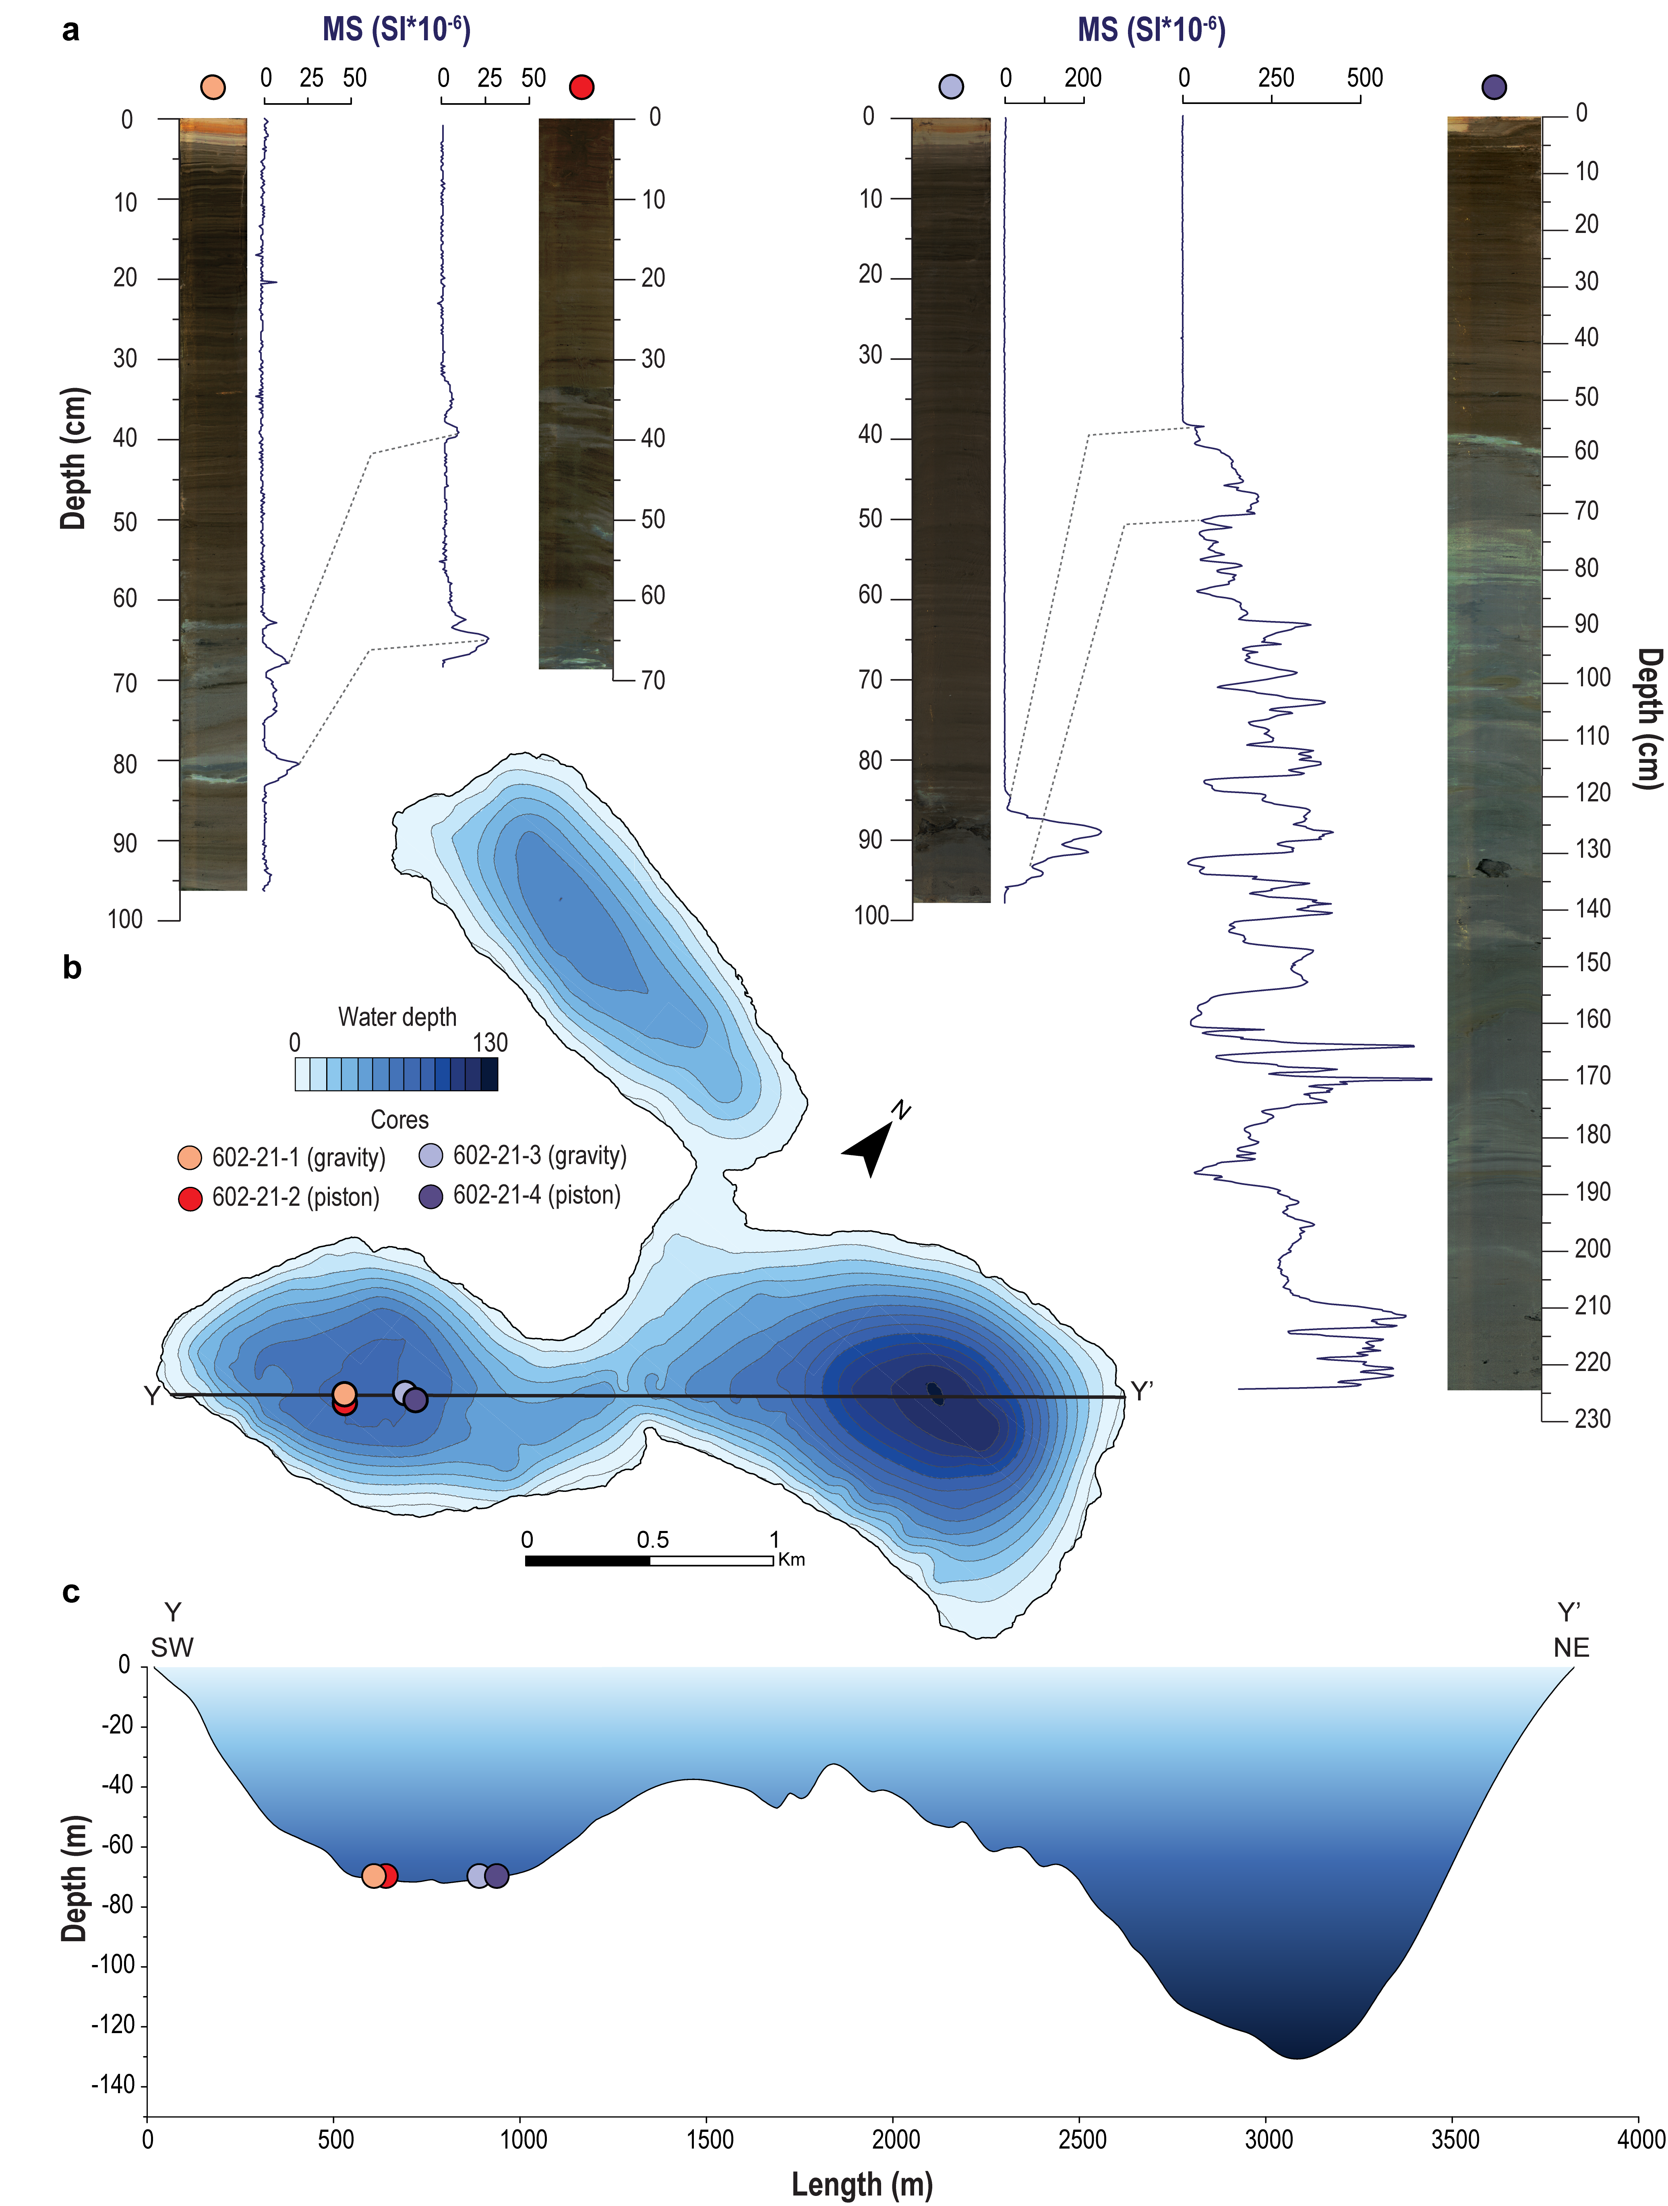
Supplementary Figure 1. Bathymetric survey of Lake Lakssjøen. a: MS-based alignment of the paired Lakssjøen gravity and piston cores. b: bathymetric map of Lake Lakssjøen, showing our coring location. c: SW-NE trending bathymetric profile that crosses coring locations (dots).
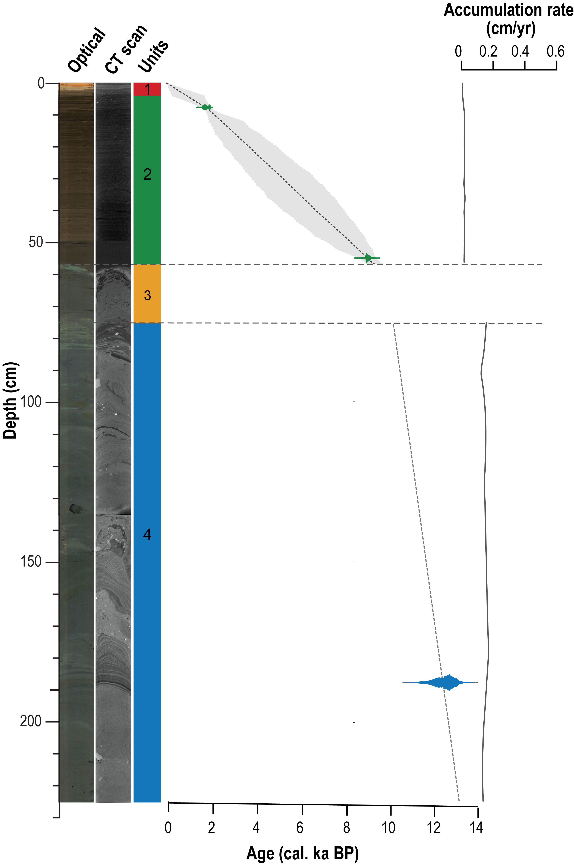
Supplementary Figure 2. Lakssjøen chronology. The black stippled line shows the weighted mean, while grey shading delimits the 95% confidence limits of our model. On the far left, we show optical image and CT imagery, as well as a log with unit divisions. ¹⁴C sample age distributions are color-coded according to the units. Dashed lines mark the extent of an event deposit. Modelled accumulation rates are plotted on the right.
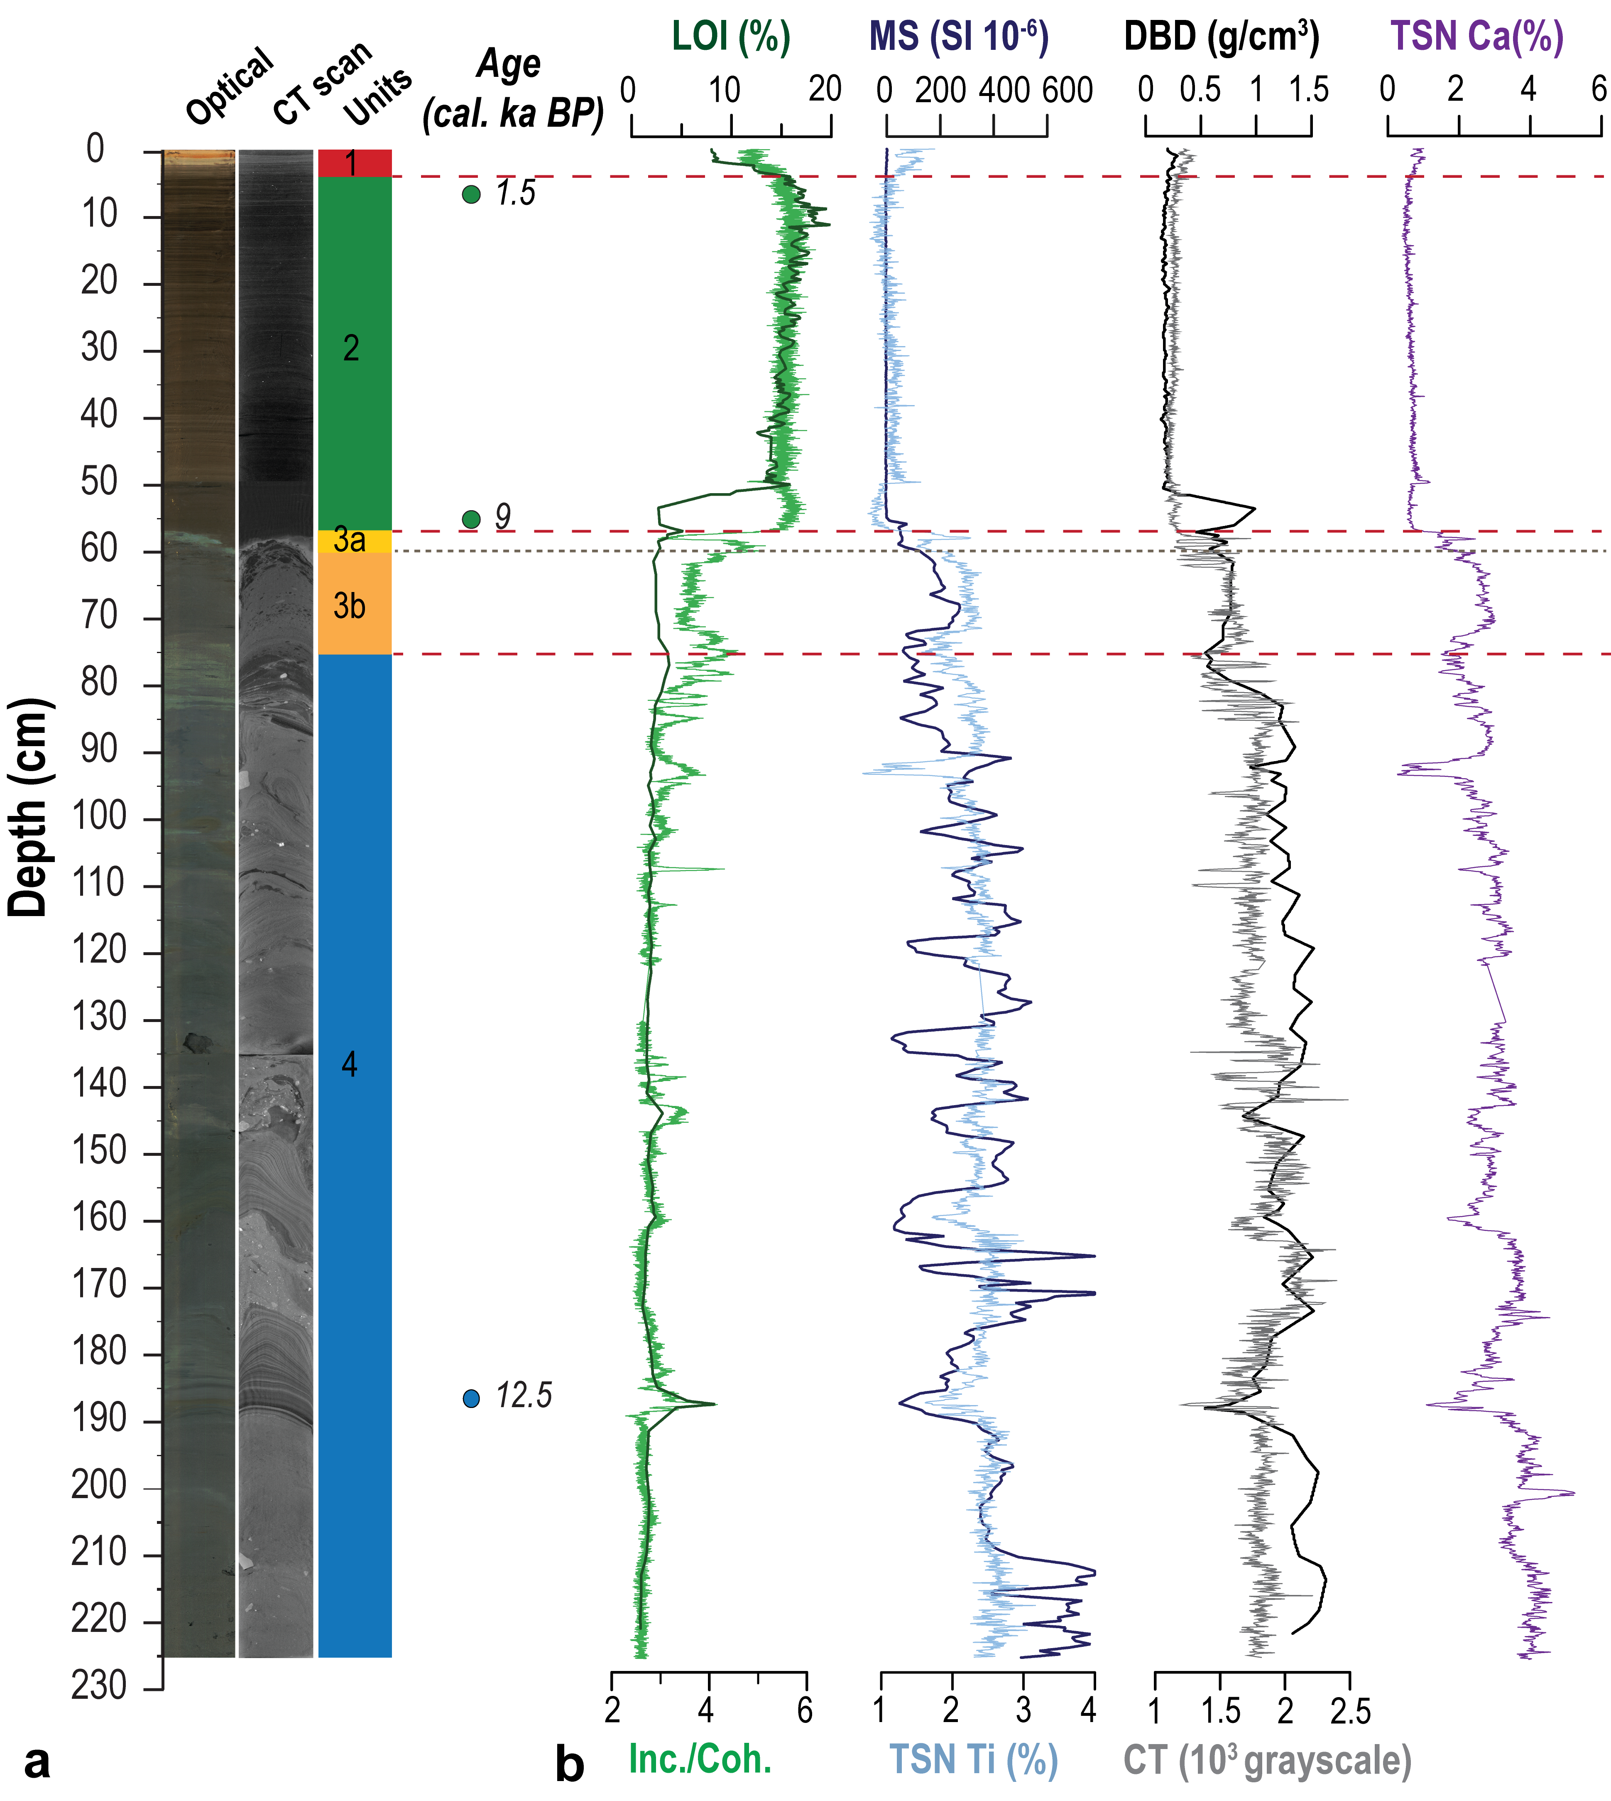
Supplementary Figure 3. Lakssjøen stratigraphy. a: From left to right - optical and CT imagery of the sedimentary record, (sub)units classification and depth placement of ¹⁴C dating samples. b: organic content—reflected by Loss on Ignition (LOI) % and XRF incoherent/coherent scattering (Inc./Coh.) ratios, minerogenic indicators – MS and Titanium (Ti) counts, density - reflected by Dry Bulk Density (DBD) values (bottom) and CT greyscale values (top), and provenance indicator Calcium (Ca).

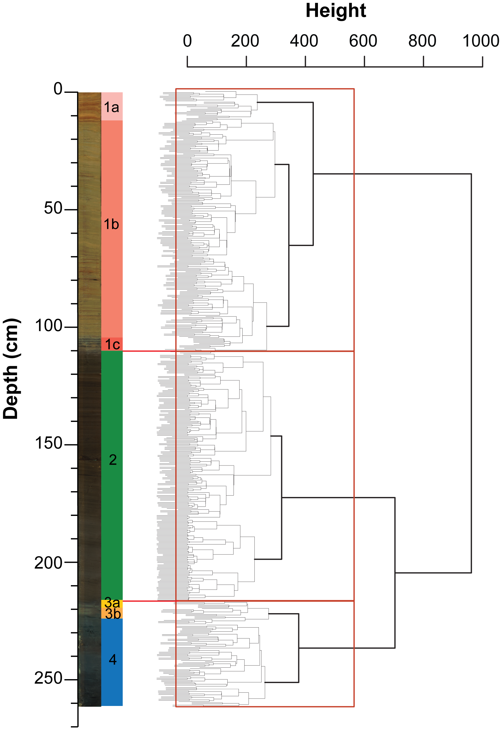
Supplementary Figure 4. Berglivatnet cluster analysis. Dendrogram showing the relationship between samples and their separation into (sub)units.
Supplementary Figure 5. Berglivatnet - detailed view of grain size EMMA results and CT close-ups a: Grain size distribution of relevant end members. b: Cumulative coefficients of determination (R²: goodness-of-fit) for the 10 EM model that we ran, highlighting the three significant EMs. c: Grain size distribution of catchment samples. d: Grain size distributions of samples from each unit, colour coded accordingly. E: From left to right – optical imagery, (sub)units classification of the sedimentary record and downcore EMMA results. F: Zoomed-in images of our CT scans in sections representative for each unit.
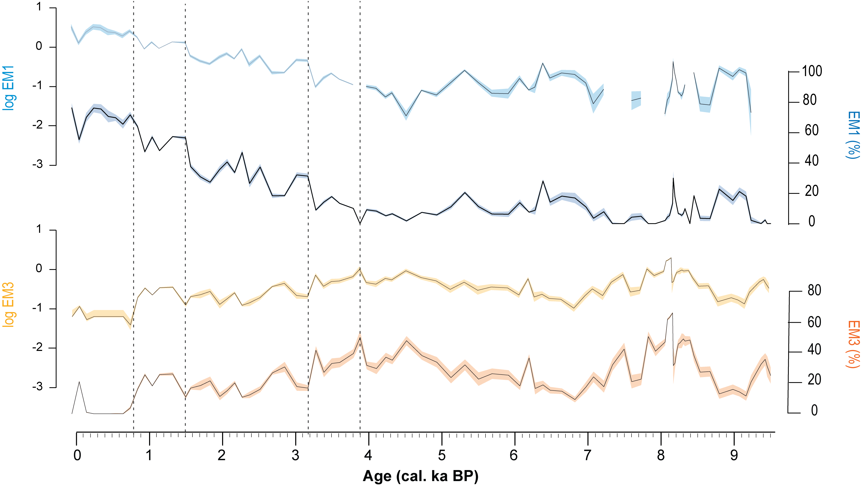
Supplementary Figure 6. Comparison between percentages and log-ratios for Berglivatnet GS EMMA output. Coloured shading highlights the analytical uncertainty (2σ) of measurements. Vertical stippled lines mark the location of identified change points.
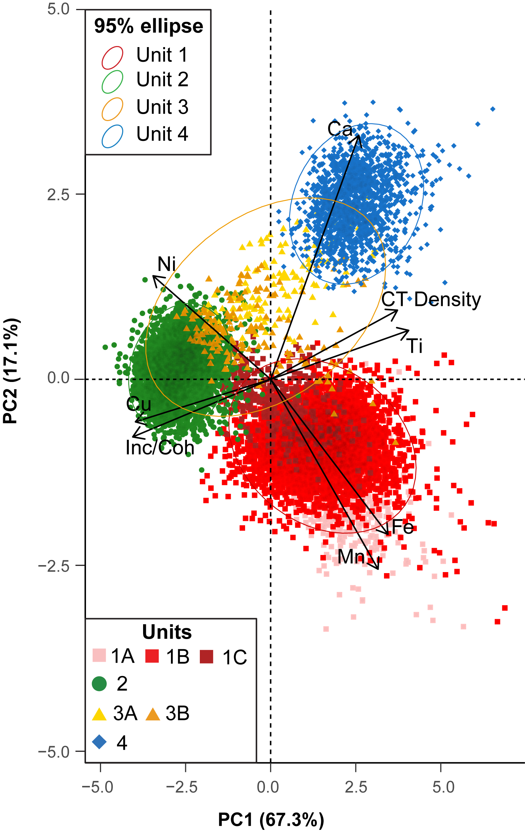
Supplementary Figure 7. Berglivatnet ordination diagram on log-transformed samples. Down-core samples and 95% prediction ellipses are coded in colors matching those of the unit subdivision shown in Figs 4 & 5. The vectors (arrows) reflect the confidence scores of selected variables on the two principal components (PCs) with the greatest explanatory power (PC1 & PC2).
Core | Lab code | Dry weight (mg) | Composite depth (cm) | δ13C‰ V-PDB | ¹⁴C age (uncal.) | Min. age (cal. BP) | Max. age (cal. BP) | Fit (cal. BP) | Material
602-21-10 | Ua-75619 | 1.2 | 14 | -26.1 | 143 ± 27 | 5 | 280 | 132 | Terrestrial leaf fragments
602-21-10 | Poz-157382 | 2.8 | 70 | N/A | 400 ± 30 | 327 | 512 | 471 | Betula fragments & terrestrial leaf fragments
602-21-11 | Poz-157383 | 2 | 103 | N/A | 945 ± 30 | 785 | 922 | 850 | Aquatic moss
602-21-11 | Poz-157384 | 2.4 | 103 | N/A | 990 ± 30 | 794 | 956 | 868 | Betula leaves
602-21-10 | Ua-75620 | 2.7 | 104 | -25.6 | 1005 ± 29 | 798 | 957 | 920 | Betula leaf & fragments
602-21-10 | Ua-75621 | 1.2 | 109 | -26.6 | 1444 ± 32 | 1297 | 1378 | 1333 | Betula fragments
602-21-11 | Ua-75622 | 1.4 | 109.5 | -26.3 | 1402 ± 32 | 1283 | 1352 | 1313 | Betula fragments
602-21-11 | Ua-79068 | 3.9 | 133 | -27.9 | 3577 ± 33 | 3727 | 3977 | 3878 | Betula fragments
602-21-11 | Poz-157385 | 4.1 | 178 | N/A | 6510 ± 40 | 7323 | 7506 | 7408 | Betula fragments
602-21-11 | Ua-75623 | 2.9 | 215.5 | -26.6 | 8488 ± 35 | 9458 | 9538 | 9503 | Terrestrial leaf fragments
602-21-11 | Poz-157339 | 2.1 | 222.5 | N/A | 9380 ± 70 | 10306 | 11060 | 10604 | Terrestrial leaf fragments
602-21-11 | Ua-75624 | 1.3 | 236.5 | -22.3 | 10261 ± 57 | 11757 | 12455 | 11985 | Terrestrial leaf fragments
602-21-11 | Ua-75625 | 0.7 | 248.5 | N/A | 11377±283 | 12751 | 13792 | 13273 | Terrestrial leaf fragments
602-21-4 | Ua-75615 | 1.3 | 7.5 | -25.7 | 1709 ± 31 | 1535 | 1633 | 1597 | Terrestrial leaf fragments
602-21-4 | Ua-75616 | 1 | 56 | -26.6 | 8102 ± 34 | 8813 | 9254 | 9030 | Betula fragments
602-21-4 | Ua-75618 | 1.2 | 187.5 | -28.7 | 10709 ± 285 | 11652 | 13224 | 12572 | Terrestrial leaf fragments
Supplementary Table 1. Radiocarbon sample overview. The table shows all ¹⁴C samples extracted from the Berglivatnet and Lakssjøen records. The laboratory number of each sample indicates where the samples were analysed (Ua – Uppsala Tandem Laboratory, Poz – Poznan Laboratory). Where available, measured δ13C values are also displayed. Minimum and maximum calibrated ages represent the 95% confidence ranges of the respective age-depth models.

Unit | Unit 4 | Unit 3 | Subunit 3b | Subunit 3a | Unit 2 | Unit 1 | Subunit 1c | Subunit 1b | Subunit 1a | All units (1-4)
Eigenvalue | 1.860 | 4.812 | 5.029 | 4.999 | 3.176 | 3.298 | 4.371 | 3.843 | 2.407 | 4.906
Variance % | 23.251 | 60.147 | 62.859 | 62.481 | 39.695 | 41.231 | 54.643 | 48.041 | 30.093 | 61.326
Cummulative % | 23.251 | 60.147 | 62.859 | 62.481 | 39.695 | 41.231 | 54.643 | 48.041 | 30.093 | 61.326
Factor loadings
Ca | 0.690 | 0.867 | 0.868 | 0.879 | 0.795 | 0.660 | 0.798 | 0.764 | 0.665 | 0.485
Ti | 0.830 | 0.797 | 0.694 | 0.931 | 0.885 | 0.752 | 0.789 | 0.859 | 0.807 | 0.729
Mn | -0.612 | 0.651 | 0.849 | 0.834 | 0.476 | 0.575 | 0.765 | 0.796 | -0.154 | 0.528
Fe | -0.258 | 0.863 | 0.939 | 0.547 | 0.855 | 0.802 | -0.956 | 0.822 | 0.759 | 0.919
Ni | -0.062 | -0.411 | -0.475 | -0.307 | -0.314 | -0.375 | 0.608 | -0.324 | -0.074 | -0.721
Cu | -0.456 | -0.859 | -0.890 | -0.813 | -0.127 | -0.356 | 0.679 | -0.229 | -0.195 | -0.882
Inc/Coh | -0.086 | -0.962 | -0.968 | -0.934 | -0.821 | -0.843 | 0.849 | -0.868 | -0.779 | -0.967
CTGrayscale | 0.184 | 0.652 | 0.485 | 0.860 | 0.124 | 0.587 | -0.248 | 0.549 | 0.252 | 0.886
Supplementary Table 2. PCA output of Berglivatnet scanning data. Eigenvalues and factor loadings are shown for the most significant (61.3%) principal component (PC1) and split into (sub)units.

