Supplementary Figure 1: The full-length gels of Caspase-3 were presented

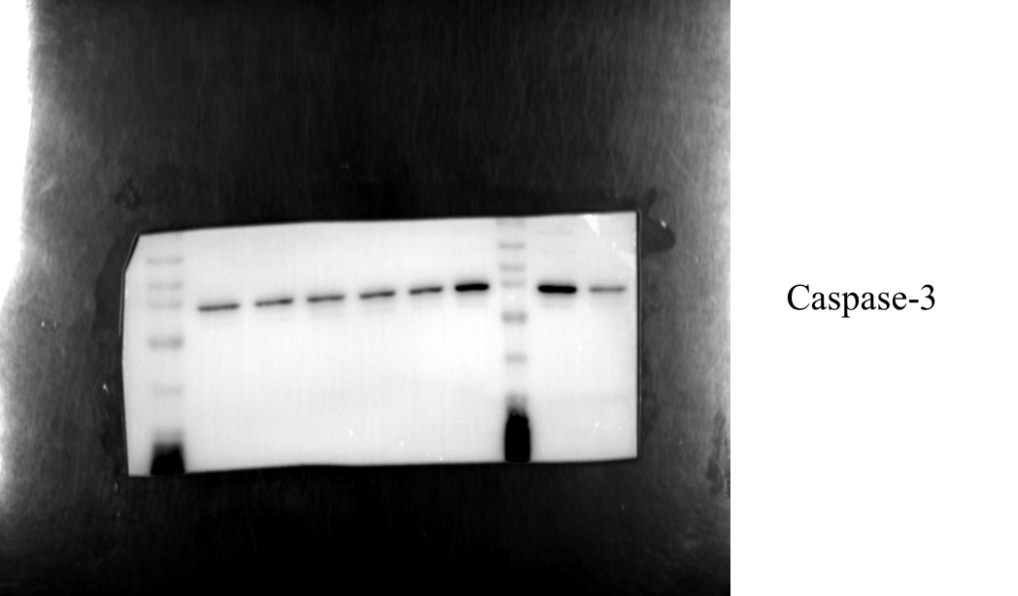

Supplementary Figure 2: The full-length gels of Bax were presented

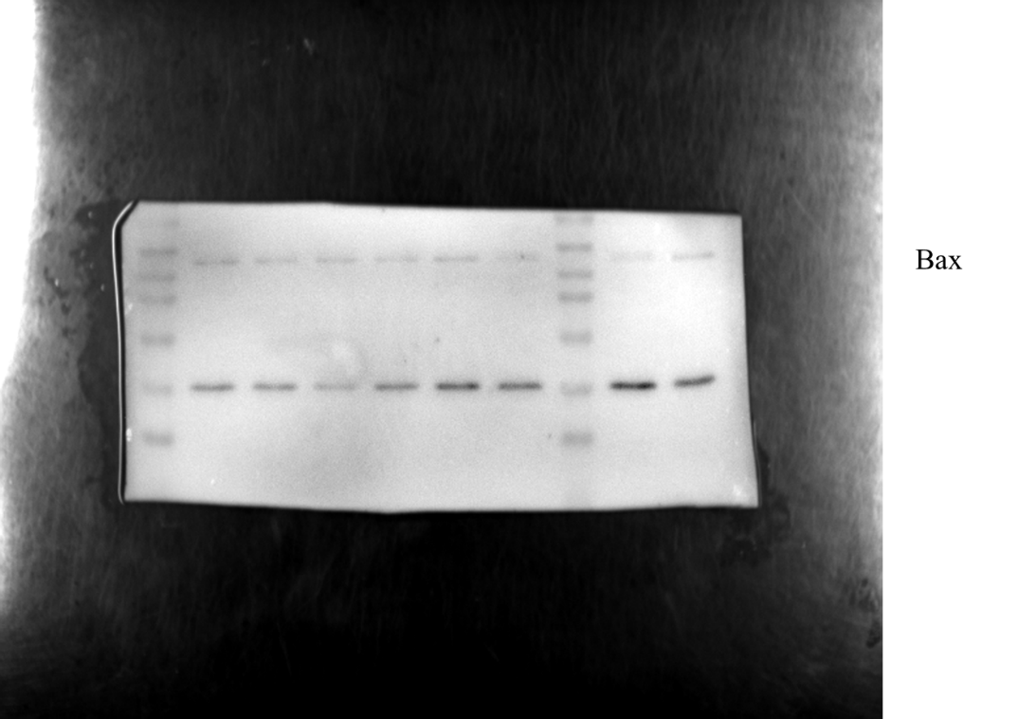

Supplementary Figure 3: The full-length gels of α-tubulin were presented

