Supplementary materials

eFigure 1

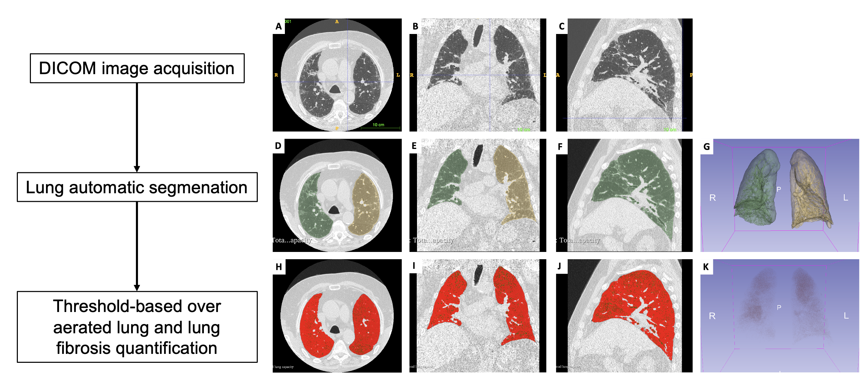

eFigure 1. Quantitative CT analysis algorithm. Panels A, B and C show transversal, coronal and axial view respectively of a chest CT scan of a patient with IPF. After CT images acquisition, lung segmentation was performed through a software-based evaluation on a dedicated workstation using the open-source 3D Slicer software (version 4.10.2, https://www.slicer.org), by means of the software extension called “Chest Imaging Platform” and the tools called “Lung CT Segmenter” (panels D, E, F and G show the transversal view, coronal view, axial view, and 3D reconstruction of segmented lungs respectively). Further, threshold-based evaluation of the over aerated areas and the extent of fibrosis was sought by means of the “Lung CT analyzer” and “Segment Editor” extensions (panesl H, I, J and K show the transversal view, coronal view, axial view, and 3D reconstruction of over aerated lung areas respectively).

eFigure 2
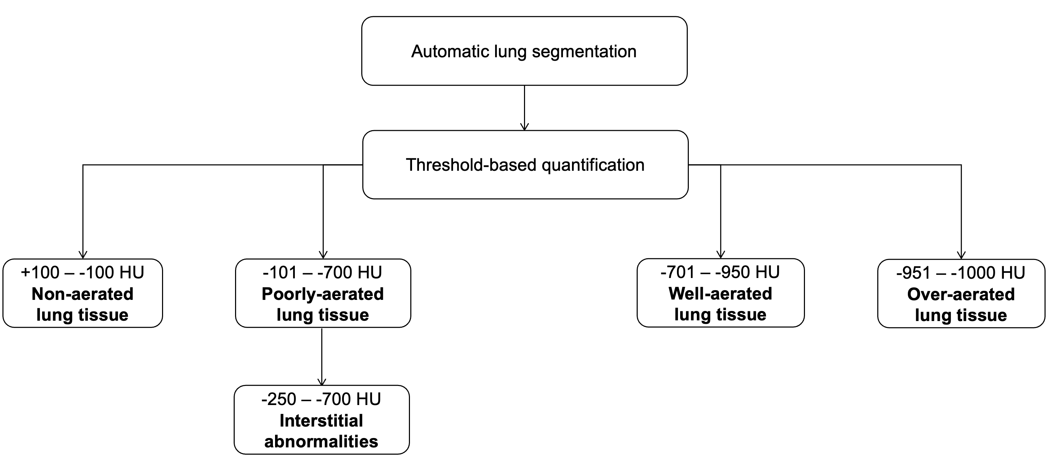

eFigure 2. Threshold based quantitative CT categories. Once automatic lung segmentation was performed, was performed the “Lung CT analyzer” and “Segment Editor” extensions of the open-source 3D Slicer software (version 4.10.2, https://www.slicer.org), were used to perform a quantitative image analysis to assess the over aerated areas and the extent of fibrosis based on specific density thresholds expressed in Hounsfield unit (HU). Specifically, the HU values relating to the well-aerated lung parenchyma were defined within a threshold between −950 and −701 HU while the threshold between –700 and −250 HU was considered to identify the interstitial lung involvement.

