Probiotics and Antimicrobial Proteins

In vitro and in silico characterization of N-formylated two-peptide bacteriocin from
Enterococcus faecalis CAUM157 with anti-listeria activity

Supplementary Data

Arxel G. Elnar¹ and Geun-Bae Kim¹*
¹Department of Animal Science and Technology, Chung-Ang University,
Anseong 17546, Republic of Korea

*Correspondence: Geun-Bae Kim, Ph.D.
Department of Animal Science and Technology,
Chung-Ang University, Anseong 17546, Republic of Korea
Tel: +82-31-670-3027, Fax: +82-31-676-5986, E-mail: kimgeun@cau.ac.kr
(A)
(B)
(C)
(D)
Supplementary Figure 1. Comparison of cell growth and bacteriocin production of Enterococcus faecalis CAUM157 between MRS and whey-based media in different temperatures: (A) cell growth at 37°C; (B) cell growth at 25°C; (C) bacteriocin production at 37°C; (D) bacteriocin production at 25°C. Bacteriocin activity was calculated based on the inhibition zones observed against Listeria monocytogenes ATCC19115.
Supplementary Table 1. Effects of whey powder concentration on the growth, fermentation profile, and bacteriocin production of Enterococcus faecalis CAUM157.
Whey  (%, w/v) | CFU/mL | Log CFU/mL | pH | Activity*  (AU/mL)
5 | 1.27×10⁹ | 9.104 | 4.070 | 0
7.5 | 1.68×10⁹ | 9.224 | 4.125 | 100
10 | 2.10×10⁹ | 9.322 | 4.220 | 200
12.5 | 2.20×10⁹ | 9.343 | 4.275 | 200
15 | 2.48×10⁹ | 9.395 | 4.345 | 200
*Activity was calculated based on the inhibition zones observed against Listeria monocytogenes ATCC 19115.

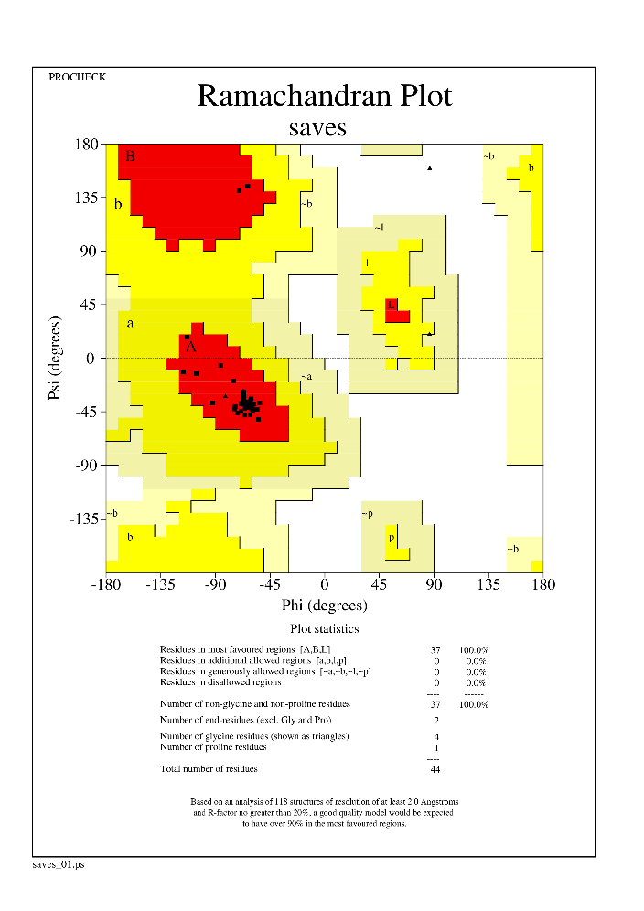
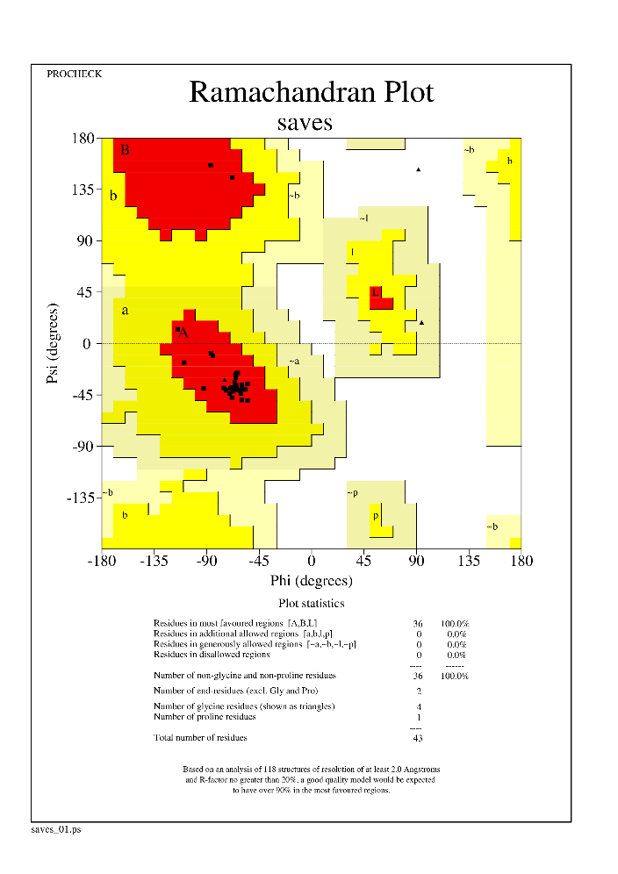
(A)
(B)
Supplementary Figure 2. Structure validation of predicted conformation of (A) M157A and (B) M157B peptides by Ramachandran plot.

