Extending anti-COVID drug discovery to Space: Repetitive stability study of Remdesivir/CD complex on ISS
(Supplementary Material)

György Dormán^{1#}, Balázs Buchholcz^{1#}, István Puskás², Pál Szabó³, Erzsébet Varga², Lajos Szente², György M. Keserű³ and Ferenc Darvas¹*
¹Innostudio, Inc., Záhony u. 7., Budapest, H-1031, Hungary
²Cyclolab Cyclodextrin Research & Development Laboratory Ltd, Illatos út 7., Budapest, H-1097, Hungary
³Research Centre for Natural Science and National Drug Research and Development Laboratory, Magyar Tudósok körútja 2., Budapest, H-1117, Hungary
# G. D. and B. B. contributed equally to this work
Corresponding author: Dr. Ferenc Darvas, ferenc.darvas@innostudio.org, df.private@gmail.com

Content
1. Sample preparation 2
1.1. Neutral sample (1st and 2nd mission) 2
1.2. Acidic sample (1st mission) 2
1.3. Sample preparation for analytical measurements after returning: 2
2. HPLC methods 3
2.1. HPLC method for SBECD chemical degradation analysis (fingerprint investigation, Method A.) 3
2.2. HPLC method for RDV purity and chemical degradation analysis (Method B) 3
2.3. HPLC‒MS method for RDV chemical degradation analysis (Method C) 4
3. HPLC degradation results 4
3.1. SBECD degradation comparison G1/S1 samples (fingerprint investigation) (1st mission): 5
3.2. RDV degradation analysis of the G1/S1 neutral samples delivered from the 1st mission 6
3.3. RDV degradation analysis of the G1/S1 neutral samples delivered from the 2nd mission 7
4. RDV degradation products’ identification 8

Sample preparation

Neutral sample (1st and 2nd mission)
A total of 400 mg (0.185 mmol) of solid SBECD (on dry basis) and 40 mg remdesivir (0.066 mmol) were homogenized thoroughly for five minutes in an agate mortar with a pestle and then quantitatively transferred into a glass vial of high hydrolytic resistance (Type I) of 5 mL volume. The powders were suspended in 1.6 mL of Millipore Synergy® ultrapure water by vortexing (500 rpm, 1 minute) at room temperature. The hydrophilic SBECD was fully dissolved, but remdesivir was only partially solubilized: the resultant liquid was a white suspension. The pH of the suspension medium was 6.5.
A 1.1 g representative sample was sent to the laboratory of Confocal Science Inc. in a 5 mL hydrolytic class I vial stoppered by bromobutyl elastomer stopper and aluminium cap.

Acidic sample (1st mission)
A total of 400 mg (0.185 mmol) of solid SBECD (on dry basis) and 40 mg remdesivir (0.066 mmol) were homogenized thoroughly for five minutes in an agate mortar with a pestle and then quantitatively transferred into a glass vial of high hydrolytic resistance (Type I) of 5 mL volume. The powders were suspended in 1.6 mL diluted hydrochloric acid of pH 1.9 prepared with Millipore Synergy® ultrapure water by vortexing (500 rpm, 1 minute) at room temperature. The hydrophilic SBECD was fully dissolved, but remdesivir was only partially solubilized: the resultant liquid was a white suspension. The pH of the suspension medium was 3.5.

Sample preparation for analytical measurements after returning:
The samples were processed for investigations after return to Earth. The control terrestrial samples were processed in an identical manner. The samples were transferred to 1.5 ml Eppendorf tubes. The supernatant and the solid particulates were separated by centrifugation (Hermle Z 216 MK, 25 °C, 20 min, at 13300 m·s⁻² relative centrifugal force). After separation, the supernatant was separated by an automatic pipette, and the solid sediment was washed by the following procedure step-by step:
- addition of Millipore Synergy® ultrapure water in volume equivalent to that of the removed supernatant
- vortexing (500 RPM speed, for 20 seconds)
- centrifugation
- removal of the supernatant
As a result, four supernatant samples were obtained:
G1: terrestrial/control sample (neutral sample)
S1: space sample (neutral sample)
G2: terrestrial/control sample (acidic sample)
S2: space sample (acidic sample)

HPLC methods

HPLC method for SBECD chemical degradation analysis (fingerprint investigation, Method A.)
A total of 1.25 mL of the supernatant was diluted in 5.0 mL of Millipore Synergy® ultrapure water. The samples were analysed by an Agilent 1260 HPLC Instrument equipped with a CD-Screen-IEC column (3 μm, 150 mm x 4.0 mm 4-dimethylamino benzyl carbamide silyl silica gel for chromatography stationary phase from Bio-Sol-Dex, Hungary).
The following eluents were used:
Mobile phase A: Chromatographic-grade water (900 mL) was added to 4.0 mL of triethylamine, adjusted to pH 4.5 with anhydrous formic acid, and then diluted to 1000 mL with water for chromatography. Mobile phase B: acetonitrile.
The following instrumental parameters were used for the analysis: gradient: 0-14 min, B%= 10-60; flow, 1.1 mL/min; injection volume, 10 μL; and detector, evaporative light-scattering detector. For the Agilent ELS detector, the carrier gas was nitrogen; the flow rate, 1.2 L/min; the evaporator temperature, 50 °C; and the nebulizer temperature, 30 °C. The detector parameters for Sedex-100 ELSD were as follows: carrier gas, nitrogen; gas pressure, 3.2 ± 0.7 bar; and temperature, 70 °C.

HPLC method for RDV purity and chemical degradation analysis (Method B)
HPLC analysis was conducted to determine the RDV content of the supernatant (liquid) fractions together and their purity. An Agilent 1260 HPLC system equipped with a diode-array detector (DAD) was used to identify and quantitate REM. Reversed-phase separation was achieved on a Kinetex C18 analytical column (Phenomenex Inc., Torrance, CA, USA) with 100 mm length, 4.6 mm internal diameter and 2.6 µm particle size using a solvent gradient of water with 0.05% formic acid with acetonitrile at 0.05% (0 min 0%, 10 min 100%) at a flow rate of 0.8 mL/min and UV-diode array (DAD) detection at 240 nm wavelength.
For confirming the reliability of the HPLC measurements we carried out reproducibility investigations. We measured 2 replicates on 5 different days and each sample twice. In all cases the standard deviations were less than 10%, which corresponds to the max 15% standard deviation required for pharmaceutical applications.
UV
 | Run 1 |  | Run 2 |  | UV |  | UV
Sample ID | Sample1 | Sample2 | Sample1 | Sample2 | Run1 | Run2 | SD overall
0123 | 3.30E+05 | 3.29E+05 | 3.61E+05 | 3.56E+05 | 0.107251 | 0.947811 | 4.810862
0125 | 3.55E+05 | 3.51E+05 | 3.03E+05 | 3.01E+05 | 0.760545 | 0.51477 | 9.018156
0126 | 3.67E+05 | 3.64E+05 | 3.41E+05 | 3.38E+05 | 0.657594 | 0.812407 | 4.324446
0130 | 3.64E+05 | 3.61E+05 | 3.96E+05 | 3.93E+05 | 0.721836 | 0.519997 | 4.893552
0201 | 3.92E+05 | 3.91E+05 | 3.85E+05 | 3.80E+05 | 0.252925 | 0.868523 | 1.404063
MS
 | Run 1 |  | Run 2 |  | MS |  | MS
Sample ID | Sample1 | Sample2 | Sample1 | Sample2 | Run1 | Run2 | SD overall
0123 | 5.43E+07 | 6.07E+07 | 4.93E+07 | 5.89E+07 | 7.933963 | 12.5095 | 9.144691
0125 | 5.92E+07 | 5.09E+07 | 5.45E+07 | 5.23E+07 | 10.59986 | 2.860207 | 6.653339
0126 | 6.01E+07 | 5.79E+07 | 5.70E+07 | 5.80E+07 | 2.624017 | 1.217136 | 2.24612
0130 | 6.12E+07 | 6.46E+07 | 5.76E+07 | 6.71E+07 | 3.855618 | 10.73727 | 6.583686
0201 | 6.55E+07 | 6.45E+07 | 6,41E+07 | 6.31E+07 | 1.055627 | 1.045424 | 1.518562
Table S1. Reproducibility of the RDV HPLC UV/MS measurements

HPLC‒MS method for RDV chemical degradation analysis (Method C)
The supernatant (liquid) fractions were subjected to HPLC‒MS degradation studies. The measurements were carried out on a Sciex 5600+ Triple TOF high-resolution mass spectrometer equipped with a DuoSpray ion source operated in positive electrospray mode. The mass spectrometer was scanned in TOF-MS mode in the mass range of 100-1000 Da, and the accumulation time was 1 sec. The resolution was above 25000 over the entire mass range. A Shimadzu Prominence LC20 system was coupled to the mass spectrometer. The LC system consisted of a binary pump, an autosampler, a column oven and a UV/VIS detector. A Kinetex C18 column (100 mm x 3 mm, 5 µm) was used for the separation of the samples. HPLC-grade water (eluent A) and acetonitrile (eluent B), both containing 0.1% formic acid, were used as mobile phases. The flow rate was 0.8 mL/min. Two microlitres of sample was injected. The column was kept at room temperature. A 240 nm wavelength was used in UV detection. Compounds were identified on the basis of retention times and the elemental compositions obtained from high-resolution data. The accepted mass accuracy was better than 5 ppm. The concentrations of the samples were approximately 1 and 5 mg/mL for the 1st and 2nd mission series, respectively. Based on preliminary measurements, a 20-fold dilution was found to be optimal for the samples. Fifty microlitres of sample was diluted with 950 µL of acetonitrile/water 50/50% containing 0.1% formic acid.

HPLC degradation results

SBECD degradation comparison G1/S1 samples (fingerprint investigation) (1st mission):
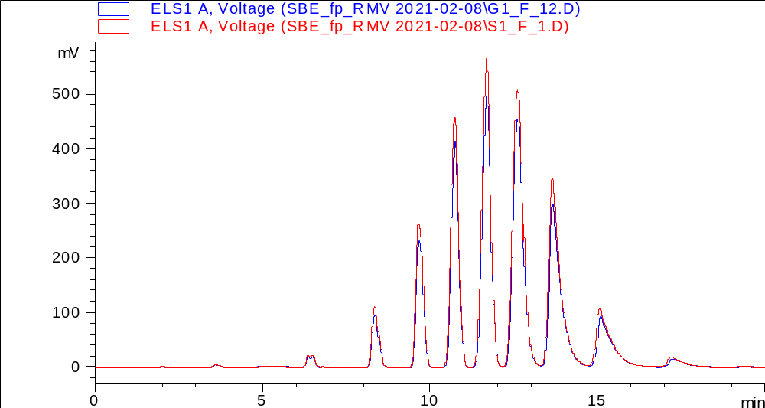
Figure S1. HPLC chromatogram of samples G1 (blue) and S1 (red) by SBECD fingerprint method (Method A)

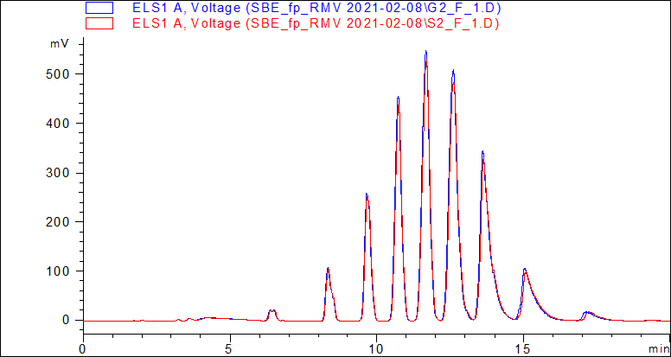
Figure S2. HPLC chromatogram of samples G2 (blue) and S2 (red) by SBECD fingerprint method (Method A)
No SBECD degradation product was detected in any of the samples.

RDV degradation analysis of the G1/S1 neutral samples delivered from the 1st mission
A series of major and minor peaks were obtained in both the UV (Fig. S3) and total ion chromatograms (TICs). The overlaid chromatograms of G1 (blue), S1 (pink) and acetonitrile as a control (orange) help visualize the differences in the samples. Peaks present only in blue and/or pink but not in orange are compounds related to RDV. Peaks present only in the real samples but not in the acetonitrile control have been discussed. (Fig. 2 and Fig. S4).
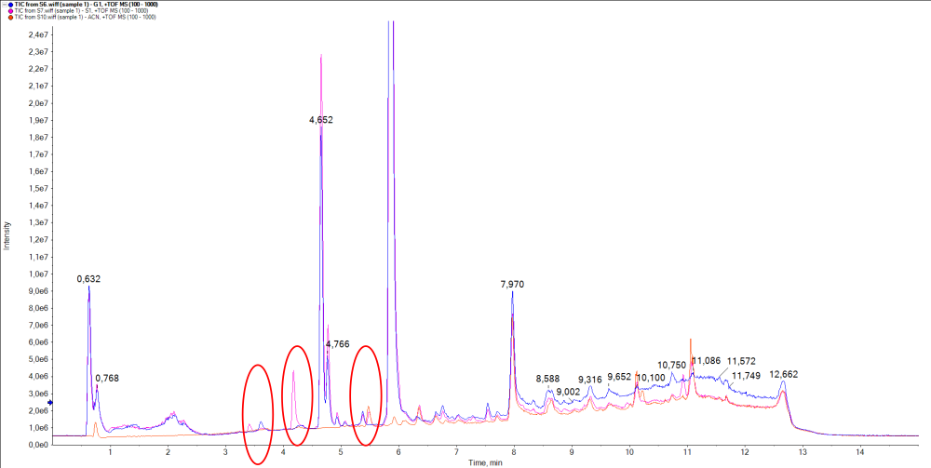
Figure S3. HPLC trace of G1 and S1 samples (UV detection)

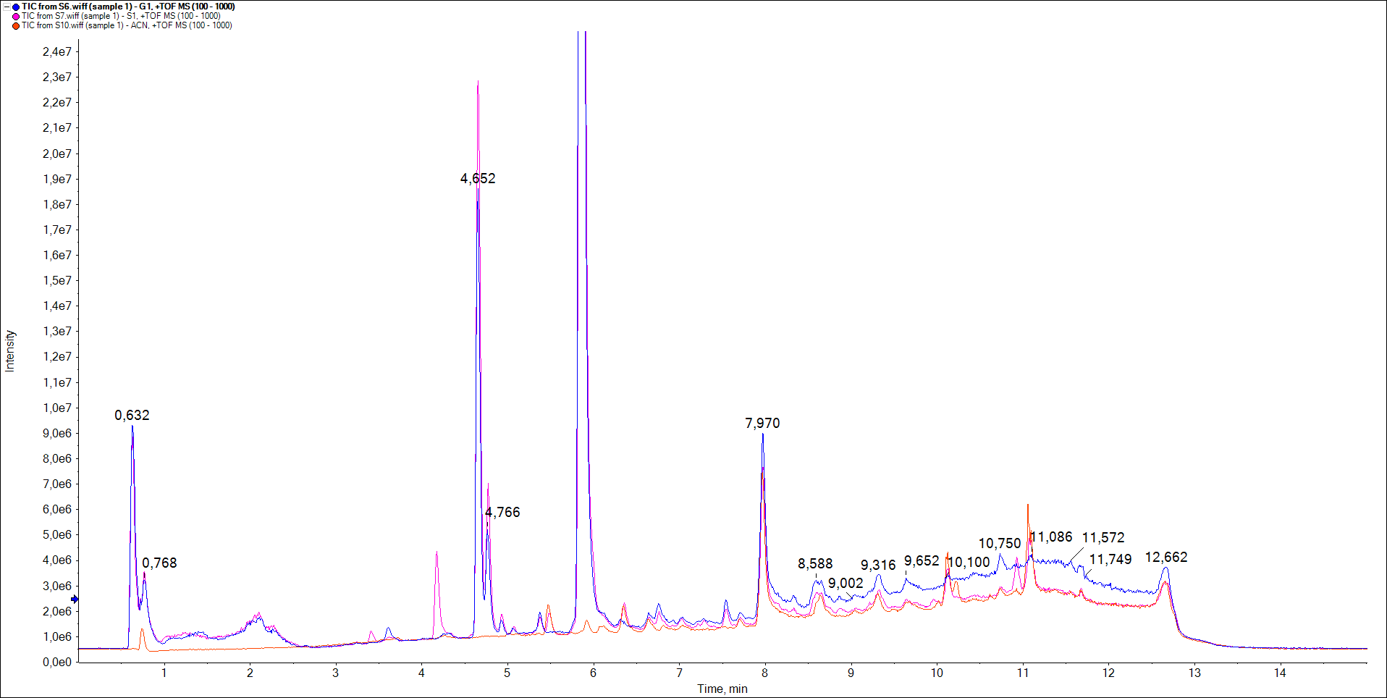
Figure S4. Total-ion chromatogram (TIC) of G1 (blue), S1 (pink) and acetonitrile blank (orange) of G1 and S1 samples (TIC)

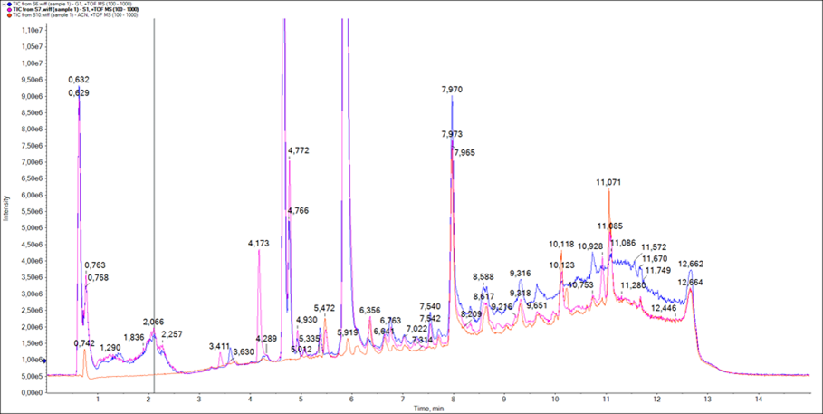

Figure S5. Zoomed total-ion chromatogram (TIC) of G1 (blue), S1 (pink) and acetonitrile blank (orange)

RDV degradation analysis of the G1/S1 neutral samples delivered from the 2nd mission

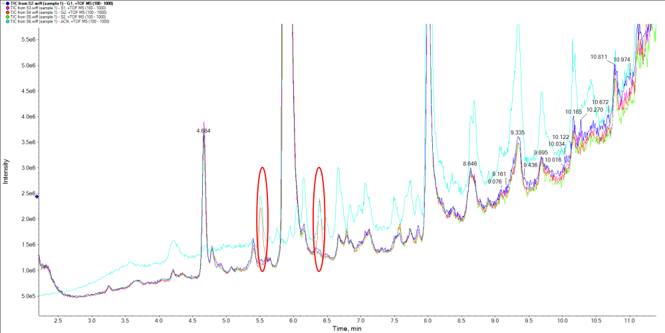
Figure S6. Zoomed total-ion chromatogram (TIC) of G1 (blue), S1 (pink) and acetonitrile blank (orange). Acetone peaks at Rt = 5.5 and 6.38 mins. (2nd mission)

RDV degradation products’ identification
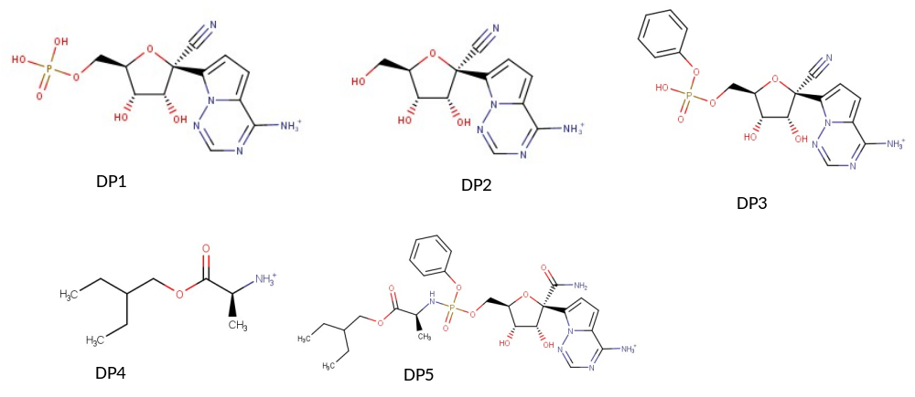
Fig. S7A. Degradation products formed under acidic stress conditions (based on Ref.)
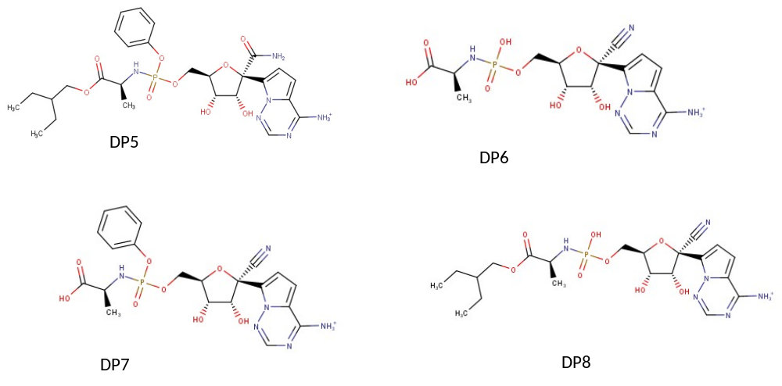
Fig. S7B. Degradation products formed under basic stress conditions (based on Dadinaboyina, et al. New J. Chem. 2021, 45, 7217-7224.)
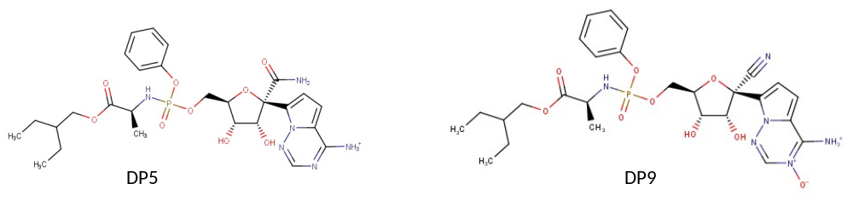
Fig. S7C. Degradation products formed under neutral (DP5) and oxidative (DP9) stress conditions (based on Dadinaboyina, et al. New J. Chem. 2021, 45, 7217-7224.)

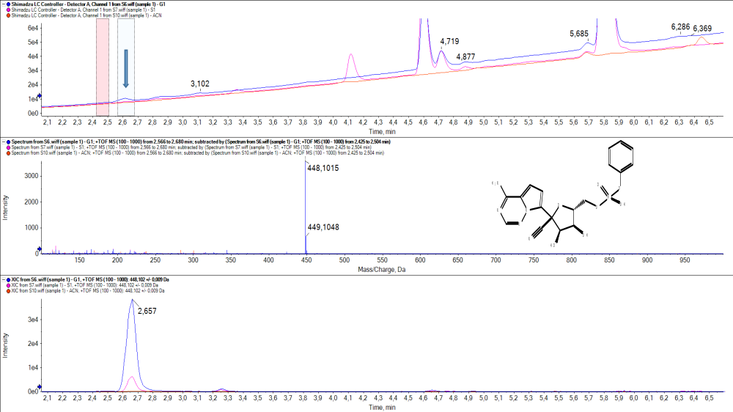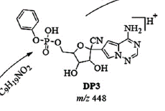
Figure S8. Degradation product at 2.657 min; (M+H=448) (RDV Deg1)

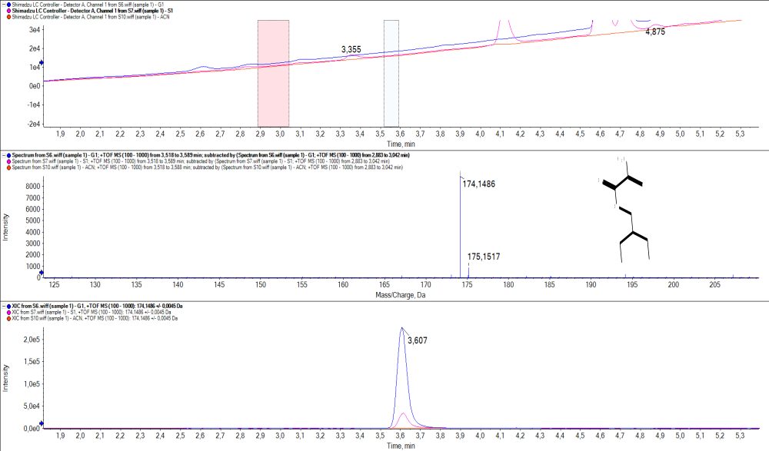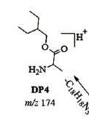
Figure S9. Degradation product at 3.6 min; (M+H=174) (RDV Deg2)

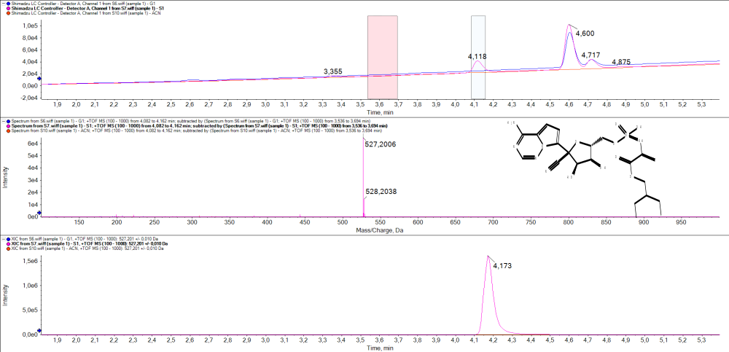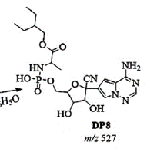
Figure S10. Degradation product at 4.173 min; M+H=527 (RDV Deg3)

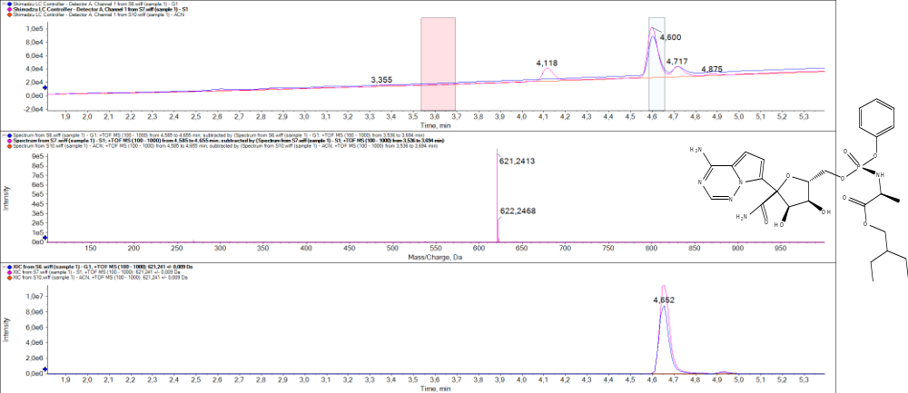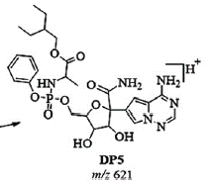
Figure S11. Degradation product at 4.652 min; (M+H=621) (RDV Deg4)

References () Dadinaboyina, S. B.; Yerra, N. V.; Adimoolam, B. M.; Parsa, S.; Bathini, N. B.; Thota, J. R. Identification and characterization of degradation products of Remdesivir using liquid chromatography/mass spectrometry. New J. Chem. 2021, 45, 7217-7224.

